Laboratory of Organic chemistry
Lab. of the first stage
Date / /

Experimental 3:
PURIFICATION AND SEPARATION OF ORGANIC COMPOUNDS
Organic compounds, whether solids , liquids or gaseous, when are separated from organic reactions are seldom pure. They may be contaminated with other compounds which are formed as a byproduct, owing to a side reaction.
These organic compounds have to be purified before using them in other chemical reaction. Several methods of purification have to be:-
1- Crystallization, 2- Sublimation, 3- Extraction, 4- Distillation,
5- Chromatographic adsorption.
The method employed depends upon the nature of the material to be separated and purified.
purification of solid organic compound by sublimation:-
Sublimation :- is the transformation of certain solid organic compound directly to the vapor state at high temperature, then condensing on a cold surface to the solid state without passing through the intermediate liquid state.
Such a process is a convenient means of separation and purification of certain compounds, that are characterized by sublimation, such as – camphor, benzoic acid, naphthalene, salicylic acid and the quinines.
EXPERIMENTAL PROCEDURE :-
1- Weight 0.5 gm of sample.
2- Put the sample in beaker then put wet filter paper on the beaker.
3- Put watch glass or funnel on the beaker.
4- Heat the sample (EX: benzoic acid) until it sublimate.
5- Record the amount of the solid organic compound after weight.
6- Calculate the percentage of purity compound.
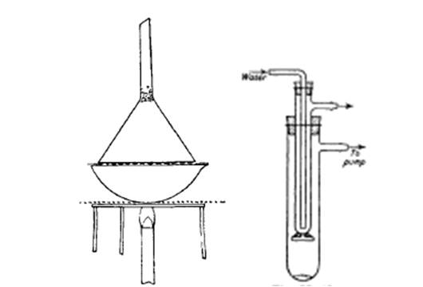
Fig. Sublimation apparatus

H.W: Explain are there other practical methods to obtain the largest amount of pure substance other than the method it was done in the laboratory?

Lecturer: Dr. Hussein N.K. AL-Salman

