Local anesthesia
A local anesthetic (LA) is a medication that causes absence of all sensation (including pain) in a specific body part without loss of consciousness, as opposed to a general anesthetic, which eliminates all sensation in the entire body and causes unconsciousness. Local anesthetics are most commonly used to eliminate pain during or after surgery.^{[2]} When it is used on specific nerve pathways (local anesthetic nerve block), paralysis (loss of muscle function) also can be induced.
Important terminologies
- General anesthesia (GA) A state of unrousable unconsciousness to which analgesia and muscle relaxation is added to produce ‘balanced anesthesia’.
- Anesthesia is the complete loss of sensation including pain and pressure.
- Analgesia The absence of pain.
- Paresthesia: is an altered sensation of tingling, this could be felt in damaged nerve or when local anesthetic starts or work or its effect wears off.
- Dysesthesias: is an abnormal sensation
- Sedation An altered level of consciousness in which the patient, although awake, has lower level of fear and anxiety.
- Relative analgesia (RA) is the most commonly used and safest form of sedation in dentistry. It has two aspects: (i) the delivery of a mixture of nitrous oxide and O2 ; (ii) a semi-hypnotic patter from the sedationist
- Mechanical trauma (compression of tissues) | - Chemical irritants
- Low temperature | - Neurolytic agents such as alcohol and phenol
- Anoxia | - Chemical agents such as local anesthetics
Many methods are used to induce local anesthesia:

A lot of chemicals could induce local anesthesia, but certain criteria are important to be met for them to be used, desirable properties are:
- It should not be irritating to the tissue to which it is applied.
- It should not cause any permanent alteration of nerve structure.
- Its systemic toxicity should be low.
- It must be effective regardless of whether it is injected into the tissue or is applied topically to mucous membranes.
- The time of onset of anesthesia should be as short as possible.
- The duration of action must be long enough to permit completion of the procedure yet not so long as to require an extended recovery.
- It should have potency sufficient to give complete anesthesia without the use of harmful concentrated solutions.
- It should be relatively free from producing allergic reactions.
- It should be stable in solution and should readily undergo biotransformation in the body.
- It should be sterile or capable of being sterilized by heat without deterioration.
Classification of nerve fibers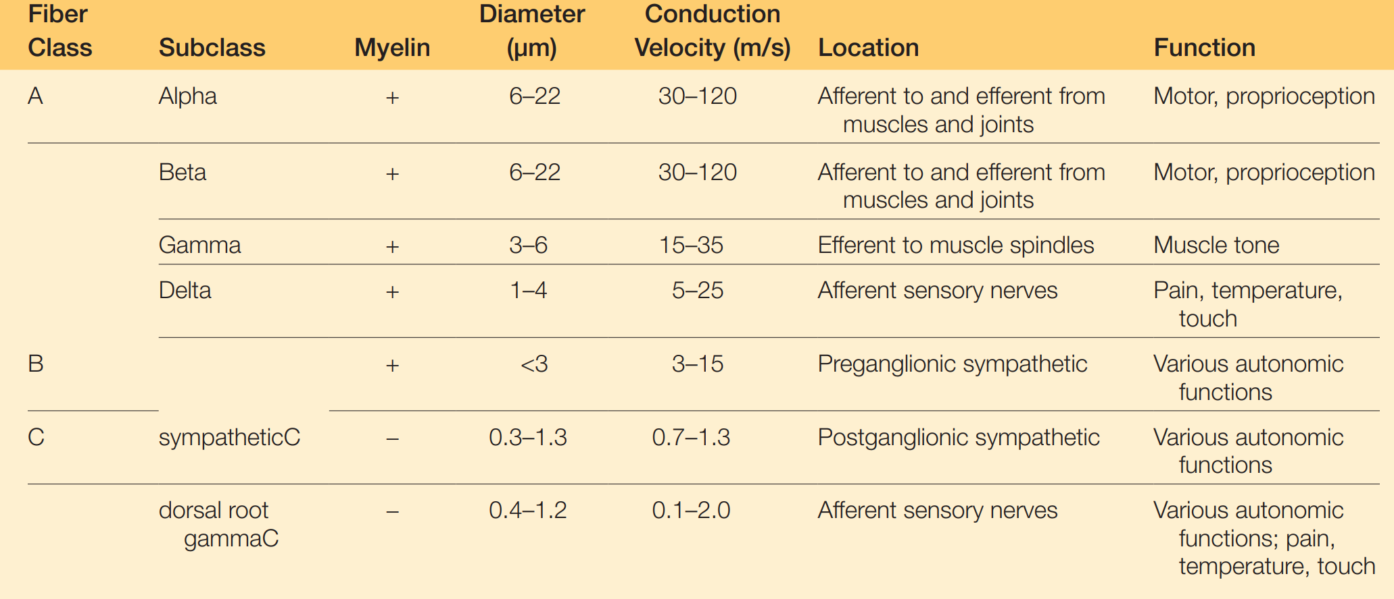

Understanding pain transmission
- The Neuron, or nerve cell, is the structural unit of the nervous system. It can transmit messages between the central nervous system (CNS) and all parts of the body. There are two basic types of neurons: sensory (afferent) and motor (efferent). The basic structure of these two neuronal types differs significantly.
- Sensory neurons capable of transmitting the sensation of pain consist of three major portions:
- The peripheral process (also known as the dendritic zone). At the end of the dendrites, receptors are present that can receive signa
- The axon is a thin cable-like structure that may be quite long (the giant squid axon has been measured at 100 to 200 cm). At the end of the axons are synapses, where the impulse is transmitted to another nerve cell or to a cell of the end organ
- The cell body is the third part of the neuron.
- Motor neurons are nerve cells that conduct impulses from the CNS toward the periphery have the same structure as the sensory one but the cell body contribute to impulse transmission not only in neuronal support.
- The function of a nerve is to carry messages from one part of the body to another. These messages, in the form of electrical action potentials, are called impulses. Nerve fibers are in resting potential until being provoked. Resting potential is -70 mV resulting from concentration difference on either side of the membrane.
Action potentials are transient depolarizations of the membrane that result from a brief increase in the permeability of the membrane to sodium, and usually also from a delayed increase in its permeability to potassium. Impulses are initiated by chemical, thermal, mechanical, or electrical stimuli.
Membrane Excitation
Depolarization
Excitation of a nerve segment leads to an increase in permeability of the cell membrane to sodium ions. This is accomplished by a transient widening of transmembrane ion channel stimuli sufficient to permit the unhindered passage of hydrated sodium ions. The rapid influx of sodium ions to the interior of the nerve cell causes depolarization of the nerve membrane from its resting level to its firing threshold of approximately −50 to −60 mV.
Repolarization: The action potential is terminated when the membrane repolarizes. This is caused by the extinction (inactivation) of increased permeability to sodium.
Absolute refractory period: Immediately after a stimulus has initiated an action potential, a nerve is unable, for a time, to respond to another stimulus regardless of its strength. That’s why impulses don’t spread in retrograde fashion.
relative refractory period: during which a new impulse can be initiated but only by a stronger than-normal stimulus.
Mechanism of action of local anesthesia
LA prevents generation and conduction of nerve impulses in that way signals are not reaching the brin to be interpreted as pain. LA acts at the nerve membrane to dispose their pharmacological action. Many theories were proposed to explain LA works, only two were reasonably accepted:
The membrane expansion theory states that local anesthetic molecules diffuse to hydrophobic regions of excitable membranes, producing a general disturbance of the bulk membrane structure, expanding some critical region(s) in the membrane, and preventing an increase in permeability to sodium ions. However, no direct evidence suggests that nerve conduction is entirely blocked by membrane expansion per se.
The specific receptor theory: the most favored today, proposes that local anesthetics act by binding to specific receptors on the sodium channel. The action of the drug is direct, not mediated by some change in the general properties of the cell membrane. Both biochemical and electrophysiologic studies have indicated that a specific receptor site for local anesthetics exists in the sodium channel either on its external surface or on the internal axoplasmic surface.
Factors influence LA action.
PH Value | Onset | Acidification of tissue to which LA is injected decrease efficacy greatly and that’s why it is of unremarkable effect at inflamed area.
Lipid solubility | Potency | Increased lipid solubility results in increased potency
Protein binding | Duration | Increased protein binding increase duration of LA. Bupivacaine greatly bind to protein receptors elongating its action
Nonnervous tissue diffusibility | Onset | increased diffusibility results in decreased time of onset
Vasodilator activity | Potency and duration | Greater vasodilator activity results in increased blood flow to the region, resulting in rapid removal of anesthetic molecules from the injection site; thus anesthetic potency and duration are decreased

In certain situations, the dental procedure could last longer than the duration of LA. Reinjection of the LA could lead to:
- Profound anesthesia: the concentration of local anesthetic in the core fibers is less than that in the mantle fibers. After deposition of a new high concentration of anesthetic near the nerve, the mantle fibers are once again exposed to a concentration gradient directed inward toward the nerve; this eventually leads to an increased concentration in the core fibers.
  - Difficulty in achieving profound anesthesia: the dental procedure has lasted longer than the clinical effectiveness of the local anesthetic drug, and the patient is experiencing pain. Readministers a volume of local anesthetic, but unlike in the first scenario, effective control of pain does not develop a process known as tachyphylaxis.
Tachyphylaxis is defined as increasing tolerance to a drug that is administered repeatedly. It is much more likely to develop if nerve function returns before reinjection (e.g., if the patient complains of pain). The duration, intensity, and spread of anesthesia with reinjection are greatly reduced. Tachyphylaxis is believed to be a result of one or combination of:
- Edema,
- Localized hemorrhage
- Clot formation.
- Transudation
- Hypernatremia
- Decreased pH of tissue

