***Antipsychotics drugs***

**It's as major tranquillizers or Neuroleptics.**

**\* We can classified Antipsychotic drugs into two types , 1st generation that act as competitive inhibitors of D2 Dopamine receptors in the brain & Peripheral ,which associated with high EPS.  
Other is 2nd generation, which have weak D2 blocking but with potent 5-HT2 antagonist activity but with less EPS .**

**Classification of Antipsychotics**

**Based on chemical structure ,antipsychotics are classified into five classes, those are:  
1. phenothiazines  
2. Ring analogues of phenothiazine   
3. Fluoro butyrophenones  
4. β-amino ketones  
5. Benzamides**

**1. Phenothiazines ( 1st generation, typical antipsychotics)**

**Three parts can be modified :**

**\*Modification on TC system.  
* Modification propyl side chain.  
* Modification aliphatic amine NR2**

**\*\* SAR of Phenothiazine**

**Modification on TC system**

**- Phenothiazines have a tricyclic structure (6-6-6 system) in which two benzene rings are linked by a sulfur and a nitrogen atom.**



**a-The phenothiazine ring without substitution is inactive and the activity depend on the nature and position of the substitution.**

**b-The substitution at position 2 (R2) with EWG increase antipsychotic activity .**

**c- So replacement of hydrogen atom at position 2 by chloro (chloropromazine), or by trifluoromethyl (triflupromazine) increase the activity.**



**The trifluoromethyl derivatives is more potent than chloro one but show higher extrapyramidal S/E(EPS).**

**d- The tranqulizing activity is retained with a variety of 2- substituents as thioalkyl and acyl group, but the 2 thioalkyl derivatives show fewer extrapyrmidal S/E .**

**e- Substitution at position 1,3,4,6,7,9 result result in loss of tranquilizing activity.**

**Modification of side chain**

**f- The 3C chain between position N- 10 and the aliphatic amino nitrogen is critical for neuroleptic activity. Shortening or lengthening the chain at this position decreases the activity.**

**i) Compound with 2 carbon side chain possess a moderate central depressant activity but**

**with predominant antihistamine and antiparkinsons disease.**

**ii) Significant change in the length and polarity of the side chain(propyl dialkyl amine)**

**lead to loss of activity, although some of these compounds are antitussive.**

**iii) Branching at β-position of the side chain with a small group as methyl produce variable changes in tranquilizing activity depending on the nature of R2 (it may enhance or decrease activity.**

**Q/ what is the general effect of β-methyl substitution on the pharmacological activity of phenothiazine?**



**In general β-methyl substituent enhance the antihistaminic antipruritic effects (trimeprazine). This occur due to steric repulsion between the methyl group at the β-position and the 1,9 perihydrogens of the phenothiazine which result in a decrease in the coplanarity of the benzene rings.**

**Modification of Aliphatic amine ( -NR2)**

**1. The aliphatic nitrogen should be tertiary to resist metabolism, if its 4◦there is no activity is**

**produced because of the high polarity (decrease lipid solubility) → ↓activity.**

**2. increasing the size of amino N-alkyl substituents (diethylamino) reduces antidopaminergic and**

**antipsychotic activity.**

**3. Substitution of piperazine group in place of terminal dimethyl amino group, as in trifluorperazine**

**and prochlorperazine result in increased potency, but result in an increase in EPS.**

**Or can be replaced by alkyl piperidyl and terminal N- should be substituted by alkyl not (H) which**

**produce no activity.**



**Note:- dimethyl amino derivative more likely produce a Parkinson like syndrome (tremor, rigidity, salivation), while the piperazine derivatives produce-in addition-dyskinetic reaction involve the muscle of the face and neck, but the advantage of piperazine derivative is that they do not cause skin and liver disorders and blood dyscrasias that is associated with dimethyl amino and alkyl piperidyl.**

**2. Ring analogues of phenothiazines :**

**These are again devided into 3 types:**

**a- Thioxanthines**

**the thioxanthine system differs from the phenothiazine system be replacement of N-H moiety with a carbon atom doubly bonded to the propylidene side chain. with the substituent in the 2 position. The Z isomers are the more active antipsychotic isomers. The compounds of the group arc very similar in pharmaco-logical properties to the corresponding phenothiazines.**

**Isosteric replacement of the phenothiazine ring nitrogen by C,or O result in a decreased activity.**



**b-Dibezodiazepines derivative . ( 2ed generation , Atypical antipsychotic)**

**2N = aza , centeral ring is 7 membered.**

**e.g. Clozapine**

**its blocks D4 & other receptors like α1 ,α2, 5-HT1A , 5-HT2A, 5-HT2C .**

**effective against both +ve & -ve symptoms of schizophrenia and low tendency to produce EPS.**



**c- Dibenzoxazepines derivative .**

**e.g. Loxapine succinate**



**3. Fluoro butyrohenones :**



**i) Haloperidol**

**\* potent antipsychotic useful in schizophrenia & psychosis .  
- used in Gilles de la torrete syndrom.  
S/E : haloperidol upon dehydration produce a metabolic. Which causes dyskinesia.**



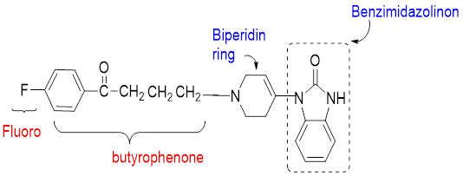**ii) Droperidol**   
- used as preanesthetic neuroleptic.   
 or as an antiemetic (to treat or prevent nausea)

Because of short acting & highly sedating properties used in combination with fentanyl preanesthetically.

**iii) Risperidone**

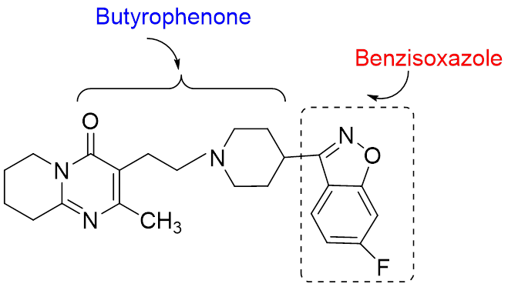

4**. β-amino ketone**

**Molindone hydrochloride**



 **5. Benzamide  
  
 s.g. Sulpiride**