Chapter 3 Working with Controls
- Designing the Form
- Form Definition
A Form is a container upon which controls are placed. When an application is executed, the form becomes a window. This graphical interface allows the user to see the Input and Output provides by application. The GUI is instructed by placing a set of visual objects on a blank window or Form. Let's start with creating a Window Forms Application by following the following steps in Microsoft Visual Studio:
File → New Project → Windows Forms Applications
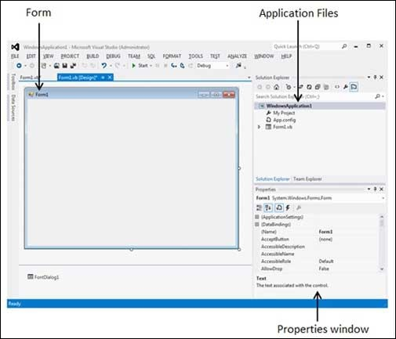
Microsoft Visual Studio creates your project and displays following window Form with a name Form1.

Every form will have title bar on which the form's caption is displayed and there will be buttons to close, maximize and minimize the form shown below. If you click the icon on the top left corner, it opens the control menu, which contains the various commands to control the form like to move control from one place to another place, to maximize or minimize the form or to close the form.

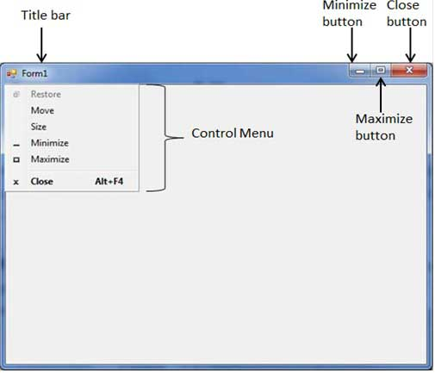

Form Events
Following table lists down various important events related to a form.

Sr.No. | Event | Description
1 | Activated | Occurs when the form is activated in code or by the user.
2 | Click | Occurs when the form is clicked.
3 | DoubleClick | Occurs when the form control is double-clicked.
4 | Enter | Occurs when the form is entered.
5 | KeyDown | Occurs when a key is pressed while the form has focus.
6 | KeyPress | Occurs when a key is pressed while the form has focus.
7 | KeyUp | Occurs when a key is released while the form has focus.
8 | Load | Occurs before a form is displayed for the first time.

Form Properties
Following table lists of important properties related to a form. These properties can be set or read during application execution.

Properties | Description
- BackColor | Sets the form background color.
- Enabled | If True, allows the form to respond to mouse and keyboard events; if False, disables form.
- Font | This property specify font type, style, size
- Height | This is the height of the Form in pixels.
- Width | This is the width of the form in pixel.
- MinimizeBox | By default, this property is True and you can set it to False to hide the Minimize button on the title bar.
- MaximizeBox | By default, this property is True and you can set it to False to hide the Maximize button on the title bar.
- Text | The text, which will appear at the title bar of the form.
- StartPosition | This property determines the initial position of the form when it's first displayed. It will have any of the following values −  - CenterParent − The form is centered in the area of its parent form.  - CenterScreen − The form is centered on the monitor.  - Manual − The location and size of the form will determine its starting position.  - WindowsDefaultBounds − The form is positioned at the default location and size determined by Windows.  - WindowsDefaultLocation − The form is positioned at the Windows default location and has the dimensions you've set at design time.

Form Methods
The following are some of the commonly used methods of the Form class.
Sr.No. | Method Name & Description
1 | Activate :- Activates the form and gives it focus.
2 | ActivateMdiChild :- Activates the MDI (Multi Documents Interface) child of a form.
3 | Close :- Closes the form.
4 | Focus :- Sets input focus to the control.
5 | Hide :- Conceals the control from the user.
6 | Refresh :- Forces the control to invalidate its client area and immediately redraw itself and any child controls.
7 | Select :- Activates the control.
8 | Show :- Displays the control to the user.
9 | ShowDialog :- Shows the form as a modal dialog box.

