- Getting Started with Visual Studio
You will use the VB component of Visual Studio to create and test projects.
- In VB, programming applications you will design and develop are called solutions.
- A solution can actually contain more than one project.
- Each solution is stored in a folder identified by the solution name.
- Steps to Open VB 2010 and Create a New Project
- Start Visual Studio 2010. Figure1
2. On the Visual Studio File menu, click New Project, or you can start a new project by clicking the blue New Project link on the Start Page. The New Project dialog box opens, as shown Figure 2.
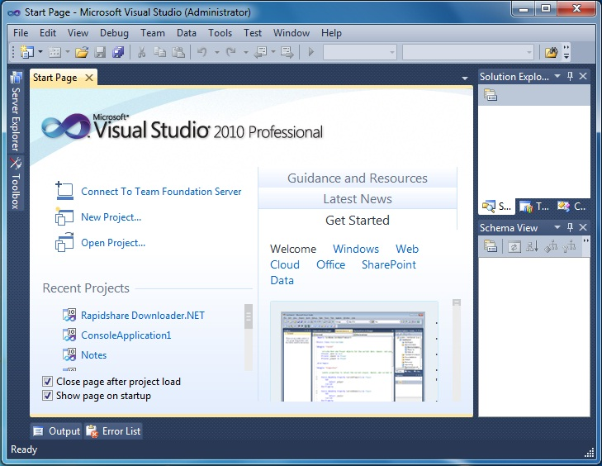
Figure1: Start Page for Visual Basic 2010 Express Edition.

The Visual Studio Start Page in this figure above is slightly different for Visual Studio 2010 (Professional or Ultimate Edition) and Visual Basic 2010 Express Edition.
Figure 2
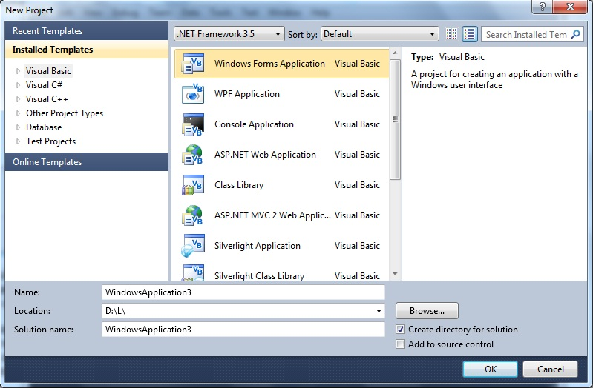
- Your first project will be a Visual Basic Project using a Windows Forms Application template as shown in the figures above.
- The default name is WindowsApplication1 – You can change the project name
- Click the OK button – it takes several seconds to create the project files from the template.
- The Integrated Development Environment
Familiarize yourself with the Integrated Development Environment (IDE). Figure 3.
- Across the top are menus with different options used in the designing of an application.
- Toolbars with shortcut icons are shown below the menus.
- Form Designer (also termed the Document Window).
- Solution Explorer Window – displays filenames for files that comprise a project. The solution name is also shown here.
- Properties Window – displays properties of the currently selected object – in the figure the properties displayed are those of the Form object.
- ToolBox Window – this is shown along the left edge of the figure in collapsed display.
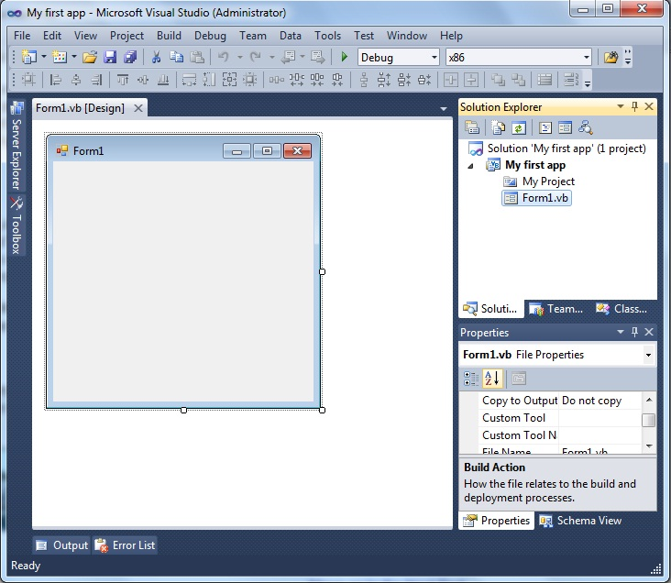

Figure 3
- Saving and Running a Project
To save a project, use File-Save. AVOID using File-Save As. You can click the Save All button on the tools bar. This will save all files in the project.

To run project there are several ways. Use the Debug menu, Start Debugging option, or press F5 function key to run the project, or Click the shortcut green arrow on the shortcut toolbar.

- Naming Rules and Conventions
Visual Basic automatically assigns a value to the Name property of each control by default, for example, Label1, Label2 or TextBox1, TextBox2 or Button1, Button2, etc. However, it is difficult to remember the difference between them so, it is best to rename them to a more meaningful name.
- An object name can begin with an uppercase letter or with “underscore” character.
- An object name can include letters, digits, and underscores.
- An object name CANNOT include a space or a punctuation mark.
- An object name CANNOT be a VB reserved word such as Button, Close, etc.
- Select object names that are meaningful.
- There are different types of rules for writing name of an object name. In this course we will use Hungarian Naming rules.

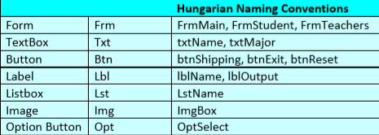
Figure 4: Examples of valid Hungarian Naming Conventions:

- Adding Program Code
Most VB objects may have code (programs) attached to it. When the user clicks on the object, VB will execute this program. Double click on any objects on the form (at design time) will transfer system to another window (View Code Window or Editor Window). You can also access the code view from the View menu or the View icon in the Solution Explorer window. Each procedure should begin with:

Private Sub object name_Events name ( ) …………. Header Line

VB commands and statements here ………………

End Sub

Notes :
* Commands are the lines of code you type in order to perform what you desire.
* A header line begins with optional keyword Private and must contain the keyword
Sub. Private Sub & End Sub are key words automatically included by VB.
* For event procedures, the name consists of object identification, an underscore ( _ ),
a valid event for the specific object, parameters between parentheses, the keyword
Handle followed by object identification, dot Character, and a valid event.
* A Remark statement is a line of code shown in green. It is used to document your program code. Remarks are very useful for large programs. Remark statements are non-executable. In VB you can begin your comments or any remark statement with an apostrophe ( ‘ ).
* Often you will need to switch between View Designer and View Code Windows. Click one of the tabs to display either the View Designer or View Code windows, Click the View Code icon in the Solution Explorer to open the coding window, Click the View Designer icon in the Solution Explorer to display the form for additional design layout, or Click the View menu and select either the Code or Designer submenu options.
* VB also provides an Auto List Members feature (Editor-Intellisense). This feature presents a drop-down list of available members (such as properties and methods). It is use to accelerating your typing and help you when you aren’t sure which property or method are available for a specific control.
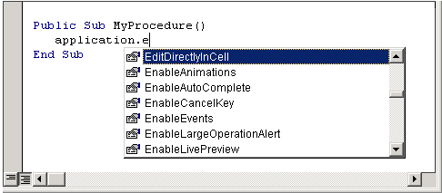

Figure 5

