 | Research Article  Chemical Review and Letters  journal homepage: www.chemrevlett.com  ISSN (online): 2645-4947 (print) 2676-7279 | 
Preparation, characterization, and in vitro performance evaluation of polymeric scaffolds containing sodium alginate microspheres with methotrexate for controlled drug delivery
Baryham S Abdul Samad*, Nadia Ashoor Hussein Al-Asady
Department of Chemistry, College of Education for Pure Science, University of Bsarah, Basra,
Iraq
*Corresponding author: Email: baryham.saad@uobasrah.edu.iq
ARTICLE INFO | ABSTRACT
Article history: | This study explores the development and characterization of polymeric scaffolds containing sodium alginate microspheres loaded with methotrexate for controlled drug delivery. We fabricated scaffolds using hexamethylene diisocyanate and polyelectrolyte, incorporating drug-loaded microspheres, scaffolds were thoroughly characterized using various analytical techniques, including FTIR, XRD and SEM, drug release kinetics were evaluated under physiological conditions, demonstrating sustained release profiles over 150 hours, examinations of void spaces unveiled highly permeable structures conducive to cellular penetration and nutrient circulation. Decomposition patterns were evaluated in oxidizing and enzymatic settings, demonstrating steady disintegration across multiple weeks. Our discoveries indicate that these frameworks show potential for utilization in pharmaceutical administration and biological tissue construction, providing adjustable characteristics and regulated discharge abilities.
Keywords:
Polymeric scaffolds, Nanoparticles, Drug delivery systems, Controlled release, Degradation, Porosity.

1. Introduction
Advanced medication administration systems have emerged as innovative strategies to boost therapeutic effectiveness and reduce unwanted side effects linked to traditional drug delivery methods [1,3], These approaches aim to administer medicinal compounds at the optimal rate and timeframe, while sustaining ideal drug levels at the intended location [4,5], Among various regulated drug delivery platforms, polymer-based frameworks have attracted considerable interest [6,7] due to their adaptability [8], biocompatibility [9,10] and potential for localized and sustained drug release [11,12]. Polymeric scaffolds are three-dimensional, porous structures fabricated from biocompatible and biodegradable polymers [13,14], these scaffolds serve as matrices for incorporating drug-loaded nanoparticles or microparticles, facilitating controlled and localized drug delivery [15,18], The porous design of these frameworks plays a vital role in facilitating efficient drug loading, cell penetration, nutrient flow, and tissue assimilation, making them particularly appealing for tissue engineering and regenerative medicine applications [19], The creation and advancement of polymer-based frameworks involve meticulous material selection, refinement of manufacturing techniques, and incorporation of functional elements to customize their properties for specific therapeutic uses. Aspects such as permeability, surface features, degradation speed, and structural integrity significantly impact the performance of these frameworks in drug delivery and tissue regeneration [20], researchers have explored various strategies to enhance the drug delivery capabilities of polymeric scaffolds, these include the incorporation of functional components such as nanofillers, polyelectrolytes, or other functional polymers to modulate the scaffold's physicochemical properties and drug release kinetics such as graphene oxide [21] or hydroxyapatite [22] to modulate the scaffold's physicochemical properties and drug release kinetics. Additionally, the use of polyelectrolytes [23] or other functional polymers can impart desirable characteristics as improved mechanical strength, controlled degradation, and tailored drug release profiles, the selection of biomaterials and optimization of fabrication techniques have been extensively studied to tailor the scaffolds' properties for specific therapeutic applications, the creation and refinement of polymer-based frameworks necessitate meticulous attention to various elements, including void spaces, surface characteristics, decomposition speed, and structural integrity. These aspects play a crucial role in determining the effectiveness of these frameworks for medication administration and biological tissue restoration purposes. Advanced characterization techniques as SEM, FTIR and XRD are employed to gain insights into the chemical composition, crystalline structure and surface morphology. Several studies have demonstrated the potential of polymeric scaffolds for controlled drug delivery in various therapeutic areas including cancer therapy, wound healing and tissue regeneration, research by Jan N. [24] successfully developed polymeric scaffold system incorporating drug-loaded nanoparticles for the sustained release of an anticancer agent, showing promising in vitro and in vivo results. Similarly Cheng M. [25] reported the fabrication of manufactured bioresorbable scaffolds filled with autologous fat graft for promoting tissue replacement in preclinical animal model, despite the promising advancements, challenges remain in optimizing the design, fabrication and performance of polymeric scaffolds for specific therapeutic applications, ongoing research efforts are focused on exploring new biomaterials, refining fabrication techniques and investigating the synergistic effects of combining scaffolds with other therapeutic modalities such as gene therapy or stem cell therapy [26]. In this research we investigate the preparation and characterization of polymeric scaffolds based on three distinct compositions: toluene diisocyanate with graphene oxide, toluene diisocyanate with polyelectrolyte, and hexamethylene diisocyanate with polyelectrolyte, these scaffolds are designed to incorporate drug-loaded nanoparticles, enabling controlled and localized delivery of therapeutic agents within the porous matrix, the comprehensive evaluation encompasses advanced characterization techniques, in vitro drug release studies and porosity measurements to elucidate the influence of scaffold composition on structural, morphological, and functional properties In addition to examining medication discharge dynamics, the investigation also assessed the potential of interlinked Gelatin/Sodium Alginate as a pharmaceutical vehicle. This was accomplished through laboratory experiments simulating biological fluids, employing Methotrexate as a representative medication. Methotrexate, 2,4-diamino-N10-methyl propylglutamic acid (MTX), is a folic acid antagonist, widely used as a therapeutic agent. it was first applied for the treatment of life-threatening neoplastic diseases (acute lymphoblastic leukemia, breast cancer, and choriocarcinoma). it also found application in other diseases: Rheumatoid Arthritis, Multiple Sclerosis, Vasculitis, Systemic Lupus Erythematosus, Psoriasis, and Inflammatory Bowel Disease, MTX's toxic effects can be severe and include hepatotoxicity, liver fibrosis, acute pneumonitis, neurotoxicity, and kidney damage. This considered, to optimize its use, it would be beneficial to develop novel formulations and targeted therapies to maximize its therapeutic effect and reduce its dosage and thus its toxic effects. The molecular structure of Methotrexate is depicted in Figure 1 [27].
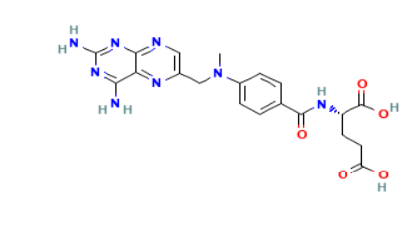
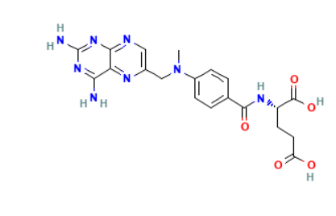

Figure 1: Methotrexate's structure
The significance of this research lies in its contribution to the development of advanced drug delivery systems with improved therapeutic outcomes and reduced side effects, by leveraging the unique properties of polymeric scaffolds and incorporating drug-loaded microspheres, this study aims to pave the way for more effective and targeted treatment strategies in various biomedical applications, such as cancer therapy, tissue regeneration, and wound healing.
2. Experimental
2.1. Materials
Poly Caprolactone ((C6H10O2) n, Mn ~80,000, Aldrich, USA). Polyethylene Glycol (PEG) (H(OCH2CH2)nOH, Mn ~6,000, Aldrich, USA),. Polyelectrolyte (PE) was supplied by a state company in the petrochemical industry (Iraq). Hexamethylene Diisocyanate (HDI) ((CH2)6(NCO)2, Sigma-Aldrich, USA, 99% purity). Chitosan (Aldrich, USA). Icariin (C33H40O15. Methotrexate (MTX) (C20H22N8O5, Aldrich, USA). Hydroxyapatite (HA) (Ca5(PO4)3(OH), Aldrich, USA, particle size <200 nm, ≥90% purity). Phosphate Buffer Solution (PBS) (LRCO). Ethylenediamine (EN) (C2H8N2, Aldrich, USA). Trimethylamine (TMA) (C3H9N, Aldrich, USA). N, N'-Dimethylformamide (DMF) (C3H7NO, Fisher Chemical). Methanol (Fisher Chemical). Hydrogen Peroxide (H2O2, Aldrich, USA). Castor Oil (Merck, Germany, USP grade). Cobalt Chloride (CoCl2, B.D.H., UK, ≥98% purity). Dialysis Bags (Hi Media Laboratories, India, molecular weight cut-off 12,000-14,000 Da). Calcium Chloride (Fluka, USA, ≥97% purity), Sodium Carbonate (Na2CO3, Fluka, USA, ≥99.5% purity)
2.2. Instruments and Characterization Techniques
Fourier-Transform Infrared Spectroscopy (FT-IR) (Shimadzu-Asinittw FTIR spectrophotometer) was utilized for the chemical analysis of the microparticles and scaffolds. At the same time, the surface morphology of prepared samples was studied using Scanning Electron Microscopy (SEM) and X-ray diffraction (XRD) (PanAlytical ). Microscopic images of the microparticles were obtained using a digital optical microscope (Optka microscope B-'290 Series). A Leica ICC50 HD Microscope Camera was employed to determine the dimensions of the MTX microparticles. UV-visible spectroscopy; (Shimadzu 1800-UV) was employed for monitoring the in vitro drug release.
2.3 Preparation of Methotrexate-Loaded microspheres
Fabrication of sodium alginate/chitosan microparticles: The sodium alginate microspheres were produced utilizing a modified version of the inotropic gelation method described in previous research [27], This process involved dissolving 40 mg of sodium alginate in 10 ml of purified water for 60 minutes at 85 °C. Separately, varying quantities of MTX (100, 200, and 300 mg), labeled as MTX1, MTX2, and MTX3 respectively, were dissolved in 3 ml of sodium hydroxide solution before being combined with the sodium alginate mixture (referred to as the carrier solution). In a separate container, chitosan solutions were prepared by dissolving 30 mg of chitosan in 30 ml of freshly made 2% v/v acetic acid solution. This was achieved using a magnetic stirrer operating at 150 rotations per minute (rpm) for 3 hours. The solution's pH was then adjusted to 5.5 using 0.1 M acetate buffer. Subsequently, 30 gm of CaCl2 was incorporated and dissolved into the chitosan solution (termed the cross-linking solution). The carrier solution was then introduced via a medical syringe into a beaker containing the cross-linking agent solution. This mixture was continuously agitated with a magnetic mixer for 30 seconds. Following this, the resulting product was filtered, rinsed with isopropyl alcohol, and allowed to dry at 25 degrees Celsius (as illustrated in Scheme 1) [28].
2.4. Preparation of Hexamethylene Diisocyanate Scaffold and Drug-Loaded microspheres:The first The creation of polyurethane frameworks involves a condensation-style polymerization, typically featuring the interaction between isocyanate (-NCO) and hydroxyl (-OH) groups to form carbamate (-NHCO) bonds. This polymerization usually occurs in two phases, resulting in segmented polyurethane:
Initial phase: A polyol reacts with a diisocyanate, producing an isocyanate-terminated prepolymer.
Subsequent phase: Chain extension occurs through the interaction of the prepolymer with a chain extender. The polyurethane prepolymer was produced using polycaprolactone and polyethylene glycol as polyols, combined with hexamethylene diisocyanate and anionic polyacrylamide polyelectrolyte PE (serving as the chain extender). Both polycaprolactone and polyethylene glycol underwent vacuum drying for 48 hours at 40 °C to eliminate trapped moisture. N, N´-Dimethyl formamide (DMF), used as a solvent, was dehydrated using calcium hydride (CaH2) and then treated with a molecular sieve. The detailed protocol for polyurethane synthesis is as follows:
Initial phase: The polyols (PCL and PEG) were combined with HDI at a 1:1:3 molar ratio in DMF solvent, with 0.1% dibutyltin dilaurate (DBTDL) catalyst to form the prepolymer. Specifically, 5 mmol each of PCL and PEG were added to 40 ml of DMF, followed by 15 mmol of HDI and 2-3 drops of DBTDL, under constant stirring.
Subsequent phase: Anionic polyacrylamide was introduced at a 1:1 molar ratio with the prepolymer. Specifically, 5 mmol of PE in 10 mL of water was added, (Refer to Scheme 2).
PU scaffolds containing 0.3 g of hydroxyapatite and 0.1 g microspheres were prepared using the same method as a control for subsequent experiments. The synthesized polyurethanes were stored in desiccators for characterization and future studies [29].
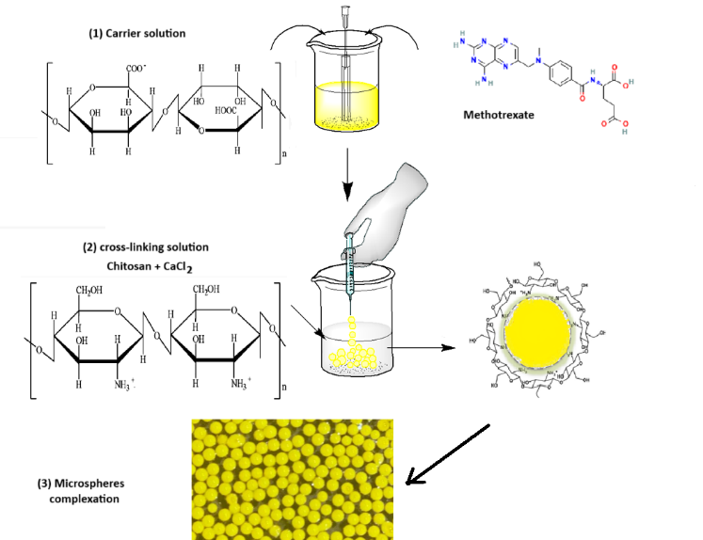
Scheme 1. Sodium alginate/chitosan microspheres preparation in two steps: (I) carrier solution (II) cross-linking solution, and (III) microspheres complexation.

Scaffold

Scheme 2: Preparation of Hexamethylene Diisocyanate

2.5 Preparation of Lysozyme Solution for Degradation Studies:
Lysozyme is an enzyme found in various biological fluids, used to investigate the degradation behavior of the prepared scaffolds under physiological conditions, the lysozyme solution was prepared by dissolving 0.15 g of lysozyme powder in 100 mL of phosphate-buffered saline (PBS) solution at a pH of 7.4, the PBS solution served as a buffering agent, maintaining a consistent pH level similar to that found in the human body. The lysozyme powder was carefully weighed and transferred into a beaker containing the PBS solution, the mixture was gently stirred using a magnetic stirrer until the lysozyme was completely dissolved, resulting in a clear, homogeneous solution, the lysozyme solution was then transferred to individual sterilized glass containers, ensuring sufficient volume for each scaffold sample to be immersed.
2.6 Preparation of Oxidation Solution for Degradation Studies
To study the oxidative degradation of the prepared scaffolds, prepared an oxidation solution using cobalt chloride (CoCl₂) and hydrogen peroxide (H₂O₂), the oxidation solution was formulated by dissolving 0.1 M of cobalt chloride in 20% (v/v) solution of 30% hydrogen peroxide. In a clean beaker, the appropriate amount of cobalt chloride was weighed and transferred, the 30% hydrogen peroxide solution was then diluted with distilled water to obtain 20% (v/v) concentration, and the diluted hydrogen peroxide solution was gradually added to the cobalt chloride while stirring continuously using a magnetic stirrer. The resulting dark blue solution was allowed to mix thoroughly until a homogeneous mixture was obtained, the oxidation solution was then transferred to individual containers, ensuring sufficient volume for each scaffold sample to be immersed.
3. Analytical Method
3.1 Morphological Study
Microscopic images of the microparticles were obtained using a digital optical microscope (Optka microscope B-'290 Series). A Leica ICC50 HD Microscope Camera was employed to determine the dimensions of the MTX microparticles. The size of three hundred microparticles was assessed by suspending dried microparticles in purified water. The suspension underwent agitation for 5 seconds. A minute droplet of the resulting suspension was placed on a pristine glass slide. The slide containing the MTX microparticles was then secured on the microscope platform. Subsequently, the average diameter and size distribution of the microparticles were calculated.
3.2 In Vitro Drug Release Studies (Methotrexate Release from Scaffolds)
To study the in vitro release of methotrexate from the scaffolds, in a dialysis bag (100 mg) microsphere was immersed 200 mL in a release medium (phosphate-buffered saline, pH 7.4 maintained at 37°C with constant agitation, at specific time intervals, aliquots of the release medium were collected and analyzed for methotrexate content using UV-visible spectroscopy at wavelength of 304 nm for methotrexate detection, the withdrawn volume was replaced with fresh release medium to maintain sink conditions, the cumulative drug release from the scaffolds was calculated and plotted as a function of time.
3.3 Porosity Studies (Liquid Displacement Method)
The porosity of the scaffolds was evaluated using the liquid displacement method, where ethanol was employed as the displacement liquid due to its ability to penetrate the porous structure of the scaffolds readily, the procedure involved the following steps:
A pre-weighed dry scaffold sample was placed in a graduated cylinder containing a known volume of ethanol V1, the scaffold sample was left immersed in the ethanol for 30 minutes to allow complete penetration of the ethanol into the scaffold's pores, after 30 minutes, the total volume of the ethanol and the immersed scaffold sample was recorded as V2, the scaffold sample was carefully removed from the graduated cylinder, and the remaining volume of ethanol was recorded as V3. The porosity percentage (P%) of the scaffold was calculated using the following equation:
P% =((V_1 - V_3 )/((V_2 - V_3))× 100% ……….(1)
Where: (V1 - V3) represents the volume of ethanol retained within the scaffold sample.
(V2 - V3) represents the total volume of the scaffold sample.
3.4 Degradation Study of Prepared Scaffolds in Oxidation Solution:
The oxidative degradation behavior investigated of the prepared scaffolds by immersing them in an oxidation solution containing cobalt chloride CoCl₂ and hydrogen peroxide H₂O₂, samples of each scaffold type were carefully cut into equal weights and immersed in individual containers filled with the oxidation solution, at predetermined time intervals (7, 14, and 21 days), the scaffold samples were retrieved from the oxidation solution and gently rinsed with distilled water to remove any residual solution, the samples were then dried in an oven at a controlled temperature for two days to ensure complete dryness. The oxidation solution was replenished every 7 days to maintain a consistent concentration of the oxidizing agents and minimize any potential deviations in the degradation conditions throughout the study.
- Results and Discussion
  - Morphology and Size Distribution
A digital optical microscope y was used to prove the spherical shape of the prepared microspheres. It has been observed that the increased concentration of Methotrexate has increased the rough surface of the microspheres compared to the drug-free. Increased drug concentration of MTX increased microspheres' mean particle size (MPS). An increase in MPS may be a result of the release in viscosity of the droplets present in the internal phase caused by the increase in Methotrexate concentration. MPS of microparticles (300 particles) was determined using an optical microscope with a magnification of (x40) with a calibrated stage micrometer: Table 1 and Figure 2.
Table 1: Diameters of microspheres estimated in microns and the number of microspheres corresponding to each average dimension for different Methotrexate concentration
Particle diameter  (µm) | Mean particle diameter (µm) d | Number of fields examined (n)
Particle diameter  (µm) | Mean particle diameter (µm) d | MTX1 | MTX2 | MTX3
305-8.5 | 6 | 0 | 0 | 0
8.5-13.5 | 11 | 35 | 24 | 10
13.5-18.5 | 16 | 68 | 46 | 25
18.5-23.5 | 21 | 90 | 86 | 89
23.5-28.5 | 26 | 72 | 70 | 75
28.5-33.5 | 31 | 10 | 11 | 20
33.5-38.5 | 36 | 4 | 19 | 27
38.5-43.5 | 41 | 6 | 13 | 17
43.5-48.5 | 46 | 9 | 15 | 26
48.5-53.5 | 51 | 6 | 16 | 11
 |  | $$\sum{n=300}$$ | $$\sum{n=300}$$ | $$\sum{n=300}$$
 | $$\sum{nd}$$ | 6655 | 7690 | 8375
Mean particle diameter | $$\sum{nd / \sum{n}}$$ | 22.18 | 25.63 | 27.91
According to the data of the above table, the mean particle diameter of the Methotrexate microspheres was 22.18, 25.63, and 27.91 for formulations MTX1, MTX2, and MTX3, respectively.
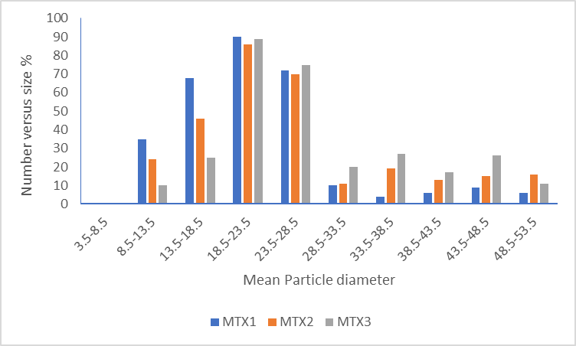
Figure 2: The curve of the distribution of dimensions of Methotrexate microspheres
  - Characterization of scaffolds
    - FTIR Analysis

We used Fourier-transform infrared (FTIR) spectroscopy to analyze the chemical composition and functional groups in our prepared scaffolds. Figure 3 presents the FTIR spectrum of the microsphere, while Figure 4 shows the spectrum of the hexamethylene diisocyanate scaffold. Examining Figure 3, which illustrates the spectrum of the microsphere, we observe several characteristic peaks. Notable peaks appear at 1007.78 cm⁻¹ and 1207 cm⁻¹, which we attribute to C-O stretching in ether or ester groups. Another significant peak at 1264 cm⁻¹ likely corresponds to C-N bending in amide or amine groups. We noted peaks at 1429 cm⁻¹ and 1479 cm⁻¹, which we associate with C-H bending in methyl or methylene groups. Two peaks at 1609 cm⁻¹ and 1665 cm⁻¹ caught our attention, and we believe these are due to N-H bending and C=O stretching in amide groups, respectively. The spectrum also shows peaks at 2856 cm⁻¹ and 2923 cm⁻¹, which we attribute to C-H stretching in methyl or methylene groups, we observed a broad peak at 3406 cm⁻¹, indicative of N-H stretching in amine or amide groups.
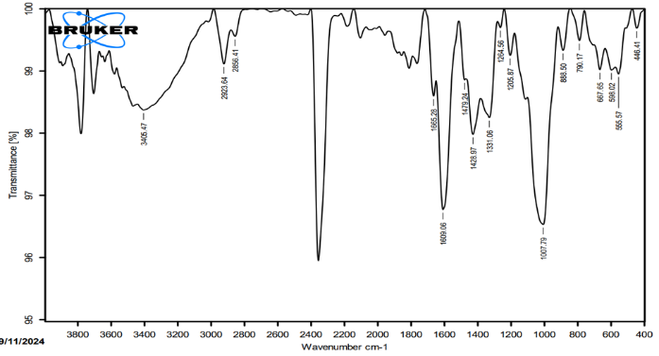
Figure 3: The FTIR spectrum of the microsphere
Turning to Figure 4, which depicts the spectrum of the hexamethylene diisocyanate scaffold, we note several key features. A peak at 1078 cm⁻¹ is likely due to C-O stretching, while the peak at 1253 cm⁻¹ corresponds to C-N bending. The peak at 1457 cm⁻¹ can be attributed to C-H bending in methyl or methylene groups. Interestingly, we found intense peaks at 1572 cm⁻¹ and 1620 cm⁻¹, which we believe are due to N-H bending and C=O stretching in amide groups. A peak at 1730 cm⁻¹ caught our attention, and we think it's related to C=O stretching in isocyanate groups. The spectrum also shows peaks at 2857 cm⁻¹ and 2926 cm⁻¹, associated with C-H stretching in methyl or methylene groups. Lastly, we observed a peak at 3332 cm⁻¹, likely due to N-H stretching in amine or amide groups. These spectral features confirm the successful synthesis of both the microsphere and the hexamethylene diisocyanate scaffold, providing valuable information about their chemical structures and functional groups. The comparison between these two spectra helps us understand the structural changes that occur when the scaffold is incorporated into the microsphere.
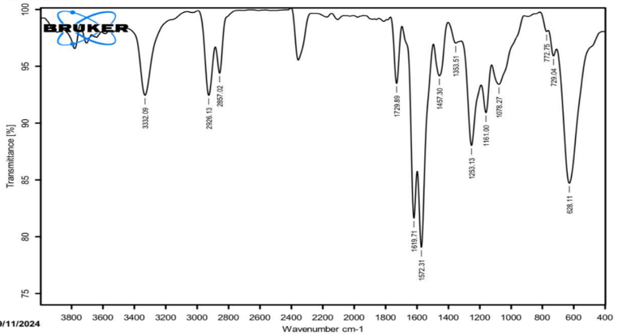
Figure 4: The FTIR spectrum of hexamethylene diisocyanate scaffold
4.2.2. XRD Analysis

The X-ray diffraction XRD analysis to investigate the crystalline structure and phase composition of the prepared scaffolds, and the XRD patterns of the scaffolds are presented in Figure 3. The XRD pattern of the hexamethylene diisocyanate with polyelectrolyte scaffold. The X-ray diffraction (XRD) peak observed at 2θ of 20.66° corresponds to a d-spacing of 4.30 Å, this peak is attributed to the crystalline structure of the polyurethane component resulting from the reaction between hexamethylene diisocyanate and polycaprolactone. The XRD peaks seen at 2θ of 11.69°, 23.48°, and 63.32° indicate the presence of the polyelectrolyte component in the scaffold matrix.
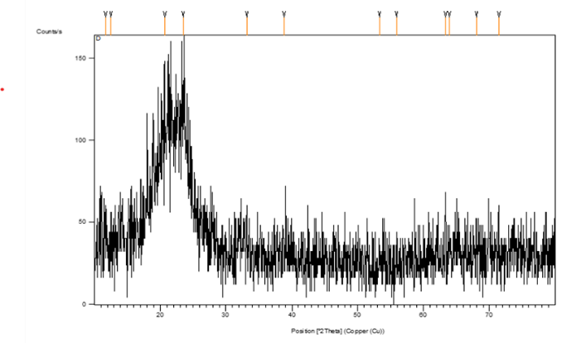
Figure 5: XRD pattern of hexamethylene diisocyanate scaffold

4.2.3 SEM Analysis
The scanning electron microscope (SEM) analysis provided detailed insights into the morphological features and microstructure of the prepared scaffolds. Photomicrographs of the scaffold MTX loaded were taken at various resolutions 150 x (1 mm), 350 (200 μm), and 25000 x (3 μm) as shown in Figure 6. The images reveal rough and wrinkled surface topography with interconnected pores and cavities of varying sizes and shapes distributed throughout the scaffold structure, this architecture is well-suited for various applications, including drug administration and tissue engineering, fibrous network with irregular pore sizes and geometries is observed within the scaffold structure, and a highly porous and interconnected architecture is evident, the SEM analysis confirms the successful fabrication of highly porous and interconnected scaffolds with varying pore sizes, geometries, and surface topographies, these structural features facilitate cell infiltration, nutrient transport and tissue integration within the scaffolds. Additionally, they enable efficient drug loading and controlled release, making these scaffolds suitable for drug delivery applications.

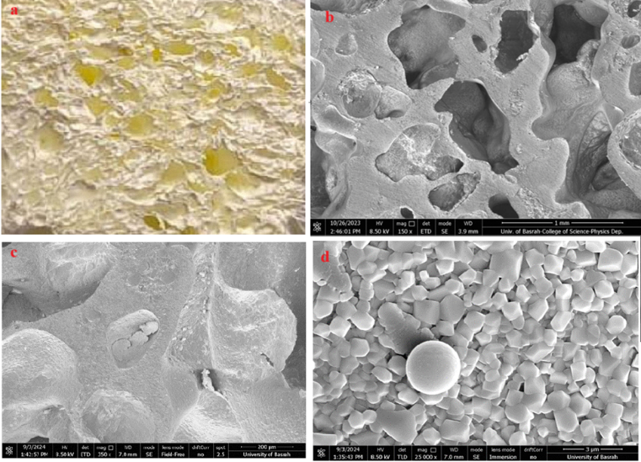

Figure 6: Images of scaffold a) photograph of the scaffold with MTX microspheres, b) SEM of the scaffold with MTX microspheres in 150x, c) SEM of the scaffold with MTX microspheres in 350x, d) SEM of the scaffold with MTX microspheres in 25000x

4.3. Drug Release Studies

We investigated the drug-release behavior of methotrexate for the prepared nanoparticles under physiological conditions, Figure 7. Where the release studies were conducted in phosphate-buffered saline (PBS) at pH of 7.4 and temperature of 37°C to mimic the physiological environment, the nanoparticles were synthesized using chemically cross-linked emulsion method with sodium alginate and chitosan as the polymeric matrix, three different drug loadings were studied, denoted as MTX1, MTX2, and MTX3 the drug release profiles were monitored over 150 hours.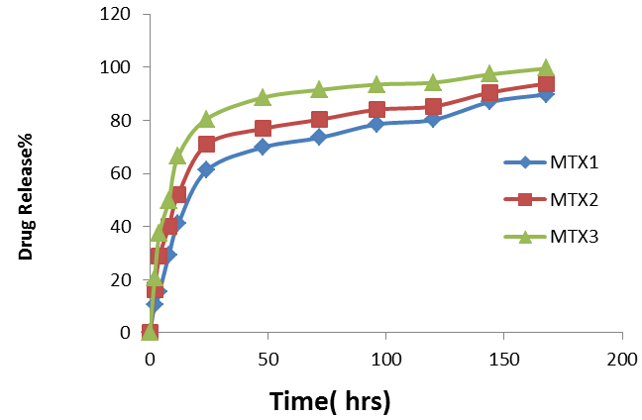

Figure 7: Drug Release Profiles of Methotrexate from microparticles

The drug release profiles exhibited a sustained and controlled release pattern over the 150 hours, indicating the potential of the microparticles as an effective drug delivery system. The drug loading influenced the release kinetics, with higher drug concentrations resulting in increased overall drug release rates. For the MTX1 sample (100mg drug loading), a gradual and sustained release was observed, reaching a maximum release of 61.14 after 24 hours, the MTX2 sample (200 mg drug loading) showed a slightly faster release rate, with a maximum release of 70.96 after 24 hours, the MTX3 sample (300 mg drug loading) exhibited the highest release rate, achieving the maximum release of 80.5 after 24 hours. Figure 8, presents the release ratio of MTX from the scaffold ( MTX sc ) in phosphate buffer (pH=7.4) at 37 °C compared with microspheres loaded drug (MTX m). The initial burst release was relatively low for all samples, indicating a stable encapsulation of the drug within the microparticle matrix, as time progressed the drug release rate increased, due to the gradual degradation or erosion of the polymeric matrix, facilitating the diffusion of the drug molecules from the nanoparticles. The sustained release behavior observed in this study is desirable for various therapeutic applications, as it can maintain effective drug concentrations in the target site for an extended period, minimizing the need for frequent dosing and potentially reducing side effects associated with fluctuating drug levels. The results demonstrate the successful encapsulation and controlled release of methotrexate from the prepared microparticles, highlighting their potential as a promising drug delivery platform, the ability to modulate the drug release rate by varying the drug loading offers opportunities for tailoring the formulation to specific therapeutic requirements.

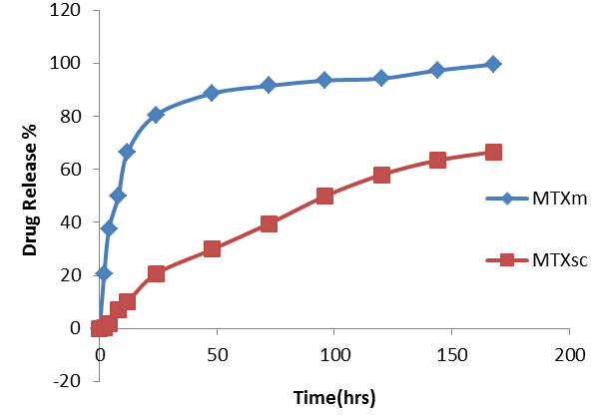

Figure 8: Release curve of Methotrexate from scaffolds and microspheres

4.4 Porosity Study

The porosity of the prepared scaffolds was evaluated using the liquid displacement method with ethanol as the displacement solvent, the porosity percentage was calculated based on the volume of ethanol remaining within the scaffold sample relative to the total volume occupied by the scaffold and ethanol. The results are presented in Table 2.

Table 2: Porosity measurements of the prepared scaffolds

Scaffolds Types | Porosity %
Hexamethylene diisocyanate scaffolds without hydroxyapatite | 91
Hexamethylene diisocyanate scaffolds with hydroxyapatite | 78
Hexamethylene diisocyanate scaffolds with hydroxyapatite and MTX micropheres | 70

The high porosity of the scaffolds is crucial for various applications, such as tissue engineering, drug delivery and filtration. Porous scaffolds facilitate cell infiltration, nutrient and waste transport and provide a favorable environment for tissue growth and regeneration. Additionally, the interconnected pores allow for efficient loading and controlled release of therapeutic agents or biomolecules. The porosity study demonstrated the successful preparation of highly porous scaffolds with varying degrees of porosity, depending on the composition and materials used. These findings provide valuable insights into the structural properties of the scaffolds and their potential applications in biomedical and industrial fields.

4.5 Degradation Study of Prepared Scaffolds
4.5.1 In Oxidation Solution

The degradation study of the prepared scaffolds in the oxidation solution exhibited distinct behaviors among the different scaffold compositions, decomposition was monitored using Figure 9.

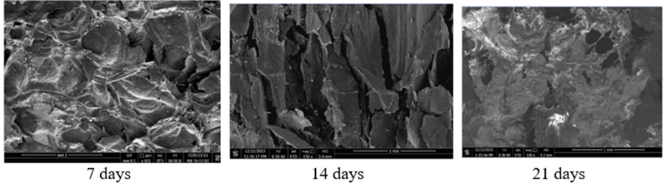
Figure 9: SEM images during the oxidative degradation of prepared scaffolds

Based on the SEM images provided for the hexamethylene diisocyanate scaffold with polyelectrolyte during oxidation degradation:
At 7 days, minimal degradation is observed, and the scaffold maintains its overall structure, with a smooth surface and intact porous network. Some minor surface roughening may be present, but the scaffold largely retains its original morphology. By 14 days, signs of degradation become more apparent, the surface shows increased roughness and some erosion of the scaffold structure, pores appear slightly enlarged, and there may be evidence of localized breakdown in certain areas, the overall scaffold architecture remains recognizable. At 21 days, significant degradation is visible, the scaffold structure shows extensive breakdown, with larger pores and cavities forming throughout, and the surface appears highly eroded and fragmented. Some regions may have completely degraded, while others still maintain remnants of the original structure. This degradation profile suggests a gradual and controlled breakdown of the hexamethylene diisocyanate with polyelectrolyte scaffold over several weeks under oxidative conditions, the scaffold demonstrates good initial stability, followed by progressive degradation, which advantageous for applications requiring sustained release or gradual tissue integration, the incorporation of polyelectrolyte influenced the degradation rate and pattern, potentially offering tunable degradation properties for specific biomedical applications. These findings highlight the influence of scaffold composition on their resistance to harsh oxidative conditions.
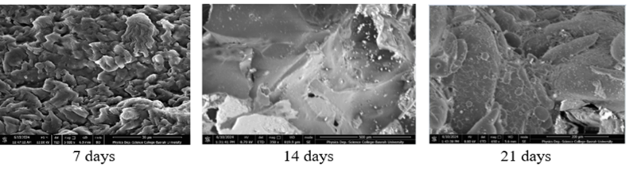
4.5.2 In lysozyme Solution
The degradation behavior of the prepared scaffolds under physiological conditions was evaluated by immersing them in a lysozyme solution. Lysozyme, an enzyme present in various biological fluids, was employed to simulate the degradation process within the human body. Samples of each scaffold type were carefully weighed and immersed in individual containers filled with a phosphate-buffered saline (PBS) solution containing lysozyme at a pH of 7.4 and a temperature of 37°C.

Figure 10: SEM images during the enzymatic degradation of prepared scaffolds

Based on the SEM images provided for the hexamethylene diisocyanate with polyelectrolyte scaffold during enzymatic degradation: At 7 days, minimal degradation is observed, and the scaffold maintains its overall structure, with a smooth surface and intact porous network. Some minor surface roughening may be present, but the scaffold largely retains its original morphology. By 14 days, signs of degradation become more apparent, the surface shows increased roughness and some erosion of the scaffold structure, pores appear slightly enlarged and there may be evidence of localized breakdown in certain areas. However, the overall scaffold architecture remains recognizable. At 21 days, significant degradation is visible, and the scaffold structure shows extensive breakdown, with larger pores and cavities forming throughout, the surface appears highly eroded and fragmented, some regions may have completely degraded, while others still maintain remnants of the original structure. This degradation profile suggests gradual and controlled breakdown of the hexamethylene diisocyanate with polyelectrolyte scaffold over several weeks under physiological conditions, the scaffold demonstrates good initial stability, followed by progressive degradation, which is advantageous for applications requiring sustained release or gradual tissue integration. The incorporation of polyelectrolyte influenced the degradation rate and pattern, offering tunable degradation properties for specific biomedical applications.

5. Conclusions
Our research has yielded several significant findings in the development of polymeric scaffolds for controlled drug delivery. The incorporation of Methotrexate-loaded sodium alginate microspheres into hexamethylene diisocyanate and polyelectrolyte scaffolds proved successful, as evidenced by comprehensive characterization studies. FTIR and XRD analyses confirmed the presence of expected functional groups and crystalline structures, while SEM imaging revealed highly porous and interconnected architecture conducive to cell infiltration and nutrient transport. The drug release studies demonstrated sustained and controlled release of Methotrexate over 150 hours, with release kinetics influenced by drug loading. This behavior is particularly advantageous for maintaining therapeutic drug concentrations over extended periods, potentially reducing dosing frequency and associated side effects. Porosity measurements indicated highly porous structures, crucial for various biomedical applications. The scaffolds exhibited controlled degradation in both oxidative and enzymatic environments, suggesting their suitability for in vivo applications where gradual breakdown is desired. These findings collectively point to the potential of our developed scaffolds as versatile platforms for drug delivery and tissue engineering. The tunable nature of the scaffolds, in terms of drug loading and degradation rates, offers flexibility in designing targeted therapies.
References
[1] S. Adepu, and S. Ramakrishna, Controlled drug delivery systems: current status and future directions. Molecules 26 (2021), 905, https://doi.org/10.3390/molecules26195905.
[2] K. K. Jain, An overview of drug delivery systems. Methods Mol Biol 2059 (2020), 1-54, https://doi.org/10.1007/978-1-4939-9798-5_1.
[3] H. Park, A. Otte, and K. Park, Evolution of drug delivery systems: From 1950 to 2020 and beyond. J Control Release 342 (2022), 53-65, https://doi.org/10.1016/j.jconrel.2021.12.030.
[4] M. Puccetti, M. Pariano, A. Schoubben, S. Giovagnoli, and M. Ricci, Biologics, theranostics, and personalized medicine in drug delivery systems. Pharmacol Res (2024), 107086, https://doi.org/10.1016/j.phrs.2024.107086.
[5] Y. Liu, X. Zhang, Y. Wang, Y. Wang, and D.-G. Yu, Electrospun multi‐chamber core–shell nanofibers and their controlled release behaviors: A review. Wiley Interdiscip Rev Nanomed Nanobiotechnol 16 (2024), e1954, https://doi.org/10.1002/wnan.1954.
[6] I. R. Calori, G. Braga, P. D. S. V. de Jesus, A. C. Tedesco, and G. R. de Souza, Polymer scaffolds as drug delivery systems. Eur Polym J 129 (2020), 109621, https://doi.org/10.1016/j.eurpolymj.2020.109621.
[7] M. I. Echeverria Molina, K. G. Malollari, and K. Komvopoulos, Design challenges in polymeric scaffolds for tissue engineering. Front Bioeng Biotechnol 9 (2021), 617141, https://doi.org/10.3389/fbioe.2021.617141.
[8] M. Z. Al Mahmud, M. H. Mobarak, and N. Hossain, Exploring the versatile applications of biocomposites in the medical field. J. Compos. Sci. 8 (2024), 22. https://doi.org/10.3390/jcs8010022
[9] A. A. Aldawood, M. M. M. Alkharobi, and M. A. A. Al-Ghamdi, Recent advances in 3D printing of tissue engineering scaffolds. Polymers 13.9 (2021) 1436, https://doi.org/10.3390/polym13091436.
[10] H. M. Bukhari, M. A. Z. Abidin, and S. A. A. Gani, Three-dimensional printing of tissue engineering scaffolds: recent advances and future directions. J. Mater. Res. 35.11 (2020): 1349-1365, https://doi.org/10.1557/jmr.2020.109.
[11] N. J. Oh, S. J. Lee, and J. H. Kim, Surface modification of 3D-printed scaffolds for tissue engineering applications: a brief review. Biomater Res 24 (2020): 3, https://doi.org/10.1186/s40824-020-00181-y.
[12] I. A. Siddique, A. R. A. Rahman, and M. R. M. Rejab, Characterization of 3D-printed scaffolds for tissue engineering. 3D Printing in Medicine (2021): 373-393, https://doi.org/10.1007/978-3-030-64222-7_17.
[13] M. Mabrouk, H. H. Beherei, and D. B. Das, Recent progress in the fabrication techniques of 3D scaffolds for tissue engineering. Mater Sci Eng C Mater Biol Appl 110 (2020),110716,ttps://doi.org/10.1016/j.msec.2020.110716.
[14] A. K. Badekila, S. Kini, and A. K. Jaiswal, Fabrication techniques of biomimetic scaffolds in three‐dimensional cell culture: A review. J Cell Physiol 236 (2021), 741-762, https://doi.org/10.1002/jcp.29935.
[15] F. Colucci, V. Mancini, C. Mattu, and M. Boffito, Designing multifunctional devices for regenerative pharmacology based on 3D scaffolds, drug-loaded nanoparticles, and thermosensitive hydrogels: A proof-of-concept study. Pharmaceutics 13 (2021), 464, https://doi.org/10.3390/pharmaceutics13040464.
[16] S. C. Kellaway, M. M. Ullrich, and K. Dziemidowicz, Electrospun drug‐loaded scaffolds for nervous system repair. Wiley Interdiscip Rev Nanomed Nanobiotechnol 16 (2024), e1965, https://doi.org/10.1002/wnan.1965.
[17] D. Kaur, and A. Kaur, Engineering of electrospun polycaprolactone/polyvinyl alcohol-collagen based 3D nano scaffolds and their drug release kinetics using cetirizine as a model drug. Int J Biol Macromol (2024), 131847, https://doi.org/10.1016/j.ijbiomac.2024.131847.
[18] A. Rahmani Del Bakhshayesh, A. Asadpour, S. Farzad-Mohajeri, S. Ghorbani, and M. A. Shokrgozar, In vivo guided bone regeneration by a 3D-printed TCP/PCL scaffold in a customized rabbit calvarial defect model. Mater Sci Eng C Mater Biol Appl 110 (2020), 110688, https://doi.org/10.1016/j.msec.2020.110688.
[19] M. Janmohammadi, Z. Nazemi, A. O. M. Salehi, A. Seyfoori, J. V. John, M. S. Nourbakhsh, and M. Akbari, Cellulose-based composite scaffolds for bone tissue engineering and localized drug delivery. Bioact Mater 20 (2023),137-163, https://doi.org/10.1016/j.bioactmat.2022.05.018.
[20] M. P. Nikolova, and M. S. Chavali, Recent advances in biomaterials for 3D scaffolds: A review. Bioact Mater 4 (2019)271-292,https://doi.org/10.1016/j.bioactmat.2019.10.005.
[21] E. I. Biru, M. I. Necolau, A. Zainea, and H. Iovu, Graphene oxide–protein-based scaffolds for tissue engineering: recent advances and applications. Polymers 14 (2022), 1032, https://doi.org/10.3390/polym14051032.
[22] M. R. Bogala, Three-dimensional (3D) printing of hydroxyapatite-based scaffolds: a review. Bioprinting 28 (2022),e00244, https://doi.org/10.1016/j.bprint.2022.e00244.
[23] G. Kastania, P. S. Georgiou, S. G. Antimisiaris, and A. G. Tsolakisa, Polyelectrolyte Multilayer Capsule (PEMC)-Based Scaffolds for Tissue Engineering. Micromachines 11 (2020), 797, https://doi.org/10.3390/mi11090797.
[24] N. Jan, A. Madni, A. Rahim, M. A. Tahir, M. J. A. Khan, A. T. Shah, M. I. Khan, and M. I. U. Din, In vitro anti-leukemic assessment and sustained release behaviour of cytarabine loaded biodegradable polymer based nanoparticles. Life Sci 267 (2021), 118971, https://doi.org/10.1016/j.lfs.2020.118971.
[25] M. Cheng, J. Janzekovic, R. Finze, M. Mohseni, S. Saifzadeh, F. M. Savi, O. Ung, M. Wagels, and D. W. Hutmacher, Conceptualizing scaffold guided breast tissue regeneration in a preclinical large animal model. Bioengineering 11 (2024), 593, https://doi.org/10.3390/bioengineering11060593.
[26] M. C. Socci, G. Rodríguez, E. Oliva, S. Fushimi, K. Takabatake, H. Nagatsuka, C. J. Felice, and A. P. Rodríguez, Polymeric Materials, Advances and Applications in Tissue Engineering: A Review. Bioengineering 10 (2023), 218, https://doi.org/10.3390/bioengineering10020218.[27] A. Lima, H. Sousa, J. Monteiro, R. Azevedo, R. Medeiros, and V. Seabra, Genetic polymorphisms in low-dose methotrexate transporters: current relevance as methotrexate therapeutic outcome biomarkers. Pharmacogenomics 15 (2014), 1611-1635, https://doi.org/10.2217/pgs.14.116.
[28] N. A. Hussein, H. A. Badran, S. A. Kamil, and R. C. Abo-Alhal, Preparation and evaluation in vitro release of sodium alginate/chitosan polyelectrolyte microparticles containing rifampicin and theoretical study using DFT. Iraqi Journal of Science 64 (2023), 1795-1811, https://doi.org/10.24996/ijs.2023.64.4.25.
[29] N. A. Hussein, and A. K. Numa, Preparation and evaluation of polyurethane scaffolds containing gelatin microspheres with cefotaxime sodium delivery for bone reatment. Iraqi Journal of Pharmaceutical Sciences 23 (2014), 70-79.

