Synoptic analysis of the thermal anomaly for the Days from
1-6, July 2025 in Iraq
Case study

Prof .Dr .Ahmad Mohammed Alhasaan Assistant Lecturer Shimaa Sami Alzinad
Basrah University-College of girl Basrah University-College of Art
ahmed.mohemed@uobasrah.edu.iq shaymaa.sami@uobasrah.edu.iq

الحراري للأيام من 1-6 تموز 2025 في العراق تحليل شمولي لحالة الشذوذ
دراسة حالة
م.م شيماء سامي الزناد أ.د احمد جاسم محمد الحسان
جامعة البصرة –كلية التربية للبنات جامعة البصرة –كلية الآداب
shaymaa.sami@uobasrah.edu.iq ahmed.mohemed@uobasrah.edu.iq
الملخص
تعرضت اجواء العراق للأيام من 1لغاية 6 تموز -2025لحالة شذوذ حراري انخفضت فيها درجات الحرارة لحدود متدنية عن معدلاتها العامة خلال هذا الشهر وهي حالة شاذة اذا ما قيست بالمعدلات الحرارية العالية لهذا الشهر وتبين من التحليل الشمولي لمستويات الضغط الثابت وتحديدا للمستوى 500 hpa سيطرة اخدود مع منخفض قطع قطبي على شرق البحر المتوسط وشمال العراق ساعد هذه الوضعية على ابعاد سيطرة المرتفع شبة المداري العلوي وخفض درجات الحرارة يحدد من تصاعد الكتلة الهوائية الحارة نحو الاعلى نتيجة خفض سماكة الغلاف الجوي وتبين من تحليل مخططات وبيانات الراديوسوند لمحطة بغداد للرصدتين (00 و1200 ) توقيت عالمي (03 -15 ) توقيت محلي وجود انحراف قوي لدرجات الحرارة بين المستوى 1000 hpa و500 hpa بلغ اكثر من -40 مْ مما ساعد على تبريد الكتلة الهوائية السطحية وخفض درجات الحرارة وتزامنت الوضعية مع نشاط الدوامة القطبية المفاجئ خلال هذا الشهر وساعد على احداث نزولات قطبية خلال شهر تموز على العراق
الكلمات المفتاحية : شذوذ حراري , المرتفع الاوربي , الراديوسوند , اخدود قطبي .
Synoptic analysis of the thermal anomaly for the period from 1-6, July 2025 in Iraq
Case study
Abstract
The Iraqi atmosphere was exposed, from July 1st to 6th,-2025 to a thermal anomaly, in which temperatures dropped to lower levels than their general averages during this month. This is an anomaly if measured by the high thermal averages for this month. A comprehensive analysis of the fixed pressure levels, specifically the 500 level, showed that. A trough with a polar low over the eastern Mediterranean and northern Iraq helped this situation to remove the control of the upper subtropical high and reduce temperatures, which limits the rise of the hot air mass upwards as a result of reducing the thickness of the atmosphere. This was shown by analyzing the radiosounde charts and data of the Baghdad observation station for the two observations (00 and 1200) Universal Time (03-15). There was a strong local temperature deviation between the 1000 hPa and 500 hPa levels, reaching more than -40°C, which helped cool the surface air mass and lower temperatures. The situation coincided with the sudden activity of the polar vortex during this month, which helped cause polar depressions during July in Iraq.
Key word: Thermal anomaly, European ِAnticyclone, radiosounde, polar trough

1-Introduction:

July is considered one of the hottest months of the year in Iraq due to distinctive radiative conditions that prevail during the summer season. These include prolonged daylight hours, increased solar radiation, clear skies, and several local geographical factors that contribute to elevated temperatures.
Additionally, the region is influenced by two dominant pressure systems: the seasonal Indian thermal low, which exerts a strong and consistent presence throughout the month, and the subtropical high-pressure system, representing the descending branch of the Hadley Cell.
The upper-level high-pressure system, which occasionally appears in the form of a semi-permanent trough or a closed cell, also plays a significant role in increasing temperature values through adiabatic heating processes in the atmospheric layers. As a result, record-breaking temperatures exceeding 50°C may occur, especially since the centers of this upper high have shown an increasing trend in recent years due to accelerating climate change (Al-Hassan & Colleague, 2024).
However, a notable decrease in temperatures during this month—despite ongoing climate change—represents a thermal anomaly, as observed during the period from 1 to 6 July 2025. This indicates the potential for polar air intrusions into the region even during summer, albeit temporarily, leading to a significant drop in temperatures and the development of anomalous thermal conditions.
Such rare climatic phenomena, particularly under the influence of ongoing and intensified climate change, call for comprehensive scientific investigation to identify their causes and understand the broader atmospheric patterns that contributed to their formation.

2-Research Problem:
The research problem is based on the following question:
What were the synoptic-scale atmospheric conditions that contributed to the thermal anomaly observed from 1 to 6 July 2025?

3-Research Hypothesis:
It is hypothesized that a combination of large-scale atmospheric conditions interacted during the period in question, resulting in the observed temperature anomaly between 1 and 6 July 2025.

4-Scope of the Study:
• Spatial Scope: The study covers the geographical area of Iraq, located between latitudes 20°5′ and 37°22′ North.
• Temporal Scope: The study focuses on the period from 1 to 6 July 2025, examining only the thermal anomaly recorded during these specific days.

5- Research Methodology and Data Used
This research employed a case study approach, a method focusing on an in-depth examination of a specific case or a small number of cases to achieve a comprehensive and accurate understanding. The approach aims to analyze various aspects of the case and draw conclusions that can be generalized to similar or comparable situations. For this case study of the thermal anomaly, surface temperature data (both maximum and minimum) for the period from 1 to 6 July 2025 were analyzed and compared with the climatological averages for the same dates over the period 1988–2024.
Additionally, pressure level maps at 1000, 850, and 500 hPa from two daily synoptic times (00Z and 12Z) were used to identify the pressure systems responsible for the thermal anomaly.
Furthermore, upper-air radiosounde observations from Baghdad International Airport were analyzed to illustrate atmospheric changes in the upper layers during the anomaly period.
6-Concept of Thermal Anomaly
The term “anomaly” generally refers to a deviation from the normal or accepted standard, system, or pattern. It can also imply uniqueness or departure from what is typical (Najib, 2001).
According to NASA, a thermal anomaly is defined as a deviation of climatic conditions from their average state at a specific location and time of year. Some surface temperature anomalies are random atmospheric phenomena not associated with any specific pattern or trend (NASA Earth Observatory).It is important to distinguish temporary thermal anomalies from permanent anomalies. Permanent anomalies represent the temperature difference between a given region and the average temperature typical for the latitude on which it lies, often reflecting constant geographic conditions (Al-Rawi and Al-Bayati, 2000).)
7-Analysis of Thermal Characteristics for the Period 1–6 July 2025
During the first week of July 2025, Iraq experienced a significant temperature drop, representing a negative thermal anomaly during a month that is typically the hottest of the year.
July is generally characterized by extreme heat due to local factors influencing intense solar radiation, extended daylight hours, and dry air conditions. Additionally, the Hadley cell’s descending northern branch, which generates the subtropical high-pressure system at altitudes exceeding 5600 meters above sea level, causes descending air currents that typically raise temperatures to record highs above 50°C.These combined factors generally make July the period of positive thermal extremes in Iraq. However, from 1 to 6 July 2025, the country witnessed negative thermal anomalies, with temperatures significantly lower than previous years, as demonstrated in Tables 1 and 2.

1-Analysis of Daily Minimum Temperatures for 1–6 July 2025
The data presented in Table (1) indicate that the daily minimum temperatures recorded a negative deviation from their long-term averages during the specified period. The highest deviations varied both spatially and temporally among the stations, in contrast to the maximum temperatures. The stations of Mosul, Erbil, Baghdad, and Nasiriya recorded the lowest deviations from the average on the fourth day, with values of(-4.5°C, -3.8°C, -7.1°C, and -4.0°C), respectively. These values correspond to the lowest maximum temperatures recorded during the same period.
In contrast, the greatest deviations were recorded at the Sulaymaniyah, Hay, and Basra stations on the sixth day, with values of(-7.0°C, -7.1°C, and -4.8°C), respectively. Notably, Hay station exhibited the largest overall deviations from the average throughout the entire period of the thermal anomaly, as shown in Table (1).This variation is attributed to the local conditions at each station, the extent of daytime surface heating, and variations in humidity levels. Nevertheless, the decline in minimum temperatures was particularly evident, constituting a clear negative thermal anomaly during this month.
2- Analysis of daily maximum temperatures for 1–6 July 2025

When comparing daily maximum temperatures during the heat wave period (1–6 July 2025) with their general averages for the reference period (1988–2024), it can be seen that they recorded a significant decrease during daylight hours, despite the usual daytime heating conditions.
All days saw a decrease in maximum temperatures, with the maximum decrease recorded on 4 July 2025, when the Mosul station recorded a maximum temperature of 39°C, a difference of -6°C from its average.Similarly, on the same day, the Sulaymaniyah and Erbil stations recorded maximum temperatures of 35°C and 36°C, respectively, which were 4.9°C and 4.0°C below average. Baghdad recorded 39°C, with a deviation of -6°C, while Ramadi recorded a temperature of 36°C on the fifth day of the month, a decrease of -6.9°C from the average. At the Hai and Nasiriyah stations, maximum temperatures of 41°C and 42°C were recorded, with differences of -4.7°C and -4.1°C, respectively.In contrast, the highest maximum temperature was recorded at the Basra station, reaching 44°C, which is -3.1°C below average, the lowest difference recorded among the stations for that day.In general, all stations showed negative temperature deviations ranging from -1.0°C to -6.0°C from their general averages during the days of thermal anomaly, indicating a clear effect of the unusual cooling phenomenon during this period..
Table (1): Minimum Temperatures (°C) Recorded from 1 to 6 July 2025 and Their Differences from the July Average (1988–2024) for Selected Stations in Iraq.
station |  | 1-Jul | 2-Jul | 3-Jul | 4-Jul | 5-Jul | 6-Jul
Mosul | Average minimum temperature (°C) | 24 | 25 | 27 | 22 | 24 | 24
26.5 | Difference from the average for the period 1988-2024 | -2.5 | -1.5 | 0.5 | -4.5 | -1.5 | 2.5
Erbil | Average minimum temperature (°C) | 25 | 24 | 26 | 22 | 23 | 22
25.8 | Difference from the average for the period 1988-2025 | -0.8 | -1.8 | 0.2 | 3.8- | 2.8 | -3.8
Sulaymaniyah | Average minimum temperature (°C) | 24 | 22 | 21 | 22 | 22 | 20
27 | Difference from the average for the period 1988-2026 | -3 | -5 | -6 | -5 | -5 | -7
Baghdad | Average minimum temperature (°C) | 26 | 24 | 24 | 23 | 25 | 25
30.1 | Difference from the average for the period 1988-2027 | -4.1 | -6.1 | -6.1 | -7.1 | -5 | -5.1
Ramadi | Average minimum temperature (°C) | 24 | 26 | 27 | 22 | 23 | 25
29 | Difference from the average for the period 1988-2028 | -5 | -3 | -2 | -7 | -6 | -4
Hai | Average minimum temperature (°C) | 30 | 24 | 25 | 27 | 27 | 24
31.1 | Difference from the average for the period 1988-2029 | -1.1 | -7.1 | -6.1 | -4.1 | -4.1 | -7.1
Nasiriya | Average minimum temperature (°C) | 32 | 27 | 29 | 27 | 30 | 27
31 | Difference from the average for the period 1988-2030 | 1 | -4 | -2 | -4 | -1 | -4
Basraha | Average minimum temperature (°C) | 35 | 28 | 30 | 28 | 29 | 27
32.2 | Difference from the average for the period 1988-2031 | -2.8 | 3.8- | -1.8 | -3.8 | -2.8 | -4.8
Source: Iraqi General Authority of Meteorology and Seismology — Unpublished Data

Table (2): Maximum Temperatures (°C) Recorded from 1 to 6 July 2025 and Their Differences from the July Average (1988–2024) for Selected Stations in Iraq.
station |  | 1-Jul | 2-Jul | 3-Jul | 4-Jul | 5-Jul | 6-Jul
Mosul | Average’ Maximum temperature (°C) | 39 | 41 | 41 | 37 | 38 | 40
26.5 | Difference from the average for the period 1988-2024 | -4 | -2 | -2 | -6 | -5 | -3
Erbil | Average ’Maximum temperature (°C) | 39 | 40 | 40 | 36 | 37 | 38
25.8 | Difference from the average for the period 1988-2025 | -1 | 0 | 0 | -4 | -3 | -2
Sulaymaniyah | Average ’Maximum temperature (°C) | 38 | 39 | 39 | 35 | 38 | 39
27 | Difference from the average for the period 1988-2026 | -1.9 | -0.9 | -0.9 | -4.9 | -1.9 | -0.9
Baghdad | Average ’Maximum temperature (°C) | 40 | 42 | 42 | 39 | 40 | 40
30.1 | Difference from the average for the period 1988-2027 | -5 | -2 | -2 | -6 | -5 | -5
Ramadi | Average ’Maximum temperature (°C) | 38 | 40 | 40 | 36 | 39 | 40
29 | Difference from the average for the period 1988-2028 | -4.9 | -2.9 | -2.9 | -6.9 | -3.9 | -2.9
Hai | Average ’Maximum temperature (°C) | 42 | 43 | 43 | 41 | 41 | 42
31.1 | Difference from the average for the period 1988-2029 | -3.7 | -2.7 | -2.7 | -4.7 | -4.7 | -3.7
Nasiriya | Average’ Maximum temperature (°C) | 44 | 43 | 44 | 42 | 43 | 43
31 | Difference from the average for the period 1988-2030 | -2.1 | -3.1 | -2.1 | -4.1 | -3.1 | -3.1
Basra | Average Maximum temperature (°C) | 45 | 44 | 45 | 44 | 45 | 44
47.1 | Difference from the average for the period 1988-2031 | -2.1 | -3.1 | -2.1 | -3.1 | -2.1 | -3.1
Source: Iraqi General Authority of Meteorology and Seismology – Climate Department, Unpublished Data.
General Characteristics of 1–6 July 2025
In order to determine the causes and conditions that led to the thermal anomaly during the first week of July over Iraq, it is essential to analyze the general synoptic conditions that prevailed over the region in general, and over Iraq in particular, to clarify the mechanism of air movement in the upper layers of the atmosphere.
The analysis included the air flow at constant pressure levels, in addition to examining upper-air data derived from radiosounde observations at Baghdad station at 00 and 12 UTC. This was done to identify the temperature distribution patterns and wind movement in the upper atmospheric layers during the anomaly days, as follows:
1- Surface level (1000 hPa):
Analysis of surface pressure maps for the period 1–6 July 2025 (at 00 and 12 UTC) indicates that on 1 July 2025, a high-pressure system originating from eastern Europe extended its influence towards northern Iraq, with its centre positioned over the Armenian Plateau, recording pressure values ranging between 1002–1005 hPa in northern Iraq and 1008–1012 hPa over Turkey.This synoptic situation is relatively uncommon, as European high-pressure systems rarely extend into the region during July.The strength of this high-pressure system contributed to the retreat of the Indian seasonal low, which registered a pressure of approximately 990 hPa, pushing it eastward to become centred over central Iran. This retreat reduced the dominance of dry tropical air masses over Iraq.
The high-pressure system continued to dominate from 2 to 5 July, with its influence extending to latitude 35°N, while the surface low receded southward. By the end of 5 July and into 6 July, the high pressure persisted over northern Iraq, while a low-pressure system was centred over the eastern Mediterranean and Cyprus, contributing to a drop in temperatures and the prevalence of north to northwesterly winds—a pattern that led to a thermal anomaly peaking on 5 July.

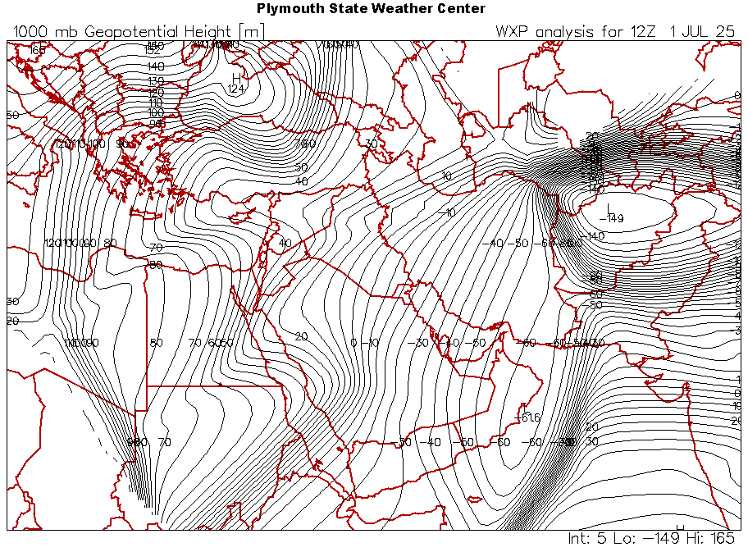  2-jul-2025-(00z) | 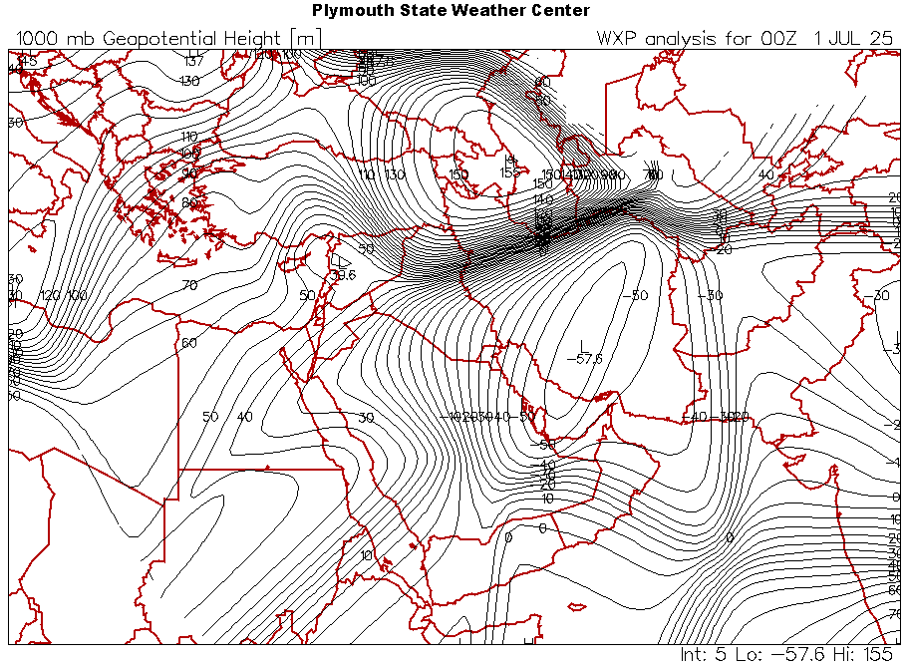  1-jul-2025-(00z)
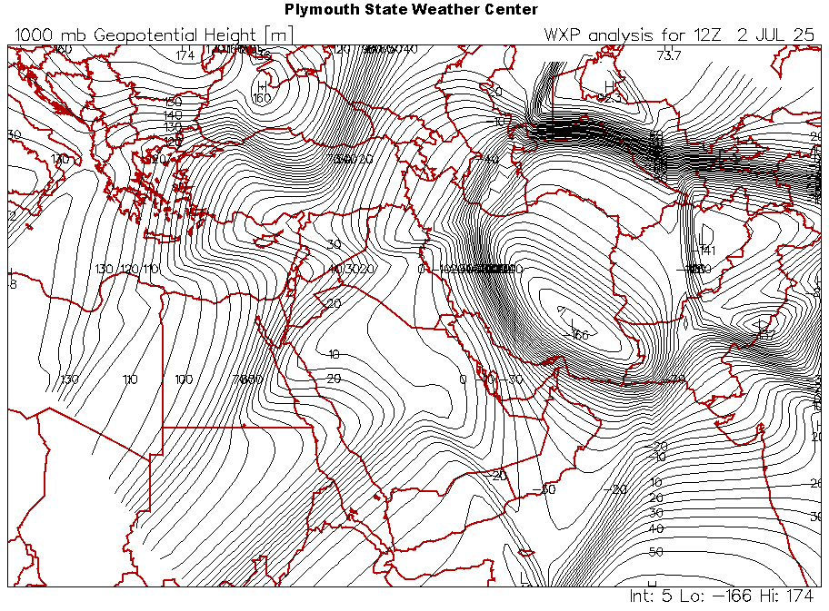  4-jul-2025-(00z) | 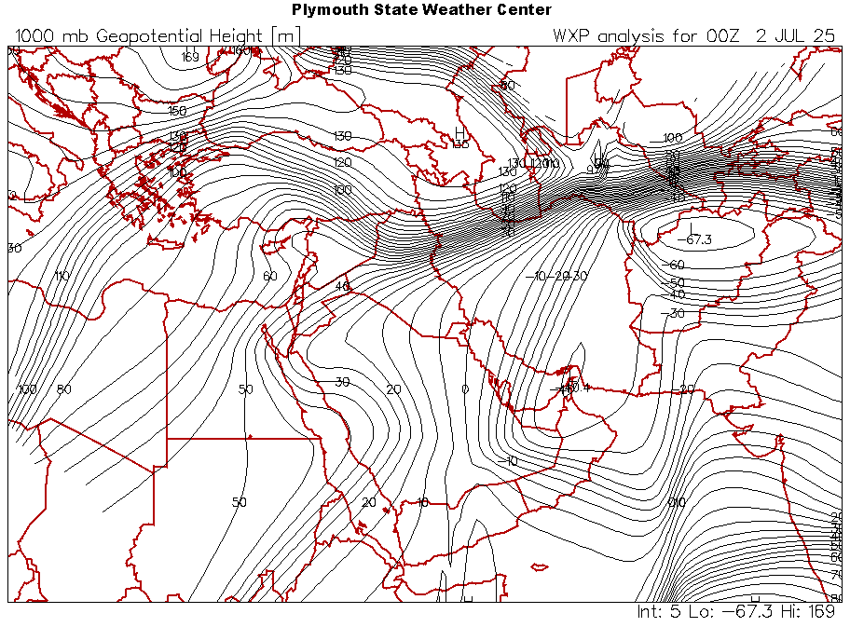  3-jul-2025-(00z)
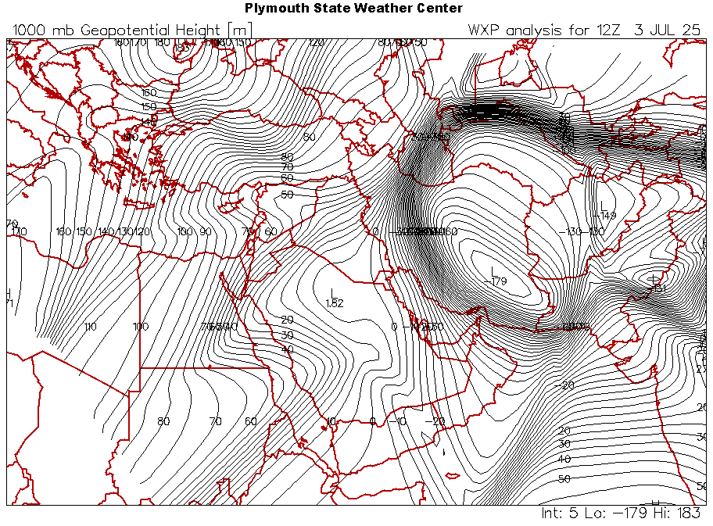  6-jul-2025-(00z) | 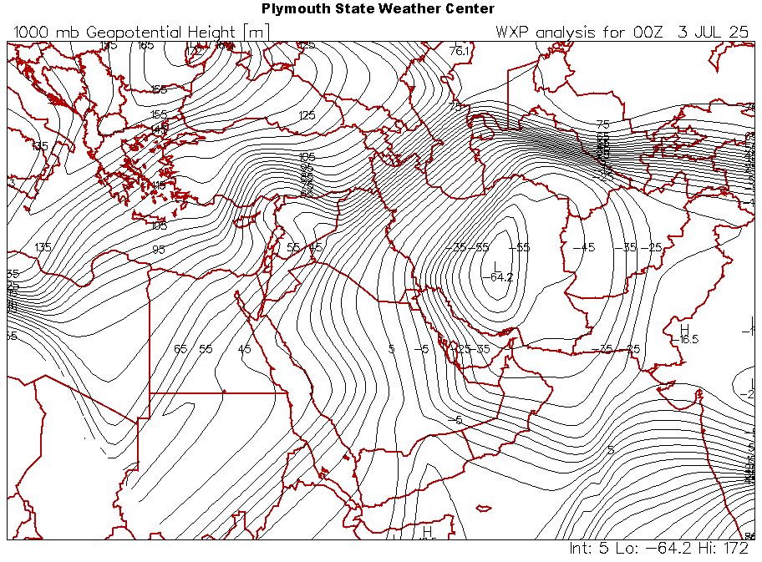  5-jul-2025-(00z)
Figure 1: Surface pressure patterns for the period 1–6 July 2025 at 1200 UTC, showing the dominance of a high-pressure system originating from Europe over northern Iraq.

1-jul2025-(1200z) | 2-jul2025-(1200z)
3-jul2025-(1200z) | 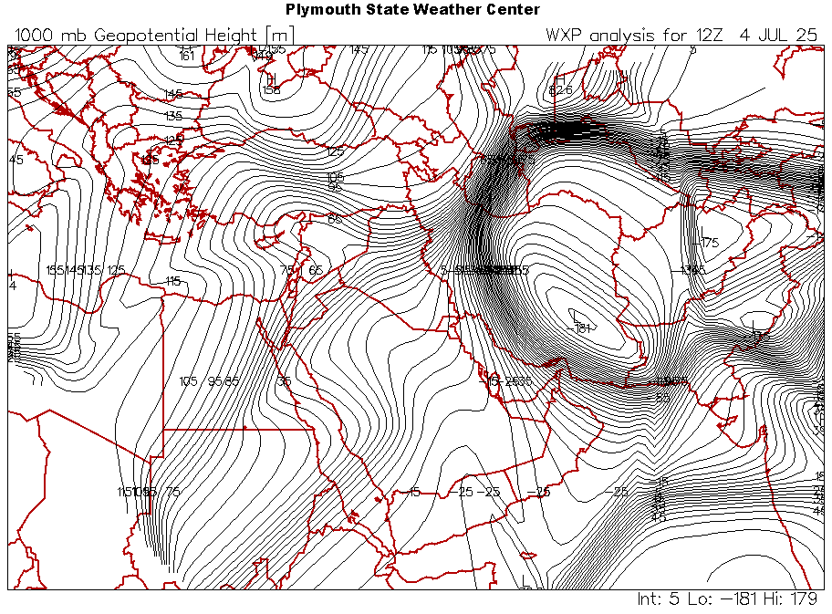  4-jul2025-(1200z)
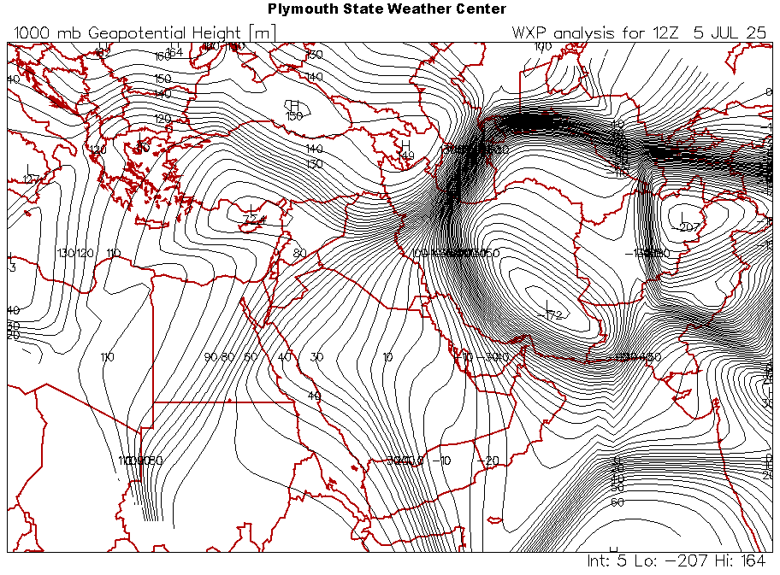  5-jul2025-(1200z) | 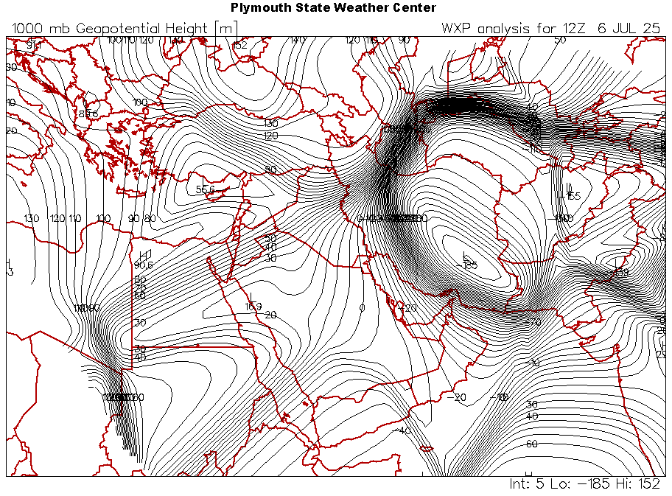  6-jul2025-(1200z)
Source: 1000 hPa level maps from the link: https://vortex.plymouth.edu/myowxp/upa/

Figure 2: Surface pressure patterns for the period 1–6 July 2025 at 00 UTC, showing the dominance of a high-pressure system originating from Europe over northern Iraq.
1-jul2025-(1200z) | 2-jul2025-(1200z)
3-jul2025-(1200z) | 4-jul2025-(1200z)
5-jul2025-(1200z) | 6-jul2025-(1200z)
Source1000hPa level maps from the link: https://vortex.plymouth.edu/myowxp/upa/
2– 850 hPa Level
Analysis of the 850 hPa level maps at an altitude of 1500 meters (Figure 1) reveals the extension and deepening of the high-pressure system originating from Europe, dominating eastern Turkey, with its influence extending into northern Iraq at this level—indicating a clear intensification of the high. This deepening led to an increase in surface air pressure values. Moreover, the strength of the upper-level high contributed to the southward retreat of the Indian seasonal surface low and its extensions at the 850 hPa level towards southern Iraq.
The maps indicate the dominance of the high-pressure system over the Iranian Plateau, which resulted in a pressure gradient between the Armenian Plateau, Turkish territory, and northern Iraq. The northwesterly winds originating from the center of the high-pressure system over Turkish territory contributed to the retreat of the warm tropical air mass from northern and central Iraq. This led to a drop in temperatures below normal levels, generating a thermal anomaly.

Table (3): Surface air pressure values (hectopascals) over eastern Turkey and Iraq for the period 1–6 July 2025.
Day | Mid &southern Iraq | Northern Iraq | East Turkey
1-July | 994-997 | 1002-1005 | 1008-1011
2-July | 997-1000 | 1005-1008 | 1012-1014
3-July | 997-1000 | 1005-1008 | 1012-1014
4-July | 1000-1002 | 1008-1011 | 1014-1018
5-July | 1000-1002 | 1008-1011 | 1014-1018
6-July | 1000-1002 | 1004-1008 | 1012-1014
Source: Surface pressure maps at the 1000 hPa level from NOAA, available at:
https://psl.noaa.gov/data/composites/day/

Figure (3): Pressure patterns at the 850 hPa level for the period 1–6 July 2025 (00 UTC observations), showing the dominance of a high-pressure system originating from Europe over northern Iraq.
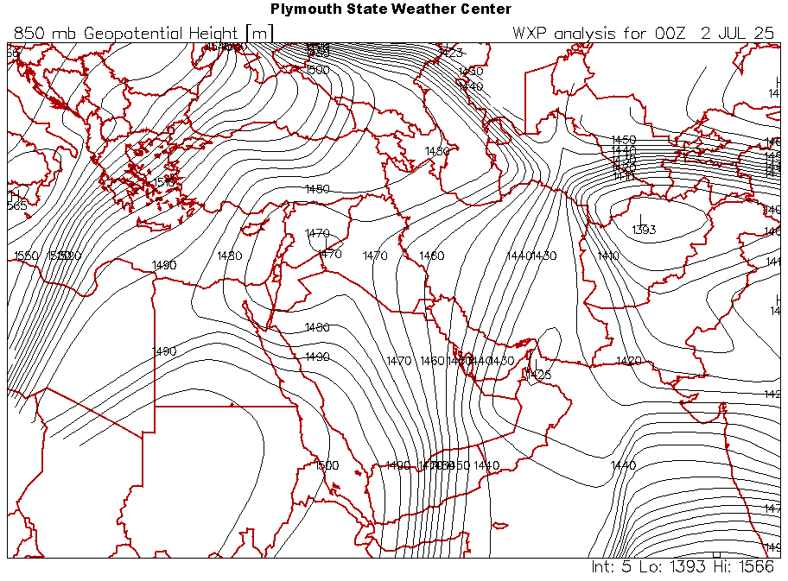  2-jul2025(00z) | 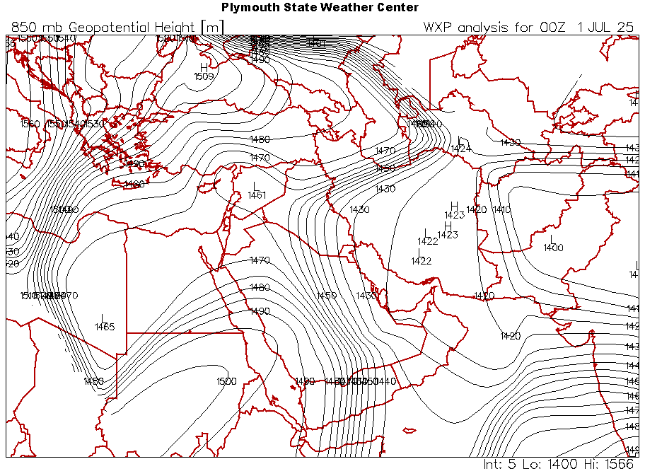  1-jul2025(00z)
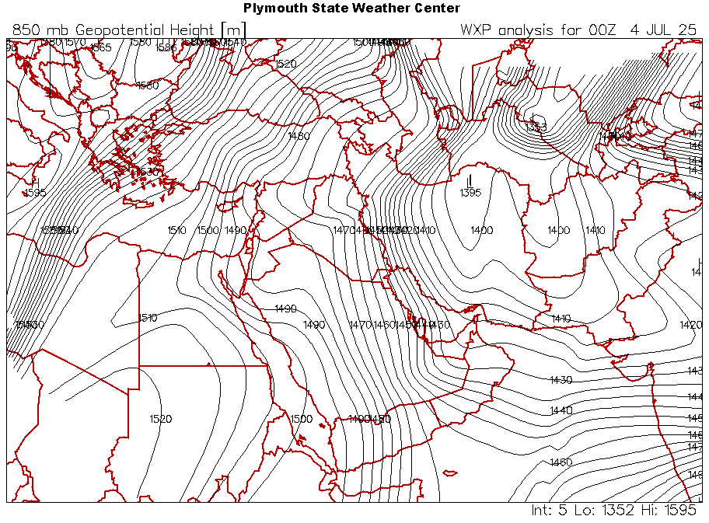  4-jul2025(00z) | 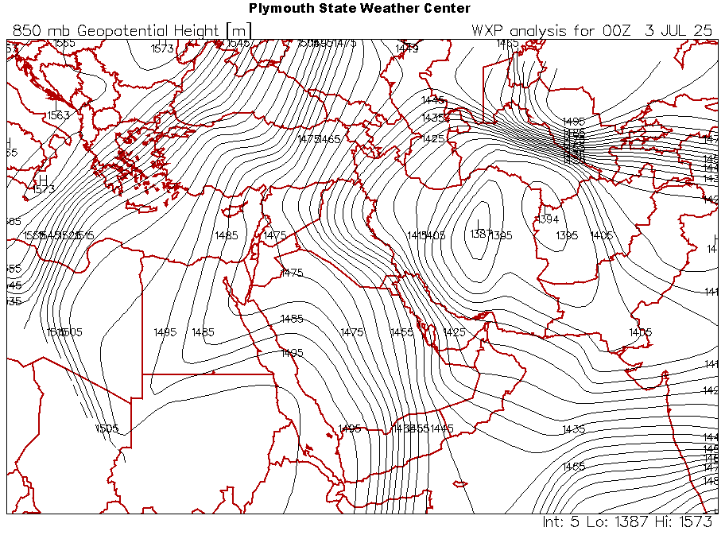  3-jul2025(00z)
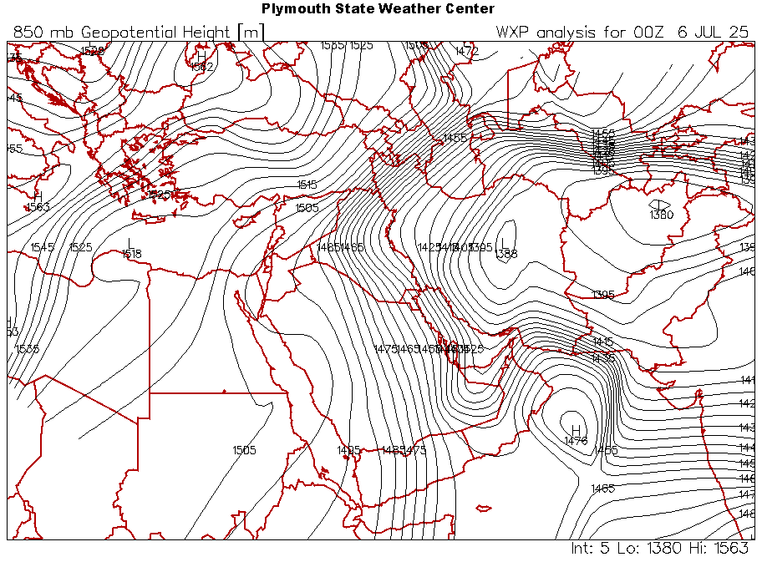  6-jul2025(00z) | 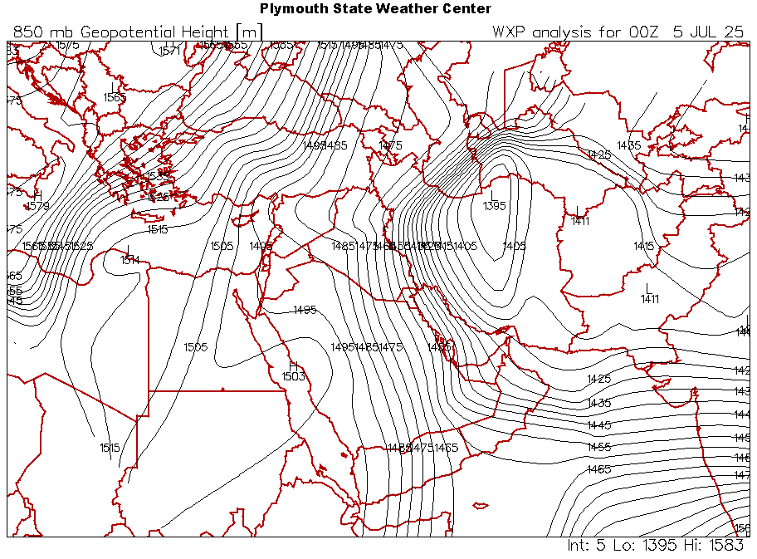  5-jul2025(00z)
Figure (4) (Figure 1): Surface pressure patterns for 1–6 July 2025 (00 and 12 UTC observations) showing the dominance of a high-pressure system originating from Europe over northern Iraq.
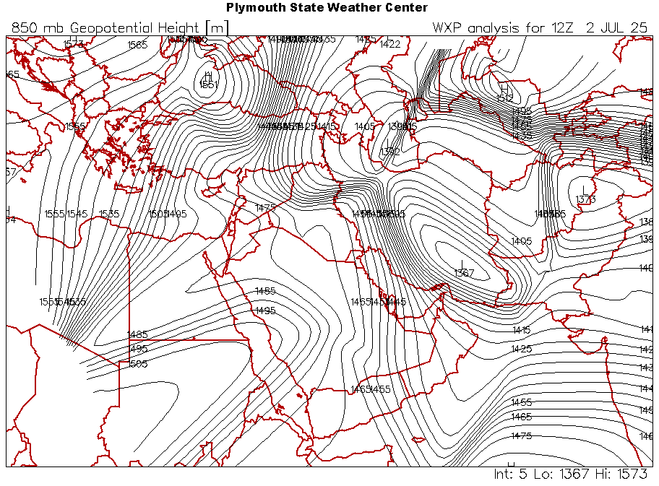  2-jul2025(1200z ) | 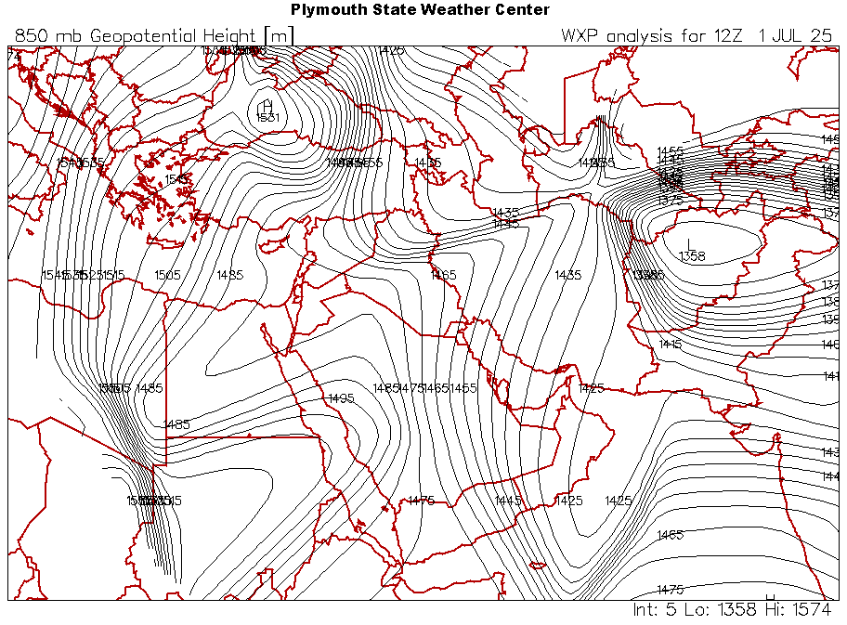  1-jul2025(1200z )
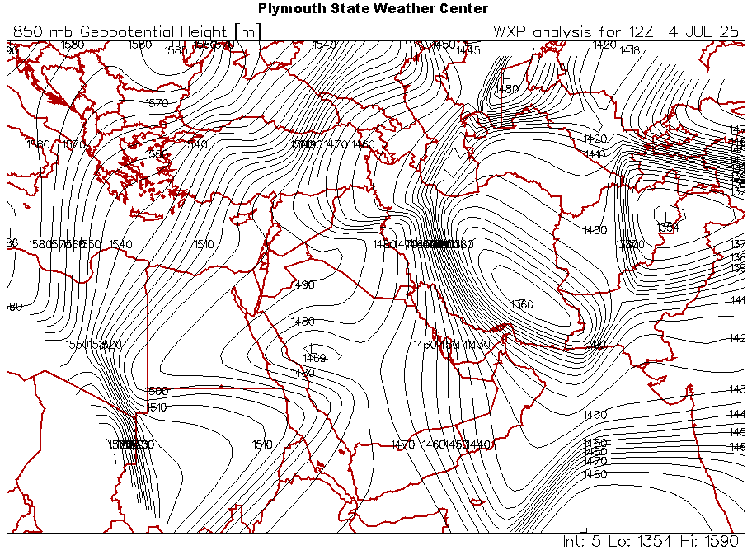  4-jul2025(1200z ) | 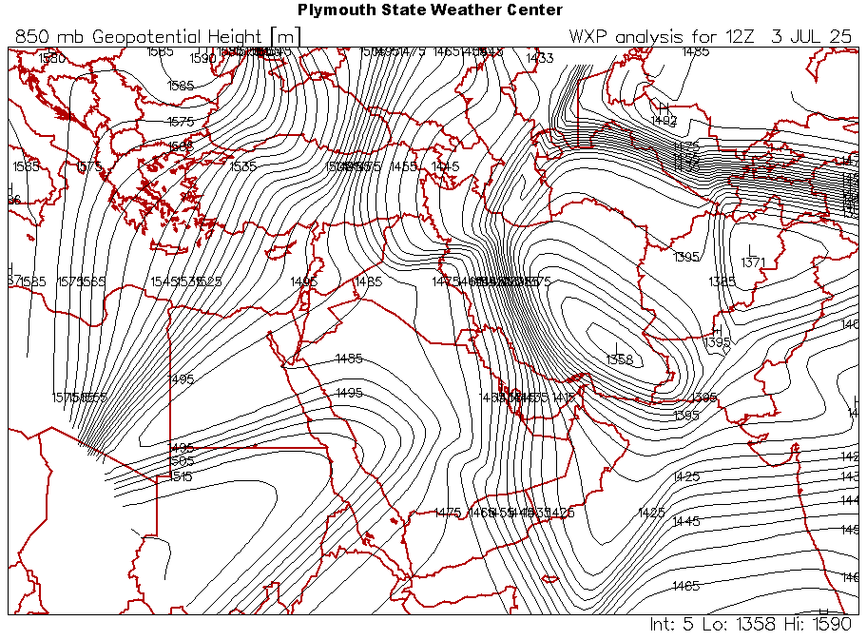  3-jul2025(1200z )
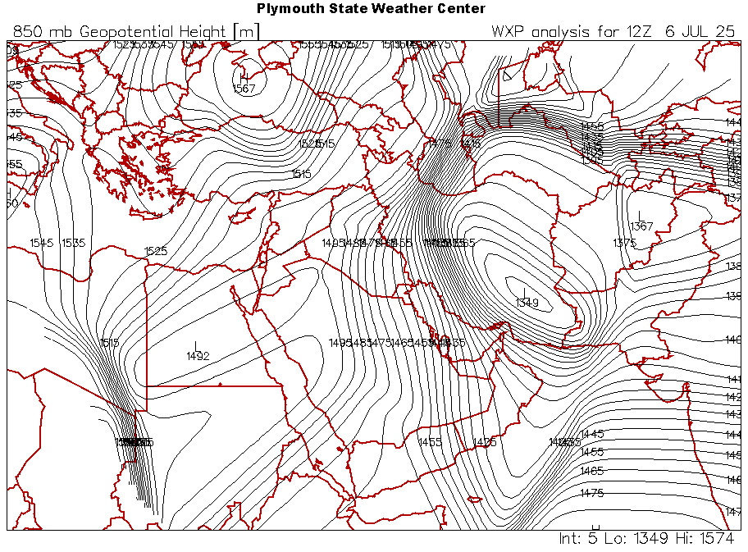  6-jul2025(1200z ) | 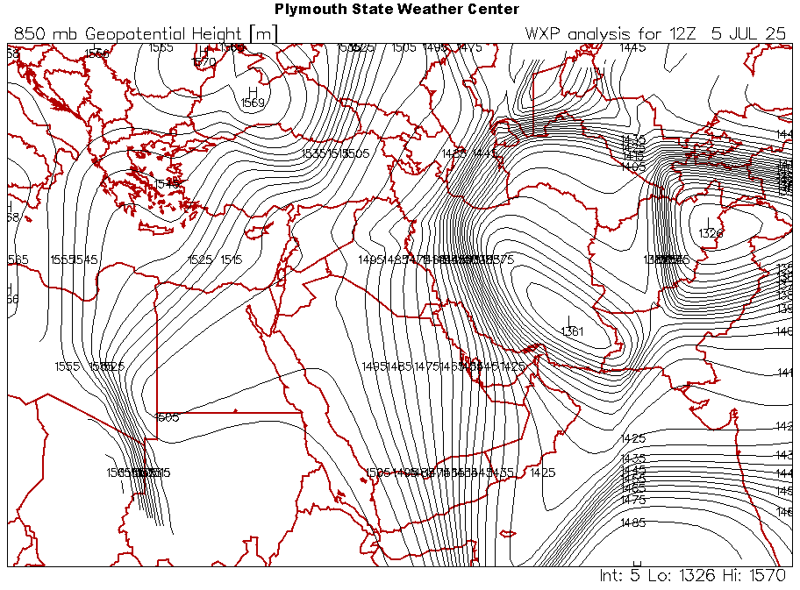  5-jul2025(1200z )
Source: 850 hPa maps from https://vortex.plymouth.edu/myowxp/upa/
3- 500 hPa level
Level 500 is the basis for generating thermal anomalies for the days of the event, as shown in maps (4), which reveal clear polar vortex activity over the European continent. The intensity of the zigzagging air waves contributed to the arrival of polar descents towards the eastern Mediterranean (Figure 5). The dominance of a deep trough with a north-eastern axis -southwest axis over northern Iraq and eastern Turkey, as shown in the map for 1 July at 00:00, where the trough axis was centred over Iraq and developed into a low pressure system over the eastern Mediterranean at 1200, which reinforced the arrival of cold polar air in the upper atmosphere. On 2 July, the low pressure system moved towards western Iraq, placing Iraq within the rising arm of the trough, and the polar trough continued to dominate Iraq, deepening on 4 July to reinforce the strength of the European surface high over eastern Turkey and its extensions over northern Iraq. The trough deepened further on 5 July and relatively maintained the characteristics of the accompanying air mass, lowering temperatures in the upper atmosphere and also affecting the characteristics of the Indian surface thermal low, as it allowed the rising currents from it to penetrate the upper atmosphere, broke the upper thermal inversion layer, and cancelled out the effect of the descending air currents, leading to a drop in temperatures during the days of 1-6 July 2025.
Figure 5: Polar vortex activity on 5 July 2025 shows polar descents towards the eastern Mediterranean, the Levant and Iraq.
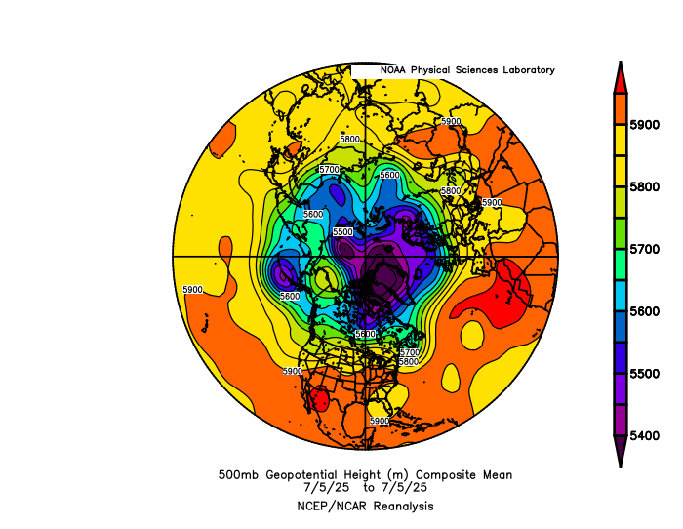
Source:500 hPa level maps available at https://vortex.plymouth.edu/myowxp/upa
Figure (7) The control of the polar trough over the eastern Mediterranean and Iraq for the days 1-6 July 20205 Observation 1200

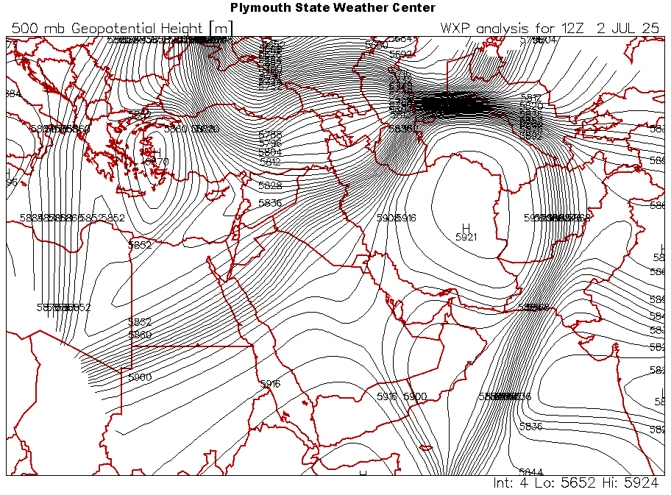  2-jul 2025(1200z) | 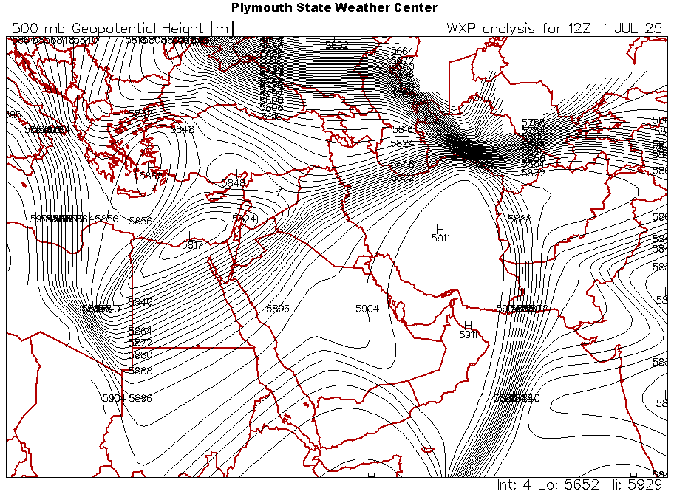  1-jul 2025(1200z)
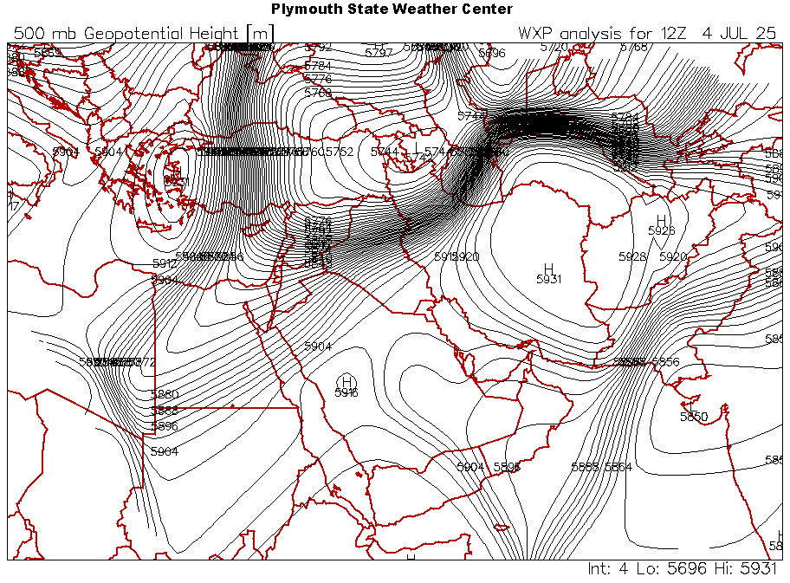  4-jul 2025(1200z) | 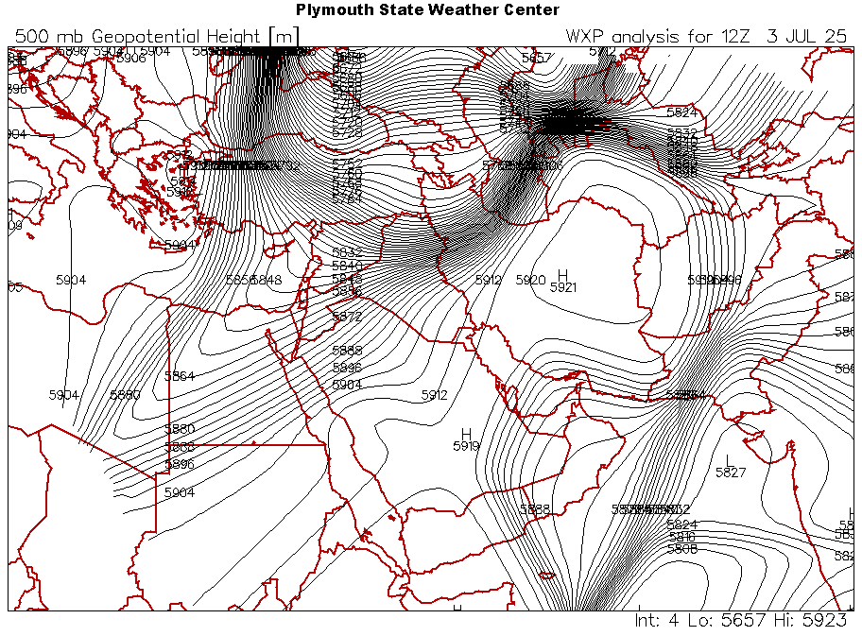  3-jul 2025(1200z)
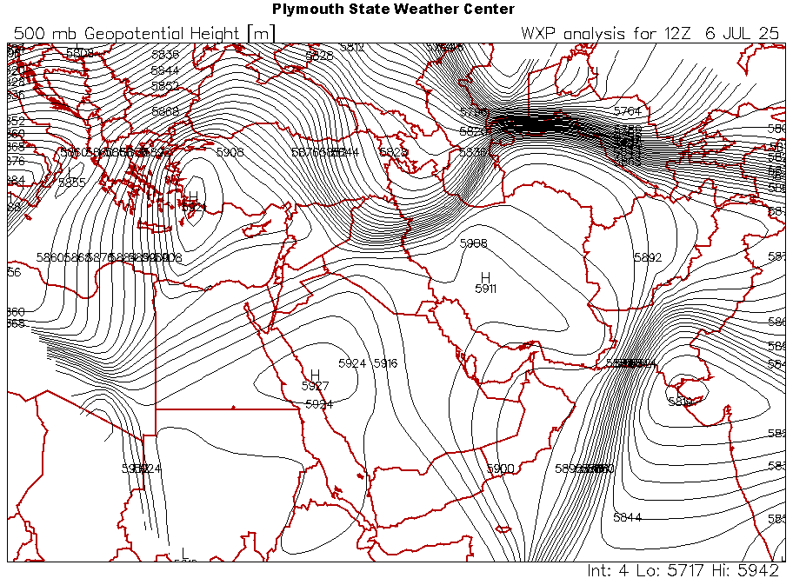  6-jul 2025(1200z) | 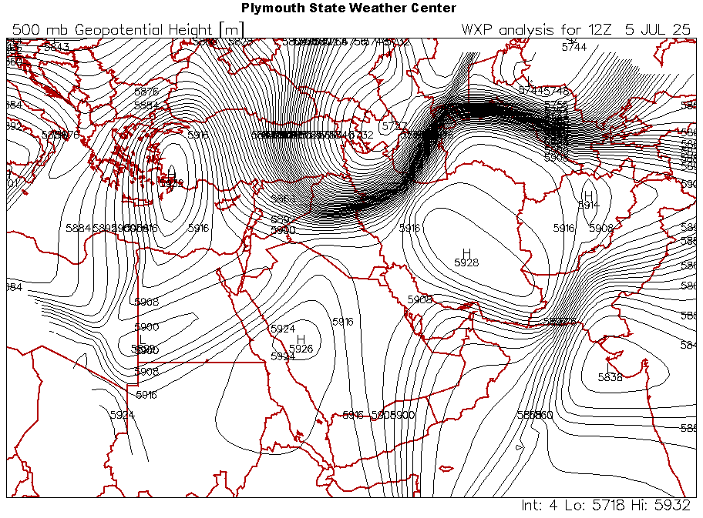  5-jul 2025(1200z)
Source:500 hPa level maps available at://vortex.plymouth.edu/myowxp/upa /

Upper–air data analysis for 1–6 July 2025 over Baghdad
An analysis of radiosounde data from Baghdad International Airport station for the period 1–6 July 2025, for the 00 and 1200 Z observations and for the 850 hPa and 500 hPa levels, shows clear changes, particularly in temperature and geopotential height at these two levels, as follows:
1-Both levels recorded a decrease in their geopotential heights during the thermal anomaly days, as shown in Tables (4) and (5). The 850 hPa level recorded heights ranging between 1434 and 1445 m at 00 UTC, and between 1448 and 1458 m at 1200 UTC — values lower than the standard height of 1500 m above mean sea level. This decrease is attributed to the influence of the European high–pressure system accompanied by its associated cold air mass, which reduced the air temperature at this level to between 21 °C and 24.5 °C at night, and between 22 °C and 24.8 °C during the day.
The same applies to the 500 hPa level, which recorded a sharp drop to 5020 m on 4 July, while ranging between 5850–5870 m on the other days for the 00 UTC observation, and between 4860–5880 m for the 1200 UTC observation. The specific situation of reduced geopotential heights at the 500 hPa level contributed to lowering temperatures throughout the anomaly period, with the lowest temperature recorded being –40.9 °C on 4 July at night, showing a significant deviation from the other anomaly days (Figure ). This situation also lowered the 1200 UTC temperatures to between –0.1 °C and –2.4 °C, which helped reinforce the surface high–pressure system with cold air and reduced surface air temperatures.
2- The dew point temperature at the 850 hPa level ranged between –2.2 °C and 6.6 °C at 00 UTC, and between 1 °C and 3 °C at 1200 UTC, with relative humidity values ranging between 17–33 % during the anomaly days at 00 UTC and between 25–27 % at 1200 UTC. This indicates dry air and a reduced moisture index at this level, which limited heat retention, especially at night.
The same situation applied at the 500 hPa level, where dew point temperature values ranged between –24 °C and –65.9 °C at 00 UTC, and between –21 °C and –49 °C at 1200 UTC, with relative humidity values between 1–14 % and 1–19 % for the two observation times, respectively. This indicates dryness of the air layer between the two levels and the absence of moisture or clouds that could limit outgoing terrestrial radiation, thus contributing to temperature reductions.Skew-T diagrams for 1–6 July clearly illustrate the low moisture indices during the anomaly days.
The source is Table (4), radiosounde readings of upper-air data at the 850 hPa level over Baghdad Airport for the period 1–6 July 2025.
00Z |  |  |  |  |  |  | 1200 Z
DAYS | Height | Temperature (°C | Dew Point | % Relative Humidity | Wind Speed | Direction | Height | Temperature (°C | Dew Point | % Relative Humidity | Wind Speed | Direction
1-Jul | 1434 | 23.6 | 6.6 | 33 | 7.2 | 302 | 1450 | 22.4 | 2.4 | 27 | 9.3 | 309
2-Jul | 1444 | 25 | 2.4 | 23.4 | 7.7 | 310 | 1448 | 24.8 | 2 | 24 | 9.3 | 312
3-Jul | 1445 | 25.4 | -1.6 | 17 | 4 | 330 | 1458 | 25 | 2.2 | 25 | 5.28 | 280
4-Jul | 1440 | 24 | -2.2 | 24 | 5 | 300 | 1448 | 23 | 1.8 | 24 | 5.1 | 325
5-Jul | 1442 | 23 | -0.6 | 20 | 4.3 | 305 | 1449 | 22 | 1 | 25 | 4.8 | 310
6-Jul | 1443 | 21 | 0.2 | 25 | 4 | 330 | 1448 | 23 | 3 | 25 | 6 | 310
The Source: : https://weather.uwyo.edu/upperair/sounding.html/

Table (5) shows the radiosounde readings of upper-air data at the 500 hPa level over Baghdad Airport for the period 1–6 July 2025.
00Z |  |  |  |  |  |  | 1200 Z
DAYS | Height | Temperature (°C | Dew Point | % Relative Humidity | Wind Speed | Direction | Height | Temperature (°C | Dew Point | % Relative Humidity | Wind Speed | Direction
1-Jul | - | - | - | - | - | - | 5580 | -0.1 | -36 | 5 | 0.3 | 230
2-Jul | 5870 | -1 | -24 | 14 | 1.09 | 210 | 5870 | -0.9 | -21 | 19 | 1.3 | 233
3-Jul | 5860 | -1.6 | -47 | 1 | 0.1 | 200 | 5870 | 2.4 | -46.6 | 1 | 0.1 | 205
4-Jul | 5020 | -40.9 | -65.9 | 5 | 0.1 | 225 | 4860 | -0.5 | -49 | 1 | 0.08 | 220
5-Jul | 5850 | -2 | -49 | 1 | 0.08 | 220 | 5870 | -1.3 | -46 | 2 | 0.08 | 225
6-Jul | 5870 | -1.7 | -49.7 | 7 | 0.08 | 225 | 5850 | -2.1 | -50 | 1 | 0.08 | 220
The source: https://weather.uwyo.edu/upperair/sounding.html/
- At the 850 hPa level, wind speeds during the 00 UTC observation ranged between 4 and 7.7 m/s, and between 4.9 and 9.3 m/s during the 12 UTC observation, with a northwesterly direction on the anomaly days. At the 500 hPa level, wind speeds ranged between 1 and 4 m/s for the 00 UTC observation, and between 1 and 19 m/s for the 12 UTC observation, with a southwesterly to westerly direction. As the station is located in central Iraq, it falls within the ascending limb of the trough, which contributed to lowering temperature values during the anomaly days by reinforcing the surface high-pressure system with upper cold air, and the prevalence of northwesterly winds from the Anatolian Plateau, thus reducing temperature values.
Figure ( 8) Skew-T diagram of radiosounde data over Baghdad Airport for 1–6 July 2025, for the 00 and 1200 UTC observations.
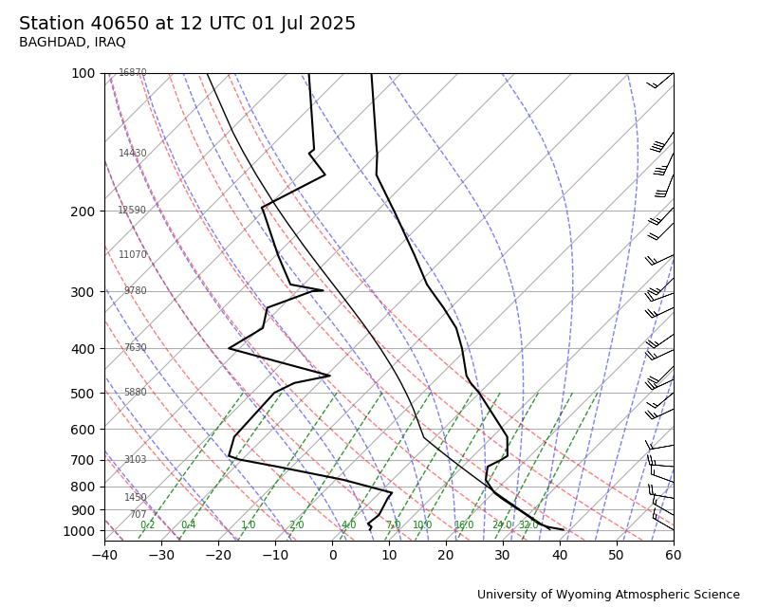 | 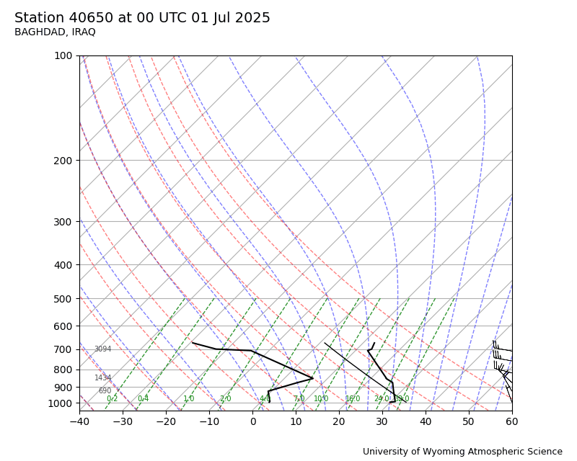
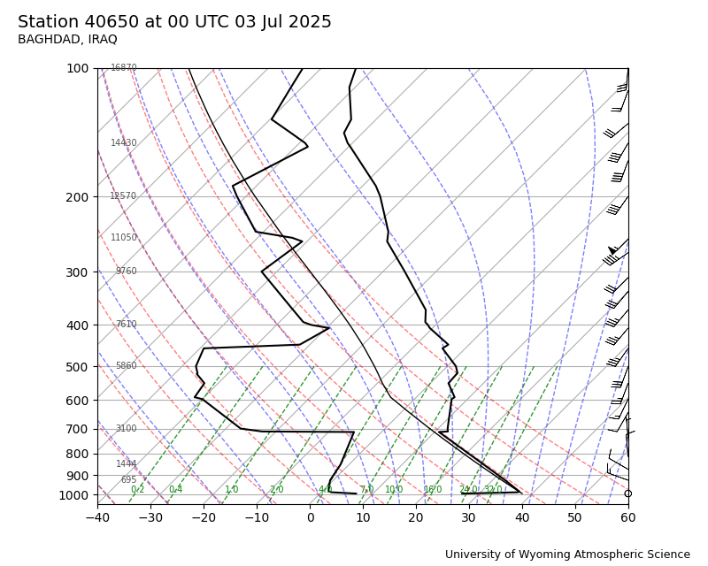 | 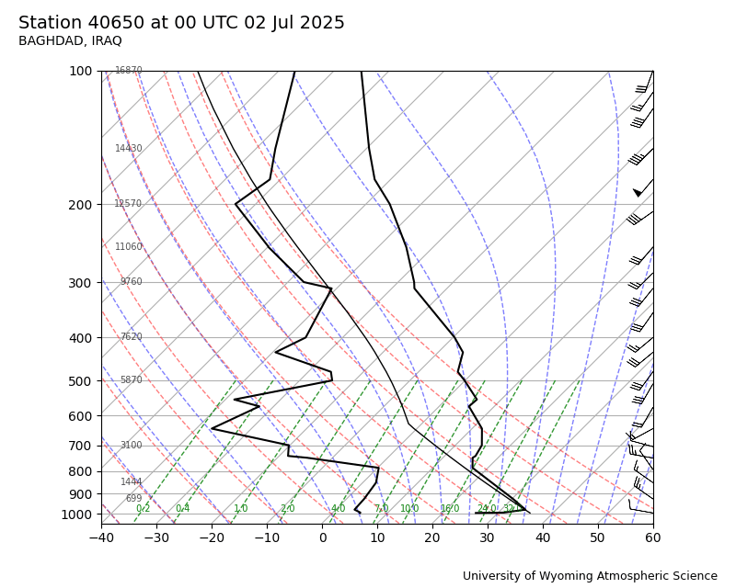
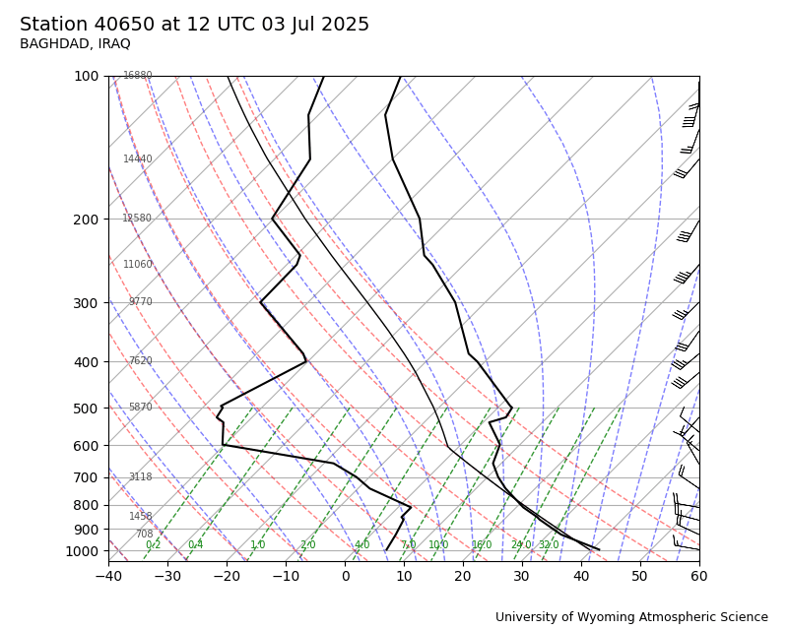

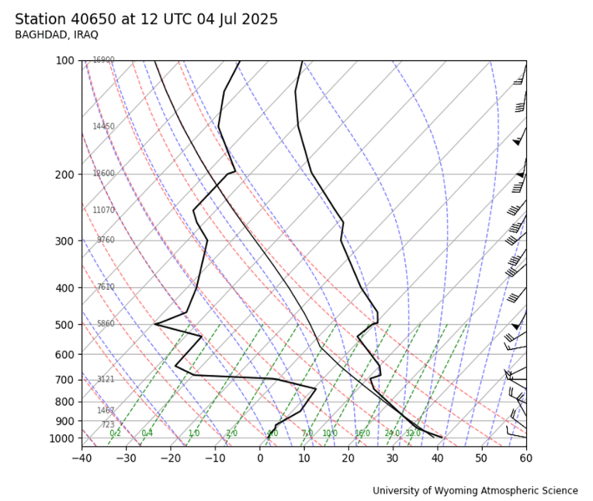 | 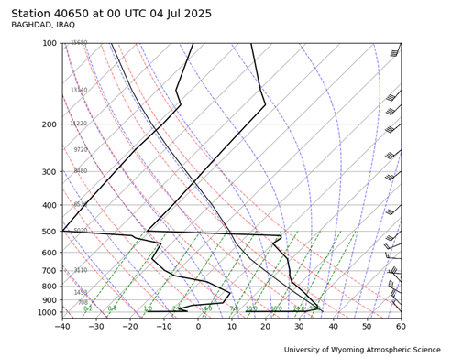
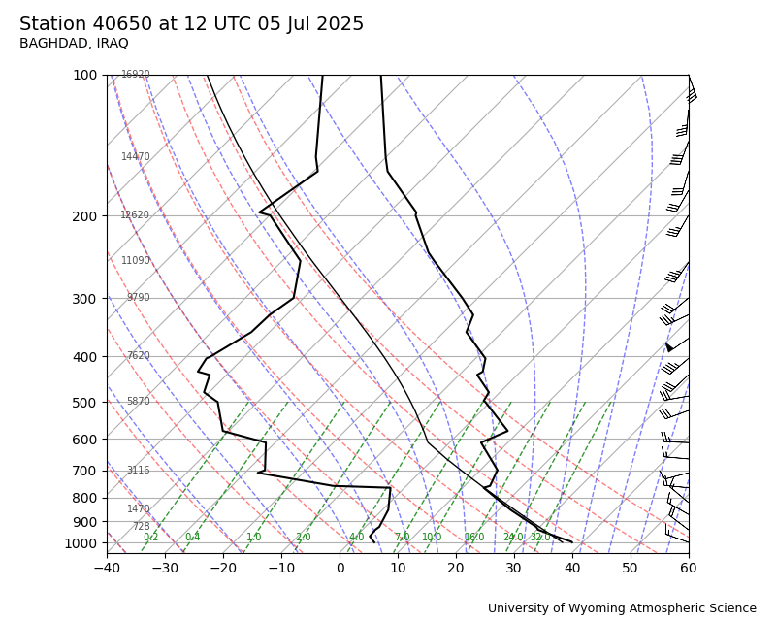 | 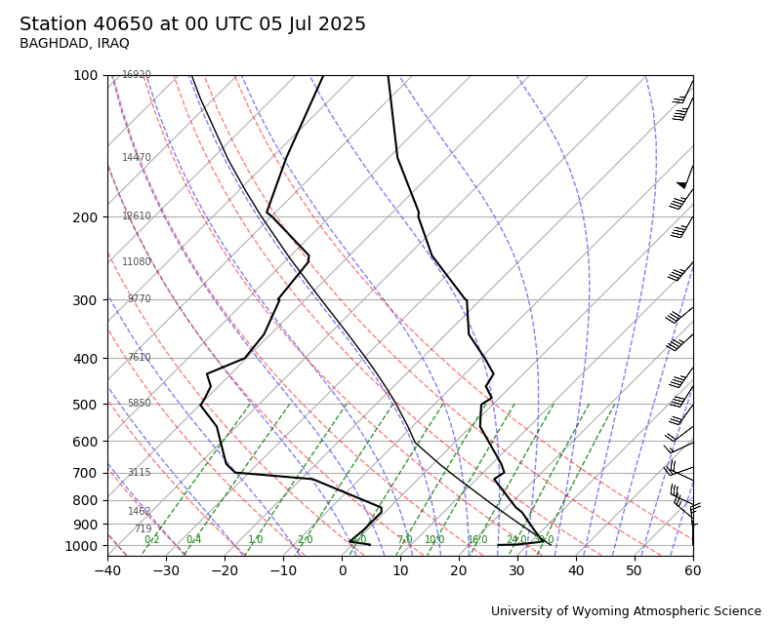
Radiosounde data for Baghdad International Airport at the link
https://weather.uwyo.edu/upperair/sounding.html/ :

Conclusions:
- During 1–6 July 2025, Iraq experienced a thermal anomaly compared to the monthly averages, peaking on 4 July with deviations ranging between 3–7 °C, representing an unusual temperature situation for this month.
- Analysis of surface maps indicates that northern Iraq was affected by the extension of a high-pressure system coming from Europe during the anomaly days, with pressure values ranging between 1012–1018 hPa over Turkey and 1008–1011 hPa over northern Iraq. This situation contributed to the southward retreat of the Indian seasonal thermal low, weakening the influence of the warm tropical air mass over Iraq. The high-pressure extensions from central Europe also helped reduce temperatures.
- The deepening of the surface high at the 850 hPa level strengthened the system and increased surface air pressure values, enhancing the dominance and persistence of the surface high, which contributed to lowering temperatures.
- The activity of the polar vortex at the 500 hPa level led to polar air incursions, manifested by the activity of polar troughs over northern Iraq and across the eastern Mediterranean. This contributed to cooling, reinforced cold air over the surface high, and facilitated the development of the thermal anomaly. The dominance of these troughs also diminished the influence of the subtropical upper-level high and suppressed descending air currents, further contributing to the temperature drop.
- Radiosounde data analysis from Baghdad International Airport during the thermal anomaly shows a decrease in temperatures at both 850 hPa and 500 hPa levels, reaching –40 °C on 4 July 2025. Dew point temperatures and relative humidity also declined, indicating dry air that enhanced nocturnal radiative cooling, contributing significantly to the surface temperature reduction.

Sources:
- Al-Hassan, Ahmed Jasim, Zanba Karim Ahmed, Variations in the Frequency and Persistence of Subtropical High Centers at 500 hPa over Iraq for the Period 1973–2023, Dijlah Journal of Humanities, Vol. 7, No. 4, 2024.
Al-Rawi, Sabah Mahmoud and Adnan Haza’a Al-Bayati, Foundations of Climatology, University of Mosul, 2nd Edition, 2000.
Radiosounde data for Baghdad International Airport available at: https://weather.uwyo.edu/upperair/sounding.html
- 1000 hPa level maps published on Plymouth University Vortex Center website: https://vortex.plymouth.edu/myowxp/upa
- 850 hPa level maps published on Plymouth University Vortex Center website: https://vortex.plymouth.edu/myowxp/upa
- 500 hPa level maps published on Plymouth University Vortex Center website: https://vortex.plymouth.edu/myowxp/upa
- Surface pressure maps at 1000 hPa from NOAA: https://psl.noaa.gov/data/composites/day/
- Najib, Iskandar, Dictionary of Synonyms, Antonyms, and Related Terms from Nouns, Verbs, Tools, and Expressions, Dar Al-Afaq Al-Arabiya for Publishing and Distribution, Cairo, 2001.
- Iraqi General Authority of Meteorology and Seismic Monitoring, Climate Department, unpublished data.
NASA Earth Observatory, Global Maps: https://earthobservatory.nasa.gov/global-maps

