Fingerprint and genetic variation of eight date palm cultivars (Phoenix dactylifera L.) usage SSR markers and morphological characters.
Hassan Abdulimam Faisal¹ Ahmed Yousef Lafta Hzaa ^{2*}
Abdul Samad Abbood Abdullah¹
¹Date Palm Research Center - University of Basra, Iraq.
²Department of Horticulture, College of Agricultural, University of Basrah, Iraq.
Corresponding author Email: ahmed.lafta@uobasrah.edu.iq.

Received date:
Accepted date:
Abstract
The date palm is regarded as one of the most important economic fruit trees worldwide. The experiment was carried out to find the fingerprint and variance for eight date palm cultivars . utilizing fruit's morphological characteristics and molecular (Simple Sequence Repeat) markers. The molecular markers of SSR primers yielded 152 bands, with an average of 25.33 bands per primer. The results showed that there were 51 polymorphic alleles in total, with a range of 1 to 6 alleles in the genotype loci and an average of 8.5 alleles. This resulted in a percentage of the total polymorphism of 100%. Additionally, primers produced distinctive bands totalling 18 distinct bands for the cultivar. Major allele frequency was on average 0.313. Genetic diversity was measured using a value of 0.794, which shows that cultivars have a high level of genetic variation. The expected mean heterozygosity was 0.875, while the mean value of the information content was 0.766 for polymorphisms. According to the results of the morphological study, there were two groups that contained cultivars. Hilali and Sultani recorded the highest level of genetic similarity between them, totalling 0.967, while Khalas and Nabtat Seif recorded the lowest level, 0.722. Date palm cultivars are distinguished from one another using morphological traits and molecular SSR markers.
Keywords: Fingerprint, Morphological, Phoenix dactylifera L, SSR, variance.
Introduction
Phoenix dactylifera L, a date palm, is a member of the Arecaceae family. The fruit tree is a subtropical one. It is a blooming monocotyledonous plant. Its cultivation is widespread in Iraq and other Middle Eastern countries. (9). There are over 5000 date palm cultivars worldwide, and there are 600 cultivars in Iraq. Despite the classification and registration of many of these cultivars in Iraq, there are still others that are not registered at this moment. This led several researchers to record these cultivars using genetic markers. (1) Simple sequence repeats (SSR) are one of the most significant and prevalent molecular markers nowadays. They are utilized for genetic mapping, fingerprint identification, and the detection of genetic variability (31) SSR marker is a co-dominant and highly reproducible DNA marker it has a high degree of polymorphism; it is abundant and evenly distributed in eukaryotic genome (30). Sixteen microsatellites were used to genetically describe 18 date palm cultivars in Libya. These results in 110 bands and an average of 6.88 bands per primer, of which 28 bands are unique and peculiar to some cultivars. The number of bands for each primer ranged from (4–11), and the average percentage of polymorphism varied from 81%. (26).
A study conducted by Zehdi-Azouzi et. al. (34) to evaluate the genetic diversity of domesticated and wild date palm cultivars in coastal areas of Tunisia used 18 microsatellites primers, which produced 125 bloated bands with an average size of 6.94 bands per locus or primer. This work demonstrates how genetic diversity can provide a thorough understanding of the genetic variety of local structures and their distribution. Nine SSR primers were used to generate 39 bands, a range of 3 to 5, and an average of 4.33 bands, which were used to characterize 12 Tunisian date palm cultivars (21).
The use of morphological markers is one of the first markers that researchers relied on classifying plants since ancient times, and a botanical key was assigned to it to facilitate its use in the study of genetic diversity, as it depends on finding differences between individuals based on phenotypic traits such as fruit or leaf traits and others, It is one of the easiest and least complicated ways to distinguish between individuals (3). The genetic link between Nigerian palm trees and palm trees from the Maghreb and the Middle East was shown using principal sequence coordinates (PCoA) analysis, with the Maghreb cultivars being more diversified than the Middle East cultivars. Nigerian cultivars were 86% more similar to Tunisian cultivars (32). Assessed the phenotypic diversity among 26 palm cultivars in Algeria using principal sequence coordinates analysis. The vegetative features of the leaf and a few fruiting traits were identified as the primary components of the variance, and cluster analysis revealed the presence of three fundamental groups. The similarity levels varied from 0.064 to 1.148 for the vegetative traits and from 0.036 to 1.256 for the fruiting traits, revealing a significant amount of phenotypic variation among cultivars. (7). The study aimed to determine the genetic fingerprint and genetic variation of eight cultivars of rare date palm grown in central Iraq, based on some molecular and morphological markers.

Material and Methods
Plant materials
This work was conducted on eight cultivars of date palm in several regions of central Iraq (Table 1). Date palm cultivars were chosen from good palm orchards during the 2022 growing season that are distinguished by an agricultural service in which all agricultural activities are carried out in accordance with the techniques employed in the palm groves, using high-quality standards to choose cultivars that were as similar as possible. The chosen cultivars had the closest potential resemblance in age and vegetative growth stage. The work was done at the University of Basrah – college of Agriculture Biotechnology Laboratory and Date Palm Research Center.
Procedures
In the molecular analysis, three samples from fresh, newly produced, pathogen-free
leaves of each cultivar were collected. Samples were collected from the places where the cultivars were grown (Table 1).These Preparation of plant samples were chopped into little pieces (1-2 cm) and dried at room temperature.
In preparation for eventual DNA extraction, they were mechanically ground into a fine powder and stored in the refrigerator.

According to (18) the CTAB technique was used to extract DNA. Utilizing the Nano Drop ND-2000 (THERMO SCIENTIFIC, USA) spectrophotometer at 260 nm, DNA efficiency and quality were assessed, and purity was calculated using the A260/A280 ratio. There were utilized ten SSR markers, which are listed in (Table 2) along with some information about them.
The SSR-PCR program's primers were those listed in Table 2, and the reaction's components were " Go Taq® Green Master Mix (1 x) 12.5 μl , primer (1.0 μM) 2 μl , template DNA (50ng) 2 μl, Sterile distilled water 8.5 μl." The final volume of the reaction was 25 l, and the reaction ingredients were put in an Eppendorf PCR tube. Reaction tubes were labeled from the top with the cultivar number and from the side with the primer number, and the additive sizes were as specified in the protocol (11).
The Next program was used to do the PCR reaction: One cycle at 95 °C for 5 min, then 35 cycles of doubling, 30 sec. at 95 °C to denature the DNA template, 45 sec. for primers to bind to DNA at (49-57 °C), and 60 sec. for primer elongation at 72 °C. After that, a last cycle lasting 10 minutes at 72 °C was performed for ultimate elongation. In order to ensure consistency, the PCR reaction was carried out twice for each primer

No. | Cultivar name | Cultivar location | Cultivar Coordinates
1 | Brim red | Karbala, Hussainiya palm station | Lat: N 32˚. 68473  Lon: E 44˚. 09955
2 | fard white | Karbala, Hussainiya palm station | Lat: N 32˚. 68378  Lon: E 44˚. 10064
3 | NabtatSeif | Karbala, Hussainiya palm station | Lat: N 32˚. 68404  Lon: E 44˚. 10017
4 | Sultani | Karbala, Hussainiya palm station | Lat: N 32˚. 68354  Lon: E 44˚. 10016
5 | Hilalli | Babylon - Tourist | Lat: N 32˚. 39563  Lon: E 44˚. 53092
6 | Khalas | Babylon - Abu Sedira palm Station | Lat: N 32˚. 63089  Lon: E 44˚. 42167
7 | Khestawi | Babylon - Tourist | Lat: N 32˚. 39563  Lon: E 44˚. 53092
8 | Tabarzal | Babylon - Tourist | Lat: N 32˚. 39701  Lon: E 44˚. 59516
Table 1. The cultivars under study, the place of collection and the coordinates of the site

Table 2: SSR Technology Primers Characteristics.
Primers name | Primers  Sequenceing | Annealing temperature  (°C) | Source
PDCAT6 | F: AATCAGGGAAACCACAGCCA  R : GTTTAAAGCCTTCTCAAGATAGCCTCAG | 53 | Akkak et al((4
PDCAT18 | F : CCTAAACCTGAATGAATCAAAGCA  R : ACTAACATAAGGACAGTGCTATGTGATTG | 54 | Akkak et al((4
MPdCIR010 | F: ACCCCGGACGTGAGGTG  R: CGTCGATCTCCTCCTTTGTCTC | 55.9 | Billotte et al. ( 8)
MPdCIR048 | F: CGAGACCTACCTTCAACAAA  R: CCACCAACCAAATCAAACAC | 51.4 | Billotte et al. ( 8)
MPdCIR070 | F: CAAGACCCAAGGCTAAC  R: GGAGGTGGCTTTTGTAGTAT | 48.7 | Billotte et al. ( 8)
mPDCIR70 | F : CCATTTATCATTCCCTCTCTTG  R: CTTGGTAGCTGCGTTTCTTG | 51.8 | Billotte et al. ( 8)
mPDCIR78 | F : CCCCTCATTAGGATTCTAC  R: GCACGAGAAGGCTTATAGT | 49.3 | Billotte et al. ( 9)
30s101A | F : CACGACGTTGTAAAACGAC  R: GGGATAATGTTGTTGCTCCG | 60 | Al-Mamari (6)
DP157 | F : TGGACAATGACACCCCTTTT  R: GCCCACACAACAACAACCTCTCT | 54.6 | Elmeer et al(11)
DP175 | F: ACACACACACACACACACACACC  R : GTGGCTTCTTTTTGGCTGTC | 57.6 | Elmeer et al(11)

For the electrophoresis of the PCR replication products, an agarose gel was prepared by dissolving 2 g of agarose powder in 100 ml of TBA solution to achieve a 2% concentration. The transfer solution (1X TBE) in the electrophoresis basin was applied to the agarose gel plate, and then 7 μl (2 μl of Bromophenol Blue Loading dye and 5 μl of PCR product) were injected into the designated holes in the gel that have been formed by the comb trail under the TBA solution. In order to compare and determine the molecular weights, a thin Promega 100 bp DNA ladder was inserted into each one of the holes. For two hours, the relay electrodes were wired to the power supply at a voltage of 65V and a current of 80 mA. after that, high-definition digital photos and gel documentation were utilized.
Ten fruits from each cultivar were selected to be measured for the morphological properties of the fruits in the ripening stage. Ten characteristics were represented by average fruit size (in cm), average fruit diameter (in cm, average fruit weight (g), average seed weight (g), average seed length (cm), average seed width (cm, placement of the hilum on the seed (in the center, in the semi-end, and at the end), shape of the median groove in the seed (in cm, wide, tight, and deep), and ripening date (1- early, 2- Medium, 3- late ).
Data analysis :
To determine the bands emerging from the PCR reaction, the graphical analysis of the molecular study data was performed using the Gel Analyzer 2010a application. The molecular weights of the bands ranged from (60 - 950) bp, according to the DNA Ladder 100 bp volume index, which was used to estimate them. In order to analyze and determine how many different bands there were, the data was entered into the Excel application. (2 and 14). A binary matrix has been created using the obtained data. Based on the presence and absence of the band, the molecular data matrix is constructed (1 assigned to present and 0 assigned to absent). With the use of the Jaccard coefficient and the set of unweighted pairs method with arithmetic average (UPGMA) analysis, a dendrogram of the genetic relatedness among eight cultivars was created. Using Power Marker V3.25 software (20) and STRUCTURE version 2.3, molecular findings were analyzed to determine gene diversity, major allele frequency, polymorphism information content (PIC), and genetic distance between cultivars.
The morphologically acquired data were examined to identify the traits that influence the total variance. Principal component analysis (PCA) was performed using Past 3 software, (16). Following the transformation of the morphological and proximal data into interval data and the calculation of similarity matrices using the Euclidean coefficient, these matrices were used to create a tree diagram.
Results and Discussion
SSR analysis
According to the results (Figures 1 and 2), six out of ten primers successfully amplified the samples, yielding 152 bands with an average of 25.33 bands per primer (Table 3). Furthermore, the bands' molecular weights ranged from (60 to 950) bp. The DP175 had the most output, 52 bands total, and the 30s101A had the lowest output, 10 bands total. The number of bands produced when the DNA template is amplified by the primer used differs depending on how well the primer binds to the plant genome and is based on nitrogenous base components in each primer, due to the variation in the number of bands that various primer binding sites with plant genomes produce (5 and 28) Furthermore, all primers demonstrated polymorphic bands and locations among genotypes, totaling 51 and an average of 8.5 bands per primer. The DP175, with 18 polymorphic bands, had the bands most, while the primers (MPdCIR010, 30s101A, MPdCIR048) had the bands fewest, with five bands with a variety of formalities. (Table 3).
The primers gave a percentage of total polymorphism of 100%, indicating that these primers are effective at detecting genetic variation between cultivars. This variation in the number of bands produced by the primers used has resulted in form polymorphism among the resulting bands for all cultivars under consideration, as the primers produced bands of polymorphism in all cultivars with a polymorphism percentage of 100%. This shows the effectiveness of the primers employed in the investigation of genetic diversity and their compatibility with the genome of the cultivars of palm trees grown in Iraq. These findings are in consistent with other researchers (13 , 34 and 33) also accounted for the high degree of polymorphism found in microsatellite chains as being the cause of the phenomena known as uneven crossing in the microsatellite region and the reason for the occurrence of this proportion of high variances (10).
Furthermore, the primers generated unique bands with a total of 18 distinct bands for the cultivar, with the DP175 primer generating the most distinct bands (8 in total), with molecular weights varying from cultivar to cultivar. No distinctive bands were produced with the MPdCIR070 primer. Since unique bands quickly give highly discriminatory results, they reduce cost and effort. A cultivar's genetic fingerprint must also be determined when there is not a band of that cultivar present in order to compare it to other cultivars. Unique bands typically show up more frequently in primers with the highest polymorphic bands between cultivars. Furthermore, while less frequently, primers that produce fewer bands can nonetheless show discrete bands (24).
Knowing that these distinctive bands can be used as a marker for differentiating between cultivars and identifying the genetic fingerprint of the cultivar allows one to distinguish between those that have them from those that do not.
The effectiveness of primers and their capacity for discrimination varied from one primer to another. The DP175 had the highest efficiency rate, 34.21%, while the 30s101A had the lowest efficiency rate, 6.56%. Additionally, the discriminatory ability of the primers was measured; DP175 had the highest discriminatory ability, which came to 35.30%. and the lowest discriminatory ability was 9.80% recorded by (MPdCIR010, 30s101A, MPdCIR048), this is because it recorded the fewest number of polymorphic bands. (Table 3).
The primer's diagnostic capacity and effectiveness express its capacity to identify the degree of variations in the sequence of nitrogenous nucleotides inside the target genome. By dividing the number of bands produced by the primer by the total number of bands, the effectiveness of the primer can be calculated. The more bands the primer produces, the more effective it is. The strength of the diagnostic primer increases with the number of divergent bands generated by the primer, revealing a wide range of variations in the genome that the primer was designed to target.(29)

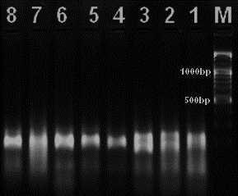 |  |  | 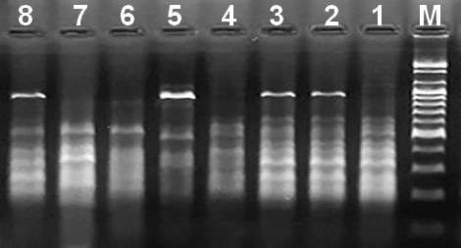
MPdCIR010 |  |  | DP175
 | Figures 1. PCR amplification of MPdCIR010 and DP175 in 8 date palm cultivars on 2% agarose gel,M=100bp plus DNA ladder ( 1.Brim red 2. Khalas 3. fard white 4. NabtatSeif 5. Hilalli 6. Khestawi 7. Tabarzal 8. Sultani )
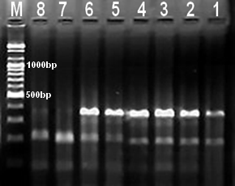 |  | 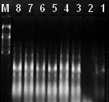
PDCAT6 |  | MPdCIR070
 | Figures 2. PCR amplification of PDCAT6 and MPdCIR070 in 8 date palm cultivars on 2% agarose gel, M=100bp plus DNA ladder ( 1.Brim red 2. Khalas 3. fard white 4. NabtatSeif 5. Hilalli 6. Khestawi 7. Tabarzal 8. Sultani )

Table 3. The total bands, their similar and different numbers, and the percentage of Polymorphism, as well as the efficiency ratio of SSR primers and their discriminating ability.
primers | no total bands | no of bands | Poly  morphism bands | Unique bands | Poly  morphism % | Primer Efficiency% | Primer Discrimination power %
PDCAT6 | 31 | 12 | 12 | 2 | 100 | 20.41 | 23.53
DP175 | 52 | 18 | 18 | 8 | 100 | 34.21 | 35.30
MPdCIR010 | 18 | 5 | 5 | 2 | 100 | 11.84 | 9.80
30s101A | 10 | 5 | 5 | 4 | 100 | 6.56 | 9.80
MPdCIR048 | 14 | 5 | 5 | 0 | 100 | 9.21 | 9.80
MPdCIR070 | 27 | 6 | 6 | 2 | 100 | 17.77 | 11.76
total | 152 | 51 | 51 | 18
Mean | 25.33 | 8.5 | 8.5 | 2.33 | 100 | 16.67 | 16.66

The primers detected 51 alleles in total, with an average of 8.5 alleles detected per locus (Table 4). Different primers (SSR10, SSR0A, and SSR48) had 5 alleles each, while primer SSR75 had 18 alleles. Additionally, the main allele's mean frequency was 0.313 and ranged from 0.250 to 0.438. Predicted heterozygosity, often known as genetic diversity, is used to gauge how frequently applied genetic diversity occurs in a variety of population genetics contexts (27). It ranged from 0.719 to 0.844 with a mean of 0.794 employing SSR markers amplified with the cultivars eight. High levels of genetic variety were present in the cultivars.(10) noted that these values were greater than those found in the eight Omani cultivars; this might be because Iraqi cultivars are more divergent than Omani cultivars. The eight types' heterozygosity was determined to be 0.875, and the markers' polymorphism information content values ranged from 0.680 to 0.826, with an average of 0.766. Heterozygosity and PIC results revealed high levels that performed better than those obtained by (6). Replication slippage is thought to occur more frequently than single nucleotide mutations and insertion/deletion events, leading to the generation of the polymorphisms detected by RAPD analysis. The emergence of this high level of diversity is expected to occur due to the unique mechanism responsible for the generation of SSR allelic diversity by homologous slip (23). Based on the results of primer amplification, a cluster analysis was done to determine the genetic relationship between cultivars, and Figure 3 shows that association. As a result of the study, the cultivars were divided into two main groups, A and B. Group A contained four cultivars since the Sultani was linked to a sub-cluster that contained the Tabarzal, which was linked to the other two cultivars (Hilalli and Khestawi). Regarding group B, the four cultivars were dispersed in a secondary cluster. The cultivar Nabtat Seif was connected to a cluster that also contained Khalas, and was connected to a branch that merged the two cultivars (Brim red and Fard white).
Table 4. Name of the primer, major allele frequency, genotype and allele counts, gene diversity, heterozygosity, and polymorphism information content (PIC) using six SSR markers
PIC | Heterozygosity | Gene  Diversity | Allele  No | Geno type No | Major.Allele  .Frquency | Marker
0.825 | 1.000 | 0.844 | 12 | 31 | 0.250 | SSR6
0.826 | 1.000 | 0.844 | 18 | 52 | 0.250 | SSR75
0.747 | 1.000 | 0.781 | 5 | 18 | 0.313 | SSR10
0.680 | 0.625 | 0.719 | 5 | 10 | 0.438 | SSR0A
0.785 | 0.750 | 0.813 | 5 | 14 | 0.250 | SSR48
0.735 | 0.875 | 0.766 | 6 | 27 | 0.375 | SSR70
0.766 | 0.875 | 0.794 | 8.5 | 25.33 | 0.313 | Mean

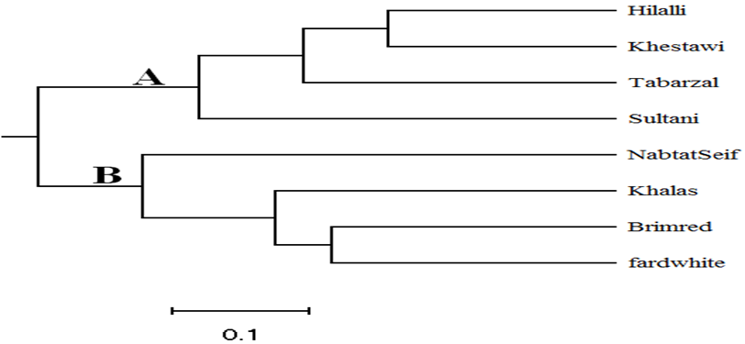
Figure 3. genetic tree dendrogram based on six SSR data
Measurements of genetic dimensions were made to assist in establishing a genetic foundation. Through (Table 5), which displays the values of the genetic dimension between the cultivars, it is possible to investigate the genetic relationship between cultivars. The genetic distance between the two cultivars (Hilalli and Khestawi) with the lowest genetic distance was 0.333. The genetic distance between the two cultivars (Tabarzel and Khestawi) was also recorded. This indicates that the cultivar Khestawi is closely related to the other twocultivars (Tabarzel and Hilalli). The presence of a shared genetic component between these cultivars, which may be a phenotypic or non-phenotypic trait, is shown by their genetic affinity, The Brim red cultivar and three other cultivars (Hilalli, Khestawi and Tabarzel). had a genetic distance of 1.000, which was the highest ever observed. The relationships that develop among a group of organisms that descend from a common ancestor can be visualized by creating a relationship tree and identifying genetic dimensions. Groups that are near to one another are placed in branches that are close to one another, and the distance between them indicates how closely related they are. Even so, this approach is an approximation, but it is a simple tool to research the connections between consanguinity and evolution. (19).
Table 5. Genetic distance among the eight palm cultivars based on six SSR markers.

cultivars | Brim red | fard white | Hilalli | Khalas | Khestawi | NabtatSeif | Sultani | Tabarzal
Brim red | 0.000
fard white | 0.417 | 0.000
Hilalli | 1.000 | 0.750 | 0.000
Khalas | 0.500 | 0.500 | 0.632 | 0.000
Khestawi | 1.000 | 0.833 | 0.333 | 0.882 | 0.000
NabtatSeif | 0.667 | 0.583 | 0.833 | 0.833 | 0.833 | 0.000
Sultani | 0.917 | 0.833 | 0.667 | 0.833 | 0.583 | 0.750 | 0.000
Tabarzal | 1.000 | 0.833 | 0.583 | 0.882 | 0.333 | 0.750 | 0.583 | 0.000

The model-based Bayesian clustering approach developed in the STRUCTURE (25) was used to identify demographics and partition the date palm inputs into various groups. The optimal number of groups (ten runs at each K) was obtained by running a mixture and a relevant frequency model for a grouping range of K values from 1 to 10. The genetic makeup of several date palm genotypes is investigated using models with two (K = 2) to six (K = 6) clusters. The change rate in the log likelihood between successive K values (DK) for the analyzed date palm accessions revealed minimal clustering at all K values (Fig. 4). Across all K values, there was no difference between date palm inputs from various geographic groups.
The genetic structure of the date palm did not alter within the K = 2 to K = 6 genotype range. This result is consistent with other studies that used SSR markers to analyze the genotype and genetic diversity of a varied global collection of date palm accessions (21). The origins of six separate societies are represented by the stratification of the most likely value of k. There was room for up to six entries, each with eight cultivars; the levels of genotypes were represented by vertical lines that were different colors. The many colors are seen as multiple groupings made up of different genotypes, as opposed to the lengthy single colors, which represent genetically identical individuals. According to Figure 4, each color corresponds to a potential progeny from which the genotype is derived.

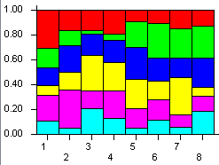 | 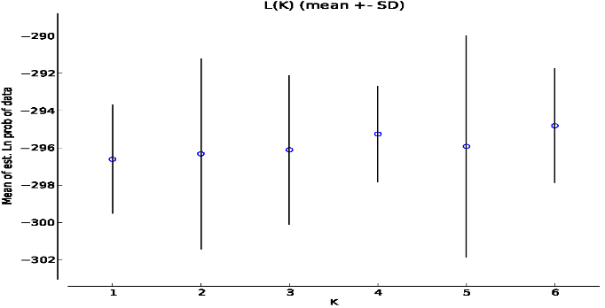
Fig. 4: Model-based clustering utilizing Bayesian analysis among 8 date palm cultivars based on allelic variations at 6 SSR loci.

Morphological study:
Table (6) depicts the physical characteristics of the fruits of eight date palm cultivars used in the analysis of the Principal components. Table (7) shows the values of the main components, indicating that there are four main components that contributed to explaining the cumulative variance. PCA was used to estimate certain significant characteristics, such as the proportion of variance for primary components and the proportion of the contribution of phenotypic traits to variance.
The first component, which made up 87.04% of the total variance, was primarily and favorably related to two aspects of fruit weight and pulp weight. While the shape of the groove and the placement of the hilum on the seed were adversely connected with this important component. The second component (6.36% of the total variation) is favourably influenced by the length, diameter, and form of the groove in the seed. The variance was only slightly influenced by the third and fourth components (3.38% and 2.33%, respectively).

Table 6. Morphological characteristics of the fruits of the eight palm cultivars

cultivars | Fruit length (cm) | Fruit Diameter (cm) | Fruit Weight (gm) | Pulp weight (gm) | Seed Weight (gm) | seed length (cm) | seed width (cm) | location of the hilum on the seed | shape of groove in the seed | maturity a period
Brim red | 3.44 | 2.43 | 7.9 | 6.7 | 1.18 | 1.84 | 0.77 | 1 | 3 | 1
Khalas | 2.52 | 1.72 | 7.15 | 6.43 | 0.71 | 1.41 | 0.52 | 2 | 1 | 2
Fard white | 3.11 | 2.37 | 8.56 | 7.82 | 0.7 | 1.51 | 0.81 | 3 | 2 | 2
NabtatSeif | 3.62 | 2.22 | 14.39 | 13.23 | 1.11 | 1.91 | 0.86 | 1 | 2 | 2
Hilalli | 3.57 | 2.51 | 10.51 | 9.34 | 1.14 | 2.13 | 0.71 | 1 | 2 | 3
Khestawi | 3.04 | 2.21 | 7.17 | 6.3 | 0.85 | 1.98 | 0.79 | 2 | 3 | 3
Tabarzal | 2.86 | 1.91 | 9.31 | 8.1 | 1.2 | 1.79 | 0.9 | 2 | 1 | 2
Sultani | 3.74 | 2.28 | 10.67 | 9.63 | 1.03 | 2.43 | 0.77 | 1 | 2 | 2

Table 7. The variance ratios of the main components and morphological traits that contributed to total variance.
PC | Eigenvalue | % variance |  | PC 1 | PC 2 | PC 3 | PC 4
1 | 11.40 | 87.04 | Fruit length (cm) | 0.08 | 0.30 | 0.01 | 0.03
2 | 0.83 | 6.36 | Fruit Diameter (cm) | 0.02 | 0.21 | 0.09 | 0.14
3 | 0.44 | 3.38 | Fruit Weight (gm) | 0.71 | -0.01 | -0.02 | 0.02
4 | 0.31 | 2.33 | Pulp weight (gm) | 0.68 | -0.10 | 0.07 | 0.13
 |  |  | Seed Weight (gm) | 0.03 | 0.09 | -0.10 | -0.13
 |  |  | seed length (cm) | 0.04 | 0.21 | 0.10 | -0.23
 |  |  | seed width (cm) | 0.01 | 0.02 | 0.01 | 0.09
 |  |  | location of the hilum on the seed | -0.12 | -0.49 | 0.30 | 0.71
 |  |  | shape of groove in the seed | -0.02 | 0.74 | 0.23 | 0.49
 |  |  | maturity a period | 0.01 | -0.06 | 0.91 | -0.37

The morphological data's principal component analysis (Figure 5) demonstrated a distinct variance across the inputs as indicated by PC1 and PC2, which combined account for 93.40% of the overall variance. The two cultivars (Hilalli and Sultani), which are genetically similar, were included on the first positive axis when the cultivars were dispersed in a three-dimensional space on the components axis. This suggests a genetic similarity between the two cultivars. While the cultivar Nabtat Seif remained far and along the same axis from them. The second positive axis comprised the two cultivars, Brim red and Khestawi, and they were closely related genetically. The final three cultivars (Fard white, Tabarzal, and Khalas) were comprised of the two components' negative axes.

These findings show that the cultivars were related despite being grown in different areas. They also show that farmers selected particular genotypes and exchanged cultivars between farms in order to create new males through limited sexual reproduction, clonal reproduction of ecotypes, and seedling selection (22). The foregoing results showed a significant proportion of the contribution of the two main components to the percentage of total variation, which contrasts with the findings of (12), who investigated 14 phenotypic features of numerous Iraqi date palm cultivars. Whereas the scatter graph of the main component analysis indicated the presence of two components (PC1 and PC2) that contributed to the total variance, the PC1 accounted for 31.86% of the variance and the PC2 for 17.93%.

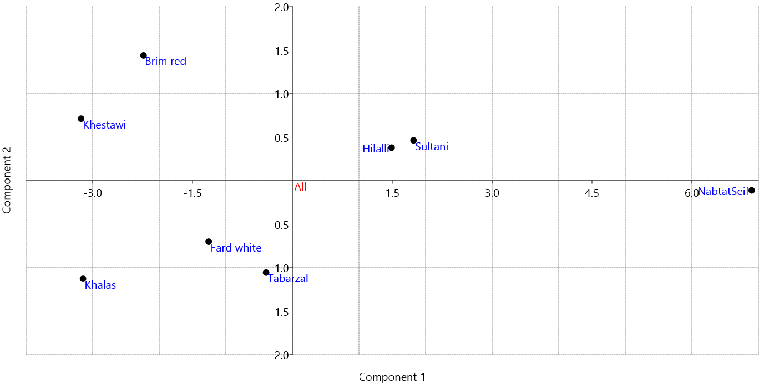
Figure 5. Scatter Diagram Plot of the First Two (PC1 and PC2) Principal coordinates analysis (PCA) of eight date palm cultivars Depending on Morphological data

By using cluster analysis, it is possible to organize crops into clusters that demonstrate the degree of their genetic affinity to one another. Depending on their origin or region, they may also be put into a single cluster (15). Based on the morphological data, the cluster analysis' results (Figure 6) showed that the cultivars were distributed into two main clusters, the first of which had two subclusters (A1 and A2). Two cultivars (Khestawi and Brim red) from subcluster A1 had a similarity score of 0.912, while three cultivars were included in subcluster A2. The cultivar Khalas was extracted from a single branch and connected to a sub-cluster of the two

cultivars (Fard white, Tabarzal) with a similarity score of 0.927. The major cluster B comprised the cultivar Nabtat Seif, which was unique to a sub-cluster, as well as another cluster that included the two cultivars (Hilalli and Sultani) with the highest genetic similarity of 0.967. The lowest genetic similarity value for the two cultivars (Nabtat Seif and Khalas) was 0.722, it should be emphasized. (Table 8).When utilizing cluster analysis to compare the results of the current study with those of (19), who examined 14 vegetative traits in numerous cultivars of date palm in Iraq, it can be seen that the traits were found to fall into two main groupings.

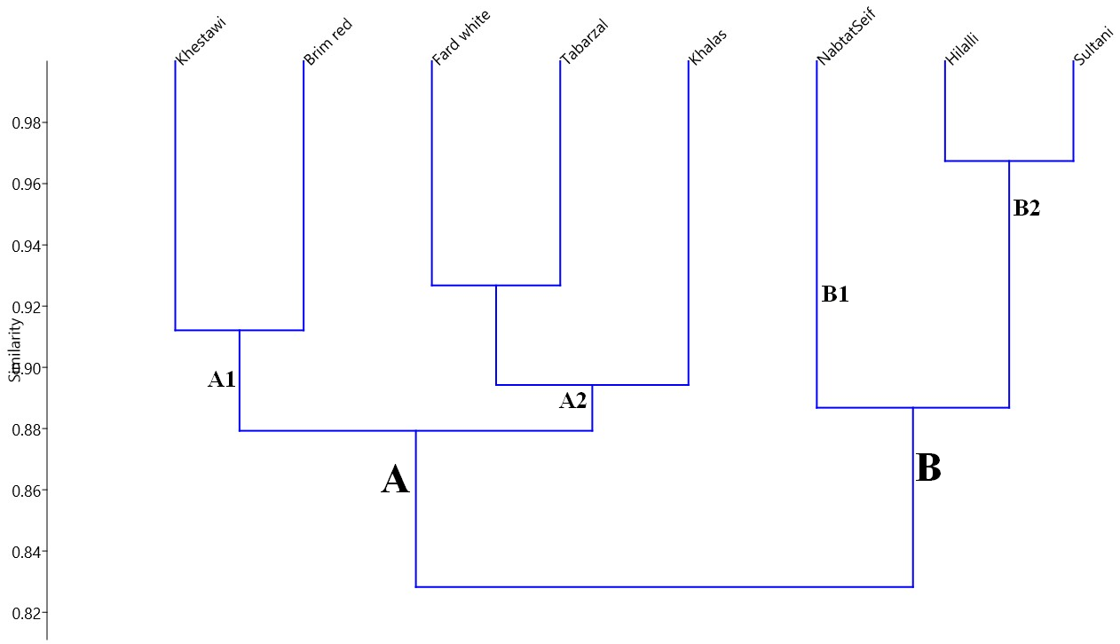
Figure 6. Cluster Analysis for eight Date Palm Cultivars Depending on Morphological data.

Table 8. Genetic similarity between the eight date palm cultivars based on Morphological characteristics.

cultivars | Brim red | Khalas | Fard white | NabtatSeif | Hilalli | Khestawi | Tabarzal | Sultani
Brim red | 1 | 0.857 | 0.885 | 0.782 | 0.864 | 0.912 | 0.866 | 0.863
Khalas | 0.857 | 1 | 0.888 | 0.722 | 0.797 | 0.908 | 0.901 | 0.802
Fard white | 0.885 | 0.888 | 1 | 0.801 | 0.879 | 0.891 | 0.927 | 0.882
NabtatSeif | 0.782 | 0.722 | 0.801 | 1 | 0.878 | 0.750 | 0.816 | 0.895
Hilalli | 0.864 | 0.797 | 0.879 | 0.878 | 1 | 0.853 | 0.890 | 0.967
Khestawi | 0.912 | 0.908 | 0.891 | 0.750 | 0.853 | 1 | 0.869 | 0.829
Tabarzal | 0.866 | 0.901 | 0.927 | 0.816 | 0.890 | 0.869 | 1 | 0.894
Sultani | 0.863 | 0.802 | 0.882 | 0.895 | 0.967 | 0.829 | 0.894 | 1

The genetic basis of growth and the speed of chemical changes that are genetically controlled in the fruits may be attributed to the variations in the physical qualities of the fruits. Additionally, the length of the growth stage and the rate of growth vary depending on the cultivar and the method of pollination within the same variety, which results in notable variations in the physical attributes of the fruits (1).
Conclusion
The findings demonstrate the wide variation among the investigated date palm cultivars, and the genetic and morphological studies assisted in identifying the links between these cultivars, which provided the basis for clustering Iraq's date palm cultivars according to the aforementioned characteristics. Such research is essential for locating the genes responsible for these traits, and numerous researchers from across the world are working hard to employ genomic technology to find the genes responsible for the most important phenotypic traits of date palms.

References
- AbdulWahid AH. 2011. Study of DNA Fingerprinting of Two Date Palm (Phoenix dactylifera L.) Male Cultivars and the Effect of Their Pollens on Some Physical and Chemical Characteristics of cv. Hillawi Fruit. PhD thesis, College of Agriculture - University of Basra.233 pp.
- Abou-ElwafaS. 2018. Identification of associated genes with drought tolerance in barley. Biol Plant 62(2),299-306. https://doi.org/10.1007/s10535-017-0765-0
- Ahmed W, Feyissa T, Tesfaye K, Farrakh S. 2021. Genetic diversity and population structure of date palms (Phoenix dactylifera L.) in Ethiopia using microsatellite markers. J Genet Eng Biotechnol 19(1), pp.1-14. https://doi.org/10.1186/s43141-021-00168-5
- Akkak A, Scariot V, Marinoni D T, Boccacci P, Beltramo C, Botta R. 2009. Development and evaluation of microsatellite markers in Phoenix dactylifera L. and their transferability to other Phoenix species. Biol Plant 53(1): 164-166. https://doi.org/10.1007/s10535-009-0026-y
- Al-Faifi S A, Migdadi H M, Algamdi S S, Khan M A, Ammar M H, Al-Obeed R S, Al-Thamra M I, El-Harty E H, Jakse J. 2016. Development, characterization and use of genomic SSR markers for assessment of genetic diversity in some Saudi date palm (Phoenix dactylifera L.) cultivars. Electron J Biotechnol. 2. https://doi.org/10.1016/j.ejbt.2016.01.006
- Al-Mamari Al-G H. 2013. Application of genomics and molecular genetics in date palm (Phoenix dactylifera L.). PhD thesis. University of Nottingham. http://eprints.nottingham.ac.uk/id/eprint/27894
- Bedjaoui H, Benbouza H. 2020. Assessment of phenotypic diversity of local Algerian date palm (Phoenix dactylifera L.) cultivars. J Saudi Soc Agric Sci 19(1), 65-75. https://doi.org/10.1016/j.jssas.2018.06.002
- Billotte N, Marseillac N, Brottier P, Noyer JL, Jacquemoud‐Collet JP, Moreau C, Couvreur T, Chevallier MH, Pintaud JC, Risterucci AM. 2004.Nuclear microsatellite markers for the date palm (Phoenix dactylifera L.) characterization and utility across the genus Phoenix and in other palm genera. Mol. Ecol. Notes. 4(2):256-258. https://doi.org/10.1111/j.1471-8286.2004.00634.x
- Chao CT, Krueger RR. 2007 . The date palm (Phoenix dactylifera L.) overview of biology, uses, and cultivation.. HortScience Aug 1;42(5):1077-82. https://doi.org/10.21273/HORTSCI.42.5.1077
- DeGiorgio M, Rosenberg N A. 2009. An unbiased estimator of gene diversity in samples containing related individuals. Mol. Biol. Evol. 26: 501-512. https://doi.org/10.1093/molbev/msn254
- Elmeer K, Sarwath H, Malek J, Baum M, Hamwieh A. 2011. New microsatellite markers for assessment of genetic diversity in date palm (Phoenix dactylifera L.). 3Biotech.;1(2):91-97. https://doi.org/10.1007/s13205-011-0010-z
- Evanno, G., Regnaut, S. and Goudet, J., 2005. Detecting the number of clusters of individuals using the software STRUCTURE: a simulation study. Molecular ecology, 14(8), pp.2611-2620. https://doi.org/10.1111/j.1365-294X.2005.02553.x
- Faqir N, Muhammad A, Shehzad A, Hyder M Z, Ali G M. 2016. Simple Sequence Repeat (SSR) markers show greater similarity among morphologically diverse Date palm (Phoenix dactylifera L.) cultivars grown in Pakistan. Pure Appl Biol. 5(3): 483. https://doi.org/10.19045/bspab.2016.50024
- Fazekas M., Madar A, Sipiczki M, Miklós I, Holb IJ. 2014. Genetic diversity in Monilinia laxa populations in stone fruit species in Hungary. World J Microbiol Biotechnol30(6):1879-1892. https://link.springer.com/article/10.1007/s11274-014-1613-4
- Haider N, Nabulsi I, MirAIi N. 2012. Phylogenetic relationships among date palm (Phoenix dacryl({era L.) cultivars in Syria using RAPD and ISSR markers. Journal of Plant Biology Research. 1: 12-24. https://www.inast.org/vol.%201%20No.%202.html
- Hammer Ø, Harper DA, Ryan PD. 2001. PAST: paleontological statistics software package for education and data analysis. Palaeontol Electron 4(1): 1-9. https://palaeo-electronica.org/2001_1/past/issue1_01.htm
- Hormaza J. 2002. Molecular characterization and similarity relationships among apricot (Prunus armeniaca L.) genotypes using simple sequence repeats. Theoretical and Applied Genetics 104(2-3): 321-328. http://dx.doi.org/10.1007/s001220100684
- Hzaa AY, Al_Amiry AH. 2021. Development, implementation of an efficient and cheap method for DNA extraction from dry leaves of date palm without using liquid nitrogen. Plant Cell Biotechnol Mol Biol 22(33&34):333-338. https://doi.org/10.6084/m9.figshare.19142051.v1
- Khierallah HS, Azhar HD. 2016. Study of genetic diversity of Iraqi date palms using some morphological markers. Int. J. Curr. Microbiol. App. Sci, 5(3), 317-327. https://doi.org/10.20546/ijcmas.2016.503.038
- Liu K, Muse SV . 2005. PowerMarker: an integrated analysis environment for genetic marker analysis. Bioinformatics 21: 2128-2129. https://doi.org/10.1093/bioinformatics/bti282
- Metoui M, Essid A, Ferchichi A, Hormaza JI. 2017. Tunisian Date Palm (Phoenix dactylifera L.) Cultivars Characterization Using Simple Sequence Repeats (SSR) Markers. Transy Rev 1(4): 4736-4741.
- Mohammadi SA, Prasanna BM. 2003. Analysis of genetic diversity in crop plants—salient statistical tools and considerations. Crop science. Jul;43(4):1235-48. https://doi.org/10.2135/cropsci2003.1235
- Moussouni S, Pintaud JC, Vigouroux Y, Bouguedoura N. 2017. Diversity of Algerian oases date palm (Phoenix dactylifera L., Arecaceae): Heterozygote excess and cryptic structure suggest farmer management had a major impact on diversity. PloS one 12(4): e0175232. https://doi.org/10.1371/journal.pone.0175232
- Oliveira E J, Pádua J G, Zucchi M I, Vencovsky R, Vieira M L C. 2006. Origin, evolution and genome distribution of microsatellites. Genet. Mol. Biol. 29(2): 294-307. https://doi.org/10.1590/S1415-47572006000200018
- Powell W, Morgante M, Andre C, Hanafey M .1996. The comparison of RFLP, RAPD, AFLP and SSR (microsatellite) markers for germplasm analysis. Mol. Breed. 2: 225-238. https://doi.org/10.1007/BF00564200
- Racchi M, Bove A, Turchi A., Bashir G, Battaglia M, Camussi A. 2014. Genetic characterization of Libyan date palm resources by microsatellite markers. 3 Biotech 4(1): 21-32. https://doi.org/10.1007/s13205-013-0116-6
- Svec D, Tichopad A, Novosadova V, Pfaffl MW, Kubista M. 2015. How good is a PCR efficiency estimate: Recommendations for precise and robust qPCR efficiency assessments. Biomol. Detect. Quantification. 1(3):9-16. https://doi.org/10.1016/j.bdq.2015.01.005
- Varshney R K, Graner A, Sorrells M E. 2005. Genic microsatellite markers in plants: features and applications. TRENDS Biotechnol 23(1): 48.55 https://doi.org/10.1016/j.tibtech.2004.11.005
- Williams J G, Hanafey M K, Rafalski J A, Tingey S V. 1993. Genetic analysis using random amplified polymorphic DNA markers. In Methods in enzymology, Vol. 218, 704-740: Elsevier. https://doi.org/10.1016/0076-6879(93)18053-F
- Yang J, Zhang J, Han R, Zhang F, Mao A, Luo J, Dong B, Liu H, Tang H, Zhang J, Wen C. 2019.Target SSR-Seq: a novel SSR genotyping technology associate with perfect SSRs in genetic analysis of cucumber varieties. Front Plant Sci 24;10:531. https://doi.org/10.3389/fpls.2019.00531
- Yusuf A, Culham A, Aljuhani W, Ataga C, Hamza A, Odewale J, Enaberue L. 2015. Genetic diversity of Nigerian date palm (Phoenix dactylifera.L) germplasm based on microsatellite markers. Int J Biosci Biotechnol 7(1): 121-132. https://doi.org/10.14257/ijbsbt.2015.7.1.12
- Zango O, Cherif E , Chabrillange N, Zehdi-Azouzi S, Gros-Balthazard M, Naqvi SA, Lemansour A, Rey H, Bakasso Y, Aberlenc F. 2017. Genetic diversity of Southeastern Nigerien date palms reveals a secondary structure within Western populations. Tree Genet Genomes 13(4): 75.. https://doi.org/10.1007/s11295-017-1150-z
- Zehdi S, Cherif E, Rhouma S, Santoni S, Hannachi A S, Pintaud J C. 2012. Molecular polymorphism and genetic relationships in date palm (Phoenix dactylifera L.): The utility of nuclear microsatellite markers. Sci. Hortic.148: 255-263. https://doi.org/10.1016/j.scienta.2012.10.011
- Zehdi-Azouzi S, Cherif E, Guenni K, Abdelkrim AB, Bermil A, Rhouma S, Salah MB, Santoni S, Pintaud J C, Aberlenc-Bertossi F. 2016. Endemic insular and coastal Tunisian date palm genetic diversity. Genetica 144(2): 181-190.. https://doi.org/10.1007/s10709-016-9888-z

