**Study of Anti-Inflammatory Effect of Dipyridamole by Evaluation Inflammatory Cells and Histopathology in Rat: Airway Models**

**Ali D. Nashmi1\*, Jawad K. Hasan1, Manal A. Ibrahim2**

[**Author Affiliations**](javascript:)

[https://researcherslinks.com/uploads/currentIssues/figures/20240605205320.png](https://researcherslinks.com/uploads/currentIssues/figures/20240605205320.png)

[View larger version:](javascript:)[Download Original File](https://researcherslinks.com/base/downloads.php?path=figures&file=20240605205320.png)

[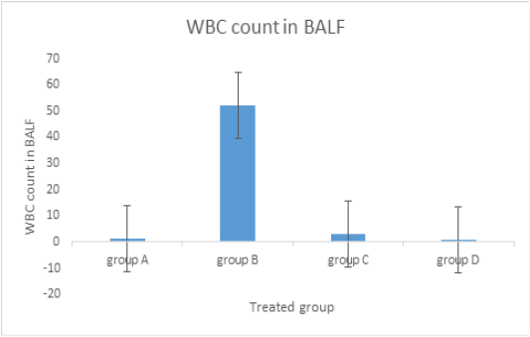](https://researcherslinks.com/uploads/currentIssues/figures/20240605213423.png)

[View larger version:](javascript:)[Download Original File](https://researcherslinks.com/base/downloads.php?path=figures&file=20240605213423.png)

**FIGURE 1**

Influence of dipyridamole on BALF WBC count. Rats in Group A received distilled water as a control for a period of 14 days. Group B: rats treated solely with airway ova sensitization served as a positive control group. Group C: oral dipyridamole (26.4 mg / kg / d) in conjunction with airway sensitization by ova. Group D: received oral prednisolone (4.12 mg/kg/d) along with airway ova sensitization.

[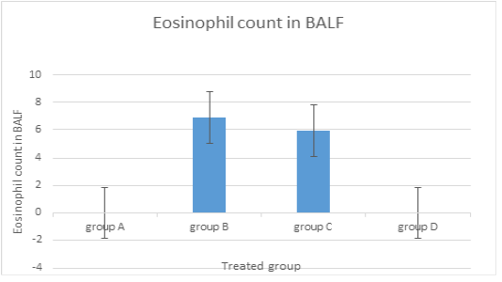](https://researcherslinks.com/uploads/currentIssues/figures/20240605215223.png)

[View larger version:](javascript:)[Download Original File](https://researcherslinks.com/base/downloads.php?path=figures&file=20240605215223.png)

**FIGURE 2**

Effect of dipyridamole on BALF eosinophil count. Rats in Group A received distilled water as a control for a period of 14 days. Group B: rats treated solely with airway ova sensitization served as a positive control group. Group C: oral dipyridamole (26.4 mg / kg / d) in conjunction with airway sensitization by ova. Group D: received oral prednisolone (4.12 mg/kg/d) along with airway ova sensitization.

[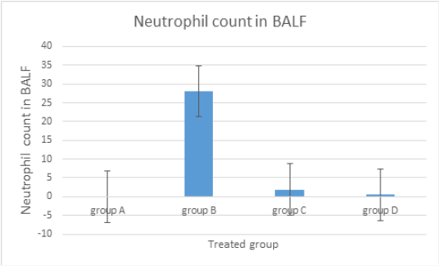](https://researcherslinks.com/uploads/currentIssues/figures/20240605210523.png)

[View larger version:](javascript:)[Download Original File](https://researcherslinks.com/base/downloads.php?path=figures&file=20240605210523.png)

**FIGURE 3**

The influence of dipyridamole on the BALF neutrophil count. Rats in Group A received distilled water as a control for a period of 14 days. Group B: rats treated solely with airway ova sensitization served as a positive control group. Group C: oral dipyridamole (26.4 mg / kg / d) in conjunction with airway sensitization by ova. Group D: received oral prednisolone (4.12 mg/kg/d) along with airway ova sensitization.

[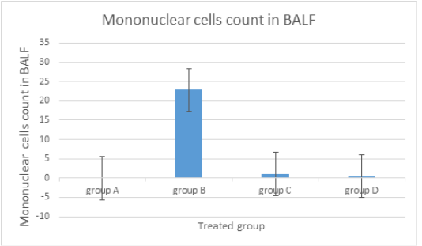](https://researcherslinks.com/uploads/currentIssues/figures/20240605212124.png)

[View larger version:](javascript:)[Download Original File](https://researcherslinks.com/base/downloads.php?path=figures&file=20240605212124.png)

**FIGURE 4**

Dipyridamole influence on the count of mononuclear cells (lymphocytes + monocytes) in BALF. Rats in Group A received distilled water as a control for a period of 14 days. Group B: rats treated solely with airway ova sensitization served as a positive control group. Group C: oral dipyridamole (26.4 mg / kg / d) in conjunction with airway sensitization by ova. Group D: received oral prednisolone (4.12 mg/kg/d) along with airway ova sensitization.

[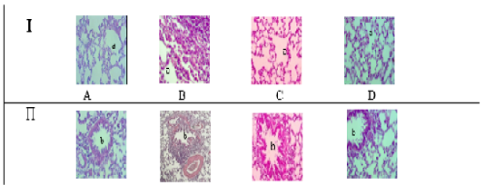](https://researcherslinks.com/uploads/currentIssues/figures/20240605215824.png)

[View larger version:](javascript:)[Download Original File](https://researcherslinks.com/base/downloads.php?path=figures&file=20240605215824.png)

**FIGURE 5**

Histopathology of rat lung tissue in response to dipyridamole. Images of lung tissue taken using an X-40 light microscope. Alveolar Sac (a) in Section I. The bronchi in Section (II) (b). Group A is the negative control; Group B is the positive control; Group C is the Dipyridamole-treated group; Group D is the group treated with prednisolone.

* [**This Issue**](javascript:)

[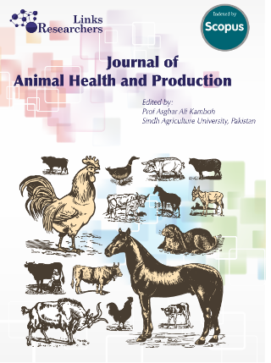](https://researcherslinks.com/journal-details/Journal-of-Animal-Health-and-Production/34/archive/2024/June)

**June 2024**

Vol. 12, Iss. 2, Pages 121-275

* [**Article details**](javascript:)
  + J. Anim. Health Prod., Vol. 12, Iss. 2, pp. 240-248
* [**Article files**](javascript:)
  + [Abstract](https://researcherslinks.com/current-issues/Study-of-Anti-Inflammatory-Effect-of-Dipyridamole-by-Evaluation-Inflammatory-Cells-and-Histopathology-in-Rat-Airway-Models/34/1/9656)
  + [Full Text HTML](https://researcherslinks.com/current-issues/Study-of-Anti-Inflammatory-Effect-of-Dipyridamole-by-Evaluation-Inflammatory-Cells-and-Histopathology-in-Rat-Airway-Models/34/1/9656/html)
  + [Full Text PDF](https://researcherslinks.com/base/downloads.php?jid=34&aid=9656&acid=1&path=pdf&file=1717622857JAHP_12_2_240-248.pdf)
  + [Full Text ePub](https://researcherslinks.com/base/downloads.php?jid=34&aid=9656&acid=1&path=epub&file=1717622857JAHP_12_2_240-248.epub)
  + [Full Text FLIP File](https://researcherslinks.com/base/downloads.php?jid=34&aid=9656&acid=1&path=edigital&file=1717620322JAHP_12_2_240-248.swf)
  + [Figures](https://researcherslinks.com/current-issues/Study-of-Anti-Inflammatory-Effect-of-Dipyridamole-by-Evaluation-Inflammatory-Cells-and-Histopathology-in-Rat-Airway-Models/34/1/9656/figures)
  + Supplementary Materials
* [**Classifications**](javascript:)
  + [Rat lung model](https://researcherslinks.com/search/journals/Rat%20lung%20model)
  + [Dipyridamole](https://researcherslinks.com/search/journals/Dipyridamole)
  + [Inflammatory cells](https://researcherslinks.com/search/journals/Inflammatory%20cells)
  + [Ovalbumin.](https://researcherslinks.com/search/journals/Ovalbumin.)
* [**Export References**](javascript:)
  + [Endnote](https://researcherslinks.com/uploads/currentIssues/exp_ref/1717620373JAHP_12_2_240-248.txt)
  + [Reference Manager](https://researcherslinks.com/uploads/currentIssues/exp_ref/1717620373JAHP_12_2_240-248.txt)
  + [Simple Text File](https://researcherslinks.com/uploads/currentIssues/exp_ref/1717620373JAHP_12_2_240-248.txt)
  + [BibTeX](https://researcherslinks.com/uploads/currentIssues/exp_ref/1717620373JAHP_12_2_240-248.txt)
* [**Services**](javascript:)
  + [Email this article](https://researcherslinks.com/email-this-article-to-colleague/Study-of-Anti-Inflammatory-Effect-of-Dipyridamole-by-Evaluation-Inflammatory-Cells-and-Histopathology-in-Rat-Airway-Models/34/1/9656)
  + [Similar Articles in RL](https://researcherslinks.com/similar-articles-in-sandf/Study-of-Anti-Inflammatory-Effect-of-Dipyridamole-by-Evaluation-Inflammatory-Cells-and-Histopathology-in-Rat-Airway-Models/34/1/9656)
  + [Similar Articles in PubMed](http://www.ncbi.nlm.nih.gov/pubmed/?term=Rat%20lung%20model%20Dipyridamole%20Inflammatory%20cells%20Ovalbumin.)
  + [Similar Articles in Scopus](http://www.sciencedirect.com/)
  + [Similar Articles in GoogleScholar](http://scholar.google.co.uk/scholar?hl=en&q=Rat%20lung%20model%20Dipyridamole%20Inflammatory%20cells%20Ovalbumin.)
  + [Copyright Information](https://researcherslinks.com/contents/copyright-information)
  + [Books from RL](https://researcherslinks.com/books)
  + [RL blog](https://researcherslinks.com/blog/)
* [**Article Usage Metrics**](javascript:)
  + [Article Usage Statistics](https://researcherslinks.com/base/livestatistics.php?jid=34&acid=1&aid=9656)
* [**Social Bookmarking**](javascript:)
* We recommend

**[Powered by](https://www.trendmd.com/how-it-works-readers" \t "_blank)**

[**Journal of Animal Health and Production**](https://researcherslinks.com/current-issues/Study-of-Anti-Inflammatory-Effect-of-Dipyridamole-by-Evaluation-Inflammatory-Cells-and-Histopathology-in-Rat-Airway-Models/34/1/9656/figures)

**June**

Vol. 12, Iss. 2, Pages 121-275

[](https://researcherslinks.com/journal-details/Journal-of-Animal-Health-and-Production/34/archive/2024/June)

**Featuring**

* [**Prevalence of Hemorrhagic Septicemia and Use of Moringa oleifera and Eucalyptus camaldulensis Extracts against Buffalo Pasteurella multocida Isolates**](https://researcherslinks.com/current-issues/Prevalence-of-Hemorrhagic-Septicemia-and-Use-of-Moringa-oleifera-and-Eucalyptus-camaldulensis-Extracts-against-Buffalo-Pasteurella-multocida-Isolates/34/1/9836)

Barkat Ali Jatoi, Amjad Hussain Mirani, Abdul Latif Bhutto, Ambreen Laghari, Abdul Samad Magsi, Ahmed Sultan Jatoi, Aneela Sultan Jatoi, Muhammad Mohsen Rahimoon6, Aarab Khan Lund, Om Parkash, Atif Ali Malak

J. Anim Health Prod., Vol. 12, Iss. 3, pp. 380-386

* [**Feed Intake, Digestibility, and Growth Performance of Young Male Kacang Goats Fed Diets Containing Different Energy Levels**](https://researcherslinks.com/current-issues/Feed-Intake-Digestibility-and-Growth-Performance-of-Young-Male-Kacang-Goats-Fed-Diets-Containing-Different-Energy-Levels/34/1/9833)

Paulus Klau Tahuk, Gerson Frans Bira, Wolfhardus Vinansius Feka

J. Anim. Health Prod., Vol. 12, Iss. 3, pp. 370-379

* [**The Influence of Differential Administration of Natural Vitamin E (Green Bean Sprouts) and Synthetic Vitamin E on the Macroscopic and Microscopic Quality of Semen in Sheep**](https://researcherslinks.com/current-issues/The-Influence-of-Differential-Administration-of-Natural-Vitamin-E-Green-Bean-Sprouts-and-Synthetic-Vitamin-E-on-the-Macroscopic-and-Microscopic-Quality-of-Semen-in-Sheep/34/1/9832)

Kusuma Adhianto, Tina Rahmawati, Rio Ramanda, Muhtarudin Muhtarudin, Sri Suharyati

J. Anim. Health Prod., Vol. 12, Iss. 3, pp. 360-369

* [**Characteristics of Pork Quality as Influenced by Gamma Irradiation: A Meta-Analysis Approach**](https://researcherslinks.com/current-issues/Characteristics-of-Pork-Quality-as-Influenced-by-Gamma-Irradiation-A-Meta-Analysis-Approach/34/1/9812)

Endy Triyannanto, Danung Nur Adli, Diah Pratiwi, Lukman Hakim, Selma Noor Permadi, Taufik Kurniawan, Angga Maulana Firmansyah, Lina Ivanti, Dinar Suksmayu Saputri, Mohammad Miftakhus Sholikin, Hari Hariadi, Tri Ujilestari, Teguh Wahyono

J. Anim. Health Prod., Vol. 12, Iss. 3, pp. 348-359