The Barramundi fish, Lates calcarifer (Bloch, 1790) in the Shatt Al-Arab river, southern Iraq

Abbas J. Al-Faisal, Ali T. Yaseen and Falah M. Mutlak

Marine Science Centre, University of Basrah, Basrah, Iraq
e-mail: abbasjsm71@yahoo.com

Materials and Methods
Six specimens of Barramundi fish were collected by gill net, from Shatt Al-Arab River in Abu Al-Khasib town in Basrah City, Southern Iraq (Fig. 1) during December 2019. The morphological characteristics included eight meristic characters (Lateral Line scales, scales above the lateral line, scales below the lateral line, gill rakers, spines and rays of dorsal fin, anal fin, pectoral fin and pelvic fin) which counted employing dissection microscope, and 19 morphometric characters were measured to the nearest mm by using digital caliper and fish measuring board following Hubbs and Lagler (1958). All morphometric measurements were percentage of standard length. The specimens are deposited in the department of Marine Vertebrates, Marine Science Centre, Iraq.

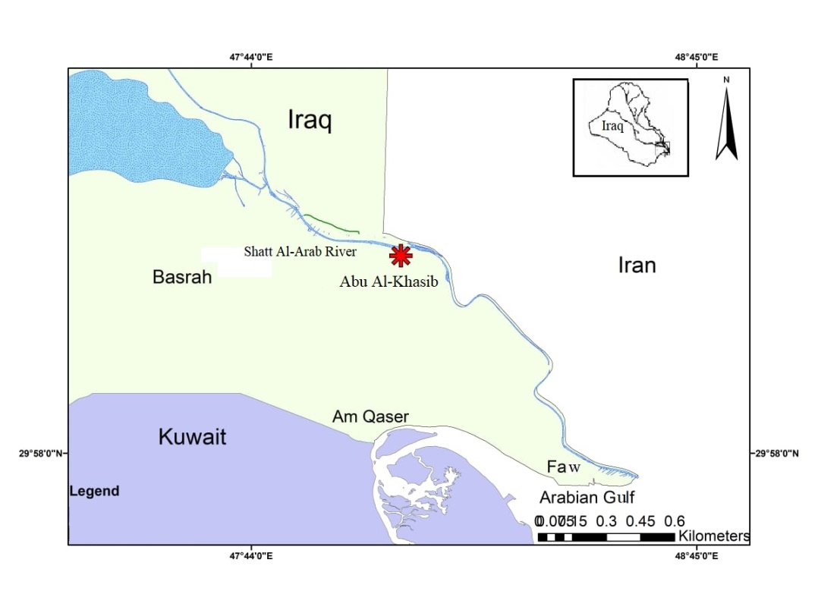
Figure 1. Sampling station in the Shatt Al-Arab River, South of Iraq.

Results
Classification:
Class: Actinopterygii
Order: Perciformes
Family: Latidae
Genus: Lates Cuvier, 1828
Species: Lates calcarifer (Bloch, 1790)
Synonym: Holocentrus calcarifer Bloch, 1790
Pseudolates cavifrons Alleyne & Macleay, 1877
Lates darwiniensis Macleay, 1878

Morphological description
Total length of the specimens ranged from 282 to 345 mm, standard length ranged from 230 to 285 mm (table, 1). Body elongate, its depth ranged from 29.73 to 32.63% in standard length, compressed 14.66 - 16.87%, with a deep caudal peduncle 11.71 - 12.36%. Head pointed, with concave dorsal profile becoming convex in front of dorsal fin. Mouth large, slightly oblique, upper jaw reaching to behind eye, teeth villiform, no canines present. Lower edge of preoperculum with a strong spine, operculum with a small spine and with a serrated flap above origin of lateral line. Lateral line contains 56 – 64 scales. Dorsal fin with 8 spines followed by 11 - 12 rays, a very deep notch almost dividing spiny from soft part of the fin. Anal fin with 3 spines followed by 7 - 8 rays. Pectoral fin short and rounded, strong serrations above its base. Anal fin rounded, with 3 spines and 7 to 8 short rays. Caudal fin rounded. The total gill rakers ranged from 13 to 14 (table, 2). Colour is olive brown above with silver sides and belly.

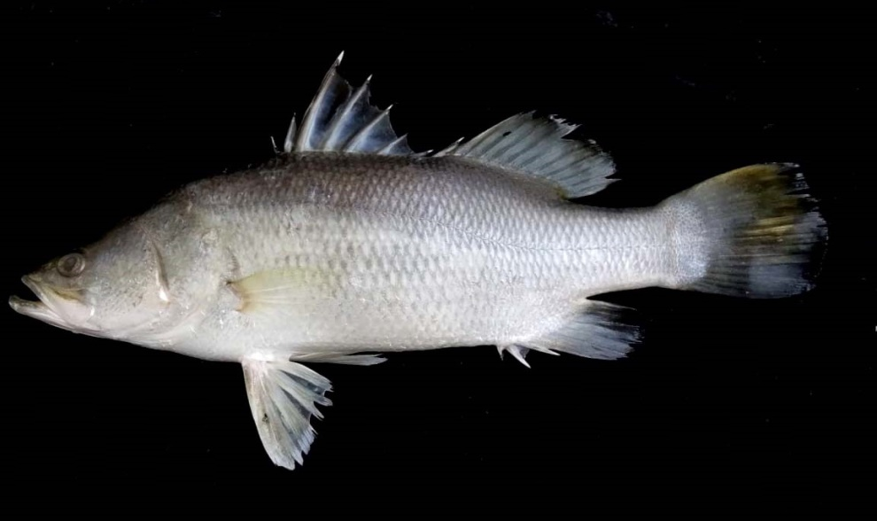
Figure 2. Lates calcarifer from the Shatt Al-Arab river.

Table (1). Morphometric characters of Lates calcarifer from the Shatt al-Arab river.

SD | Mean | Range | Morphometric characters
26.30 | 311.5 | 282 - 345 | Total length (mm)
23.23 | 254.5 | 230 - 285 | Standard length (mm)
0.94 | 31.22 | 29.73 - 32.63 | Body depth % in SL
0.74 | 15.33 | 14.66 - 16.87 | Body width % in SL
0.79 | 34.82 | 33.31 - 35.84 | Head length % in SL
1.32 | 20.47 | 18.30 - 22.06 | Head depth % in SL
0.42 | 11.63 | 11.03 - 12.16 | Head width % in SL
0.14 | 7.94 | 7.72 - 8.15 | Snout length % in SL
0.30 | 4.62 | 4.16 - 4.96 | Eye diameter % in SL
0.28 | 3.93 | 3.46 - 4.27 | Interorbital distance % in SL
0.88 | 41.07 | 40.00 - 42.55 | Predorsal length % in SL
0.94 | 17.46 | 16.16 - 18.84 | Postdorsal length % in SL
1.17 | 22.16 | 20.57 - 23.75 | 1st Dorsal fin length % in SL
0.90 | 19.33 | 17.70 - 20.67 | 2nd Dorsal fin length % in SL
0.64 | 13.84 | 13.04 - 15.03 | Anal fin length % in SL
0.70 | 17.47 | 16.83 - 18.95 | Pectoral fin length % in SL
0.75 | 21.28 | 19.85 - 22.30 | Pelvic fin length % in SL
1.31 | 17.62 | 16.59 - 20.33 | Caudal peduncle length % in SL
0.24 | 12.07 | 11.71 - 12.36 | Caudal peduncle depth % in SL

Table (2). Meristic characters of Lates calcarifer from the Shatt al-Arab river.
Range | Meristic characters
56 - 64 | Lateral Line
6 - 7 | Scales above the lateral line
10 - 11 | Scales below the lateral line
8 | spines | Dorsal fin
11 - 12 | soft rays
3 | spines | Anal fin
7 - 8 | soft rays
16 - 17 | Pectoral fin rays
1 | spines | Pelvic fin
5 | Soft rays
13 - 14 | Gill rakers

