**Histopathological Study of some**

**Abnormalities of Infertility in the Queens**

**Abeer A Yaseen1 Dhuha Adel Kareem2Zainab Waheed3Taher abdulhussen fahad4**

**1,4 Surgery and Obstetrics Department, Veterinary Medicine College, University of Basrah, Iraq.**

**2Anatomy and Histology Department, Veterinary Medicine College, University of Basrah, Iraq.**

**3Pathology and poultry disease Department, Veterinary Medicine College, University of Basrah,Iraq.**

**Email:** **abeer.yaseen@uobasrah.edu.iq**

**Abstract**

The present study deals with causes of infertility abnormalities in queens. The sample of the present study consists of eight of the female reproductive system of queens. The sample of this study was collected from queens of different places in Basra randomly. Then the female reproductive system of queens was completely removed by the operation of ovario- Hysterectomy in which this operation was done weekly in the laboratory of surgery in Basra Veternerary Medicine,The female reproductive system was completely grossly diagnosed in order to know the infections in it. In addition, our study confirmed the importance of the ovaries and uterus in fertility of queens, The present study showed that six of the sample were uninfected in which the percentage was (75%); while two of the sample were infected in their ovaries and uterus in which the percentage was (25%). The result of the study showed that one of them has follicular cyst (12.5%) in ovary and endometritis (12.5%) .

**1. Introduction**

Felines with reproductive genetic abnormalities have a variety of sexual differentials usually noted after puberty.

Infertility is described as the inability of a queen to give birth to healthy kittens. There are several reasons, including inability to cycle, inability to mate, inability to conceive, or inability to bring a pregnancy to term (1). The steps of the female cat's estrous cycle are often characterised and used inconsistently by different researchers. It is commonly categorised into five behavioural stages: proestrus, estrus, interestrus, diestrus, and anestrus (2). However, there may be four phases when interestrus and anestrus overlap (3 and 1).

It is possible for cats to have dysfunctional or nonexistent menstrual periods. There are many potential causes for this. A queen who never starts her first heat cycle may be diagnosed with chromosomal problems, hermaphroditism, or faulty uterine or ovarian development due to hereditary or genetic reasons. The queen's atypical menstrual cycles might be the result of environmental pressures, drugs, or insufficient day duration. Additionally, ovarian cysts and tumours may interfere with the reproductive cycle of the cat via the secretion of different hormones. Other prevalent reasons of infertility or subfertility in this species include ovarian and uterine disease, uterine pathology, chromosomal abnormalities, and dietary variables (4)

Lesions of the ovaries, uterus, and vagina are prevalent in small animal medicine; they may have a significant impact on the normal reproductive potential of dogs and cats and pose a threat to the patients' overall health. Inclusion of serosa In bitches and queens, cysts, adenomyosis, and endometrial polyps are examples of cysts that arise from the uterine serosa, myometrium, or endometrium (5).

In nations where cat owners often do not go to veterinary facilities for elective neutering, pyometra is a frequent disease (6). Progesterone stimulation results in either acute or chronic purulent endometritis. stimulates the endometrial gland secretions and decreases the myometrial contractions which lead to fluid accumulation, followed by ascending uterine infection from vaginal bacteria (7,8,9,10,11) . Most cases of the disease are seen during diestrus or fake pregnancy, when progesterone is in charge for about 40 days. (12).

In open pyometras, vaginal discharge may be noticed with mild, nonspecific clinical signs. However, in closed pyometra, sepsis, peritonitis, and even animal death may occur (6).

The queen typically enters adolescence between the ages of 4 and 12 months (1), with the precise date dependent on the photoperiod, the breed, and the cat's weight (13). Seasonally polyestrous female cats have frequent estrous cycles during mating season but long periods of anestrus during the colder months. If ovulation does not take place, the breeding season typically starts in January or February and lasts until late summer or early autumn (14). The female cat is an induced ovulator, with copulation resulting in the production of luteinizing hormone (LH), which leads to ovulation (15). This is true for the majority of queens, however spontaneous ovulation has been seen in up to 60% of female cats (16).

The average healthy queens reaches sexual maturity well before 7 to 8 months (17) of age and beings an estrous cycle once every 4 to 12 months(18).

**Materials and methods**:

The present study depended mainly on collecting the sample of the queens. eight of the female reproductive system of queens. The sample was collected from queens of different places in Basra randomly. This had been done by removing the internal reproductive system through a surgical operation . The study started from December 2020 until February 2021 in the breding season in which the materials of eight of reproductive system of queens were collected during the period mentioned above .The work has been done in the laboratory of surgery and the laboratory of obstetrics in college of veterinary Medicine at University of Basra.

The reproductive system of queens were grossly diagnosed by cleaning the female reproductive system using water to remove all the plankton such as dirt, blood and tissues . During the grossly diagnosis , it was seen that the infection of ovaries was clear and enlargement was noted on the right ovary .This ovary was totally removed and part of uterus removed and put in 10% of formalin liquid to cut the tissue. By the diagnosis of tissue , it was seen that the ovary was infected in non-cancerousalso noted infection in uterus, so we takespecimen from infected uterus, put in 10% formalin .

**2-Histopathology procedure:**

After being fixed for three days (48 hours in 10% formalin), the specimen was dehydrated in increasing concentrations of 50%, 70%, 95%, and 100%. After passing through a sequence of alcohol concentrations (70%, 80%, 90%, 100%, and 100%), the specimens were washed with xylene solution and embedded in paraffin wax at 55 degrees Celsius. After that, the blocking tissue was microtomed to a thickness of 5um. The sliced paraffin block was placed on an albumin slide, stained with hematoxylin and eosin, and examined under a microscope after being placed in a 37°C water bath (19).

**Result**

**Anatomical:** The female reproductive tract of the queens consists of the ovaries , oviduct, uterus, vagina, and valve, as in the Fig (1) .

**Histopathological:** The result of examination eight specimens of queens reproductive system showed specimens abnormal as in table (1) cases which appeared affect in ovaries as in fig (2) ovarian cysts , they show follicular cysts also with fibrosis and fill with fluid and ataractic body fig (4,8,9). .

The secondary specimen show endometritis with hyperplasia of the epithelium cells , glands filled with secretion , also congested blood vessels and inflammatory cells in glandular layer and found edema and fluid in the muscular layer as in fig (3).

The third specimen oviduct, show increase folded and projection , anther Section of oviduct, there are hyperplasia of epithelial cells fig (5,6).

**Table(1) frequency distribution of pathological condition**

|  |  |  |
| --- | --- | --- |
| **Incidence** | **No.** | **% of pathogenesis** |
| **Follicular cysts** | **1** | **12.5%** |
| **Endometritis** | **1** | **12.5%** |
| **normal** | **6** | **75.1%** |
| **Total of specimen** | **8** |  |

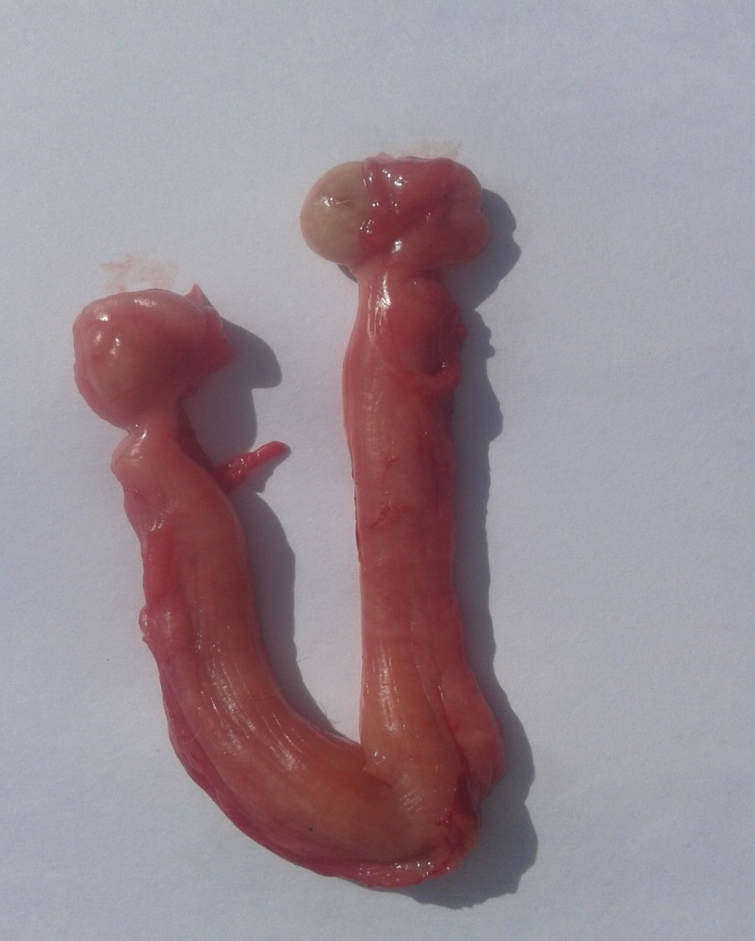

**Ovaries**

**oviducts**

**cervix**

**vagina**

**Uterine body**

**Uterine horn**

**Figure(1) female reproductive tract in queen**

**Figure(1) female reproductive tract in queen (Fossum and Hedlund,2007)**

**A**

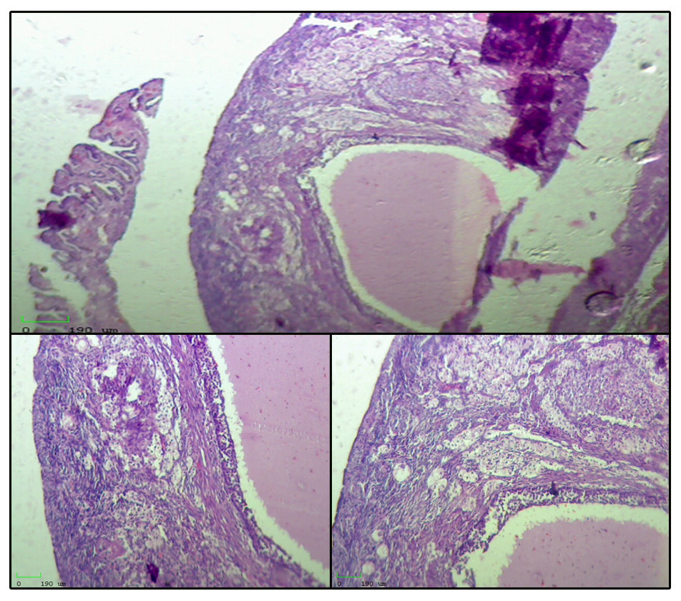

**A**

**FC**

**B**

**C**

**A**

**F**

Figure(2), ovary show(A) follicular cyst(**FC**) ,(B) There are one layer of cells surrounded by fibrosis and fill with fluid(**F**) and(C) Ataractic body (**A**), (H&E10X).

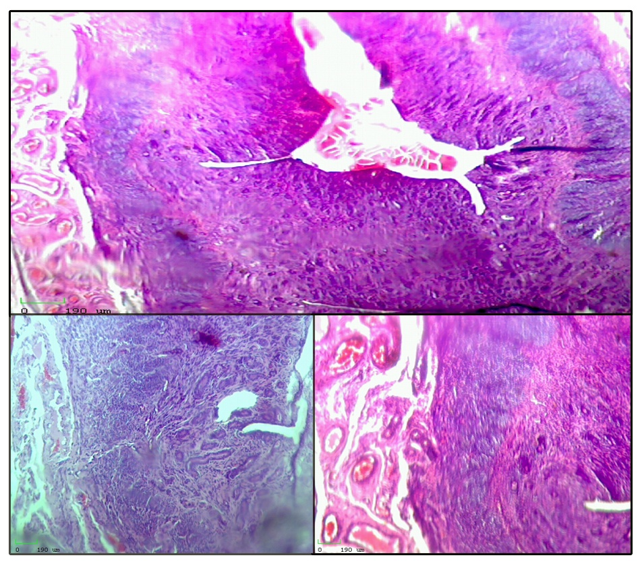

**O**

**C**

**A**

**H**

**CO**

**B**

Figure(3) Uterus (A) Show endometritis , hyperplasia of the epithelium cells , glands filled with secretions(**H**)(H&E4X). (B) There are congested blood vessels and inflammatory cells in glandular layer (**CO**) (H&E 4X ). and(C) Found edematous and fluid in muscular layer (**O**)(H&E 10X).

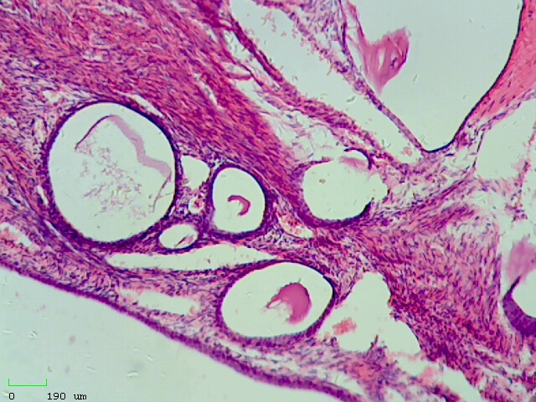

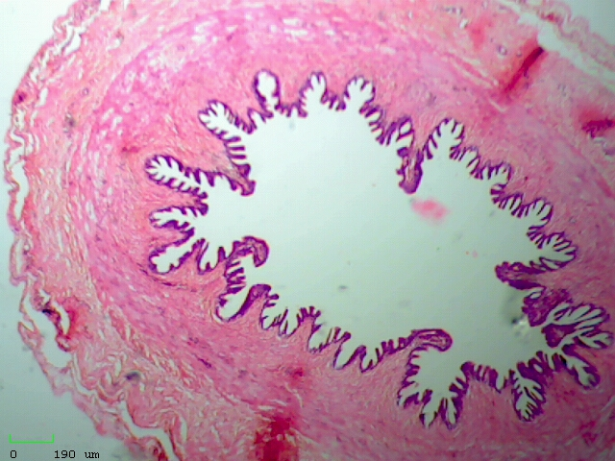

**Tunica**

**Fig (4 ):** Section of ovary, cystic ovary (H&E 10X).

**Fig (5 ):** Section of oviduct, show increase folded and projection (H&E 10X).

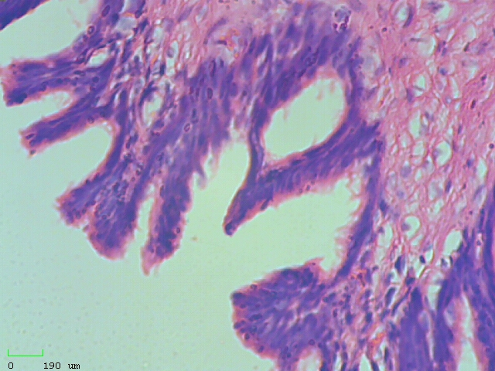

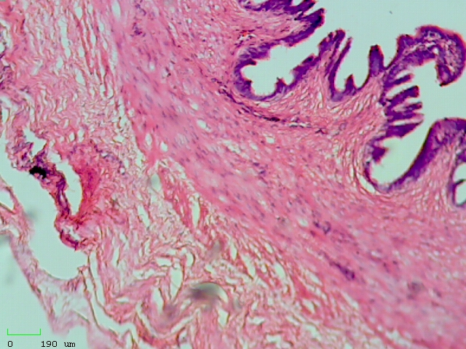

**Fig (6 ):** Section of oviduct, there are hyperplasia of epithelial cells (H&E 10X).

**Fig (7 ):** Section of oviduct, may be hyperplasia (H&E 40X).

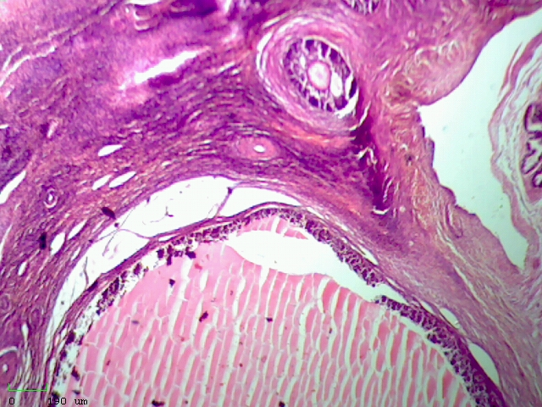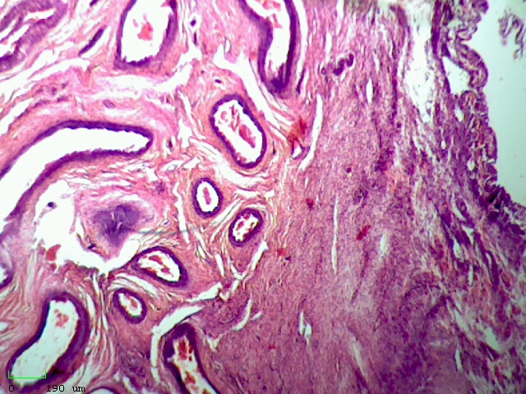

**cortex**

**Medulla**

**Fig (9 ):** Section of ovary, cystic ovary (H&E 10X).

**Fig (8 ):** Section of ovary, cystic ovary(luteal cyst) (H&E 10X).

**5. Discussion**

Out of 8 speciment of cats reproductive system we found only two lesion on in uterus and other in ovary .

**follicular cysts :**

In present study , follicular cysts comprised (12.5%) which were less than (20) about (40%) but more than (21) about (10%) in queens.

**Uterine abnormalities :**

**Endometritis**

While endometritis was found in the research (12.5%), this finding agrees with (20) and does not accord with (21) owing to the diminutive size of the uterus, which impedes biopsies that are representative. This may impede the ability to diagnose endometritis and, hence, discover infertility issues (22).

Endometrial Status in Queens Evaluated by Histopathology Findings and Two Cytological Techniques: Low-Volume Uterine Lavage and Uterine Swabbing

endometritis with hyperplasia of the epithelium cells , glands filled with secretion , also congested blood vessels and Thompson and Drew(23). inflammatory cells in glandular layer and found edema and fluid in the muscular layer agree with(24);(5).

Inflammation of the uterine endometrial tissue, caused by a bacterial pathogen infection, is known as endometritis. Hormonal disorders, postpartum infections, or dystocia may all induce uterine inflammation **(25,26).**

Increased progesterone levels increase bacterial development in the uterine lumen by causing hyperplastic endometrium and endometrial glands, decreased myometrial contractions, and an impaired local leukocyte response to infection. Estradiol in ovarian cystic fluid activates endometrial gland and causes it to release endometrium fluid by increasing oestrogen and progesterone receptors. Furthermore, increasing progesterone concentrations reduce cellular immunity during the early luteal phase, according to (27;11)they claimed that acute or chronic purulent endometritis, as a result of progesterone stimulation. Progesterone stimulates the endometrial gland secretions and decreases the myometrial contractions which lead to fluid accumulation, followed by ascending uterine infection from vaginal bacteria.

Follicular cysts (cats 35.29%,), cystic corpus luteum (dogs 16.66%), and cystic rete ovarii (dogs 16.66%) are the most common pathological conditions among the recorded ovarian lesions, followed by ovarian neoplasms (cats 35.29%), according to (28) who state that cystic ovarian disease is the most common pathological condition.

They are thin-walled structures that hold transparent, viscous fluid. Many follicular cysts may form in a single ovary without affecting its ability to function normally (20).

The veterinary literature rarely talks about problems with the uterine tube (**29**). This is likely a result of the infrequency with which the uterine tube is examined, as shown by this study. Except for uterine tube neoplasia, uterine tubelesions were often detected with other reproductive tract diseases or as part of a research method in this study. In both instances, the uterine tube was not the main investigated tissue.

Salpingitis was invariably related with metritis/pyometra in this research. Primary salpingitis and its result, tubal occlusion, are leading causes of female infertility. Because dogs and cats3 have a sphincter at the tubeuterine junction, ascending salpingitis is not a recognised cause of infertility in pet carnivores. Cat with hydrosalpinx reported (30,31).

**References:**

1-Brown, J.L. (2011). Female reproductive cycles of wild female felids. Animal Reproduction Science, 124:155-162.

2- Feldman, E.C. & Nelson, R.W. (2004). Feline reproduction. I: Kersey, R. & LeMelledo, D. (red), Canine and Feline Endocrinology and Reproduction. (3rd edition). Missouri: Saunders, 1016-1043.

3- Chatdarond, K.(2003)Reproductive physiology of the female cat. Ph.D thesis ,, Swedish university of agriculture sciences, Uppsala.

4- England GCW, Russo M. Ultrasonographic characteristics of ealy pregnancy failure in bitches. Theriogenology, v.66, p.1694-1698, 2006.

5- Schlafer DH, Gifford AT, 2008: Cystic endometrial hyperplasia, pseudo-placentational endometrial hyperplasia, and other cystic conditions of the canine and feline uterus. Theriogenology 70, 349–358.

6- Hagman, R., 2018. Pyometra in small animals. J Veterinary Clinics: Small Animal Practice 48, 639-661.

7- Misk,T.N. and sherry,T.M. Pyometra in Cats: Medical Versus Surgical Treatment. Journal of Current Veterinary Research, ISSN: 2636-4026.

8-Agudelo,C.F. A review Cystic endometrial hyperplasia-pyometra complex in cats Veterinary Quarterly 2005; 27(4): 173-182

. 27:4, 173-182, DOI: 10.1080/01652176.2002.9695198.

9- Hasan, T.; Hossan, M.; Tahsin,N. ;Hossain,A. and Uddin,M.2021 Pyometra in a Cat: A Clinical Case Report. Biomedical Journal of Scientific & Technical Research

Volume 37, 5; pp 29851-29856.

10- Kenney, K., Matthiesen, D., Brown, N., Bradley, R., 1987. Pyometra in cats: 183 cases (1979-1984). Journal of the American Veterinary Medical Association 191, 1130-1132.

11- Hagman, R., Holst, B.S., Möller, L., Egenvall, A., 2014. Incidence of pyometra in Swedish insured cats. Theriogenology 82, 114-120.

12- Hollinshead, F., Krekeler, N., 2016. Pyometra in the queen: to spay or not to spay? Journal of feline medicine and surgery 18, 21-33.

13-FELDMAN, EC & NELSON, RW (1987) Canine and Feline Endocrinology and Reproduction, Ed Pedersen, pp525-548,Sounders, Philadelphia.

14- Shille, V.M. (1979). Some endocrine events in the reproductive cycle of the domestic cat. Dissertation Abstracts International, 40:3606.

15- Brown, J.L. (2006). Comparative endocrinology of domestic and nondomestic felids. Theriogenology, 66:25-36.

16- Kutzler, M.A. (2007). Estrus induction and synchonization in canids and felids. Theriogenology, 68:354-374.

17- Griffin, B.(2001a) .Domestic cats as Laboratory Animals, in :Fox, J.G(ed):Laboratory Animal Medicine . San Diego, CA, Academic Press.

18- Long,S.(2006). Genetics and Reproduction Physiology of Dog and cats. Philadelphia, WB Saunders CO,PP.81-86.

19- Finkbeiner , W.E., Ursell , P.H. and Davis , R.L. Autopsypatholoy ;Manual and atlas .2nded :- Saunders an imprint of Elsevier inc .USA . 100-299.(2009)

20- Fossum TH. and Hedlund CH. ( 2007 ) . surgery of reproductive and genital system . in : Fossum TH . (Ed) , small animal surgery , Elsevier Mosby , st. Loins , 702-714

21- Johnston SD, Kustritz MV, Olson PN. Canine and Feline Theriogenology. 1st ed. WB Saunders Company, Philadelphia; 2001.

22- Johnston SD (2005) . Clinical approach to infertility in cats with primary anestrus. Vet Clin North Am Small AnimPract 21:421-425.

23- Martí,A.; Serrano,A.; Pastor, J.;Rigau,T.;Petkevičiuté,U.;Calvo,M.A.; Arosemena,E.L.; Yuste,A.; Prandi,D. Aguilar,A. and Alamo,M.M. (2021)Animals (Basel). Endometrial Status in Queens Evaluated by Histopathology Findings and Two Cytological Techniques: Low-Volume Uterine Lavage and Uterine Swabbing Jan; 11(1): 88 doi: 10.3390/ani11010088.

24- Thompson,K. & Drew,B.T.(2022).Supplemental feeds and foraged corn grain dust: a comparison of the number of days survived in vitro by young adult honey bees (Apis mellifera). Journal of Apicultural ResearchVolume 61- Issue 1, Pp 1-: 24

25- Nomura K, Funahashi H, 1999: Histological characteristics of canine deciduoma induced by intrauterine inoculation of E.coli suspension. J Vet Med Sci 61, 433– 438.

26- Kempisty BD, Bukowska M, Wozna H, Piotrowska M, Jackowska A Zuraw S, Ciesiolka P, Antosik H, Maryniak E, Ociepa SZ, Porowski KP, Brussow JM, Jaskowski MN. 2013. Endometritis and pyometra in bitches: a review. Veterinarni Medicina 58(6):289–297.

27- Tawfik,M.F.; Samah S. Neweshy,O.M.; and Manakhly,S.M.. Pathological Study on Female Reproductive Affections in Dogs and Cats at Alexandria Province, Egypt Alexandria Journal of Veterinary Sciences 2015, 46: 74-82, ISSN 1110-2047,

DOI: 10.5455/ajvs.187841.

28- Sugiura, K., Nishikawa, M., Ishiguro, K., Tajima, T., Inaba, M., Torii, R., Hatoya, S., Wijewardana, V., Kumagai, D., Tamada, H., Sawada, T., Ikehara, S., Inaba, T. 2004. Effect of ovarian hormones on periodical changes in immune resistance associated with estrous cycle in the beagle bitch. Immunobiology. 209: 619–927.

29- Fontbonne. 2011. Infertility in bitches and queens: recent advances. Rev. Bras. Reprod. Anim. Belo Horizonte. 35:202-209.

30- Benirschke K: Pathologic processes of the oviduct. In: The Mammalian Oviduct, eds. Hafez ESE, Blandau RJ,p. 27 1. The University of Chicago Press, Chicago, 1969.

31- Cline EM, Jennings LL, Sojka NJ: Feline reproductive failures. Feline Practice 11(3):10, 1981.

**الخلاصة :**

الدراسة الحالية أعدت لدراسة العقم و مسبباته في القطط حيث تم جمع ثمانية نماذج للجهاز التناسلي الانثوي للقطط .نماذج الدراسة تم جمعها عشوائيا حيث جمعت القطط من مناطق متفرقة من محافظة البصرة حيث تم ازالة الجهاز التناسلي الانثوي كليا في عملية جراحية في مختبر الجراحة وتم ذلك خلال فترة البحث .وبعد ازالة الجهاز التناسلي الانثوي فحص عياني لمعرفة الاصابات الموجودة في مختلف أجزاء الجهاز التناسلي وخاصة في المبايض والرحم .ومن مجموع ثمان نماذج ظهر نموذجين مصابات( 25%) و ستة نماذج سليمة ( 75%) . احد النماذج وجدة الاصابة بالمبيض (التكيس الجريبي ) بنسبة( 12.5% ) و الاصابة الاخرى التهاب بطانة الرحم بنسبة ( 12.5%) .