ISSN: 0258-2724 DOI：10.35741/issn.0258-2724.57.1.

Category
Please select the type of your manuscript
(see Author Guidelines)
Category.
Please select the most suitable field of scientific research
from the approved list of the journal categories

Estimation of Residual Stresses in Quenched 4140 Low Alloy Steel Using X-Ray Diffraction (XRD)

Haider M. Mohammad ^{a,}*, Haider Mahdi Lieth ^{a, b}, Murtadha Abbas Jabbar ^{b}
ª Department of Materials Engineering /College of Engineering / University of Basrah
Basrah, Iraq, haider.mohammed@uobasrah.edu.iq
^{b} Department of Mechanical Engineering /College of Engineering / University of Basrah
Basrah, Iraq, haider.lieth@uobasrah.edu.iq
Received: ▪ Review: ▪ Accepted: ▪ Published
This article is an open-access article distributed under the terms and conditions of the Creative Commons
Attribution License (http://creativecommons.org/licenses/by/4.0)

Abstract
During the quenching process, coolants, heating temperature and holding time must be carefully selected to avoid high temperature difference which lead to undesired high residual stresses which consider a limitation to the surface life of the material. The aim of the present paper is to estimate the values of residual stresses in quenched 4140 low alloy steel using XRD and study the effect of holding time and heating temperature on the behavior and values of residual stresses. The experimental work involves: selection of material, preparation of material, annealing to remove unknown history of selected alloy, hardening, hardness test, and X-ray diffraction test. The theoretical work involves discovering of an empirical equation to study the behavior of residual stresses in terms of heating temperature and holding time. The results showed that the holding time play the main role in the values of residual stresses.

Keywords: Residual Stresses; Quenching; XRD

摘要 The authors may not translate the abstract and keywords into Chinese themselves.
关键词:

Introduction
Depending on the heat treatments, steel has a set of properties that in turn depend on the composition in addition to the phases and microconstituents contained in it [1].
Heat treatments of low alloy steel is an economical way to produce components with a reliable service property. Also, the microstructures of the material will be modified due to heat treatment. The resulting microstructure influences mechanical properties like ductility, hardness, wear resistance, and strength or prepare the material for improved manufacturability [2].
Quenching method is one of the most important heat treatment methods that include the rapid cooling process from solution treating temperature or austenitizing. The successful hardening method associated with quenching will give desired specifications such as hardness, microstructure, strength, or toughness while minimizing distortion, residual stress, and the possibility of cracking. In general, coolants, heating temperature and holding time must be selected to produce heat rates and cooling rates qualified of ensuring agreeable microstructure in the section of quenched materials. However, the using of coolants with high heat removal rates must be avoid to prevent high residual stresses, distortion, and cracking problems. Heat treatments of steel refer to two variables (holding time and heating temperature) controlled processes that relieve residual stresses and/or modify material properties such as hardness (strength), ductility, and toughness [3].
One of the best techniques used to measure residual stress is the X-ray diffraction (XRD). This technique considers easy to use, available and accurate [4]. The measurements of residual stresses using XRD technique will be done using the distance between crystallographic planes as a strain gage. The value of the residual stresses refers to the interval change of the lattice planes from their free value of stress to a new value as a results of deformations [5].
Diego et al. [6], estimated the magnitude of residual stresses (compressive) in spring AISI/SAE 5160 steel samples generated by high-speed water quenching using X-ray diffraction. Compressive residual stresses of about 700 MPa were obtained at the surface and sub-surface of the samples.
Frederico et al. [7], calculate and resolve the residual stresses of a cold-forged part AISI 1045 steel samples. To aid in choosing the measurement points in the samples, a numerical simulation was used. The results showed that intensity and nature of previous residual stresses and heat treatment are effect on the values of residual stresses.
Kumar et al. [8], used X-ray diffraction technique for measuring residual stress after welding on aerospace material. The numerical analysis of weld residual stress has a good agreement with the XRD measurements of residual stresses.
The present work aimed to estimate the values of residual stresses resulted from quenching process of 4140 Low-alloy steel using X-ray diffraction results and discovering of empirical equation of residual stresses in terms of two variables (heating temperature and holding time) depending on the experimental results.

MATERIALS
Material used in this study was 4140 low alloy steel that have wide range of applications by all industry sectors, such as hollow shafts, hollow parts, transmission shafts, bushings, bearings mustard rings, cylinders, conveyor rolls, gears, threaded fasteners such as bolts, nuts and studs, etc. This type of steel gives a good strength and toughness with excellent impact properties, and good machinability. Welding is not recommended because of the likelihood of quench cracking occurring properties [9].
The measurements of constituents of alloying elements for this type of low alloy steel (4140 low alloy steel) was done chemically according to ASTM A751standard [10], with spectro, (Ametk, Materials spectrometer analyzer, Germany made) as listed in Table 1 and compared with the standard values.

Table 1. Chemical Analysis of AISI 4140 Low Alloy Steel.
Element Wt.% | Measured Wt.% | Standard Wt. % [11].
C | 0.4 | 0.38 – 0.43
Cr | 1.12 | 0.8 – 1.1
Mn | 0.76 | 0.75 – 1
Mo | 0.12 | 0.15 – 0.25
Si | 0.2 | 0.15 – 0.3
S | 0.037 | ≤ 0.035
P | 0.03 | ≤ 0.04
Fe | Balance | Balance

EXPERIMENTAL WORK

Specimens Preparations
A round bar of AISI 4140 low alloy was cut into 50 samples with a thickness of 5mm and a diameter 10 mm. All samples were heated at different temperature and different holding time ranges using electrical furnace, and quenched in oil medium as a cooling liquid.

Pretreatments
Preheating was done to the specimens at temperature a proper temperature to remove any effects of hardening processes carried previously and residual stresses [12]. For the present study, annealing was done by heating the specimens to 850ºC for one hour followed by a slow cooling in furnace to ensure phase transformation to ferrite and pearlite structure.

Heat Treatment
A rapidly cooling process of heated material by immersing it in oil, leading to a different residual stresses depending on the temperature and holding time. This process sets up residual stresses in heated parts and sometimes results in cracks. For the present work, heat treatment involved heating of samples to high temperature range (800,850,900,950, and 1000°C) for different holding time (30, 60, 90, and 120 minute) using electrical furnace (Thermolyne type, UK made), and quenched in oil.

Hardness Test
Hardness test for the quenched samples was done using Vickers hardness by means of a modern tester model HV-30, according to ASTM E92 standard [13]. Vickers hardness test involves diamond indenters which have a pyramid shape with an angle of 136°. The test was started with an application of a load of 10 kg for a specified period of time (10s). Then the dimensions of indentation were measured manually through a micrometer that was equipped in the tester. The process was repeated three times for each sample, taking the best suitable value of these three readings.

X-Ray Diffraction Test
In the present work, Copper radiation is used in the X-ray diffraction test. By X-rays, crystalline substance will irradiated; it gives a distinctive diffraction style that is found by the crystalline structure of all phases present with this material.
It is observed that peaks of varying altitude corresponding to energy of X-ray diffraction from different (hkl) planes in the crystalline structure will appear of each phase in the diffraction style at discrete 2Ɵ angle. The test conditions are listed in Table 2 below:

Table 2. XRD Measurement Conditions
X-ray tube
Target | Cu
Voltage | 40 (kV)
Current | 30 (mA)
Slits
divergence slit | 1.0 (deg)
scatter slit | 1.0 (deg)
receiving slit | 0.3 (mm)
Scanning
drive axis | Theta-2Theta
scan range | 10.0 - 90.0
scan mode | Continuous Scan
scan speed | 10.00 (deg/min)
preset time | 1.20 (sec)

Calculations of Residual Stresses
The residual stress equations related to x-ray diffraction are listed. The strain is measured and equations of elasticity are used to measure residual stress.
The orthogonal axes systems used to derive equations are shown in Figure 1.
The axes Si are for the surface of the sample with S₁ and S₂ on the surface.
L_{i} define the laboratory system with L₃ is in the direction of the normal to the planes (hkl) whose interplanar distance d will be measured.
L₂ makes an angle φ with S₁ and is in the plane which is defined by S₁ and S₂ .
When the interplanar lattice distance d is obtained from the diffraction peak for a given reflection hkl, the strain component along L₃ can be obtained using the following equation [5]:

${{(ε}_{33}^{,})}_{∅φ}=\frac{d_{∅φ}-d_{o}}{d_{o}}$ (1)

Where d_{o} is the unstressed interplanar distance.

$\frac{d_{∅φ}-d_{o}}{d_{o}}=\frac{1+ϑ}{E}\left(σ_{11}\cos^{2}∅+σ_{12}sin2∅+σ_{22}\sin^{2}∅-σ_{33}\right)\sin^{2}φ+\frac{1+ϑ}{E}σ_{33}-\frac{ϑ}{E}tr\left(σ\right)+\frac{1+ϑ}{E}\left(σ_{13}cos∅+σ_{23}sin∅\right)sin2φ$ (2)

For biaxial stress state,

$\frac{d_{∅φ}-d_{o}}{d_{o}}=\frac{1+ϑ}{E}σ_{∅}\sin^{2}φ- \frac{ϑ}{E}(σ_{11}+σ_{22})$ (3)

In Two Tilt Method, the variation of d with $\sin^{2}φ$ is assumed linear. The line need only two tilts to define (φ, φ=0).
For this method, Equation (3) can be written as:

$\frac{∆d}{d}=\frac{1+ϑ}{E}σ_{∅}\sin^{2}φ-\frac{ϑ}{E}(σ_{11}+σ_{22})$ (4)

If Bragg’s law is differentiated:

$\frac{∆d}{d}=-\frac{cotθ(∆2θ)}{2}$ (5)

From Equations (4) & (5):

$σ_{φ}=\left(\frac{Ecotθ}{2(1+ϑ)\sin^{2}φ}\right)∆2θ$ (6)

S3
L₃
L₂
S2
S_{ø}
L₁
_{S1}
φ
ø

Figure 1. Sample and laboratory coordinate systems [5].

Results and Discussion
Hardness test results for 4140 low alloy steel that austenitized at different temperatures and different soaking times then quenched in oil are depicted in Figure 2. It can be seen that the quenching process affected the hardness by increasing its value as the temperature increase till reached the maximum value at an austenitizing temperature of 900°C. This behavior is attributed to an increase in the amount of martensite phase and also AISI 4140 contains no (Ni) element which makes the role of carbide formers elements is so obvious in increasing hardness. The hardness value starts to decrease as the temperature exceeds 900°C as a result of the formation of the retained austenite phase at room temperature. Furthermore, the soaking time has a powerful effect on changing the hardness value. It is obvious from the same figure that increasing holding time decreases the hardness value as a result of austenite grain growth which finally will change the shape of martensite at room temperature.

Figure 2. Hardness variation with austenitizing temperature at different holding times.

Figure 3 shows micrographs of 4140 low alloy steel austenitized at different temperatures for 120 min. the quenched in oil. Distinctly, the microscopic structure is dominated by the martensite phase, which is characterized by the needle shape. Martensite is a metastable phase and very hard brittle because dislocations can easily move in which martensite is extremely supersaturated with carbon and B.C.T structure has no close-packed slip planes. Also, martensite has a fine grain size and an even finer substructure combined with those grains. It can be observed from these micrographs that the amount martensite increase with increasing the temperature. The formed martensite phase taken the lathe shape in the range of temperature (800 - 900 °C) as shown in Figure 3 a, b, and c. Increasing the temperature affected the shape of martensite where plate form was created because of the austenite grain growth when the temperature exceeded 900 °C as shown in Figure. 3 d and e. Also, retained austenite affects the martensite reaction and the execution of quench treatment. During quenching process, martensite plates formed and it surround and isolate by small pools of austenite. The surrounding martensite must deform, but the strong martensite resist the transformations. Therefore, retained austenite remain in the structure due to existing martensite cracks.

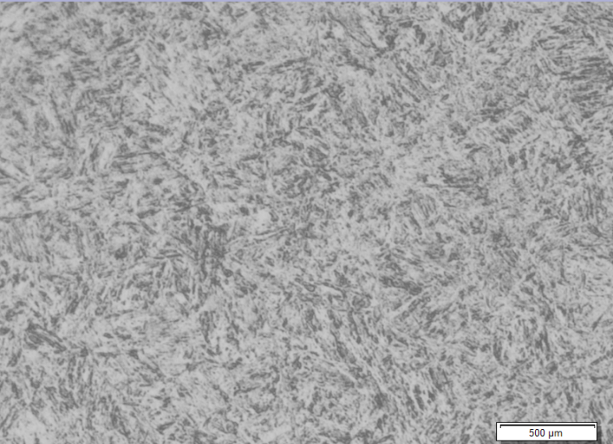

a

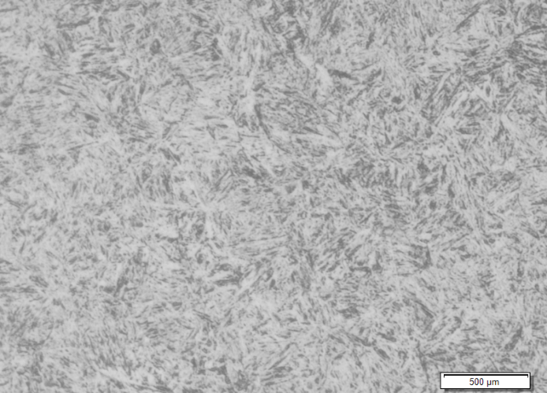

b

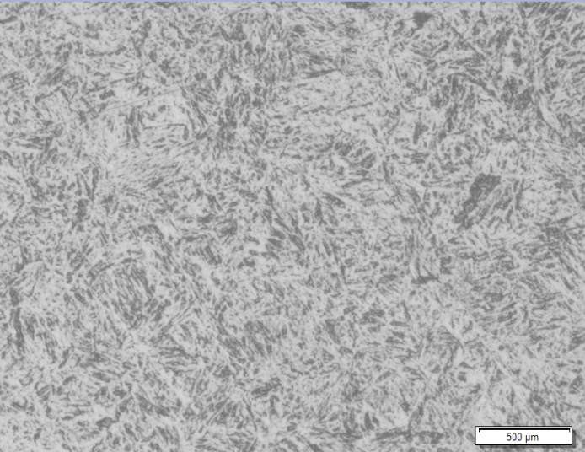

c

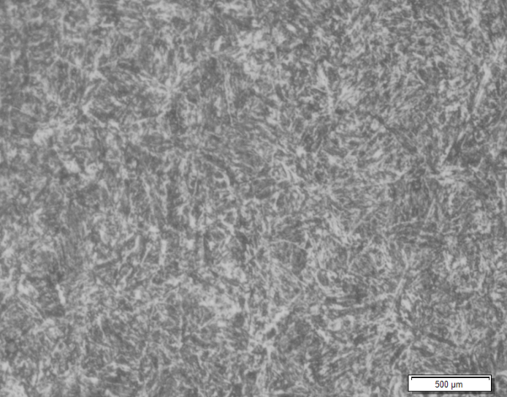

d

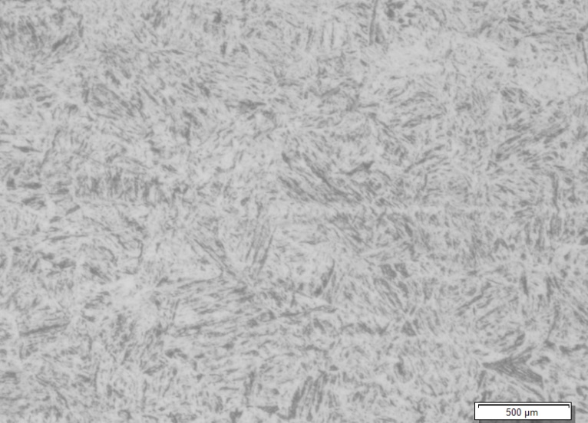

e

Figure 3. Microstructure of AISI 4140 alloy steel heated for two hours at (a) 800 °C, (b) 850 °C, (c) 900 °C, (d) 950 °C, (e) 1000 °C.

The recorded patterns of XRD for samples as-received and those heated for different temperatures and different soaking times and quenched in oil are illustrated in Figure 4. The peak of plane (200) ɣ which belong to retained austenite phase was not observed in any of the recorded patterns [6].
Using XRD results and residual stresses calculations, an empirical equation was discovered in terms of two variables (heating temperature and holding time) using Lab-Fit Software.
211 α
200 α
110 α
110 α
211 α
200 α
(d)
(c)
The experimental results of residual stresses were compared with the estimated values of Equation 7 as shown in Figure 5. The results obtained of residual stresses by empirical equation were shown to be agreed well against experimental values, the correlation coefficient (R) reaches to 0.9929.
Figure 6 shows the effect of heating temperature on the residual stresses at different holding time. Residual stress is completely distributed in the compressive stress region. Another observation is that the stress is linearly increasing with increase heating temperature for different holding time. At low holding time results (30 minutes), high residual stresses are recorded.

$σ_{Res}=\frac{T}{(A+Bt^{2})}$ (7)
Where: $σ_{Res}$: Residual Stresses,
T: Heating Temperature (º C),
t: holding time (min.)
A,B: Constants

a

b
Figure 4. XRD patterns of AISI 4140 alloy steel heated for different times at (a) 800 °C,(b) 850 °C, (c) 900 °C, (d) 950 °C, (e) 1000 °C
e
d
c

Figure 5. Comparison between empirical equation results and experimental results of Residual Stresses

Figure 6. The resulting residual stresses at different heating temperatures and different times.

Conclusions
After quenching of 4140 low alloy steel samples and estimation of residual stresses depending on the XRD results and calculations, the following conclusions are recorded:
1. Calculation of residual stresses of quenched low alloy steel using XRD test is very useful method.
2. Holding time play a principal role in the values of residual stresses, and at increasing holding time will reduce the residual stresses.
3. from results of hardness test, the best heating temperature is 900ºC that will give excellent results of hardness.

References
[1] ASM HANDBOOK (2010) Principle of Heat Treating of Steels. Article to Key to Metals, Vol.4.
[2] BUCHMAYER B., and KIRKALDY J.S. (1990) Modeling of the temperature field transformation behavior, hardness and mechanical response of low alloy steels during cooling from the austenite region, Springer J. Heat treat 8, 127-136.
[3] ASM HANDBOOK (2002) Heat Treating. American Society for Metals, Vol.4, Metals Park, Ohio, USA.
[4] VLADIMIR IVANOVITCH MONINE, JOO DA CRUZ PAYO FILHO, RODRIGO STOHLER GONZAGA, ELISA KIMUS DIAS PASSOS, and JOAQUIM TEIXEIRA DE ASSIS (2018) X-Ray Diffraction Technique for Residual Stress Measurement in NiCrMo Alloy Weld Metal, Advances in Materials Science and Engineering, Vol. 2018.
[5] OSMAN A. (2004) Residual Stress Measurement Using X-Ray Diffraction, Master Thesis Submitted to the Office of Graduate Studies of Texas A&M University.
[6] DIEGO E. LOZANO, GEORGE E. TOTTEN, YANETH BEDOLLA-GIL, MARTHA GUERREROMATA, MARCEL CARPIO, and GABRIELA M. MARTINEZ (2019) X-ray Determination of Compressive Residual Stresses in Spring Steel Generated by High-Speed Water Quenching, Materials, Vol.12, 1154.
[7] FREDERICO O. N., THIAGO L., LARA O., DURVAL U. B., and ALEX S. DA SILVA (2014), Influence of Heat Treatment on Residual Stress in Cold-Forged Parts, Hindawi Publishing Corporation Advances in Materials Science and Engineering, Vol. 2014.
[8] KUMAR, SANDEEP, CRIVOI, ALEXANDRU, TAN, MING JEN, TAI, ANNA, MARINESCU,and IULIAN (2016) Evaluation of Residual Stress by X-Ray Diffraction and Correlative Stress Modelling, Materials Research Proceedings, Vol.2, PP. 211-216.
[9] VERMA P. (2013) Iron-Iron carbide phase diagram, Department of Metallurigcal and Materials, Indian Institution of Technology, Khargpar.
[10] ASTM (2001) Standard test methods, practices, terminology for chemical analysis of steel products, Annual Book of ASTM standard A751 – 01.
[11] ASTM (1999) Standard specification for steel bars, carbon and alloy, hot wrought and cold finished, general requirements, Annual Book of ASTM Standard A29.
[12] J. L. SMITH, G. M. RUSSEL, and S. C. BHATIA (2008) Heat Treatment of Metals, Stalish Kumar Jain for CBS Publishers and Distributors, 1st edition, ISBN:978-81-239-1644-6, Vol. 1.
[13] ASTM (2017) Standard test methods for vickers hardness and knoop hardness of metallic materials, Annual Book of ASTM Standard E92-17, ASTM International.
[14] ASKELAND D.R., and PHULE P.P. (2003) The science and engineering of materials, Fourth Edition Brooks/Cole, A division of Thomson learning.

