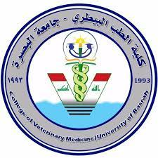
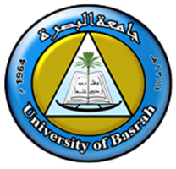
Republic of Iraq Ministry of Higher Education and Scientific Research
University of Basrah
College of Vet0erinary Medicine
Department of Veterinary Microbiology and
Parasitology

Production of Recombinant Bacteriocin from Lactobacillus spp. as Antibacterial Agent Against Pathogenic Bacteria.

A Thesis
Submitted to the council of College of Veterinary Medicine/ University of Basrah in Partial Fulfilment of the Requirement for the Degree Doctorate of Physiology in Science of Veterinary Microbiology

By
Khadeeja Sami Madhi
B.S.C. Veterinary Medicine (2007)
M.S.C. Veterinary Microbiology (2013)

Supervisors
Prof.Dr. Mohammed H. Khudor Prof.Dr. Rasha M. Othman
2021A.D 1442A.H

