Experimental Study of Hollow RC Beams Strengthened by Steel Fiber under Pure Torsion

Mazin Diwan Abdullah¹ and Hawraa S. Malik²
1Civil Engineering Department, Basrah University
2Civil Engineering Department, Almaaqal University
Mazen.abdullah@uobasrah.edu.iq

Abstract:

This paper examines the effectiveness of pure torsional loads on hollow reinforced concrete high-strengthened beams. Engineers need to know how much twist a structural member generates when exposed to torsional loads to design it properly. This is done through an experimental investigation of the torsional behavior of reinforced concrete (RC) beams using twelve hollow rectangular beams with varying parameters such as the spacing of the stirrups, the influence of steel fiber fraction, and the main reinforcement amount. Four values of fiber volume fractions (0, 0.5%, 0.75%, and 1%), three spacing of transverse reinforcements (60,100, and150) mm, and various longitudinal reinforcements (8Ф12 mm, 6Ф12 mm, and 4Ф12 mm) have been used. The tested beams have the same length (1000mm), cross-sections, concrete mixture, and quality control. In the hollow beams, the interior dimensions were 180mm x 180 mm, while the exterior dimensions were 300mm x 300 mm. Torsional loads were applied to all the beams using custom-built test equipment. This study highlighted that the structural characteristics of hollow RC beams could be improved by increasing the fiber volume, lowering the stirrup spacing, and increasing the longitudinal reinforcement. Torsion moments rose by 132% when the fractional volume of fiber climbed from 0% to 1%, while they rose by 71.27% when the longitudinal reinforcement was increased from 4 to 8 bars for beams with fractional volumes of fiber of 0.5 percent and the same transverse reinforcement ratios.

Keyword: reinforced concrete beams, RC beams, steel fiber, torsional moments, pure torsion

1-Introduction
Hollow Cross Section (HCS) members are being used more frequently in structures nowadays, including bridges and buildings. This is primarily because they have advantages over traditional open-section members in terms of both structural and aesthetically pleasing design elements. The most well-known use of hollow cross sections is to provide economic lightweight and long-span members.
For RC beams, premature torsion failure may occur if a torsional moment is supplied to a reinforced concrete beam without transverse reinforcing before its flexural strength reaches its limit. As this failure occurs suddenly and without pre-warning, it is generally catastrophic; therefore, stirrups and steel fibers have traditionally been used to prevent the torsional failure of concrete beams.
Since steel fibers' effects on hollow beam torsion behavior with stirrup reinforcement are not well understood, it is difficult to design properly. This research addresses the use of steel fibers in the hollow concrete beam under pure torsion. This research are looking for ways to improve the torsional strength of hollow reinforced concrete beams by altering the stirrup spacing, adding reinforcement along the longitudinal axis, and adding steel fiber. This experimental study tests eleven beams with different steel fiber aspect ratios, stirrups spacing, and various numbers of longitudinal reinforcements.

2- Background
In most structures, the torsion action occurs more frequently, but it rarely occurs by itself. Torsion, on the other hand, is regarded as one of the crucial structural activities, alongside shear, flexure, and axial tension-compression. Torsion causes the failure of the concrete member, which is caused by tensile stress. This failure was caused by a pure shear state. The model's tensile strength was significantly increased with the inclusion of steel fibers. This property of Reinforced concrete with steel fibers led to various examining of it under various loading techniques. Limited data was provided about the performance of steel fiber reinforced concrete members with hollow sections under pure torsion. The prior tests demonstrated that the use of steel fiber increased the torsional strength of members.
Chalioris and Karayannis [1] experienced the behavior of reinforced concrete beams with steel fibers under torsion. 35 beams with T-shaped, L-shaped, and rectangular cross-sections with steel fibers with an aspect ratio lf/df = 37.5 are presented and discussed. To assess the efficacy of fibers as a prospective stirrup replacement, the steel fibers were used as the only shear torsional reinforcement the results showed that fibrous concrete beams had a better torsional performance concerning the corresponding non-fibrous control beams. Okay Fuad and Serkan Engin [2] found that adding steel fiber reinforcement to RC beams changed their torque capability. Constantin E. Chalioris and Chris G. Karayannis [3] reported an experimental study using eleven RC beams with rectangular spiral reinforcement subjected to torsion; according to test results, torsional capacity was enhanced for beams with a rectangular spiral reinforcement. Lopes and Bernardo [4] examined sixteen hollow beams with concrete compressive strength ranging from 46.2 to 96.7 MPa and torsional reinforcement ratios ranging from 0.3 to 2.68 %. They found a novel failure type where the beam corners break off at a specified reinforcement ratio, which prevents the beam from reaching its predicted maximum strength and ductility. Enthuran and Sattainathan [5] reported that crimped steel fibers with 1.5% and 2.0 % volume fractions resulted in increased torque and twist angles. Therefore, the result suggested that RC beams with a greater volume proportion of steel fibers exhibit superior torsional performance. Sudhir and Keshav [6] investigated the effect of adding 1.5% steel fibers on improving concrete torsional strength. The inclusion of steel fibers enhanced the torsional strength, concrete crack resistance, and the combined torsional-shear-bending strength while decreasing the deflection. Kandekar and Talikoti‏ [7] investigated the torsional behavior of RC beams strengthened using aramid fiber strips. They constructed twenty-one RC beams: three with normal reinforcement, three with torsional reinforcement, and the remaining fifteen with normal reinforcement and with aramid fiber strips of 150 mm width and varied spacings of 100, 125, 150, 175, and 200 mm. All beams with aramid fiber strips were found to have increased torsional moment bearing capability. With modest changes in the twist angle, torsional moment carrying capacity improves as strip spacing decreases. Hameed, Ali, and Al-Sherrawi [8] found that under pure torsion tests, adding steel fibers to RC beams improves the ultimate torsion strength for three specimens up to 28.55%, 38.09%, and 49.46% when compared to RC beams without fibers. These enhancements are dependent on the increment in fiber content. Facconi, et al. [9] showed that steel fiber reinforced concrete beams exhibit stable torsional behavior after cracking in terms of improved crack control, increased torsional resistance, and cracked stiffness. Ashour et al. [10] evaluated the impact of adding steel fiber on the behavior of reactive powder concrete beams with hollow T-sections under pure torsion. The researchers determined that a beam with a 2% fiber volume fraction raised the cracking torsional moment by 184% and the final torsional moment by 66%. Sai Nitesh et al. [11] studied the effect of adding 0.5 % hook steel fiber to self-compacting concrete beams with recycled coarse aggregate. To test the strength of the concrete using natural and recycled coarse material, 32 beams were constructed. The result showed a large increase in the ultimate torque, torsional stiffness, angle of twist, and torsional toughness in self-compacting concrete compared with vibrated concrete for natural and recycled coarse aggregate with steel fibers. Ibrahim et al. [12] studied the effect of spacing and type of stirrups. The investigation comprised ten reinforced concrete beam specimens: seven hollow sections with various ratios of rectangular spiral stirrups, two solid beams with spiral and closed rectangular stirrups, and one hollow beam with closed rectangular stirrups. Compared to standard closed stirrups, the findings revealed that inclined spiral rectangular stirrups in beam reinforcement enhanced the torsional capacity and strained energy by 16% and 27%, respectively, for solid beams and 18% and 16%, respectively, for hollow beams. Min-Jun Kim et al. (2020) tested eleven RC beams with various torsional reinforcement amount and different cross-sectional properties. The results indicated that solid and hollow sections have the same levels of torsional strength. Furthermore, regardless of cross-sectional properties, specimens with less arranged torsional reinforcement exhibited ductile behavior compared with the ACI 318-19 building code [13]. Facconi et al. [13] investigate six steel fiber reinforced concrete (SFRC) beams under torsion. The tested beams were divided into three groups; beams with no stirrups, beams with minimum transverse reinforcement amount (according to Euro code 2), and beams with hooked steel fibers (25 or 50 Kg/m3). The results indicate that the addition of steel fibers increases the maximum resisting torque and maximum angle of twist compared with the same specimen without fibers. Moreover, SFRC has a relatively high post-cracking stiffness compared to RC elements [14]. Hadi and Mohammed [15] studied the behavior of reinforced concrete beams with straight and hooked steel fiber under combined torsional-flexural load. The experimental study involved three fixed supported beams with dimensions of 250mm * 300mm * 1800mm and different types of fibers with a volume percentage of 1.5%. The beam with hooked steel fibers has a 33.37% increase in compressive strength and a 55.08% increase in tensile strength. It was also concluded that the use of hooked fiber had the greatest influence on improving the cracking behavior of beams. Using hooked and straight fibers, beams are able to sustain larger loads at the same rate of deflection/twisting, with a 128.13 % and 74.76% increase in ultimate load, respectively. Despite the fact that the applied load was torsional-flexural, all tested beams failed due to excessive twisting. Abdulkadir et al. [16] experimented RC members with 0, 30, and 60 kg/m3 steel fibers under shear, torsion, and axial load. The results indicate that increasing the ratio of steel fiber increases the torsional moment capacity and decreases shear strength capacity. Moreover, increasing the steel fiber content increases the moment capacity and axial load of RC columns. Hussain et al [17] experimented with the structural performance of ten flat slabs with and without a square opening using four types of fiber to gain a better understanding of how the variance of fiber type and shape affects the flexural behaviors of two-way slabs. Results revealed that the existing fiber in concrete improved the mechanical properties of hardened concrete mix, and the compressive strength, flexural behavior of reinforced concrete slab and flexural strength capacity.
Most of the experimental and theoretical studies that were mentioned above corresponded to concrete beams with solid section under pure torsion. Few studies on hollow reinforced concrete beams under pure torsion are available in literature. The present study is an attempt to investigate the behavior and load carrying capacity in torsion for hollow RC beams to show the effect of adding different steel fiber ratio, different longitudinal reinforcement and stirrups that influence the torsional strength capacity and also behavior of the beam. The angle of twist, cracking torsional moment and ultimate torsional moment were measured.
3- Martials and Method
The beam specimens in this study were cast using plywood molds constituted from a single part (external parts). The fallen were used to make the tested beams' hollow shape, as shown in Figure 1. A 1 cm square stock was placed inside the molds to maintain the proper concrete cover to hold the reinforcement through the construction process. A typical poker vibrator was employed during the concrete casting to facilitate consolidation and precise concrete placement within and around the reinforcement.
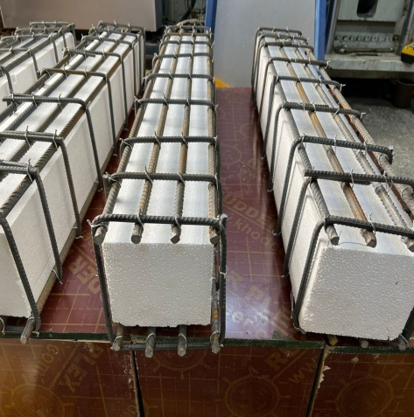 | 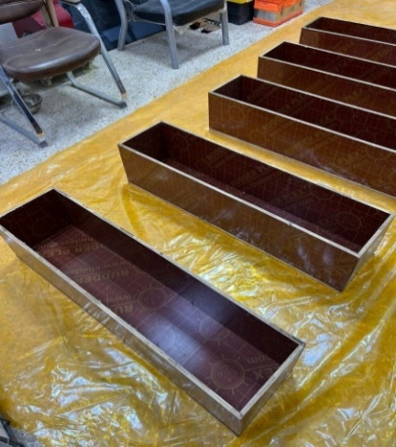 | 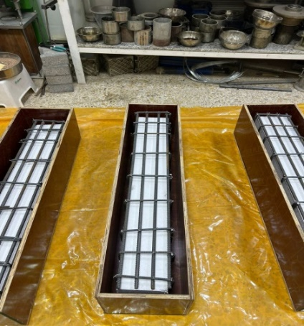
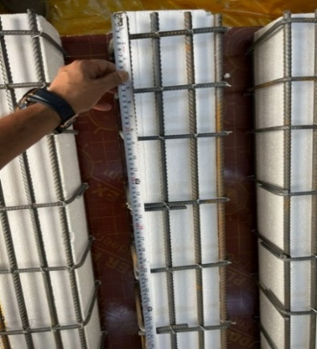 | 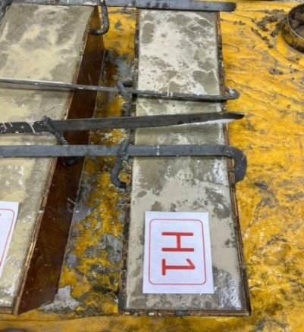 | 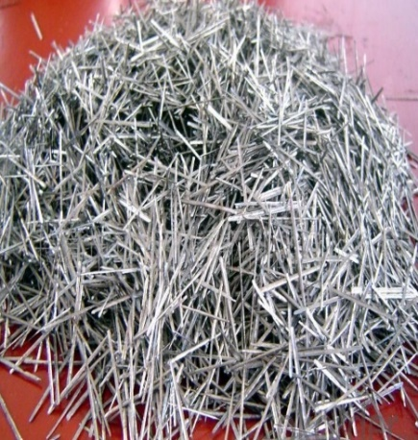
Figure 1: Concrete casting.
Portland cement, natural sand, and aggregate were used in the concrete mixture to meet the IQS (5/1984) [18, 19] and ASTM 33-03 [20] specifications. Tables 1 and 2 represent the cement's chemical and physical characteristics, whereas Tables 3 and 4 provide the properties of sand and aggregate, respectively. The maximum size of the used aggregate is 10 mm, and the percentages used in the concrete mix design were (1:1.31:2.8/0.32 by weight) for (cement: sand: gravel/water), respectively, Test beams' compressive strength was determined using three 150-millimeter concrete cylinders, each 300mm high. The compressive strength of the cylinder in 28-days was designed to be 65 MPa according to ACI 218 [21]. Steel with a yield strength of 547 MPa was used. The steel fiber ratios of 0. 5%, 0.75 %, and 1% of the concrete weight were used. The design of RC beams was done by using ACI 318[21].
Table1: Chemical properties of cement [16]. | Table2: Physical properties of cement [16].
Composition of cement (%) Specification limit  (CaO) 62.83  SiO2 22.54  AL2O3 5.4  Fe2O3 2.64  MgO 3.23 5%  SO3 2.45 2.8%  (Na2O) 0.24  (K2O) 0.62  (L.O.I) 0.71 4.00 (Max.)  (I.R) 0.57 1.50 (Max.)  (L.S.F) 0.91 0.66-1.02  Cement compound  C4AF 7.93 7.72-8.02  C3A 10.21 11.96-12.3  C2S 33.65 28.61 – 37.9  C3S 38.51 31.03- 41.05 | Physical property Test results Limit of IQS No. 5/1984  Setting time (Vicat apparatus), hr:min Initial Final 00:57 8:47 00:45 (Min.) 10:00 (Max.)  Compressive strength (70.7mm cube), MPa 3-day 7-day 19.7 26 15 (Min.) 23 (Min.)
 | Table 4: Specification of used gravel [18].
Sieve size  In. | Passing  % | Standard  %
2 | 100 | 100
1.5 | 98 | 95-100
3/4 | 65 | 35-70
3/8 | 12 | 10-30
3/16 | 2 | 0-5
Pan | 0
F.M. | 7.1
M.A.S | 1.5 in
Sp.gr. | 2.61

Table 3: Specification of used sand [18].

Sieve size | Passing % |  | Standard
No. 8 | 100 |  | 100
No. 4 | 95 |  | 95-100
No. 8 | 83 |  | 80-100
No.16 | 67 |  | 50-85
No. 30 | 48 |  | 25-60
No. 50 | 17 |  | 5-30
No. 100 | 6 |  | 2-10
F.M. |  | 2.7
M.A.S |  | No.4
A.S.S. |  | No.30
Sp. gr. |  | 2.61

3.1 Specimen Details
The factors evaluated in this work include the fiber volume percentage, the main reinforcement quantity, and the spacing of the stirrups, all of which impact the torsional capacity of the beam. Twelve hollow reinforced concrete beam specimens with an overall length of 1000 mm are shown in Figure 2 with exterior and interior dimensions 300 x 300mm and 180 x 180 mm, respectively. As shown in Table 5, this work consists of three groups.
Group A
Is used to study the influence of stirrup spacing and fiber volume fraction (Vf) on the torsional strength of beams. The impact of adjusting the stirrup spacing on the torsional strength of these beams under pure torsion was investigated using six reinforced hollow concrete beams. The stirrup spacing for these beams is 60, 100, and 150 mm, and the VF range is 0.5% to 0.75%.
Group B
Deals with the effect of fraction volume of fiber on the behavior of hollow reinforced concrete beams. Four RC beams were presented to find the fiber's ratio (Vf) impact on the beam's torsional strength. These beams have a varied volume fraction of fibers (0, 0.5%, 0.75%, and 1%).
Group C
Calculation of torsional displacement Studies the effect of changing the amount of main reinforcement and fiber volume fraction (Vf) for the same reinforcement. Six reinforced concrete beams were used to find the effect of longitudinal reinforcement amount on the beam torsional strength. The main reinforcement includes 8Ф12 mm, 6Ф12 mm, and 4Ф12 mm, and Vf ranges between 0.5 to 0.75%.

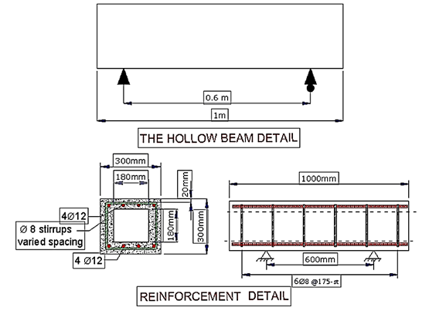
Figure 2: Details of reinforcement of hollow RC beams.
Table 5: Specimens groups details.

Case Study | Longitudinal Steel number | Spacing of Stirrup | Vf % | Beam’s Number | Group
Effect of stirrup Spacing of on pure torsion | 4 | 150 | 0.5 | H11 | A
 | 4 | 100 | 0.5 | H2
 | 4 | 60 | 0.5 | H9
 | 4 | 150 | 0.75 | H12
 | 4 | 100 | 0.75 | H3
 | 4 | 60 | 0.75 | H10

Case Study | Number of Longitudinal  Steel | Spacing of Stirrup | Vf % | Beam's Number | Group
Effect of steel fiber ratio on pure torsion | 4 | 100 | 0 | H1 | B
 | 4 | 100 | 0.5 | H2
 | 4 | 100 | 0.75 | H3
 | 4 | 100 | 1 | H4
Case Study | Number of Longitudinal  Steel | Spacing of Stirrup | Vf % | Beam's Number | Group
Effect of amount of longitudinal steel reinforcement on pure torsion | 4 | 100 | 0.5 | H2 | C
 | 6 | 100 | 0.5 | H5
 | 8 | 100 | 0.5 | H7
 | 4 | 100 | 0.75 | H3
 | 6 | 100 | 0.75 | H6
 | 8 | 100 | 0.75 | H8

3.2 Test Setup and Devices
Figure 3 shows the torsional testing machine used to test the hollow RC beams. This machine has been enhanced by adding an arm to apply pure torsion. A heavy steel plate of 45 mm thickness in wedge shape was used to make a torsion arm with a net length equal to 0.65 m. Four bolts were utilized to fasten two steel plates on the top and bottom sides of the tested beam to secure the test arm. The RC beams were built to be simply supported at two bearings, with the roller support located underneath the bearing to facilitate movement of the beam specimens, allowing them to be readily rotated under the supplied torque, as shown in Figure 4. Figure 5 show a Schematic of applied loading.

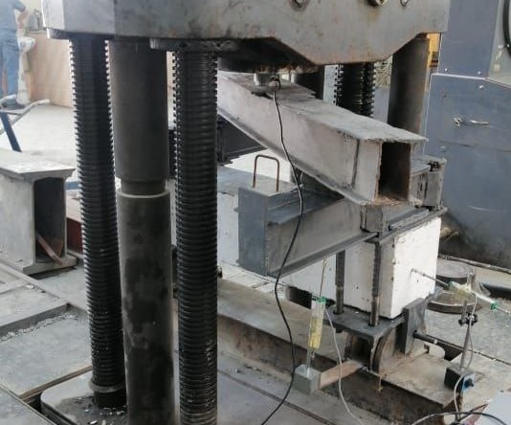 | 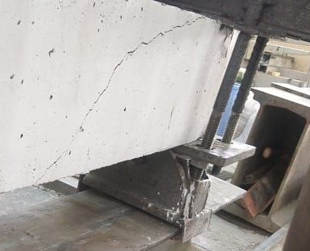
Figure 3: The torsional test machine. | Figure 4: The support of the tested beam.

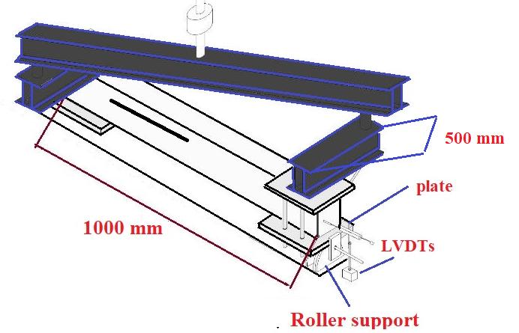
Figure 5: typical cross- section of the tested machine
3.3 Measurements Angle of Twist
Figure 6 shows the addition of linear variable differential transformers (LVDTs) at the beam ends to determine the twist angle. By averaging the deflections from the LVDTs on both sides of the tested beam, the twist angle was computed.
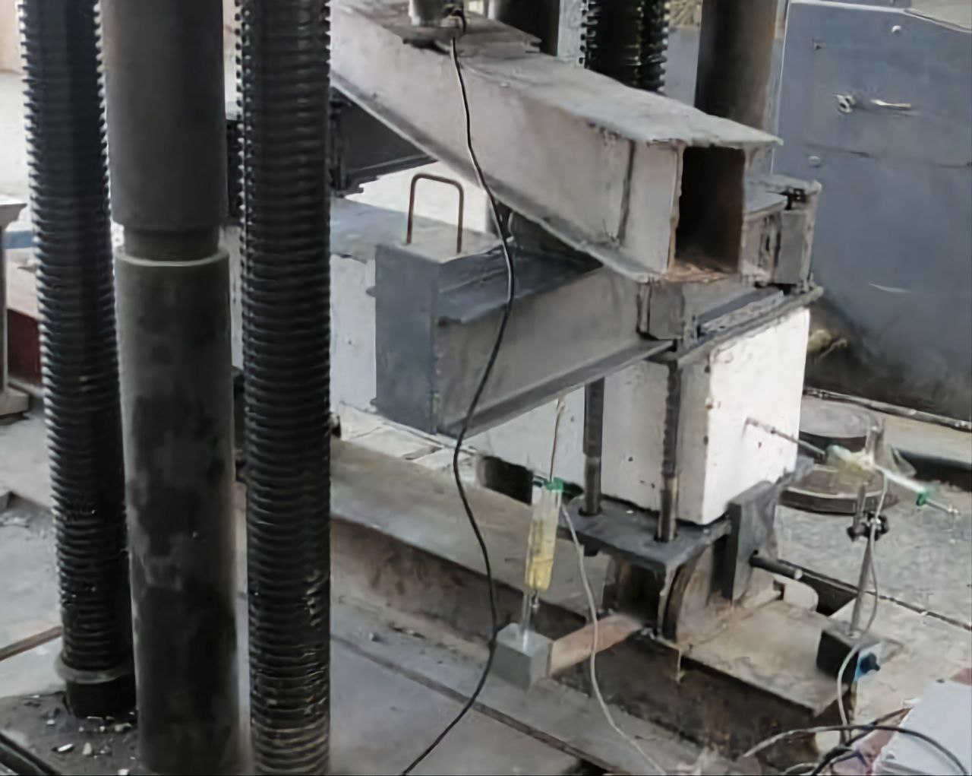 | 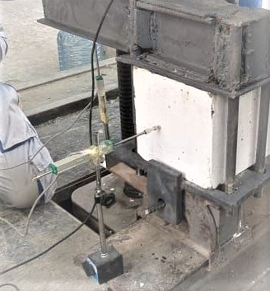
Figure6: Location of LDVTs.

4- Results and Discussion
The load was applied at the ends of a 650 mm torsion lever arm from the beam center to achieve a pure torsional moment in the present investigation. The torsion moment was applied to the beam using a hydraulic testing machine with five kN increments, and the test continued until the beams' failed. The torque produced after the appearance of the first crack is indicated as the cracking torsional moment (Tcr), whereas the torque that causes beam failure is known as the ultimate torsional moment (Tu). Two LDVTs are positioned at the maximum torsional moment sites to measure the twist angle. Table 6 shown the twist angel, cracking and ultimate torsional moment.
Table 6: The overall results of tested beams
Beam’s Number | Maximum twist Angle (degree%) | Cracking Torque (kN.m) | Ultimate Torque  (kN.m)
H1 | 9.40 | 8.3 | 21.1
H2 | 10.85 | 15.77 | 26.24
H3 | 12.87 | 17.59 | 29.51
H4 | 15.89 | 19.25 | 32.09
H5 | 12.06 | 16.35 | 44.37
H6 | 13.24 | 18.50 | 47.94
H7 | 14.3 | 17.18 | 44.94
H8 | 14.42 | 19.17 | 49.79
H9 | 14.04 | 18.42 | 30.87
H10 | 15.18 | 19.25 | 31.96
H11 | 9.80 | 8.50 | 20.30
H12 | 10.20 | 9.70 | 21.55

4.1 Effect of spacing of stirrups
The Tcr is the torque at which the applied stresses exceed the section's tensile strength, and the cracks begin to appear. After the appearance of these cracks, rapid deformations, and a drop in the reading of the tested machine, the load-carrying capacity of the beam will decrease. In this case, it is referred to as the ultimate torsional moment (Tu). Two beams, H11 and H12, were selected to represent the control beams to study the effect of changing the spacing of stirrups. Figure 7 indicates that the values of Tcr and Tu are improved by minimizing the spacing of stirrups and increasing the fiber's ratio for the same stirrups spacing. The increments in the cracking moment of beams H2 and H9, which have a steel fiber ratio of 0.5% and stirrups spacing of 100 mm and 60 mm, were equal to 85.53% and 116.7%, respectively, compared to the control beam (H11). The increases in the ultimate torsional moment for the two beams (H2 and H9) are 29.26% and 43.25%, respectively. It was also discovered that increasing the steel fiber ratio from 0.5 percent in beam H11 to 0.75 percent in beam H12 enhanced the cracking torsional moment and ultimate torsional moment by 14.12 % and 6.16 %, respectively. The effect of fibers fraction on both Tcr and Tu is decreased with the reduction of stirrups spacing. So, to improve the behavior of the beams, the stirrups should be increased.
The angle of twist (Ø) is measured by the deflection rate on both sides of the beam, which was measured using the previously described LDVTs. Increasing the number of stirrups with the corresponding fiber fraction and main reinforcement improves the beam stiffness and the twist angle. Figure 8 depicts the relation between the difference in twist angle and the Tu for each beam compared to the control beams.

Figure 7: Torsional moment of the tested beams.
Figure 8: The twist angle and torque relationship.

It can be shown that increasing the stirrups improves Tcr, Tu, and Ø. The rate of increment in the torsional resistance of the tested beams to the corresponding spacing of stirrups was not proportional, as shown in Tables 7 and 8. Figures 9.1 to 9.3 demonstrate that the cracking torsional moment increased by 116.7 %, the twist angle improved by 48.82 %, and the ultimate torsional moment improved by 48.31 %.
Table 7: Effect of spacing of stirrups on the beam torsional moment.
Increasing in(Tu) according to H11&H12  (%) | Ultimate Torque (Tu)  (kN.m) | Increasing in(Tcr) according to H11&H12  (%) | Cracking Torque (Tcr)  (kN.m) | Vf% | Stirrups  Spacing (mm) c/c | Beam No.
---- | 20.3 | ---- | 8.5 | 0.5 | 150 | H11
29.26 | 26.24 | 85.53 | 15.77 | 0.5 | 100 | H2
43.25 | 30.87 | 116.7 | 18.42 | 0.5 | 60 | H9
---- | 21.55 | ---- | 9.7 | 0.75 | 150 | H12
36.94 | 29.51 | 81.34 | 17.59 | 0.75 | 100 | H3
48.31 | 31.96 | 98.45 | 19.25 | 0.75 | 60 | H10

Table 8: Effect of stirrups spacing on the twist angle.

Decreasing in (Ø) according to H11&H12  (%) | Maximum Twist Angle (Ø)  (degree %) | Vf% | Spacing of Stirrups  (mm) c/c | Beam No.
---- | 9.8 | 0.5 | 150 | H11
10.71 | 10.85 | 0.5 | 100 | H2
46.94 | 14.04 | 0.5 | 60 | H9
---- | 10.2 | 0.75 | 150 | H12
26.18 | 12.87 | 0.75 | 100 | H3
48.82 | 15.18 | 0.75 | 60 | H10

Figure 9.1: Cracking torsional moment Improvement.
Figure 9.2: Improvement of the ultimate torsional moment.
Figure 9.3: Twist angle Improvement.
4.2 Effect of Steel Fiber ratio

According to Table 9 and Figure 10, increasing the fiber percentage increases the ultimate and cracking torque. The crack torsional moment of the beam increases by 90 %, 112 %, and 132 %, respectively, as it increases from zero to 0.5, 0.75, and 1%, while the ultimate torque increases by 24.4, 45.6, and 62.7%, respectively, in comparison to the beam without steel fiber (H1). The addition of steel fiber enhances the concrete tensile strength and improves the ductility of the beams. The beam fails when the tensile stresses on concrete raise and exceed the concrete tensile strength, the beam cracks but the fibers continue to resist the raising tensile stresses until the steel fibers completely pull out at a critical crack. All of the tested beams failed owing to excessive torsional shear stress, resulting in a large diagonal torsional fracture.
Figure 11 depicts the relationship between the twist angle difference and the torsional moment of the tested beams. Increasing the fiber ratio while maintaining the same stirrup spacing and the number of main reinforcements increases beam stiffness and twist angle.

Table 9: Effect of steel fiber ratio on cracking and ultimate torsional moment.

Increasing in(Tu) according to H1  (%) | Ultimate Torque (Tu)  (kN.m) | Increasing in(Tcr) according to H1  (%) | Cracking Torque (Tcr)  (kN.m) | Vf % | Beam No.
0 | 21.1 | ---- | 8.3 | 0 | H1
24.4 | 26.24 | 90 | 15.77 | 0.5 | H2
45.6 | 29.51 | 112 | 17.59 | 0.75 | H3
62.7 | 32.09 | 132 | 19.25 | 1 | H4

Figure 10: Torsional moment of the tested beams
Figure 11: The twist angle and torque relationship

These results reveal that 𝑇𝑐𝑟, 𝑇𝑢, and Ø are improved by increasing the fiber fraction. As evident in Tables 9 and 10, the rate of increment in the torsional properties to the steel fiber ratio was not the same for all tested beams. Figures 12.1 to 12.3 demonstrate that the cracking torsional moment increased by 132 %, the twist angle improved by 69.04 %, and the ultimate torsional moment improved by 62.1%.

Table 10: The effect of fiber ratio on the twist angle.

Decreasing in (Ø) according to H1  (%) | Maximum Twist Angle (Ø)  (degree %) | Vf % | Beam No.
---- | 9.40 | 0 | H1
15.42 | 10.85 | 0.5 | H2
36.91 | 12.87 | 0.75 | H3
69.10 | 15.89 | 1 | H4

Figure 12.1: Improvement of the Tcr.
Figure 12.2: Improvement of the twist angle.
Figure 12.3: Improvement of the Tu.
4.3 Effect of main reinforcement

The impact of modifying the number of longitudinal reinforcements with the two distinct fiber ratios was investigated in this experimental study section by comparing two beams (H5 and H7) with the control beam (H2). The cracking and ultimate torsional moments rise by 3.68% and 69.09%, respectively, for beam H5, and by 8.94% and 71.27%, respectively, for beam H7, as the number of longitudinal reinforcement increases (see Table 11 and Figure13). The increase in the fiber ratio from 0.5% to 0.75% resulted in an 11.5% increase in cracking load and a 12.46% rise in ultimate torsional moment for beams with the same longitudinal reinforcement (4bars). Beam H8, which contains the largest main reinforcements (8 bares) and the highest steel fiber ratio (0.75%), has an 8.98% growth in carrying capacity and 68.72% development in cracking resistance according to H3. As a result, the beam torsional strength increased by increasing the longitudinal reinforcements. Also, it can be observed the fact that the effect of changing the fiber ratio and main reinforcement on the ultimate torsional moment will decrease by increasing the number of main reinforcements from 6 to 8 bars.
Figure 14 depicts the relationship between the torsional moment and the average twist angles for the examined beams. The stiffness and twist angle of the beams could well be improved by increasing the main reinforcements while maintaining the same stirrup and fiber spacing ratio. Fig.14 shows the relation between the average of two twist angles and the torsional moment for the tested beams. Increasing the number of main reinforcements with the same spacing of stirrups and fibers ratio leads to an improvement in the beams stiffness and angle of twist (see table 12).

Table 11: Effect of main reinforcement number on cracking and ultimate torsional moment.

Increasing in(Tu) according to H2&H3  (%) | Ultimate Torque (Tu)  (kN.m) | Increasing in(Tcr) according to H2&H3  (%) | Cracking Torque (Tcr)  (kN.m) | No.  of longitudinal steel  reinforcement | Vf % | Beam No.
---- | 26.24 | ---- | 15.77 | 4 | 0.5 | H2
69.09 | 44.37 | 3.68 | 16.35 | 6 | 0.5 | H5
71.27 | 44.94 | 8.94 | 17.18 | 8 | 0.5 | H7
---- | 29.51 | ---- | 17.59 | 4 | 0.75 | H3
62.45 | 47.94 | 5.17 | 18.50 | 6 | 0.75 | H6
68.72 | 49.79 | 8.98 | 19.17 | 8 | 0.75 | H8

Table 12: Effect of increasing the longitudinal steel number on the twist angle.
Decreasing in (Ø) according to H2&H3  (%) | Maximum Twist Angle (Ø)  (degree) | longitudinal  reinforcement number | Vf  % | Beam No.
---- | 10.85 | 4 | 0.5 | H2
11.15 | 12.06 | 6 | 0.5 | H5
31.80 | 14.30 | 8 | 0.5 | H7
---- | 12.87 | 4 | 0.75 | H3
2.87 | 13.24 | 6 | 0.75 | H6
12.04 | 14.42 | 8 | 0.75 | H8

Figure 13: load-carrying capacity of the tested beams
Figure 14: Torque-twist relationship.

According to current observations of tested beams, increasing the longitudinal reinforcement number improves Tcr, Tu, and Ø. As evident in Tables 11 and 12, the increment rate in the torsional properties to the relating number of longitudinal reinforcement was not the same for all tested beams Figures 15.1 to 15.3 show that the cracking torsional moment increased by 81.71 %, the twist angle improved by 31.98 %, and the ultimate torsional moment improved by 8.98%.

Figure 15.1: Improvement of the Tu.
Figure 15.2: Improvement of the angle of twist.
Figure 15.3: Improvement of the Tcr.
4.4 Crack Patterns of Tested Beams
Figure 15 shows the failure modes of the tested beams. Control beam (H1) demonstrates typical torsion failure behavior, with spiral diagonal fractures seen throughout the beam's cross-section, with an angle of around 45 degrees. Increasing the applied load, larger cracks will appear until the concrete fails by crushing in the center of the beam. This mode of failure is the typical mode of beams without steel fiber. On the other hand, beams with steel fibers fail differently, especially those with a high steel fiber fraction where the presence of fiber makes the crack control system resist pseudo-ductility in post-cracking action. To be more precise, the primary cracks started to show up on the beam's surface before the post-peak falling branch of the torque vs. twist response started to develop (Figs. 8, 11 and 14). As the torque deducted after the peak, the damage gradually summarized in a single crack, whose width larger than the other and it’s increased until the test's ending. From the figure (16) it can be seen that the hollow beam H10 with the largest fiber volume of fraction and less spacing of stirrups is the best one in resisting cracks.
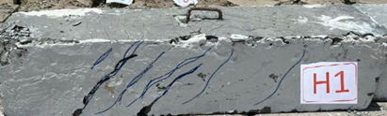 | 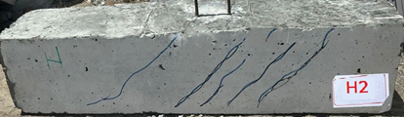
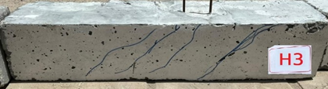 | 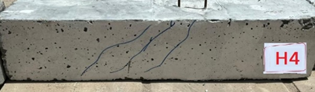
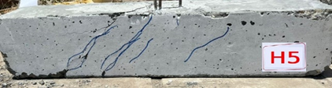 | 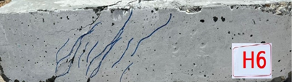
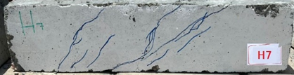 | 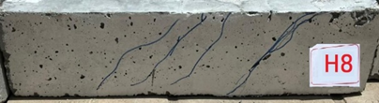
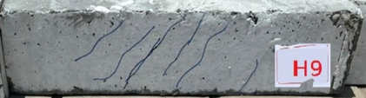 | 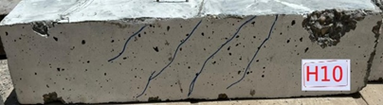
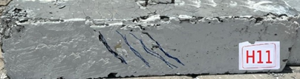 | 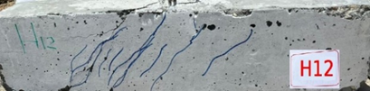
Figure 16: Failure mode of the tested beams.

5-Summery and Conclusion

The experimental results concerning the torsion behavior of full scale hollow reinforced concrete beams under pure torsional loading are presented and discussed. The main variables were longitudinal reinforcement, stirrups and steel fiber ratio. The angle of twist, cracking torsional moment and ultimate torsional moment for HCS beams were measured. It is possible to draw the following conclusions based on the test results:

- The deformations and torsional stresses of hollow RC beams were improved by increasing the number of stirrups.
- The deformations and torsional stresses for hollow RC beams were improved using a larger number of longitudinal reinforcements.
- The insertion of steel fibers to hollow RC beams subjected to a pure torsion load enhanced the principal tensile stress resistance following crack formation until total fiber pullout occurred at the critical fracture.
- The percentage of improvement for Tcr, Tu, and Ø for beams H1 to H12 is:
- Tcr has a range of 3.68%-132%.
- Tu ranges from 29.26% to 71.27%.
- Ø ranges from 2.87% to 69.1%.
- It is preferable to increase the torsional strength (Tcr and Tu) of the hollow beam rather than its stiffness. Before the failure, the significant increase in Ø makes adding main reinforcement and stirrups is better to save lives and draw attention to the situation.
- For beams H1 through H12, the relationship between twist angles and torsional moments is the same. Stress energy in the beam could be increased by including additional stirrups and main reinforcement.
- With increasing main reinforcements, the rise in Tu is more than the increase in Tcr in hollow RC beams, whereas the rise in Tcr is greater than the increase in Tu with increasing VF and number of stirrups.
- the effect of steel fiber is decresses with increasing in main reinforcement and decreasing in the spacing of stirrups for Tcr and Tu

References

- Chalioris, C. E., & Karayannis, C. G. (2009). Effectiveness of the use of steel fibres on the torsional behaviour of flanged concrete beams. Cement and Concrete Composites, 31(5), 331-341.‏
- Okay, Fuad, and Serkan Engin. "Torsional behavior of steel fiber reinforced concrete beams." Construction and Building Materials 28.1 (2012): 269-275.‏
- Chalioris, C. E., & Karayannis, C. G. (2013). Experimental investigation of RC beams with rectangular spiral reinforcement in torsion. Engineering structures, 56, 286-297.‏
- Lopes, S. M. R., & Bernardo, L. F. A. (2014). Cracking and failure mode in HSC hollow beams under torsion. Construction and Building Materials, 51, 163-178.‏
- Enthuran.T and Sattainathan Sharma, “Experimental Study on Torsional Behaviour of Crimped Steel Fiber Reinforced Beam”, International Journal of Engineering Science and Computing, 6(4), 2016, pp. 3950- 3953.
- Patil, S. P., & Sangle, K. K. (2016). Tests of steel fibre reinforced concrete beams under predominant torsion. Journal of Building Engineering, 6, 157-162.‏
- Kandekar, S. B., & Talikoti, R. S. (2018). Study of torsional behavior of reinforced concrete beams strengthened with aramid fiber strips. International Journal of Advanced Structural Engineering, 10(4), 465-474.‏
- Hameed, Ali A., and M. H. Al-Sherrawi. "Torsional strength of steel fiber reinforced concrete beams." International Journal of Civil Engineering and Technology 9.6 (2018): 1388-1396.‏
- Facconi, Luca, et al. "Experimental study on steel fiber reinforced concrete beams in pure torsion." Proceedings of the Fib Symposium in Krakow, Krakow, Poland. 2019.‏
- Khuzaie, H. M. A. A., & Atea, R. S. (2019). Investigation of torsional behavior and capacity of reactive powder concrete (RPC) of hollow T-beam. Journal of Materials Research and Technology, 8(1), 199-207.‏
- Nitesh, K. S., Rao, S. V., & Kumar, P. R. (2019). An experimental investigation on torsional behaviour of recycled aggregate based steel fiber reinforced self-compacting concrete. Journal of Building Engineering, 22, 242-251.‏
- Ibrahim, A., Askar, H. S., & El-Zoughiby, M. E. (2020). Torsional behavior of solid and hollow concrete beams reinforced with inclined spirals. Journal of King Saud University-Engineering Sciences.‏
- Kim, M. J., Kim, H. G., Lee, Y. J., Kim, D. H., Lee, J. Y., & Kim, K. H. (2020). Pure torsional behavior of RC beams in relation to the amount of torsional reinforcement and cross-sectional properties. Construction and Building Materials, 260, 119801.‏
- Facconi, Luca, et al. "Steel fibers for replacing minimum reinforcement in beams under torsion." Materials and Structures 54.1 (2021): 1-18.‏
- Hadi, M. A., & Mohammed, S. D. (2021). Improving torsional–flexural resistance of concrete beams reinforced by hooked and straight steel fibers. Materials Today: Proceedings, 42, 3072-3082.‏
- Aydin, A. C., Kiliç, M., Maali, M., BAYRAK, B., & Erkan, T. U. N. Ç. (2021). The torsional and shear behavior of steel fiber reinforced RC members. Architecture, Civil Engineering, Environment, 14(2), 47-65.‏
- Hussain, H. K., Abbas, A. M., & Ojaimi, M. F. (2022). Fiber-type influence on the flexural behavior of rc two-way slabs with an opening. Buildings, 12(3), 279.‏
- Iraqi Specification No. 5, "Portland Cement", Baghdad, 1984.
- Iraqi Specification No. 45, "Natural Sources for Gravel that is Used in Concrete and Construction", Baghdad, 1984
- ASTM C33-03," Standard Specification for Concrete Aggregates", American Society for Testing and Material, approved June 10, 2003.
- ACI Committee 318. (2011). Building Code Requirements for Structural Concrete (ACI 318M-11) an ACI Standard and Commentary. Farmington Hills, MI: American Concrete Institute. 503 pp.

