Iraqi Journal for Electrical and Electronic Engineering  Original Article or Review Article or Short Article | Open Access
Enhancement Spectral and Energy Efficiencies for Cooperative NOMA Networks
Haider S. Msayer*^{(1,2)}, Husham L. Swadi⁽¹⁾, Haider M. AlSabbagh⁽¹⁾
⁽¹⁾University of Basrah, College of Engineering, Department of Electrical Engineering
⁽²⁾Basra Oil Company (BOC)
Correspondence
*Haider Shaker Msayer
Elecrtrical Engineering Department,
University of Basrah, Basrah, Iraq.
Al–Khalij Al–Arabi Q.
Email: haidermsc2020@gmail.com

Abstract
The tremendous development in the field of communications is derived from the increasing demand for fast transmitting and processing huge amounts of data. The non-orthogonal multiple access (NOMA) system was proposed to increase the spectral efficiency (SE) and improve energy efficiency (EE) as well as contribute to preserving the environment and reducing pollution. In NOMA system, a user may be considered as a relay to the others that support the coverage area based on adopting the reuse the frequency technique. This cooperation enhances the spectral efficiency, however, in the cell there are other users may affect the spectral allocation that should be taken into consideration. Therefore, this paper in conducted to analyze the case when three users are available to play as relies. The analyses are performed in terms of the transmitted power allocation in a fairness manner, the system's performance is analyzed using the achievable data rates and the probability of an outage. The results showed an improvement in throughputs for the second and third users, as its value ranged from 7.57 bps/Hz to 12.55 bps/Hz for the second user and a quasi-fixed value of 1,292 bps/Hz for the third user at the transmitted power ranging from zero to 30 dBm.
KEYWORDS: Energy Efficiency, Spectral Efficiency, Cooperative Non-Orthogonal Multiple Access, Relay.

I. Introduction

The mature 4G networks were successfully applied in different types of wireless communications to satisfy the increasing demand for cellular data traffic that have high capacities and speed. However, the demand was ambitious to enhance connecting all things through the internet that required a considerable attention to allocate the available limited spectral [1].

Researchers turned to 5G with some new protocols to support high speed and a large capacity that need a very high bandwidth to enhance the spectrum efficiency [2,3]. The trend towards 5G meets many requirements of the tremendous technological development that is increasing exponentially, it provides capacities 1000 times more than 4G with a large bandwidth and very high speeds of up to 10 Gigabits per second. This unprecedented technological progress requires the provision of Infrastructures that accommodate the massive increase of devices served by 5G networks [1,4].

Transformation to 5G requires a rise in energy consumption, a significant increase in energy bills, and an increase in the operating costs of the mobile phone network, as energy increase leads to serious creates significant environmental, economic and financial risks to the world [5]. The increased energy consumption, the rise greenhouse gas emissions, the large carbon footprint, the increased health concerns on humans and the environment and the strive to extend the battery lifetime of smart devices. All these challenges lead to the term green communication (GC) [6].

The quest to make the 5G and beyond to improve energy efficiency and to increase sources of clean energy, preserve the environment from high carbon, preserve primary energy sources from overuse and search for alternative sources that reduce pollution in the world, as well as reduce operational expenses that burden the field of communications financially and economically [7].

5G networks operate with higher bandwidth than previous generations, this allows them to have a high download speed of up to 10 G /sec and with the increase in bandwidth that will serve cellular networks. In addition to being used as an Internet service provider in general for all mobile and desktop devices and to support new applications in the Internet-of-Things (IoT) and machine-to-machine domains [8,9].

5G and beyond support access to a very high data rate, massive communications with very low latency, high application mobility and support new applications with high reliability and securing and preserving user data [10,11].

One of the new technologies used in 5G networks is Non-Orthogonal-Multiple-Access (NOMA) technology, through which it is possible to control traffic and enhance the spectrum where several users can share the same radio resource [12]. NOMA outperformed the traditional orthogonal multiple access (OMA) system that supported previous generations from 1G to 4G. As we can see, Orthogonal Frequency-Division-Multiple-Access (OFDMA) has been used in 4G networks, which made a big leap in the field of communications in the previous decade, but it does not meet the increasing demand of users [13-15].

The NOMA system relies on two basic techniques, it starts by using the theory of the Superposition Coding (SC) process that takes place at the transmitter, where all the signals that are transmitted at the same sub band frequency are collected and combined, each signal gives a specific weight of power so that the least weight is allocated to the transmitted power to the closest (strongest) user, and the allocation begins to increase to users who are farther from the base station [16,17].

The second technique is the process of Successive Interference Cancellation (SIC) at the receiving side, it can be summarized as an iterative algorithm in which data is decoded in decreasing order of power levels [18,19]. Decoding superposition signal that contains all signals were sending at the same band, then multiplying the farthest user’s signal by the corresponding allocation weight and subtract it from the decoding signal, then, the previous process is repeated for the second stronger user until the desired user is reached [20,21]. The paper is organized as follows: Section 2 is conducted to illustrate the model adopted in this paper to analyze the NOMA downlink system, while Section 4 presents solutions to the considered problem in a cooperative manner and shows the simulation results. Finally, the achieved conclusions are summarized in Section 5.

II. System model

Assume that the power allocation vector is $β=[β_{1},β_{2},β_{3},………,β_{k}]$ . If the transmitted power per sub band is $P_{t}$, then the user set power allocation should be [22]

$\sum_{j=1}^{k}{P_{t}}β_{j}= P_{t}$ (1)

Where

$\sum_{j=1}^{k}{β_{j}}= 1$

and $1≤j≤k$

Then, the signal to interference noise ratio and the achievable rate are [22]:

$γ_{NOMA}^{(j)}=\frac{{\left|h_{j}\right|}^{2}P_{t}β_{j}}{\sum_{i=1}^{j-1}{{\left|h_{j}\right|}^{2}P_{t}β_{i}}+σ^{2}}$ (2)

$R_{NOMA}^{(j)}=\log_{2}{(1+γ_{NOMA}^{(j)})}$ (3)

Where

$h_{j}$ : Rayleigh fading coefficient between the $BS$ and the $U_{j}$.

$σ^{2}$ : the variance of the AWGN.

$P_{t}$ : transmitted power
Consider a downlink NOMA network system, shown in Fig. 1, with the source represented by the base station ($BS$), and three users: the near user ($U_{n}$), the middle user ($U_{m}$), and the far user ($U_{f}$). Assuming the near user has very good channel conditions with the base station, and there is no direct channel between them and the other two users due to a barrier between them, assume that each node in the system has a single antenna (the base station and each user has one antenna). Also, consider the model with a fixed power allocation has a power control circuit in the base station to divide the transmit power among the three users and give the signals a power weight.
Figure 1: NOMA technique has two of three users out of services.
From Eq. (3), the achievable rate of the three users is:
$R_{NOMA}^{(n)}=\log_{2}{( 1+\frac{{\left|h_{sn}\right|}^{2}P_{t}β_{n}}{σ^{2}} )}$ (4)
$R_{NOMA}^{(m)}=\log_{2}{( 1+ \frac{{\left|h_{sm}\right|}^{2}P_{t}β_{m}}{{\left|h_{sm}\right|}^{2}P_{t}β_{n}+σ^{2}})}$ (5)
$R_{NOMA}^{(f)}=\log_{2}{( 1+\frac{{\left|h_{sf}\right|}^{2}P_{t}β_{f}}{{\left|h_{sf}\right|}^{2}P_{t}\left(β_{n}+β_{m}\right)+σ^{2}} )}$ (6)

Where:

$h_{sn}$ : The Rayleigh fading coefficient between the $BS$ and the $U_{n}$.

$h_{nm}$ : The Rayleigh fading coefficient between the $U_{n}$ and the $U_{m}$.

$h_{nf}$ : The Rayleigh fading coefficient between the $U_{n}$ and the $U_{f}$.
This model is employed to assess the data rates for the three users with a barrier among them. Figure 2 shows the average achievable rates (bps/Hz), it’s clear that, because of no channel links among the middle and far users with the base station, therefore, the achievable rate for them is zero, the near user achieves data rate ranging from 13.14 bps/Hz to 23.11 bps/Hz at a transmitting power ranging from 0 to 30 dBm. This justified with the outage probability for the three users, it can be seen in Fig. 3, the second and third users are out of service.

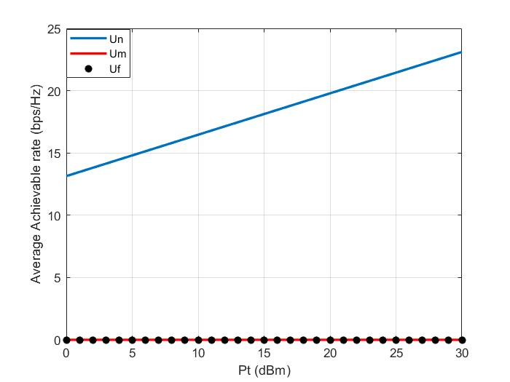
Figure 2: Average achievable rates vs transmit power without cooperative relay.
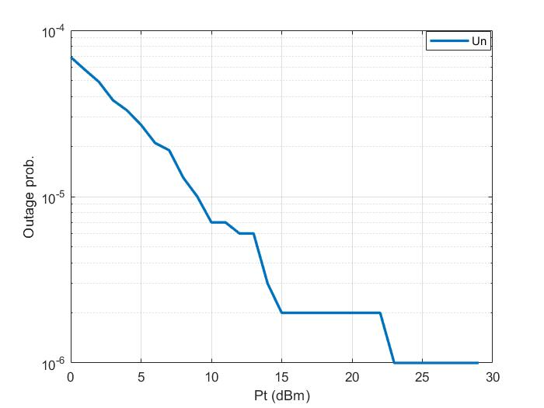
Figure 3: Outage probability of near user NOMA without cooperative relay.
III. Cooperative NOMA Downlink System.
Sometimes there are users located at the cell edge or out of coverage, in that case their signal can be relayed by a relay to improve the reliability for those users under poor channel conditions [22], Figure 4 illustrates the BS communicates with them via the near user by acting as a decode-and-forward relay[23].

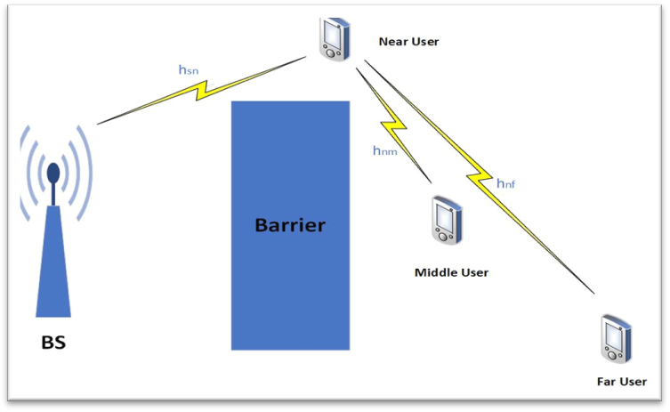
Figure 4: System model-1 of cooperative NOMA- Near User is a Relay to the other two Users.
the achievable rate of the near user is,
$R_{COOP}^{n}=\frac{1}{2}\log_{2}{(1+\frac{{\left|h_{sn}\right|}^{2}P_{t}β_{n}}{σ^{2}})}$ (7)

Now, the near user (relay) will send the signals to both the middle and far users through a special channel between the relay and the middle user and another one between the relay and the farthest user.
$R_{COOP}^{m}=\frac{1}{2}\log_{2}{(1+\frac{{\left|h_{nm}\right|}^{2}P_{t}β_{m}}{σ^{2}})}$ (8)
$R_{COOP}^{f}=\frac{1}{2}\log_{2}{(1+\frac{{\left|h_{nf}\right|}^{2}P_{t}β_{f}}{{\left|h_{nf}\right|}^{2}P_{t}β_{m}+σ^{2}} )}$ (9)
MATLAB is used to simulate the model. Table -1 shows the values of the simulation values that are used in the model.
values that are used in the model.
Table -1
Values of parameters used in the simulation.
Simulation Factors
$$RT$$ | $$1{bps}/{Hz}$$
$$β_{n}$$ | $$0.04$$
$$β_{m}$$ | $$0.16$$
$$β_{f}$$ | $$0.8$$
$$d_{sn}$$ | $$5m$$
$$d_{nm}$$ | $$5m$$
$$d_{nf}$$ | $$10m$$
$$η$$ | 4
Band Width | $$1GHz$$
Thermal noise density | $$-174 dBm/Hz$$

where,
$d_{sn}$ : the distance between the $BS$ and the $U_{n}$.
$d_{nm}$ : the distance between the $U_{n}$ and the $U_{m}$.
$d_{nf}$ : the distance between the $U_{n}$ and the $U_{f}$.
$η$ : Path loss exponent.
Based on Eqs. (7), (8) and (9) to simulate the rates that can be achieved with the transmitted power shown in Fig. (5). It’s clear that the achievable data rate increases linearly for both near and middle users due to using the SIC technology to remove co-channel interference of larger unwanted powers, resulting in higher signal-to-noise ratio and high data rates that can be achieved with increased transmitted power Pt. The results show that an improvement in data rates for the second and third users, with a value ranging from 7.57 bps/Hz to 12.55 bps/Hz for the second user and a near-constant value of 1,292 bps/Hz for the third user at the transmitting power ranging from zero to 30 dBm, the first user’s achievable data rate is reduced by a half due to the relying (a new value ranging from 6.56 bps/Hz to 11.55 bps/Hz).
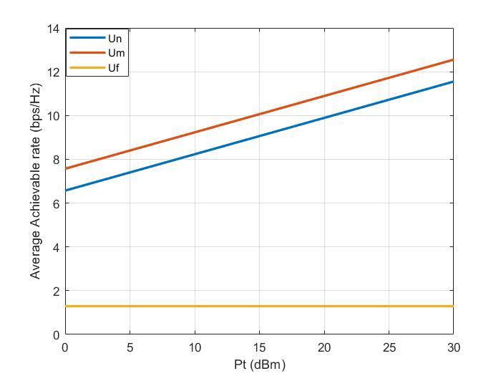
Figure 5: Average achievable rates vs transmit power with cooperative Un relay.
Figure 6 illustrates variation of the outage probability to the transmitted power. It shows that, all users are safe from the outage by contribution of the near user and using it as a relay to extend the coverage network to the other users.
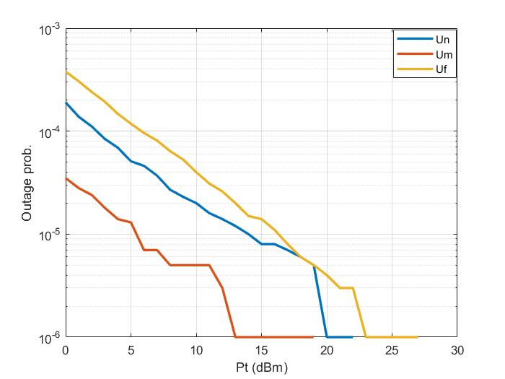
Fig (6): Outage probability of 3 users – Near User is a cooperative Relay.
It’s clear that in Fig. 7 the fluctuation of the instantaneous values of the near and middle users’ achievable rate. It is always higher than the target rate, as well as the stability of the value of the far user’s achievable rate above the threshold target rate despite its low value, which gives the continuity working of the three users without outage. The middle user outperforms the far user in terms of throughputs due to the channel's strength, proximity to the relay, and absence of interference.

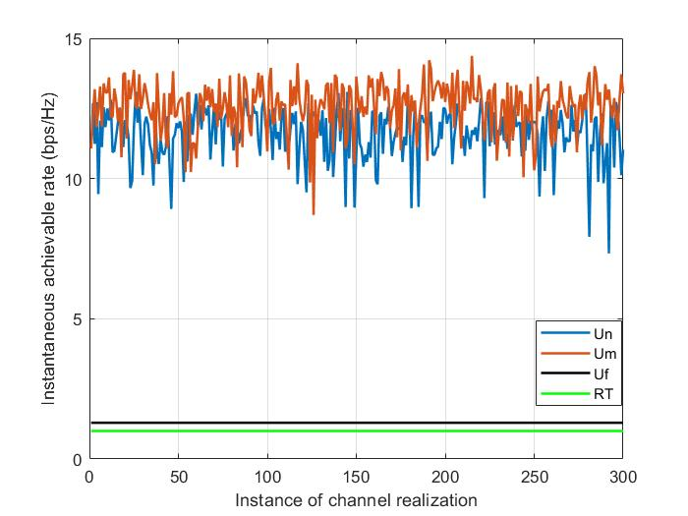
Fig (7): Instantaneous Achievable Rates bit/s/Hz with NOMA cooperative Un relay.

IV. Conclusion
In this paper, a framework has been proposed to increase the area of the spectrum while increasing energy efficiency, based on the principle of the power allocation between users by using the NOMA technology, as well as relying on the principle of cooperation and increasing energy using one of the green energy methods. The system's performance is analyzed using the achievable data rates and the outage probability.
A model has a barrier between the second and third users with absence of a link between them and the base station. The first user acts as a signal relay for the other users, they will be entered into the work and the cooperation will increase the achievable data rate values from zero to (a value ranging 7.57 bps/Hz to 12.55 bps/Hz) and (1,292 bps/Hz), respectively, at transmitting power ranging from zero to 30 dBm. The first user’s achievable data rate has been reduced by half due to the relying, these values make all users working without outage, thus increasing the throughput, spectrum efficiency, and reliability of all users of the proposed system.

References
[1] P. Gandotra, R. K. Jha, and S. Jain, “Green Communication in Next Generation Cellular Networks: A Survey,” IEEE Access, vol. 5, pp. 11727–11758, 2017, doi: 10.1109/ACCESS.2017.2711784.
[2] K. Asatani, “Trends and Issues in 5G Networking and Beyond,” J. ICT Stand., vol. 5, no. 3, pp. 203–224, 2018, doi: 10.13052/jicts2245-800x.531.
[3] M. Liu, “Research on the Development of Intelligent Logistics Based on 5G Technology,” Proc. - 2021 2nd Int. Conf. Urban Eng. Manag. Sci. ICUEMS 2021, pp. 107–110, 2021, doi: 10.1109/ICUEMS52408.2021.00029.
[4] M. Usama and M. Erol-Kantarci, “A survey on recent trends and open issues in energy efficiency of 5G,” Sensors (Switzerland), vol. 19, no. 14, 2019, doi: 10.3390/s19143126.
[5] B. P. Chapa, S. R. Gottapu, and V. K. Mogadala, “India by 2020,” 2018 Int. Conf. Recent Innov. Electr. Electron. Commun. Eng., pp. 639–643, 2020.
[6] P. C. Barman and M. H. Khan, “5G- Future Generation Technologies of Wireless Communication ‘Revolution 2020,’” Am. J. Eng. Res., vol. 4, no. 5, pp. 206–215, 2015.
[7] A. Bohli and R. Bouallegue, “How to Meet Increased Capacities by Future Green 5G Networks: A Survey,” IEEE Access, vol. 7, pp. 42220–42237, 2019, doi: 10.1109/ACCESS.2019.2907284.
[8] J. Lorincz, Z. Klarin, and J. Ožegović, “A comprehensive overview of tcp congestion control in 5g networks: Research challenges and future perspectives,” Sensors, vol. 21, no. 13, 2021, doi: 10.3390/s21134510.
[9] B. Issa and Q. Thabit, “Review in IoT for Healthcare in Our Life Engineering,” Iraqi J. Electr. Electron. Eng., vol. 18, no. 1, pp. 9–20, 2022, doi: 10.37917/ijeee.18.1.2.
[10] W. Strielkowski, M. Dvořák, P. Rovný, E. Tarkhanova, and N. Baburina, “5G Wireless Networks in the Future Renewable Energy Systems,” Front. Energy Res., vol. 9, no. November, 2021, doi: 10.3389/fenrg.2021.714803.
[11] A. Israr, Q. Yang, W. Li, and A. Y. Zomaya, “Renewable energy powered sustainable 5G network infrastructure: Opportunities, challenges and perspectives,” J. Netw. Comput. Appl., vol. 175, p. 102910, 2021, doi: 10.1016/j.jnca.2020.102910.
[12] A. Andrawes, R. Nordin, and N. F. Abdullah, “Energy-efficient downlink for non-orthogonal multiple access with SWIPT under constrained throughput,” Energies, vol. 13, no. 1, 2019, doi: 10.3390/en13010110.
[13] H. M. Alsabbagh, “Influence of the number of antennas on the outage probability of Non-Orthogonal Multiple Access in 5G systems,” Journal of Engineering and Applied Sciences, vol. 13, no. 19. pp. 8051–8056, 2018, doi: 10.3923/jeasci.2018.8051.8056.
[14] A. Ebrahim, A. Celik, E. Alsusa, and A. M. Eltawil, “NOMA/OMA mode selection and resource allocation for beyond 5G networks,” IEEE Int. Symp. Pers. Indoor Mob. Radio Commun. PIMRC, vol. 2020-Augus, pp. 0–5, 2020, doi: 10.1109/PIMRC48278.2020.9217161.
[15] M. Ibrahim and H. AlSabbagh, “Adaptive OFDMA Resource Allocation using Modified Multi-Dimension Genetic Algorithm,” Iraqi J. Electr. Electron. Eng., vol. 12, no. 1, pp. 103–113, 2016, doi: 10.37917/ijeee.12.1.11.
[16] H. Y. Lee and S. Y. Shin, “A Novel User Grouping in Phase Rotation Based Downlink NOMA,” IEEE Access, vol. 10, pp. 27211–27222, 2022, doi: 10.1109/ACCESS.2022.3157318.
[17] W. Bai and P. Lin, “Performance Optimization of Ultra -Dense Network Based on Non-Orthogonal Multiple Access,” Proc. IEEE Int. Conf. Softw. Eng. Serv. Sci. ICSESS, vol. 2020-Octob, pp. 193–196, 2020, doi: 10.1109/ICSESS49938.2020.9237721.
[18] X. Pei, Y. Chen, M. Wen, H. Yu, E. Panayirci, and H. V. Poor, “Next-Generation Multiple Access Based on NOMA with Power Level Modulation,” IEEE J. Sel. Areas Commun., vol. 40, no. 4, pp. 1072–1083, 2022, doi: 10.1109/JSAC.2022.3143240.
[19] A. Marzook, H.Mohammed and H.Sawadi, “Performance of Non – Orthogonal Multiple Access (NOMA) with Successive Interference Cancellation (SIC),” Iraqi J.Electr. Electron. Eng., (15-16), pp. 152-156, 2020,doi: 10.37917/ijeee.sceeer.3rd.21.
[20] Z. Wei, J. Yuan, D. W. K. Ng, M. Elkashlan, and Z. Ding, “A Survey of Downlink Non-orthogonal Multiple Access for 5G Wireless Communication Networks.” 2016, [Online]. Available: http://arxiv.org/abs/1609.01856.
[21] S. Rezvani, E. A. Jorswieck, R. Joda, and H. Yanikomeroglu, “Optimal Power Allocation in Downlink Multicarrier NOMA Systems: Theory and Fast Algorithms,” IEEE J. Sel. Areas Commun., vol. 40, no. 4, pp. 1162–1189, 2022, doi: 10.1109/JSAC.2022.3143237.
[22] Z. Ding, M. Peng, and H. V. Poor, “Cooperative Non-Orthogonal Multiple Access in 5G Systems,” IEEE Commun. Lett., vol. 19, no. 8, pp. 1462–1465, 2015, doi: 10.1109/LCOMM.2015.2441064.
[23] C. E. Garcia, P. V. Tuan, M. R. Camana, and I. Koo, “Optimized Power Allocation for a Cooperative NOMA System with SWIPT and an Energy-Harvesting User,” Int. J. Electron., vol. 107, no. 10, pp. 1704–1733, 2020, doi: 10.1080/00207217.2020.1756432.

