**Toxic effect of lead and cadmium on phenotypic and chemical properties of *Trigonella foenum-graecum***

Arooba Heliji Muhammed* Widad Mizban Taher* and Salwa Abdul zahra Abduljaleel**

**\*College of Science, Department of Ecology, Basrah University**

**\*College of Science, Department of Ecology, Basrah University**

**\*\*College of Science, Department of Biology, Basrah University**

**Abstract:**

Current study aims to determine the effect of cadmium and lead on the phenotypic and physiological characteristics of plant *Trigonella foenum-graecum* in soils after different concentrations of the two elements were added*,* as well as studying the effect of cadmium and lead on the active chemical compounds in plant and there medicinal role.

The plant seeds were planted and monitored for a period of seven months, from November 2020 to May 2021 and recording the required observations and results after exposing the plants to concentrations (10, 25, 50) ppm of each element cadmium, lead and a mixture of the two elements.

The highest salinity was recorded 1.848 mg/ for treated soil with cadmium at concentration 50ppm and the lowest 0.884 mg/L for treated soil with mixture at concentration 10ppm, result recorded highest number of active chemical compounds about 41 compound for mixture treatment at concentration 50 ppm, and lowest 21 compound for the control treatment.

Key word: cadmium, lead, *Trigonella foenum-graecum*, pollutants

**Introduction**

Heavy metals are among the most important environmental pollutants (Hamaze *et al*., 2020) it is related to the processes of growth, development and reproduction in living organisms it can become toxic in high concentrations such as lead and cadmium (MDE, 2003) it has harmful effects as it is highly toxic and non-degradable it has along biological half-life in addition to its ability to bio accumulate in differernt parts of the body as well as the accumulation across the levels of the food chain, which is called bio magnification its ability to cause cancerous tumors as well as to combine with other elements that may form new, more toxic compounds (Younus and AL-Khafaji, 2020).

Lead is one of the most toxic heavy metals in the environment, plants respond to the toxic effects of lead in different ways (Gupta *et al*., 2009) the element interacts with cellular compounds and increases the thickness of the cell wall, plant cell wall usually contain pectin, this process is the cornerstone of plant cell resistance to lead toxicity (Eun *et al*., 2002) with increased to organ and tissue infrastructure, chloroplasts, nucleus, cell wall and cell membrane in plants, this damage can cause loss of organelle function and can effect normal physiological protein synthesis and cell division with plant species (Salazar and Pignata, 2014).

Cadmium is a highly toxic trace element even if it appears in low concentrations it affects the opening and closing of stomata and the process of transpiration and photosynthesis in plants, plants grown in soil containing high levels of cadmium show visible symptoms of infection such as stunted growth, browning of root tips and eventually death (AL-Gizzi *et al*., 2020).

In the current study was used *T.foenum-gra*ecum because of its medical importance, its seeds containing many active substances in clouding alkaloids Trigonelline and choline and compounds of calcium, phosphorous and vitamin D. In addition to 25% proteins,50% carbohydrate, 6% fixed oil, 1.05% volatile oils, 28%gels and 25% alkaloids (AL-Mayah, 2013).

**Materials and methods**:

The study was conducted in the Ecology Department of the College of Science, University of Basrah for a period of six months, from November to May for the academic year (2020-2021) for the purpose of knowing the effect of cadmium Cd and lead Pb pollution on plant *Trigonella foenum-graecum*.

**Calculation of the germination percentage of the experimental plant**

*Trigonella foenum-graecum* seeds were grown in plastic dishes with 25 seeds per dish and 4 dishes for a total of 100 seeds, after placing filter paper in the dish as culture medium the seeds were sprinkled with distilled water, the dishes were closed and placed in a culture incubator at 20 Cº (in the Microbiology Laboratory- Department of Ecology) then the number of seeds growing every 5 days was recorded for the plant.

Calculate the percentage of germination from the equation:

Germination percentage %=Number of seeds growing / Total number of seeds*100

**Preparation of heavy metal concentrations**

Standard solutions were prepared using a standard solution of concentration 1000 mg/L from dissolving lead nitrate salts Pb(NO3)2 and cadmium nitrate salts Cd(NO3)2 depending on the equation described before (Abbas *et al*., 2014)

W (g) = mg/L1000 * MW/Ar*N. atoms *V/1000

W=required weight (g)

MW=the molecular weight of the compound

Ar= the atomic weight of the element

N. atoms= the number of atoms of the element

V= required volume (milliliter)

Attended the initial test concentrations (5,10,15,25,50,75) ppm using the law of dilution

X1 × V1 = X2 × V2

To determine the concentrations in which plants grow, was chosen (10, 25, 50) ppm.

Used plastic pots prepared for cultivation, with a rate of 3 replications for each concentration, the experiment lasted for 40 days under laboratory conditions.

The temperature was measured in the laboratory with a graduated mercury thermometer, measure the pH ,salinity and total organic carbon of the soil were measured with 3 replicates for each concentration of the soil and control samples, plant high, leaf length, chlorophyll a, b, total chlorophyll, carotene and total plant organic carbon were estimated with 3 replicates for each concentration of the plant and control samples.

**Prepare the mixture of the two components**

The pre-prepared cadmium and lead elements were mixed in known proportions and according to the required concentrations and mixed together to find out the effect of the interference on plants, the experiment was conducted for 40 days and with 3 replications as well.

**Conduct the experiment**

After observing the growth of the plant for a period of two months and the appearance of its true leaves, at a height of 30 cm.The plants in the experiment were irrigated with the prepared concentrations of both components and the mixture, while the control plants (comparator) were irrigated with distilled water.

**Soil**

After completing the experiment (four months), the potting soil for each plant was taken and concentrated and dried at room temperature, then cleaned and sieved with a sieve whose holes size is 63 mm and kept in plastic containers for the purpose of making the required measurements on them.

**Measuring the physical and chemical properties of the soil**

**1-Temperature measurement**

The temperature in the laboratory was measured with a graduated mercury thermometer from 0-100 Cº, by placing the thermometer in the laboratory and leaving it for five minutes, then recording the reading for it.

**2- pH and salinity measurement**

Measure the pH and salinity according to the method described before Estefan *et* *al*.(2013), take a weight of 25 g of soil and put it in a glass beaker, add 75ml of distilled water to the glass beaker, shake well and then leave for 24 hours, then the solution was filter papers, then the pH of the filter was determined using a pH-meter a model HQ411d American made, salinity was estimated with a salinity meter model SD320 Con German –made and the output is expressed in mg/L.

**3- Measurement of soil total organic carbon**

Amount of total soil organic carbon by Weaver and Clemmets (1973) incineration method it takes 1 g of soil, then it was placed in an eyelid with a known weight and then put into the restoration furnace at a temperature 550 Cº for 48 hour, the sample was weighed after it was extracted from the furnace and according to the weight difference, which is the amount of total organic carbon, according to the equation:

**Total carbon weight= weigh the syringe with the soil before burning-weight the syringe with the soil after burning*100**

**1-Measure the height of the plant and the length of the leaves**

Both the height of the plant and the length of the leaves of the plant used in the study were measured from the surface of the soil to the top of the plant with three repetitions using a ruler, express the result in centimeter according to the source Ogbo *et al*.(2010).

**2- Measurement of total chlorophyll and carotene**

Estimated each of chlorophyll A, chlorophyll B and total chlorophyll by crushing with 80% acetone according to the method mentioned in Abbas (1987), take 1g of fresh leaves of the plant and add 20 ml of acetone in a concentration 80% (prepared from 80% acetone to which 20 ml distilled water has been added), the sample was left for 24 hour after which it was crushed in a ceramic mortar until green plant extract is obtained the samples were filtered by filter paper and the remnants of the ceramic mortar were washed with 5 ml of acetone to obtain all the extracts, complete the volume to 50ml then measure the total chlorophyll in the filtrate using a Specterophotometer on both wavelengths (663 chlorophyll A, 645 chlorophyll B) nm, the readings were recorded at each wavelength, then the following equation was used to find the final value of total chlorophyll :

Total chlorophyll=[20.2(A645)+8.02(B663)]*V/1000*W

In the same way, the concentration of carotene in the plant was estimated at a wavelength 480 nm depending on the method (Kirk and Allen, 1965) according to the equation:

Carotene= [A 480+(0.114*A663)-(0.638*A645)]*V/1000*W

**3- Measurement of the total organic carbon of plant**

The amount of total organic carbon of the plant according to (Ball, 1964) incineration method, after drying the plant and grinding them with ceramic mortar, take 1g of the plant and placed in eyelid of known weight, and then the eyelid was placed in the incineration furnace at temperature of 450 Cº for 24 hour, the sample was weighed after extracting it from the furnace and according to the weight difference, which is the amount of total organic carbon of the plant according to the equation below

W.T.C=W. eyelid with the plant before burning-W. eyelid with the plant after burning*100

**4- Chemical determination**

Estimated chemicals in the plant according to (Haarborn, 1984) after drying and grinding the plant take 1g from dried and ground plant and placed in 100 ml glass beaker then add to it 10 ml of ethyl alcohol concentration of 70%, shake well and put the mixture on the Megnetic stirrer for three hours, the extract was left for 24 hour and then filtered through filter papers the filtrate was collected and placed in a test tube and sent to the Nahran Omar laboratories of the Basrah Oil Company for the purpose of conducting chemical analysis using GC-MS.

**Results and discussion**

**Physical and chemical properties**

**Temperature**

Figure (1) shows the rate temperatures measured during the experiment period, it was noted that the highest temperature was 21.5Cº on the twentieth day of the experiment and the lowest was 19.5 Cº on the tenth and fortieth day of the experiment

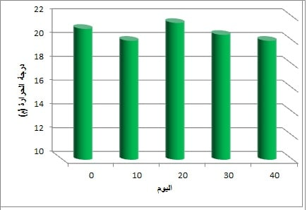

Temperature (**Cº)**

**Day**

Figure (1): the rate air temperature

**pH**

Figure (2) shows the pH rate of soils contaminated with the different concentration of cadmium and lead elements for a plant *T. foenum- graecum* the highest was 6.50 in the treatment of the mixture at concentration 50ppm and the lowest 6.12 to treatment lead in concentration 10ppm compared the control sample, which had a pH of soil 6.74.

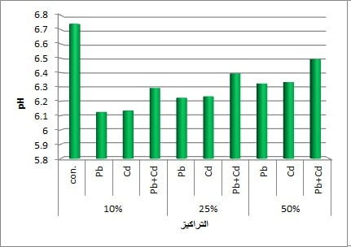 The statistical analysis showed that there were no significant differences at the level (*p*< 0.05).The reason for the low pH value may be attributed to the addition of cadmium and lead to soils of plant *T. foenum- graecum* these results are agreement with the study (AL-Jubouri, 1995), (Abu Dahl, 1999) and (AL-Jumaily and Rahi, 2000) who found that adding sulfur lowered the pH of the soil.

**Concentration**

**25ppm**

**50ppm**

**10ppm**

Figure (2): pH rate of soils contaminated with different concentrations of cadmium and lead for plants *T. foenum- graecum*

**Salinity**

Figure (3) shows the salinity rate of soils contaminated with different concentrations of cadmium and lead for plant *T. foenum- graecum*, and it was the highest 1.848 mg/L to treatment cadmium at concentration 50ppm and the lowest 0.884 mg/L in mixture treatment at concentration 10 ppm while the control sample whose salinity was 1.398 mg/L . The statistical analysis showed that there were no significant differences at the level (*p*<0.05). The reason for this may be attributed to the addition of cadmium and lead to the potting soil, which may increase the salinity of the soil, also carrying watering causes the accumulation of salts and the absence of organic matter in the potting soil lead to high concentrations of salinity in it.

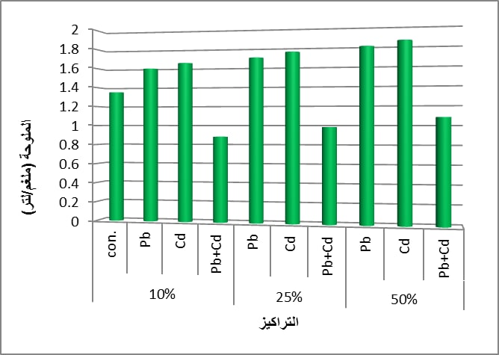

**Salinity (mg/L)**

**50ppm**

**Concentration**

**25ppm**

**10ppmm**

Figure (3): salinity rate for soils contaminated with different concentrations of cadmium and lead for plant *T. foenum- graecum*

**Total organic carbon of soil**

Figure (4) shows the total organic carbon rate for soil contaminated with different of cadmium and lead for plant *T. foenum- graecum* the highest was 0.06 g for the two treatments of cadmium, lead at both concentrations (25,50) ppm and the lowest 0.02 g at concentration50 ppm treatment the mixture compared with the control sample, which amounted to total organic carbon 0.05 g. The statistical analysis showed that there were significant differences at the level (*p<*0.05). The reason for this is that soil contamination with heavy metals leads to an increase in the total organic carbon in the soil (Shirdam *et al*., 2008).

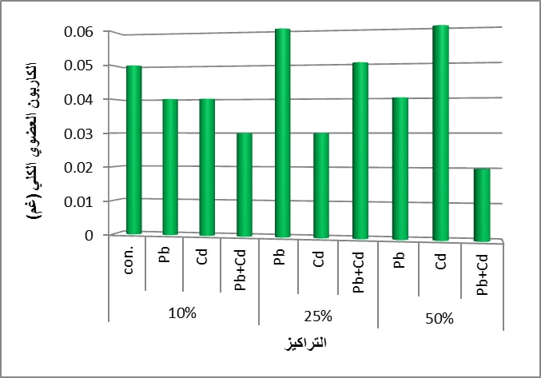

**Organic carbon (g)**

**50ppm**

**25ppm**

**10ppmm**

**Concentrations**

Figure (4): total organic carbon rate of soils contaminated with different concentrations of cadmium and lead for plant *T. foenum- graecum*

**Plant examinations**

**Plant height**

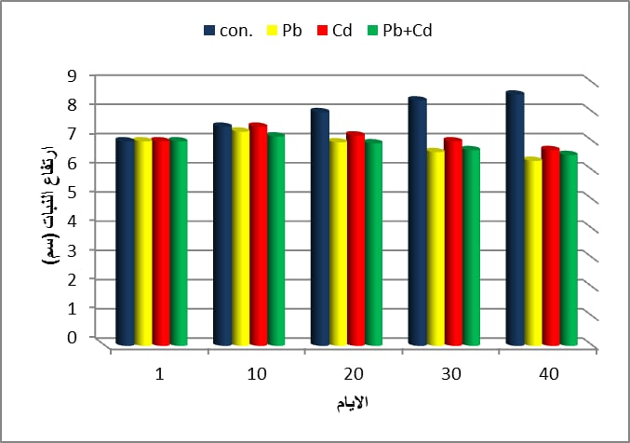Figure (5) shows the rate of high plant *T. foenum- graecum* the highest was 7.3 cm to treatment cadmium on the tenth day of the experiment and the lowest 6.2 cm to treatment lead at the end of the experiment compared with the control sample which reached a plant height 8.6 cm. The statistical analysis showed that there were significant differences at the level (*p*< 0.05).The results show that the plant height was affected by heavy metals added to the soil the effect of the lead element is from the height of the plant, and the reason for this is due to the toxicity of the lead element it can affect the permeability of the plasma membrane, resulting in a decrease in the water content of cells especially, the interference of cadmium with the water balance was diagnosed(Costa and Morel, 1994).The toxicity of the cadmium element is a reason for the effect of plants, and stunting is one of the main and visible symptoms of cadmium toxicity(Moreno et al., 1999).

**Plant height (cm)**

**Days**

Figure (5): the rate of height of the plant *T. foenum- graecum* pollutant with different concentrations of cadmium and lead

**Leaf length**

Figure (6) shows the rate leaf length of plant *T. foenum- graecum* pollutant with different concentrations of cadmium and lead the highest was 1.34cm in treating cadmium at the beginning of the experiment, and the lowest was 0.98cm in treating the mixture at the end of the experiment compared to the control sample which the length of the leaf was 1.5 cm. The statistical analysis showed that there were significant differences at the level (*p*< 0.05). This effect may be attributed to the deterioration of the plasma membrane by heavy metals, which leads to a decrease in the absorption of nutrients, causing poor growth and a lack of leaf area.(Baccio *et al*., 2003).

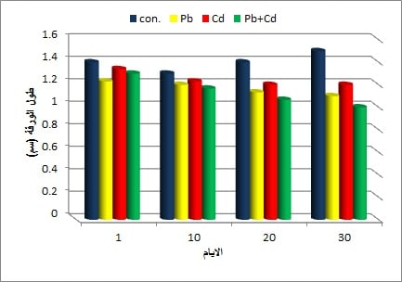

**Leaf length (cm)**

**~~D~~ays**

Figure (6): the rate leaf length of the plant *T. foenum- graecum* polluted with different concentrations of cadmium and lead

**Chlorophyll A**

Figure (7) showed the rate chlorophyll A of the plant *T. foenum- graecum* polluted with different concentrations of cadmium and lead the highest was 0.0299 mg/g in the mixture treatment on the 20th day of the experiment, and the lowest was 0.0104 mg/g in the mixture treatment at the end of the experiment compared with the two control samples in which chlorophyll A was 0.0424, 0.0394 mg/g. The statistical analysis showed that there were significant differences at the level (*p*< 0.05).The reason for this is due to the effect of the mineral stress of heavy elements on the leaves of plants, as the color of the leaves changes to yellow, and that the deterioration that occurs to chlorophyll occurs during the inhibition of the action of some enzymes, and the lack of leaf area as a result of exposure to heavy elements is an indirect cause of the decrease in the content of chlorophyll in leaves (AL-Nuaimi, 1990).

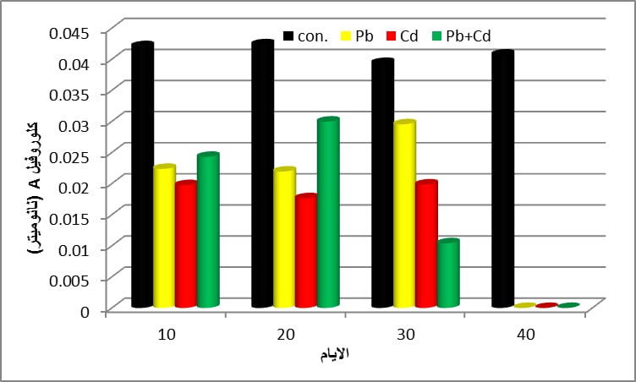

**Chlorophyll A (mg/g)**

**Days**

Figure (7): the rate of chlorophyll A of the plant *T. foenum- graecum* polluted with different concentrations of cadmium and lead

**Chlorophyll B**

Figure (8) showed the rate chlorophyll B of the plant *T. foenum- graecum* polluted with different concentrations of cadmium and lead the highest was 0.0292 mg/g in the cadmium treating at the beginning of the experiment and the lowest was 0.01205 mg/g in the mixture treated at the end of the experiment compared with the two control samples in which chlorophyll B 0.0562, 0.0611 mg /g. The statistical analysis showed that there were significant differences at the level (*p*< 0.05).The reason is that heavy metals have a toxic effect on plant leaf components, especially since the more cadmium is in the plant tissues, the less its content of chlorophyll is due to the inhibitory effect of cadmium on the work of the enzymes contributing to the chlorophyll synthesis process (AL-Mayah and AL- Assadi, 2012).

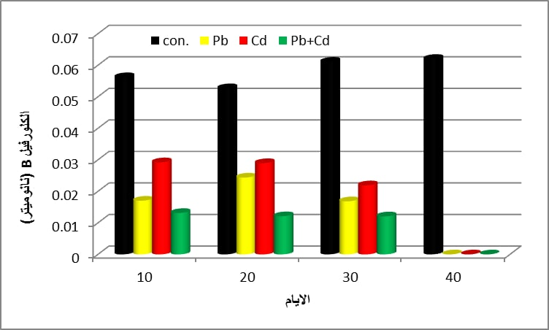

**Chlorophyll B (mg/g)**

**Chlorophyll B (mg/g)**

**Days**

Figure (8): the rate of chlorophyll B of the plant *T. foenum- graecum* polluted with different concentrations of cadmium and lead

**Total chlorophyll**

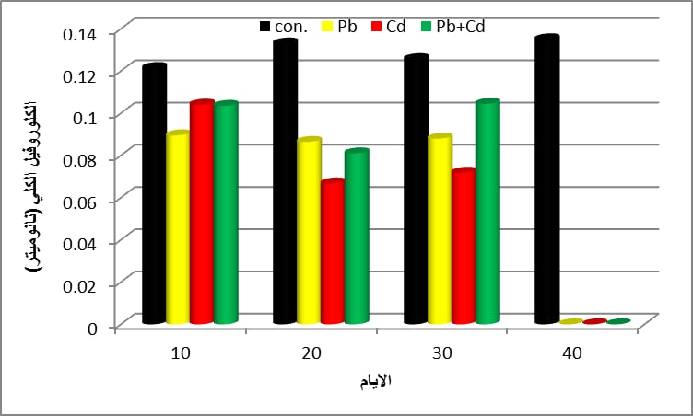 Figure (9) shows the total chlorophyll rate of the plant *T. foenum- graecum* polluted with different concentrations of cadmium and lead the highest was 0.10405 mg/g in treated cadmium at the beginning of the experiment and the lowest was 0.0667 mg/g in treated cadmium on the 20th day of the experiment compared with the two control samples in which the total chlorophyll rate was 0.1256, 0133 mg/g. The statistical analysis showed that there were significant differences at the level (*p*< 0.05). Reducing the total chlorophyll content is a symptom of plant toxicity after being exposed to different concentrations of heavy metals, and it is the most important vital indicator of elemental stress plant for stress element (Karmakar *et al*., 2014).

**Total chlorophyll (mg/g)**

**Days**

Figure (9): the total chlorophyll rate of the plan *T. foenum- graecum* polluted with different concentrations of cadmium and lead

**Carotene**

Figure 10 showed the carotene rate of the plant *T. foenum- graecum* polluted with different concentrations of cadmium and lead the highest was 0.00395 mg/g in the cadmium treatment at the beginning of the experiment and the lowest was 0.00104 mg/g in the cadmium treatment on the twentieth day of the experiment compared with the two control samples whose carotene levels were 0.0042, 0.0041 mg/g. The statistical analysis showed that there were significant differences at the level (*p*< 0.05). This is due to the fact that increasing the carotene content is a defensive strategy for plants to combat mineral stress. Some non-enzymatic antioxidants, including carotenoids, may play a role in the events of resistance to heavy elements by protecting the changeable macromolecules from the attack of free radicals that are formed during various metabolic reactions that lead to oxidative stress (Galli *et al*., 1996).

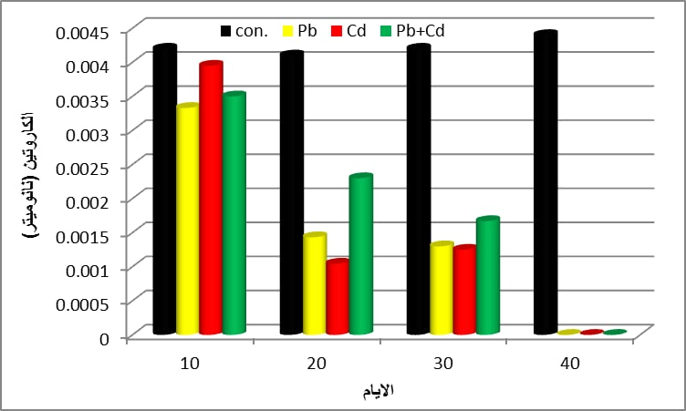

**Carotene (mg/g)**

**Days**

Figure (10): the rate of carotene for the plant *T. foenum- graecum* polluted with different concentrations of cadmium and lead

**Total organic carbon of plant**

Figure (11) shows the total organic carbon of the plant *T. foenum- graecum* polluted with different concentrations of cadmium and lead, the highest was o.51 g for the cadmium treatment at 10 ppm and the lowest was 0.31g at 50 ppm for the mixture treatment compared to the control sample whose the total organic carbon was o.55g. The statistical analysis showed that there were significant differences at the level (*p*< 0.05).The reason for this may be attributed to the mineral stress that leads to an increase in the total organic carbon (Macoustra *et al*., 2015).

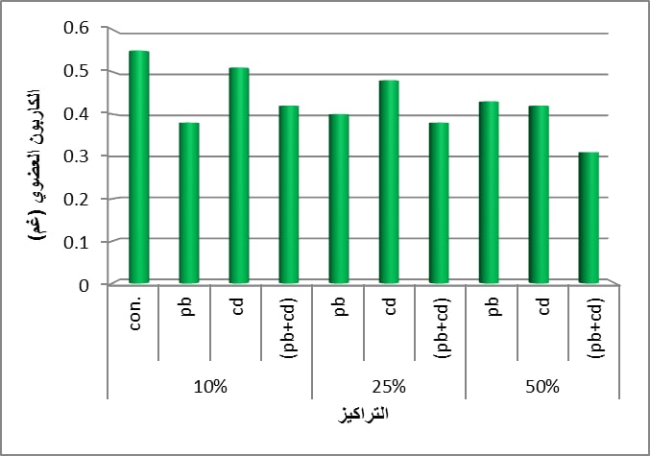

**Organic carbon (g)**

**25ppm**

**Concentrations**

**50ppm**

**10ppm**

Figure (11): total organic carbon rate for the plant *T. foenum- graecum*

Contaminated with different concentrations of cadmium and lead

**The number of active chemical compounds extracted from the plan*T. foenum- graec*um:**

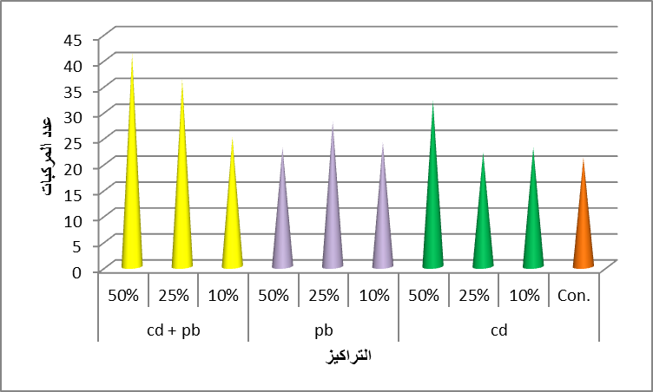Figure (12) shows the number of active chemical compounds extracted from the plan *T. foenum- graecum* Contaminated with different concentrations of cadmium and lead,The number of chemical compounds extracted from the plant *T. foenum- graecum* varied according to the concentrations of cadmium and lead added, the number of compound diagnosed with GC-Mass technology in the control sample was 21 compounds the concentration of 50 ppm for the treatment of the mixture showed 41 compounds, followed by 36 compounds for the concentration of 25 ppm for the treatment of the mixture. The reason for this difference in the number of diagnosed compounds is due to the stress caused by adding heavy elements to plants, as they have a physiological reaction to protect the seeds from stress and increase their resistance against those heavy elements. The characteristic of the plant *T. foenum- graecum* it deals with seeds accordingly the plant takes the defensive role by producing many effective compounds which is a reaction to that increase in the concentration of heavy metals and thus works to prevent reaching them and make.

**Number of compounds**

10

25

50

10

25

50

50

10

25

**Concentration (ppm)**

Figure (12): the number of active chemical compounds extracted from the plant *T. foenum- graecum* Contaminated with different concentrations of cadmium and lead

**Percentages of active chemical compounds extracted from the plant *T. foenum- graecum*:**

**1-Compound Ethyl Oleate**

Ethyl Oleate is an aromatic compound of the ester group found in organic supplements (marjoram oil).It also one of the compounds that are used at present in the production of biofuels (Tapanes *et al*.,2003) by which extract from the plant of the barnacles J.tropha curcas (L.) it is a colorless oil although some samples may appear yellow it is regulated as afood additive in the United States by the Food and Drug Administration and is also used as a solvent for pharmaceutical preparations containing lipophilic substances such as steroids, lubricants and plasticizers (Laposata, 2010).

From Appendix (1) recorded the highest percentage of compound Ethyl Oleate which was 3.27% for the concentration 50 ppm to treat lead and the lowest percentage of the compound Ethyl Oleate which was 2.03% for the concentration 25 ppm to treat the mixture compared to the control sample, in which the percentage of the compound was 4.42%. Figure (13)

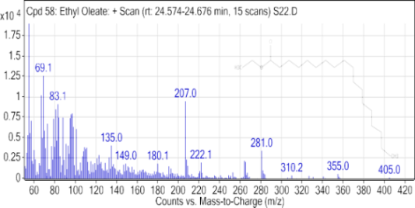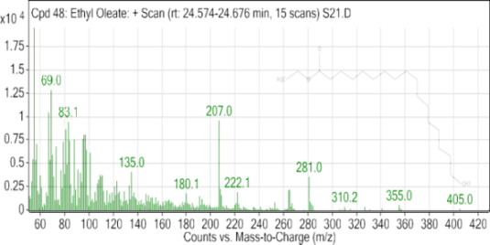

con

10ppmcd

50ppmcd

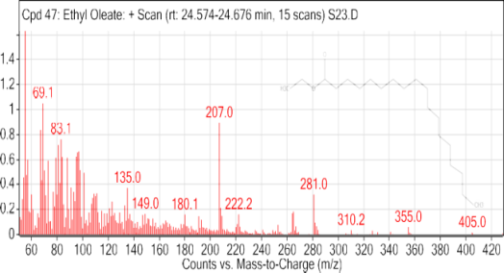

25ppmcd

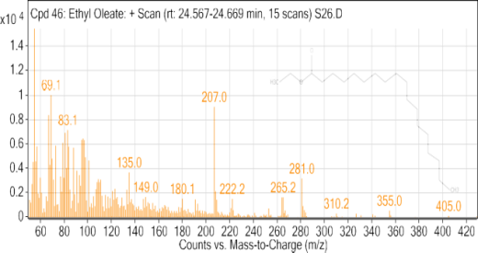



10ppmpb

25ppmpb



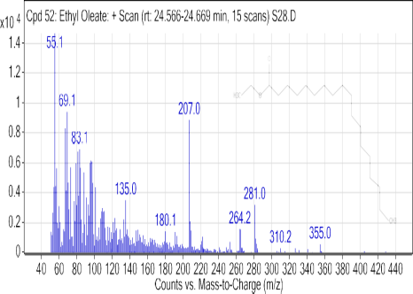



50ppmpb

10ppm(cd+pb)

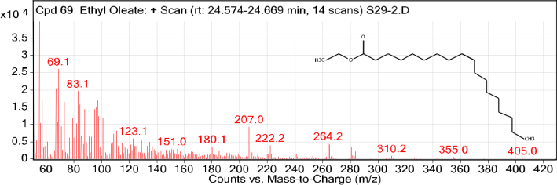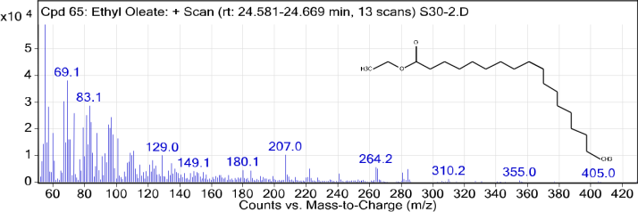

50ppm (cd+pb)

25ppm (cd+pb)

Figure (13): Chemical structure of the compound Ethyl Oleate in the plant *T. foenum- graecum* Contaminated with different concentrations of cadmium and lead

**2- Compound Cyclotrisiloxane, hexamethy**

Cyclotrisiloxane, hexamethy of manufactured compounds used for cosmetic agents this compound does not occur naturally. From Appendix (1) recorded the highest percentage of compound Cyclotrisiloxane, hexamethy which was7.17% for the concentration 25 ppm to treat the cadmium and the lowest percentage of the compound Cyclotrisiloxane, hexamethy which was 0.70% for the concentration 10 ppm to treat the mixture compared to the control sample, in which the percentage of the compound was 1.70%. Figure (14).

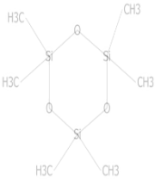

Con.

10ppmcd

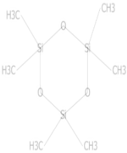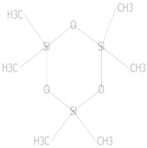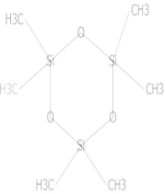

25ppmcd

50ppmcd

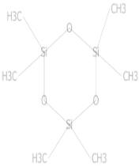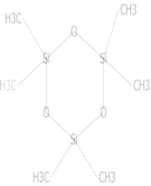

50ppm pb

25ppmpb

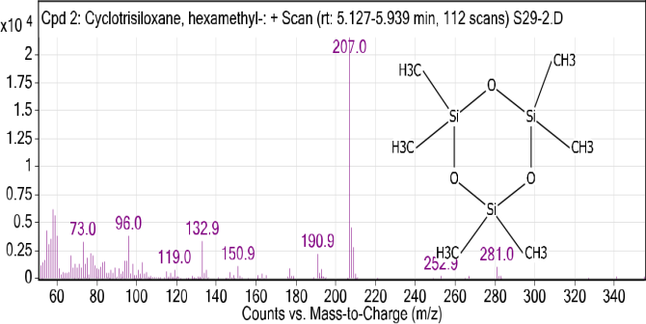

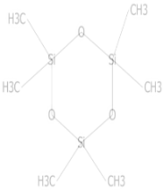

25ppm (cd+pb)

10ppm (cd+pb)

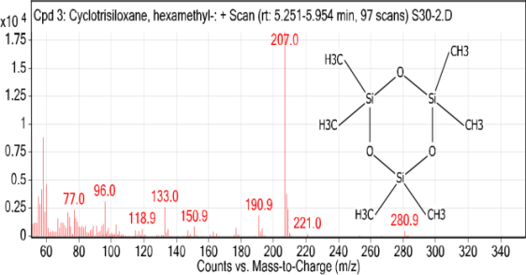

50ppm (cd+pb)

Figure (14): Chemical structure of the compound Cyclotrisiloxane, hexamethy in the plant *T. foenum- graecum* contaminated with different concentrations of cadmium and lead

**3-Compound Cyclotetrasiloxane, octamethyl**

The compound Cyclotetrasiloxane, octamethyl is one of the compounds used in many different industries it causes its accumulation on different parts of the body such as the liver and the respiratory system, and this compound has not been isolated from nature. From Appendix (1) recorded the highest percentage of the compound Cyclotetrasiloxane, octamethyl which was 3.51%for the concentration 25 ppm to treat mixture while the lowest percentage was recorded for concentration 10ppm to treat cadmium was 1.82% compared with the control sample, which was the percentage 3.90%. Figure(15).

50ppmcd

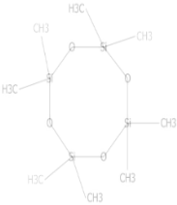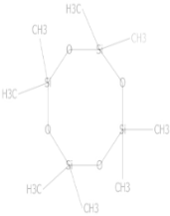

25ppmcd

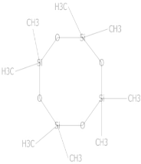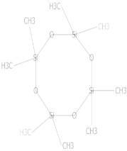

25ppmpb

50ppmpb

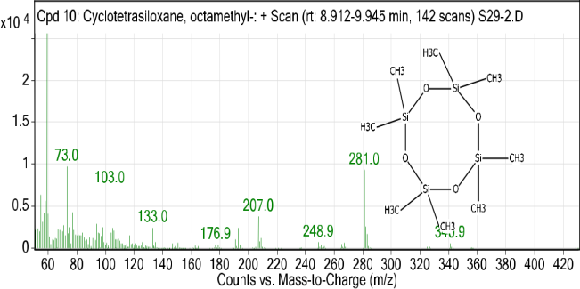

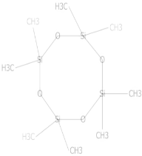

10ppm(cd+pb)

**25ppm(cd+pb)**

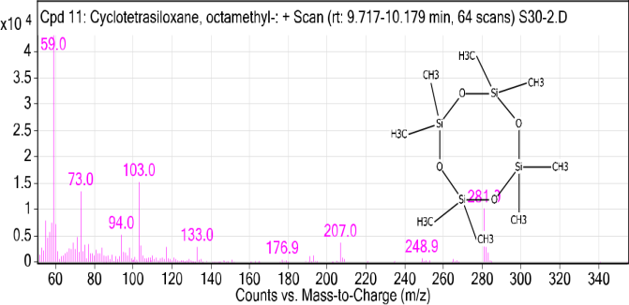

50ppm(cd+pb)

Figure (15): The chemical composition of the ompoundCyclotetrasiloxane,octamethyl in the plant *T. foenum- graecum* contaminated with different concentrations of cadmium and lead

**4- Compound Benzenemethanol,4-hydroxy-.alpha.-[1-(methylamino)ethyl]-,(R*,S*)**

ThecompoundBenzenemethanol,4-hydroxy-.alpha.-[1-(methylamino)ethyl]-(R*,S*) is one of the alkaloid compounds that have not been isolated so far from the natural world it is a compound that has the ability to increase the secretion of adrenaline in the synapsesm it is used as a stimulant and a bronchodilator, athletes use it as a stimulant to increase endurance in championship games, and it is also used with pain relievers to relieve cold symptoms by relieving airway congestion, which reduces the amount of mucus and facilitates breathing. From Appendix (1) recorded the highest percentage of the compound Benzenemethanol,4-hydroxy-.alpha.-[1-(methylamino)ethyl]-,(R*,S*)]- which was28.30% for the concentration 25ppm to treat lead, its lowest percentage was 14.22% for the concentration 50ppm to treat lead compared with the control sample, in which the percentage was 17.21%..Figure(16).

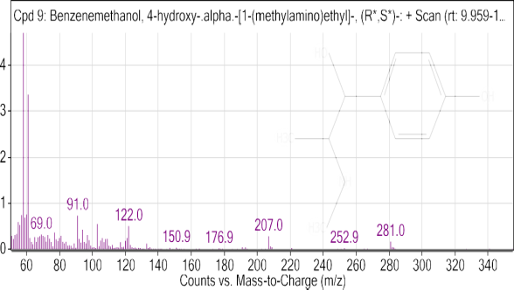

con

10ppmcd



25ppmcd

50ppmcd



25ppmpb

10ppmpb



50ppmpb

10ppm(cd+pb)

Figure (16): The chemical composition of the compound Benzenemethanol,4-hydroxy-.alpha.-[1-(methylamino)ethyl]-,(R*,S*) in the plant *T. foenum- graecum* contaminated with different concentrations of cadmium and lead

**5-Compound 2, 5-Octadecadiynoic acid, methyl ester**

The compound 2, 5-Octadecadiynoic acid, methyl ester is among the derivatives of fatty acids, as it was diagnosed for the first time from the tea plant Camellia sineensis which is used in alternative medicine and in the treatment of infections. From Appendix (1) recorded the highest percentage of the compound 2, 5-Octadecadiynoic acid, methyl ester which was 23. 92% for concentration 10ppm to treat mixture, the lowest percentage was 3.23% for concentration 50ppm to treat mixture compared with the control sample in which the percentage was 6.06%. Figure(17).



con



10ppmcd

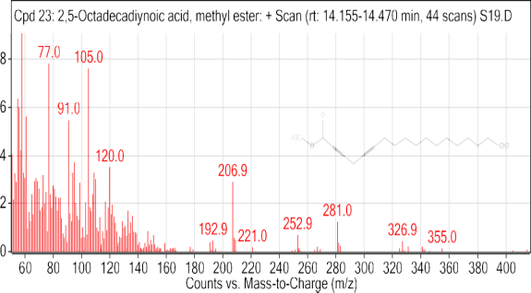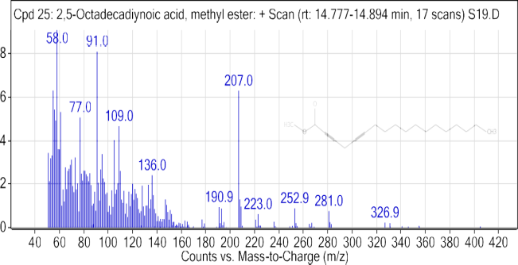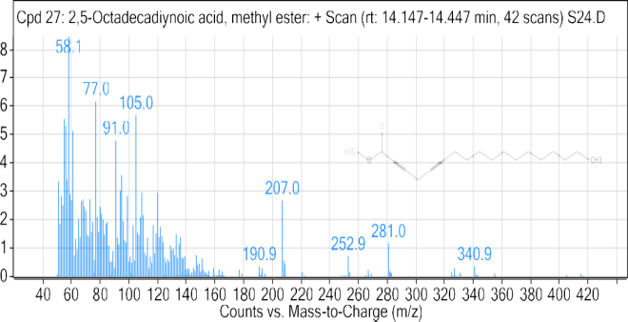

25ppmcd

50ppmcd



10ppmpb

25ppmpb



50ppmpb



10ppm(cd+pb)

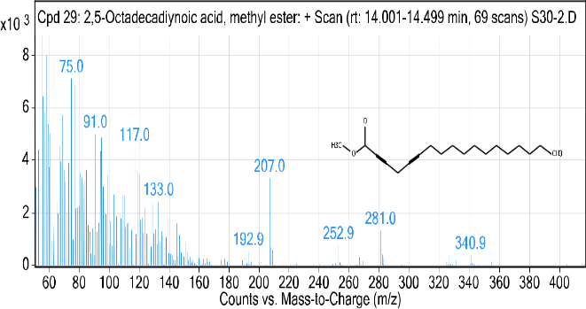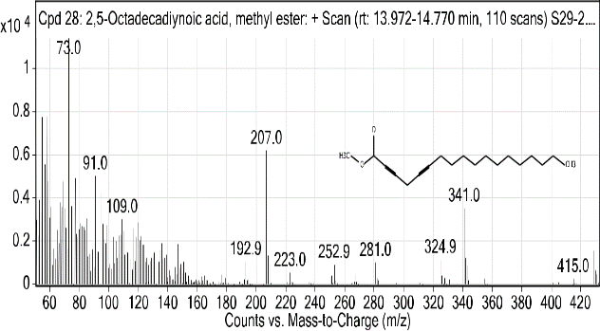

50ppm(cd+pb)

25ppm(cd+pb)

Figure (17): The chemical composition of the compound 2, 5-Octadecadiynoic acid, methyl ester in the plant *T. foenum- graecum* contaminated with different concentrations of cadmium and lead

**6-Compound2, 7-Diphenyl-1,6-dioxopyridazino[4,5;2',3'] pyrrolo[4',5'-d]pyridazine**

The compound 2,7-Diphenyl-1,6-dioxopyridazino[4,5;2',3'] pyrrolo[4',5'-d]pyridazine one of the alkaloids isolated from the plant *Datura* (L.) From Appendix (1) recorded the highest percentage of the compound 2,7-Diphenyl-1,6-dioxopyridazino[4,5;2',3'] pyrrolo[4',5'-d]pyridazine which was 0.76%for concentration 25ppm to treat cadmium and the lowest percentage, which was 0.52% for concentration10ppm to treat lead compared with the control sample in which the percentage was 1.27%. Figure (18).



Con

10ppmcd

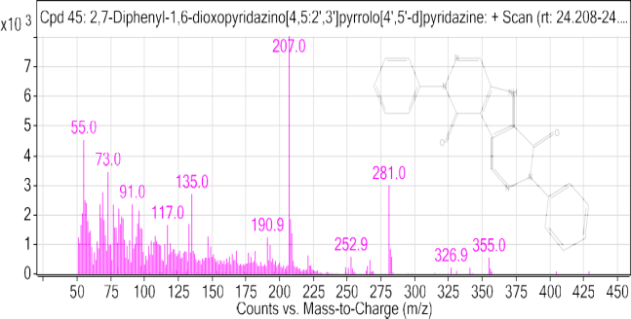

25ppmcd

50ppmcd



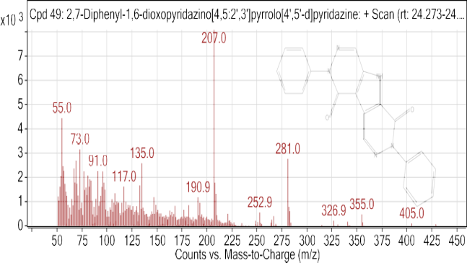

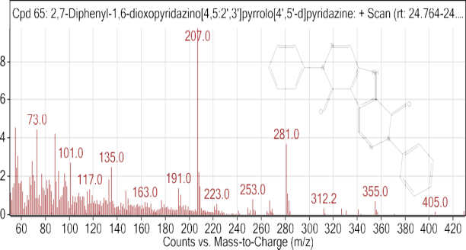

10ppm(cd+pb)

50ppmpb

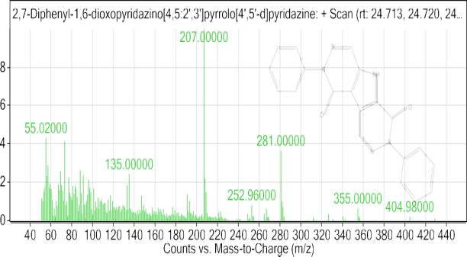

25ppmpb

25ppm(cd+pb)

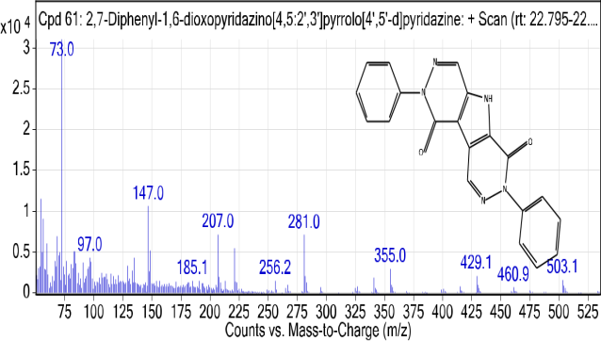

50ppm (cd+pb)

Figure (18): The chemical composition of the compound2,7-Diphenyl-1,6-dioxopyridazino[4,5;2',3'] pyrrolo[4',5'-d]pyridazine in the plant *T. foenum- graecum* contaminated with different concentrations of cadmium and lead

**7- Compound Phen-1, 4-diol, 2, 3-dimethyl-5-trifluoromethyl**

The compound Phen-1, 4-diol, 2, 3 -dimethyl-5-trifluoromethyl- of the benzoide compounds Trifluoromethylbenzenes isolated from the leaves of the wild celery plant *Apium graveolens* (L.). From Appendix (1) recorded the highest percentage of the compound Phen-1, 4-diol, 2,3-dimethyl-5-trifluoromethyl which was 4.50% for concentration 50ppm to treat lead and the lowest percentage 0.33% for concentration 25ppm to treat mixture compared with the control sample, which was the percentage 1.84%. Figure (19).

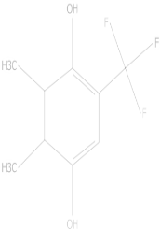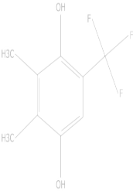

10 ppmcd

con

50ppmcd

25 ppmcd

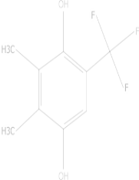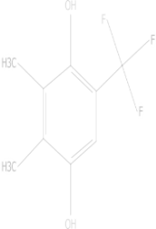

25ppmpb

10ppmpb

50ppm pb

10ppm (cd+pb)

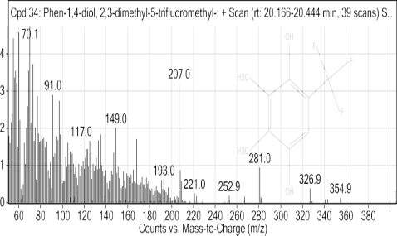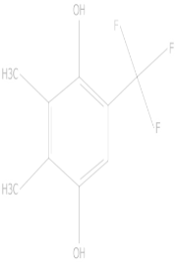

50%pb

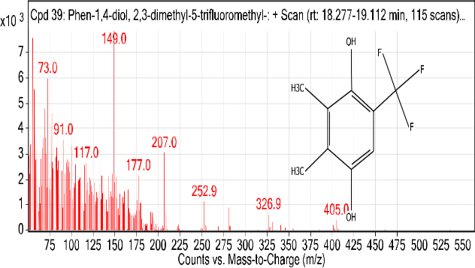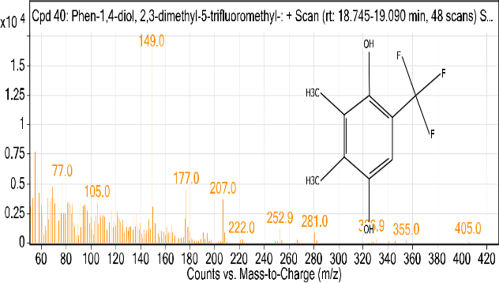

50ppm (cd+pb)

25ppm (cd+pb)

Figure (19): The chemical composition of the compound- Phen-1,4-diol,2,3-dimethyl-5-trifluoromethyl in the plant *T. foenum- graecum* contaminated with different concentrations of cadmium and lead

**8-Compound 1-Ethynyl-3, trans (1,1-dimethylethyl)-4,cis-methoxycyclohexan-1ol**

The compound1-Ethynyl-3,trans (1,1-dimethylethyl)-4,cis-methoxycyclohexan-1ol was first identified in the plant *Cassia angustifolia*, it is one of the compounds that are included in the composition of many medicinal drugs, such as drugs antifungal (Candidiasis) and in anti- inflammatory. From Appendix (1) recorded the highest percentage of the compound 1-Ethynyl-3,trans(1,1-dimethylethyl)-4,cis-methoxycyclohexan-1ol which was 22.77% for concentration 10ppm to treat lead and the lowest percentage 1.01% for concentration 50ppm to treat mixture compared with the control sample, which was the percentage 7.69%. Figure (20).

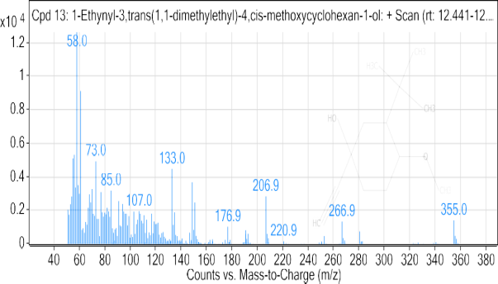

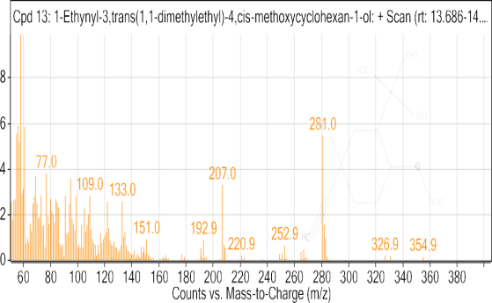

10%cd

con

50%cd

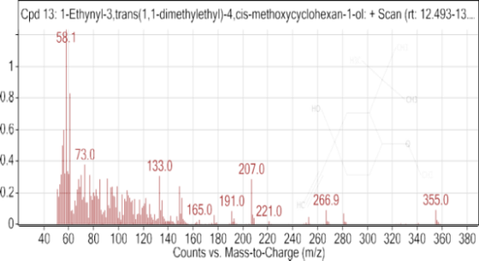

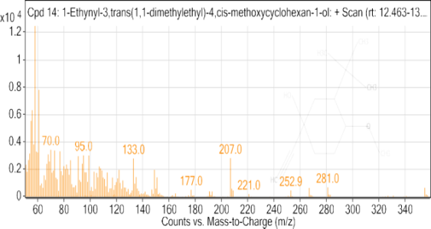

10%pb

25ppmcd

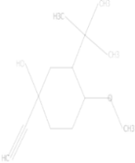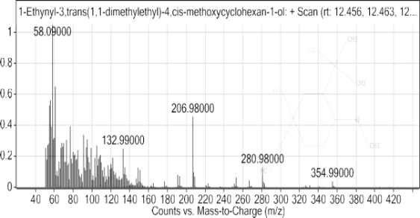

25%cd

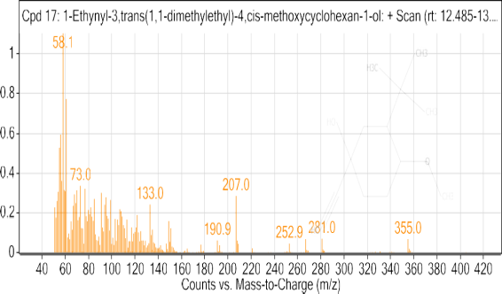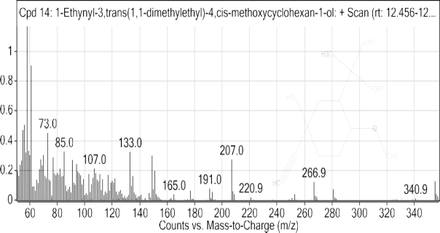

25%pb

10%(cd+pb)

50%pb

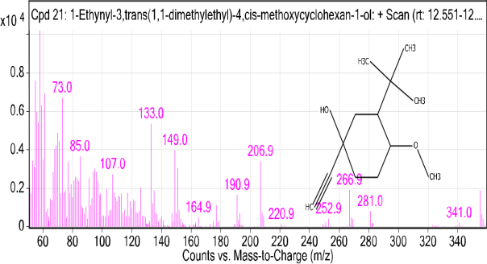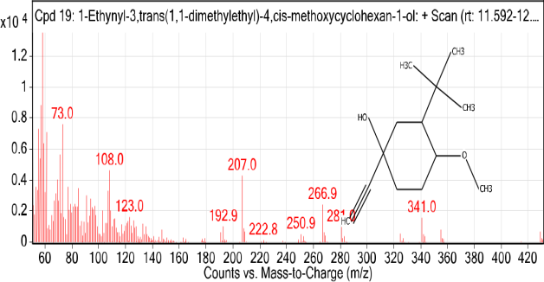

25%(cd+pb)

50%(cd+pb)

Figure (20): The chemical composition of the compound1-Ethynyl-3, trans (1, 1-dimethylethyl)-4, cis - methoxycyclohexan-1ol in the plant *T. foenum- graecum* contaminated with different concentrations of cadmium and lead

**9-Compound Acetamide,N-methyl-N-[4-(3-hydroxypyrrolidinyl)-2-butynyl]-**

The compound Acetamide, N-methyl-N-[4-(3-hydroxypyrrolidinyl)-2-butynyl] belongs to the class of organic compounds known as alpha-amino acids and their derivativatives. From Appendix (1) recorded the highest percentage of the compound Acetamide, N-methyl-N-[4-(3-hydroxypyrrolidinyl)-2-butynyl] which was 3.30% for the concentration 25ppm to treat lead and the lowest percentage 0.25% for the concentration 50ppm to treat mixture compared with the control sample, which was the percentage 4.73%.Figure (21).

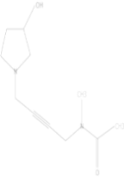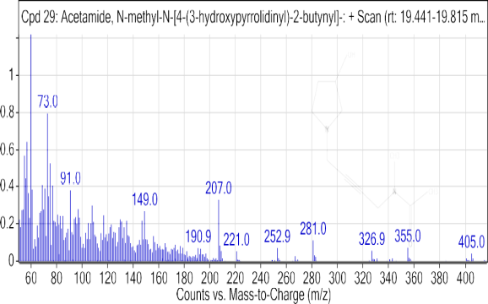

10%cd

Con

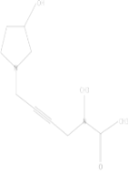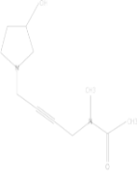

50%cd

25%cd

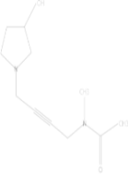

10%pb

25%pb

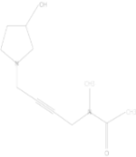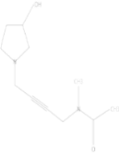

50%pb

10%(cd+pb)

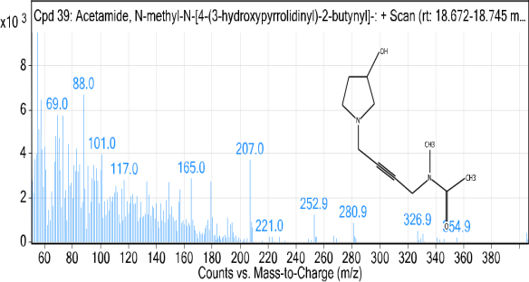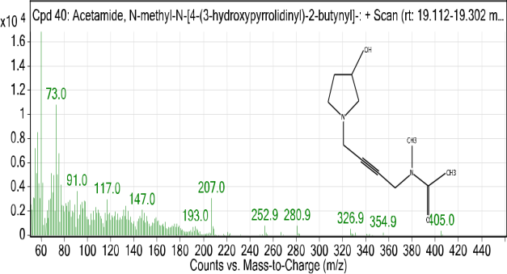

25%(cd+pb)

50%(cd+pb)

Figure (21): The chemical composition of the compound Acetamide,N-methyl-N-[4-(3-hydroxypyrrolidinyl)-2- butynyl]- in the plant *T. foenum- graecum* contaminated with different concentrations of cadmium and lead

**10-Compound Hexadecanoic acid, ethyl ester**

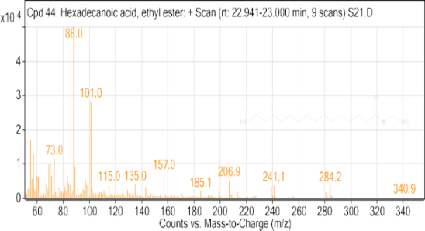The compound Hexadecanoic acid, ethyl ester is the fatty acid derivative that has been identified in rice, vanilla and several fatty acid esters and other plants are also considered a colorless solid that has a wax-like odor and does not dissolve in water and is used as an agent for conditioning hair and skin. From Appendix (1) recorded the highest percentage of the compound Hexadecanoic acid, ethyl ester which was 5.64% for concentration 50pppm to treat mixture and the lowest percentage 1.29% for concentration 10ppm to treat lead compared with the control sample, which was the percentage 3.54%. Figure (22).

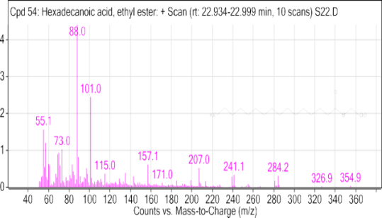

con

10%cd

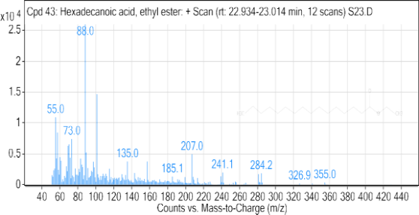



25%cd

50%cd

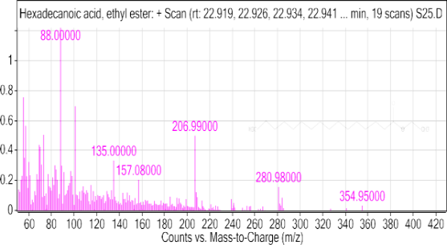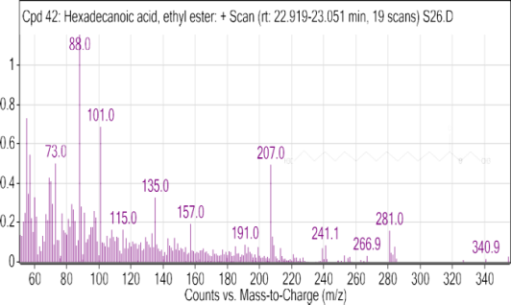

25%pb

10%pb

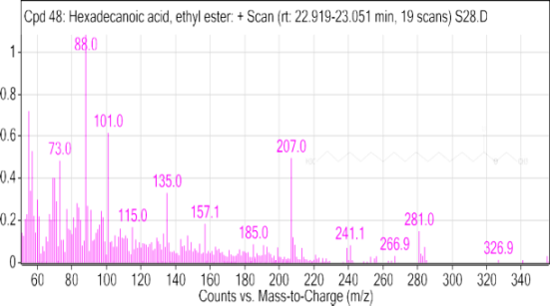

10%(cd+pb)

50%pb

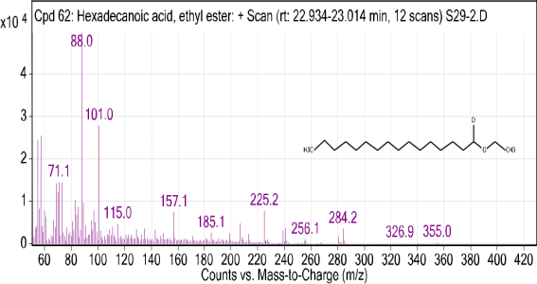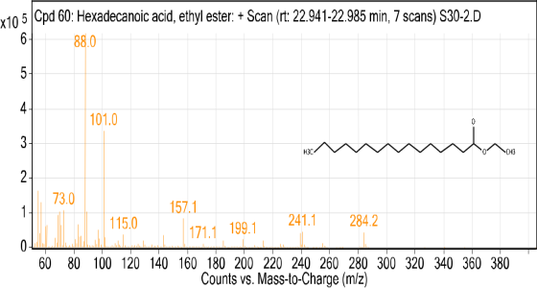

50%(cd+pb)

25%(cd+pb)

Figure (22): The chemical composition of the compoundHexadecanoic acid, ethyl ester in the plant *T. foenum- graecum* contaminated with different concentrations of cadmium and lead

**11-Compund Methyl 10, 11-tetradecadienoate**

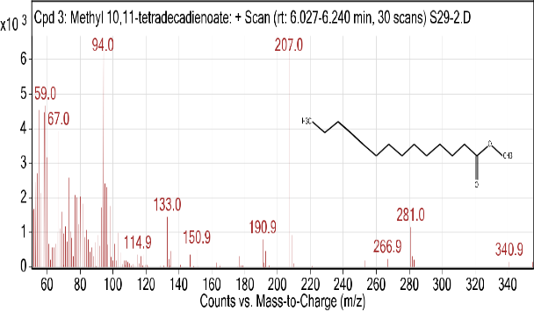The compound Methyl 10,11-tetradecadienoate is an important starting compound for both natural and synthetic organic synthesis, it is a colorless liquid that is insoluble in water but it can be produced in oils and is a precursor of steroids in plants and it is a flavoring component and included as an additive to cigarettes (Jooj *et al*., 2009). From Appendix (1) recorded percentage 1.847% for concentration 50ppm for treat lead and 0.145% for concentration 25ppm to treat mixture. Figure (23).

25ppm (cd+pb)

50ppm pb



Figure (23): The chemical composition of the compound Methyl 10, 11-tetradecadienoa in the plant *T. foenum- graecum* contaminated with different concentrations of cadmium and lead

**12- Compound3-(1, 3-Dihydroxyisopropyl)-1, 5, 8, 11-tetraoxacyclotridecane**

A crown ether compound in the form of a white solid, soluble in water, and used in phase catalysts (Wel *et al*.,1988). From Appendix (1) recorded percentage 0.360% for concentration 50ppm to treat mixture and 0.334% for concentration 25ppm to treat mixture. Figure (24).

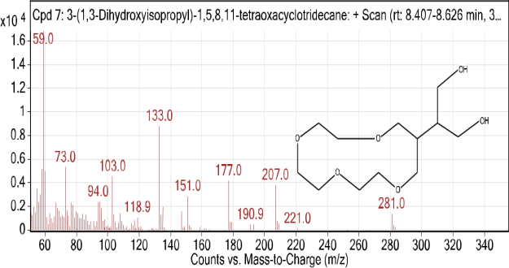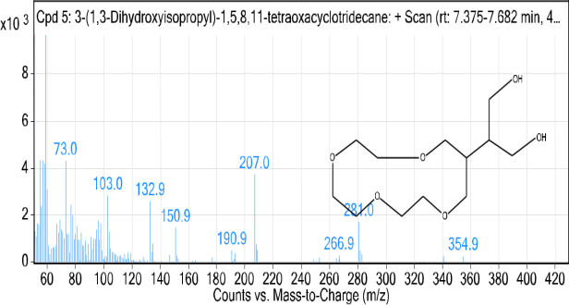

50ppm(cd+pb)

25ppm (cd+pb)

Figure (24): The chemical composition of the compound 3-(1, 3-Dihydroxyisopropyl)-1, 5, 8, 11-tetraoxacyclotridecane in the plant *T. foenum- graecum* contaminated with different concentrations of cadmium and lead

**13-Compound 3-buten-2-one, 4-(5,5-dimethyl-1-oxaspiro[2.5]oct-4-yl**

A ketogenic compound, it is an important chemical with a smell that is used with other ingredients in the perfume and flavor industry (Noda *et al*., 1998). From Appendix (1) recorded percentage 1.399% for concentration50ppm to treat mixture. Figure (25).

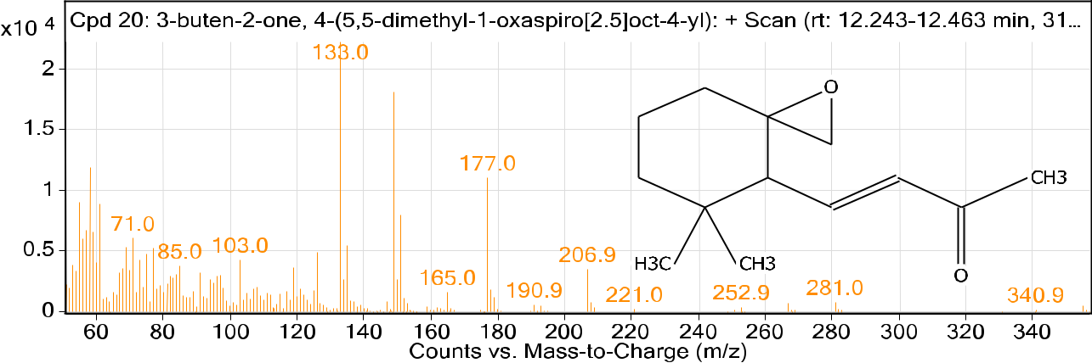

50ppm (cd+pb)

Figure (25): The chemical composition of the compound 3-buten-2-one, 4-(5,5-dimethyl-1-oxaspiro[2.5]oct-4-yl in the plant *T. foenum- graecum* contaminated with different concentrations of cadmium and lead

**14-Compound 5-Methoxycyclooctanol**

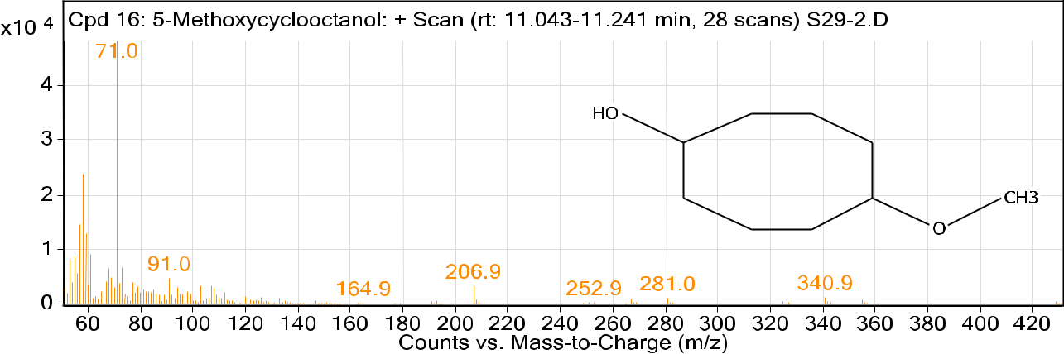 The compound belonging to the saturated fatty acids on yellowish oily liquid that is used as a protective material to protect agricultural crops from animals. From Appendix (1) recorded percentage 1.340% for concentration 25 ppm to treat mixture. Figure (26).

25ppm (cd+pb)

Figure (26): The chemical composition of the compound 5-Methoxycyclooctanol in the plant *T. foenum- graecum* contaminated with different concentrations of cadmium and lead

**15-Compound Bi-2-cyclohexen-1-yl**

An aromatic hydrocarbon organic compound. The compound is widely used in organometallic chemistry as it forms coordination complexes with a number of transition metals (Saunders *et al*., 1996). From Appendix (1) recorded percentage 1.378% for concentration10ppm to treat mixture. Figure (27).



10ppm (cd+Pb)

Figure (27): The chemical composition of the compound Bi-2-cyclohexen-1-yl in the plant *T. foenum- graecum* contaminated with different concentrations of cadmium and lead

**16-Compound cis-13-Eicosenoic acid**

The compound unsaturated fat, it is classified as an omega-7 fatty acid (Avato *et al*., 2003). From Appendix (1) recorded percentage 0.526% for concentration50ppm to treat mixture. Figure (28).

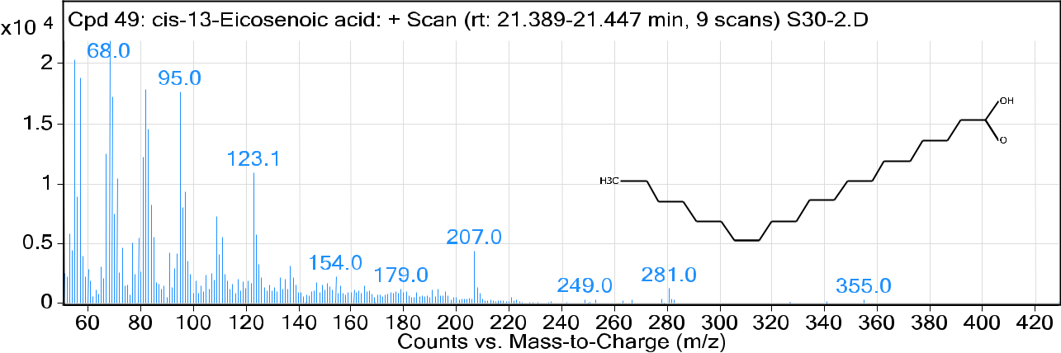

50ppm (cd+pb)

Figure (28): The chemical composition of the compound cis-13-Eicosenoic acid in the plant *T. foenum- graecum* contaminated with different concentrations of cadmium and lead

**17-Compound Fenretinide**

Active compound as an antitumor agent (Sabichi *et al*., 2003). From Appendix (1) recorded percentage 0. 259% for concentration25ppm to treat mixture. Figure (29).

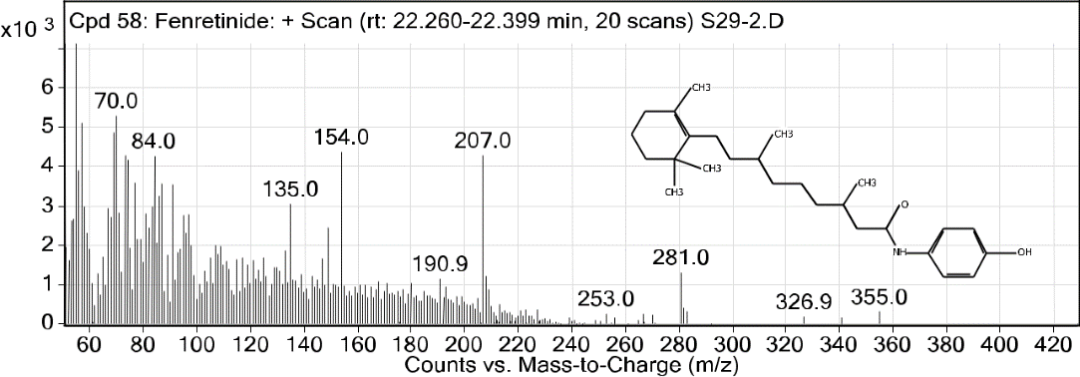

25ppm(cd+pb)

Figure (29): The chemical composition of the compound Fenretinide in the plant *T. foenum- graecum* contaminated with different concentrations of cadmium and lead

**18- Compound Palmitoleic acid**

The compound is unsaturated fatty acid; it is classified as an omega-7 fatty acid (Ogunleye *et al*., 1991). From Appendix (1) recorded percentage 1.215% for concentration25ppm to treat mixture and 0.624% for concentration50ppm to treat mixture. Figure (30).

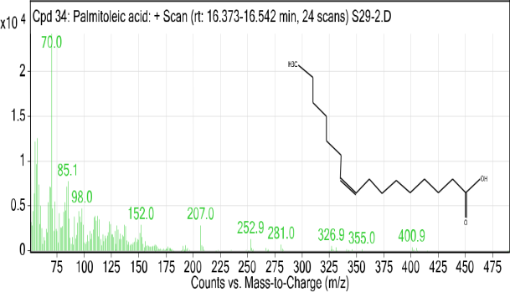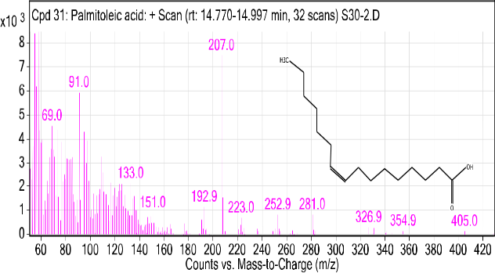

25ppm(cd+pb)

50ppm (cd+pb)

Figure (30): The chemical composition of the compound Palmitoleic acid in the plant *T. foenum- graecum* contaminated with different concentrations of cadmium and lead

**19- Compound Z-10-Methyl-11-tetradecen-1-ol propionate**

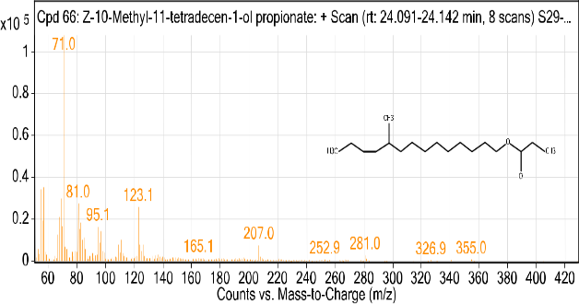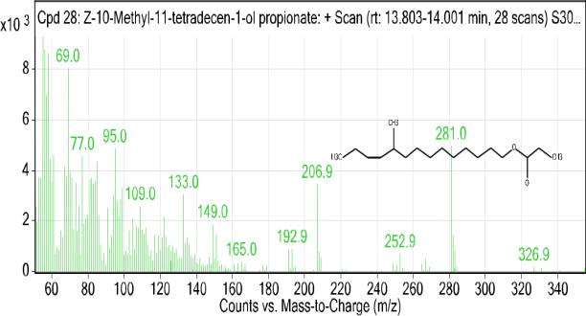The compound is Crystallin complex of the main unsaturated fatty acids in hydrogenated vegetable oils (Veronesi *et a*l., 2006). From Appendix (1) recorded percentage 1.216% for concentration25ppm to treat mixture and 0.566% for concentration50ppm to treat mixture. Figure (31).

25ppm(cd+pb)

50ppm(cd+pb)

Figure (31): The chemical composition of Compound Z-10-Methyl-11-tetradecen-1-ol propionate in the plant *T. foenum- graecum* contaminated with different concentrations of cadmium and lead

**20-Compound Diosgenin**

Compound Diosgenin an alkaloid used as a raw material for the manufacture of a number of hormones, including progesterone, which is used in contraceptive pills (Atich *et al*., 2013). From Appendix (1) recorded percentage 8.851% for concentration25ppm to treat mixture and 7.214% for concentration50ppm to treat mixture. Figure (32).

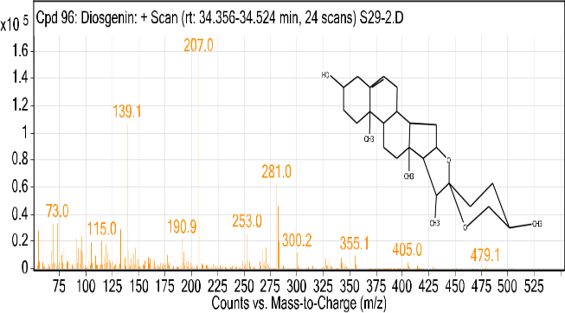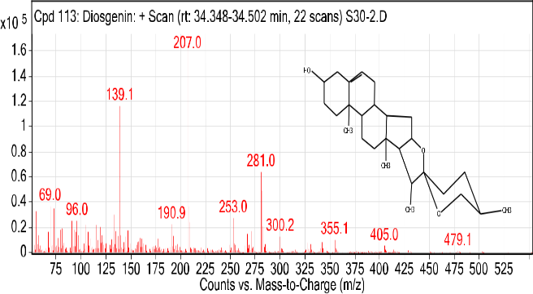

25%(cd+pb)

50ppm (cd+pb)

.

Figure (32): The chemical composition of Compound Diosgenin in the plant *T. foenum- graecum* contaminated with different concentrations of cadmium and lead

**21- Compound Phytol**

An acyclic alcohol compound that can be used as a raw material in industry and commercially used in the manufacture of perfumes, cosmetics, household detergents, shampoo and soap (Islam *et al*., 2018). From Appendix (1) recorded percentage 0,948% for concentration 50 ppm to treat mixture. Figure (33).

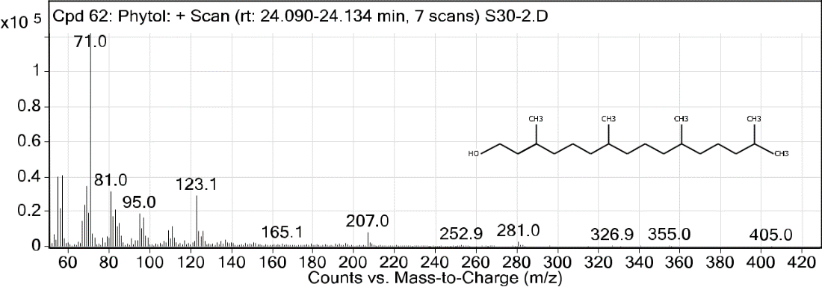

50ppm (cd+pb)

Figure (33): The chemical composition of CompoundPhytol in the plant *T. foenum- graecum* contaminated with different concentrations of cadmium and lead

**22- 1-Hexacosanol**

Alcoholic substances derived from Chinese wax. From Appendix (1) recorded percentage 19.838% for concentration 25 ppm to treat mixture and percentage 21.001% for concentration 50 ppm to treat mixture. Figure (34).

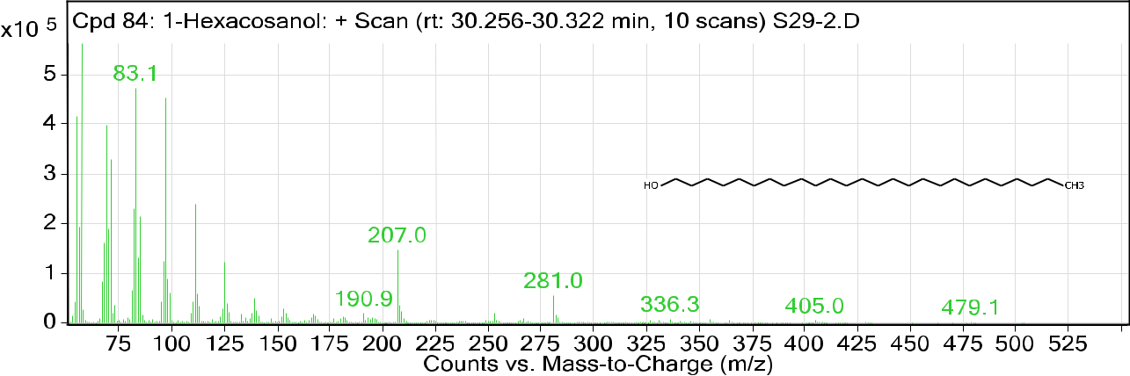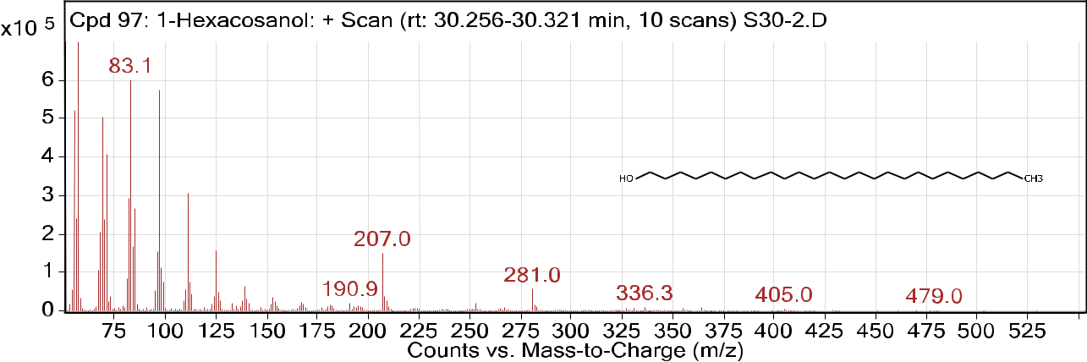

25ppm(cd+pb)

50ppm(cd+pb)

Figure (34): The chemical composition of Compound- 1-Hexacosanol in plan *T. foenum- graecum* contaminated with different concentration of cadmium and lead

**Appendix (1): Percentages of the active chemical compounds in plant *T. foenum- graecum***

|  |  |  |  |  |  |  |  |  |  |  |  |
| --- | --- | --- | --- | --- | --- | --- | --- | --- | --- | --- | --- |
| Formula | 50ppm (cd+pb) | 25ppm (cd+pb) | 10ppm (cd+pb) | 50ppm pb | 25ppm pb | 10ppm pb | 50ppm cd | 25ppm cd | 10ppm cd | Con. | Name |
| C15H24O2 | 1.420 | -- | -- | -- | -- | -- | -- | -- | -- | -- | (2R,3R,4aR,5S,8aS)-2-Hydroxy-4a,5-dimethyl-3-(prop-1-en-2-yl)octahydronaphthalen-1(2H)-one |
| C29HSOO | 14.819 | 18.070 | -- | -- | -- | -- | -- | -- | -- | -- | .gamma.-Sitosterol |
| C18H34OSi | -- | -- | -- | -- | -- | -- | -- | -- | 8.021 | -- | [1-(3,3-Dimethyloxiran-2-ylmethyl)-3,7-dimethylocta-2,6-dienyl]trimethylsilane |
| C10H17N | -- | -- | 2.333 | 3.233 | -- | -- | 2.566 | -- | -- | 3.385 | 1-(1,4-cyclohexadienyl)-2-methylaminopropane |
| C16H30O2 | 0.254 | -- | -- | -- | 2.299 | -- | 4.049 | -- | -- | -- | 1,2-15,16-Diepoxyhexadecane |
| C30H52O3S | -- | 0.561 | -- | -- | -- | 7.019 | 9.473 | -- | -- | -- | 1,25-Dihydroxyvitamin D3, TMS derivative |
| C10H22O2 | -- | 0.724 | -- | -- | -- | -- | -- | -- | -- | -- | 1,7-Octanediol, 3,7-dimethyl- |
| C14H24O3 | 1.216 | 0.553 | -- | -- | 0.531 | 0.531 | 0.885 | 0.577 | 2.034 | 1.180 | 12-Hydroxy-14-methyl-oxa-cyclotetradec-6-en-2-one |
| C19H30O2 | -- | 1.643 | -- | -- | -- | -- | 1.968 | -- | -- | -- | 13,16-Octadecadiynoic acid, methyl ester |
| C13H22O2 | 1.006 | 3.144 | 13.501 | 9.856 | 8.111 | 22.765 | 1.539 | 15.440 | 2.992 | 7.690 | 1-Ethynyl-3,trans(1,1-dimethylethyl)-4,cis-methoxycyclohexan-1-ol |
| C37H76O | 1.271 | 0.716 | 1.225 | -- | -- | -- | 0.283 | -- | -- | -- | 1-Heptatriacotanol |
| C26H54O | 21.001 | 19.838 | -- | -- | -- | -- | -- | -- | -- | -- | 1-Hexacosanol |
| C13H24N2O | 0.485 | 0.946 | -- | 1.224 | 0.937 | -- | -- | 1.052 | 0.746 | 1.208 | 1-Methyl-8-propyl-3,6-diazahomoadamantan-9-ol |
| C12H22N2O | -- | -- | 0.491 | 0.786 | 0.436 | 0.387 | 0,431 | -- | -- | -- | 1-Propyl-3,6-diazahomoadamantan-9-ol |
| C14H24O4 | 0.442 | -- | 3.314 | 1.667 | 1.256 | 0.762 | 0.960 | 0.467 | 0.373 | 0.564 | 2,2-Dimethyl-6-methylene-1-[3,5-dihydroxy-1-pentenyl]cyclohexan-1-perhydrol |
| C13H22OSi2 | -- | -- | 0.388 | -- | -- | -- | -- | -- | -- | -- | 2,4,6-Cycloheptatrien-1-one, 3,5-bis-trimethylsilyl- |
| C19H30O2 | 3.232 | 3.819 | 23.915 | 8.114 | 8.743 | 3.797 | 4.063 | 5.294 | 13.272 | 6.603 | 2,5-Octadecadiynoic acid, methyl ester |
| C9H19BCI2S | -- | -- | 1.585 | -- | -- | -- | 1.844 | -- | -- | -- | 2-Pentene, 3-(chloroethylboryl)-2-(chlorodimethylsilyl)-, (E)- |
| C2OH4OO3S | -- | 9.016 | -- | -- | -- | -- | -- | -- | -- | -- | 2-Trimethylsiloxy-6-hexadecenoic acid, methyl ester |
| C21H24O6 | 0.360 | 0.334 | -- | -- | -- | -- | -- | -- | -- | -- | 3-(1,3-Dihydroxyisopropyl)-1,5,8,11-tetraoxacyclotridecane |
| C24H42O6 | -- | 1.016 | -- | -- | -- | -- | -- | -- | -- | -- | 3,6,9,12-Tetraoxatetradecan-1-ol, 14-[4-(1,1,3,3-tetramethylbutyl)phenoxy]- |
| C13H20O2 | 1.399 | -- | -- | -- | -- | -- | -- | -- | -- | -- | 3-buten-2-one, 4-(5,5-dimethyl-1-oxaspiro[2.5]oct-4-yl) |
| C12H17NO2 | -- | -- | -- | -- | 2.515 | 2.048 | -- | -- | -- | -- | 4-(3-Dimethylaminopropoxy)benzaldehyde |
| C12H7N50 | -- | -- | 5.473 | 7.213 | 5.380 | 4.108 | 6.312 | 5.905 | 4.370 | 7.476 | 5-Amino-1-benzoyl-1H-pyrazole-3,4-dicarbonitrile |
| C9H18O2 | -- | 1.340 | -- | -- | -- | -- | -- | -- | -- | -- | 5-Methoxycyclooctanol |
| C8H12O | -- | -- | -- | -- | -- | -- | -- | -- | -- | 1.503 | 6-Methyl-3-cyclohexen-1-carboxaldehyde |
| C8H12O | -- | -- | -- | -- | -- | -- | 1.522 | -- | -- | -- | 7-ormylbicyclo[4.1.0]heptane |
| C27H44O3 | -- | -- | 0.689 | -- | 0.630 | 2.686 | 3.493 | 3.634 | 1.933 | -- | 9,10-Secocholesta-5,7,10(19)-triene-3,24,25-triol, (3.beta.,5Z,7E)- |
| C11H18N2O2 | 0.249 | 0,727 | 0.457 | 3.192 | 3.296 | 2.075 | 3.052 | 3.130 | 0.960 | 4.726 | Acetamide, N-methyl-N-[4-(3-hydroxypyrrolidinyl)-2-butynyl]- |
| OH27AsO3S | -- | -- | -- | -- | -- | -- | 4.049 | -- | -- | -- | Arsenous acid, tris(trimethylsilyl) ester |
| C12H25N | 0.886 | -- | -- | -- | -- | -- | -- | -- | -- | -- | Aziridine, 2-methyl-2-(2,2,4,4-tetramethylpentyl)- |
| C10H15N | 0.471 | -- | -- |  | -- | -- | -- | -- | -- | -- | Benzeneethanamine, N,.alpha.-dimethyl- |
| C10H15NO2 | -- | -- | 12.082 | 14.215 | 28.301 | 24.994 | 14.388 | 16.881 | 25.677 | 17.205 | Benzenemethanol, 4-hydroxy-.alpha.-[1- (methylamino)ethyl]-, (R*,S*)- |
| C12H18 | -- | -- | 1.378 | -- | -- | -- | -- | -- | -- | -- | Bi-2-cyclohexen-1-yl |
| C9H12O | 0.170 | -- | 0.482 | -- | 0.654 | 0.495 | -- | 0.642 | 0.465 | -- | Bicyclo[2.2.1]hept-5-en-2-yl-acetaldehyde |
| C20H38O2 | 0.526 | -- | -- | -- | -- | -- | -- | -- | -- | -- | cis-13-Eicosenoic acid |
| C18H54O9Si | -- | 0.850 | -- | -- | -- | -- | -- | -- | -- | -- | Cyclononasiloxane, octadecamethyl- |
| C8H24O4Si | 2.102 | 3.506 | 2.557 | 3.439 | 2.128 | -- | 3.295 | 2.424 | 1.822 | 3.904 | Cyclotetrasiloxane, octamethyl- |
| C20H26N2O2 | o.407 | 0.162 | -- | 1.406 | 1.057 | 0.949 | 1.419 | 1.458 | 1.356 | 2.069 | Dasycarpidan-1-methanol, acetate (ester) |
| C10H12O2 | -- | -- | -- | -- | 0.371 | -- | -- | -- | -- | 1.601 | Dicyclopentadiene diepoxide |
| C27H24O3 | 7.214 | 8.851 | -- | -- | -- | -- | -- | -- | -- | -- | Diosgenin |
| C18H24O | 1.963 | -- | 6.148 | 7.357 | 5.343 | 4.647 | 6.309 | 6.341 | 5.586 | 8.613 | Estra-1,3,5(10)-trien-17.beta.-ol |
| C16H27NO2 | 0.304 | -- | -- | -- | -- | -- | -- | -- | -- | -- | Ethanamine, N,N-diethyl-2,2-dimethyl-2-[(3,5-dimethoxy)phenyl]- |
| C20H38O2 | 2.230 | 2.032 | 2.647 | 3.279 | 2.359 | 2.140 | 3.034 | 2.898 | 2.653 | 4.421 | Ethyl Oleate |
| C26H33NO2 | -- | 0.259 | -- | -- | -- | -- | -- | -- | -- | -- | Fenretinide |
| C10H16N2O | -- | -- | -- | -- | -- | -- | 1.837 | -- | -- | -- | Formamide, N-methyl-N-4-[1-(pyrrolidinyl)-2-butynyl]- |
| C18H36O2 | 5.635 | 1.341 | 1.643 | 1.965 | 1.433 | 1.290 | 1.905 | 2.063 | 2.038 | 3.540 | Hexadecanoic acid, ethyl ester |
| C7H8F3N3O | -- | -- | -- | 1.784 | 3.317 | 3.043 | -- | 4.659 | 3.452 | -- | Histamine, N-trifluoroacetyl |
| C10H17CIN20 | 0.891 | -- | -- | -- | -- | -- | -- | -- | -- | -- | L-Valine, N-[2-(chloroimino)-3-methyl-1-oxobutyl]- |
| C15H26O2 | -- | 0.145 | -- | 1.847 | -- | -- | -- | -- | -- | -- | Methyl 10,11-tetradecadienoate |
| C16H32O2 | 10.378 | 5.580 | -- | -- | -- | -- | -- | -- | -- | -- | n-Hexadecanoic acid |
| C13H21NO | -- | 1.059 | 12.699 | 14.239 | 10.098 | 9.581 | -- | 13.581 | 10.584 | 13.64 6 | N-Methyl-1-adamantaneacetamide |
| C20H40O2 | 10.092 | -- | -- | -- | -- | -- | -- | -- | -- | -- | Octadecanoic acid, 17-methyl-, methyl ester |
| C18H34O2 | 0.319 | 0.455 | -- | -- | -- | -- | -- | -- | -- | -- | Oleic Acid |
| C8H9NO2 | 0.879 | 1.202 | 3.307 | 4.094 | 2.813 | 2.334 | 3.981 | 3.621 | 2.824 | 6.397 | Oxime-, methoxy-phenyl-_ |
| C16H30O2 | 0.624 | 1.215 | -- | -- | -- | -- | -- | -- | -- | -- | Palmitoleic acid |
| C9H9F3O2 | 1.358 | 3.633 | 1.421 | 4.502 | 0.970 | 0.882 | 2.590 | 1.561 | 1.243 | 1.841 | Phen-1,4-diol, 2,3-dimethyl-5-trifluoromethyl- |
| C20H40O | 0.948 | -- | -- | -- | -- | -- | -- | -- | -- | -- | Phytol |
| C10H15N0 | -- | -- | -- | -- | -- | -- | 0.268 | -- | -- | -- | Pseudoephedrine |
| C10H16O3 | -- | -- | -- | -- | -- | -- | 3.954 | -- | -- | -- | R-Limonene |
| C14H24OSi | 0.524 | 0.404 | -- | -- | -- | 0.355 | -- | -- | -- | -- | Silane, triethyl(2-phenylethoxy)- |
| C15H26O2 | 0.952 | -- | -- | 4.010 | 2.811 | -- | 1.370 | -- | -- | -- | Undec-10-ynoic acid, butyl ester |
| C18H34O2 | 0.566 | 1.216 | -- | -- | -- | -- | -- | -- | -- | -- | Z-10-Methyl-11-tetradecen-1-ol propionate |

**Reference**

Abbas, M.F.(1987).Fruit and vegetable care and storage.Book house press. University of Baghdad.P440.

Abbas, M.F.;AL- Eidani, T.Y.and Mohammed, A.R.(2014). Phytoremdiation of lead contaminated soil by Brassica juncca (L.)czem.J.Dhi Qar Sciences,5(1): 38-45.

Abu Dawah,Y.M.(1999).Effect of adding foamed sulfure and phosphate fertilizer on the availability of phosphorous,iron and manganese and their concentrations in the dry matter vegetative parts (Triticum aestivum L.) Abu Ghraib class.J. Iraqi agricuilural Sciences,30(1): 79-93.

AL-Gizzi, I.A; AL-Hejuje, M.M.and Nema, J.D.(2020).Concentration of some Heavy Metals Emissions from Electrical Generators in Air and Green Plants in BasrahCity, Iraq.J.Biol .Appl. Environ. Res, 4(2):90-101.

AL-Jubouri, K.D.(1995).Effect of adding foamed sulfur and phosphorous on growth and nutrient content of Potato plants .Master Thesis. Faculty of Agriculture. University of Baghdad.

AL-Jumaily, A.A. and Rahi, H.S.(2000).Effect of foamed sulfur on some soil properties in green house and laboratory.J.Iraqi agricuilural Sciences,33(3): 49-53.

AL-Mayah, A.R.A. (2013).Medicinal plants and herbal medicine.AL-Baseer Library for Printing and Publishing.Lebanon.P358.

AL-Mayah, A.R.A; AL-Assadi, W.M.T.(2012).Cumulative ability of a vegetarian Ceratophyllum demersum, Hydrilla verticillata for some laboratory heavy metals.J.Basrah Research (Processes),38(2): 72-85.

AL-Nuaimi, S.N.(1990). The relation ship of soil to water and plant.Ministry of Higher Education and Scientific Research,University of Basrah.P537.

Atich; Diet, Z. ;Birgit and Boltam. (2013).Botamical Modulation of Menopusal symptoms: Mechanisms ofAction. J. Planta Medica, 79(7): 538-553.

Avato, P.; Pesante, M.A.; Fanizz, F.P. and Santos, C.A. (2003). Seed oil composition of paullinia cupana var. Sorbilis (Mart.) Ducke. J. Lipids, 38(7): 80-773.

Baccio, D.D.; Tognetti, R.; Sebastianiand, L.and Vitagliano, C.(2003). Responses of Populus deltoids X Populus nigra (Populus X euramericana) clone I-214 to high zinc concentrations.New Phytologist, 159: 443-452.

Ball, F.D. (1964). Loss on ignition as an estimate of organic matter and organic carbon in non-calcareous soils.J. Soil Sci., 15: 84-92.

Chatterjce, S.;Variyar, P. and Sharms, S.(2009).Stability of lipid constituents in radiation processed fenugreek seeds and turmeric: role of phenolic antioxidants. J.Agric.Food Chem., 57: 9226-9233.

Costa, G. and Morel, J.L. (1994). Water relations, gas exchange and amin acid content in Cd-treated lettuce.J Plant Physiol.Biochem., 32:561-570.

Estefan, G.; Sommer, R. and Ryan, J. (2013). Methods of soil, plant and water analysis. A manual for the West Asia and North Africa region, lcarda: 170-176.

Eun, S.-O.; Youn, H.S.and Lee, Y.(2002). Lead disturbs microtubule organization in the root meristem of Zea mays.J. Physiol . Plant., 110(3): 357-365.

Galli, U.; Schuepp, H. and Brunold, C. (1996).Thiols in cadmium- and copper-treated maize (Zea mays L.), Planta, 198( 1): 139-143.

Gupta, A.; Rai, D.K.; Pandy , R.S. and Sharmam, B.(2009). Analysis of some heavy metals in the riverine water, sediments and fish from river Ganges at Allahabad. J.Environ. Monit. Assess., 157(449): 1-4.

Haarborn, J.B. (1984).Phytochemical methods. A guid to modern techniques of plants analysis.2ⁿ ͩ ed. Chapman and Hall, London, New York.:282.

Hamza, S.M; AL-Saadi. A.A.M and AL-Abbawy, D.A.H.(2020). Astudy of physical and anatomical characteristics of the heavy metal accumulation of Juncus Rigidus Desfontaines, 1798(FAMIL Y, JUNCACEAE) in Basrah Province, southeren of Iraq. J.Bull.Iraq nat .Hist .Mus, 16(1): 63-81.

Islam, M.T; Ali, E.S. and Shilpt, J.A. (2018). Phytoli :Areview of biomedical activities. J .Food and Chemical Toxicology, 121: 82-94.

Jooj, H. and Jetten, A. A.M. (2009).Molecular mechanisms involved in farnesol- induced apoptosis. Cancer lite, 287(2):35-123.

Karmakar, N.; Chakravarty, A.; Bandopadhyay, P.K. and Das, P.K.(2014).Response of fenugreek(Trigonella foenum-graecum L.) seedings under moisture and heavy metal stress with special reference to antioxidant system. J. African of Biotechnology, 13(3): 434-440.

Kirk, J.T.O. and Allen, R.L. (1965). Dependence of chloroplast pigments synthesis on protein synthetic effects on actilione. Biochem Biophys Res Commum, 21: 523-530.

Laposata, M.(2010). Fatty acid ethyl esters: recent observations. Prostaglandins, Leukotrienes and Essential Fatty Acids, 67(2-3):193-196.

MDE (Maryland Department of Environment) 2003. Water quality analysis of heavy metals for the Loch Raven Reservoir impoundment in Baltimore County, Maryland.U.S.Environmental Protection Agency.

Moreno, J.L.; Hernandez, T. and Garcia, C.(1999). Effects of a cadmium-containing sewage sludge compost on dynamics of organic matter and microbial activity in an arid soils.J. Biol. Fert. Soils, 28: 230-237.

Noda, C.; Alt, G.P.; Werneck, R.M.; Henriques, C. A. and Monteiro, J.L.F.(1998). Aldol condensation of citral with acetone on basic soild catalysts. Brazillian Journal Chemical Engineering, 15(2): 120-125.

Ogunleye, A.; Fakoya, A.T.; Yilizeki, S.; Tojo, H. ; Sasajima, I.; Kobayashi, M. ; Tateishi, S. and Yamaguchi, K. (1991). Fatty acid composition of breast milk from Nigerian and Japanese women. J. Nutr Sci Vitaminol (Tokyo), 37(4):42- 435.

Ong, G.; Yap, C.; Maziah , M. and Tan, S. (2011). Heavy metal accumulation in a medicinal plant from peninsular Malaysia. Journal of Biological Sciences, 11(2):146-155.

Sabichi, A.L.; Modiano, M.R.; Lee, J.J.; Peng, Y.M.; Xu, M.J.; Villar, H.; Dalton, W.S. and Lippman, S.M.(2003). Breast tissue accumulation of retinamides in a randomized short – term study of Fenretinide. J. Clinical cancer Research, (7): 5-2400.

Salazar, M.J. and Pignata, M.L.(2014).Lead accumulation in plants grown in polluted soils: Screening of negative species for phytoremediation. J.Geochem. Explor., 137:29-36.

Saunders; Martin; Vazquez, J.; Hugo, A.; Khong and Anthony. (1996). NMR of dissloved in organic solids. J. Phys. Chem., 100(39): 15968-15971.

Shirdam, R.; Zand, A.; Bidhendi, G. and Mehrdadi, N. (2008). Phytoremediation of hydrocarbon-contaminated soils with emphasis on the effect of petroleum hydrocarbons on the growth of plant species. Phytoprotection, 89(1): 21-29.

Tapanes, N.C.O.; Aranda, D.A.G.; Carneiro, J.W.D. and.Antanes, O.A.C.(2008).Transes erification of Jatropha Curcas oil glycelides:theoretical and experimential Stadies of biodiestel reaction.Fuel, 87(10-11): 2286.

Veronesi, U.; Mariani, L.; Di Mauro, M.G and Depalo, G.(2006).Fiften-year result of arandomized phase trial of Fenretinide to prevent second breast cancer. J. Annals of Oncology, 17(7):71-1065.

Weaver, J.G. and Clements, F.E. (1973). Plant ecology. Tata McGraw-Hill Publishing Company. LTD. New Delhi.

Wel, C.I.; lyman, R. and Diana, S.S. (1988). Temperture and solvent effects on the experiment dipolemoments of three crown ethers. J. Heterocyclic chem., 25(1):73-79.

Yonus, B.M and AL-Khafaji, B.Y.(2020).Determination of Trace Elements Lead, Nickel and Cadmium in Ground Water from Wells near Southern Refineries, Basrah-Iraq.Mesopot.J.Mar.Sci., 35(1): 43-50.