Heat Flow Calculation through FM-DQDs-FM System: Strong Coupling Regime
M. A. Najdi¹ , J. M. AL-Mukh² , H. A. Jassem^{1,a)}
¹Physics Department, Collage of Science, University of Basrah, Basrah, Iraq
²Physics Department, Collage of Education for Pure Science, University of Basrah, Basrah, Iraq

^{a)} Corresponding authors: hayfaa.jassem@uobasrah.edu.iq

Abstract. In this paper, we concentrate on the low-temperature domain to analyze and compute the heat current via a device with double quantum dots sandwiched between two ferromagnetic electrodes (FM-DQDs-FM), in the situation of an antiparallel magnetic arrangement. Non-equilibrium Greene’s functions in a linear response regime were used to perform the research. By taking into account all the system-influencing coefficients, including the coupling between paired quantum dots and electrodes, the spin exchange interaction, the intra-dot Coulomb correlation energy, and spin-polarization on electrodes, our calculations were carried out in the strong inter-dot coupling regime. These findings were examined in relation to the temperature gradient and the effective energy levels of the quantum dots. No new changeable physical characteristics were produced when the spin-polarization was increased. According to our calculations, the spin exchange interaction had a ferromagnetic character when it was equal to $0$ and $0.3 eV$. These findings could pave the way for developing spin caloritronic and thermodynamic nanostructures.
Keywords: Double quantum dots, Heat current, Strong coupling regime, Temperature gradient, Spin exchange interaction
INTRODUCTION
The passage of electrons across ever-shrinking structures has been made easier recently because of developments in nano-creation processes. Electronics with sub-micron and nanoscale dimensions (mesoscopic systems) could be more rapid and less expensive than devices with a traditional macroscale design. Quantum transfer of charge and energy are two fundamental processes in mesoscopic systems [1–5]. The Wiedemann-Franz law states that heat transfer and charge transport occur more often [6, 7]. But they have never been treated equally in the literature on mesoscopic physics. Charge transport has received greater attention recently [8–12] compared to energy transfer, which is more difficult to quantify both theoretically and practically. When a substantial amount of heat accumulates, the performance and stability of electrical equipment may be compromised. As a result, heat generation has emerged as a significant barrier in highly interconnected electronic systems. Numerous studies have been conducted on the creation, conversion, storage, and transit of heat in nano-devices [13]. The rules controlling heat generation are better understood as a result of such scientific research, which also makes it simpler to create energy-efficient electrical components.
The thermoelectric effect, which allows energy to be converted into heat and vice versa, may be used to collect waste heat and convert it into useable electric power [14]. For thermoelectric devices to function well, charge and heat conduction must be precisely controlled [15–19]. With an understanding of mesoscopic physics, it is possible to employ charge and heat transfer in ways that were previously unimaginable. The next generation of highly integrated electronic systems may be able to reduce heat emission thanks to spintronics, a promising new field of study. However, heat flow cannot be detected because spintronic devices are unable to produce electricity and because it is difficult to detect even the smallest temperature changes in such nano-structures. Research on thermal energy is expanding, also thermal and electrical transport connections are significant [20–23]. Heat without charge transport effects is demonstrated by energy harvesting throughout quantum dots [24, 25] and rectification [26, 27]. It is beneficial to work on creating (molecular) quantum dots with excellent thermal connections for electrodes or another heat source for electrical purposes. However, maintaining the strong temperature gradient required to produce large temperature variations through nano-scale connections may be difficult. To lessen the temperature differential across the quantum dot junction, several sequentially linked quantum dots must be considered. Changing the positions of the energy levels in an active region may generally be used to modify the transport properties of quantum dots junctions and other comparable systems [28, 29]. Two closed quantum dots coupled to right and left reservoirs running at various temperatures makes up a typical apparatus for testing heat transfer capabilities. Because the heat resistance of a serially connected quantum dots junction system may be greater than that of individual quantum dot systems, serially linked double quantum dots (DQDs) systems may be able to survive a substantial temperature difference across the junction. To explore thermoelectric transport between quantum dots and molecules, a method including a unified treatment of the system’s electron dynamics is required. For this purpose, one may use Green’s function formalism, which is described in reference [30].
Our study investigates the heat transport over a series of DQDs positioned between two ferromagnetic electrodes. The electron correlation on each dot, the inter-dot coupling, as well as the spin exchange interaction, all affect the properties of electron tunneling through DQDs.

MODEL CALCULATION
The Anderson Hamiltonian, which considers exchange interactions as well as all couplings, may be used to represent the system under investigation [31],
$$H=H_{DQDs}+H_{electrodes}+H_{QD-QD}+H_{DQDs-electrodes} (1)$$
DQDs Hamiltonian with electronic level $E_{di}^{σ}$ also spin $σ$, is denoted by the 1st term in equation (1), (first two terms in equation (2)),
$$H=\sum_{σ}{\sum_{i=1}^{2}{E_{di}^{σ}n_{di}^{σ}}+\sum_{i=1}^{2}{{U_{i}n}_{di}^{σ}n_{di}^{-σ}}}$$
$$+\sum_{σ}{\sum_{α}{\sum_{k_{α}}{E_{k_{α}}^{σ}n_{k_{α}}^{σ}}}}$$
$$+\sum_{σ}{\{(V_{12}}C_{d1}^{σϯ}C_{d2}^{σ}+H. c.)+\frac{1}{2}J_{°} (C_{d1}^{σϯ}C_{d2}^{σϯ}C_{d1}^{σ}C_{d2}^{σ}+H.c.)\}$$
$$+\sum_{σ}{\sum_{α}{\sum_{i=1}^{2}{\sum_{k_{α}}{{(V}_{{ik}_{α}}^{σ}C_{di}^{σϯ}C_{k_{α}}^{σ}}}}}+H.c.) (2)$$
$n_{di}^{σ}$ denotes the corresponding spin-dependent occupation numbers, as $n_{di}^{σ}=C_{di}^{σϯ}C_{di}^{σ}$, $C_{di}^{σ}$ and $C_{di}^{σϯ}$ are the annihilation and creation operators of the QD electronic state $i (≡1,2)$ with spin $σ (≡↑,↓)$. The energies of quantum dot levels are represented in as follows:
$$E_{d1}^{σ}=E_{1}+{U_{1}n}_{d1}^{-σ}-Jn_{d2}^{σ}$$
$$E_{d2}^{σ}=E_{2}+{U_{2}n}_{d2}^{-σ}-Jn_{d1}^{σ} (3)$$
$E_{i}$ stands for the effective energy levels of the quantum dot $i$ while $J$ stands for the spin exchange interaction. $U_{i}$ stands for the intra-dot Coulomb repulsive energy on the dot $i$ sites. The second term in equation (1) and the third term in equation (2) represent the electrons in the electrodes. $E_{k_{α}}^{σ}$ stands for the energy levels of a single electron in the electrodes $α$ ($≡L,R$) with momentum $k_{α}$ and spin $σ$, $n_{k_{α}}^{σ}$ stands for the corresponding occupancy numbers. The third term in equation (1), the fourth and fifth terms in equation (2), reflect the Hamiltonian for the interaction between two quantum dots, where the non-effective spin exchange energy is $J_{°}$ and the inter-dot hopping energy is $V_{12}$. Eventually, the tunneling energy amongst electrodes and each quantum dot is denoted by the last term in equation (1), (sixth term in equation (2)), and $C_{k_{α}}^{σ} (C_{k_{α}}^{σϯ})$ is the annihilation (creation) operator of an electron with momentum $k_{α}$, where $V_{{ik}_{α}}^{σ}$ is the tunneling spin-dependent magnitude between each ferromagnetic electrode and the nearest quantum dot.

FIGURE 1. Energy diagram of DQDs system in series arrangement sandwiched between two ferromagnetic electrodes in antiparallel case.
$n_{di}^{σ}$ can be calculated by the following relations [32],
$$n_{di}^{σ}=\int_{-∞}^{μ_{α}^{σ}}{ρ_{iα}^{σ}\left(E\right)}f_{α}^{σ}\left(E,T_{α}\right)dE ; f_{α}^{σ}\left(E,T_{α}\right)=\frac{1}{e^{(E-μ_{α}^{σ})/k_{B}T_{α}}+1} (4)$$
$f_{α}^{σ}\left(E,T_{α}\right)$ is the Fermi distribution function in the electrode $α$ and $μ_{α}^{σ}$ is the chemical potential of electrode $α$. The localized density of states ($ρ_{iα}^{σ}\left(E\right)$) on dot $i$ with spin $σ$ connected to the electrode $α$ can be represented in terms of Green’s functions [33],
$$ρ_{iα}^{σ}\left(E\right)=-\frac{1}{π} Im G_{iα}^{σ}\left(E\right) (5)$$
Where, $Im G_{iα}^{σ}\left(E\right)$ denotes the imaginary components of Green’s functions; it is provided by [34],
$$G_{1L}^{σ}\left(E\right)=\frac{1}{2}\left\{\frac{(1+W_{1}^{σ}/V_{1}^{σ})}{\left(E-E_{1+}^{σ}\right)+iΓ_{1L}^{σ})}+\frac{(1-W_{1}^{σ}/V_{1}^{σ})}{\left(E-E_{1-}^{σ}\right)+iΓ_{1L}^{σ})}\right\} (6a)$$
$$G_{2R}^{σ}\left(E\right)=\frac{1}{2}\left\{\frac{(1-W_{2}^{σ}/V_{2}^{σ})}{\left(E-E_{2+}^{σ}\right)+iΓ_{2R}^{σ})}+\frac{(1+W_{2}^{σ}/V_{2}^{σ})}{\left(E-E_{2-}^{σ}\right)+iΓ_{2R}^{σ})}\right\} (6b)$$
$Γ_{iα}^{σ}$ denotes level broadening due to the coupling interaction of the ith QD energy levels with the continuum energy levels of electrode $α$. Level broadening happen energy independent at the wide band limit [35]. Meanwhile, the $E_{i±}^{σ}$ energies are defined as [36],
$$E_{i±}^{σ} =E_{i}+U_{i}n^{-σ}-Jn^{σ}±V_{i}^{σ} (7)$$
where,
$$n^{σ}=\frac{n_{d1}^{σ}+n_{d2}^{σ}}{2} ; V_{i}^{σ}=\sqrt{V_{12}^{2}+({W_{i}^{σ})}^{2}} (8)$$
$$W_{i}^{σ}=U_{i}M^{-σ}+JM^{σ} ; M^{σ}=\frac{n_{d1}^{σ}-n_{d2}^{σ}}{2} (9)$$
$ρ_{iα}^{σ}\left(E\right)$ on DQDs are determined by substituting equation (6) into equation (5), then $ρ_{iα}^{σ}\left(E\right)$ is given as follows;
$$ρ^{σ}(E)=\sum_{j=+,-}{\sum_{i=1,2}{\sum_{α}{K_{ij}^{σ}ρ_{iαj}^{σ}\left(E\right)}}} (10)$$
As $j≡+,-$, if $i=1⇒α≡L$, & if $i=2⇒α≡R$,
$$ρ_{ij}^{σ}\left(E\right)=\frac{Γ_{iα}^{σ}}{{(E-E_{ij}^{σ})}^{2}+{(Γ_{iα}^{σ})}^{2}} (11)$$
In equation (10), reduced functions $K_{ij}^{σ}$ are utilized for simplicity,
$$K_{1j}^{σ}=\frac{1}{2π}\left(1+j\frac{W_{1}^{σ}}{V_{1}^{σ}}\right) ; K_{2j}^{σ}=\frac{1}{2π}\left(1-j\frac{W_{2}^{σ}}{V_{2}^{σ}}\right) (12)$$
After solving the integral in equation (4) analytically by using the Summerfield expansion [37,38], where equations (4) and (7) are solved self-consistently to obtain the occupation numbers of quantum dots energy levels and the “molecular orbitals energies” of DQDs. The heat current ($I_{Q}$) is the electrical current that flows in response to the thermal gradient $(∆T)$, is calculated by the following formula [39]:
$$I_{Q}=\frac{1}{h}\sum_{σ}{\int{dE\left(E-μ\right)}\left[f_{L}^{σ}(E)-f_{R}^{σ}(E)\right]} τ^{σ}(E) (13)$$
$τ^{σ}(E)$ represents the electron with spin’s energy-dependent transmission function also is provided by [40],
$$τ^{σ}\left(E\right)=2πΓ^{σ} ρ^{σ}\left(E\right) ; Γ^{σ}=\frac{Γ_{1L}^{σ}Γ_{2R}^{σ}}{{(Γ}_{1L}^{σ}{+Γ}_{2R}^{σ})} (14)$$
We can write $I_{Q}^{σ}$ by utilizing the Sommerfeld expansion as follows:
$$I_{Q1L,α}^{σ}=\sum_{j}{{\{K}_{1j}^{σ}}\left(E_{1j}^{σ}-μ_{eq}\right)\left\{\tan^{-1}\left(\frac{{μ_{α}^{σ}-E}_{1j}^{σ}}{Γ_{1L}^{σ}}\right)-\tan^{-1}\left(\frac{{-2β-E}_{1j}^{σ}}{Γ_{1L}^{σ}}\right)\right\}$$
$$+\frac{K_{1j}^{σ}Γ_{1L}^{σ}}{2}\ln{\begin{aligned}\left(\frac{{\left({μ_{α}^{σ}-E}_{1j}^{σ}\right)}^{2}+{\left(Γ_{1L}^{σ}\right)}^{2}}{{\left({-2β-E}_{1j}^{σ}\right)}^{2}+{\left(Γ_{1L}^{σ}\right)}^{2}}\right) \\ \end{aligned}}$$
$$+\frac{π^{2}}{6}{\left(k_{B}T_{α}\right)}^{2}ρ_{1Lj}^{σ}\left( μ_{α}^{σ}\right)\left(1-\frac{2\left(μ_{α}^{σ}-μ_{eq}\right)}{K_{1j}^{σ}Γ_{1L}^{σ}}\left({μ_{α}^{σ}-E}_{1j}^{σ}\right)ρ_{1Lj}^{σ}\left( μ_{α}^{σ}\right)\right)\} (15)$$

$$I_{Q2R,α}^{σ}=\sum_{j}{{\{K}_{2j}^{σ}}\left(E_{2j}^{σ}-μ_{eq}\right)\left\{\tan^{-1}\left(\frac{{μ_{α}^{σ}-E}_{2j}^{σ}}{Γ_{2R}^{σ}}\right)-\tan^{-1}\left(\frac{{-2β-E}_{2j}^{σ}}{Γ_{2R}^{σ}}\right)\right\}$$
$$+\frac{K_{2j}^{σ}Γ_{2R}^{σ}}{2}\ln{\begin{aligned}\left(\frac{{\left({μ_{α}^{σ}-E}_{2j}^{σ}\right)}^{2}+{\left(Γ_{2R}^{σ}\right)}^{2}}{{\left({-2β-E}_{2j}^{σ}\right)}^{2}+{\left(Γ_{2R}^{σ}\right)}^{2}}\right) \\ \end{aligned}}$$
$$+\frac{π^{2}}{6}{\left(k_{B}T_{α}\right)}^{2}ρ_{2Rj}^{σ}\left( μ_{α}^{σ}\right)\left(1-\frac{2\left(μ_{α}^{σ}-μ_{eq}\right)}{K_{2j}^{σ}Γ_{2R}^{σ}}\left({μ_{α}^{σ}-E}_{2j}^{σ}\right)ρ_{2Rj}^{σ}\left( μ_{α}^{σ}\right)\right)\} (16)$$

then,

$$I_{Q1L}^{σ}=2πΓ^{σ}\left(I_{Q1L,L}^{σ}-I_{Q1L,R}^{σ}\right) ; I_{Q2R}^{σ}=2πΓ^{σ}\left(I_{Q2R,L}^{σ}-I_{Q2R,R}^{σ}\right)$$
$$I_{Q}^{σ}=I_{Q1L}^{σ}+I_{Q2R}^{σ} (17)$$

Finally, we get the total heat current as;
$$I_{Q}=\sum_{σ}{I_{Q}^{σ}} (18)$$
It is important to note that the unit for heat current is arbitrary (${\left(eV\right)}^{2}/h$ ).We build an enlarged program in Fortran 90 in order to do a numerical calculation of the heat current, also we utilize MATLAB in order to produce the 3D visualizations.

RESULTS AND DISCUSSION
At the non-equilibrium condition brought on by a temperature gradient, we investigate the aspects of heat transfer in this system imposed in our research. The model calculation is used to calculate the total heat current leaving the electrodes as well as the left also right flowing heat currents (2). The left electrode's heat current is computed as follows [41]:

$$I_{QL}=\frac{1}{h}\sum_{σ}{\int{dE\left(E-μ_{L}^{σ}\right)}\left[f_{L}^{σ}(E)-f_{R}^{σ}(E)\right]} τ^{σ}(E) (19)$$
$μ_{eq}$ in equations (15) also (16) is equal to $μ_{L}^{-σ}$ for spin-down electron also to $μ_{L}^{σ}$ for spin-up electron. The heat current flowing from the right electrode should be provided,
$$I_{QR}=\frac{1}{h}\sum_{σ}{\int{dE\left(E-μ_{R}^{σ}\right)\left[f_{R}^{σ}\left(E\right)-f_{L}^{σ}\left(E\right)\right]}} τ^{σ}(E) (20)$$
$μ_{eq}$ equals $μ_{R}^{-σ}$ ($μ_{R}^{σ}$) for spin-down (spin-up) electron. The basis of our model calculation, we can compute $I_{QL}$ as follows :
$$I_{QL}=\sum_{σ}{Γ^{σ}(I_{Q1L,L}^{σ}}+I_{Q2R,L}^{σ}-I_{Q1L,R}^{σ}-I_{Q2R,R}^{σ}) (21)$$
According to equation (21), $I_{QR}=-I_{QL}$, in the case of antiparallel arrangement, $μ_{L}^{σ}=μ_{R}^{-σ}=-μ_{L}^{-σ}=-μ_{R}^{σ}=0.005 eV$ are used. $I_{Q}=I_{QL}+I_{QR}$ is the total amount of heat going away from the electrodes. As a function of the temperature difference, the intra-dot Coulomb repulsive energy is used to figure out how heat flows. The strong inter-dot coupling regime yields our findings $V_{12}≫Γ_{iα}^{±σ}$ for the antiparallel magnetic arrangement case with $Γ_{1L}^{σ}=Γ_{2R}^{-σ}=Γ_{0}(1+P)$ also $Γ_{1L}^{-σ}=Γ_{2R}^{σ}=Γ_{0}(1-P)$, where $Γ_{0}$ is the hybridization function [42].
The heat current is computed with$P=0.3$, then $Γ_{1L}^{σ}(=Γ_{2R}^{-σ})>Γ_{1L}^{-σ}(=Γ_{2R}^{σ})$, bearing in mind the chemical potentials locations. The correlation energy values employed are $U_{i}=(0.05, 0.2) eV$. According to Figures (2)-(4), for a specific value of $U_{i}=0.05 eV (0.2 eV)$, $I_{QL}$ is greater than $I_{QR}$ for $∆T >-30 K (20 K)$. For $J=-0.3 eV$, these values are lying at $∆T>-45 K$ for $U_{i}=0.05 eV$ and at $∆T>15 K$ for $U_{i}=0.2 eV$. However, the heat current values predicted for $U_{i}=0.2 eV$ are less than those computed for $U_{i}=0.05 eV$ (Figure (2)), where rising $U_{i}$ shows that the molecular orbitals are full outside the energy window. In Figure (4), the previous indicated characteristics may be enumerated, however due to antiferromagnetic spin exchange, the heat currents are less than those computed for $J=0$. In Figure (3), $J=0.3 eV$, the heat current values rise, whereas the correlation energy plays no effect for ferromagnetic nature. Increasing the spin polarization to $0.7$ has no effect on the physical properties. The inter-dot coupling energy also hybridization functions play a crucial role in the determination of these characteristics.

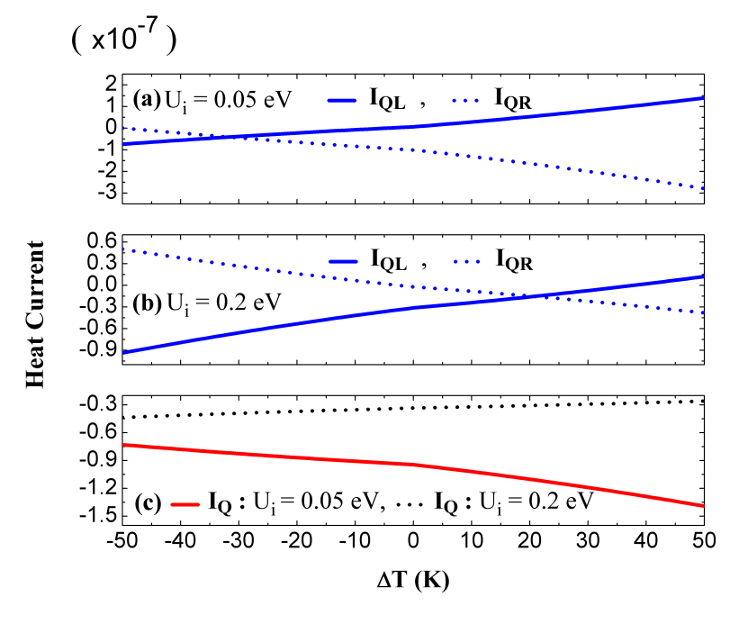
FIGURE 2. Components of $I_{Q}$ as a functions of $∆T (K)$ for two values of $U_{i} (eV)$ at, $P=0.3$, $V_{12}=0.2 eV$, $J=0$, $E_{i}=0.1 eV$, $Γ_{0}=0.001 eV$, $Γ_{1L}^{σ}=Γ_{2R}^{-σ}=0.0013 eV$ also $Γ_{1L}^{-σ}=Γ_{2R}^{σ}=0.0007 eV$.

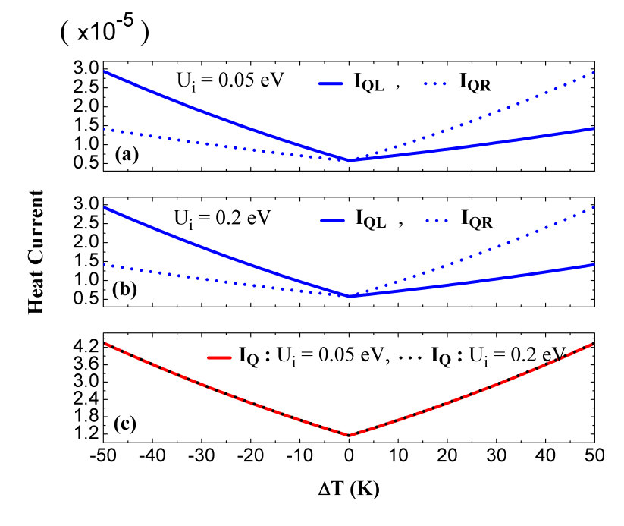
FIGURE 3. Components of $I_{Q}$ as a functions of $∆T (K)$ for two values of $U_{i} (eV)$ at, $P=0.3$, $V_{12}=0.2 eV$, $J=+0.3 eV$, $E_{i}=0.1 eV$, $Γ_{0}=0.001 eV$, $Γ_{1L}^{σ}=Γ_{2R}^{-σ}=0.0013 eV$ also $Γ_{1L}^{-σ}=Γ_{2R}^{σ}=0.0007 eV$.

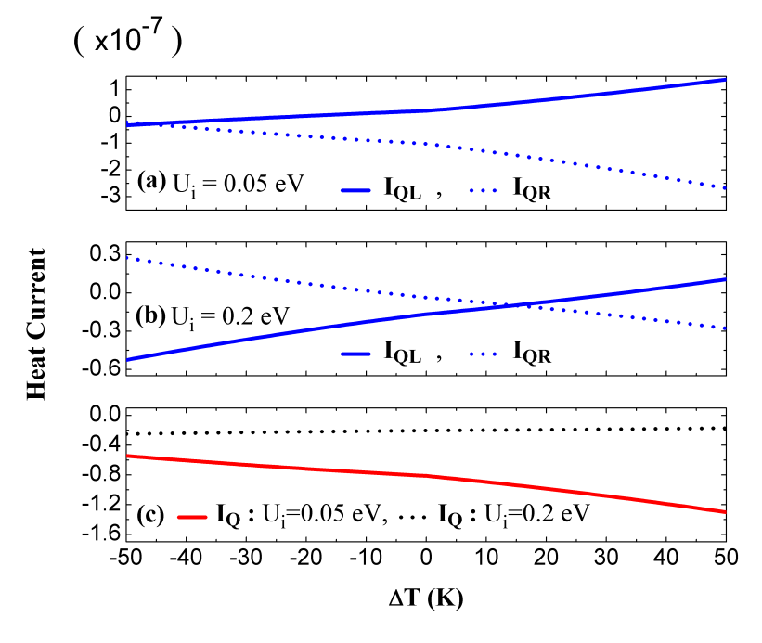
FIGURE 4. Components of $I_{Q}$ as a functions of $∆T (K)$ for two values of $U_{i} (eV)$ at, $P=0.3$, $V_{12}=0.2 eV$, $J=-0.3 eV$, $E_{i}=0.1 eV$, $Γ_{0}=0.001 eV$, $Γ_{1L}^{σ}=Γ_{2R}^{-σ}=0.0013 eV$ also $Γ_{1L}^{-σ}=Γ_{2R}^{σ}=0.0007 eV$.

We investigate the role of effective quantum dots energy levels ${( E}_{i}=E_{1}=E_{2})$ for the values of $U_{i}=0.05 eV$ and $0.2 eV$ to demonstrate the best operating conditions for a nano-device. Figures ((5)-(7)) illustrate our heat current estimations as a functions of $E_{i}$ and $∆T$. All of these characters have quite unusual physical characteristics. The first pertains to $E_{i}$ values when $I_{Q}=0$; we denote this by $E_{i0}$. The second is the effective quantum dots energy levels that correlate to the highest $\left|I_{Q}\right|$ values.
Our results are shown in Figures (5)-(7) for $P=0.3$ also spin exchange interactions are $0$, $0.3 eV$ and $-0.3 eV$. There are twelve values of $E_{i0}$ at which $I_{Q}=0$ for each value of $U_{i}$ and $J$ (Table (1)); at these values, the charge current takes the maximum value whilst at the nearest values around $E_{i0}$, the heat current takes the maximum value.

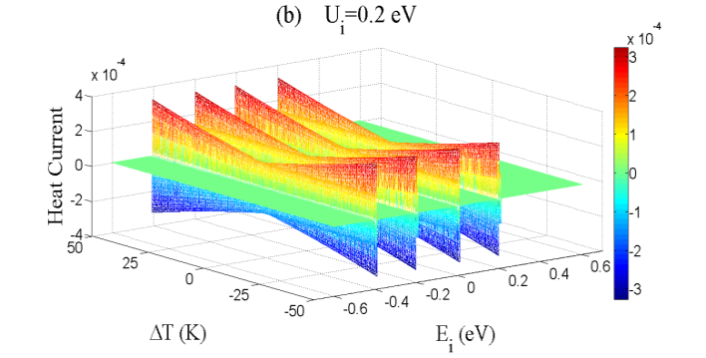
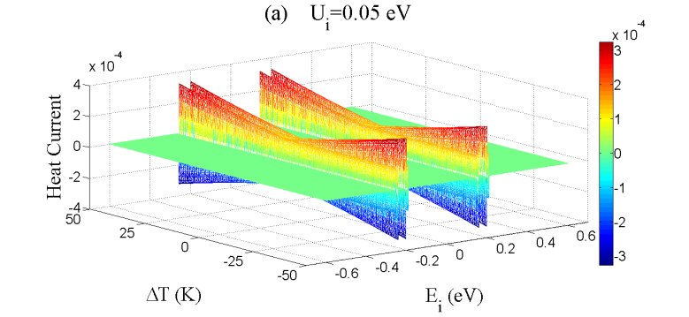

FIGURE 5. $I_{Q}$ as a functions of $∆T (K)$ also as a function of $E_{i} (eV)$ for two values of $U_{i} (eV)$ with, $P=0.3$, $V_{12}=0.2 eV$, $J=0$, $Γ_{0}=0.001 eV$, $Γ_{1L}^{σ}=Γ_{2R}^{-σ}=0.0013 eV$ also $Γ_{1L}^{-σ}=Γ_{2R}^{σ}=0.0007 eV$.

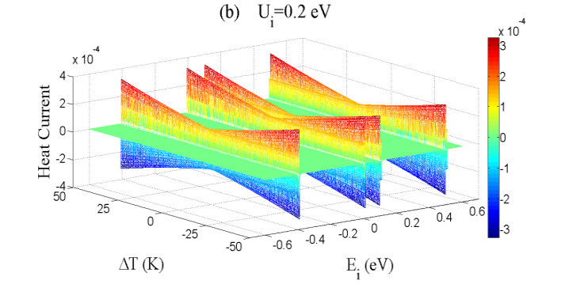
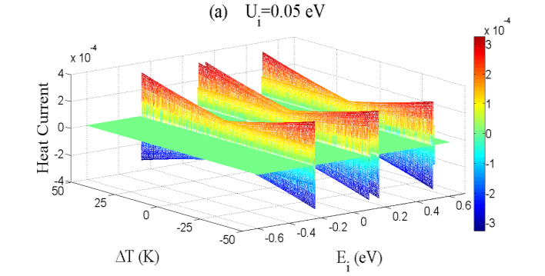

FIGURE 6. $I_{Q}$ as a functions of $∆T (K)$ also as a function of $E_{i} (eV)$ for two values of $U_{i} (eV)$ with, $P=0.3$, $V_{12}=0.2 eV$, $J=+0.3 eV$, $Γ_{0}=0.001 eV$, $Γ_{1L}^{σ}=Γ_{2R}^{-σ}=0.0013 eV$, also $Γ_{1L}^{-σ}=Γ_{2R}^{σ}=0.0007 eV$.

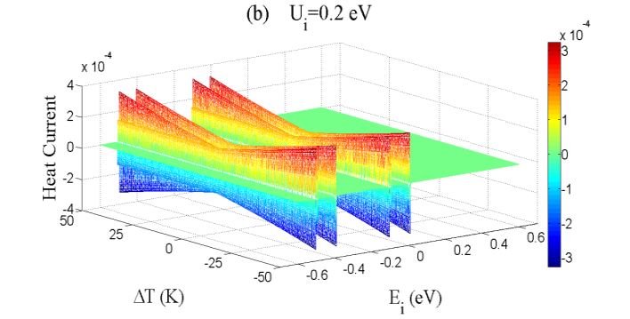
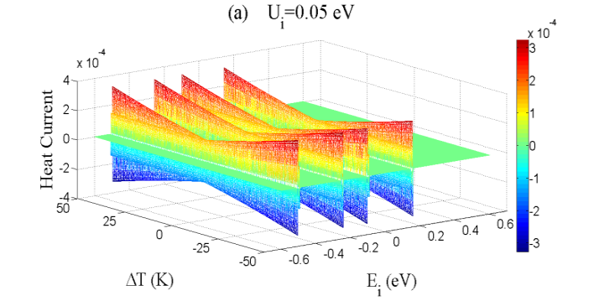

FIGURE 7. $I_{Q}$ as a function of $∆T (K)$ also as a function of $E_{i} (eV)$ for two values of $U_{i} (eV)$ with, $P=0.3$, $V_{12}=0.2 eV$, $J=-0.3 eV$, $Γ_{0}=0.001 eV$, $Γ_{1L}^{σ}=Γ_{2R}^{-σ}=0.0013 eV$ also $Γ_{1L}^{-σ}=Γ_{2R}^{σ}=0.0007 eV$.

Figure (8a) depicts the $E_{i}$ range for the values shown in Figure (5) with $U_{i}=0.05 eV$. A specific value of $E_{i0}$ is noted in Figure (8b). For various values of $∆T$, the curves exhibit opposing behavior. A positive $∆T$ indicates that $T_{L}>T_{R}$, while a negative $∆T$ indicates that $T_{L}<T_{R}$. One of the most significant practical properties that may be used in heat engineering is the range of $E_{i}$ values around each value of $E_{i0}$. Our calculations reveal that spin-polarization has no effect on $E_{i0}$ values. This finding agrees with the coupling regime used in our computations. Both the spin exchange interaction and the Coulomb correlation energy may influence $E_{i0}$ values.

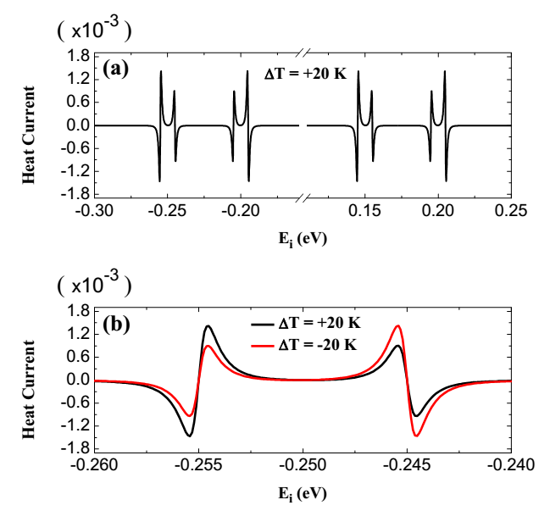

FIGURE 8. $I_{Q}$ as a functions of $E_{i} (eV)$ for two values of $∆T (K)$ with, $P=0.3$, $V_{12}=0.2 eV$, $U_{i}=0.05 eV$, $J=0$, $Γ_{0}=0.001 eV$, $Γ_{1L}^{σ}=Γ_{2R}^{-σ}=0.0013 eV$ also $Γ_{1L}^{-σ}=Γ_{2R}^{σ}=0.0007 eV$.

TABLE 1. $E_{i0} (eV)$ for the case of antiparallel magnetic arrangement for two values of $J (eV)$ also $U_{i} (eV)$ at $V_{12}=0.2 eV$, $∆T=20 K$ with $Γ_{0}=0.001 eV$, $Γ_{1L}^{σ}=Γ_{2R}^{-σ}=0.0013 eV$ also $Γ_{1L}^{-σ}=Γ_{2R}^{σ}=0.0007 eV$.

$$J (eV)$$ | $$E_{i0} (eV)$$
 | $$U_{i}=0.05 eV$$ | $$U_{i}=0.2 eV$$
0.3 | -0.255, -0.25, -0.245  0.095, 0.1, 0.105  0.145, 0.15, 0.155  0.495, 0.5, 0.55 | -0.405, -0.4, -0.395  -0.005, 0, 0.005  0.095, 0.1, 0.105  0.495, 0.5, 0.505
0 | -0.255, -0.25, -0.245  -0.205, -0.2, -0.195  0.145, 0.15, 0.155  0.195, 0.2, 0.205 | -0.405, -0.4, -0.395  -0.205, -0.2, -0.195  -0.005, 0, 0.005  0.195, 0.2, 0.205
-0.3 | -0.505, -0.5, -0.495  -0.255, -0.25, -0.245  -0.105, -0.1, -0.095  0.145, 0.15, 0.155 | -0.505, -0.5, -0.495  -0.405, -0.4, -0.395  -0.105, -0.1, -0.095  -0.005, 0, 0.005

CONCLUSIONS
The heat current flowing through an FM-DQDs-FM system in the case of antiparallel arrangement and strong inter-dot coupling regime ${( V}_{12}≫Γ_{iα}^{±σ})$ investigated in this paper. Increasing the inter-dot hopping interaction $V_{12}$ allows the electron to readily tunnel across the junction, increasing the heat current amplitude. The heat currents flow for each electrode is calculated utilizing the non-equilibrium Green’s function technique also Sommerfeld’s expansion. The spin-polarization is verified at $0.3$, also raising the spin-polarization to higher values yields no additional physical properties. This outcome is consistent with the pairing technique employed in our accounts. Both the spin exchange interaction and the Coulomb correlation energy may be used to alter the values of $E_{i0}$.
Finally, two parameters, designated by $∆T$ also $μ_{α}^{σ}$, may either collaborate with or oppose the flowing heat currents. Changing the locations of the energy levels in the active region with regard to the conduction window may control the transport properties of molecular junctions. A gate voltage supplied to the active region may shift the energy levels, also they can determine the locations of $E_{i0}$ that can be used to implement on-off switching for the flowing heat current. Controlling heat currents in spintronic devices is linked to problems sensing minor temperature changes in these nano-structures. The thermal resistance of a DQDs system may be higher than that of a single QD system. Because of this quality, the serial DQDs system can certify a reasonably big temperature gradient. In a positive or negative thermal bias, decreasing or increasing the amplitude of the heat current is suitable for building a highly efficient thermal diode. Our findings might pave the way for the development of thermodynamic also spin caloritronic nanostructures.

REFERENCES
[1] Y. Imry, Introduction to Mesoscopic Physics, Oxford Univ., (1997).
[2] G. Chen, Nanoscale energy transport and conversion: a parallel treatment of electrons, molecules, phonons, and photons, Oxford university press, (2005).
[3] Y. Dubi, M. Di Ventra, Colloquium: Heat flow and thermoelectricity in atomic and molecular junctions, Rev. Mod. Phys. 83 (2011) 131.
[4] J.-H. Jiang, Y. Imry, Linear and nonlinear mesoscopic thermoelectric transport with coupling with heat baths, Comptes Rendus Phys. 17 (2016) 1047–1059.
[5] G. Benenti, G. Casati, K. Saito, R.S. Whitney, Fundamental aspects of steady-state conversion of heat to work at the nanoscale, Phys. Rep. 694 (2017) 1–124.
[6] M. Bürkle, Y. Asai, How to Probe the Limits of the Wiedemann–Franz Law at Nanoscale, Nano Lett. 18 (2018) 7358–7361.
[7] L. Jin, S.E. Zeltmann, H.S. Choe, H. Liu, F.I. Allen, A.M. Minor, J. Wu, Disorder recovers the Wiedemann-Franz law in the metallic phase of VO 2, Phys. Rev. B. 102 (2020) 41120.
[8] Y.M. Blanter, M. Büttiker, Shot noise in mesoscopic conductors, Phys. Rep. 336 (2000) 1–166.
[9] S. Datta, Quantum transport: atom to transistor, Cambridge university press, (2005).
[10] H. Haug, A.-P. Jauho, Quantum kinetics in transport and optics of semiconductors, Springer, (2008).
[11] R. Sánchez, M. Büttiker, Optimal energy quanta to current conversion, Phys. Rev. B. 83 (2011) 85428.
[12] D. Sánchez, R. López, Scattering theory of nonlinear thermoelectric transport, Phys. Rev. Lett. 110 (2013) 26804.
[13] L. Qiu, N. Zhu, Y. Feng, E.E. Michaelides, G. Żyła, D. Jing, X. Zhang, P.M. Norris, C.N. Markides, O. Mahian, A review of recent advances in thermophysical properties at the nanoscale: From solid state to colloids, Phys. Rep. 843 (2020) 1–81.
[14] D.M. Rowe, Thermoelectrics handbook: macro to nano, CRC press, (2018).
[15] F.J. DiSalvo, Thermoelectric cooling and power generation, Science (80-. ). 285 (1999) 703–706.
[16] R.S. Whitney, Most efficient quantum thermoelectric at finite power output, Phys. Rev. Lett. 112 (2014) 130601.
[17] O. Entin-Wohlman, J.-H. Jiang, Y. Imry, Efficiency and dissipation in a two-terminal thermoelectric junction, emphasizing small dissipation, Phys. Rev. E. 89 (2014) 12123.
[18] R. Sánchez, J. Splettstoesser, R.S. Whitney, Nonequilibrium system as a demon, Phys. Rev. Lett. 123 (2019) 216801.
[19] F. Zhuo, Z.Z. Sun, J.-H. Jiang, Cooperative spin caloritronic devices, ArXiv Prepr. ArXiv1602.01285. (2016).
[20] P.A. Erdman, J.T. Peltonen, B. Bhandari, B. Dutta, H. Courtois, R. Fazio, F. Taddei, J.P. Pekola, Nonlinear thermovoltage in a single-electron transistor, Phys. Rev. B. 99 (2019) 165405.
[21] D.B. Karki, M.N. Kiselev, Nonlinear Seebeck effect of SU (N) Kondo impurity, Phys. Rev. B. 100 (2019) 125426.
[22] A.-M. Daré, Comparative study of heat-driven and power-driven refrigerators with Coulomb-coupled quantum dots, Phys. Rev. B. 100 (2019) 195427.
[23] F. Chi, Z.-G. Fu, J. Liu, K.-M. Li, Z. Wang, P. Zhang, Thermoelectric Effect in a Correlated Quantum Dot Side-Coupled to Majorana Bound States, Nanoscale Res. Lett. 15 (2020) 1–9.
[24] G. Jaliel, R.K. Puddy, R. Sánchez, A.N. Jordan, B. Sothmann, I. Farrer, J.P. Griffiths, D.A. Ritchie, C.G. Smith, Experimental realization of a quantum dot energy harvester, Phys. Rev. Lett. 123 (2019) 117701.
[25] U. Eckern, K.I. Wysokiński, Two-and three-terminal far-from-equilibrium thermoelectric nano-devices in the Kondo regime, New J. Phys. 22 (2020) 13045.
[26] H.K. Yadalam, U. Harbola, Statistics of heat transport across a capacitively coupled double quantum dot circuit, Phys. Rev. B. 99 (2019) 195449.
[27] S. You, D. Xiong, J. Wang, Thermal rectification in the thermodynamic limit, Phys. Rev. E. 101 (2020) 12125.
[28] N.A. Zimbovskaya, Thermoelectric properties of a double-dot system in serial configuration within the Coulomb blockade regime, J. Chem. Phys. 153 (2020) 124712.
[29] S. Dorsch, A. Svilans, M. Josefsson, B. Goldozian, M. Kumar, C. Thelander, A. Wacker, A. Burke, Heat driven transport in serial double quantum dot devices, Nano Lett. 21 (2021) 988–994.
[30] J.-S. Wang, B.K. Agarwalla, H. Li, J. Thingna, Nonequilibrium Green’s function method for quantum thermal transport, Front. Phys. 9 (2014) 673–697.
[31] D.M.-T. Kuo, S.-Y. Shiau, Y. Chang, Theory of spin blockade, charge ratchet effect, and thermoelectrical behavior in serially coupled quantum dot system, Phys. Rev. B. 84 (2011) 245303.
[32] J.W. Gadzuk, J.K. Hartman, T.N. Rhodin, Approach to alkali-metal chemisorption within the Anderson model, Phys. Rev. B. 4 (1971) 241.
[33] Y. Nishikawa, O.J. Curtin, A.C. Hewson, D.J.G. Crow, J. Bauer, Conditions for observing emergent SU (4) symmetry in a double quantum dot, Phys. Rev. B. 93 (2016) 235115.
[34] M.A. Najdi, J.M. Al-Mukh, H.A. Jassem, Model Parameterization for Coherent Manipulation in Spin Current through FM-QD1-QD2-FM, in: J. Phys. Conf. Ser., IOP Publishing, (2021) 12102.
[35] T. Fukadai, T. Sasamoto, Transient dynamics of double quantum dots coupled to two reservoirs, J. Phys. Soc. Japan. 87 (2018) 54006.
[36] M.A. Najdi, H.A. Jassem, J.M. AL-Mukh, Electron tunneling through serially coupled double quantum dots: The coulomb blockade, in: IOP Conf. Ser. Mater. Sci. Eng., (2018) 12043.
[37] Y.S. Liu, X.F. Yang, X.K. Hong, M.S. Si, F. Chi, Y. Guo, A high-efficiency double quantum dot heat engine, Appl. Phys. Lett. 103 (2013) 93901.
[38] X. Zhou, F. Qi, G. Jin, Enhanced spin figure of merit in an Aharonov-Bohm ring with a double quantum dot, J. Appl. Phys. 115 (2014) 153706.
[39] M.A. Sierra, R. López, J.S. Lim, Thermally Driven Out-of-Equilibrium Two-Impurity Kondo System, Phys. Rev. Lett. 121 (2018) 96801.
[40] Y. Kleeorin, Y. Meir, Quantum phase transition in a realistic double-quantum-dot system, Sci. Rep. 8 (2018) 1–7.
[41] U. Eckern, K.I. Wysokiński, Charge and heat transport through quantum dots with local and correlated-hopping interactions, Phys. Rev. Research 3.4 (2021): 043003.‏
[42] F.-B. Yang, Spin-polarized transport through a hybrid Majorana quantum dot system coupled ferromagnetic leads, Phys. E Low-Dimensional Syst. Nanostructures. 109 (2019) 164–168.

