Find Edge Map for Medical Images Based on Texture Characteristics

***Abstract__* Finding the edges of the images is an important process, especially medical images, to access the image data accurately to find the objects in the image, especially in the analysis and diagnosis processes Detecting edges in noise images is still a very difficult process. Several methods have been introduced to solve the problem, such as Sobel, Prewitt, and canny, but it is still difficult to process noisy images. The current research presents a proposed system designed to detect edges in a medical image and has been applied to medical MRI images. The proposed system consists of two phases, the first phase is the initial processing phase and this process aims to prepare the image for the processors, the second stage of the proposed system, it is the edge detection stage. The edges of the images entered into the system are detected by finding an edge map, and depending on the texture characteristics of the image, as the method used for edge detection is the Laws method and according to the following steps:1. Create two-dimensional filters.2. The process of circumventing images and laws filters. The efficiency and effectiveness of the proposed system were analyzed through the results of experiments that showed that the performance of the system is very good and gives excellent and accurate results, by comparing the results of the proposed system with traditional methods of edge detection. Results like sobel, prewitt and canny showed that the proposed system gives a better and faster performance.**

***Keywords__ Edges, Texture, Wrap, Vector, Law's Mask***

INTRODUTION I.

Finding the right edges is a difficult process in photos, especially noise images, due to the methods of capturing the images, the devices used, the intensity of lighting, etc., where the noise affects the edge and makes it difficult to find the correct edges[1][2]. The use of technology and the establishment of methods became more efficient and rapid to solve this problem[3].In this research, magnetic resonance imaging (MRI) is used, which takes detailed pictures of the soft tissues in the body. One of the advantages of an MRI image over other medical imaging is that the image on the MRI is very detailed and can show the smallest anomaly that has a high signal-to-noise ratio[4]. An MRI scan gives a very detailed picture of the soft tissues that lie in the brain. Magnetic resonance imaging depicts many details in the anatomy and is sensitive to anomalies[5].

The process of finding edges is an essential step in many processes such as analysis, which is one of the applications of computer vision[6]. In the medical field, obtaining the correct edges is very useful and helps in understanding the medical image to diagnose tumors and others[7]. extracting characteristics, and revealing and discovering internal organs from the human body in this type of image with high accuracy, and this is an important case for the medical side, in the detection of the internal parts of the body for diagnosis and treatment[19]. Edge detection of these images is very important for specialists in interpreting the images to obtain accurate information [1]. Where different methods are used to detect different edges in the image such as Canny, Sobel, Laplacian, etc[20]. Edge detection methods mainly depend on the difference of gray levels in the image, which is used to detect strokes. The disadvantage of the Sobel edge detection method is that it is sensitive to noise, and is imprecise at the rough edge which leads to false edge detection[7]**.** Disadvantages of Laplacian edge detection It responds to some of the existing edges, and is sensitive to noise, in addition to that the Laplacian method produces double edges and is unable to detect the edge direction[8]. The disadvantages of the canny method are time-consuming and complicated by calculations[9]. These methods share a common problem which is not revealing the edge details, and it also failed to extract the correct edges of the objects in noisy images[10]. As a result of what has been explained above, the importance of designing an effective system that enables it to detect edges accurately and efficiently, especially in medical images, and avoiding deficiencies in traditional methods. The purpose of this research is also to achieve the best method for detecting border areas compared to other classical detection methods after this simplified explanation of the importance of edge detection, especially in medical images, and the limitations of traditional methods, the need to design a system that could detect edges accurately and efficiently emerged. This structured search is as follows. Section 2 describes the details of the proposed system. The experimental results are suggested in Section 3. Finally, Section 4 provides the conclusions of this work.

II. The Proposed System

The proposed system is designed to detect edges in a medical image. The system consists of two stages, the initial processing stage, which is in which the process of standardizing the size of the input images to a uniform size and then the process of converting them to gray in addition to the process of improving the edges of the image and the second stage is the detection of edges where the edge is discovered by finding an edge map depending on the texture characteristics For the image. The structure of the proposed general system can be illustrated as in "Fig. 1" as follows: 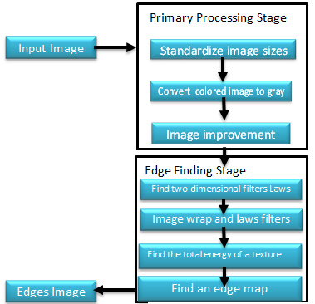

Fig. 1 General Diagram Of The Proposed System

*A. Pre_ Processing Stage*

This process aims to prepare the image for the following processors, and includes a set of sequential steps as follows:

First: .size standardization for input images: This process is performed on the input image to standardize the volumes for all input images. Second: The process of converting the image to gray: This process is carried out by converting the image to a gray color. The purpose of the above two processes is to obtain a suitable image for processing in terms of storage and time. Third: Enhanced: The image is enhanced by applying an average vector to the input image, in the blurred and distorted image. The image vector is randomly distributed across all pixels of the image, and in this process, the average local process is applied, and for all image vector values with an average of eight local neighbors of the vector and for each pixel in the image. This is a process that eliminates the random orientation of vectors in the previous vector image and makes them more uniform, which gives more accurate results in the edge of the object in the image. The average vector of the image is calculated using the following steps:

First: Perform wrapping the image with a Gaussian mask to remove noise and soften the image. Eq. "(1)" and Eq."( 2)" explain how to apply this step.

*𝐶𝑂𝑥 (𝑖, 𝑗) = −𝐺𝑀𝑦 × I(𝑥, 𝑦) ≈ $\frac{∂I(x,y)}{∂y}$ (1)*

*𝐶𝑂𝑦 (𝑖, 𝑗) = 𝐺𝑀𝑥 × I(𝑥, 𝑦) ≈ $-\frac{∂I(x, y) }{∂x}$ ( 2)*

I (𝑥, 𝑦): represent the input image, G𝑀x and: GMy masks represent in the and directions, where the masks are calculated using the following Eq. "(3) and Eq."(4)"

*𝐺𝑀𝑥 (𝑥, 𝑦) = $\frac{1}{\sqrt{2π}σ }$ ($\frac{x}{\sqrt{x^{2}+y^{2}}}$) exp ( - $\frac{x^{2}+ y^{2}}{2σ2}$) (3)*

*𝐺𝑀𝑦 (𝑥, 𝑦) = $\frac{1}{\sqrt{2π}σ }$ ($\frac{y}{\sqrt{x^{2}+y^{2}}}$) exp ($-\frac{x^{2}+y^{2}}{2σ2}$) (4)*

Where 𝜎 is the standard deviation of the distribution that plays a fundamental role in the behavior of the function. In the proposed method, the window size used is [3 x 3] and the value is (0.375), so the values of the masks used are:

𝐺𝑀𝑥 =

𝐺𝑀𝑦 =

Second: Calculate the maximum number of points in the matrix from Eq."(5)":

*𝑀𝑃 = 𝑚𝑎𝑥𝑖,j ( ) (5)*

Third: Calculate the vector information using the Eq. "(6)":

*VI (𝑖, 𝑗) = $\frac{1}{MP}$ (𝐶𝑂𝑥 (𝑖, 𝑗) 𝑖⃗ + 𝐶𝑂𝑦 (𝑖, 𝑗)⃗j) (6)*

Where 𝑀𝑃, 𝐶𝑂𝑥, and 𝐶𝑂y were calculated in the previous steps.

Forth: .Calculate the magnitude and direction of the average vector using[21] Eq."(7) and Eq. "(8)":

*𝐴V(𝑖, 𝑗) = $\frac{1}{NP }$ Σ(𝑖, 𝑗)∈N   ( 7)*

Where 𝑁𝑃 is the total number of pixels and their neighborhoods and the direction is calculated according to *the Eq."(8)" : D(𝑖, 𝑗)= $\frac{1}{Np }$ Σ (𝑖, 𝑗) ∈N tan−1() ( 8)*

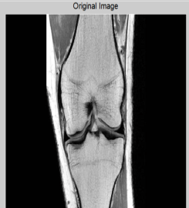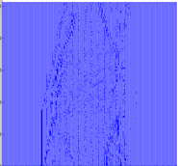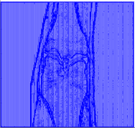

(a ) (b) (c)

Fig. 2. (a)Input Image (b) Vector Image (c) Average Vector Image

**2.2 Edge detection stage**

**The edges of the images entered into the system are detected by finding an edge map and depending on the texture of the image. The derivation of the edge map gives great knowledge about boundaries.**

**The Laos tissue method has been used to extract the edge detection tissue. The Laos method consists of the following steps:**

**2.2 Edge detection stage**

**The edges of the images entered into the system are detected by finding an edge map and depending on the texture of the image. The derivation of the edge map gives great knowledge about boundaries.**

**The Laos tissue method has been used to extract the edge detection tissue. The Laos method consists of the following steps:**

***B. Edge Detection Stage***

*B. Edge Detection Stage*

The edges of the images entered into the system are detected by finding an edge map and depending on the texture of the image. The derivation of the edge map gives great knowledge about boundaries. The Law's texture method has been used to extract the edge detection texture. The Law's method consists of the following steps:

* *Creating Two-Dimensional Laws Filters*

In this process the one-dimensional laws filters are configured as follows:

Law's Texture is one of the statistical methods developed by K. I. Laws to measure the texture of images[11]. This method is used in many applications such as medical imaging for tissue analysis and study[12][13]. This method creates texture features locally using masks that wrap with the gray image to create the texture feature locally[14]. warp masks are two-dimensional, often used to characterize texture, and to produce one-dimensional convoluted filter vectors of three and five lengths:



Where, (L5) level-average of the gray level, Gaussian is used to give a local center weight. (E5) Edge - extracting edge features, it uses (gradient) that responds to the edges of a row or column step. (S5) Point - Extract points, it uses (LOG) to detect points. (R5) Ripples - To extract ripples, it uses Gabor to detect ripples[15].

All masks have a zero-sum except for L5 and. L3 wraps an image texture with Law's masks and calculates energy stats a describes texture properties that can be used to identify texture. When the wrapping process is applied to the image, the one-dimensional masks are converted into two-dimensional masks by multiplying each mask with the other masks[16]. The texture of the image is wrapped with Laws masks[17]. By using four one-dimensional masks, I produced sixteen masks, and these masks will be reduced to nine because there are masks of similar value, therefore, it is replaced by an average of each pair of masks as shown in Table 1. where the wrapping is between the input image and nine masks. To produce nine images that represent the image texture features. When applying each mask to the image, it gives a different texture feature as shown in Table2. Next, we find the total energy, to obtain features of the total texture[18].

TABLE 1. TEXTURE MASKS USE

|  |  |
| --- | --- |
| **Masks** | **The Used Masks** |
| L5E5\E5L5 | Average(L5E5\E5L5) |
| L5S5\S5L5 | Average(L5S5\S5L5) |
| L5R5\R5L5 | Average(L5R5\R5L5) |
| E5S5\S5E5 | Average(E5S5\S5E5) |
| E5R5\R5E5 | Average(E5R5\R5E5) |
| S5R5\R5S5 | Average(S5R5\R5S5) |
| S5S5 | S5S5 |
| R5R5 | R5R5 |
| E5E5 | E5E5 |

TABLE 2. THE MEANNING OF LAWS TEXTURE MASK

|  |  |
| --- | --- |
| Mask Name | Description - Adjectives Extracted from the Texture |
| E3L3 | Gray plane intensity in the horizontal direction and edge detection in the vertical direction |
| L3E3 | Edge detection in the horizontal direction and the intensity of the gray plane in the vertical direction |
| L3S3 | Scar detection in the horizontal direction and the gray level density in the vertical direction |
| S3L3 | Gray level intensity in the horizontal direction and scarring in the vertical direction |
| L3L3 | Express the intensity of the gray plane from three contiguous points in both the horizontal and vertical directions |
| E3S3 | Spot detection in the horizontal direction and detection in the vertical direction |
| E3E3 | Edge detection in both vertical and horizontal directions |
| S3E3 | Edge detection in the horizontal direction and spot detection in the vertical direction |
| S3S3 | Spot detection in both horizontal and vertical orientation |

To prepare the image for the application of Laws filters, the lighting effect is reduced by subtracting each point from the average intensity for each point in the image and this is done using Eq."(9)", the result of this process is shown in "Fig. 3":

Whereas: f(𝑖, 𝑗) = f(𝑟, 𝑡)– 𝑚𝑒𝑎𝑛(f(𝑟, 𝑡)) (9)

𝑖=1…n, 𝑗=1…m, 𝑟=𝑖…i+𝑑-1,𝑡=𝑗…𝑗+𝑑-1

d: represents the filter length which is equal to (5) and [n, m] represents the image size.

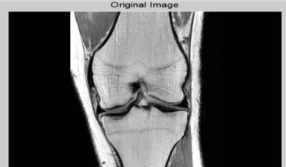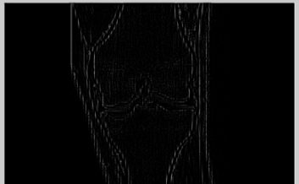

(a ) (b)

Fig. 3. (a)The Original Image (b) The Image After Brightening Reduction

* *The Process of Wrapping Images and Laws Filters*

In this process, the input image is filtered by the laws' texture filters, which calculate by wrapping the input image with each of the 16 laws masks, and by replacing the center point with the result of applying the wrapping process, and this is done by using Eq."(10)": 𝑓 ́(𝑖, 𝑗) = 𝑓(𝑖, 𝑗) ∗ ℎ𝑘 (10)

The following sixteen masks will be reduced by replacing each pair of the following attributes with their average, the sixteen masks as follows: L5E5\E5L5, L5S5\S5L5, L5R5\R5L5, E5S5\S5E5, E5R5\R5E5, S5R5\R5S5, E5E5, S5S5, R5R5.

The remaining nine masks after reducing are[L5E5, L5R5, E5S5, S5S5, R5R5, L5S5 E5E5, E5R5, S5R5]

Therefore, the output of this process will be nine images, each image representing (one of the image texture properties as shown in "Fig. 4". 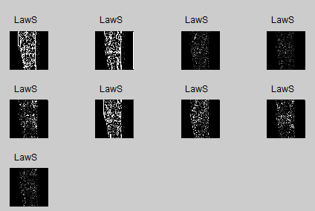Fig. 4. The Result of Applying Laws Masks to the Image

* *The Process of Collecting Image Texture Energy*

Calculate the energy of the texture by adding the absolute value of the filters resulting from the adjacent values around the point to obtain nine characteristics and according to the Eq. "(11)"

𝑓 ́́ (𝑖, 𝑗) = $\frac{1}{w2 } \sum_{n={-w}/2}^{w/2}{\sum_{m={-w}/2}^{w/2}{|}}{f ́}_{k}(n,m)|$ (11)

As shown in "Fig. 5", then the attributes are collected in one form and as shown in "Fig.. 6", for the original image, 𝑓 (𝑖, 𝑗) the small texture characteristics 𝑓𝑘 (𝑖, 𝑗) are calculated using the image wrapping with filters. ℎ𝑘 According to Eq. "(10)". 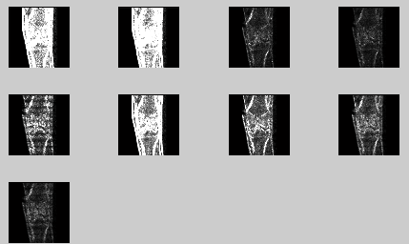

Fig. 5. The Laws Energy Texture Image

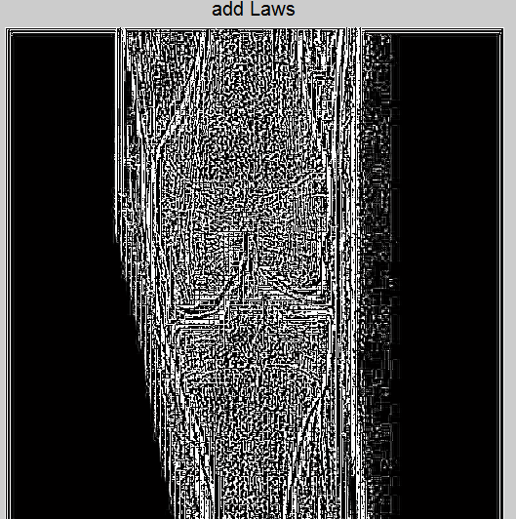

**Fig. 6. The Final Image of Laws**

* *Find an Edge Map*

This process takes the result of the previous process of Law's texture and enters it into the detection of the Canny edge. The Canny edge detection is an ideal method for detecting the edge that is caused by (Gaussian) noise and is supposed to reveal the edge by reducing noise and centering it at the edge. canny edge detection steps: First: Wrap the image produced by Law's Texture with Gaussian masks because the image contains noise. To avoid the noise problem, we use Gaussian masks to reduce the noise in the image by homogenizing according to Eq."(12)": G(𝑥, 𝑦) = $\frac{1}{2πσ2 }exp\left[\frac{-x2+y2}{2σ2}\right]$ (12)

**(a ) (b)**

**Fig. 9. (a)Image Kidney (b) The Edge Map**

Where is the standard deviation of the distribution that plays an important role in the behavior of the Gaussian function and its value is small.

Second: Calculate the size and direction of the gradient, using a 2 × 2 size window to calculate the size and orientation of the image 𝑓 (𝑥, 𝑦) according to Eq. " (13)" and Eq. "(14)": -

∇𝑓 = $\left(\frac{∂f}{∂x},\frac{∂f}{∂y}\right)$

|  |  |
| --- | --- |
| x, | x , y+1 |
| x+1,y | x+1,y+1 |

𝐺𝑥 [𝑥, 𝑦] = $\frac{1}{2}$ ((𝑥, 𝑦 + 1) − (𝑥, 𝑦) + (𝑥 + 1, 𝑦 + 1) − (𝑥 + 1, 𝑦) (13) 𝐺y [𝑥, 𝑦] = $\frac{1}{2}$ ((x, y)-(𝑥+1,y) + (𝑥,𝑦 + 1) − (𝑥 + 1, 𝑦+1)) (14)

Where $\frac{∂f}{∂x}$ = 𝐺𝑥 [𝑥, 𝑦], $\frac{∂f}{∂y}$ = 𝐺𝑦 [𝑥, 𝑦] The gradient and direction values are calculated according to Eq. "(15)" and Eq. "(16)" respectively:

M[𝑥, 𝑦] = $\sqrt{{Gx}^{2}\left[x, y\right]+{Gy}^{2}[x, y] }$ (15)

θ[𝑥, 𝑦] = arctan ( $\frac{Gy[x,y]}{Gx[x,y]}$) (16)

Third: Remove the small values to reveal the edges: each pixel is compared to the center of a 3 × 3 window with a pixel and using the calculated gradient direction to find the largest local value in the image gradient and save the pixels that have the largest local value, in addition to that put the zero instead of the pixel value whose values are less than the maximum because the values must be reduced, so only higher values will remain.

Forth:. Selection of the threshold, the simplest method used to determine the threshold value is to calculate the average values of the image data as in Eq. "(17)", "Fig.. 7" and "Fig. 8" present the outputs of this process.

𝑇 = $\frac{1}{H*W }$ $\sum_{i=1}^{H}{\sum_{i=1}^{W}{f(i, j)}}$ (17)

Where: W is the width of the image, H: the height and "Fig. 7" shows the result of this process.

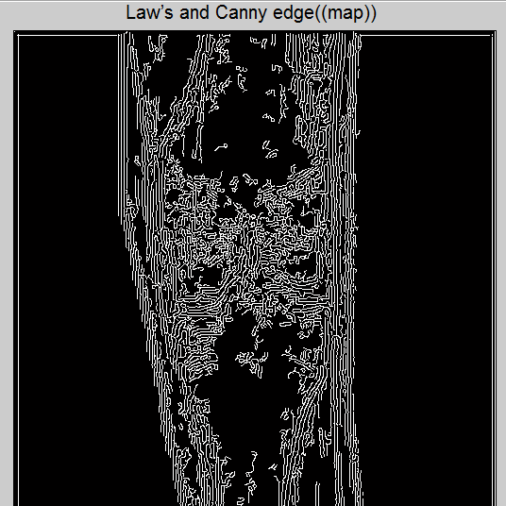

Fig. 7: The Edge Map

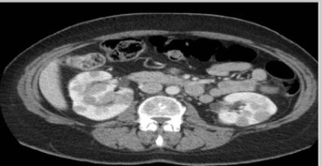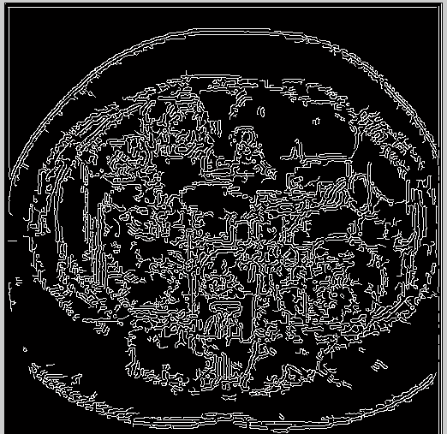

(a ) (b)

Fig. 8 (a)Image Kidney (b) The Edge Map

III. Results

The proposed system was applied and tested on various medical images in "fig. 9". Each form of the following experiments contains four images:- (a) The input image. (b) Compute the average of the edge vector which gives the direction and size of the edge. The vector is defined as arrows, as the arrows indicate the direction of moving each pixel towards the vertical or horizontal direction. The main advantages of this process are the elimination of randomness in the previously calculated directions and making them regular, which will give better and more accurate results and increase the clarity of the edges in the image.(c) Laws texture result d) Edge map representing image edge detection. )

This system provides a complete description of the edges of the image where the best edges are selected in the image and it shows importance by using this system to detect edges and borders with high accuracy. 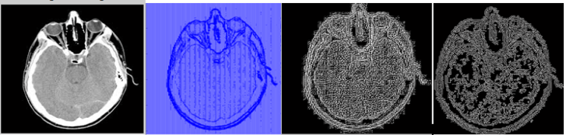

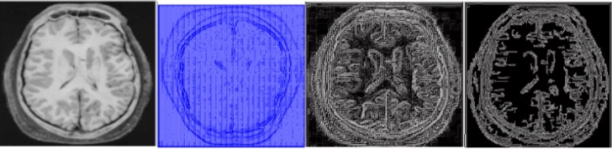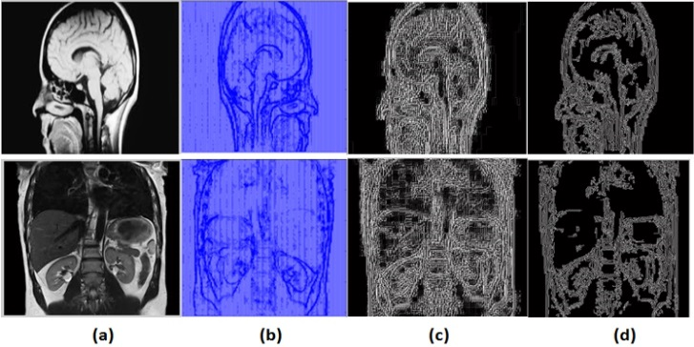

Fig. 9. (a) Input Image (b) Image Vector (c) Laws Texture Image (d) Edge Map

IV. Comparison of the Results

The proposed method can also be compared with various techniques for edge detection such as Sobel, Roberts, and Zerocross, Canny. The goal of the proposed system is to produce an edge map that must be clean by extracting the edge characteristics of the original image, "Fig. 10" shows the images obtained using various edge detection technologies as well as the suggested system. 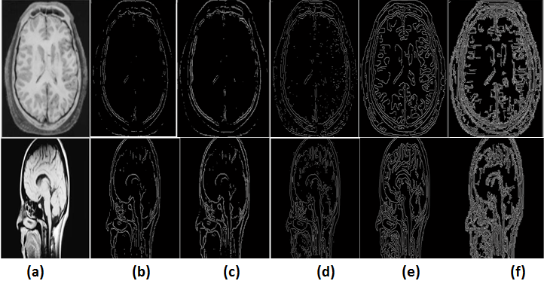

Fig. 10: (a) Original Image (b)Sobel (c) Roberts (d)Zerocross (e) Canny (f)The Proposed System

We will notice that the edges detected in the proposed system are more than the edges detected in other methods, as the proposed system was able to detect the undiscovered edges in traditional methods, thus increasing the detection efficiency to be used in applications that require more edge detection.

The proposed system can evaluate by computing the mean square error (MSE) and the peak signal to noise ratio (PSNR) as shown in the Table 3. the result of these operations to different medical images.

TABLE 3.: PERFORMMANCE PARAMETERS

|  |  |  |
| --- | --- | --- |
| No.  Experiments | Mean  Square  Error(MSE) | Peak Signal to  Noise  Ratio(PSNR)(db) |
| 1 | 0.0046153 | 67.9909 |
| 2 | 0.0062524 | 68.4634 |
| 3 | 0.0032580 | 66.0574 |
| 4 | 0.0071312 | 70.7936 |
| 5 | 0.0234521 | 68.2341 |

V. Conclusions

The proposed system has been successfully tested on various types of medical images, including the brain, kidneys, and heart. It can also be applied to any type of image. The proposed system also features in detection of edges in relying on the vector average, which eliminates randomness in the directions calculated from previously vector information and makes them regular, which gives better and more accurate results and increases the clarity of edges in the image. Also, the process of analyzing the image texture (to find the edge map) and extracting the features is an essential step in the system where the texture of the image is analyzed using the Laws texture technique and then the image properties are studied. There are several techniques used in analyzing the texture, but the analysis using Law's Texture method has proven its effectiveness. The application used in this study, but greatly increases the processing time. The proposed system gives better results compared to previous methods of edge detection, and the edges can be detected in complex medical images with high accuracy compared to the existing conventional models. Edge extraction can be helpful for clinicians in detecting abnormalities in the human body.

REFERENCE

1. Jamil Saif, Mahgoub Hammad, and Ibrahim Alqubati, "Gradient-Based Image Edge Detection," International Journal of Engineering and Technology, Vol.8, No.3, pp.153-156, June 2016.
2. Haiyan Yu1, Jiulun Fan," A novel segmentation method for uneven lighting image with noise injection based on non-local spatial information and intuitionistic fuzzy entropy ",Yu and Fan EURASIP Journal on Advances in Signal Processing (2017) 2017:74 , DOI 10.1186/s13634-017-0509-5.
3. JUN-HO HUH, YEONG-SEOK SEO," Understanding Edge Computing: EngineeringEvolution With Artificial Intelligence" , Digital Object Identifier 10.1109/ACCESS.2019.2945338, November 21, 2019.
4. Mahmut Yurt, Salman UH Dar, Aykut Erdem, Erkut Erdem, Kader K Oguz, Tolga Çukur,", Image Synthesis in Multi-Contrast MRI With Conditional Generative Adversarial Networks", [IEEE Transactions on Medical Imaging](https://ieeexplore.ieee.org/xpl/RecentIssue.jsp?punumber=42) ( Volume: 38, [Issue: 10](https://ieeexplore.ieee.org/xpl/tocresult.jsp?isnumber=8854342), Oct. 2019).
5. Jose B., Kaisar K., Daniel S. Asfaw, Sergi V., Arnau O.," Deep convolutional neural networks for brain image analysis on magnetic resonance imaging: a review", [Volume 95](https://www.sciencedirect.com/science/journal/09333657/95/supp/C), April 2019, Pages 64-81
6. **J. Kuruvilla, D. Sukumaran, A.Sankar, Siji P. Joy," A review on image processing and image segmentation", 2016 International Conference on Data Mining and Advanced Computing (SAPIENCE).**
7. Amit D. Purohit, S.T. Khandare, "A Survey on Different Color Image Segmentation Techniques Using Multilevel Thresholding," International Journal of Computer Science and Mobile Computing, Vol.6, No.4, pp.267– 273, April 2017.
8. J. S. Owotogbe,T. S. Ibiyemi, and B. A. Adu," Edge Detection Techniques on Digital Images -A Review", Volume 4, Issue 11, November–2019, International Journal of Innovative Science and Research Technology, ISSN No:-2456-2165.
9. Johari N, Singh N. "Bone fracture detection using edge detection technique." Advances in Intelligent Systems and Computing. 2018;584:1119.Available:https://doi.org/10.1007/978-981-10-5699-4_2.
10. V. Rabila, G. Bharatha Sreeja," BM3D Based On Affine Transformation for Image Denoising", International Journal of Scientific Research in Computer Science, Engineering and Information Technology© 2017 IJSRCSEIT| Volume 2 | Issue 2| ISSN : 2456-3307.
11. A. Sagiterry , Elysia, J. Wesley, Y. Purnama," Mammogram Classification using Law's Texture Energy Measure and Neural Networks", International Conference on Computer Science and Computational Intelligence (ICCSCI 2015).
12. Baojun Li, Hernan Jara, Heishun Yu, Michael O’Brien, Jorge Soto, "Enhanced Laws Textures: A Potential MRI Surrogate Marker of Hepatic Fibrosis in a Murine Model," Magnetic resonanceimaging, Vol.37.11.008,2016.
13. Hassan Bagher-Ebadian, Farzan Siddiqui, Liu Chang, Benjamin Movsas, Indrin J. Chetty, " The Impact of Smoothing and Noise on Robustness of CT and CBCT Radiomics Features for Patients with Head and Neck Cancers," Department of Radiation Oncology, Henry Ford Hospital, Detroit, MI, Vol.44, No.5, 06 March 2017.
14. J. Chaki., N.  Dey.," Texture Feature Extraction Techniques for Image Recognition", 2020 – Springer.
15. Diana Veiga, Nelson Martins, Manuel Ferreira, João Monteiro, "Automatic Microaneurysm Detection Using Laws Texture Masks and Support Vector Machines," Computer Methods in Biomechanics and Biomedical Engineering:Imaging& Visualization,2017.
16. Gan Hong Seng, Tan Tian Swee, and Hum Yan Chai, "Research on Law’s Mask Texture Analysis System Reliability," Research Journal of Applied Sciences, Engineering and Technology, Vol. 7, No. 19, pp. 4002-4007, May 15, 2014.
17. J. Chaki,N. Dey,V. Rajinikanth,Amira S. Ashour," Recognition of Skin Diseases Using Curvelet Transforms and Law’s Texture Energy Measures",Proceedings of the 8th International Workshop Soft Computing Applications (SOFA 2018), Vol. II.
18. Fatimah Al-Hafiz, Shiroq Al-Megren and Heba Kurdi," Red blood cell segmentation by thresholding and Canny detector", The 8th International Conference on Current and Future Trends of Information and Communication Technologies in Healthcare (ICTH 2018).
19. Bhawna Goyal, Ayush Dogra, Sunil Agrawal and B.S.Sohi," Noise Issues Prevailing in Various Types of Medical Images",Biomedical & Pharmacology Journal,September 2018.Vol. 11(3), p. 1227-1237.
20. Sattar D., Robert J. Thomas, Marc M.," Comparison of deep convolutional neural networks and edge detectors for image-based crack detection in concrete", Construction and Building Materials, Volume 186, 2018, pp. 1046-1063.
21. Jalal Al-Anssari, Anca Ralescu," Three-Dimensional Unsharp Masking Spatial Filter of a Field of Vectors for Geometrical Edges Magnitude and Direction Detection in Point Cloud Surfaces",2019 IEEE International Conference on Humanized Computing and Communication (HCC) DOI:[10.1109/HCC46620.2019](https://doi.org/10.1109/HCC46620.2019)