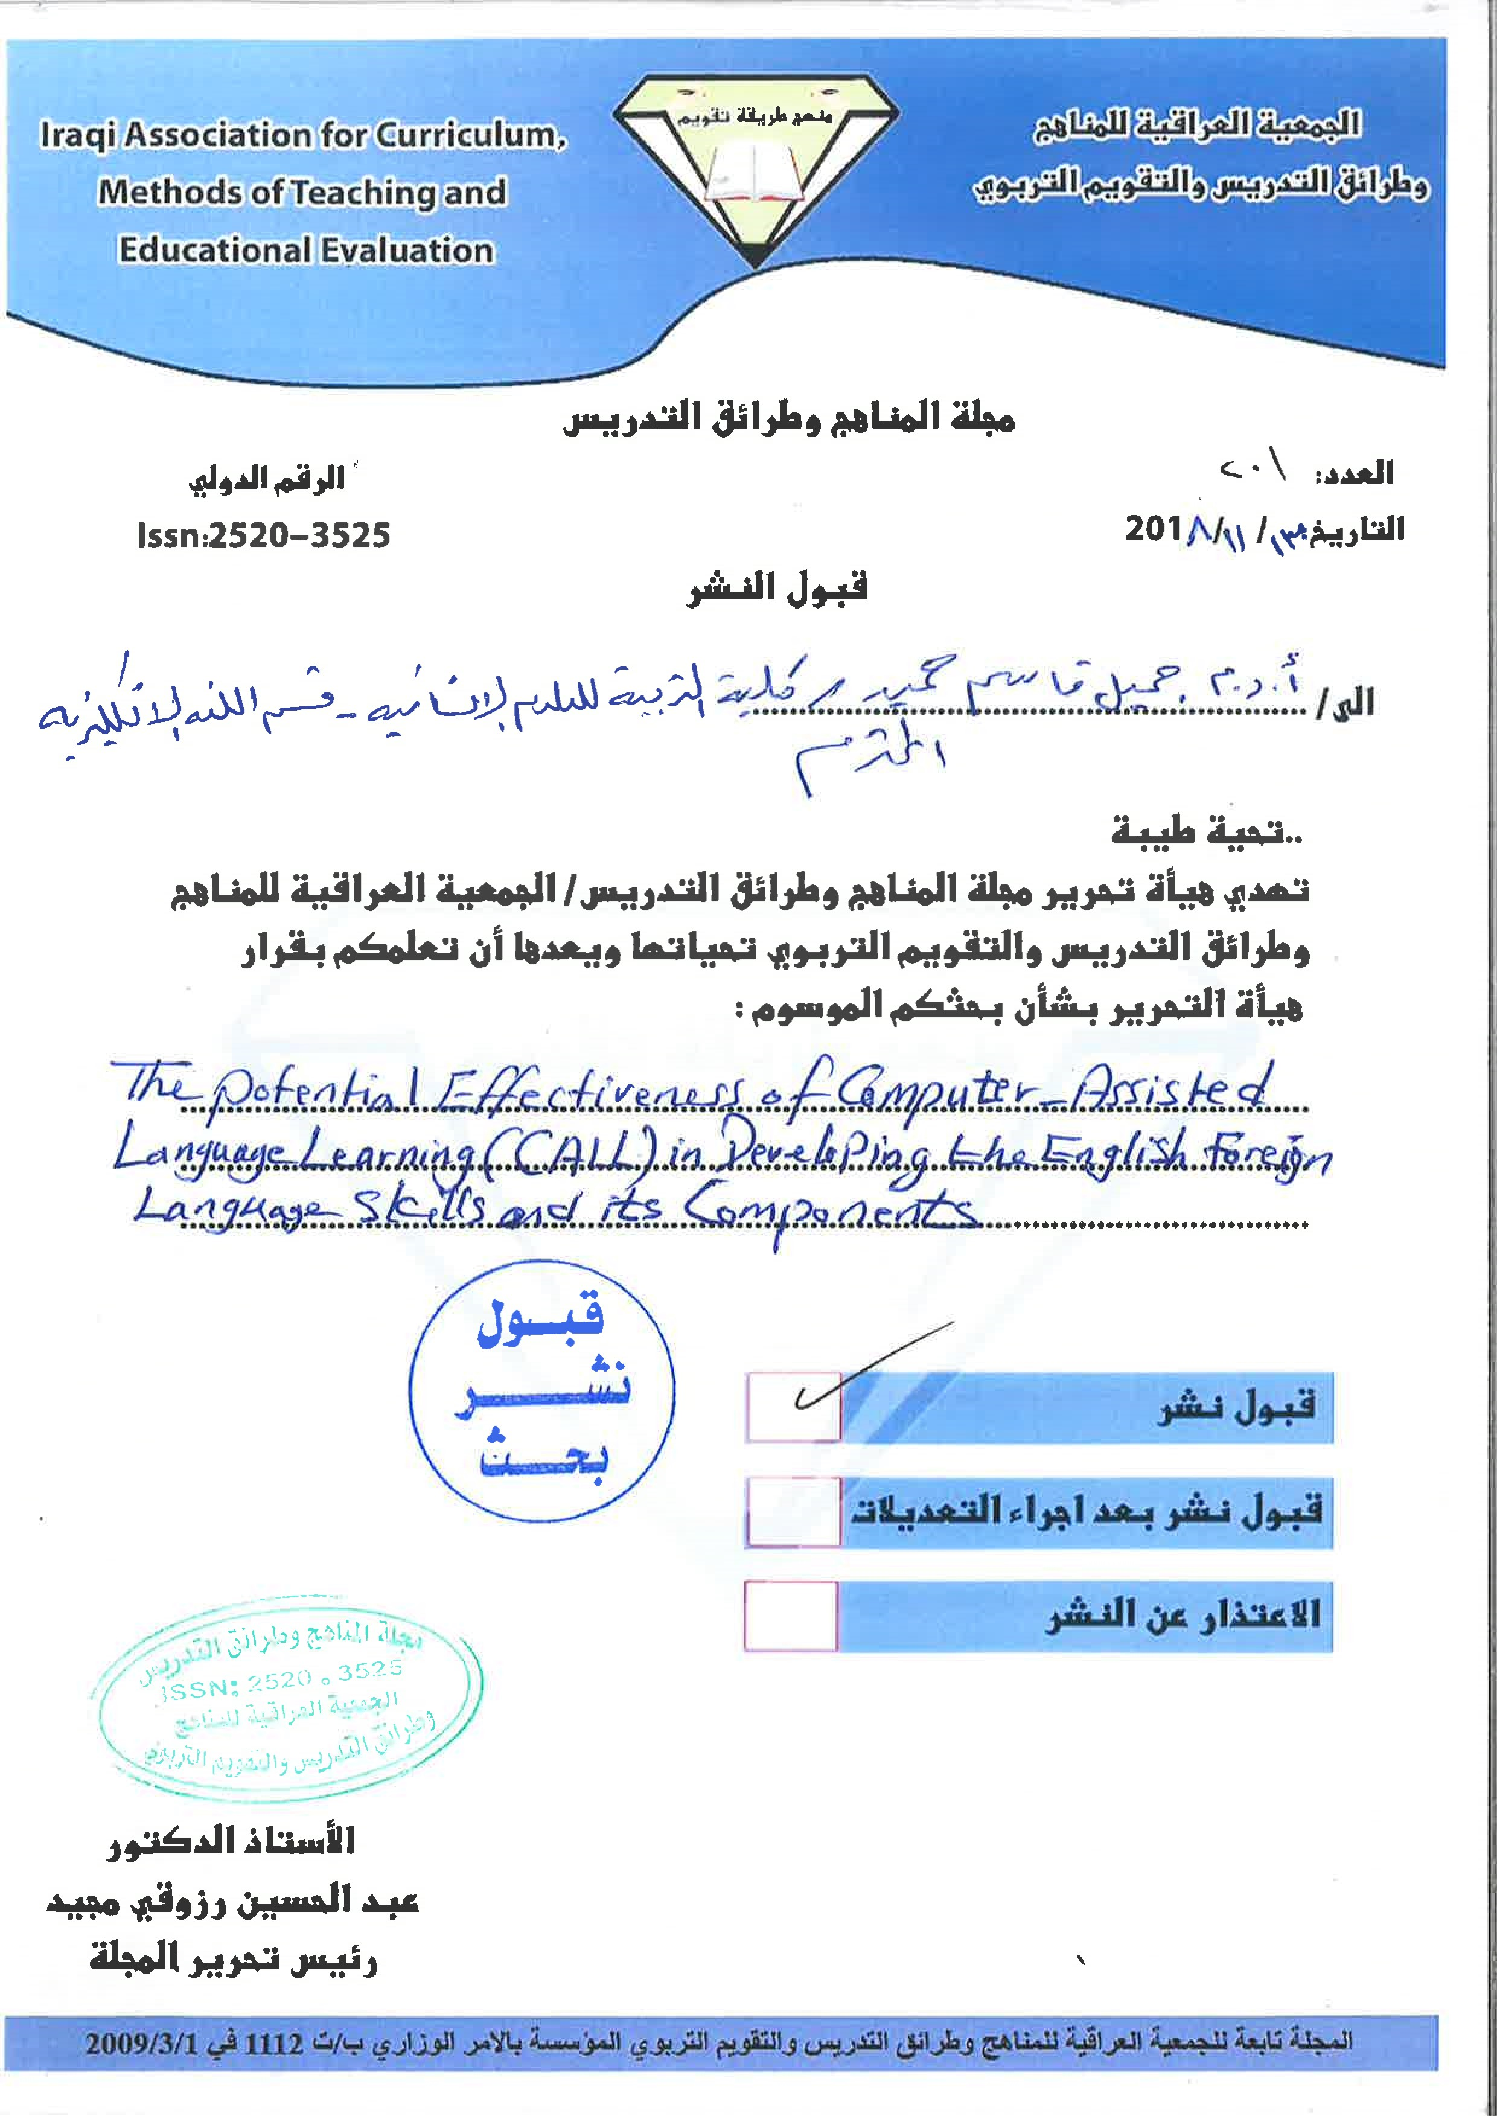

The Potential Effectiveness of Computer-Assisted Language
Learning (CALL) in Developing the English Foreign
Language Skills and its Components
Assist. Prof. Dr. Jameel Qasim Hameed
Department of English
College of Education for Human Sciences
University of Basra

Abstract
Computer-Assisted Language Learning (CALL) is widely accepted to be a tool which can be used to facilitate the language learning process, particularly English language learning and teaching. This research is divided into two main parts: theoretical and practical. The theoretical part aims to provide an overview of the stages of the history of CALL and its role in language teaching. It also focuses on the relationship between CALL and language skills and components. Then, it discusses the usefulness of multimedia and the Internet that is used in CALL. Next, it presents some pros and cons of CALL. The practical part consists of conducting a questionnaire, giving research objective, results and discussions. The research ends up with some conclusions built on the findings arrived at, some recommendations are also presented.
Keywords: CALL, stages, role, language skills and components, multimedia, Internet, pros and cons, questionnaire, objective, results and discussions, conclusions and recommendations.

1. Preliminaries

1.1 Introduction
The introduction of computers as an aid in the language classroom is the most significant milestone in recent language teaching methodology. This has led to the rise of the Computer-Assisted Language Learning (CALL) on the scene of English Language Teaching. "Computer-Assisted Language Learning (CALL) stands for the search for and study of the applications of the computer in language teaching and learning" (Naeini, 2012:9). Also, it can be defined as any process in which a learner uses a computer to improve his or her language (Ziegler, 2014:1). In addition, Gündüz (2005:197) states that CALL "is a term used by teachers and learners to describe the use of computers as part of a language course. ' The computer is " a flexible classroom aid, which can be used by teachers and learners, in and out of class, in a variety of ways and for a variety of purposes. " (Gündüz , 2005:197). Computers, which have entered the school life in the late 1950s in developed countries, are still developing day by day throughout the world. Today, they have become more powerful, faster, easier to use, more convenient and cheaper, and they can process and store much more data, as well. Equipment such as CD-ROMs, DVDs, USB Pen Drivers/ USB Memory Sticks and printers used with computers have also developed rapidly. Using these, a computer program can handle sound, pictures and videos along with characters.
At the end of the 20th century, the computer mediated communication (CMC) and the Internet have reshaped the use of computers for language learning. Computers are no longer used only for the purpose of information processing and display but also as a tool for communication. Learners of a language , with the use of the Internet, can now simultaneously communicate with speakers of the target language all over the world. Nevertheless, as Gündüz (2005:194) mentions that, " computers can never replace the 'live' teacher, especially in language teaching, where the emphasis is on mutual communication between people." It can just play a role in teaching a second or foreign language as an aid to the teacher.
CALL plays a crucial role in developing language skills (listening, speaking, reading and writing) and also language components such as, grammar, vocabulary and pronunciation. It is important to be used by teachers especially in areas where there are no native speakers of the target language. Above all, CALL encourages learners' autonomy and motivation. They can depend on themselves in choosing the materials which are suitable for their level. In this way, they become more responsible for their own learning. Generally speaking, the use of computer technology stimulates language learning. In CALL environment students become more curious and motivated.
1.2 Statement of the Problem
The problem is that some teachers and learners do not make use of or are unable to employ computer as a teaching aid in teaching/learning English as a foreign language.
1.3 Hypothesis
If learners of the English language are aware of the significant role that computer-Assisted Language Learning (CALL) plays in developing English foreign language skills and language components, they can also develop their everyday life communication perfectly.

2. Stages of the History of Computer-Assisted Language Learning in Language Teaching
According to Warchauer (1996:NP) the history of CALL can be divided into three phases: behaviouristic CALL, communicative CALL and integrative CALL. Each stage corresponds to a certain pedagogical approach.
2.1 Behaviouristic CALL
Behaviouristic CALL is the first phase of CALL. In this regard, Khamkhien (2012:56) mentions that it was conceived in the 1950s and implemented in the 1960s and 1970s under the influence of the Audio-

lingual Method. Gündüz (2005:198) states that repetitive language drills (the so called drill and practice exercises) were used. The computer served here as a mechanical tutor which delivers instructional material to the students. This represents a hindrance for motivation. Further, it included extensive drills, grammatical explanations and translation at various intervals. Related to this, Warchauer (1996:NP) says that behaviouristic approach to language learning has been rejected by most language teachers, and the increasing sophistication of computer technology has led to other possibilities.
2.2 Communicative CALL
Communicative CALL is the second phase of CALL. KledeckaNadera (2001:24) mentions that the communicative CALL emerged in the late 1970s and early 1980s. The focus of CALL in this phase is on using forms rather than on the forms themselves. In other words, communicative CALL corresponded to the cognitive theories which stressed that learning is a process of discovery, expression and development. It allowed the learners to make their own utterances and sentences, not only by repeating ready-made ones, but by using them communicatively.
hl.o
According to Warchauer (1996:NP) there are several types of CALL programs used during this phase of communicative CALL. The first CALL model used for communicative activities is the computer as a tutor model. It includes programs like text reconstruction and language games. They are similar to the drill and practice programs mentioned in the behaviouristic CALL. The computer is the knower of the right answer, but the process of finding the right answer involves a great degree of student choice, control and interaction. They provide practice in a non-drill format.
Another CALL model used for communicative activities involves the computer as stimulus. Here, the purpose is not on having students discover the right answer, but on stimulating students' discussion, writing, or critical thinking. Software used for such aims include programs which may not have specially designed for language learning such as Sim City, Sleuth, or Where in the World is San Diego? (Warchauer, 1996:NP).
The third model of computers in communicative CALL involves the computer as a tool. The goal here is to help the learner use or understand language. It is not important that the programs should provide language material. Examples of computer as a tool involve word processors, spelling and grammar checkers and desk-top publishing programs and concordancers (Warchauer, 1996:NP).
2.3 Integrative CALL
Integrative CALL is the third stage. Khamkhien (2012:57) mentions that it started in the 1990s. The innovation of multimedia (providing text, graphic, sound and animation) and the Internet led to a shift from the use of the computer for drill and tutorial purposes to a medium for extending education beyond classroom. Here, there is a focus on integrating various skills like reading, writing, speaking and listening. Gündüz (2005:199) explains that programs here mainly task based and sought to place language learners to authentic language context.

3. The Role of CALL in Language Teaching
CALL plays a significant role in promoting the process of language teaching. Mutlu and Erö z-Tuga (2013: 107) say that " CALL environments foster learner autonomy. " Learners have high motivation level to learn the English language, take responsibility for their own learning and continue language study outside the classroom. In addition, Naeini (2012: 9) states that computer and the Internet could be considered as motivating tools that help learners "to develop more positive attitudes toward learning a foreign language.
One of the most important reasons for using the computer is its unique ability to deliver materials that meet the needs of the individual learner visually by displaying texts, graphics, or videos on a screen. It can also present sounds in the form of audios (Gündüz, 2005:197). Moreover, the authentic materials, the computer helps to display, bridge the gap between the language that is used in the classroom and the one used in the real-world communicative situations.

4. CALL and Language Skills and Language Components
4.1 Listening Skill
In learning a foreign language, listening skill plays an important role. In order to communicate well in a foreign language. Students should have enough sources of input for listening to enhance their listening skill. That is, the first thing that a student needs to develop to be able to communicate in a foreign language is his listening comprehension skill. Dehghani and Jowkar (2012:106) state that " the development of all other language skills is interwoven with listening skills, it is said 10 be at the heart of both first and second language learning. "
The Internet is a useful tool for developing listening skill. Hubbard (2009:6) says "Thanks to the World Wide Web, today learners of almost any language can find a wealth of authentic audio and video to listen for both language and culture.
In addition, most of textbooks include audio so that a teacher can provide the opportunity for his students to listen to native speakers of the target language. During listening to a recorded section they may complete a leaflet given in the activity book. In this way, students' listening comprehension will be developed step by step. Also, a teacher may ask students to listen to an audio, then, he/she may ask them to supply a summary for what they have listened to. Moreover, Gündüz (2005:204) suggests that " One of the simplest ways of giving practice in listening comprehension is to use a multiple-choice or fill-in program in conjunction with... the latest multimedia containing a recorder. "
Furthermore, as listening is a challenging skill for the difficulty that learners face in recognizing the linguistic information form an acoustic signal in real time to identify its meaning, teaching this skill must include extensive practice in decoding and making meaning. As such the benefit of CALL activities lie in slowing down the process, capturing the oral

language in text and showing word boundaries in contrast to normal listening in which students neither can see speech or the boundaries between words nor they can stop or slow down the speech they listen to (Chapelle and Jamieson, 2008: 125).
4.2 Speaking Skill
Speaking is a crucial skill. Bahadorfar and Omidvar (2014:9) mention that "Speaking is the use of verbal and non-verbal symbols, in a variety of contexts. " Also, Bahadorfar and Omidvar (2014:9) state that "Good speaking skills are the act of generating words that can be understood by listeners. " Consequently, teachers should do their best to prepare students as much as possible to be able to speak English in real life situations. In other words, they should develop their communicative competence, because, most of the times, the first impression of a person is based on his/her ability to speak fluently and comprehensively.
Gündüz (2005:203-204) refers that "Dialogue studies can be made by the computers with the aid of the movies; students watching these dialogues can see the conversation, setting and cultural atmosphere clearly. " In this way, they would be more familiar with the target language. Moreover, teachers may expose learners to watch a video and ask them to describe it or ask them short questions and they would answer depending on their observation of the conversation. In addition, the teachers may ask the learners to describe some pictures on the screen.
Bahadorfar and Omidvar (2014:12) add a further view in stating that
To improve speaking, students can use Skype, MSM Messenger Google talk (used to have conferences on line) and other applications where students can connect with friends, other students, teacher and even native speakers, these ways of learning have been observed to improve oral proficiency in students and make up for the lack of native speakers in the area where students live and what is more, on line conferences also enhance intercultural awareness, motivation and raise the level of interaction.
In terms of teaching speaking, Chapelle and Jamieson(2008: 153-156) suggest the following five tips :
l - select CALL materials that teach the sounds and accents that are relevant for students
- choose CALL materials that explicitly teach English speaking skill.
- Provide opportunities for oral practice through interaction with the computer.
- Evaluate learners' performance and provide feedback.
- Help learners develop strategies for explicit online learning of oral language through the use of online reference tools.
4.3 Reading Skill
Reading is an important skill. Learners can gain understanding and knowledge about a particular subject through reading about it. Today, learners highly depend on the computer as a supporter. They search through several websites and download many texts in the computer.
Many websites, such as, Wikipedia encyclopedia, Spark notes, Cliffs notes and Shmoop guide provide a wide range of reading materials. Students read the materials in order to judge whether they are beneficial or not, then they print them and read them more and more. Through using the computer with the aid of the Internet it became easier to tackle many subjects like poetry, novel, drama etc. Moreover, many websites provide quizzes so that students can measure their understanding of what they have read. Also, they can check whether the answers are correct or incorrect and read the correct answer. Many students prefer using the computer in reading rather than other devices, because it is easier to handle and the size of the screen is suitable for reading.
As to highlight the importance of CALL in reading skill, Chapelle and Jamieson(2008:65) state that the variety of electronic texts and CALL activities make it easy to find appropriate texts for students in terms of the level of difficulty and that covers topics of interest to students.

4.4 Writing Skill
Writing is one of the major skills. Gündüz (2005:203) mentions that
The word processing program is one of the most common purposes for
318
which computers are used and it is regarded as the most powerful to use when starting to work with CALL. "
Gündüz (2005:203) adds further:
Word-processing programs transforms the computer into a sophisticated and flexible writing aid that can improve learners' writing skills and attitude toward writing. The main principle of word-processing programs is based on the ability to manipulate text freely. By writing text into the memory of a computer, the writer can play round with his text until entirely satisfied. The word-processor provides useful practice for guided and free writing.
So, using the computer in writing is beneficial. Students have the opportunity to correct their mistakes in an easier way without attempting to re-write the text from the early beginning. Also, spelling and grammar checkers are useful; however, Xiao-Ping (2014:756) says that suggestions given by the computer are not always suitable or perfect, so students need to take more autonomy and responsibility for their writing tasks when using the writing programs and grammar checkers. They have to decide if the suggestions are acceptable or not. Above all, the Internet gives opportunity to communicate by e-mail, for example, and to have pen friends. This allows the learner to participate in the target language culture.
#1.ioll
Moreover, Chapelle and Jamieson (2008:110) emphasizes that teachers can use writing in call activities in order to make students expand their knowledge of English and also to interact among students and other people outside the classroom. Students can put their ideas into English by using the computers to produce e-mail messages, Web pages or other documents created with a word progressing program. So far we have discussed the effect that Computer Assisted Language Learning has on developing foreign language skills, and then the research proceeds to show this effect on improving the minor language components: grammar, vocabulary, and pronunciation .

4.5 Grammar
Grammar is one of language components. Gündüz (2005:204-205) outlines that computer software and the World Wide Web provide useful activities for grammar. Some grammar activities that can be done on the
Computer might be :matching, multiple choice , fill in the gaps or complete the following . Also, quizzes can be done either online or after printing them . When doing it online, learners can ask for immediate feedback by clicking on the submission button.
Some grammar books are associated with CD-ROM. The CD-ROM includes useful exercises. Doing such exercises on the computer is enjoyable. Students can be provided with the right answer immediately after finishing the exercise. This is better than searching about it at the end of the book. Moreover, Hinkel and Fotos(2002) summarize some important ideas that shows how CALL can be used for teaching grammar which include discourse- based grammar form- focused instruction, and interaction (cited in Chapelle and Jamieson, 2008: 39).
4.6 Vocabulary
Gündüz (2005:205) states that computer software provides interesting vocabulary activities such as, guessing games or word building activities. They provide a nice challenge for students. Some vocabulary books, such as " English Vocabulary in Use" come with CD-ROMs. The materials and the exercises on the CD-ROM help learners to improve their vocabulary. Learners can test themselves. Also, they can even personalize tests to cover the topics that they want to practice. In addition, some games are included in the CD-ROM. Such games help learners practice vocabulary in a fun way. These games are quick. Students, might play for five or ten minutes a day to remember more vocabulary. Moreover, the CD-ROM has a dictionary, this needs internet connection. Furthermore, students can check their progress at any time using the progress section. This will help them to see which exercise they have completed. It can also show them areas where they need more practice. Students can print out tests, exercises and the answers.
4.7 Pronunciation
Pronunciation is one of the minor skills that learners should manipulate during their learning progress. Neri, Mich, Gerosa & Giuliani (2008:393) state that "several recent studies have shown that early exposure [o an L2 can indeed lead to more accurate speech perception and
320
production in that L2 than late exposure. " Neri, Mich, Gerosa & Giuliani (2008:393) also recommend that "researchers and educators must devise optimal ways to provide pronunciation training for young learners.
⁰
r
19äi.J.Ld
uol.tlIaacJl
e-äfil).b9
Hubbard (2009:7) explains that there are applications by which learners can improve their pronunciation. Learners can use the computer applications to listen to native speakers' model. They can also record their own voices and compare them with the model in order to match it. Another area that can be combined with recording is speech visualization. Here, learners not only have the opportunity to hear the model, but they can view a graphic representation of it.
Some pronunciation tips or videos are available on (bbclearningenglish.com). These videos provide explanations on vowels and consonants with examples. These explanations are useful to gain semi-like native speaker pronunciation. In addition, (Engvid.com) provides some tips for sounding like native speakers. Here, some instructions about assimilation, intonation etc. are available.

5. Types of Software Program used in CALL

5.1 Internet and CALL
The Internet is a useful tool and widely used by people throughout the world. Bahadorfar and Omidvar (2014:12) states that over the Internet, learners can find a lot of authentic materials, such as: audio, video, podcasts etc. In this way, learners get exposed to a great amount of target language and this helps them develop their language skills. In addition, Ellis (1995:13) says that online dictionaries are beneficial for vocabulary acquisition since they provide examples of usage, synonyms, antonyms and other associative information.
Gündüz (2005:209-210) explains that the appearance of Computer Mediated Communication (CMC) and the Internet has reshaped the uses of computers for language learning at the end of the 20th century. With the arrival of the Internet, the computer has been transformed from a tool for information processing and communication. Learners can quickly communicate with other learners of the target language all over the world. Warchauer (1996:NP) indicates that this communication can be either synchronous in which the interaction and communication occurring in real-time, such as through chat or conferencing software (all participants are chatting online simultaneously) or asynchronous where communication may take place at different points in time, such as in email. It also allows not only one-to-one communication but also one-to-many, allowing a teacher or learner to share a message with a small group, the whole class or an international discussion list of hundreds of people. In addition, social media like facebook is a beneficial tool in learning a foreign language. Some facebook pages such as, BBC Learning English, Global ELT, English Vocabulary, etc. provide useful materials. Accordingly, the Internet is an important tool for developing foreign language skills. It should be used in the right way by the learner. That is, the learner should know how and when to use it in order not to get lost during surfing the Net.
5.2 Multimedia
Using variety of media in the classroom is beneficial. This increases learners' motivation, provides flexibility and develops creativity. Iacob (2009:141) states that using materials on CD-ROMs (Compact Disk-Read Only Memory), DVDs or even Web-based resources offering students new entertaining ways of practicing their listening and responding skills.
^{e}
Nowadays, several books are accompanied by CDs or DVDs. For example, most drama and novel books are associated with DVDs that include films. Learners can easily know what is going in the play or the novel by watching a film based on its events. . Iacob (2009:142) mentions that "This learning environment is similar to the one in the real world where listening is combined with seeing which address a natural way of students' learning, especially when they were children. " Moreover, some English textbooks include audio as a component. Learners can simply listen to native speakers. This empowers their pronunciation skill, especially when they expose themselves to such an experience at early age.
Warschauer (1996: NP) says that multimedia technology allows a variety of media ( text, graphics, sounds, animation and videos) to be
322

accessed on a single machine. What makes multimedia more powerful is that it entails hypermedia. This means that multimedia resources are all linked together and that learners can navigate the web. A learner can watch a video on a specific topic and move easily to another one that is connected to the san-le topic. Dehghani and Jowkar (2012:107) state that "Video materials have been identified as valuable resources for language study since they can provide a total communicative situation. "

6. Advantages and Disadvantages of CALL
6.1 Advantages of CALL
Computer-Assisted Language Learning plays a significant role in motivating learners and developing their language skills. Professional teachers can use the computer with the aid of multimedia and the Internet to develop their students' creative thinking and help them to use language in real-life situations. Learners can also make use of the computer outside the regular class time to work at their own pace.
⁰
Abu Naba'h, Hussain, Al-Omari and Shdeifat (2009:436) state that using the computer makes learners use many senses during the learning process. Also, the use of the computer screen which is accompanied by pictures, colors, music, sounds and animation attracts learners' attention and empowers their faculties of retention. Iacob (2009:143) says that technology improves motivation, engagement and interest. Accordingly, learners can make use of the Internet to get exposed to the target language as much as possible. Using audio and video technologies brings content to life and stimulates learning.
In addition, Gündüz (2005:207) says that the computer guides the learner towards the correct answer and it can repeat an activity without errors arising from repetition by humans. Moreover, learners can use the computer to practice in a particular language at any level of difficulty. Such as, elementary, pre-intermediate, intermediate, upper-intermediate or advanced level.
Furthermore, Gündüz (2005:205) states that "The writing process is another area where computers have added a great deal of value. " Today, learners can improve their written text easily by the aid of spelling and grammar checkers. Also, they can interact with native speakers of the target language by e-mail, for instance, and chatt with them. In this way, they can develop their cultural awareness. Consequently, CALL has many advantages and should be an essential part of any language learning process.
6.2 Disadvantage of CALL
Although using computers in language classes has an important role in language learning process, there are some disadvantages of CALL. According to Gündüz (2005:207) CALL requires computers, software and other equipment which are expensive. So it is not easy to re-equip laboratories for several years.
Also, Khamkhien (2012:58) states that computers and software programs do not run the lesson for the teacher. The teacher plays an important role in using the appropriate program for the students' level. If it is not suitable for their level, the activity will turn to be a chaos.
In addition, Gündüz (2005:208) mentions some other disadvantages. Firstly, computers are not suitable to all sorts of activities that go on in the classroom. Also, computers cannot conduct and control open ended dialogues and cannot give feedback to open ended questions. Moreover, "It is tiring to read from a screen than from a printed text; or to scroll the screen than turn over the page. "

324

7. Methodology
7.1 Conducting a Questionnaire
The questionnaire consists of nineteen items designed around fourpoint scale ( strongly agree, agree, neutral and disagree). The questionnaire was conducted in the Department of English, College of Education for Human sciences, University of Basrah. After collecting the data, the percentage has been used to figure out the results of the questionnaire.
7.2 Objective
The items of the questionnaire aim to identify the potential effectiveness of Computer-Assisted Language Learning (CALL) in developing English foreign language skills and language components.
⁰
(Plillaac.ll
c-äfil).b9
*I-qn
r
19äi.ud

7.3 Participants
The participants were 50 fourth year students. Their task was to indicate their views by ticking one of the four options ( strongly agree, agree, neutral and disagree). The learners of the fourth year were chosen because they might have enough experience with CALL and they might be more aware of their own learning.
7.4 Results and Discussion
The following table shows the results of the questionnaire:
(S= Strongly agree, A= Agree, N— Neutral and D= Disagree)
 | Items | s | A | N | D
I | It is beneficial for learners to use the computer in their free time for learning purposes. | 22% | 66% | 12% | 0%
2 | Computer helps learners listen to audios provided on CD-ROMs associated with some books they read so that they would have semi-like native speaker's pronunciation. | 32% | 38% | 22% | 8%
3 | The learner ought to record his/her voice and compare it to a native speaker's voice in order to check his/her | 26% | 40% | 26% | 8%

 | language performance.
4 | Learners should watch videos that provide some tips for sounding like a native speaker. | 28% | 48% | 20% | 4%
5 | The Internet provides useful audios and videos that help learners develop their listening comprehension skill. | 54% | 36% | 8% | 2%
6 | It is preferable that students watch a film based on the events of a particular play or novel they study. | 40% | 40% | 12% | 8%
7 | The use of the computer screen which is accompanied by pictures, colors, music and animation attracts learners' attention and empowers their faculties of retention. | 20% | 50% | 26% | 4%
8 | Playing some quick vocabulary games is useful and helpful to remember more vocabulary. | 36% | 46% | 16% | 2%
9 | Online dictionaries are beneficial for vocabulary acquisition since they provide examples of usage, synonyms, antonyms and other associative information. | 28% | 46% | 22% | 4%
10 | Doing grammar exercises on the computer is enjoyable because students can be provided with the right answer immediately after finishing it. | 24% | 52% | 14% | 10%
1 1 | The Internet provides useful materials for learners to understand the subjects they study. | 36% | 34% | 28% | 2%
12 | Reading via the computer is better than reading via other devices because it is easier to handle and the size of the screen is suitable for reading. | 12% | 32% | 30% | 26%
13 | Writing via the computer allows the writer to organize his/her paragraphs in a good way. | 8% | 44% | 40% | 8%
14 | Spelling and grammar checkers are useful to improve writing skill. | 36% | 46% | 12% | 6%
15 | The Internet gives opportunities to communicate with native speakers. This allows the learner to participate in the target language culture. | 38% | 48% | 12% | 2%
16 | Using social media is a useful activity in learning a foreign language. | 28% | 50% | 22% | 0%
17 | The computer is a flexible classroom aid, which can be used by teachers and learners, in and out of class, in a variety of ways and for a variety of purposes. | 20% | 42% | 36% | 2%
18 | In Computer-Assisted Language Learning (CALL), the teacher should choose the programe that is suitable for the learner's level of proficiency; otherwise, the activity will turn to be a chaos | 18% | 54% | 28% | 0%
19 | In general, CALL is useful as R method for teaching. | 22% | 46% | 30% | 2%
As indicated in the previous table, the first item of the questionnaire shows the following results: (22 % S), (66 % A), (12 % N) and (0 % D). This indicates that most of learners tend to use the computer in their free time for learning purposes as it is an easy and fast way to process the information.
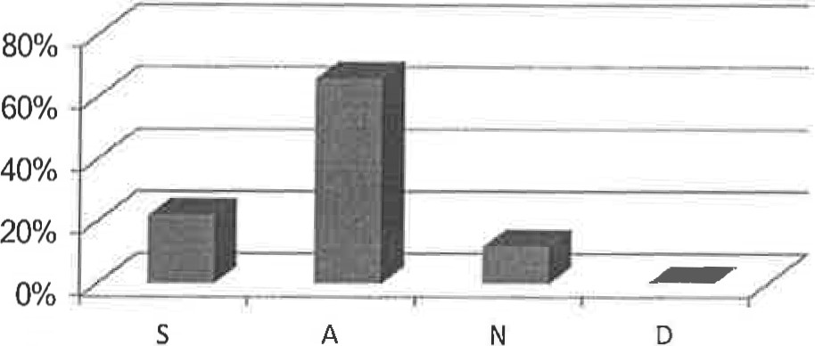 | B It is beneficial for learners to use the computer in their free time for learning purposes.
Figure (1) : the percentage of students' responses to item(l)
The second item shows these results: (32 % S), (38 % A), (22 % N) and (8 % D). This indicates that most of learners are responsible for their own learning. They can have semi-like native speakers' pronunciation by listening to audios provided on CD-ROMs associated with some books they read.
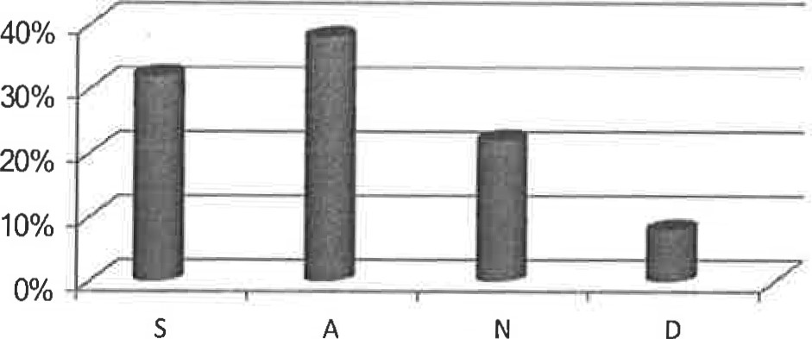  D | Computer helps learners listen to audios provided on CD-ROMs associated with some books they read so that they would have semilike native speaker's pronunciation.
Figure (2) : the percentage of students' responses to item(2)
The third point shows the following results: (26% S), (40% A), (26%N) and (8 % D). This indicates that the learners are aware of the importance of developing their own pronunciation and language performance by the necessity to record their voice and checking it with the native speaker's voice.
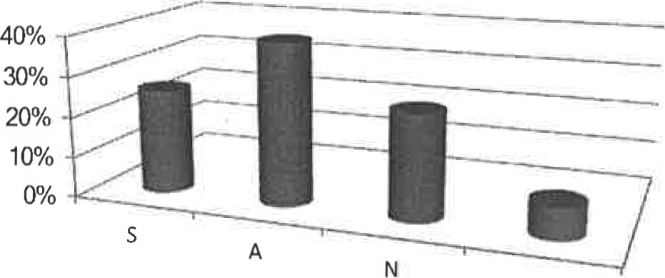D | The learner ought to record his/her voice and compare it to a native speaker's voice in order to check his/her language performance.

Figure (3) : the percentage of students' responses to item(3)
The fourth point shows the following results: (28% S), (48% A), (20%N) and (4 % D). This indicates that most of the learners are aware of the appropriate way to learn English. That is, using videos as a learning tool would help a great deal to sound like a native speaker.
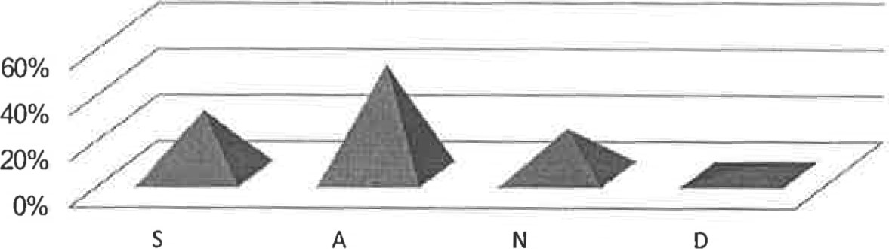
Learners should watch videos that provide some tips for sounding like a native speaker.
Figure (4) : the percentage of students' responses to item(4)
The fifth point shows the following results: (54% S), (36% A), (8%N) and (2% D). This indicates that most of the learners make real use of audios and videos that the Internet provides to develop their listening comprehension skill.

r•19 ä.i.ud CJDlffI aa.c.ll . outoaill cÄ).b9 #1.iolI hl.n
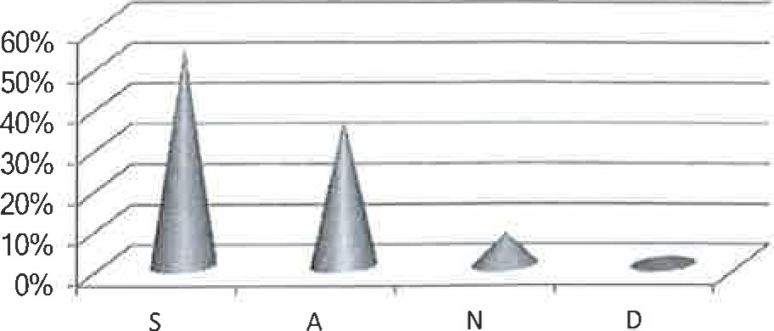 | The Internet provides useful audios and videos that help learners develop their listening comprehension skill.
Figure (5) : the percentage of students' responses to item(S)
The sixth item shows these results: (40% S), (40% A), (12%N) and (8% D). This indicates that most of the learners think that watching a film based on the events of a particular play or novel they study is beneficial.
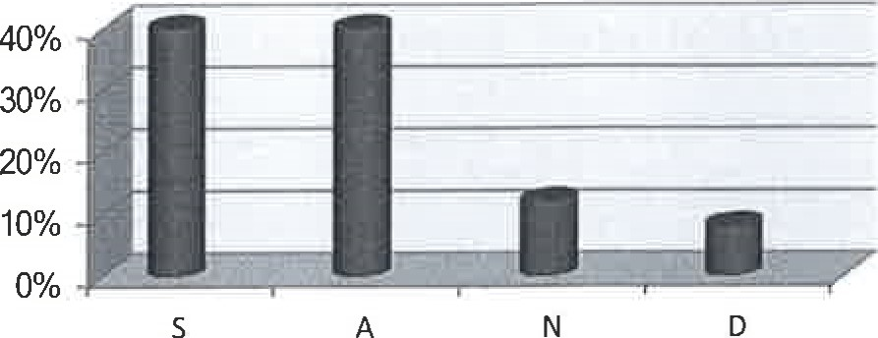 | It is preferable that students watch a film based on the events of a particular play or novel they study.
Figure (6) : the percentage of students' responses to item(6)
The seventh point shows the following results: (20% S), (50% A), (26%N) and (4% D). This indicates that most of the learners get attracted by the computer screen which is accompanied by pictures, colors, music and animation and that it empowers their faculties of retention. those pictures, colors, and animation bring kind of entertainment which make a good motif for students to study.
50% | D | The use of the computer screen which is accompanied by pictures, colors, music and animation attracts learners' attention and empowers their faculties of retention.

329
14.

Figure (7) : the percentage of students' responses to item(7)
The eighth point shows the following results: (36% S), (46% A), (16%N) and (2% D). Due to the tendency of young generation to play games, this technique as the students' responses show, is useful to remember more vocabulary in an interesting way.
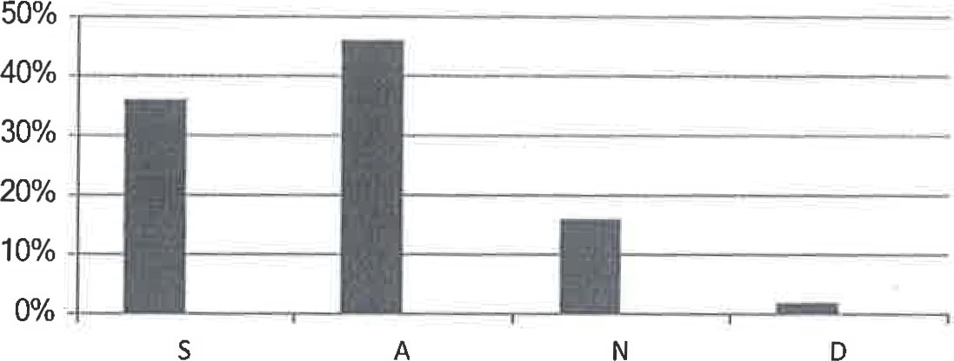 | • Playing some quick vocabulary games is useful and helpful to remember more vocabulary.
Figure (8) : the percentage of students' responses to item(8)
The ninth point shows the following results: (28% S), (46% A), (22%N) and (4% D). This indicates that online dictionaries are beneficial for vocabulary acquisition. Although paper dictionaries offer the same information, but students prefer online dictionaries for the ease of use and the quick access to the required vocabulary.
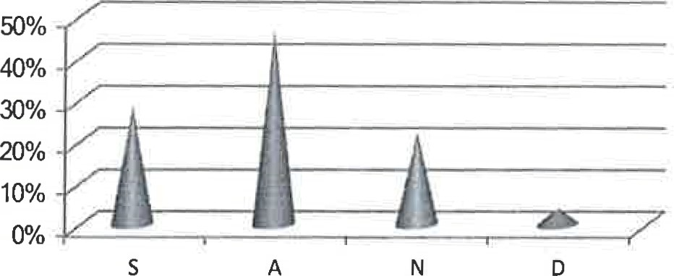 | Online dictionaries are beneficial for vocabulary acquisition since they provide examples of usage, synonyms, antonyms and other associative information.
Figure (9) : the percentage of students' responses to item(9)
The tenth point shows the following results: (24% S), (52% A), (14%N) and (10% D). This indicates that doing grammar exercises on the computer is beneficial because students can be provided with the right answer immediately. This feedback is useful to students as to enhance their right answers and identify their wrong ones.
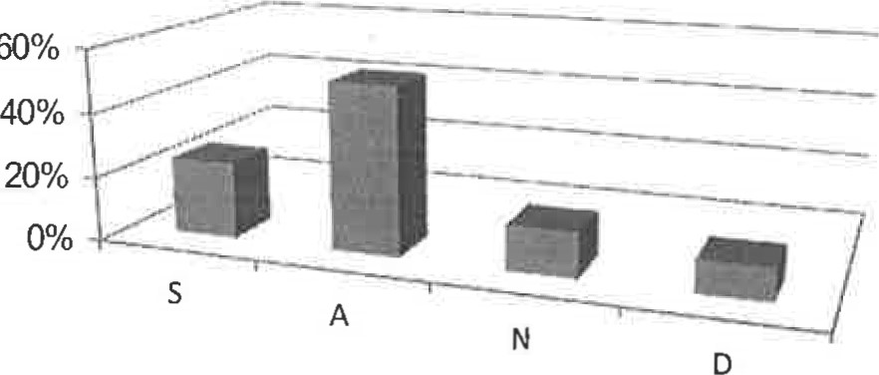 | Doing grammar exercises on the computer is enjoyable because students can be provided with the right answer immediately after finishing it.
Figure (10) : the percentage of students' responses to item(10)
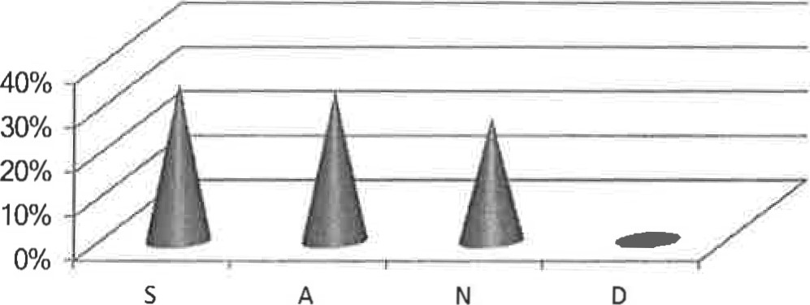  s | The Internet provides useful materials for learners to understand the subjects they study.
The eleventh point shows the following results: (36% S), (34% A), (28%N) and (2% D). Because of the variety of subjects provided in the internet, high percentage of students agree on the benefit of the internet in supplying the useful materials to understand the subject they study.

Figure (11) : the percentage of students' responses to item(11)
The twelfth item shows these results: (12% S), (32% A), (30%N) and (26% D). This indicates that many learners prefer reading via the computer because it is easier to handle and the size of the screen is suitable for reading. However, some students prefer reading via other devices.
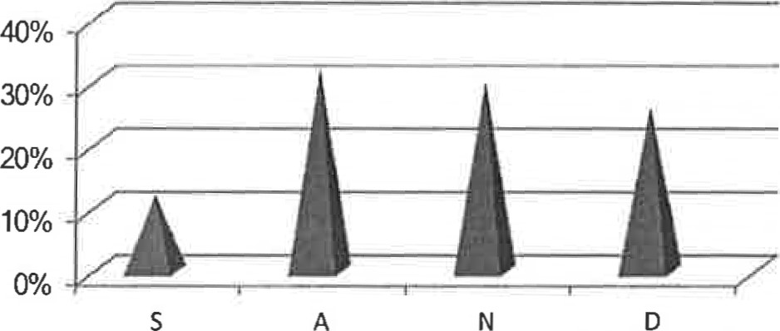 | Reading via the computer is better than reading via other devices because it is easier to handle and the size of the screen is suitable for reading.
331
Figure (12) : the percentage of students' responses to item(12)
The thirteenth point shows the following results: (8% S), (44% A), (40%N) and (8% D). These results indicate that the computer is a useful tool to be used to organize written texts in a good way; moreover, the writer can play round with his text without attempting to write it from the early beginning which is a time- saving feature.
Writing via the computer allows the writer to organize his/her paragraphs in a good way. | 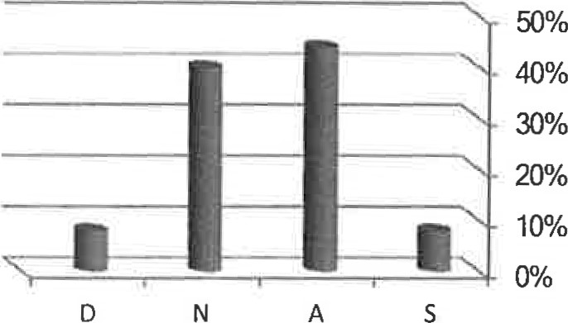

Figure (13) : the percentage of students' responses to item(13)
The fourteenth point shows these results: (36% S), (46% A), (12%N) and (6% D). This indicates that grammar checkers are useful to improve writing skill which means that students can handle their spelling and grammatical mistakes while writing texts via computer.
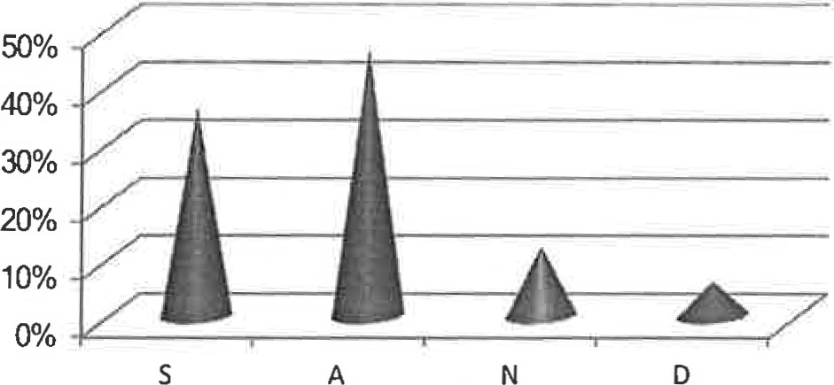  D | Spelling and grammar checkers are useful to improve writing skill.
Figure (14) : the percentage of students' responses to item(14)
The fifteenth point shows these results: (38% S), (48% A), (12%N) and (2% D). This indicates that the Internet gives opportunities to communicate with native speakers of the target language and this allows the learner to participate in the foreign language culture.

Figure (15) : the percentage of students' responses to item(15)
The sixteenth point shows these results: (28% S), (50% A), (22%N) and (0% D). As the different social media are widely used among the young generation, students agree on the importance and the usefulness of the social media in learning a foreign language.
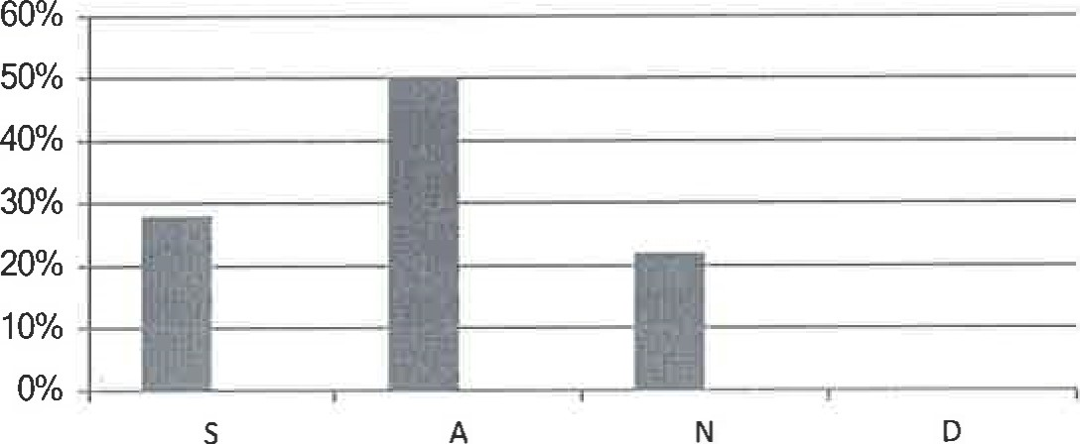 | • Using social media is a useful activity in learning a foreign language.
Figure (16) : the percentage of students' responses to item(16)
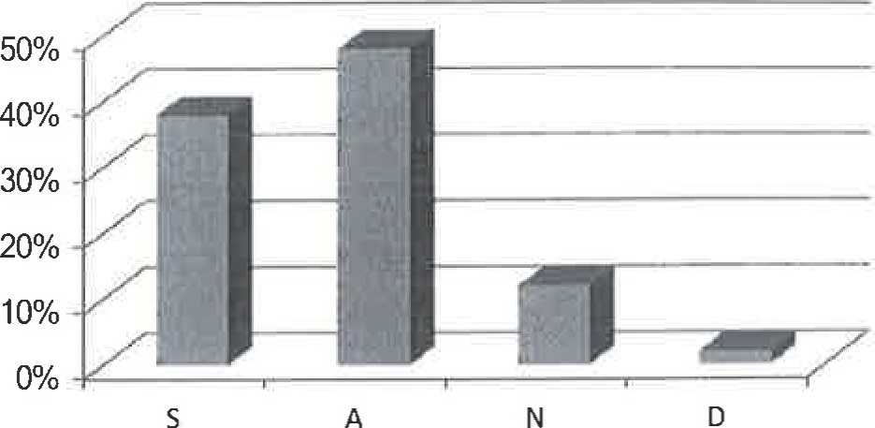 | B The Internet gives opportunities to communicate with native speakers. This allows the learner to participate in the target Vanguage culture.
The seventeenth point shows these results: (20% S), (42% A), (36%N) and (2% D). This indicates that the computer is a flexible classroom aid, which can be used by teachers and learners, in and out of class, in a variety of ways and for a variety of purposes.
333
14.

Figure (17) : the percentage of students' responses to item(17)
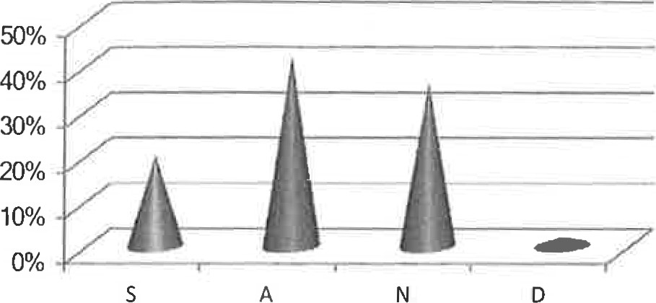
• The computer is a flexible classroom aid, which can be used by teachers and learners, in and out of class, in a variety of ways and for a variety of purposes.
The eighteenth item shows the following results: (18% S), (54% A), (28%N) and (0% D). This indicates that in order for the Computer-Assisted Language Learning (CALL) to be successful, the teacher should choose the program that is suitable for the learners' level of proficiency. Otherwise, the activity will turn to be a chaos.
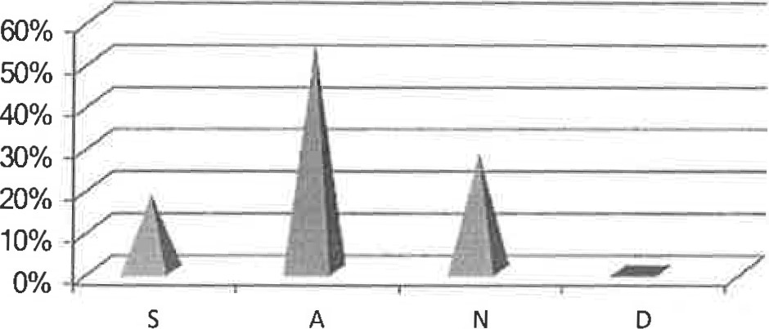 | In Computer-Assisted Language  Learning (CALL), the teacher should choose the program that is suitable for the learners' level of proficiency. Otherwise, the activity will turn to be a chaos.
Figure (18) : the percentage of students' responses to item(18)
Finally, the nineteenth point shows these results: (22% S), (46% A), (30%N) and (2% D). This indicates that most of the learners agree that CALL is useful as a method for teaching all language skills.
Figure (19) : the percentage of students' responses to item(19)
8. CConclusions and Recommendations
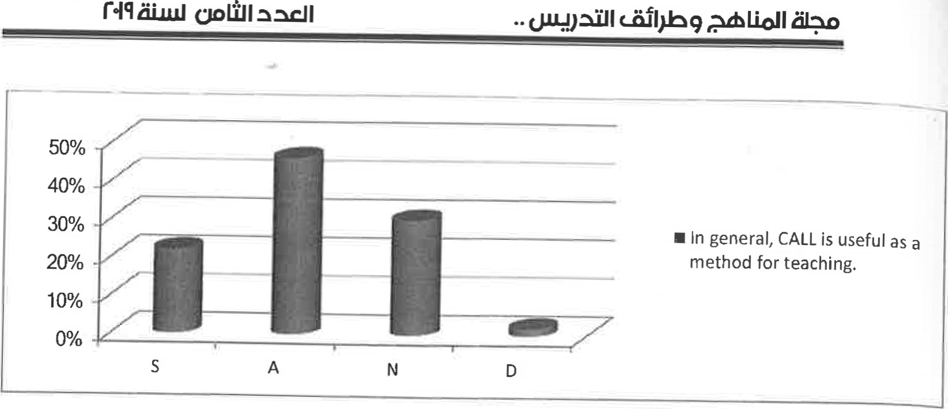
From the results of the questionnaire, the learners' view of CALL have been investigated. The results reveal the learners' favorable attitudes towards the use of CALL. Two essential conclusions might be drawn from the results of this questionnaire. Firstly, it might be concluded that computers and language learning are closely inter-related and the integration of both can enable learners to improve the foreign language skills. Computers can be a very important source for providing the input which is authentic. Secondly, CALL can be effectively used as a device to enhance the motivation of EFL learners. The use of the screen which is accompanied by pictures, colors, music and animation attracts learners' attention and empowers their faculties of retention.
Based on the results of the questionnaire there are some recommendations: firstly, schools that have computers should encourage teachers to use CALL in their classroom. Also, learners of the foreign language should make use of the computer with the aid of the Internet and multimedia to improve the foreign language skills and components. In addition, parents should use the computer to motivate their children to get exposed to the target language at an early age.

References

Abu Naba'h, A.; Hussain, J.; Al-Omari, A. and Shdeifat, S. (2009). " The Effect of Computer Assisted Language Learning in Teaching English Grammar on the Achievement of Secondary Students in Jordan". The International Arab Journal of Information Technology. 6. 4. p. 436. http://ccis2k.org/iajit/PDF/vol.6.no.4/452.pdf
Bahadorfar, M. & Omidvar, R. (2014). "Technology in Teaching Speaking
Skill". Acme International Journal of Multidisciplinary Research. 2. 4. p.p. 9, 11. http://aiimr.net/documents/2.4/2402.pdf
Chapelle, Carol A, and Jamieson, Joan(2008). Tips for Teaching with CALL Practical Approaches to Computer- Assisted Language Learning. H.
Douglas Brown(ed.). United States of America: Pearson Education,lnc.
Dehghani, P. A. & Jowkar, M. (2012). " The Impact of Computer- Video Projectors on EFL Learners' Listening Comprehension Academic Research International". 3. 1. pp. 106-107.
http://www.savap.org.pWiournals/ARInt.Nol.3(1)/2012 (3. I - 13).pdf
Ellis, C. N. (1995). " The Psychology of Foreign Language Vocabulary Acquisition: Implication for CALL". International Journal of Computer Assisted Language Learning (CALL) ". http://wwwpersonal.umich.edu/—ncellis/NickEllis/Publications files/CALLPaper.pdf
Gündüz, N. (2005). "Computer Assisted Language Learning". Journal of
Language and Linguistic Studies". 1. 2. p.p. 194, 197-199, 203-205, 207210. http://oswaldowiki.pbworks.com/w/file/fetch/54594217/CALL.pdf
Hubbard, P. (2008). " General Introduction
In http://web.stanford.edu/—efs/callcc/callcc-intro.pdf
Iacob, I. (2009). "The Effectiveness of Computer Assisted Classes for English as a Second Language". Anale. Seria Informaticä. 7. p-p. 141-143. http ://arxiv.org/ftp/arxiv/papers/0905/0905.4611 . pdf
Khamkhien, A. (2012)." Computer Assisted Language Learning and English Language Teaching in Thailand: Overview". Mediterranean Journal of Social Sciences. 3. pp. 56-58 http://www.mcser.org/images/stories/2_iournal/.../attapol.pdf Kledecka-Nadera, A. (2001). "Application of Computer Assisted Language Learning in the Developmant of Reading Comprehension Skills ". In http://wa.amu.edu.pl/wa/files/i fa/papers/kledecka/kledecka-mgr.pdf
Mutlu, A., & Erö z-Tuga, B. (2013). " The Role of Computer-Assisted Language Learning (CALL) in Promoting Learner Autonomy". Eurasian Journal of Educational Research. 51. p. 107.
http://www.e jer.com.tr/0down load/pd fler/eng/amutl uen g51 upd f
Naeini, B. M. (2012). "Meeting EFL Instructors' Needs through Developing Computer Assisted Language Learning (CALL)". International Journal of Language Teaching and Research. l. l. P. 9.
http://researchpub.org/i ournal/i iltr/number/vol I -no I -2.pdf
Neri, A.; Mich, 0.; Gerosa, M. & Giuliani, D. (2008). " The effectiveness of computer assisted Assisted Language Learning. pronunciation training for foreign language learning by children". Computer 21. 5. P. 393. http://www.informaworld.com/indexj905674348.pdf
Warschauer M. (1996) "Computer Assisted Language Learning: an
Introduction". In Fotos S. (ed.) Multimedia language teaching, Tokyo.
Logos International: 3-20. httD://www.ict41t.org/en/warschauer.htm
Xiao-Ping, Z. (2014). " A Review of " Perceptions of the Computer- Assisted Writing Program among EFL College Learners"". The 9th International Conference on Computer Science & Education (ICCSE 2014). P. 756. http://www.yeedao.net/iccse2014/cd/data/papers/13170.pdf
Ziegler, N. (2014). " Computer-Mediated Communication and the Berlitz Virtual Classroom". In https://www.berlitz.com.br/img/berlitz%20white%20paper bvc _full%20repor t june%202014.pdf.

