Date of publication xxxx 00, 0000, date of current version xxxx 00, 0000. Scie + proofreading
Digital Object Identifier /ACCESS.20
Novel Partial Overlapped Gaussian Pulses Multi-Access System Aided by Data Analysis
Salam Alyassri¹, Muhammad Ilyas ², Ali Marhoon ³, and Oguz Bayat.⁴
¹Electrical, and computer Engineering Department, University of Altinbas
²Electrical, and computer Engineering Department, University of Altinbas
³Electrical Engineering Department, University of Basra
⁴Electrical, and computer Engineering Department, University of Altinbas
Corresponding author: Salam Alyassri (salam.alyassri@ ogr.altinbas.edu.tr).

ABSTRACT Until the emerging of the fourth generation (4G) of the mobile communication systems, orthogonality was the main feature to save the spectrum. Orthogonal frequency-division multi-access (OFDMA) adopted as a multi-access system in the physical layer for 4G of communication. The increasing demand for high data rate communications, which is caused by the flourish of some new technologies such as virtual reality and remote sergeant, has motivated the researchers to study an alternative to OFDM. The reason for this is that the new systems require a higher data rate and lower latency than the conventional communication systems. The non-orthogonal multi-access systems (NOMA) have gained attention, especially in the fifth-generation (5G) communication systems. NOMA systems suggested with a multi-power level to sending and receiving signals that result in more complexity in receiving devices. This paper suggests partial-overlapped subcarriers, which in concise is a non-orthogonal multi-access system, for 5G mobile communications. The basic idea of the proposed methodology is a dependency on the signal shapes rather than the power of signals that represent in the main principle of the ordinary NOMA. Where the Gaussian-pulses suggested as an alternative to Sinc signals, Sinc is the shape of subcarriers into OFDM. Also, these signals have had adapting characteristics that relied on the similarity between the sent data. The proposed model presents encouraging results for the bit error rate (BER). Beside, Gaussian-pulses together with data analysis like in the supposed schema save spectrum up to (13.8%) more than OFDM, so more spectrum saving. Finally, a decrease in out-band compared to OFDM, which means enhancing the spectrum efficiency too.
INDEX TERMS 5G Communication; BER; Data Analysis; Multi-access Systems; Gaussian-shape Pulses; Spectral Efficiency.

I. INTRODUCTION
Spectrum utilization is the most critical concern in uplink and downlink communication. Therefore, the communication resources shared by the users with the aid of the multiple access techniques. These resources shared in terms of time, frequency, or code. Furthermore, they divided into different channels, and these channels allocated to different users depending on the type of resource that spliced. In some techniques, there is no interference between the channels such as in the time-division multiple access (TDMA) or frequency-division multiple access (FDMA). However, some systems utilize the orthogonality features to allow some amount of interference such that in the orthogonal frequency division multi-access (OFDMA) or code division multiple access (CDMA) [1]. Orthogonality means the capability of allowing a full interference or a part of it, which results in more channels in the same bandwidth and more throughput in the same spectrum. That is the main reason for using OFDMA in the physical layer for 4G communication.
One of the main objectives of 5G communications systems is to deliver Gigabit data transmission to cellular users. That fulfilled by presenting huge developments in all layers of the communication system. For this reason, the physical layer must have witnessed significant modifications to verify new technologies. Orthogonal access systems such as OFDMA are one of the most valuable concepts that need to be developed [2].
One of these improvements is the fast-convolution (FC)-based waveform for new radio fifth-generation (5G) [3]. Besides, orthogonal time-frequency space (OTFS) suggested as a group of OFDM symbols with cyclic prefix (CP) to describe OTFS over OFDM [4].
The peak to average power ratio (PAPR) is the most parameter that the researchers focus on it. The high value of PAPR, which represents the most prominent disadvantage in OFDM systems, means the low response to a high power amplifier (HPA) in antenna, which results in more errors in received data [5], there is a relation between the price of HPA and the range of its linear response [6]. A. Nahar et al. suggest a new approach called rotating phase shift (RPS) to reduce PAPR [7], Whereas, in [8] advise a random phase updating algorithm to reduce PAPR.
Another approach to enhance the OFDM communication is by Digital Pre-Distortion (DPD) process. Before sending data, this process performed to mitigate the effect of the channel by changing the transmitted data depending on the prior information of the channel. In [9] use the statistical approximated multi-sine technique to enhance the DPD performance, while an iterative learning method applied to DPD in [10].
Another trend to bypass the disadvantages of OFDMA is suggested by finding alternative systems to multi-access in the physical layer. An alternative approach of multi-access to orthogonal ones is the non-orthogonal multiple access (NOMA) in which the mobile equipment (ME) devices receive the information at the same time and frequencies with a multi-level of signal power values. Furthermore, users with the best communication conditions have less power than users who have limited communication conditions [11] [12]. For distinguishing the signals, the nearest receiver has successive interference cancelation (SIC). In consequence, it enhances the spectral efficiency and energy efficiency compared with OFDMA [13]. NOMA systems are better than OFDMA by the ability to alleviate the multiple access interference (MAI) with immense spectral efficiency. Also, there is a varied range of separation for each user [14]. SIC techniques have some disadvantages that should take into account. SIC imposes different throughput to users and a series of cancelation process to detect the desired signal [15]. Therefore, it requires more complexity in the receivers, more dependency on the channel’s characteristics, and more dependency to calculate the delays between users because of the difference in distances to the base station [16]. Practically, when the SIC cannot cancel the entire interference that propagates the errors to each user [17]. Besides, a variety of decoding time that relies on the distance of mobile equipment (ME) from the base station. This time is increased in the nearest ME as the number of MEs increased, so there is an unpredictable time for decoding [18]. However, NOMA systems have some challenges that should face. Firstly, with low latency communication, there is a challenge with NOMA because of the extra computation required for interference cancelation. Secondly, there is a challenge with the calculation of the best power levels for each user. Finally, Multipath fading channels produce errors that are very critical in SIC receivers [19].
Channel characteristics are always fluctuating, so relying on them may result in unacceptable values of errors. In this research, the NOMA system suggested differently to avoid the dependency on the channel characteristics. The principle of interference is satisfied but not entirely, like the multi-power sent signals NOMA systems. Gaussian-shaped signal relies on the proposed system in addition to the correlation between transmitted data. The correlation calculation presented as a part of data analysis. Automation by using the data analysis and artificial intelligence has become vital in the next generation of communications due to the predictability of abnormal behavior of the network, which helps for identifying the appropriate resources for users. As a result, the system provides better service to customers [20] and a more optimized network [21]. Therefore, traffic management, administration of the system, and organization of the radio entries to it can use data analysis [22] or rely on a database to establish predictive radio resources administration [23]. Extensive data analytics used to optimize radio access networks in the 5G communication system researched [24]. Besides, data analysis can use with big data to decrease power consumption by building an adaptable communication system depend on customer movement [25]. The correlated data studied in this work and utilized to reduce the BER via calculating the correlation matrix and rearrange channels distribution. Furthermore, correlation values exploited to calculate the standard deviation of subcarriers and the gap between them.
Because of the whole system that supposed in this research, the spectrum efficiency, which related to the ratio of overlapping, reaches more than 13% compared to OFDM. In concise, means safe 13% or more for the spectrum. Bit error rate (BER) also decline than what resulted in OFDM. Furthermore, the response in the out-band region can neglect in reverse to OFDM multi-access system, where it is one of the problems is to get rid of the out-band signal.
This article organized as follows. The later section demonstrates the methodology, which used to analyze the supposed partial-overlapped system. Furthermore, the third section illustrates the results and findings. Section IV concludes the article.

II. METHODOLOGY
Recognizing the changes in the subcarrier signal shaping and how these new updated signals would use as a multi-access system that explained in this section. Furthermore, mathematically analysis of the interfered data also described. Finally, studying the correlation and how it will affect subcarriers' features demonstrated, too, to give a comprehensive view of the supposed system.
A. GAUSSIAN SHAPE SUBCARRIERS
The sharing spectrum among users needs planning for the resources to prevent the not beneficial interference and loss of information.
OFDMA subcarriers have an orthogonal overlapping in which each peak of the signal spectrum is located at zero value of other signals spectrum as shown in Fig.1-a, where the number of subcarriers is four. Ordinary shape to OFDM subcarriers is the Sinc signal, as shown in Fig.1-a.
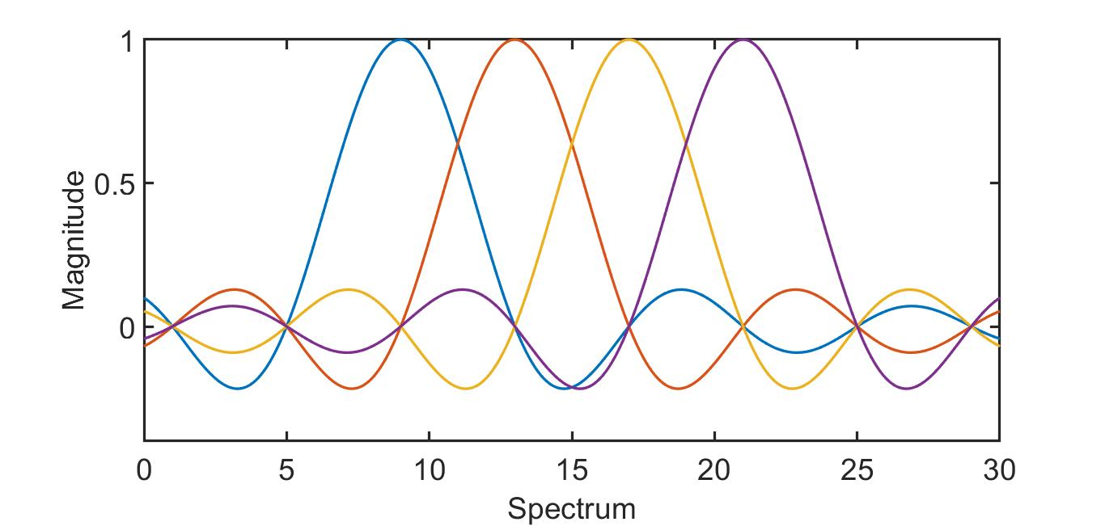

(a)
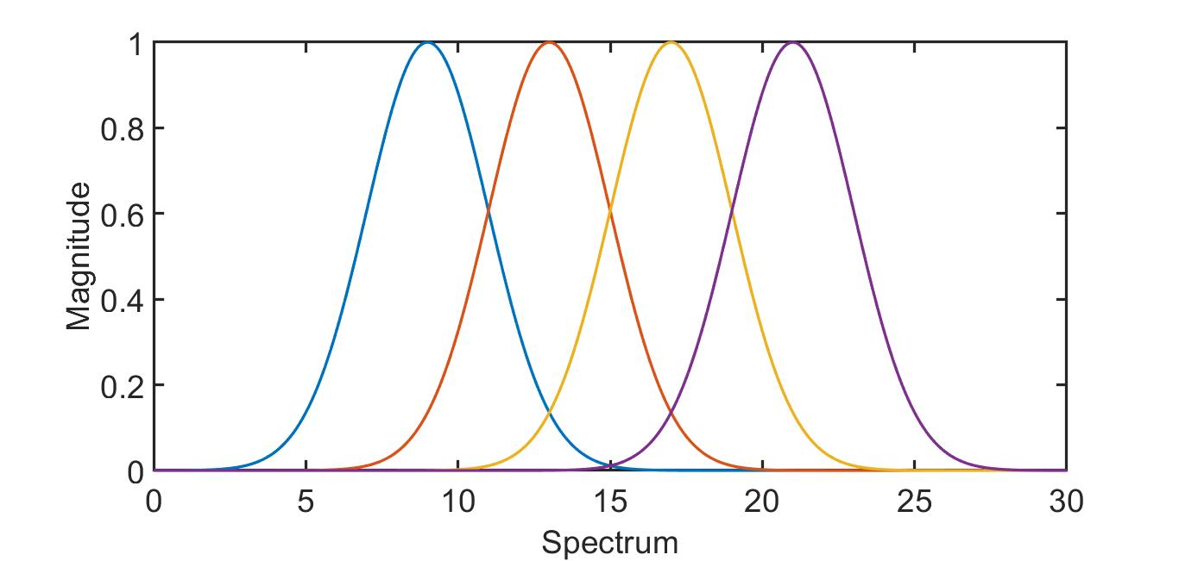

(b)

FIG.1. Spectrum analysis to four subcarriers. (a) Four OFDM Sinc subcarriers (b) Four Gaussian subcarriers.

Nevertheless, in this work, the Gaussian-shaped signals selected to be the sub-band spectrum shape. Like what shown in Fig.1-b. The Gaussian signals have a bell shape, which described by the following formula:

$N(f0,σ)=\frac{1}{σ.\sqrt{2π}} e^{\frac{{-(f-f0)}^{2}}{{2σ}^{2}}}$ (1)
Where
$N$ is an abbreviation to result shape function and called normal distribution,
$f0$ is a center frequency, which is a mean value to the function and
$σ$ is a standard deviation to the normal distribution

This type of pulses can use in the radar system to overcome the side lobe, which introduced by the Sinc shape signals in OFDM [26]. Furthermore, it can use in an ultra-wideband system (UWB) [27]. Zhanbiao et al [28] describe the benefit of using multi signals with different center frequencies and different deviations to satisfy the federal communications commission (FCC) emission mask. In [29], the authors used Gaussian-shaped pulses as base-band pulses in the continuous phase modulation (CPM). As a result, the suggested system relies on using partially overlapped signals with Gaussian-pulses for shaping.
B. SUGGESTED MULTI-ACCESS SYSTEM
The spectrum efficiency has a high priority portion in researches for 5G mobile communication. For this reason, the NOMA systems are more effective than OFDMA as multi-access systems. However, the NOMA still requires a complicated receiver, which has a SIC filter. Therefore, the suggested system has a novel design that depends on Gaussian-pulses shaping to build multi access-system, which has partial overlapping that means non-orthogonality among overlapped signals.
For subcarriers signals, the magnitude of them must be the same. That cause explains the use of Gaussian membership- function rather than normal Gaussian function. The Gaussian membership function is a unity amplitude pulses whose magnitude unrelated to the standard deviation value [30], so the equation to these pulses will be:

$N'(f0,σ)=e^{\frac{{-(f-f0)}^{2}}{{2σ}^{2}}}$ (2)

Consequently, unified peak pulses with different standard deviation values used to describe the spectrum of the proposed communication system.
The Gaussian membership-function shape represents the spectrum of the subcarriers of the proposed system. One can figure out the effect of changing the mean, which here is the center frequency of each subcarrier, and the standard deviation onto the magnitude and the shape of the resulted signal in Fig.2. In FIG.2-c, the similarity shape between the summed signal and the transmit signal is high, but there is a difference in the magnitude. That result suggests a Gaussian filter into the receiver with a max value equal to reciprocal of the amplification factor that what shown in Fig.3. Moreover, it is a valuable point for the proposed system, so the next step is a mathematic analysis to describe this interfered communication system.
C. GAUSSIAN SIGNALS ANALYSIS
For Gaussian distribution, the majority of the probability takes place in the range (-3σ+u, 3σ+u), which is equal to 99.7 percent of the whole distribution [31]. Therefore, the scope of frequency (f) must be inside to ranges of the three Gaussian signals (transmitted, interfered, and received) as shown in the following:

$-3σ1+f1≤f≤3σ1+f1$ (3)

$-3σ2+f2≤f≤3σ2+f2$ (4)

$-3σr1+fr1≤f≤3σr1+fr1$ (5)

Where
Transmitted Gaussian signal =$N'(f1,σ1)$=$N(f1,σ1)$.$σ1\sqrt{2.pi}$
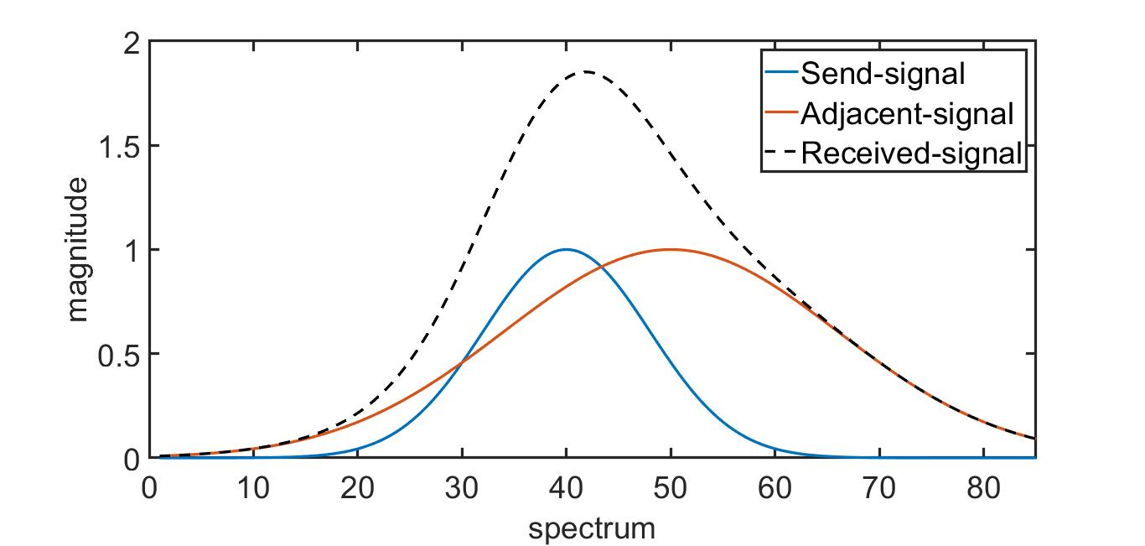
(a)
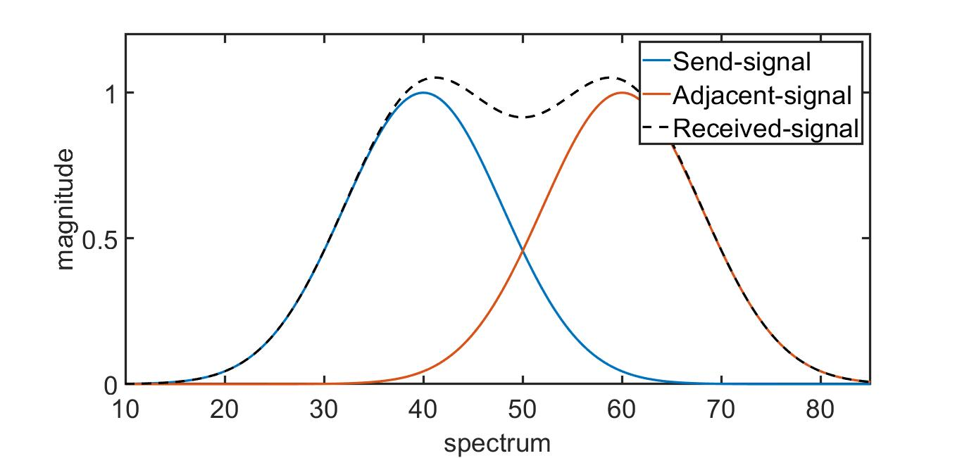 (b)
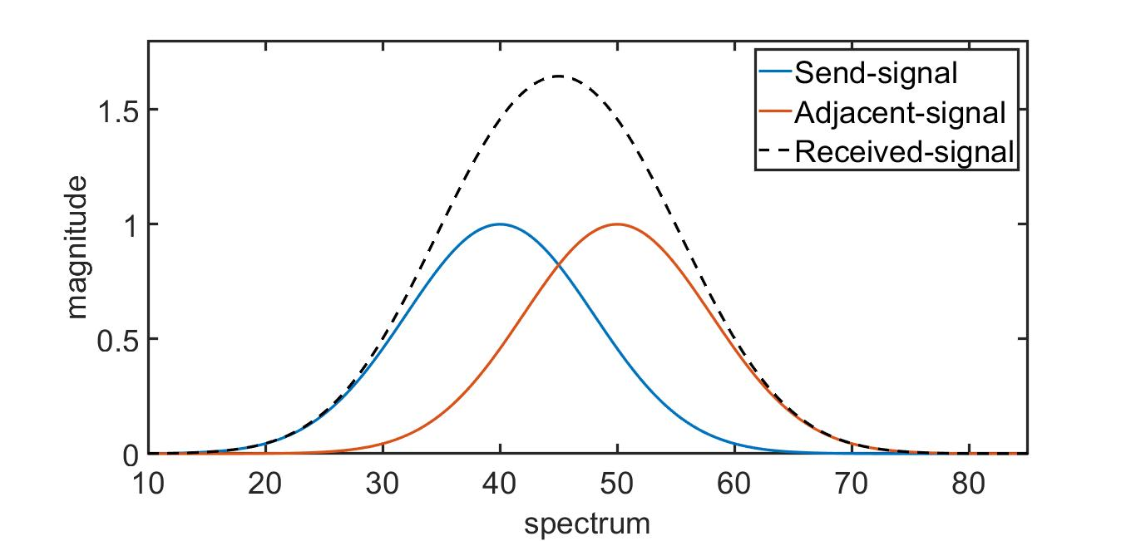
(c )

FIG.2. The resulting signal (dashed black line) resulted from adding two signals (red and blue lines). a) Add two signals with different standard deviation. b) Add two signals with the same standard deviation and they have a gap, which results in a signal that has a shape not the same to the send signal. c) Add two signals with the same standard deviation and the gap allowed to getting a signal has a shape similar to the send signal.
Interfered Gaussian signal =$N'(f2,σ2)=N(f2,σ2). σ2\sqrt{2.pi}$
Received Gaussian signal =$N'(fr1,σr1)$=$N(fr1,σr1). σr1\sqrt{2.pi}$

Subtracting (4) from (3) results in the following:

$-3σ1+f1-(3σ2+f2)≤0≤3σ1+f1-(-3σ2+f2)$ (6)

$/(f2-f1)/≤3(σ1+σ2)$ (7)

In the proposed system, the suggestion is f2 >f1 so

$(f2-f1)≤3(σ2+σ1)$ (8)

Using the same analysis, it can be found that:

$(fr1-f1)≤3(σr1+σ1)$ (9)

Also,
$(f2-fr1)≤3(σ2+σr1)$ (10)

If the required guard from the third subcarrier and second subcarrier, the same analysis can be done and the result will be as follows:

$(f3-f2)≤3(σ3+σ2)$ (11)

Thus, by subtracting (11) from (8), we will get:

$(f3-f2)-3(σ2+σ1)≤3(σ3+σ2)-(f2-f1)$(12)

$(f3-f1)≤3σ3+6σ2+3σ1$ (13)

The inequalities (8, 11, and 13), describe the feasible frequency bandwidth that depend on the Gaussian-pulses variance values ($σ3,σ2 andσ1)$.
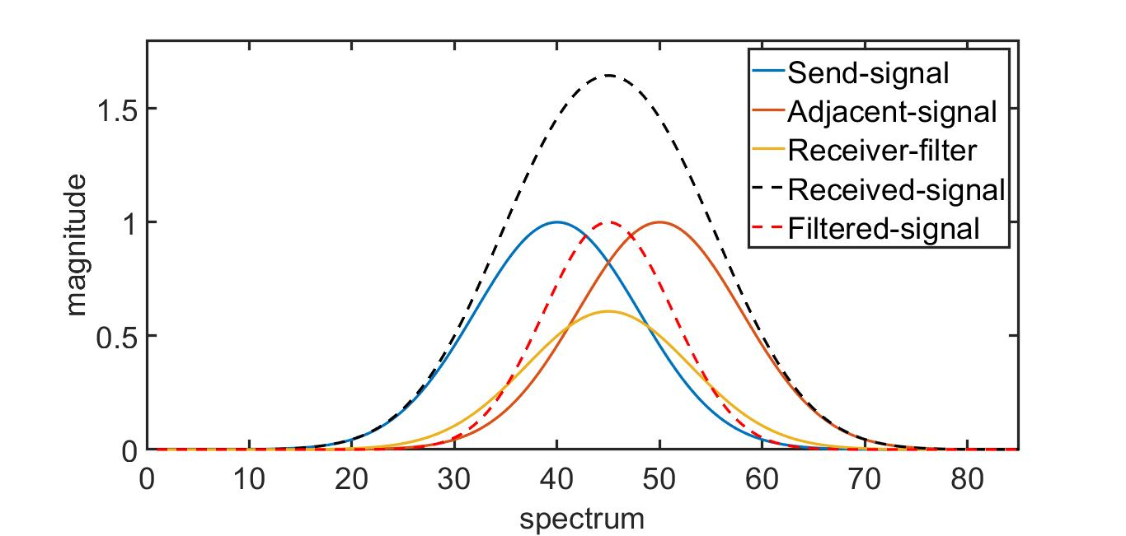

FIG.3. Get a signal (red dashed line) that has a shape similar to the send signal by multiplying the resulted signal (black dashed line), from adding two signals (blue and red line), by the filtering signal (yellow line).
To collect these mathematical results, the chart illustrated in Fig.4 is suggested to represents the proposed system. The received data can be described in:
$|rj|=max( |N'(fr1,σr1). (qj.N'(f1,σ1)+fj.N'(f2,σ2))|)$ (14)

Where
$rj$ is a received bit,
$qj$ is a sent bit and
$fj$ is an interfered bit.
If the modulation system is a QAM with (k) order, then the max value of the error should be:

$ej=\frac{Aj}{{(log}_{2}K)}$ $(15)$
Where
Aj is the jth max amplitude for QAM, and
K is the rank (e.g. 16QAM has K=16).

FIG.4. Supposed system, qj is jth-transmitted bit; fj is jth interfered bit and rj is jth-received bit, iDATA interfered data and rDATA received data.
Channel
qj
Data
iData
rData
QAM
QAM
MAX
Gaussian-Pulses
Gaussian-Pulses
Gaussian-Pulses
AWGN
rj
fj
QAM

Q is an array of transmitted bits and R is an array of received bits, then the error must be in the following inequality:

$|qj|-|rj|≤ej$ (16)
Where
qj is the jth transmit bit from Q array,
rj is the jth interfered bit from R array, and
ej is the jth error value.

Assume that (A=1) and (K=256) in (15), then substitute the result in (16) yields:

$|qj|-|rj|≤1/{(log}_{2}256)$(17)

$|qj|-|rj|≤0.125$ (18)

By substituting the value rj from (14) into (18), the result is:

$|qj|-max(|N'(fr1,σr1)(qj.N'(f1,σ1)+fj.N'(f2,σ2))|)≤0.125$ (19)

$|qj|≤max(|e^{\frac{{-(f-fr1)}^{2}}{2{σr1}^{2}}}(qj.e^{\frac{{-(f-f1)}^{2}}{2{σ1}^{2}}}+ ij.e^{\frac{{-(f-f2)}^{2}}{2{σ2}^{2}}})|)+0.125$(20)

If the max value is required, one value for (f) should be taken, which satisfies this situation. Furthermore, this value hopefully represents to be the receiver frequency, so:

$f=fr1$ (21)

Substitute (21) in (20):

$|qj|≤(|qj.e^{\frac{{-(fr1-f1)}^{2}}{2{σ1}^{2}}}+fj.e^{\frac{{-(fr1-f2)}^{2}}{2{σ2}^{2}}}|) +0.125$(22)
One of inequalities’ property for absolute values is

$|A+B|≤|A|+|B|$ (23)

Thus, by using this property in (22), the following inequality obtained:

$$|qj|≤(|qj|.e^{\frac{{-(fr1-f1)}^{2}}{2{σ1}^{2}}}+|fj|.e^{\frac{{-(fr1-f2)}^{2}}{2{σ2}^{2}}}) +0.125 (24)$$

$|qj|≤\frac{(|fj|. e^{\frac{{-(fr1-f1)}^{2}}{2{σ1}^{2}}}+0.125)}{(1-e^{\frac{{-(fr1-f2)}^{2}}{2{σ2}^{2}}})}$ (25)

Substitute the maximum values of (fr1-f1) and (fr1-f2) in (9 and 10) to (25) results in:

$|qj|≤\frac{(|fj|. e^{\frac{{-9(σr1+σ2)}^{2}}{2{σ2}^{2}}}+0.125)}{(1-e^{\frac{{-9(σr1+σ1)}^{2}}{2{σ1}^{2}}})}$ (26)

From (26), there is a proof to the possibility of interference and explanation that range of accepted overlapping is relating to the values of the deviation of adjacent interferer’s, sender’s and receiver’s signals. Besides, one can deduce the range of interference connect to the rank of the QAM modulator too. Finally, this result is very motivating to simulate the system by MATLAB to sense the effect of these parameters on the overall system and to prove the ability to decode the original data from received data despite the interference. Q and R theoretically are independent and random strings. However, in most of the human’s information, there is a correlation between them. Therefore, the proposed system has a data analysis process that affects the subcarrier allocation array and the variance of subcarriers to decrease the BER. Like what described in the next two sections.
D. CORRELATION
J.Han et al. [31] refer to the ability to detect repeated information by using correlation analysis. As an example, one can recognize how much true the male like fictions rather than females by use (chi-square) test [31]. Besides, the correlation coefficient, which has a range from one to minus one, describes the rules from databases. The amount of similarity between two features can represent by the correlation value. Similarity increased when its value approaches one and it decreases when its value approaches minus one. Furthermore, when the correlation value equal to zero means the features are orthogonal. The correlation coefficient can compute from the following equation:

$r_{A,B}=\frac{\sum_{i=1}^{n}{(a_{i}-A^{'})(b_{i}-B^{,})}}{nσ_{A}σ_{b}}$ (31)
Where
$r_{A,B }$is a Pearson’s product-moment coefficient,
$a_{i}$ and $b_{i}$ are instance values,
$A^{'}$ and $B^{,}$ are average values,
$σ_{A} and σ_{b}$ are standard deviation value and
n is the number of elements in each feature[31].
Similarity calculation between two multi-dimensional objects can be satisfied as a matrix of correlation values. As shown in TABLE. 1, where each object has three dimensions, and each dimension in the first object compared to every second dimension.
When the correlation computations in the same object between its dimensions. In this case, the resulted values represented by the triangle table to omit the repeated data that what shown in TABLE.2.

TABLE.1
Similarity matrix between objects A and B where each of them has three dimensions.
 | dA1 | dA2 | dA3
dB1 | 0.02 | 1 | 0.003
dB2 | -0.02 | 0 | 0.4
dB3 | -1 | 0.4 | 1

TABLE.2
Similarity matrix between objects A’s dimensions, which has three dimensions.
 | dA1 | dA2 | dA3
dA1
dA2 | -0.02
dA3 | -1 | 0.4
D. FIND THE BEST SUBCARRIER ALLOCATION ARRAY
As a case study, we have used six pictures to find the similarity between every two images. Here the matrix is considered to be full (not triangle) to decrease the complexity of finding the best subcarrier allocations array. The result as in TABEL.3:

TABLE.3
The similarity matrix between six images and the result is a full matrix of correlation.
Image | First | Second | Third | Fourth | Fifth | Sixth
First | 1 | 0.0829 | -0.0706 | -0.0024 | 0.1051 | 0.1257
Second | 0.0829 | 1 | 0.1413 | 0.4814 | 0.5667 | 0.2534
Third | -0.0706 | 0.1413 | 1 | 0.2526 | 0.0244 | 0.0033
Fourth | -0.0024 | 0.4814 | 0.2526 | 1 | 0.2379 | 0.3088
Fifth | 0.1051 | 0.5667 | 0.0244 | 0.2379 | 1 | 0.3026
Sixth | 0.1257 | 0.2534 | 0.0033 | 0.3088 | 0.3026 | 1

With the concept, “Highest correlated images should be as far away as possible“ the algorithm to find the best array of subcarrier allocation started. Firstly, search to the minimum value in TABLE.3 then regard it as an initial point. After that, update cells value by (one) as shown in TABLE.4 to outside these values from the next iteration. Continuously iterate to search about two later minimum values, by searching in the third row and first column. In each iteration after finding the initial point, the algorithm would found two minimum values one from the row and other from a column, so decrease the time of computation and made the complexity O(n) rather than O(n²) when the iterations did by one dimension. In three iterations, the correlation matrix is as TABLE.5, TABLE.6, and TABLE.7 by iterations one, two, and three, respectively. Rearrange the images depend on the resulted subcarrier allocation array, so the transmission images with associated subcarriers being as TABLE.8. FIG.5 stated the whole algorithm built to this analysis.

TABLE.4
Updating the similarity matrix between six images by make cell (1, 3) and (3, 1) equal to one.
Image | First | Second | Third | Fourth | Fifth | Sixth
First | 1 | 0.0829 | 1 | -0.0024 | 0.1051 | 0.1257
Second | 0.0829 | 1 | 0.1413 | 0.4814 | 0.5667 | 0.2534
Third | 1 | 0.1413 | 1 | 0.2526 | 0.0244 | 0.0033
Fourth | -0.0024 | 0.4814 | 0.2526 | 1 | 0.2379 | 0.3088
Fifth | 0.1051 | 0.5667 | 0.0244 | 0.2379 | 1 | 0.3026
Sixth | 0.1257 | 0.2534 | 0.0033 | 0.3088 | 0.3026 | 1

TABLE.5
Searching in similarity matrix about the least correlation in row three and column one.
Image | First | Second | Third | Fourth | Fifth | Sixth
First | 1 | 0.0829 | 1 | -0.0024 | 0.1051 | 0.1257
Second | 0.0829 | 1 | 0.1413 | 0.4814 | 0.5667 | 0.2534
Third | 1 | 0.1413 | 1 | 0.2526 | 0.0244 | 0.0033
Fourth | -0.0024 | 0.4814 | 0.2526 | 1 | 0.2379 | 0.3088
Fifth | 0.1051 | 0.5667 | 0.0244 | 0.2379 | 1 | 0.3026
Sixth | 0.1257 | 0.2534 | 0.0033 | 0.3088 | 0.3026 | 1

TABLE.6
Updating similarity matrix between six images by make cell (1, 4), (1, 6), (3, 4), (3, 6), (4, 1), (4, 3), (4, 6), (6, 1), (6, 3) and (6, 4) equal to one.
Image | First | Second | Third | Fourth | Fifth | Sixth
First | 1 | 0.0829 | 1 | 1 | 0.1051 | 1
Second | 0.0829 | 1 | 0.1413 | 0.4814 | 0.5667 | 0.2534
Third | 1 | 0.1413 | 1 | 1 | 0.0244 | 1
Fourth | 1 | 0.4814 | 1 | 1 | 0.2379 | 1
Fifth | 0.1051 | 0.5667 | 0.0244 | 0.2379 | 1 | 0.3026
Sixth | 1 | 0.2534 | 1 | 1 | 0.3026 | 1

TABLE.7
Searching in similarity matrix about the least correlation in sixth row and fifth column.
Image | First | Second | Third | Fourth | Fifth | Sixth
First | 1 | 0.0829 | 1 | 1 | 0.1051 | 1
Second | 0.0829 | 1 | 0.1413 | 0.4814 | 0.5667 | 0.2534
Third | 1 | 0.1413 | 1 | 1 | 0.0244 | 1
Fourth | 1 | 0.4814 | 1 | 1 | 0.2379 | 0.3088
Fifth | 0.1051 | 0.5667 | 0.0244 | 0.2379 | 1 | 0.3026
Sixth | 1 | 0.2534 | 1 | 1 | 0.3026 | 1

TABLE.8
Mapping images on channels depending on the subcarrier allocation array
Channel | Images
1 | Fifth
2 | Fourth
3 | First
4 | Third
5 | Sixth
6 | Second

FIG.5. Algorithm to find the subcarrier allocation array. Where the argmin_{r} is an index to the minimum value in a row, argmin_{c} is an index to the minimum value in a column, (Push) to insert a value to the begin of the array while (PushLast) to insert the value to the end of the array and (:) mean all.
Algorithm 1 Finding Subcarrier Allocation Array:
Input correlationMatrix
Output Subcarrier Allocation Array
minR =argmin_{r} (correlationMatrix);
minC =argmin_{c} (correlationMatrix);
Push (Subcarrier Allocation Array, minR);
While not all spectrums in Subcarrier Allocation Array
correlationMatrix (minR, minC)=1;
correlationMatrix (minC, minR,)=1;
minRNext =argmin_{r} (correlationMatrix(minR,:));
Push (Subcarrier Allocation Array, minRNext);
correlationMatrix (minR,:)=1;
correlationMatrix (:,minR)=1;
minR= minRNext;
minCNext =argmin_{c} (correlationMatrix(:,minC));
PushLast (Subcarrier Allocation Array, minCNext);
correlationMatrix(minC,:)=1;
correlationMatrix(:,minC)=1;
minC= minCNext;
End While

E. THE PROPOSED SYSTEM MODEL
QAM modulator used to modulate the transmitted data. Then, the resulted data multiplied by a Gaussian shape signal. Secondly, the data transmitted through the channel. After that, the transmitted data interfered with the adjacent ME’s data, and the resulted combination undergoes the effect of additive white Gaussian noise (AWGN). Finally, the received data multiplied by a Gaussian shape signal and take the peak value as a result. The whole system described previously in Fig.4.
III. RESULTS AND DISCUSSIONS
A. INPUT DATA AND SYSTEM PARAMETERS
The supposed system will be compared with OFDMA. Also, the comparison is done with another system that has also Gaussian-pulses but has not any correlation computations to calculate spectrum allocation array. This system named the ordinary Gaussian system.
System Parameters:
1) Data was 3200 decimal values, where each value has the range (0-255).
2) Using a 256QAM modulator that used to obtain a higher data rate rather than (128 and 64) QAM systems, and to examine communication in a highly sensitive environment.
Channel:
The AWGN channel suggested to model the communication channel to study the effect of signal to noise ratio (SNR) values on BER.
OFDMA:
Comparison with OFDMA led to implementing OFDMA system associated with these characters showed in TABLE.9:

TABLE.9
OFDMA Characteristics
Characteristic | Value
Subcarriers | 64
IFFT and FFT size | 64
Cyclic prefix length | 25% of Frame’s length

Ordinary Gaussian-pulses system
This system changes the Sinc subcarriers by Gaussian-pulses without data analysis to control the offsets between subcarriers. This system also regarded as a reference to comparison, so its characteristics illustrated in TABEL.10:

TABLE.10
Ordinary Gaussian-pulses Characteristics
Characteristic | Value
Subcarriers | 64
Variance | 0.4
Gaussian-pulses system aided by data analysis
The supposed system adds the preprocessing steps before sending the data, which described in the next section. Other characteristics showed in TABLE.11:

TABLE.11
Ordinary Gaussian-pulses Characteristics
Characteristic | Value
Subcarriers | 64
Receivers signals variance | 0.36
B. TESTING
Besides, to use Gaussian-pulses, like ordinary Gaussian-pulses, additive pre-transmit steps used as following:
- Extract frames from data, where each frame had length equal to the number of subcarriers.
- Build a square correlation matrix with (n*n) dimensions, where (n) is the number of subcarriers.
- Applying the algorithm shown in FIG.5 to calculate the subcarrier allocation array.
- Rearrange the sequence of each frame depends on the subcarrier allocation array.
- Calculate the variance to transmit subcarriers, which they relate to the values of correlation between every two successive frames.

$σ_{sendi}=0.4+0.4 f(corri)$(32)

Where
$σ_{sendi}$ Is variance of ith subcarrier.
$f(corri)$ is a function related to ith correlation value.

Compared with the ordinary Gaussian-pulses system, should take the same bandwidth. That yields:

$f(corri)=0.1*corri$(33)

- Calculation of the subcarriers' frequencies will be an optimization problem to satisfy the inequalities (8, 9, and 10). That shown in FIG.6, TABELE.12 demonstrates the abbreviations in FIG.6.
TABLE.12
Abbreviations used in optimization problem to find subcarriers frequencies
Abbreviation | Meaning
BER | Bit Error Rate
SendFreq | Send Frequencies values
RecFreq | Receive Frequencies values
SendVariance | Send Variance values
RecVariance | Receive Variance values
sendfreq_{i} | ith send frequency value
recfreq_{i} | ith receive frequency value
sendvar_{i} | ith send variance value
recvar_{i} | ith receive variance value

FIG.6. Optimization problem to find the transmit and receive frequencies with lowest value of BER.
Optimization Problem to Find Subcarriers Frequencies:
Min BER( SendFreq, RecFreq, SNR)
S.T
$∀({sendfreq}_{i}-{recfeq}_{i-1}-3({sendvar}_{i}+{recvar}_{i-1}))≤0;$
$$∀({recfreq}_{i}-{sendfreq}_{i-1}-3({recvar}_{i}+{sendvar}_{i-1}))≤0;$$
$∀({sendfreq}_{i}-{sendfreq}_{i-1}-3({sendvar}_{i}+{sendvar}_{i-1}))≤0;$
$${sendfreq}_{i}∈SendFreq;$$
$${recfreq}_{i}∈RecFreq;$$
$${sendvar}_{i}∈SendVarience; and$$
$${recvar}_{i}∈RecVarience.$$

A linear programming algorithm to find the best values of subcarriers’ frequencies can solve this optimization problem. Also, to speed the computation that BER calculated with (SNR=20dB). Furthermore, the inequalities showed in FIG.6 must be converted to equalities with constants as follows:
$({sendfreq}_{i}-{recfreq}_{i-1}-k1*3({sendvar}_{i}+{recvar}_{i-1}))=0$(34)

$({recfreq}_{i}-{sendfreq}_{i-1}-k2*3({recvar}_{i}+{sendvar}_{i-1}))=0$ (35)

$({sendfreq}_{i}-{sendfreq}_{i-1}-k3*3({sendvar}_{i}+{sendvar}_{i-1}))=0$(36)

Where

$${sendfreq}_{i}∈SendFreq$$
$${recfreq}_{i}∈RecFreq$$
$${sendvar}_{i}∈SendVarience and$$
$${recvar}_{i}∈RecVarience.$$
C. CONSTANTS VALUES
The result for constants in (34, 35, and 36) as shown in TABLE.13:

TABLE.13
Constants for optimization problem
Constant | Value
K1 | 0.448
K2 | 0.009
K3 | 0.11

D. BER COMPARISON
Use these constants to find the frequencies of transmitting and receiving signals. After that, simulate the resulting values with the supposed system to find the BER with a range of SNR is (0dB-50dB). The FIG.7 shows a comparison to BER in OFDM, ordinary Gaussian-pulses, and Gaussian-pulses aided by data analysis with abbreviations (OFDM, ordGaussian, and daGausian), respectively.
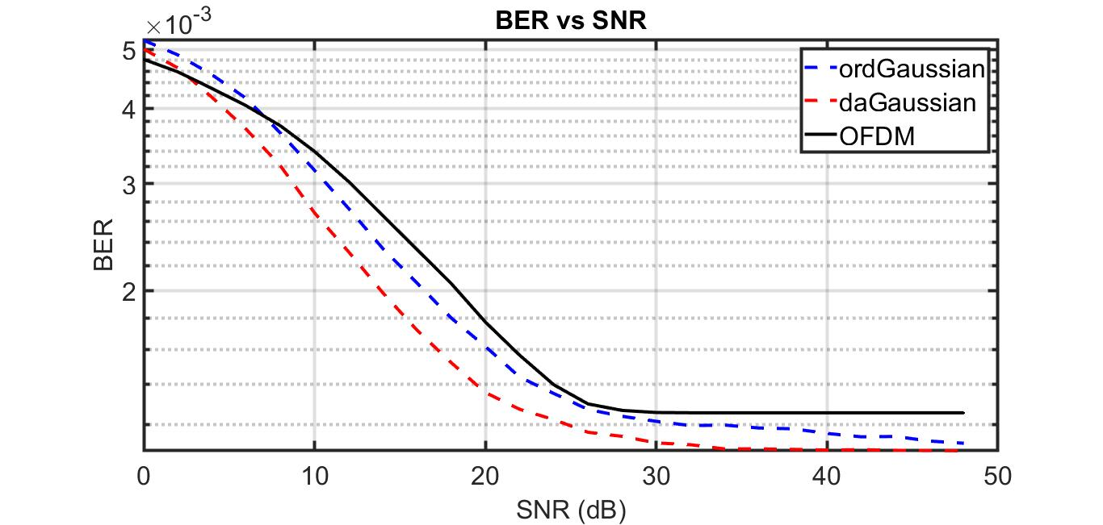FIG.7. BER with range (0dB-50dB) to OFDM (black line), ordinary Gaussian-pulses (blue dashed line), and Gaussian-pulses aided by data analysis(red dashed line).
E. IN-BAND REDUCTION
Another performance in the communication system is spectral saving. In-band saving spectral calculated concerning OFDM that what explained in TABLE.14.

TABLE.14
Spectral saving regard to OFDM
System | Value
Ordinary Gaussian-pulses | 14.87%
Gaussian-pulses aided by Data analysis | 13.87%

F. OUT-BAND REDUCTION
The comparison in the Out-band spectrum between OFDM and the supposed system explained in FIG.8. Out-band decreasing noticeably, which is one of the problems in OFDM.
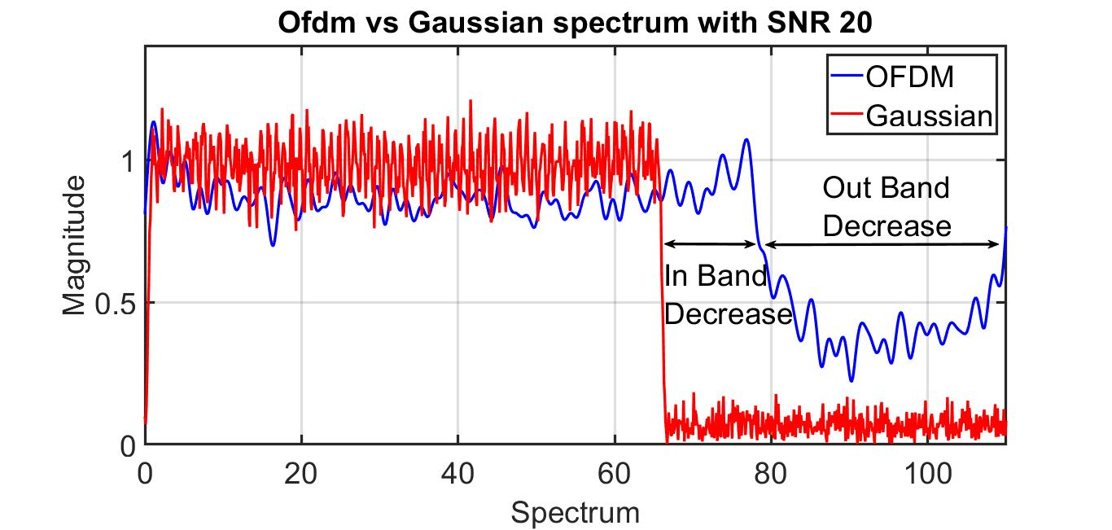FIG.8.Spectrum comparison between OFDM (blue line) and Gaussian-pulses with data analysis system (red line) when SNR =20dB.
IV. CONCLUSION
The necessity to spectral efficiency is noticeably raised because of the increasing demand for high data rate transmission, especially when nowadays technologies appear. Therefore, researchers are motivated to improve the spectral efficiency of 4G OFDM systems. Non-orthogonal multi-access systems are alternatives to provide better spectrum utilization. The proposed structure in this work can consider as a partial-overlapped system, where this system produces non-orthogonal subcarriers. Gaussian shape signal is relied on to construct the subcarrier spectrum of the entire system. Besides, this pulse shaping aided by data correlation calculations provides a smaller spectrum footprint with less by (13.8%) regard to OFDM with In-band, and negligible Out-band values, which results in higher spectral efficiency. Decreasing in BER clearly, especially if data similarity calculation considered in computing the frequencies values. In summation, the communication system with data analysis gives improved communication systems rather than relied only on the physical properties and mathematical analysis. These results can be in new novel smart communication systems, which will be suitable for 5G communication.
REFERENCES
- A. Goldsmith, Wireless Communications. USA: Cambridge University Press,pp299-237, 2005.
- P. Banelli, S. Buzzi, G. Colavolpe, A. Modenini, F. Rusek, and A. Ugolini, “Modulation Formats and Waveforms for 5G Networks: Who Will Be the Heir of OFDM?: An overview of alternative modulation schemes for improved spectral efficiency,” IEEE Signal Process. Mag., vol. 31, no. 6, pp. 80–93, Nov. 2014.
- J. Yli-Kaakinen, T. Levanen, A. Palin, M. Renfors, and M. Valkama, “Generalized Fast-Convolution-Based Filtered-OFDM: Techniques and Application to 5G New Radio,” IEEE Trans. Signal Process., vol. 68, pp. 1213–1228, 2020.
- V. Rangamgari, S. Tiwari, S. S. Das, and S. C. Mondal, “OTFS: Interleaved OFDM with Block CP,” arXiv Prepr. arXiv2001.02446, 2020.
- R. Prasad, “OFDM for Wireless Communications Systems.” Artech House,pp 149-181, 2004.
- R. A. Abdelaal, A. S. Behbahani, and A. M. Eltawil, “On the performance of Massive MIMO cellular systems with power amplifiers,” Wirel. Telecommun. Symp., pp. 1–5, 2014.
- A. Nahar, A. Abdalla, A. Jaber, and M. M. Ali, “PAPR Reduction Using Eight Factors Rotating Phase Shift Technique Based on Local Search Algorithm in OFDM,” Rev. Comput. Eng. Res., vol. 4, pp. 38–53, 2017.
- H. Nikookar and K. S. Lidsheim, “Random Phase Updating Algorithm for OFDM,” vol. 48, no. 2, pp. 123–128, 2002.
- A. Prata, J. Sveshtarov, S. C. Pires, A. S. R. Oliveira, and N. B. Carvalho, “Optimized DPD Feedback Loop for m-MIMO sub-6GHz Systems,” IEEE MTT-S Int. Microw. Symp. Dig., vol. 2018–June, no. 1, pp. 485–488, 2018.
- K. Li, N. Guan, and H. Wang, “Iterative Learning Control Assisted Neural Network for Digital Predistortion of MIMO Power Amplifier,” IEEE Veh. Technol. Conf., vol. 2018–June, pp. 1–5, 2018.
- Z. Ding, M. Peng, and H. V Poor, “Cooperative Non-Orthogonal Multiple Access in 5G Systems,” IEEE Commun. Lett., vol. 19, no. 8, pp. 1462–1465, Aug. 2015.
- A. Osseiran, J. F. Monserrat, and P. Marsch, “5G mobile and wireless communications technology.”, Cambridge University Press, 2016.
- H. Huang and M. Zhu, “Energy Efficiency Maximization Design for Full-Duplex Cooperative NOMA Systems With SWIPT,” IEEE Access, vol. 7, pp. 20442–20451, 2019.
- N. Smaili, M. Djeddou, and A. Azrar, “Residual self-interference cancellation in NOMA-OFDM full duplex massive MIMO,” in 2017 International Conference on Mathematics and Information Technology (ICMIT), 2017, pp. 43–47.
- K. Higuchi, “Non-orthogonal Multiple Access ( NOMA ) with Successive Interference Non-orthogonal Multiple Access ( NOMA ) with Successive,” no. July, 2016.
- P. Sun, W. Yuan, and H. Cheng, “A Novel Successive Interference Cancellation Arithmetic Based on NOMA System,” vol. 147, no. Ncce, pp. 1124–1132, 2018.
- W. Saetan and S. Thipchaksurat, “Power Allocation for Sum Rate Maximization in 5G NOMA System with Imperfect SIC: A Deep Learning Approach,” in 2019 4th International Conference on Information Technology (InCIT), 2019, pp. 195–198.
- T. Manglayev, R. C. Kizilirmak, Y. H. Kho, N. Bazhayev, and I. Lebedev, “NOMA with imperfect SIC implementation,” in IEEE EUROCON 2017 -17th International Conference on Smart Technologies, 2017, pp. 22–25.
- R. Kizilirmak, “Non-Orthogonal Multiple Access (NOMA) for 5G Networks,” 2016.pp.83-98.
- M. Garuba, “Big Data Analytics for User-Activity Analysis and User-Anomaly Detection in Mobile Wireless Network,” vol. 13, no. 4, pp. 2058–2065, 2017.
- P. Chiu, J. Reunanen, R. Luostari, and H. Holma, “Big Data Analytics for 4.9G and 5G Mobile Network Optimization,” in 2017 IEEE 85th Vehicular Technology Conference (VTC Spring), 2017, pp. 1–4.
- Y. Liu, S. Han, S. Wang, and G. Liu, “On Big Data Analytics for Greener and Softer RAN,” IEEE Access, vol. 3, pp. 3068–3075, 2016.
- E. Pateromichelakis et al., “End-to-End Data Analytics Framework for 5G Architecture,” IEEE Access, vol. 7, pp. 40295–40312, 2019.
- S. Han, C. I, G. Li, S. Wang, and Q. Sun, “Big Data Enabled Mobile Network Design for 5G and Beyond,” IEEE Commun. Mag., vol. 55, no. 9, pp. 150–157, 2017.
- S. Barmpounakis, P. Magdalinos, N. Alonistioti, and A. Kaloxylos, “Data Analytics for 5G Networks : A complete framework for network access selection and traffic steering Data Analytics for 5G Networks : A Complete Framework for Network Access Selection and Traffic Steering,” no. February 2019, 2018.
- M. A. Haleem, A. Haimovich, and R. Blum, “Sidelobe mitigation in MIMO radar with multiple subcarriers,” in 2009 IEEE Radar Conference, 2009, pp. 1–6.
- C. Cai, X. Li, X. Xu, and H. Wu, “A novel uwb pulse design method of optimizing combination with differential Gaussian pulse,” in 2008 4th International Conference on Ultrawideband and Ultrashort Impulse Signals, 2008, pp. 228–230.
- Zhanbiao Jia, Hong Chen, Xiaoxia Cai, and Xiaobo Chen, “A novel pulse design based onsinusoid Gaussian function for UWB communication,” in 2010 3rd IEEE International Conference on Broadband Network and Multimedia Technology (IC-BNMT), pp. 1240–1244, 2010.
- W. Ma, “CPM Modulator Design Based on Modified Gaussian Pulse Shaping,” in 2010 International Conference on Communications and Mobile Computing, 2010, vol. 2, pp. 292–295.
- K. Basterretxea, J. M. Tarela, and I. del Campo, “Digital Gaussian membership function circuit for neuro-fuzzy hardware,” Electron. Lett., vol. 42, no. 1, pp. 44–59, 2006.
- R. L. Ott and M. T. Longnecker, An introduction to statistical methods and data analysis. Nelson Education, pp. 171-178, 2015.
- J. Han, M. Kamber, and J. Pei, “Data mining concepts and techniques third edition,” Morgan Kaufmann, 2011.

SALAM ALYASSRI received his B.S. degree in Computer Engineering from the University of Basra / Engineering College, Iraq, in 2002, and his M.Sc. degree in Computer Engineering from the University of Basra/ Engineering College, Iraq, in 2005. He is currently working in BOC company. His research related to applying Neural Networks on Cellular communication systems. Worked as lecturer in Basra collage 2015 and Kenooz University 2018. Work in Programming the e-management systems for six years in IDC company. He has experience in database management and theoretical background on communication researchs so he interest in applied artificial intelligence on communication systems.
MUHAMMAD ILYAS (S’18) received his B.S. degree in Computer Engineering from COMSATS IIT Abbottabad, Pakistan, in 2010 and his M.S. and Ph.D. degrees in Electrical and Computer Engineering from Altinbas University, Istanbul, Turkey in 2014 and 2018 respectively. He is currently pursuing his career as a lecturer (Assistant Professor) at Altinbas University, Istanbul, Turkey. His current research interests include in vivo wireless communication, wireless body area networks, neural networks, and implantable devices.
ALI MARHOON is a Professor in the Department of Computer Science & Electrical Engineering at the University of Basrah where he has been a faculty member since 1990. Ali completed his Ph.D. at Basrah University in 2002 and his undergraduate studies at Basrah University in 1982. His research interests lie in the area of Networking, IoT applications, ranging from theory to design to implementation. He has collaborated actively with researchers in several other disciplines of computer science, particularly computer architecture on problems at the hardware/software interface.
Ali has served on few conference and workshop program committees and served as the Program Chair for IJEEE 2019. He supervised about 30 M. Sc. And 15 Ph. D. Students.

OGUZ BAYAT received a B.S. degree from Istanbul Technical University, Istanbul, Turkey, in 2000, and an M.S degree from the University of Hartford, CT, USA, in 2002, and a Ph.D. degree from Northeastern University, Boston, MA, USA, in 2006, all in electrical engineering. Before attending the Communication and Digital Signal Processing Research Center at Northeastern University in 2002, he served as an adjunct faculty in the Department of Electrical and Computer Engineering at the University of Hartford. He is currently working as a technical leader/manager on the Nortel project at Airvana Inc, Boston, MA, USA, and he has been involved in the research and development of CDMA 1xEV-DO Rev 0, Rev A and Rev B radio node and radio node controller software products since 2005. Since 2011, he has been serving as a Professor in the Department of Electrical and Electronics Engineering of Altınbas University. His current research interests are in the area of wireless communication, digital signal processing, channel coding, channel estimation, and equalization techniques in particular multilevel coding, turbo coding and equalization for wireless communication systems.

