[Name of the proceedings]
A Proposed Framework for Healthcare based on Cloud Computing and IoT Applications

Waleed Noori Husseinª, Haider N. Hussain^{b}, Ihsan Mardan Humod^{c}
ªAL-Zahraa College of Medicine, University of Basrah, Basrah,Iraq
^{b}College of Science, University of Basrah,Basrah,Iraq
^{c}AL-Zahraa College of Medicine, University of Basrah, Basrah,Iraq
Abstract
The Internet of Things (IoT) envisions the total integration of numerous “stuffs” utilizing the internet as the information system’s foundation to enable intelligent engagements between encircling people and items. As the core component of IoT, the cloud offers useful exclusive application services in many application domains. In order to leverage relevant and unique IoT-related services, a range of IoT cloud providers is currently emerging in the sector. This paper introduces a data collection approach based on the literature review that is currently being carried out to analyze the evolution of Cloud Computing with the advent of the IoT definition to see how much the internet of things has been impacted by cloud computing. E-health is used in our research as a case study designing and implementing the e-health smart network infrastructure to avoid delays in transmitting patient medical data to healthcare providers. This paper introduces a framework that offers applications that use wireless sensors in their infrastructure.

Keywords: Internet of things, Cloud Computing, Healthcare, Smart Cities;
- Introduction
The Internet of Things (IoT) and cloud computing are two outstanding optimal ICT paradigms that have recently gained the interest of academicians. The cloud computing paradigm acknowledges and foster the dissemination of software and hardware services via the Internet, per an on-demand based on utility structure [1]. Many assume that, as a revolution, the cloud will reshape the IT sector. The National Institute of Standards and Technology of the United States offers a wide and generic description of Cloud Computing, as well as observations and characteristics (NIST). Cloud computing is defined as a network connection framework that promotes ubiquitous, basic, on-demand network access to a prevalent pool of customizable computing assets (for example, administrations, applications, storage, servers, and systems) that can be immediately released and monitored with no proper coordination or by attempting to reach the service operator [2]. To be comprehended and exploited, the IoT paradigm requires a huge amount of virtual and physical diverse items linked to the World Wide Web. IoT allows several objects to communicate with each other and allows their services to be invoked in context to add value to applications. The earliest IoT applications are centered on RFID (Radio Frequency Identification) and Wireless Sensor Network technologies, which are as common as other industries in business, production, transportation, and green/sustainable operations [3]. The fast progress of engineering's, such as short-range improved energy capabilities and cellular transmission, is geared at constructing a global network of things [4]. This would result in the production of enormous quantities of data that affect the placement, processing, and accessibility of information. Cloud storage can be seen as a good solution for managing and processing information from all the IoT data collected [5]. Fig.1. shows the year-over-year growth of IoT connections and the projected growth for 2020.

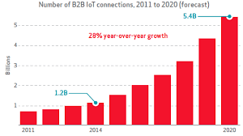

Fig.1. Projected IoT Growth for 2020 [6]

- Cloud computing and IoT unification
The two phrases, IoT and cloud, have developed independently. In this section, however, some of the benefits resulting from their incorporation have been explained to be used in the future. Cloud computing’s almost infinite possibilities offset its technological restrictions, such as storage computation and energy, and can provide substantial advantages to IoT [7, 8]. Cloud and IoT are considered as an evaluation. However, a lot of common benefits were identified because of their integration which predicts the future. Also, IoT can gain great benefits from cloud computing, such as unlimited capacity and resources. Cloud can also provide an effective solution that helps to realise the management of the use of things and composition [9, 10]. Cloud computing will gain from IoT in a widely dispersed and sophisticated form by communicating with things in the actual environment and offering fresh products in a range of real-life circumstances. Cloud computing acts as an intermediary layer between objects (i.e., devices) and applications [11, 12]. Furthermore, cloud and IoT connections provide unprecedented avenues for data gathering, integration, and exchange with others [13]. Cloud data should be compatible with a standard API that allows it to use security protection and would be available from anywhere. The tools for processing IoT devices are not required to perform data processing. It is typically possible to integrate captured information and transfer it to more efficient node storage, but not an adequate scalability challenge to achieve infrastructure. With its on-demand limitless capacity approach, the Cloud provides enough material for the Internet of Things to handle unprecedented dynamic requirement analysis. Data-driven decision-making and prediction algorithms will be available at a cheap budget, resulting in higher revenues and lower threats. A few of the IoT requirements are to enable IP access systems to connect via dedicated hardware, which can be very expensive to support such communication [13]. In addition, cloud computing is capable of offering an efficient solution for applying IoT service management. Cloud exploits data problems by applications and composition. Moreover, IoT scope is extended to handle real things of the IoT world is more dynamic behaviour. By providing a new service in real life which results in a great benefit for cloud computing. The features of IoT and cloud computing are derived from many factors that motivate the adoption of these two technologies [14].
- Services under cloud computing and IoT
The combination of cloud computing and the IoT allows creating applications and services [15, 16]:
  - Sensing as a Service (SaaS)
This sort of service gives you total entry to the detector [15]. The sensing as a service paradigm is expected to be developed on the pinnacle of IoT services and infrastructure [17]. Using the SaaS cloud, sensing servers can be used to handle sensing requests from different locations. Unless a data owner initiates a sensing query from either a smartphone or computer via a website front-end, the application also will be used for a sensing database which will then move the application to a subset of cell devices that are in the area of interest [18].

  - Sensing and Actuation as a Service (SAaaS)
It allows automated control logic to be deployed in the Cloud in this sort of service [19]. To be allowed to deploy SAaaS, sensors and actuators must be offered as guaranteed or somehow layered services established between sensor networks and devices or other qualified platforms.
  - A sensor as a Service (SenaaS)
In this type of service, it enables ubiquitous management of remote sensors [20].
  - Database as a Service (DBaaS)
Database as a Service (DBaaS) represents a self-service cloud-based approach for deploying databases and database applications to target consumers without the involvement of IT personnel [21].
- Advantage of cloud computing with IoT
Previous investigations have showcased the advantages of cloud computing with IoT in a greater perspective [22-24]. Storage capacity, Computational resources, and New capabilities are some of the benefits of cloud computing. Table 1 outlines the cloud computing benefits.
Table 1. The benefits of cloud computing with IoT
Benefits | Descriptions
Storage resources | By definition, IoT contains different sources of data (i.e., stuff), generating a large amount of non or semi-structured data only with three components characteristic of Big Data. The most efficient and expensive approach for dealing with IoT data in the cloud.
Computational resources | IoT systems have restricted computing resources and do not allow data processing on-site. At a minimal expense, data-driven cloud decision-making and prediction algorithms would be viable, with better revenues and fewer uncertainties.
New capabilities | IoT is categorised by a substantial heterogeneity degree in terms of computers, technologies, and protocols. Scalability, accuracy, and accessibility. They are not easy to acquire. Cloud deployment can offer solutions to several of these problems.

These advantages will make companies and individuals begin to consider how to use the technologies they have enabled. It may also help firms preserve revenue and run their operations more efficiently and effectively. It may help organisations overcome challenges with cloud computing, such as limited funds and infrastructure, and make sense of their IoT data.
- Cloud Computing problems and concerns with IoT
There have been several challenges and difficulties with cloud computing and IoT deployment. In the latest release, software systems in smart gadgets were also addressed, including conducting with limited support, along with traditional integrated systems, advanced software infrastructure will be included with the network and server background to handle smart gadgets and items and facilitate the best service that assists these objects [25]. Stabilisation has also been reported to be an issue. Data needs to be stabilised in the real world to ensure technical interoperability from all technologies can send and process massive amounts of data. One of the main challenges that are facing users to establish interoperability with the applications or platforms is the changing of employed APIs while developing. Therefore, any application which has been designed or developed on a platform cannot be used on other platforms [26]. IoT cloud concerns and challenges make organisations unwilling or reluctant to implement cloud technologies. However, considering the challenges and problems that could arise, they must remember that cloud computing may also offer further advantages. It can be seen that for businesses, their main concern is to maintain stable performance and growth. IoT and cloud bring benefits to their business. It also cuts down the expenses of hiring third parties.
- Methodology
Fig. 2. shows how this research is carried out. The data was collected by deploying an application to the cloud to receive and store sensor data in a cloud database to be analysed. Consequently, Sensor data will be stored in a highly scalable available database that is running in the cloud. An analytical analysis will be done utilizing extensive analytic techniques to identify intriguing trends from a huge quantity of data in an attempt to understand the outcomes received from the sensors. This result provides us with a solid knowledge of the benefits and challenges that businesses must weigh when combining cloud computing and IoT in our research. The outcomes of this analysis also suggest that it is beneficial for organizations and scholars to consider the researcher’s conclusions before using cloud computing and IoT technologies in the actual world. Our outcome will be a proposed framework that serves different types of applications such as e-health, smart home, smart city, and other applications that need to use Wireless Sensor Networks (WSNs) in their infrastructure. E-health is used in our research as a case study designing and implementing the e-health smart network infrastructure to avoid delays in transmitting patient medical data to healthcare providers.
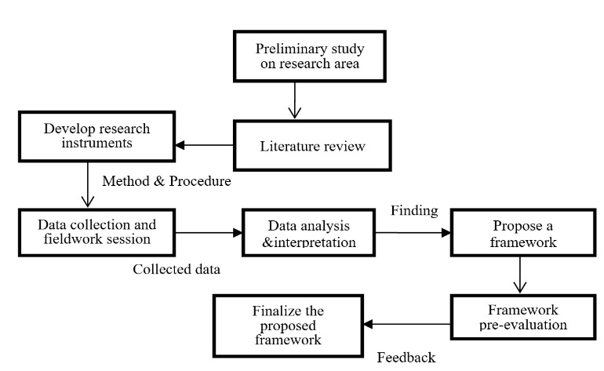

Fig.2. Key stages in the research process

- The proposed Framework

Fig. 3. shows how the proposed framework serves different types of applications such as e-health, smart home, smart city, and other applications that need to use Wireless Sensor Networks (WSNs) in their infrastructure. The proposed framework is in the cloud, which is responsible for providing a service to store sensor data and analysing, managing, updating, visualizing real-time data, as well as making appropriate decisions depending on real-time data and historical data.

IoT applications
ID and sensor data
Web server
Database
Decision making

Fig.3. The proposed Framework

On the cloud side, the Amazon Platform has been selected as the cloud provider. Amazon platform offers many cloud services and components, including Virtual Machine, load balancer, traffic manager, high scalability and availability services, machine learning and data analysis tool, big data solution, load testing, and security and privacy. The decision-making algorithm was implemented using SQL Server Stored Procedure. A stored procedure is a collection of SQL assertions put together to execute a specific job. We implemented the decision-making algorithm using SQL Server Stored Procedure as shown below. A stored procedure is a collection of SQL assertions that are put together to execute a specific job. The system is responsible for generating appropriate medical decisions using a decision-making algorithm, which is based on standard medical practices and a patient’s historical medical data. Proposed decisions Medical personnel responsible for the healthcare of a patient will be sent for approval. The system sends final decisions to the patient after medical staff approval. As a consequence, the client may receive a high-quality treatment, and the e-health Smart System aids medical professionals by offering real-time data gathering, vanishing manual data collection, and permitting the observation of a significant number of clients simultaneously. The experiment was conducted on thirty people as the subject patient. In this experiment, we focused on measuring the body temperature for the person at different times, as shown in Fig. 4.

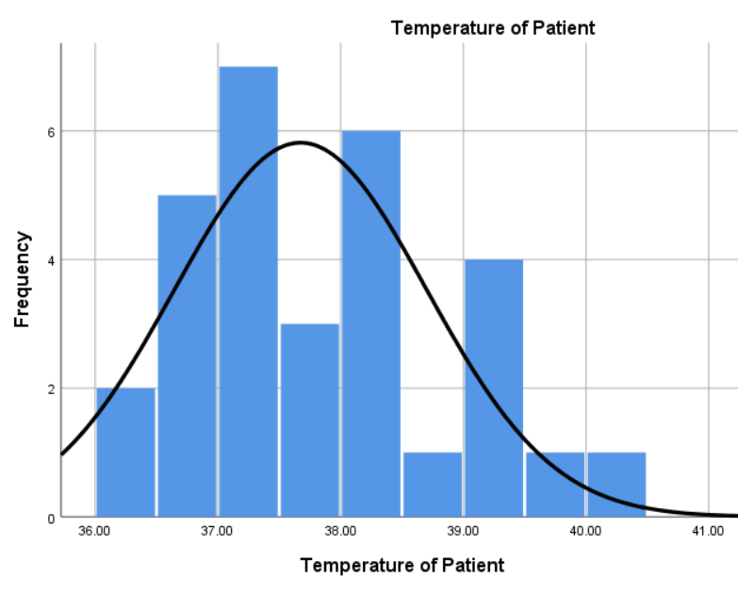
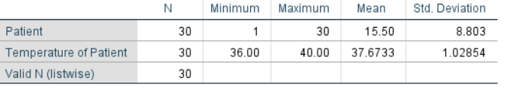

Fig.4. Body temperature monitoring

Medical practitioners may also determine choices based on the client’s condition if the client is considered an emergency situation. Since the body temperature sensor requires a while to create the right temperature, we employed the delay approach to achieve a sufficient level of accuracy. We noted that the 30-second delay in collecting body temperature would help to achieve high-temperature measurement precision since it takes 30 seconds for the temperature sensor to read the correct temperature. However, applying the delay technique is not required if the patient is already wearing a private sensor. As a result, we noticed that every occasion needed a maximum of one minute to read the body temperature, including delay time. We found this result to be quick in comparison to the traditional manual technique.

- CONCLUSIONS
Given the necessity for companies to sustain steady performance and development, cloud computing unification with IoT may be very beneficial. Nevertheless, there are several issues that must be tackled while adopting IoT cloud computing. Cloud computing offers many IoT services, so healthcare and smart cities needs to choose the right IoT services and platforms. The potential of cloud computing and IoT has been explored in this paper to have a clear understanding of IoT cloud computing and to be aware of the variables that may influence IoT. It also defined the methods used. The goal of this study is to determine the possibilities for various cloud computing and IoT applications. The e-health framework has been used as a case study for the possible implementation of various IoT applications.

References
[1] Foster D, White L, Erdil, D. Adams A. Toward a cloud computing learning community. in Proceedings of the Working Group Reports on Innovation and Technology in Computer Science Education, ed, 2019, pp. 143-155. http://dx.doi.org/10.1145/3344429.3372506.
[2] Yadav A, and Garg M. Monitoring Based Security Approach for Cloud Computing, Ingénierie des Systèmes d'Information; 2019,vol. 24. https://doi.org/10.18280/isi.24060.
[3] Landaluce H, Arjona L, Perallos A, Falcone F, Angulo I, and Muralter F. A review of IoT sensing applications and challenges using RFID and wireless sensor networks, Sensors;2020, vol. 20, p. 2495. https://doi.org/10.3390/s20092495.
[4] Akpakwu G. A, Silva B. J, Hancke G. P, and Abu-Mahfouz A. M. A Survey on 5G Networks for the Internet of Things: Communication Technologies and Challenges, IEEE Access; 2018, vol. 6, pp. 3619-3647. http://dx.doi.org/10.1109/ACCESS.2017.2779844.
[5] Kaur H, Alam M, Jameel R, Mourya A, and Chang V. A proposed solution and future direction for blockchain-based heterogeneous medicare data in cloud environment, Journal of medical systems; 2018 vol. 42, pp. 1-11. http://dx.doi.org/10.1007/s10916-018-1007-5.
[6] Thierer A, Castillo A. Projecting the growth and economic impact of the internet of things. George Mason University, Mercatus Center; 2015. http://dx.doi.org/10.2139/ssrn.2618794.
[7] Zhou J, Leppanen T, Harjula E, Ylianttila M, Ojala T, Yu C et al. Cloudthings: A common architecture for integrating the internet of things with cloud computing, Computer Supported Cooperative Work in Design (CSCWD), 2013 IEEE 17th International Conference on, 2013, pp. 651-657. http://dx.doi.org/10.1109/CSCWD.2013.6581037.
[8] Li M. Research on the mechanism and influence factors of urban style building based on cloud computing logistics information," Cluster Computing; 2019, vol. 22, pp. 13873-13880. http://dx.doi.org/10.1007/s10586-018-2120-4.
[9] Bouguettaya A, Singh M, Huhns M, Sheng Q, Dong H Yu, Q, et al. A service computing manifesto: the next 10 years, Communications of the ACM;2017, vol. 60, pp. 64-72, http://dx.doi.org/10.1145/2983528.
[10] Peng Z. An Operation and Maintenance Strategy of Intelligent Building Information Model Data Based on Cloud Computing, Ingénierie des Systèmes d'Information;2020, vol. 25. http://dx.doi.org/10.18280/isi.250408.
[11] Merlino G, Dautov R, Distefano S, and Bruneo D. Enabling workload engineering in edge, fog, and cloud computing through OpenStack-based middleware, ACM Transactions on Internet Technology (TOIT); 2019 vol. 19, pp. 1-22. http://dx.doi.org/10.1145/3309705.
[12] Hou Y, Cao Z, and Yang S. Cloud intelligent logistics service selection based on combinatorial optimization algorithm, Journal Européen des Systèmes Automatisés;2019, vol. 52, pp. 73-78. http://dx.doi.org/10.18280/jesa.520110.
[13] Gebremeskel G, Chai Y, and Yang Z. The paradigm of big data for augmenting internet of vehicle into the intelligent cloud computing systems, International Conference on Internet of Vehicles; 2014, pp. 247-261. http://dx.doi.org/10.1007/978-3-319-11167-4_25.
[14] Yang J, Wang C, Zhao Q, Jiang B, Lv Z, and Sangaiah A. Marine surveying and mapping system based on Cloud Computing and Internet of Things, Future Generation Computer Systems;2018, vol. 85, pp. 39-50. http://dx.doi.org/10.1016/j.future.2018.02.032.
[15] Suciu G, Fratu O, Halunga S, Cernat C, Poenaru V, and Suciu V. Cloud consulting: ERP and communication application integration in open source cloud systems, Telecommunications Forum (TELFOR); 2011 19th, 2011, pp. 578-581. http://dx.doi.org/10.1109/TELFOR.2011.6143614.
[16] Rao B, Saluia P, Sharma N, Mittal A, and Sharma S. Cloud computing for Internet of Things & sensing based applications, Sensing Technology (ICST), Sixth International Conference on; 2012, pp. 374-380. http://dx.doi.org/10.1109/ICSensT.2012.6461705.
[17] Abdelwahab S, Hamdaoui B, Guizani M, and Znati T. Cloud of things for sensing-as-a-service: Architecture, algorithms, and use case, IEEE Internet of Things Journal;2016, vol. 3, pp. 1099-1112. http://10.1109/JIOT.2016.2557459.
[18] Kanagaraj E, Kamarudin L, Zakaria Gunasagaran A, and Shakaff A. Cloud-based remote environmental monitoring system with distributed WSN weather stations, IEEE SENSORS; 2015, pp. 1-4. http://dx.doi.org/10.1109/ICSENS.2015.7370449.
[19] Satpathy S, Sahoo B and Turuk A. Sensing and actuation as a service delivery model in cloud edge centric internet of things, Future Generation Computer Systems 2018 vol. 86, pp. 281-296. http://dx.doi.org/10.1016/j.future.2018.04.015.
[20] Schuh G, Pitsch M, Rudolf Karmann S, and Sommer M. Modular sensor platform for service-oriented cyber-physical systems in the European tool making industry; 2014, Procedia Cirp, vol. 17, pp. 374-379, http://dx.doi.org/10.1016/j.procir.2014.01.114 .
[21] Raghavendran C, Satish G, Varma P, and Moses G, A Study on Cloud Computing Services, International Journal of Engineering Research & Technology (IJERT) ICACC; 2016, vol. 4. http:// 10.4236/ait.2016.64004.
[22] Stergiou C, Psannis K, Kim B, and Gupta B, Secure integration of IoT and cloud computing, Future Generation Computer Systems;2018, vol. 78, pp. 964-975. http://dx.doi.org/10.1016/j.future.2016.11.031.
[23] Wang M and Zhang Q. Optimized data storage algorithm of IoT based on cloud computing in distributed system, Computer Communications;2020, vol. 157, pp. 124-131. http://dx.doi.org/10.1016/j.comcom.2020.04.023.
[24] Abdulqadir H, Zeebaree S, Shukur H, Sadeeq M, Salim B, Salih A, et al. A study of moving from cloud computing to fog computing, Qubahan Academic Journal; 2021, vol. 1, pp. 60-70. http://dx.doi.org/10.48161/qaj.v1n2a49.
[25] Sundmaeker H, Guillemin P, Friess P, Woelfflé S. Vision and challenges for realising the Internet of Things. Cluster of European research projects on the internet of things, European Commision. 2010 Mar 3;3(3):34-6. http://10.4236/ait.2016.64004.
[26] Rashidi B, Sharifi M, and Jafari T,A survey on interoperability in the cloud computing environments, International Journal of Modern Education and Computer Science;2013, vol. 5, p. 17. http://dx.doi.org/10.5815/ijmecs.2013.06.03.

