Overdose Of Tussirum Induced Histopathological Changes Of The Liver and Kidney In in male Domastic Rabbits
Majdy F. Majeed , Abdal J. Rasmy,*Yasmeen J. Mohammed and **Zenab M. Abd Al Rahmman
Department of Histology and Anatomy * Department of pathology and ** Veterinarian Practitioner

Abstract

In this study, the histopathological changes due to overdose usage of Tussirum drug (0.75 and 3 ml/Kg) in liver and kidney were assessed in rabbite with light microscopes. Six male rabbites (1 ± 0.5 Kg ) were included and divided into three groups. Normal saline (3ml/Kg) was given orally as placebo in the control group I (N= 2). Group II and III (N= 4 for each) was received Tussirum orally at a single dose of (0.75 and 3ml/kg/day) for 30 days respectively. the results were recorded that both doses of Tossirum were induced that blood vessel congestion, aggregation of Kuppfer cells, inflamintion infiltrations and Sinusoidal dilatation in the liver parenchyma in addition to the cytoplasmic vacuolation, degeneration, pyknotic nuclei in the hepatocytes and. On the other hand, renal damage was observed in the kidneys of treated rabbits, necrosis of glomular, degeneration of nucli and degeneration in the lining epithelial cells of renal, also noted that glomular shrinkage, dilated of reanal tubules and hyperplasia of tubles walls, as well as to necrosis of renal tubules endothelium, closing of renal tubules lumen, isulation of renal tubules endothelium and density in some nucli chromatic Finally, the investigators concluded that Tossirum toxicity induced hepatocellular and renal damage.
Kay Word: Tossirum, Histopathological, Liver, Kidney, Male Rabbit.

Introduction

Tussirum drug which contain codeine is one of the centrally acting narcotic opioids approved for use as an antitussive. It is an alkaloid that found in the opium poppy and has pharmacological and toxicological activity. Opium poppy has been used throughout the human history for hypnotic and a variety of medicinal properties (analgesic, anti-tussive and anti-diarrheal). The name of codeine was derived from the Greek word "kodeia" for poppy head. Later in 1832 in France, codeine was isolated during the morphine extraction by Pierre Robiquet (1). Codeine metabolism occurs in the liver by the cytochrome p450 enzyme system and by-products are excreted through the kidneys. Its biotransformation occurs in the liver, firstly by the phase I reactions (mainly O- and N- demethylation) and secondly by the phase II reactions (mainly conjugation of O-and N-demethylated compounds), in turn eleven and twelve metabolites are produced respectively (2and 3). Numerous studies on humans and experimental animals have proved that intravenous codeine misuse leads to various morphological changes in the liver tissue, the intensity of which increases with the length of codeine abuse, including vesicular degeneration, fatty changes, reduction of glycogen content in hepatocytes,and vascular changes (4;5).
acute and Chronic administration of codeine can cause various disorders such as respiratory depression through a direct effect on the brain and heart rate depression through vasodilatation of the peripheral vessels, gastrointestinal system, the impact of opioid-induced bowel dysfunction (OBD) extends beyond constipation to encompass a myriad of gastrointestinal (GI) signs and symptoms, ranging from decreased gastric emptying and re_ux to abdominal pain, cramping, bloating, nausea, and vomiting (6). However Many authors reported that anaesthetic, sedative and narcotic drugs affect kidney functions according to the duration and period of drug administration (7;8;9, 10, and11). (12) revealed that renal tubular dysfunction, diabetes inspidus, progressive renal insufficiency and systemic amyloidosis occur in subcutaneous nacrotic druge.
The present study was carried out to clarify the correlation between histological changes microscope to show changes occurred in the organelles and inclusions of the liver cell and kidney post-application of the repeated administration of an addictive codeine drug on the rabbit, in a trial to elucidate the cause of the hepatic and renal toxicity in narcotic addicts with special reference to its effect.

Materials and methods

1- experimental animals:
Male Rabbit (nine animals) was used weighing (1 - 1.5 Kg). They were acclimatized to the laboratory conditions for 2 weeks. Animals were housed in standard home cages with proper ventilation, temperature, illumination “12 hr dark–light cycle”.
The experiment was carried out on nine rabbits that were divided into three groups. Group I served as a control group (N=2) was given normal saline 0.9% (3ml/kg/day). Group II and III was orally given tussirum drug at a dose level of 0.75 and 3ml/kg/day only one time for 30 days of orall administration respectively. However this dose is equivalent doses of addictive to humans.

2- Druge:
Tussirum Syrup (Samarra drugs factory – Iraq- SDI) were used in this study, Each 1ml of tussirum drug was contains 8mg of codeine. orally given to rabbits by the gastric tube as dose ( 0.75 and 3ml/kg/day) for 30 days.

3- Histological examination
Animals were sacrified under diethyl ether anesthesia after 30 days of treatment the liver and kidney rapidly was removed. For light microscope preparations, livers and kidneys were cut into small slices fixed in 10% formalin, then dehydrated in a graded series of ethanol, embedded in paraffin wax and sectioned at 5um thickness. Slides were thren stained with hematoxylin and eosin stain for histological examination (13).

Results

1- Tussirum and histopathological in the liver .
No deaths were observed in any of the control or treated groups during the 30 days treatment, however, the histological study of control rabbit liver (group I), was showed that the hepatocytes are arranged in strands with one or two spherical nuclei, sinusoids are occupied by blood cells. The cytoplasm of hepatic cells is slightly eosinophilic; one the central vein has generally a circular outline (Fig. 1A).
The different level of tussirum doses (0.75 and 3 ml/Kg) had varied adverse effect on morphology and histopathology and its effect increased with the rise in dose quantity. In group II Tussirum treatment (0.75ml/Kg) was revealed the histopathological changes in liver were revealed congestion, cytoplasmic vaculation and aggregation of Kuppfer cells (Fg.1.B.), also appearing of Sinusoidal dilatation (sd) and Pyknotic (Fg.1.C.), while other histological section was showed degeneration and necrosis (Fg.1.D.). group III (3ml/Kg) tussirum at 30 days represented by congestion, hemorrhage, cytoplasmic vaculation, degeneration of nucli and necrosis. In addition to inflamination infiltration, Sinusoidal dilatation, degeneration and necrosis cytoplasmic cells (Fig1.E. F. G.). while states of pyknotic, infiltration inflamination, hemorrhage and loss of normal shape for tissue are shown in (Figs1. H. and I.).

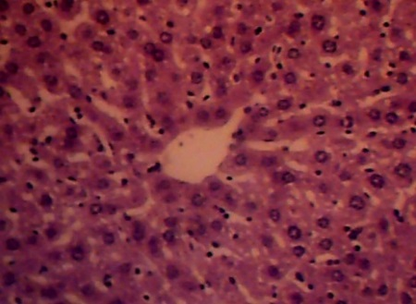
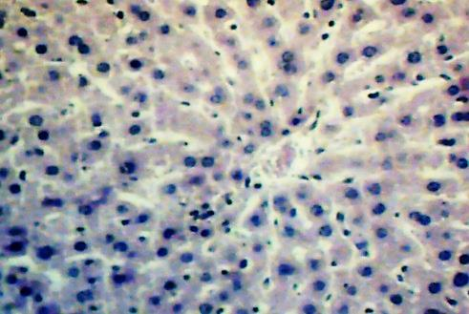
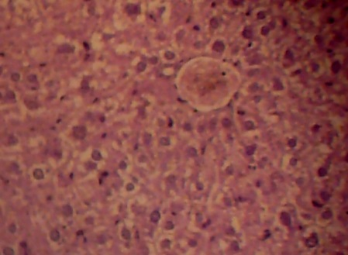
A
hc
cv
ec
C
sd
pk
B
cg
cva
kc

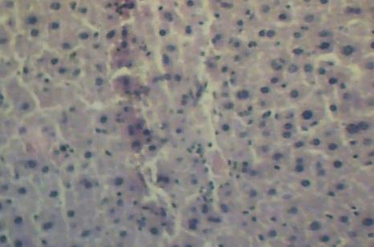
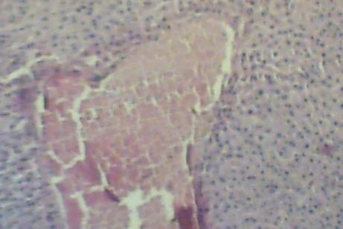
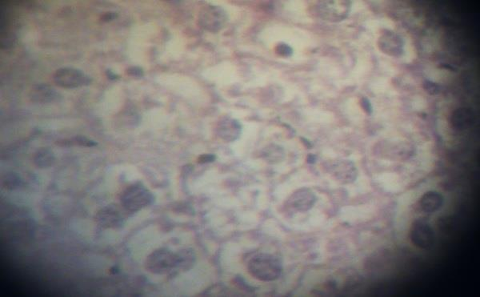
D
dg
nc
E
dg
he
F
cva
dg
nc

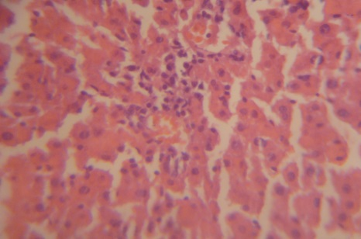
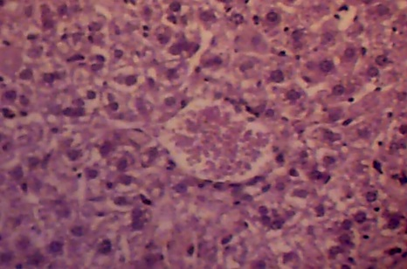
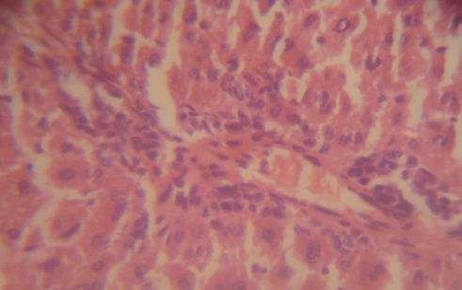
G
ii
sd
dg
nc
H
cg
pk
I
ii
he
sd

Figure 1. (1.A.) Section in control rabbit liver showing the hepatocytes (hc) arranged in strands around the central vein (cv) have a presinusoidal space contains endothelial cells (ec) (400X). (1.B.) Transverse section of liver treated with 0.75 ml/kg tussirum appearing of congestion (cg), cytoplasmic vaculation (cva), aggregation of Kuppfer cells (kc) (400X). (1.C.) Transverse section of liver treated with 0.75 ml/kg tussirum appearing of Sinusoidal dilatation (sd) and Pyknotic (pk) (400X). (1.D.) Transverse section of liver treated with 0.75 ml/kg tussirum appearing degeneration (dg) and necrosis (nc) (100X). (1.E.) Transverse section of liver treated with 3ml/kg tussirum appearing of congestion (cg) and hemorrhage (he) (100X). (1.F.) Transverse section of liver treated with 3ml/kg tussirum appearing cytoplasmic vaculation (cva), degeneration of nucli (dg) and necrosis (nc) (1000X). (1.G.) treated with 3ml/kg showed inflamination infiltration (ii), Sinusoidal dilatation (sd), degeneration (dg) and necrosis (nc) (100x). (1.H.) treated with 3ml/kg showed congestion (cg) and more states of pyknotic (pk) (400X). (1.I.) treated with 3ml/kg showed infiltration inflamination (ii), hemorrhage (he), dilation of Sinusoidal (sd) and loss of normal shape for tissue ( ) (100X). (hematoxylin & eosin).

2- Tussirum and histopathological in the kidney
The control kidney indicated the presence of normal glomular and renal tubules (Fig.2.A). In group II Tussirum treatment (0.75ml/Kg) was found the histopathological changes in kidney there wasloss of some glomerulus, degeneration of renal tubules epithelium and necrosis also recorded that necrosis of glomular, degeneration of nucli and degeneration in the lining epithelial cells of renal tubules were also noted revealed(Fig.2. B.C.), While other histological section was showed that glomular shrinkage, dilated of reanal tubules and hyperplasia of tubles walls (F.2.D.). group III (3ml/Kg) tussirum recorded the histopathological pictures of the 30 days represented by hemorrhage, hyperplasia, closing some renal tubules and degeneration of renal tubules epithelium, were also notedacute hemorrhage, congested glomerulus, necrosis of renal tubules endothelium (2.E.F.). while, states of glomular shrinkage, infltaration inflammation, necrosis of renal tubules and hypernucli in some renal tubules were shown in (2.G.), also appeared necrosis of renal tubules endothelium, closing of renal tubules lumen, isulation of renal tubules endothelium and density in some nucli chromaticwere also notsd (2.H.and I.).
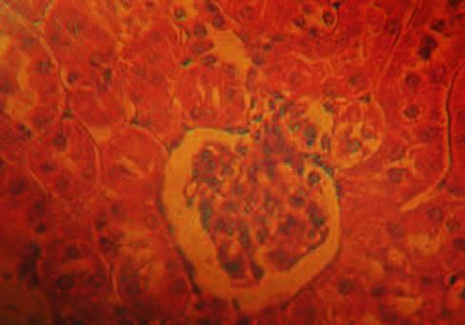
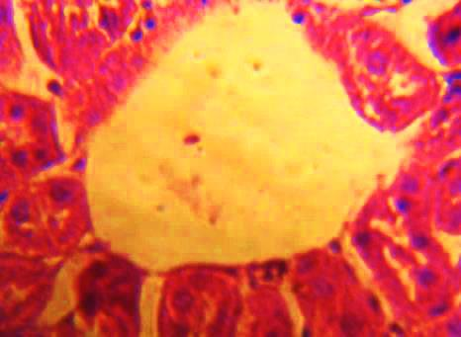
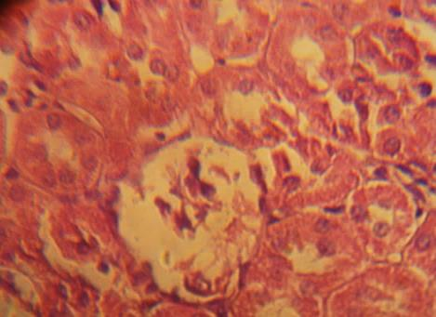
A
r
g
B
log
dg
nc
C
ng
dgn
det

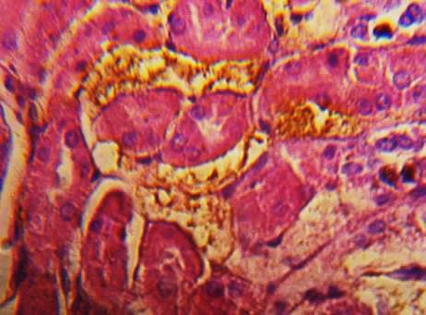
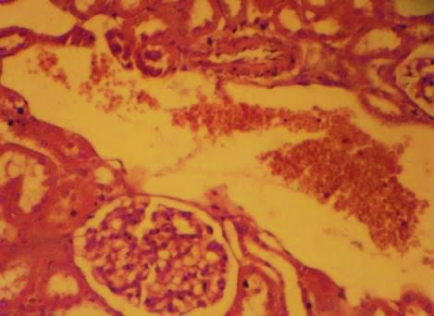
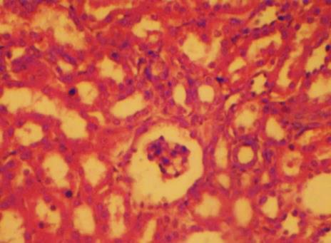
E
hem
hypc
drte
F
hem
gc
nrte
D
gsh
drt
hyp

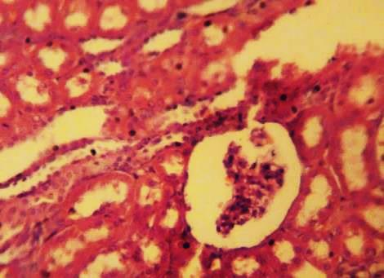
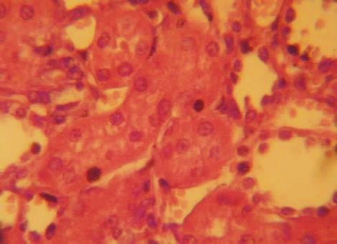
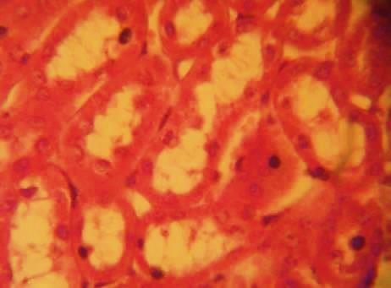
G
gsh
ii
nrt
hynt
I
crtl
irte
dnc
H
rte
crtl

Figure 2. (2.A.) Section in control rabbit kidney treated showing normal renal tubules (r) and glomerulus (g). (2.B.) Transverse section of kidny treated with 0.75ml/kg tussirum appearing of loss of some glomerulus (log), degeneration of renal tubules epithelium (dg) and necrosis (nc). (2.C.) necrosis of glomular (ng), degeneration of nucli (dgn) and degeneration in the lining epithelial cells of renal tubules (det). (2.D.) Transverse section of kidny treated with 0.75ml/kg showing of glomular shrinkage (gsh), dilated of reanal tubules (drt) and hyperplasia of tubles walls (hyp). (2.E.) Transverse section of kidny treated with 3ml/kg tussirum appearing hemorrhage (hem), hyperplasia and closing some renal tubules (hypc) and degeneration of renal tubules epithelium (drte). (2.F.) Transverse section of kidny treated with 3ml/kg tussirum appearing acute hemorrhage (hem), congested glomerulus (gc), necrosis of renal tubules endothelium (nrte). (2.G.) Transverse section of kidny treated with 3ml/kg tussirum appearing of glomular shrinkage (gsh), infltaration inflamintion (ii), necrosis of renal tubules (nrt) and hypernucli in some renal tubules (hynt). (2.H.) Transverse section of kidny treated with 3ml/kg tussirum appearing of necrosis of renal tubules endothelium (rte)and closing of renal tubules lumen (crtl). (2.I) Transverse section of kidny treated with 3ml/kg tussirum appearing closing of renal tubules lumen (crtl), isulation of renal tubules endothelium (irte) and density in some nucli chromatic (dnc) (hematoxylin & eosin × 400 original magnification).
Discussion

The opioids are being widely used since very long time, their long-term effects especially at histological level, are not clearly understood (14). Codeine is causes respiratory depression, psychological and physical addiction similar to that of other opiates and the analgesic efficacy of tramadol can further be improved by combination with a non-opioid analgesic (15). The morphine and other its derivatives; widely used opioid in recent years as an effective analgesic agent for the treatment of acute or chronic pain (16). All types morphine derivatives are metabolised in the liver and excreted by the kidneys, it may cause hepatotoxicity and nephrotoxicity during its metabolism (17).
Toxicity of codeine for rats, the oral LD,, is 427 mg codeine/kg body weight, the intraperitoneal LD50 is 130 mg/kg, the subcutaneous LD50 is 229 mg/kg, and the intravenous LD,, is 75 mglkg; for mice, therespective LD,, values are 250, 60, 84, and 54 mg/kg. The intra- muscular LD,o in mice is 290 mg/kg. The intra- venous LD50 in dogs is 69 mg/kg, and in rabbits it is 34 mg/kg (18). Codeine causes cytotoxicity in isolated rat hepato- cytes as measured by a time- anddose-dependent leakage of lactate dehydrogenase (19).
At concentrations of 0.5 or 1.25 ml codiene, cell death began after 60 minute sand viability decreased to less than 10% after 120 to 150 minutes. Hepatotoxicity was inhibited by the addition of metyrapone, an inhibitor of cytochrome P450 metabo lism, indicating that the cytotoxicity was caused by a P450 generated metabolite of codeine.
The different level of codeine doses (0.75 ml/kg and 3ml/kg) had varied adverse effect on liver histological was represented by vaculation, hyperplasia, hypertrophy, degeneration and necrosis and theses effects were increased with the rise in dose level. The results was agreed with 20) showed that the liver in mice was appeared histological changes after treated with different dose of Opium derivatives.
Morphine other its derivatives such as (codeine and tramadole), administration caused histological lesions, such as inflammatory infiltration, necrosis, hyperpigmention, degerneration and vessels congestion, also showed that pathocytological, such as torn and convolution of the nuclear membrane and distance between nuclei and irregular chromatin were noted. Our results are consistent with previous studies this finding is in agreement with previous study (21).
The liver and kidneys are responsible for the metabolism and excretion of morphine (22., 23). Morphine may cause hepatotoxicity and nephrotoxicity during its metabolism (24). Renal damage like focal cortico-medullary mineraliza- tion, focal regeneration in tubular epithelium, and min- eral/crystal deposition in intertubular region in kidneyshas been shown after long-term use of LAAM (25). It has been found that there was kidney change in the tubular cells(14).

Refrances

1. Wen-Zhou Z.; Wei-Jian, Y. ; Xiu- Li, Z. and Bao-Xia, H. (2014). Pharma coeconomic evalution of morphine. Asian Pac J. Cancer Prev, 15(20): 8797 – 8800.
2. Bannwarth, B., (1999). Risk-benefit assessment of opioids in chronic noncancer pain. Drug Safety, 21: 283-296.
3. Collet, B.J., (2001). Chronic opioid therapy for non-cancer pain. British Journal of Anaesthesia, 87: 133-143.
4. Karadzlc (2015).
5. Wasmuth JC. Epidemiology, trasmission and natural history. In: Mauss S, Berg T, Rockstroh J, Sarrazin C, Wedemeyer H, editors.( 2011). Short Guide to Hepatitis C. Flying Publisher;. pp. 13-18.
6. Brunton L, Lazo J, Parker K. (2005). Opioid analgesics. In: Goodman LS, Hardman JG. Limbird LE. Gilman, Alfred Goodman, Goodman and Gilman’s the Pharmacological Basis of Therapeutics. New York: McGraw Hill. 11th ed.; 547 – 591.
7. El-Banhawy, M.A. and El-Attar, E. (1993): Influence of chloramephenicol on some histoiogical and histochemical aspects of rat liver. Egypt. J. Anaesthesiol, 7: 120-123.
8. Abdel baset SA, Massoud AA and Hassan MA. (1993). Histopathological and Biochemical studies on the effect of clobazam and temazepam (Hypnotic Drugs) in male rats. J. Egypt. Ger. Soc. Zool., 12 (C): 319-344.
9. El-Negmy, F.A.; Zahran, F.M. and Abass, H.I. (1994): Effect of heroin administration on some kidney and liver functions of adult female rabbits. J. Egypt, Ger. Soc. Zool., 15 (A), 177-189.
Me hendale S.R. and Yuan C.S.(2006). Opioid-induced gastrointestinal ysfunction. Dig Dis.; 24: 105 – 112.
10. Abdel-Moneim LA (2001). Morphine-induced histological and histochemical changes in kidney and adrenal gland of neonatal and young rats. J. Egypt. Cer. Soc. Zool., Vol. 36 (C): 207-227.
11. El-Sherif, G.; Zharan, W.M.; Gabri, M.S. and Abdel-hamid, T.F. (2002). Histoiogical, histochemical investigations and ATP-ASE localiza-tion in the male albino rat kidney after morphine sulphate administration. J. Egypt. Ger. Soc. Zool., (39 C): 15-28.
12. Neugarten J, Gallo, G.R.; Katz, L.A.; Bubenstein, J. and Baldwin, D.S. (1986): Amyloidosis in subcutaneous heroin abusers. Am. J. Med., 81; 635-640.
13. Luna, L.G.(1968). Manual of Histological Staining Methods of the Arme Forces Institute of Pathology. McGro Hill,Inc.Printed ,USA .,PP:32-47.
14. Atici, S., Cinel, I., Cinel, L., Doruk, N., Eskandari, G., Oral, U. (2005). Liver and kidney toxicity in chronic use of opioids: an experimental long term treatment model. J. Bio. sci. 30: 245-252.
15. Lanier R K, Lofwall M R, Mintzer M Z, Bigelow GE, Strain EC. (2010). Physical dependence potential of daily tramadol dosing in humans. Psychopharmacology (Berl). 211(4): 457–466.
16. Lee R C, Tavish M C and Sorkin E M (1993). Tramadol: a preliminary review of its pharmacodynamic and pharmacokinetic properties, and therapeutic potential in acute and chronic pain states; Drugs 46 313–340
17. Wu WN, Mcknown LA, Gauthier AD, Jones WJ and Raffa RB (2001). Metabolism of analgesic, tramadol hydrochloride, in ratand dog. Xenobiotica, 31: 423-441.
18. RTECS, (1991). Bethesda (MD): National Institute for Occupational Safety and H 1971. Updatedquarterly.Availablefrom: National Library of Medicine, Bethesda, MD.
19. Ellington, S.P., and Rosen, G.M. (1987). Codeine-mediatedhepatotoxicity in isolated rat hepatocytes. Toxicol. Appl. Phannacol. 90:156-165.
20. Saleem, R. ; Iqbal, R. ; Abbas, M. N. ; Zahra, A. ; Iqbal, J. and Ansari, M. S. ( 2014 ). Effects of Tramadol on Histopathological and Biochemical Parameters in Mice (Mus musculus) Model . Global Journal of Pharmacology 8 (1): 14-19
21. Ordog T, Vertes Z, Vertes M.(1992). Inhibition of oestradiolinduced DNA synthesis by opioid peptides in the rat uterus. Life Sci. 51: 1187-1196.
22. Coughtrie M W, Ask B, Rane A, Burchell B and Hume R (1989 ). The enantioselective glucuronidation of morphine in rats and humans. Evidence for the involvement of more than one UDP glucuronosyltransferase isoenzyme; Biochem. Pharmacol. 38:3273
23. Milne R W, McLean C F, Mather L E, Nation R L, Runciman W B, Rutten A J and Somogyu A A (1997) . Influence of renal failure on the disposition of morphine, morphine-3-glucuronide and morphine-6-glucuronide in sheep during intravenous infusion with morphine; J. Pharmacol. Exp. Ther. .282:779–786
24. Van der Laan J W, Krajnc-Franken M A ,van Loveren H. (1995). Immunotoxicological screening of morphine and methadone in an extended 28 day study in rats. Int. J. Immunopharmacol. .17: 535–543
25. Borzelleca J F, Egle J L Jr, Harris L S, Johnson D N, Terrill J B and Belleville J. A. (1994). Toxicological evaluation of mu-agonists. Part I: Assessment of toxicity following 30 days of repeated oral dosing of male and female rats with levo-alpha– acetylmethadol HCL (LAAM); J. Appl. Toxicol.. 14 :435–446 – 3280.

الجرعة المفرطة للتوسيرام وتأثيراته المرضية النسجية في كبد وكلية الارانب المحلية
مجدي فيصل مجيد و عبد الجبار رسمي حويط و*ياسمين جاسم محمد و**زينب محمد عبد الرحمن
كلية الطب البيطري فرع التشريح والانسجة * فرع الامراض وامراض الدواجن ** طبيب بيطري ممارس

الخلاصة

الدراسة الحالية ناقشت تأثير الجرعة المفرطة لدواء التوسيرام ( 0.75 و 3 مل/كغم) في مستوى التغيرات المرضية النسجية تحت المجهر الضوئي للكبد والكلية في الارانب المحلية. اجريت التجربة على عشرة من الذكور البالغة والتي قسمت الى الى ثلاث مجاميع تضمنت مجموعة السيطرة (اثنين من الحيوانات) كانت جرعة فمويا 3مل/كغم من المحلول الفسلجي، المجموعة الثانية (اربعة حيوانات) كانت جرعة التوسيرام بتركيز ( 0.75 مل/كغم)، اما المجموعة الثالثة (اربعة حيوانات) فقد جرعت 3 مل/كغم من الدواء ولمدة ثلاثون يوما. اظهرت النتائج ولكلا الجرعتين تغيرات مرضية نسجية تمثلت باحتقان الاوعية الدموية والارتشاح الالتهابي والتنكس والتنخر وفقدان الشكل السوي لنسيج الكبد بالاضافة الى تفجي سايتوبلازمي وتنكس وتنخر وتغلض نواة الخلايا الكبدية. اما الكلية فقد اظهرت تلف كلوي واضح تمثل بتنكس خلوي وتنخر واحتقان الاوعية الشعرية الكلوية اضافتا الى ارتشاح التهابي وانسداد النبيبات.

