PROFILE OF CLEFT LIP AND CLEFT PALATE IN BASRAH PROVINCE SOUTH OF IRAQ BETWEEN 2013-2015

Hanaa Khazaal Jaber¹, Sundus Abdul Wadood², Adil G. Fadil. ³
¹ Assistant Lecturer, Department of oral and maxillofacial surgery, Basrah University, College of dentistry, Iraq.
² Lecturer, Department of oral and maxillofacial surgery, Basrah University, College of dentistry, Iraq.
³ Lecturer, Department of pediatric dentistry, orthodontic and preventive dentistry, Basrah University, College of dentistry, Iraq.

___________________________________________________________________________

ABSTRACT
Aims
To study the profile of patients with cleft lips and palate in Basra province.
Background
Orofacial clefts are the most common congenital malformation of the face, and its pattern varies with geography worldwide. Pattern and magnitude remain uncertain due to very few studies.
Methodology
This study includes 363 cases of orofacial clefts divided to Cleft Lip (CL), cleft palate (CP) and cleft lip and palate (CLP). Patients enrolled in the Al Sadder Teaching Hospital's plastic and reconstructive surgery department in Basrah, south of Iraq, from January 2013 to December 2015. Variables Data collected such as age, sex, residence, type, degree of orofacial clefts and family history were noted.
Result
Among all OFCs cases under study, 186 (51.2%) were males, and 177 (48.7%) were females. Age of patients at presentation ranged from 1 day to 49 years with a median age of 2 years. The predominant type is CP 170 (46.8%) followed by CL 129 (35.5%) then cleft lip and palate 64 (17.6%) cases were noted. Statistically significant differences found between those cases with positive family history forming 207 (57%) from all cases and those with negative family history 156 (43%) of cases. Most of the cases came from rural areas 247 (68%) compare with 116 (32%) cases from urban areas with significant differences.
Conclusion
In this study, all types of OFCs are increased in Basrah and seen more commonly in males; OFCs associated significantly with positive family history. The role of environmental factors in increasing congenital abnormalities in Basrah, particularly in rural areas, cannot be excluded and requires further research.

Keywords: Cleft lip and palate, prevalence, risk factors, associated anomalies.

INTRODUCTION
Orofacial clefts (OFCs) are congenital abnormal spaces or gaps in the alveolus or palate of the upper lip. They are the most frequent serious congenital anomalies affecting the orofacial region¹. OFCs classified as the cleft lip (CL), cleft palate (CP), and cleft lip and palate (CLP), this congenital deformity caused by abnormal facial development during gestation (failure in the union of palatal, median and lateral nasal processes)². These highlights may introduce alone, as a component of a disorder, or alongside other related abnormalities CL and CP commonly influence the lip, alveolar edge, and hard and soft palates), issues related with these oddities are dental problems, malocclusion, nasal deformation, feeding, ear and speech troubles ³.
Despite OFCs that occur in all races, however, the prevalence of specific cleft conditions varies greatly across geographic areas and ethnic groups. OFCs, for example, occur more commonly among Asian populations than African ones. It is essential to understand the prevalence of craniofacial anomalies in each community to determine the size of the problem, the effort to improve the quality of life of these patients, and the efficacy of interventions. Although efforts have made to record the frequency of congenital disabilities over the years, precise epidemiological data for many countries do not exist exist⁴. Blacks have the lowest levels of OFC incidences, the highest incidence rate in native Americans found to be 3.74 per 1000 live births, followed by Japanese as 3.36 per 1000 live births. In the USA, these anomalies affect about one in every 700 babies, with a slightly lower incidence rate of 1.3 per 1000 live births. Most of the epidemiological studies have conducted in the USA and Europe. Asians are at higher risk than whites or blacks⁵. Research about the epidemiology of facial cleft in Arab countries shows an increased incidence of the cleft in Eygpt, Saudi Arabia and Iraq⁶.
Cleft lip and cleft palate aetiology are multifactorial, present in various cultures and races as well as in countries at different frequencies. This multifactorial includes both genetic and environmental factors including malnutrition, drugs, alcohol, smoking, infections, traumatic stress and pollutions. On average, approximately 1 out of every 500-750 live births results in a cleft⁷. Several studies have demonstrated that the incidence is highest among Asians, followed by Caucasians, and lowest in people of African descent⁸.

Methodology
A retrospective study, based on a government facility review of the registries for the years 2013-2015, the researchers follow the ethical approval of the Basrah journal of Surgery (https://sites.google.com/site/basjsurg/publication-ethics-and-malpractice-statement), also important facilitation document for the collection of research information records in the plastic surgery department from the Faculty of Dentistry to Al Saddr Teaching Hospital. The papers checked for the culmination of the data required. Every one of them was complete when the issue identifies with the following: Age, sex, residence, type and degree of cleft lip and palate, and family history. We obtain 363 complete records about the subject under study. The data collected were coded and fed to SPSS version 19 to get frequency tables and perform statistical testing. To conclude a statistical association, the chi-squared test used to study the association between variables, and p-value of 0.05 or lower considered significant.

Result
Between 2013 and 2015, there were 363 births born with OFCs. Within these three years, just 129 (35.5%) of cleft lip cases, 170 (46.8 %) cleft palate cases, and 64 (17.6 %) cleft lip and palate cases found. Observing that in 2013 there were 70 (19.3%) OFCs, in 2014, 171 (47.1%) OFCs and in 2015, 122 (33.6%), as shown in table (1). Orofacial clefts found to be increased with years, as shown in table (2), the prevalence rate of OFCs in 2013 was 0.68 per 1000 population, and increased to (1.6, and 1.2 per 1000) with statistically significant differences in the following two years respectively. OFCs' percentage increased in 2014 were 144.3% and 74.3% in 2015 compared to 2013. Table (3) reveals that cleft lip cases were 68 (18.73 %) for males compared with 61 (16.80 %) for females, while cleft palates are seen similarly in both genders, 85 (23.42 %). For cleft lip and palate, 33 for males (9.09%) and 31 for females (8.54%), respectively. Table (4) reveals that an increased in all forms of cleft cases in a rural area, 247 (68.04%) than in urban area 116 (31.96%). However, the cases of OFCs with a positive family history were 207 (57.02%) compared to those of negative family history 156 (42.98%) with statistically significant differences, as shown in table (5).
As shown in figures (1,2, and 3), there were more cases in rural areas with positive family history than urban ones. The most significant number of cases recorded from a rural area, CL is the prevalence. At the same time, CP is more prevalent in patients with positive family history than in female patients with positive family history.

Table I: Distribution of the orofacial deformities (CL, CP and CLP) according to the years of the study
Year | Deformity |  |  | Total | P-Value
 | Cleft lip | Cleft palate | Cleft lip and palate
2013 | 22 | 37 | 11 | 70 | 0.0001
 | 6.06% | 10.19% | 3.03% | 19.3%
2104 | 48 | 78 | 45 | 171
 | 13.22% | 21.49% | 12.40% | 47.1%
2015 | 59 | 55 | 8 | 122
 | 16.25% | 15.15% | 2.20% | 33.6%
Total | 129 | 170 | 64 | 363
 | 35.5% | 46.8% | 17.6% | 100%

Table II: Prevalence rate of OFCs in Basrah population.
Year | Total population | No. of cases | PR/1000
2013 | 102351* | 70 | 0.68
2014 | 106779* | 171 | 1.6
2015 | 101635* | 122 | 1.2
- The source: Basrah health directorate
TableIII: Distribution of the orofacial deformities (CL, CP and CLP) according to gender
Gender | Deformity |  |  | Total | P-Value
 | Cleft lip | Cleft palate | Cleft lip and palate
Male | 68 | 85 | 33 | 186 | 0.896
 | 18.73% | 23.42% | 9.09% | 51.2%
Female | 61 | 85 | 31 | 177
 | 16.80% | 23.42% | 8.54% | 48.8%
Total | 129 | 170 | 64 | 363
 | 35.5% | 46.8% | 17.6% | 100%

Table IV: Distribution of the orofacial deformities (CL, CP and CLP) according to residency
Residence | Deformity |  |  | Total | P-Value
 | Cleft lip | Cleft palate | Cleft lip and palate
Rural | 82 | 124 | 41 | 247 | 0.169
 | 22.59% | 34.16% | 11.29% | 68.04%
Urban | 47 | 46 | 23 | 116
 | 12.95% | 12.67% | 6.34% | 31.96%
Total | 129 | 170 | 64 | 363
 | 35.5% | 46.8% | 17.6% | 100%
7
Table V : Table: distribution of the orofacial deformities (CL, CP and CLP) according to family history
Family History | Deformity |  |  | Total | P-Value
 | Cleft lip | Cleft palate | Cleft lip and palate
Positive | 88 | 77 | 42 | 207 | 0.001
 | 24.24% | 21.21% | 11.57% | 57.02%
Negative | 41 | 93 | 22 | 156
 | 11.29% | 25.62% | 6.06% | 42.98%
Total | 129 | 170 | 64 | 363
 | 35.5% | 46.8% | 17.6% | 100%

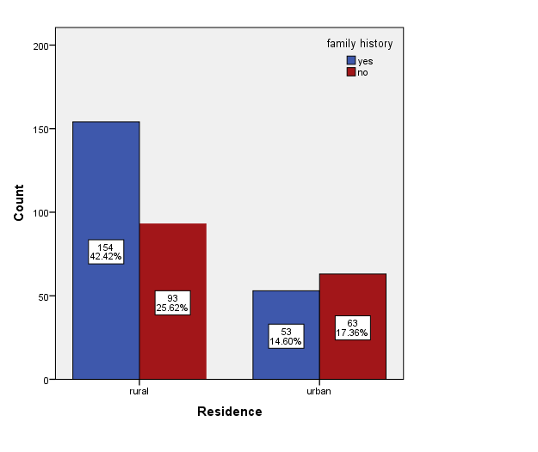
Figure I: relation of the orofacial deformities (CL, CP and CLP) according to residency with the presence of family history

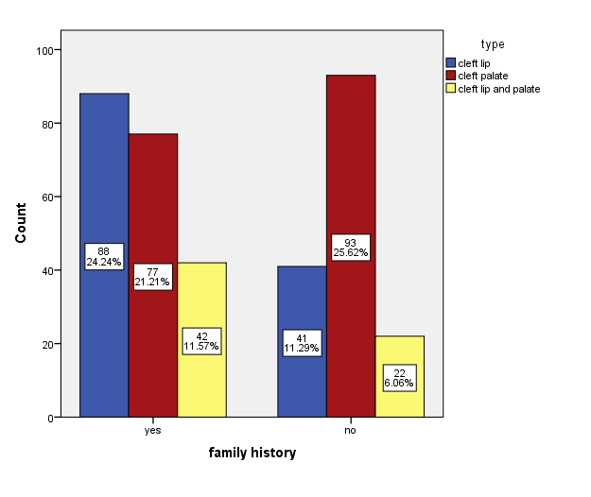
Figure II: distribution of the orofacial deformities (CL, CP and CLP) according to family history

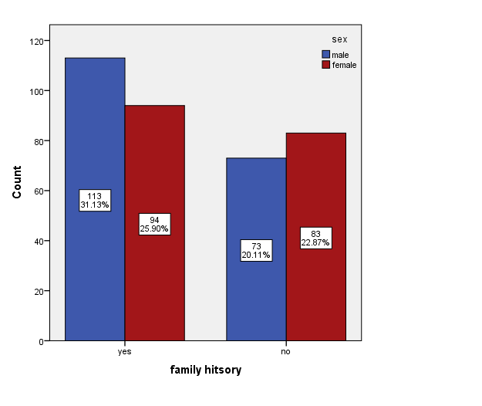

Figure III: gender distribution affected by OFCs according to family history.

Discussion
The current finding reveals that the numbers of OFCs cases increased with the years. It,s recorded in 2013, CL cases were 31.4% and increased to 48.4% in 2015. This increase was not clear completely that owing to the number of the years included in this study. In 1994, 43 patients (24 male and 19 females) were conceded for treatment, while in 2003 the number expanded to 79 (42 guys and 37 females), in this examination the quantity of cases between 2013-2015 was 363 (186 guys and 177 females), the proportion of male to females was 1:0.95. These findings are apparent agree with review in Basrah 2003 was nearly as double as the number of cases in 1994 that attributed to the increased of pollution in the city⁹.
There were no significant differences between gender and type of OFCs. A gender disparity observed with male predominance, the male to female ratio were in CL (1.1:0.8), CP (1:1) and CLP (1:0.9), this finding agrees with a study in Hawler¹, analysis in Saudi Arabia¹⁰, and study in Jordan¹¹, but disagrees with reviews in Basrah⁹, Anbar², Erbil⁵, and South Afriqa¹².
Regarding the type of OFCs in this study, CP first followed by CL then CLP, agrees with the study in Al Anbar², and a Statistics By Country for Cleft Palate⁶, but disagree with review in Arbils⁵, a study conducted in Iran⁸, Uganda³, and in Pakestan¹³.
Correlation between the residence of patients and OFCs deformity was seen more in rural 247 (68%) than in urban 116 (31%), these finding in agreement with a study in taxas¹⁴, and disagree with review in Iran¹⁵. Since women living in rural areas have limited access to insurance, health services, as well as to smoke from remote oil wells¹⁶ also the contamination by depleted uranium weapons spatially used in rural Basrah regions during the Gulf War¹⁷.
The most exciting finding saw in this examination was the connection of family history of the OFCs and the advancement of the congenital anomalies, a significant association (p<0.001) was distinguished, around 207 out of them all out 363 cases had a positive family history of OFCs. This finding was in agreement with that observed in other studies^{18,19}. Positive family history saw more in rural than the urban area (Figure I). The highest number of cases were observed cames from a rural area, mainly because of low socioeconomic status, in addition to increasing the incidence of relative marriage²⁰, CL is the prominence. Occasionally, CP is more in patients with a positive family history (Figure II), positive family history more in male than female (Figure III), this agrees with study in India^{18,21}. The environment may play a significant role, includes frequent contributors such as diet, adequacy of prenatal care, usage of smoking and alcohol, maternal age and socio-economic inequalities, as well as less frequent contributors like pollution and chemical agents experienced both indoors and outdoors. In many cases, two or more environmental factors may be interrelated or synergistic²².

Conclusion

All forms of congenital orofacial anomalies are increased with years in this study and shown most commonly in males; the primary cleft is CL followed by CP and finally CLP. OFCs cases with positive family history increased significantly. The most common risk factors associated with this anomalies were consanguineous marriage, the duration, especially in rural areas.

AKNOREGMENT
Thanks and appreciation to Dr Faleh Muhsen, the Manager of Al Sader Teaching Hospital and to Dr Jabbar Lazem Almajedee, the head of consultation Department in Al Sader Teaching Hospital for their agreement to work in the research. Thanks and appreciation to Miss. Kolood Fadil Abd Alhasan, responsible of the Plastic surgery ward and Miss. Hanaa Hasan Hamza accountable for the patients file, for their cooperation with us to collecting information from the patients' files.

References
1. Noori, M. A. & Shihab, O. I. Birth Prevalence of Cleft lip and/or Palate in Hawler City A retrospective Hospital based One year Study. Zanco J. Med. Sci vol. 13 https://www.iasj.net/iasj?func=fulltext&aId=159859 (2009).
2. Kh Al-Rawi Anb Med Vol, M. J. & Kh Al-Rawi, M. Cleft Lip and Palate in Anbar Province. Al-Anbar Med. J. 10, 92–95 (2012).
3. Dreise, M., Galiwango, G. & Hodges, A. Incidence of cleft lip and palate in Uganda. Cleft Palate-Craniofacial J. 48, 156–160 (2011).
4. Vieira, A. R. et al. Medical sequencing of candidate genes for nonsyndromic cleft lip and palate. PLoS Genet. 1, 0651–0659 (2005).
5. Nouri, M. A., Hamad, S. A. & Rasheed, N. E. Incidence of Cleft Lip and Palate in Erbil City. MDJ 7, 106–112 (2010).
6. WrongDiagnosis. Statistics By Country for Cleft Palate. (2010).
7. Losee, J. E. & Lin, A. Y. Cleft palate. in Handbook of Craniomaxillofacial Surgery 305–342 (Mosby/Elsevier, 2014). doi:10.1142/9789814295109_0012.
8. Kianifar, H., Hasanzadeh, N., Jahanbin, A., Ezzati, A. & Kianifar, H. Cleft lip and palate: A 30-year epidemiologic study in North-East of Iran. Iran. J. Otorhinolaryngol. 27, 35–41 (2015).
9. F. Fathallah, Z. ANALYTIC RETROSPECTIVE STUDY OF CLEFT LIP & PALATE REFERRED TO PLASTIC UNIT IN BASRAH TEACHING HOSPITAL. Med. J. Basrah Univ. 23, 1–4 (2005).
10. Kumar, P., Hussain, M. T., Cardoso, E., Hawary, M. B. & Hassanain, J. Facial clefts in saudi arabia: An epidemiologic analysis in 179 patients. Plast. Reconstr. Surg. 88, 955–958 (1991).
11. Al Omari, F. & Al-Omari, I. K. Cleft lip and palate in Jordan: Birth prevalence rate. Cleft Palate-Craniofacial J. 41, 609–612 (2004).
12. Hlongwa, P., Levin, J. & Rispel, L. C. Epidemiology and clinical profile of individuals with cleft lip and palate utilising specialised academic treatment centres in South Africa. PLoS One 14, 1–14 (2019).
13. Elahi, M. M. et al. Epidemiology of cleft lip and cleft palate in Pakistan. Plast. Reconstr. Surg. 113, 1548–1555 (2004).
14. Messer, L. C. et al. Urban-Rural Residence and the Occurrence of Cleft Lip and Cleft Palate in Texas, 1999-2003. Ann. Epidemiol. 20, 32–39 (2010).
15. Noorollahian, M. et al. Cleft lip and palate and related factors: A 10 years study in university hospitalised patients at Mashhad - Iran. African J. Paediatr. Surg. 12, 286–290 (2015).
16. Stephenson, J. Health in Iraq. JAMA 297, 2069 (2007).
17. Al-Ansari, N., Pusch, R. & Knutsson, S. Suggested landfill sites for hazardous waste in Iraq. Nat. Sci. 05, 463–477 (2013).
18. Kot, M. & Kruk-Jeromin, J. Familial cleft lip with or without coexisting cleft palate. Polski merkuriusz lekarski : organ Polskiego Towarzystwa Lekarskiego vol. 15 158–160 https://pubmed.ncbi.nlm.nih.gov/14648982/ (2003).
19. Setó-Salvia, N. & Stanier, P. Genetics of cleft lip and/or cleft palate: Association with other common anomalies. Eur. J. Med. Genet. 57, 381–393 (2014).
20. Wisam Abdullah Jasim et al.,, Wisam Abdullah Jasim et al. Neurosurgical Congenital Anomalies in Basrah Socio Demographic Review. Int. J. Med. Pharm. Sci. 8, 33–38 (2018).
21. Sah, R. K. & Powar, D. R. Epidemiological Profile of Cleft Lip and Palate Patients Attending Tertiary Care Hospital and Medical Research Centre, Belgaum, Karnataka–A Hospital Based Study. IOSR J. Dent. Med. Sci. 13, 78–81 (2014).
22. Al-Hadithi, T. S., Al-Diwan, J. K., Saleh, A. M. & Shabila, N. P. Birth defects in Iraq and the plausibility of environmental exposure: A review. Conflict and Health vol. 6 3 (2012).

