**Lattice Thermal Conductivity Modelling of A Diatomic Nanoscale Material**

**Adil. H. Awad**

Department of Physics, College of Education for Pure Science, University of Basrah, Basrah, Iraq.

**Abstract:** A new approach for expressing the lattice thermal conductivity of diatomic nanoscale materials is developed. The lattice thermal conductivity of two samples of GaAs nanobeam at 4-100K is calculated on the basis of monatomic dispersion relation. Phonons are scattered by nanobeam boundaries, point defects and other phonons via normal and Umklapp processes. A comparative study of the results of the present analysis and those obtained using Callaway formula is performed. We clearly demonstrate the importance of the utilised scattering mechanisms in lattice thermal conductivity by addressing the separate role of the phonon scattering relaxation rate. The formulas derived from the correction term are also presented, and their difference from Callaway model is evident. Furthermore their percentage contribution is sufficiently small to be neglected in calculating lattice thermal conductivity. Our model is successfully used to correlate the predicted lattice thermal conductivity with that of the experimental observation.

**Keywords:** Thermal conductivity, GaAs nanobeam, Dispersion relation, Diatomic nanostructure, Scattering mechanisms

**1. INTRODUCTION**

Lattice thermal conductivity in semiconductors remains an interesting subject given that no fundamental demonstration of its behaviour has yet been performed within the experimental temperature range.The anharmonicities of lattice forces control thermal conductivity via lattice waves along with the external boundaries and several crystal imperfections. Thermal conductivity has been regularly utilised as a major transport property, which effectively describes crystalline solids and is essential for recognising the behaviour of bulk and nanoscale systems. The literature reports that lattice thermal conductivity can be solved using the Boltzmann transport equation within the frame of the relaxation time approximation[1,2]. Callaway[3] presented a model, which is amenable to computations and accepted at low temperature region to predict the lattice thermal conductivity of bulk semiconductors. Callaway expected a linear dispersion relation, which is the limiting form for small wave vectors and thus, he utilised phase velocity in place of group velocity. However, he did not distinguish between monatomic and diatomic lattices. Holland[4] modified Callaway's model to become applicable to regions with a wide temperature range by considering the two-mode conduction of phonon. A number of mechanisms for predicting the lattice thermal conductivity of bulk GaAs depend on the Boltzmann transport equation and relaxation time approximation has been improved[5-10], by considering different scattering mechanisms.

Considerable interest has been demonstrated in understanding the thermal conductivity of nanoscale semiconductors, which are considered a potential material system for high- temperature, high-frequency and high-power equipment[11]. The thermal properties of these nanostructure materials are lower than those of their corresponding bulk materials[12-27]. This reduction is attributed to the variations in phonon density of states [14,17,19,23] and phonon-boundary scattering[23]. The semiempirical calculation of lattice thermal conductivity is expected to coincide with the experimental results[17,28-30].

Fon et al.[31] measured the effective thermal conductance in suspended GaAs nanobeams with various geometries and dopant profile, at 4-40K, using Callaway's model. They considered the phonon relaxation of surfaces, electrons, point defects and the contribution of Umklapp three-phonon scattering processes. Given the exponential term, they suggested that the Umklapp processes of three phonon scattering are the fundamental mechanisms that cause thermal resistance. They unexpectedly determined that the existence of dopants is considerably affected by the scattering of phonons. Fon et al.[31] pointed out that the dopant in nanobeam device provides additional effective phonon scattering processes, such as by point defects, mobile electrons and donor state electrons.

Barman and Srivastava theoretically addressed Fon et al.'s[31] estimation using the

Callaway model and a treatment

for three-phonon scattering that depends on an isotropic continuum phonon dispersion



relation[32]. They suggested that the reduction in lattice thermal conductivity of the doped samples compared with that of the undoped samples relies on electron-phonon scattering, whereas phonon reflection by rough surfaces only plays a minor role in controlling thermal conductivity .

Mamand et al.[33] also presented a theoretical prediction of the thermal conductivity of Fon et al's. samples using the Callaway model via two-mode conduction. The scattering of phonons by nanobeam boundaries, dislocations, electrons, imperfections and other phonons is conducted to match the measured thermal conductivity to the experimental data.

In the present study, a new approach is used to evaluate the lattice thermal conductivity of GaAs nanobeam samples with different dopant profiles at low temperatures (4-100K), by adopting a diatomic phonon dispersion relation. The proposed formula for thermal conductivity and the correction term are based on the solution for the Boltzmann transport equation via relaxation time approximation, where in the scattering of phonons by nonabeam boundaries, point defects and other phonons is effectively performed to fit the calculated values of the lattice thermal conductivity with the experimental curves.

**2. MODEL DEVELOPMENT**

**2.1. Expressions For Lattice Thermal** **Conductivity**

The simplest formulas for the Callaway[3] and Holland models[4] fail to capture the difference between the formulas for monatomic lattice and diatomic lattice thermal conductivities. Their models were developed on the basis of Debye's approximation of linear

phonon dispersion. Therefore, the present work considers the 1D diatomic lattice with lattice constant  . The forces are assumed to act between the nearest neighbour atoms with masses  and . The solution for the motion equations of such lattice is as follows[34]:



(1)

where the phonon wave vector can be given by:



(2)

Then, the corresponding group velocity will be

(3)

The density of phonon states can be written as:

 (4)



(5)

where





Here,  and *N* and *V* are the number and volume of primitive cells respectively. Using



and the temperature

we obtain

 (6)

where,

 

 and 

Awad[35] suggested that lattice thermal conductivity per unit volume exhibits the following form:



(7)

Hence, using Eq.(6), lattice thermal conductivity is transformed as follows:



(8)

where represents total relaxation time and

.

**2.2. Correction Term**

Callaway[3] investigated the effect of considering the conservation of total wavelength via the normal process of three-phonon scattering. The thermal conductivity of this process is called the correction term . Assuming the Debye model for a solid, an approximate method was developed to estimate the value of the correction term. To avoid such approximation, we use the diatomic dispersion relation to express the formula for. With help of Eq. (2), we define the quantity as follows:

(9)



In terms of the dimensionless parameter *x*, we use Eq.(3) to obtain the following:

 (10)

Awad[35] determined in terms of (combined scattering relaxation time) and the Boltzmann transport equation as follows:

 (11)



(12)

Thus, on the basis of Eqs. (9), (10) and (11), Eq. (12) exhibits the following form:



(13)

Hence, we obtain  as follows:

 (14)

where,





|  |  |  |
| --- | --- | --- |
| Undoped nanobeam | Doped  nanobeam | Parameter |
| 3.1 | 4.2 | 108 |
| 0.17 | 2.0 | 10-44 |
| 1.0 | 1.0 | 10-13 |
| 1.7 | 1.5 | 10-8 |

The total relaxation time  in Eq. (11) is transformed as follows:

 (15)

When Eq.(15) is substituted into Eq.(8) , the following is derived:

 (16)

where,

 ,





The resulting thermal conductivity is obtained using Eq.(14)

 (17)

where the final expression for the correction term as follows:

 (18)

In our calculation, we consider boundary scattering,point defect scattering[1]and Normal [1] and Umklapp[36] three-phonon scattering. Matthiessen's rule indicates that the combined scattering relaxation rate exhibits the following form:

  (19)

where all the scattering processes are operated independently as an approximation.

**3. RESULT AND DISCUSSION**

GaAs is a binary semiconductor compound from the AnB8-n families of Types III-V, which crystallise in the zincblende structure (lattice constant a=5.65A)[37], masses 12.4710-23 g and 11.610-23 g[38],Debye temperature  and **.** We present an analysis of the low-temperature lattice thermal conductivity (4-100 K) of GaAs nanobeams using the expressions presented earlier. Adjustable parameters are obtained for the doped and undoped samples that best fit the experimental data and then listed in Table 1. A

**Table 1.** Values of parameters used in the calculation of lattice thermal conductivity of GaAs nanobeams

consistent result is achieved as shown in Figure 1, when compared with the experimental data of Fon et al.[31], i.e. close agreement is found. Fig. 1 also shows the measured lattice thermal

conductivity compared with that predicted with the Callaway integral-using the adjustable parameters- listed in Table 1. The temperature dependence of lattice thermal conductivity indicates that the new formula used in our calculation is applicable to doped and undoped nanobeams. Fig. 1 also shows that the Callaway model overestimates the lattice thermal conductivity values of GaAs nanobeam, that Callaway’s frame is obtained on the basis of Debye's estimation, which is excessively far from reality. Mingo et al.[17,18], suggested that the poor results acquired the Callaway model are attributed to the use of linearised dispersion relations. We believe that the significance of the present approach lies in realising a form that is a characteristic of a crystal, where the present expressions distinguish between the thermal conductivities of monatomic and diatomic lattices.

**Fig. 1.** Comparison between the lattice thermal conductivities of doped and undoped GaAs nanobeams and that obtain using Calaway model. The symbols represent the experimental data of Fon et al.[31], whereas the lines represent the theoretical calculation

The curves to the predicted correction term are shown in Fig. 2, along with the results obtained from the Callaway integral. The temperature dependence of the percentage contribution of this term  is classified in Fig. 3. These figures clearly demonstrate that

the contribution of the correction term to the total lattice thermal conductivity is minimal, and can be disregarded. A similar behaviour was recently recorded by Awad[35,39-41] for three Si nanowire samples. Fig. 2 clearly shows that the Callaway model overestimates the values of the correction term for the doped and undoped GaAs nanobeams. Several interesting features are presented in Fig. 2, where a remarkable difference between the values of the correction term in the basis of the Callaway model and that determined in the present work, is noted.

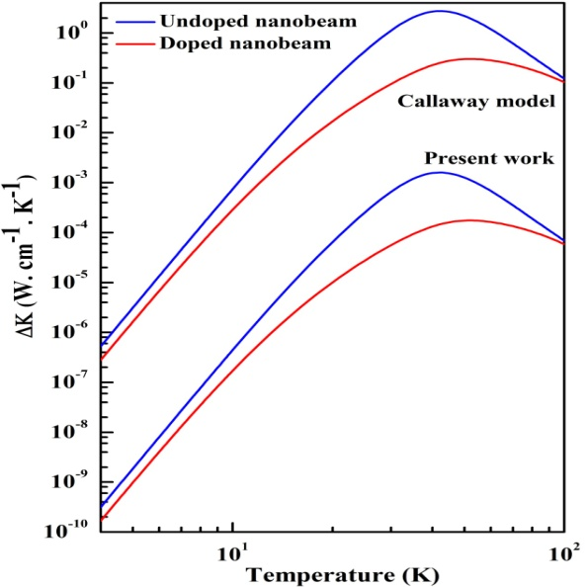

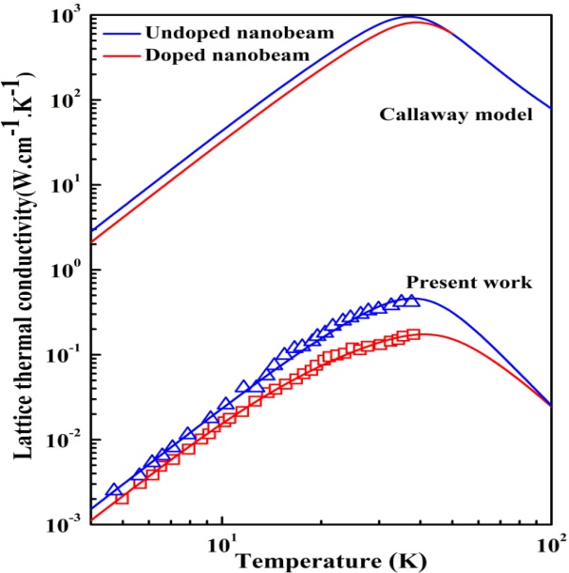**Fig. 2.** Calculated correction terms of doped and undoped GaAs nanobeams compared with the obtained theoretical results of the Callaway model.

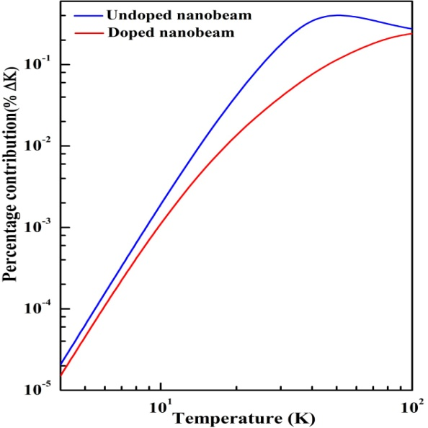

**Fig. 3.** Percentage contributions of the correction terms of the doped and undoped GaAs nanobeams vs. temperature.

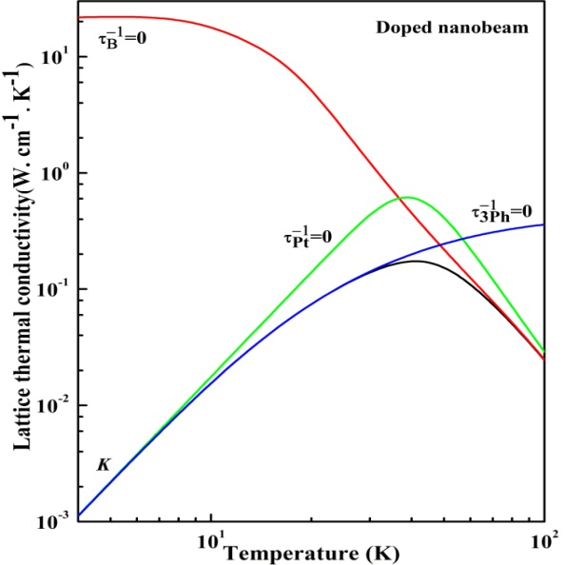

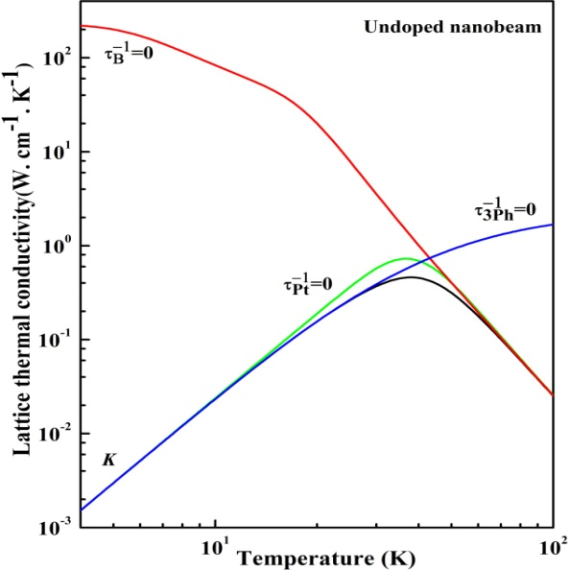

**Fig. 4.** Influence of the absence of scattering relaxation rates on the lattice thermal conductivities of the doped and undoped GaAs nanobeams.

To clarify the magnitude of each scattering relaxation rate relative to the effect of other scattering rates, we plotted two dopant cases in Fig. 4 for the adoptd scattering relaxation rates. We can sensibly consider that lattice thermal conductivity below the conductivity maxima region, is strongly influenced by nanowire size, which is spread over a wide range of temperatures. This finding is attributed to phonon mean free path that is tuned by the nanostructure's cross section. Similar results have also been reported for nanostructure devices[42-45]. The effect of  on the measured thermal conductivity of the doped nanobeam is approximately twice higher than that on the magnitude of the undoped nanobeam, thereby reflecting the major role of these scattering processes near the conductivity maxima. The results of the  curves of the nanobeam's lattice thermal conductivity indicate the significance of the three-phonon scattering processes at high temperatures. It generally begins to dominate starting at 50K. However, point defect scattering is typically frequency dependent. Thus, the efficient scattering of high-frequency phonons at high temperatures is reasonable. But, efficiency is reduced when temperature further increases due to the presence of , which is frequency- and temperature-dependent. Moreover,  is controlled by Umklapp processes rather than normal processes, and thus, is more effective in the undoped nanobeam structure. A similar behaviour was reported by Fon et al.[31] in their analysis of the experimental results of GaAs nanobeams.



**4. CONCLUSIONS**

We implemented a model to investigate the lattice thermal conductivity of a diatomic nanostructure. Our model is found to be valid for GaAs nanobeam samples with different dopant profiles, and obtained within the range of 4-100K. The proposed model can be generally applicable to predicting the lattice thermal conductivity of nanostructure devices. The comparitive study shows the major differences with the results obtained using the Callaway model. We also demonstrate the importance of the correction term in this work i.e. small values can be disregarded in our calculation. Finally, nanobeam boundary scattering is determined to control the reduction of lattice thermal conductivity over a wide range of temperatures.

**List of Symbols**

*a* Lattice constant

*M(m)* Masses of atoms

*q* Phonon wave vector

 Group velocity

 Density of phonon states

*N* Nnumber of primitive cells

*V* Volume of primitive cells

Maximum phonon frequency

 Dimensionless parameter

 Debye temperature

 Lattice thermal conductivity

 Phase velocity

 Correction term

 Total relaxation time

 Relaxation rate of Normal process

 Relaxation rate of Umklapp process

 Temperature gradient

 Boundary scattering relaxation rate

 point defects scattering relaxation rate

 3-phonon scattering relaxation rate

**CONFLICT OF INTEREST**

The author confirm that this article content has no conflict of interest.

**References**

[1] Klemens, P.G.; Solid State Physics, Vol. 7, Eds. F. Seitz, D. Turnbull, Academic Press, New York, **1958**, 1.

### [2] Carruthers, P.; Theory of Thermal Conductivity of Solids at Low Temperatures. *Rev. Mod. Phys.*, 1961, *33(1)*, 92-138.

[3] Callaway, J.; Model for lattice thermal conductivity at low temperatures. *Phys. Rev.*, **1959**, *113(4)*, 1046–51.

[4] Holland, M.G.; Analysis of lattice thermal conductivity. *Phys. Rev.*, **1963**, *132*, 2461–2471.

### [5] Dubey, K.S.; G. S. Verma, G.S.; Phonon Conductivity of InSb and GaAs in the Temperature Range 2-300 °K. *Phys. Rev.*, 1971, *B4*, 4491-4531.

[6] Hunt, D.R.; Ph. D. Thesis, University Coll. Sci. Swansea, U.K. **1974**.

# [7] Dubey, K.S.; Analysis of lattice thermal conductivity of GaAs at high temperatures. *J. of Thermal analysis*, 1978, *14*, 213-219.

[8] Al-Edani, M.C.; M.Sc. Thesis, Univ. of Basrah, Basrah (Iraq) **1978**.

[9] Awad, A.H.; Hussain, W.A.; Phonon conductivity of Gallium Arsenide. *Dirasat, Natural and Engineering science*, **1998**, *25(1)*,167-174.

### [10] Ansari, M.A; Ashokan, V.; Indu, B.D.; Kumar, R.; Lattice Thermal Conductivity of GaAs. *Acta Pysica Polonica* , 2012, *A121(3)*, 639-646.

[11] Morkoc, H.; Nitride Semiconductors and Devices, Springer-Verlag, Berlin, **1999**.

# [12] Majumdar, A.; Microscale Heat Conduction in Dielectric Thin Films. *J. Heat Trans.*, 1993, *115*, 7-16.

### [13] Asheghi, M.; Leung, Y.K.; Wong, S.S.; Goodson, K.E.; Phonon-boundary scattering in thin silicon layers. *Appl. Phys. Lett.*, 1997,*71(13)*, 1798-1800.

### [14] Balandin, A.; Wang, K.L.; Significant decrease of the lattice thermal conductivity due to phonon confinement in a free-standing semiconductor quantum well. *Phys. Rev*., 1998, *B58*, 1544-1549.

### [15] Balandin, A.; Wang, K.L.; Effect of phonon confinement on the thermoelectric figure of merit of quantum wells. *J. of Appl. Phys.*, 1998, *84*, 6149-6153.

[16] Li, D.; Wu, Y.; Fan, R.; Yang, P.; Majumdara, A.; Thermal conductivity of Si/SiGe superlattice nanowires. *Appl. Phys. Lett.*, **2003**, *83(15)*, 3186-3188.

[17]Mingo, N.; Calculation of nanowire thermal conductivity using complete phonon dispersion relations. *Phys. Rev.*, **2003**, *B68*, 113308–113311.

[18] Mingo, N.; Yang, L.; Li, D.; Majumdar, A. Predicting the thermal conductivity of Si and Ge nanowires. *Nano Lett.*, **2003**, *3*, 1713–1716.

### [19] Pokatilov, E.P.; Nika, D.L.; Balandin, A.A.; Acoustic-phonon propagation in rectangular semiconductor nanowires with elastically dissimilar barriers.

*Phys. Rev.*, **2005**,*B72*, 113311.

# [20] [Hochbaum](https://www.nature.com/articles/nature06381#auth-1), A.I.; Chen, R.; [Delgado](https://www.nature.com/articles/nature06381#auth-3), R. D.; [Liang](https://www.nature.com/articles/nature06381#auth-4), W.; [Garnett](https://www.nature.com/articles/nature06381#auth-5), E. C.; [Najarian](https://www.nature.com/articles/nature06381#auth-6), M.; [Majumdar](https://www.nature.com/articles/nature06381#auth-7), A.; Yang, P.; Enhanced thermoelectric performance of rough silicon nanowires. *Nature*, 2008, *451*, 163–167.

[21] Martin, P.; Aksamija, Z.; Pop, E.; Ravaioli, U.; Impact of phonon-surface roughness scattering on thermal conductivity of thin Si nanowires. *Phys. Rev. Lett.*, **2009**, *102*, 125503-4.

### [22] [Sellan](https://aip.scitation.org/author/Sellan%2C+D+P)*,*D.P.; [Turney](https://aip.scitation.org/author/Turney%2C+J+E)*,*J.E.; [McGaughey](https://aip.scitation.org/author/McGaughey%2C+A+J+H),A.J.H.; [Amon](https://aip.scitation.org/author/Amon%2C+C+H), C.H.; Cross-plane phonon transport in thin films.

*J. of Appl. Phys*., **2010**, *108(11)*, 113524.

[23] Turney, J.E.; McGaughey, A.J.H.; Amon, C.H.; In-plane phonon transport in thin films. *J.Appl. Phys.*, **2010**,*107*, 024317-8.

### [24] McGaughey, A.J.H.; Landry, E.S.; Sellan, D.P.; Amon, C.H.; Size-dependent model for thin film and nanowire thermal conductivity. *Appl. Phys. Lett.*, 2011, *99*, 131904-3.

### [25] Tian, Z.; Esfarjani, K.; Shiomi, J.; Henry, A.S.; Chen, G.; On the importance of optical phonons to thermal conductivity in nanostructures. *Appl. Phys. Lett.*, 2011, *99*, 053122-6.

# [26] Hopkins, P.E.; Reinke, C.M.; Su, M.F.; Olsson, R.H.; Shaner, E,A,; Leseman, Z.C.; Serrano, J.R.; Phinney, L.M.; El-Kady, I.; Reduction in the thermal conductivity of single crystalline silicon by phononic crystal patterning. *Nano Lett.*, 2011, *11(1)*, 107-112.

[27] [McGaughey](https://aip.scitation.org/author/McGaughey%2C+Alan+J+H), A. J. H.; [Jain](https://aip.scitation.org/author/Jain%2C+Ankit), A.; Nanostructure thermal conductivity prediction by Monte Carlo sampling of phonon free paths. *Appl. Phys. Lett.*, **2012**, *100*, 061911-061913.

[28] Shi, L.; Hao, Q.; Yu, C.; Mingo, N.; Kong, X.; Wang, Z.L.; Thermal conductivities of individual tin dioxide nanobelts. *Appl. Phys. Lett.*, 2004, *84*, 2638-2640.

### [29] Mingo, N.; Broido, D.A.; Carbon nanotube ballistic thermal conductance and its limits. *Phys. Rev.* *Lett.*, 2005, *95*, 096105-4.

### [30] Mingo, N.; Broido, D.A.; Length Dependence of Carbon Nanotube Thermal Conductivity and the “Problem of Long Waves”. Nano Lett., 2005, *5(7)*, 1221-1225.

[31] Fon, W.; Schwab, K.C.; Warlock, J.M.; Roukes, M.L.; Phonon scattering mechanisms in suspended nanostructures from 4 to 40 K.*Phys. Rev.*, **2002**, *B66*, 045302-5.

[32] Barman, S.; Srivastava, G.P.; Thermal conductivity of suspended GaAs nanostructures: Theoretical study. *Phys. Rev.*, **2007**, *B73*, 205308-6.

# [33] Mamand, S.M.; Omar, M.S.;Muhammed, A.J.; Calculation of lattice thermal conductivity of suspended GaAs nanobeams: Effect of size dependent parameters. *Adv. Mat. Lett.*, 2012, *3(6)*, 449-458.

[34] C. Kittel, Introduction to Solid State Physics, 7th ed. John Wiley and Sons, Inc, New York, 1996.

[35] Awad, A.H.; Modeling nanostructure lattice thermal conductivity :The dispersion relation role.*J. of Therm. Anal. and Calor.*, **2015**, *119(2)*, 1459-1467.

[36] Herring, C.; Role of low energy phonons in thermal conduction. *Phys. Rev.*, **1954**, *95*, 954-960.

[37] Driscoll, C. M. H., Willoughby, A. F. W., Mullin, J. B., Straughan, B. W.; Gallium Arsenide and Related Compounds 1974, Bok, J., (ed.), London and Bristol: Institute of Physics, **1975**, 275.

[38] Kaplan, H.; Sullivan, J.J.; Lattice vibrations of zinc-blende structure crystals. *Phys. Rev.*,**1969**, *130*, 120.

[39] Awad, A.H.; Dubey, K.S.; Analysis of the lattice thermal conductivity and phonon–phonon scattering relaxation rate: application to Mg2Ge and Mg2Si. *J. Therm. Anal.*, **1982**, *24*, 233–60.

[40] Awad, A.H.; Debye temperature dependent lattice thermal conductivity of silicon. *J. of Therm. Anal. and Calor.*, **1999**, *55*, 187-196.

[41] Awad, A.H.; Contribution to the lattice thermal conductivity due to the three phonon normal processes in the presence of core dislocations in the frame of the Callaway integral. *Acta physica Hungarica*, **1990**, *67(1-2)*, 211-216.

[42] Li, D.; Wu, Y.; [Kim, P.;](https://aip.scitation.org/author/Kim%2C+Philip) Shi, L.; Yang, P. [Majumdar](https://aip.scitation.org/author/Majumdar%2C+Arun), A.; Thermal conductivity of individual silicon nanowires. *Appl. Phys. Lett.*, **2003**, *83(14)*, 2934-2944.

[43] Kazan, M.; Guisbiers, G.; Pereira, S.; Correia, M.R.; Masri, P.; Bruyant, A.; Volz S.; Royer, P.; Thermal conductivity of silicon bulk and nanowires: effects of isotopic composition, phonon confinement, and surface roughness. *J. Appl. Phys.*, **2010**, *107*, 083503-14.

[44] Chen, K.Q.; Li, W.X.; Duan, W.; Shuai, Z.; Gu, B.L.; Effect of defects on the thermal conductivity in a nanowire. *Phys. Rev.*,**2005**, *B72*, 045422-5.

### [45] Santamore, D.H.; Cross, M.C.; Effect of Phonon scattering by surface roughness on the universal thermal conductance. *Phys. Rev. Let.*, 2001,*87*, 115502.