Guggulsterone Suppresses Ovalbumin- Induced Inflammation in Rat Asthmatic Model
Zainab H. Ahmed^{1,*}, Munaf H. Zalzala² and Manal A. Ibrahim¹
¹Lecturer, Department of Pharmacology and Toxicology, College of Pharmacy, University of Basra, Basra, Iraq.
² Assist of Professor, Department of Pharmacology and Toxicology, College of Pharmacy, University of Baghdad, Baghdad, Iraq.
* Corresponding author.
Abstract:
Background: Asthma is an inflammatory airway disease, which is characteristic by wheezing, chest tightness, dyspnea and cough, all symptoms that are occupied with obstruction of respiratory airway. Aim: investigate guggulsterone activity on improve inflammatory events that associated with asthma. Method: 48 healthy rats (albino, male) divided to 6 groups, rats were sensitized with OVA and preparation lung tissue homogenate for measurement of inflammatory parameters by ELISA and RT-PCR. Also, preparation of lung tissue for histopathological examination. Results: All parameters are significant reduction in treated group with guggulsterone than sensitized group. Also, gugglsterone-treated group's slides with less inflammatory signs compared to sensitized group slide. Conclusion: Guggulsterone improve inflammatory events that associated with asthma.
Key words: gugglsterone, asthma, anti-inflammatory activity , NF-kappaB.
1. Introduction:
Asthma is an inflammatory airway disease, which is characteristic by wheezing, chest tightness, dyspnea and cough, all symptoms that are occupied with obstruction of respiratory airway. The etiology of disease may be many factors. It is believed to be a combination of environmental and genetic factors.⁽¹⁾
One of the most impotent inflammatory mediators is IL-4, which has the role in regulating Th2 cell survival and proliferation and IgE synthesis in airway allergic responses.⁽²⁾ On other hand, other an important inflammatory cytokine is IL-5, that plays a major role in eosinophil differentiation, proliferation, maturation, and migration to tissue sites with survival.⁽³⁾ Recently, many studies were suggested that IL-33 is present with asthma. After the injury of the lung epithelial cell, IL-33 produces as an alarm signal and stimulates other immune cells to release of IL-5 and 13.⁽⁴⁾
In addition, TNF is a majority inflammatory mediater, which is a chemoattractant for eosinophils and neutrophils, and raises the eosinophils cytotoxic activity on endothelial cells. One of most important transcription factor is NF-κB, which plays major roles in the production of pro-inflammatory cytokine.⁽⁵⁾
Guggulsterone (GS) is a bioactive steroid plant, GS is potent ligands to steroid receptor, specifically glucocorticoid receptor. GS has potent anti-inﬂammatory effects through inhibiting the stimulation of NF-κB (transcription factor) in response to TNF-a and a direct inhibiting the activation of IKK. Also, GS has antioxidant activity, it is inhibited xanthine oxidase and superoxide dismutase. Both enzymes that enhance the production of ROS (reactive oxygen species) that contributed in pathophysiologic with asthma.⁽⁶⁾
2. Methodology:
2.1. Chemicals:
Chemicals and drugs used in recent study including ovalbumin (OVA) (Chadwll Heath ESSEX, England), guggulsterone (Xi’an geekee biotech, China), Prednisolone (Pioneer, Iraq), Formaldehyde (37%) (Naturel, Turkey) and AL(OH)₃ (MERK Darmstadt, Germany).
2.2. Animals:
Forty healthy rats (albino, male), that weighing (150-300 gm), were taken from animal house of the University of Baghdad/ College of Pharmacy. Rats were put under photoperiods (12:12-hrs dark/light cycle) and controlled temperatures.
2.3. Experimental design:
Group I: Rats were administrated distal water orally without sensitization as control group. Group II: Rats were administrated distal water orally with sensitization as positive control group. Group III: Rats were administrated (25 mg/kg) guggulsterone orally with sensitization. Group IV: Rats were administrated (50 mg/kg) guggulsterone orally with sensitization. Group V: Rats were administrated prednisolone (4.12mg/kg) orally with sensitization.
OVA induced-rats by modified protocol of Manal et al (2013), Tong et al (2008), and Michael et al (1999) studies. Rats were sensitization by IP injection of 1mg OVA, 100mg of Al(OH)₃ in 1ml of PBS (phosphate buffer saline) at (1-3) days, then 100mg OVA , 100mg AL(OH)₃ in 1ml of PBS at 6th day, after that animal were challenged at 9th day by glass chamber with the nebulizer with 1% OVA (1gm OVA in 100ml PBS) for 30 minutes daily for 6 days.^{(7), (8) & (9)}
2.4. Lung tissue preparation:
The left lung was removed. Then, lung tissue was divided for three parts for histopatholigic examination, PCR analysis and homogenate samples.
2.5. Measurement of IL-4, IL-5, IL-33, TNFα and IgE in tissue homogenate by ELISA KIT:
ELISA kit (Mybiosource kit) is depended on sandwich (enzyme linked immune-sorbent) assay method. Plate (96 wells) was coated with polyclonal antibody and biotin. The samples added to the plate and wash buffer used for washing the wells. Then, TMB substrates were utilized for produce blue color. After that stop solution was added to change the color of reaction (yellow color). The amount of parameters direct proportional with density of yellow color that read by a microplate reader (450 nm).
2.6. Measurement of gene expression of TNFα and NF-κB by RT-PCR:
Total RNAs were extracted using Trizol (Bioneer, South Korea). Thirty gram of lung tissue was used to extract total RNA for the complementary DNA synthesis using random primers. Reverse transcriptase-PCR was performed following standard procedures. The primer pairs of the expected products were as follows (forward and reverse, respectively): TNF-alpha, 5′- CTTCTCATTCCTGCTCGTGG-3′ and 5′- TGATCTGAGTGTGAGGGTCTG -3′, NF-κB 5′- CTACGAGACCTTCAAGAGCATC -3′ and 5′- GATGTTGAAAAGGCATAGGGC -3′, and GAPDH, 5′- TCCAGTATGACTCTACCCACG -3′ and 5′- CACGACATACTCAGCACCAG -3′. Amplification products were resolved by 1.0% agarose gel electrophoresis, stained with ethidium bromide and photographed under ultraviolet light. Primers were purchased from Bioneer ,South Korea. Real-Time PCR was performed using AccuPower GreenStar qPCR PreMix according to the manufacturer’s instructions (Bioneer, Cat No: K-6210).
2.6. Histopathological examination of lung tissue:
The left lung is removed from all the experimental rats. Then it was washed with normal saline solution for preparation tissue to histopathological examination. Then, the washed lung tissues were fixed with formaldehyde (10% of formaldehyde in water). The sample was dried from water by Xylene. This process is done overnight and automated. Finally, molten wax was surrounded the specimen in the container and solidification by cooling and embedding in the wax block. Then, the thin section slide was stained and mounted by the protective cover slip.
2.7. Statistical analysis:
Statistical Package for the Social Sciences (Spss, version 25) statistic program was used in the present study for data analyzing. An unpaired Student t-test and one-way ANOVA test used for comparison between groups for finding significant statistic different.
3.Results:
3.1. Effect of guggulsterone on IL-4, IL-5 and IL-33 levels in lung tissue homogenate:
IL-4, IL-5 & IL-33 are inflammatory cytokines. IL-4, IL-5 & IL-33 levels (mean ± Std. Error) for rats of group II (positive control) (78.3 ± 5.2, 97 ± 19.7 & 82.4 ± 4.7, respectively) were significantly elevation (p<0.001) than group I (control group) (19.5 ± 5.1, 26.8 ± 1.6 & 35.9 ± 4, respictively) as showed in figure 1. The other significant different in IL-4, IL-5 & IL-33 levels for rats of treated groups III (25 mg/kg guggulsterone) (19.2 ± 2.8, 43.5 ± 11 & 41.4 ± 3.9) , IV (50 mg/kg guggulsterone) (16.6 ± 2.4, 32 ± 13.4 & 37.8 ± 3.1) &V(4.12 mg/kg predinsoline) (27.6 ± 2.4, 50.7 ± 6.2 & 46.8 ± 5.4, respectively) were significant reduction (p<0.001) as compared to seneitized group II (positive control group) (78.3 ± 5.2, 97 ± 19.7). Also, IL-4 levels for rats of group IV (16.6 ± 2.4) than other treated group V (27.6 ± 2.4).

Figure 1: Inhibitory effect of guggulsterone on OVA-induced IL4, IL-5 & IL-33 expression in lung tissue homogenate.
Values are indicated as means ± Std. Error (n=8) for each group. Group I: Control group, Group II: Positive control group (with sensitization), Group III: Guggulsterone (25 mg/kg) with sensitization, Group IV: Guggulsterone (50 mg/kg) with sensitization, Group V: Predinsoline (4.12 mg/kg) with sensitization. *** symbol referred to significant different (p<0.001) compared to control group, unpaired test student t-test. Groups with non-identical letters are significantly different (p<0.05).
3.2. Effect of guggulsterone on TNFα levels in lung tissue homogenate:
TNF levels (means ± Std. Error) in tissue homogenate for rats of sensitized group II (positive control group) (210.9 ± 26) was significantly elevated (p<0.01) than group I (control group) (94.1 ± 21.1) as showed in figure 2. Furthermore, TNF levels in tissue homogenate for rats of treated groups (III, IV & V) (124.2 ± 23.3, 113.1 ± 20.1&115.4 ± 10.4) were significantly reduction (p<0.05) than IL-33 levels in tissue homogenate for rats of sensitized group II (positive control group) (210.9 ± 26).

Figure 2: Inhibitory effect of guggulsterone on OVA-induced TNF-alpha expression in lung tissue homogenate.
Values are indicated as means ± Std. Error (n=8) for each group. ** symbol referred to significant different (p<0.01) compared to control group, unpaired test student t-test. Groups with non-identical letters are significantly different (p<0.05).
3.3. Effect of guggulsterone on IgE levels in lung tissue homogenate:
IgE is immune marker appeared with an asthmatic pathway. IgE levels in lung tissue homogenate (means ± Std. Error) for rats of group II (sensitized, positive control group) (176.7 ± 7.5) was significantly increased (p<0.001) than group I (control group) (52.8 ± 5.7) as noted in figure 3. Besides, there were significant reduction (p<0.001) in IgE levels in tissue homogenate (means ± Std. Error) for rats of treated groups (III, IV & V) (44.9 ± 8.1, 58.7 ± 2.1, & 47.6 ± 7.3, respectively) compared to sensitized group II (positive control group) (176.7 ± 7.5).

Figure 3: Inhibitory effect of guggulsterone on OVA-induced IgE in lung tissue homogenate.
Values are indicated as means ± Std. Error (n=8) for each group.*** symbol referred to significant different (p<0.001) compared to control group, unpaired test student t-test. Groups with non-identical letters are significantly different (p<0.05).
3.4. Effect of guggulsterone on gene expression of TNFα and NF-κB:
Gene expression of TNFα and NF-κB (means ± Std. Error) for rats of group II (positive control group) (1.94 ± 0.21, 3.33 ± 0.43) were significantly raised (p<0.001) than group I (control group) (0.41 ± 0.22, 0.7 ± 0.16 ) as appeared in figure 4. Also, gene expression of TNFα for treated rats of group V was significantly elevation (p<0.05) in compared to group I (control group). There were significant reduction (p<0.001) between gene expression of TNFα and NF-κB (means ± Std. Error) for rats of treated groups (III (0.52 ± 0.23, 0.94 ± 0.08), IV (0.74 ± 0.17, 0.98 ± 0.11) & group V (1.07 ± 0.21, 1.11 ± 0.16) than sensitized group II (positive control group) (1.94 ± 0.21).

Figure 4: Effect of gugglsterone on gene expression of TNFα & NF-Κb in lung tissue.
Values are indicated as means ± Std. Error (n=8) for each group. *** & * symbols referred to significant different (p<<0.05) compared to control group, unpaired test student t-test. Groups with non-identical letters are significantly different (p<0.05).
3.8. Histological assessment of rats՛ lung tissue for all studied groups:
Figure 5 showed that (D) the cross section of lung tissue for rats group I (control group) and noted that alveolar sac was cleared. Inﬂammatory cells were not agglomerate in the interstitial tissue. While, (E) group II (positive control group) manifested inflammatory cells were agglomerated in interstitial tissue. Also, Alveolar sac was filled with inflammatory cells. On other hand, (F), (G) & (H) treated groups ( III (25 mg/kg guggulsterone), IV (50 mg/kg guggulsterone) & V (4.12 mg/kg predinsoline)) appeared that very less number of inflammatory cells agglomerated in interstitial tissue and alveolar sac was cleared.
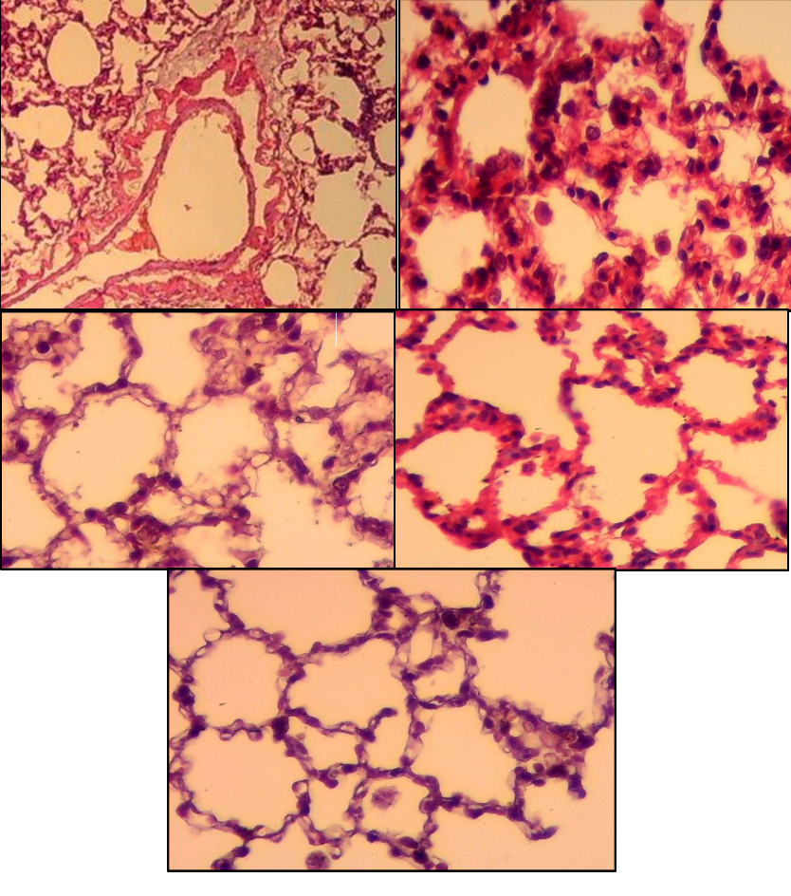
H
G
F
E
D
B
A
B
B
A
A
C
Figure 5: Cross section of lung tissue for the experimental rats with H&S stain (40x). (A) Alveolar sac, (B) Bronchiole, (C) Interstitial tissue, (D) Group I (E) Group II, (F) Group III, (G) Group IV & (H) Group V.
4. Discussion:
Asthma is one of the inflammatory and chronic airways disorders, which is manifested that an adaptive and innate immune systems with each other with epithelial cells to produce BHR, overproduction of mucus and airway wall narrowing and remodeling.⁽¹⁾ Predinsoline is traditional ant-inflammatory drug, which is used in this study for comparison pharmacological activity with gugglsterone.
In the current study, IL-4 and IL-5 are proinflammatory mediators, which are higher for rats of sensitized group than control group, Bagnasco et al (2016) study revealed that IL-4 & IL-5 levels in lung tissue are significantly higher in asthmatic group compared to control group. ⁽¹⁰⁾ On other hand, IL-4 & IL-5 are significantly reduction with treated groups with guggulsterone due to guggulsterone has anti-inflammatory activity due to its steroid structure and its ability to bind with glucocorticoid receptor in target nucleus and inhibit the pro-inflammatory transcription factors, AP-1 and NFκB and reduced the gene expression of IL-4& IL-5. ⁽¹¹⁾ The other inflammatory mediaters is IL-33and it՛s level in tissue homogenate for rats of sensitized group is significantly more than control group I. This results in line with the other previous study, Allinne et al (2019).⁽¹²⁾ IL-33 levels reduce in treated groups because guggulsterone is occupied with nuclear GR in target cells that lead to increase of DUSP1 expression lead to induce of feedback inhibition of MAPKs and reduce of IL-33 inflammatory signaling pathway. ⁽¹³⁾
TNF-α is a powerful proinflammatory cytokine that mediated to inflammatory response of asthma. Kumar et al (2017) study appeared that TNF is higher with asthmatic group in compared to normal group. ⁽¹⁴⁾ Similarly, Al-Quraishi (2013), & Froidure et al (2016) revealed that higher level of IgE in asthmatic group than control group. ⁽¹⁵⁾ ^{& (16)} While, Treated groups with guggulsterone that showed significant reduction in TNFα & IgE levels due to gugglsterone has anti-inflammatory activity mediated by glucocorticoid receptor. ⁽¹⁷⁾
Furthermore, TNFα and NF-kB could be measured gene expression in mRNA through RT-PCR technician. In this study, Gene expression of TNFα and NF-kB are significantly elevation with sensitized group than control group. Busse et al(2005) & Ather et al (2011) studies appeared that quantitative expression of TNFα and NF-kB are higher in asthmatic group in compared to normal subjects.^{(18) & (19)} On other hand, guggulsterone has anti-inflammatory activity lead to suppress the gene expression of proinflammatory cytokines including IL-1B, IL-6, IL-8, and TNF-α. Consequently. ⁽¹⁷⁾
Histopathologic results in the recent study appeared inflammatory cells were agglomerated in interstitial tissue of asthmatic lung tissue for rats of sensitized group. Furthermore, Alveolar sac was filled with inflammatory cells and the wall thickness of bronchiole was increased due to pathogenesis pathway of asthma. Guggulsterone with anti-inflammatory activity appeared that lung tissue returned to the normal state with very less number of inflammatory cells agglomerated in interstitial tissue.^{(1), (20)}
5. Conclusion:
Guggulsterone is natural material that has many anti-inflammatory activities through several mechanisms that mediated by steroid receptors and affected on many inflammatory mediaters. In future, further many studies that performed guggulsterone could be used for treatment of airway and other inflammatory diseases.
References
1. Kudo M, Ishigatsubo Y, Aoki I. Pathology of asthma. Frontiers in microbiology. 2013;4:263.
2. Gour N, Wills-Karp M. IL-4 and IL-13 signaling in allergic airway disease. Cytokine. 2015;75(1):68-78.
3. Greenfeder S, Umland SP, Cuss FM, Chapman RW, Egan RW. Th2 cytokines and asthma. The role of interleukin-5 in allergic eosinophilic disease. Respiratory research. 2001;2(2):71-9.
4. Momen T, Ahanchian H, Reisi M, Shamsdin SA, Shahsanai A, Keivanfar M. Comparison of Interleukin-33 Serum Levels in Asthmatic Patients with a Control Group and Relation with the Severity of the Disease. International journal of preventive medicine. 2017;8:65.
5. Chen L, Deng H, Cui H, Fang J, Zuo Z, Deng J, et al. Inflammatory responses and inflammation-associated diseases in organs. Oncotarget. 2017;9(6):7204-18.
6. Deng R. Therapeutic effects of guggul and its constituent guggulsterone: cardiovascular benefits. Cardiovascular drug reviews. 2007;25(4):375-90.
7. Algaem MA, Numan IT, Hussain SAJAJoPS. Effects of Valsartan and Telmisartan on the LungTissue Histology in Sensitized Rats. 2013;1(4):56-60.
8. WANG Tong, YIN Kai-sheng, LIU Kou-yin LG-j, LI Yu-hua, Jun-di C. Effect of valsartan on the expression of angiotensin II receptors in
the lung of chronic antigen exposure rats (Chin Med J 2008;121(22):2312-2319).
9. Salmon M, Walsh DA, Huang TJ, Barnes PJ, Leonard TB, Hay DW, et al. Involvement of cysteinyl leukotrienes in airway smooth muscle cell DNA synthesis after repeated allergen exposure in sensitized Brown Norway rats. Br J Pharmacol. 1999;127(5):1151-8.
10. Bagnasco D, Ferrando M, Varricchi G, Passalacqua G, Canonica GW. A Critical Evaluation of Anti-IL-13 and Anti-IL-4 Strategies in Severe Asthma. International Archives of Allergy and Immunology. 2016;170(2):122-31.
11. Rico-Rosillo G, Vega-Robledo GB. The involvement of NF-?B Transcription factor in asthma. Revista alergia Mexico (Tecamachalco, Puebla, Mexico : 1993). 2011;58(2):107-11.
12. Allinne J, Scott G, Lim WK, Birchard D, Erjefält JS, Sandén C, et al. IL-33 blockade affects mediators of persistence and exacerbation in a model of chronic airway inflammation. The Journal of allergy and clinical immunology. 2019;144(6):1624-37.e10.
13. Chan BCL, Lam CWK, Tam L-S, Wong CK. IL33: Roles in Allergic Inflammation and Therapeutic Perspectives. 2019;10(364).
14. Kumar S, Joos G, Boon L, Tournoy K, Provoost S, Maes T. Role of tumor necrosis factor–α and its receptors in diesel exhaust particle-induced pulmonary inflammation. Scientific Reports. 2017;7.
15. Ghadah M. Saleh Al-Quraishi. Serum Levels of Total IgE, IL-12, IL-13 and IL-18 in Children Patients with Asthma
Ghadah M. Saleh Al-Quraishi. IJPS. 2017;22.
16. Froidure A, Mouthuy J, Durham SR, Chanez P, Sibille Y, Pilette C. Asthma phenotypes and IgE responses. The European respiratory journal. 2016;47(1):304-19.
17. Raghad A. Khaleel, Zalzala MH. Ameliorating Effect of Oral Guggulsterone Administration in Imiquimod-Induced Psoriasis in Mice. IJPS. 2018;27.
18. Busse PJ, Zhang TF, Srivastava K, Lin BP, Schofield B, Sealfon SC, et al. Chronic exposure to TNF-α increases airway mucus gene expression in vivo. Journal of Allergy and Clinical Immunology. 2005;116(6):1256-63.
19. Ather JL, Hodgkins SR, Janssen-Heininger YMW, Poynter ME. Airway epithelial NF-κB activation promotes allergic sensitization to an innocuous inhaled antigen. American journal of respiratory cell and molecular biology. 2011;44(5):631-8.
20. Hamid Q. Gross pathology and histopathology of asthma. The Journal of allergy and clinical immunology. (2003;111:431-2.).

