Assess the mmp9 expression in human Prostate cancer
Shatha Q. AL Tamimi
College of Dentistry - Branch of Basic Sciences, Basra University, Iraq

Abstract
Prostate cancer is one of the more popular types of cancer, in elderly men, and MMP-9 participates in the progression and invasion of the tumor by their potential to destroy the extracellular matrix of the tissue and then facilitated a migration of cancer cells to form primarily to the secondary tumor. The current study aimed to estimate the MMP9 expression at serum and tissue between controls and patients of prostate cancer, due to the role of proteolysis enzyme such MMP9 in the progression of prostate cancer, to investigate whether there are differences in the levels of circulating immune reactive proteins of MMP-9 complex with Prostate cancer. The method: we used about 100 serum samples by Enzyme-linked assay and 60 samples of embedded tissue by Immunohistochemistry staining (IHCS).Results: The results showed that there is a significant variation between patients and control samples in serum and tissue with a significant value <0.05%.Conclusion: there is an increased expression of MMP9 in the serum and tissue of human prostate cancer.
Keywords: Prostate cancer, MMP9, Immunohistochemistry, Enzyme-linked assay.

Introduction
Prostate cancer is a widespread urological malignancy in elderly persons and is considered the most popular cause of malignancy-associated death in males around a world (Jemal et al.,2011).
The extracellular matrix has a great role at the support structure of the tissue, and association in the repression of cellular migration and proliferation of cancer cells, remodeling mediated by matrix metalloproteinase, may occur during carcinogenesis (Bodnar et al.,2015).
The family of MMPs is a protease of zinc-dependent, consist of more 25 species of proteases, which are participated in the normal tissue reconstruct, degradation of almost components of an extracellular matrix and basal membranes such as growth factor, Chemokines, Cytokines, and receptors of the cells surface (Lindsey and Zamilpa.,2012).
MMP9 belong for the gelatinase subdivide of family's MMP high expression of MMP 9, it has been noted in various malignancies, Matrix metalloproteinase -9 has been implicated in the growth of cancer according to the type IV collagen degradation, main structure of a basement membrane, this modifies in extracellular matrix, promote the cancer emigration from the basic site of the tumor and diffused from local and regional disease to the beginning metastasis (Kessenbrock et al.,2010).
MMP 9 has important in several biological- processes, it is able to separation many plasma proteins from their surface of a cell, several research dependents on the amount of MMP9 as a biomarker to various specific cancers (Huang,2018).
MMP 9 has a great role in the invasion of tumor, metastasis, angiogenesis, and mediate in the microenvironment of the tumor (Farina and Mackay.,2014).

Materials and Methods
The group of the current study included samples of blood and paraffin-embedded tissues, the range of age was 50-90, the protocol of this study was confirmed by an ethical committee, and patients signed written consent before any blood samples were taken. It included also the permission to use tissue samples and data from medical records, information on cancer histopathology, and other information was got (age, weight, sport, smoking, job, from pathology reports, expression of mmp9, was assessed by Enzyme-linked assay& immunohistochemistry.

Blood sample
Venous blood samples were obtained from all cases and allowed to clot centrifugation, sera were got, and stored at -80c until assayed.

Tissue sample
All tissue samples were paraffin-embedded, formalin-fixed histological from malignant and non-malignant prostatic benign hyperplasia disease
Enzyme -linked assay
The serum level of circulating mmp9 was measured by using an Immunosorbent assay (ELISA) kit (BioSource company, USA) according to manufactures instructions.
Immunohistochemistry
Expression of MMP9 in prostatic tissue was assayed Immunohistochemistry assay was performed on FFPE tissue Procedure (Cuello, 1993):
Serially sectioned tissue at 4mm thickness was taken, then de-waxed and rehydrated, Antigen Retrieval was performed by the Microwave oven was turn on for 5 minutes on the high power(~700 watts) and made sure that slides are still cover with retrieval solution, after that, the sections were immersed in hydrogen peroxide 3%, in for 5 mins, 100 μl primary antibody solution was added to the slides for at least 60 minutes at 37 °C with humidified, Secondary Antibody Reaction: 100 μl of biotinylated secondary antibody was applied to every Slide, a humidity of chamber for at least 30 minutes.at room temperature, substrate Preparation: One drop (approximately 20μl) from DAB chromogen then add to each 1ml of substrate buffer, mixed immediately and applied to tissue sections, counterstaining with enough Mayer's hematoxylin was applied to cover the sections and incubated for 5 minutes, rinsed gently with distilled water for 5 minutes mounted and examine.

Evaluation of MMP 9 Immunohistochemistry staining
The immunostaining MMP9 in samples was detected by founding or not found of brown granules in the cell's cytoplasm to staining of the positive & negative, then recorded by semi-quantitative according to the evaluating intensity & percent of cells which positively stained, due to the intensity of staining the samples were categories into three 1: Weakened, 2: Median, and 3: powerful. According to the percent of positive staining, the cases were grouped to 3 categories as follow score 1: <10% tumoral cells positive, score 2: 10 to 50% tumoral cells positive, and score:3 >50% tumoral cells positive, in the positive staining, a maxim score is 9, and a minimum is 1, in the final, the threshold value was 4, so the value >4 is considered a high and ≤ 4 is a low score(Avadanel et al .,2013)
The statical analysis was performed by spss.23…. P-value <0.05 is a significantly value.

The results
The present study used about 100 serum sample (50 healthy &50 patients) and that there are high levels of MMP9 in the malignant prostate cancer compared to benign as clear in (chart-1), the p -value (p<0.05) for statically, with Mean concentration of MMP9 and Standard Deviation
M±SD: 7.7163± 4.12176 for patients and 5.8136±2.5989 for control
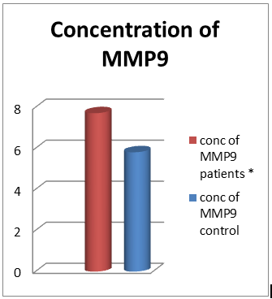
*

Chart 1: Compared the concentration of MMP9 between serum of normal and malignant. *indicate a increase a significant between control and treatment groups.

There are also variables in IHCS of MMP9 between Age groups of cases (group1:50-60, group 2:60-70, group3 :70-80, group 4: more 80) at p-value <0.05.
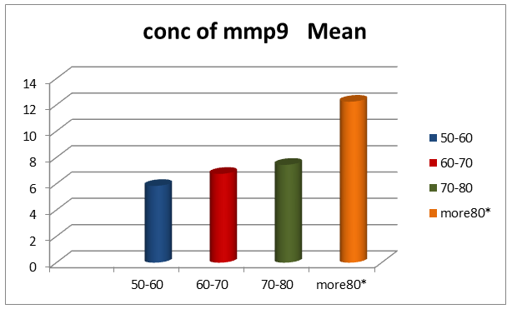
*

Chart 2: different in IHCS between age groups. *indicate to a significant increase in group 4

Chart 2: different in IHCS between age groups. * indicate a difference significantly between Age groups.

Immunostaining of MMP9
Immunohistochemistry staining to a total 26with malignant prostate cancer and 36 benign showed different intensity strong, moderate, and low as demonstrated in figure (1) and there are highly significantly IHCS in MMP9 expression level between benign and malignant of prostate cancer at P-value <0.05, as detailed in the below
table according to the percentage of immune positive tumoral and intensity of staining as summarized above

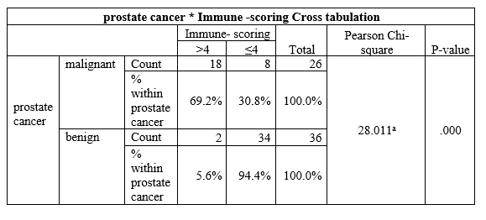
Table1: Immunoscoring of MMP9 between benign and malignant prostate cancer.

a. 0 cells (0.0%) the expected count less than 5.

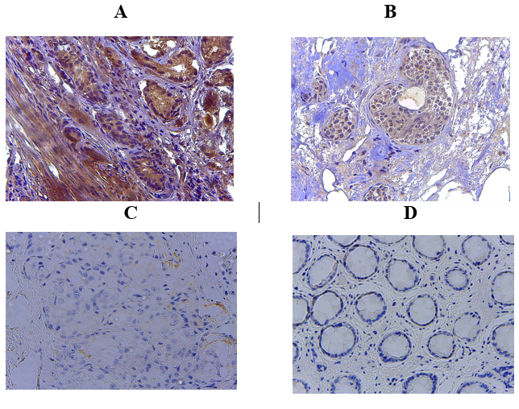

Figure (1): demonstrated Immunohistochemistry expression of MMP9 in human Prostate tissue with different intensity, (A) positive strong staining(B)positive moderate staining, (c)positive weak staining, (D) negative staining.

Discussion
MMPs have the ability to promote the progression of cancer by rising the growth of cancer-cell, metastasis, migration, invasion, and angiogenesis. MMPs do all these effects by splitting different groups of substrates, that contain not only components structural of extracellular matrix, but in addition, receptor tyrosine kinases, growth factor-binding proteins, cell adhesion molecules, growth factor precursors, and another proteinase (Egeblad and Werb,2002).
MMP9 can destroy the (ECM) structures and has a great effect on the functions of pathophysiological, excessive expression and dysregulation of MMP9 are caused several diseases, so inhibition and regulation of MMP9 are very important in the therapeutic approach for struggle several diseases such as cancer, so the MMP9 inhibitors can act as an anticancer (Mondal,2020).
The recent study found that the expression of MMP-9 by used immunohistochemistry assay was overexpressed in prostate cancer cells contrast to benign, whereas (Brehmer et al 2003) clarify that there are no significant differences between malignant and benign epithelial cells in MMP9 expression
Immunohistochemically study of the prostate tissue exposes special aspects of the expression of proteins that have a great role in proliferative processes, in the distribution of collagen type IV, MMP-9, and tissue inhibitor of MMP (Babichenko, et al, 2014).
MMPs expression has little or unnoticeable in most benignant states and virtually raised in most of the malignant tumor in human tumors such as carcinomas of colon, prostate, lung, breast, and pancreas (Stearns et al,1996, Talvensaari et al,1998, Bramhall et al,1997, Kawano et al,1997., Murray et al,1996). There is overexpression of all type of MMPs in Prostate carcinoma compared with benign pathologies (Escaff, et al,2010)
High expression and activity of MMPs, especially MMP9, has been related to a group of pathological processes such as cleaving and reconstruct of ECM (Giannelli and Antonaci,2002., Egeblad and Web,2002).
The activity and concentration of MMPs in plasma Enzyme-linked assay have a great effect in a diagnosis, therapy monitoring, and assessing a progression of malignant in prostate cancer (Morgia., et al 2005).
Previous studies indicated the serum level of MMP9 in those with or without bone metastasis in cancer of breast and prostate were highly significant (Incorvaia et al., 2007).
MMPs levels in serum and tissue are extra expression, significant prognostic, involved in many aspects in a progression of prostate cancer, and effect on their microenvironment which indicates their role in molecular biology in prostate cancer (Gong et al,2014).
We observed there is a significant association between age and MMP-9 concentration (Cancemi et al,2020). also demonstrated that the concentration of MMP9 increases with aging. (Babichenko et al,2014) refer to that there are negative correlations between age and concentration of MMP-9 in prostate adenocarcinoma.
Also (Mannello et al,2005) mentioned MMPs role in the behavior of cells, survival, and death, so there are novel roles in decrease apoptosis of cancer cell during the progression of tumor directly or indirect by their influence on the early stages of programmed cell death, so it essential to carefully target the role of MMPs in extracellular, intracellular and intra-nuclear, so more study carried out to function these enzymes in cancer therapies.
Conclusion:
Our results mention to the MMP-9 expression is highly significant at prostate cancer to compare with controls in serum and tissue samples, which that indicating to their role in the tumor, and may be considered as a biomarker to cancer diagnoses and progression.

References Avădanei,R ., Căruntu,I., Amălinei,C., Lozneanu,L., Balan,R., Grigoraş,A., Apostol, D.,Giuşca,S.,(2013).High variability in MMP2/TIMP2 and MMP9/TIMP1 expression in secondary liver tumors. Rom J Morphol Embryol; 54(3):479-85.
Babichenko,I., Andriukhin,M.,Pulbere,S.,Loktev,A.(2014). Immuno- histochemical expression of matrix metalloproteinase-9 and inhibitor of matrix metalloproteinase-1 in prostate adenocarcinoma. Int J Clin Exp Pathol. ; 7(12): 9090–9098.
Bodnar M., Szylberg L., Kazmierczak W., Marszalek A.(2015) Tumor progression driven by pathways activating matrix metalloproteinases and their inhibitors. Journal of Oral Pathology & Medicine.;44(6):437–443.
Bramhall, S. R., Neoptolemos, J. R., Stamp, G. W., and Lemoine, N. R. Imbalance of expression of matrix metalloproteinases (MMPs) and tissue inhibitors of matrix metalloproteinases (TIMPs) in human pancreatic carcinoma. J. Pathol., 182: 347–355, 1997.
Brehmer, B .Biesterfeld ,S .,and Jakes ,G.(2003).Expression of matrix metalloproteinase (MMP-2 and -9 ) and their inhibitors (TIMP-1 and -2) in prostate cancer tissue.prostate cancer and prostatic disease,6:217-222.
Cancemi ,P., Aiello,A , Accardi,G. , Caldarella ,R., Candore,G. , Caruso,C. , Ciaccio,M. , Cristaldi,L. , Gaudio ,F., Siino,V and Vasto ,S.(2020).The Role of Matrix Metalloproteinases (MMP-2 and MMP-9) in Ageing and Longevity: Focus on Sicilian Long-Living Individuals (LLIs). . . Incorvaia ,L., Badalamenti, G.,Rini, G.,Arcara,C., Fricano, S.,Sferrazza,C., Trapani, D., Gebbia, N., Leto,G.(2007). MMP-2, MMP-9 and activin A blood levels in patients with breast cancer or prostate cancer metastatic to the bone. Anticancer Res:27(3B):1519-25.
Egeblad,M and Werb,Z . New functions for the matrix metalloproteinases in cancer progression. Nat Rev Cancer. 2002;2:161–174.
Escaff,,S ., Fernández,J.M, González,L.O, Suárez,A., S. González-Reyes, J M González, and F J Vizoso,F.J.(2010).Study of matrix metalloproteinases and their inhibitors in prostate cancer. 102(5): 922–929.
Farina ,A,R and Mackay ,A,R.(2014).Gelatinase b\MMP-9 in tumor pathogenesis and progression.cancer ,6:240-296.
Giannelli ,G and Antonaci ,S . Gelatinases and their inhibitors in tumor metastasis: from biological research to medical applications. Histol Histopathol. 2002;17:339–345.
Gong,Y.,Chippada-Venkata,U,D and William,K,Oh .(2014). Roles of Matrix Metalloproteinases and Their Natural Inhibitors in Prostate Cancer Progression. Cancers (Basel). 6(3): 1298–1327.
Huang,H. Matrix Metalloproteinase-9 (MMP-9) as a Cancer Biomarker and MMP-9 Biosensors: Recent (2018) . Sensors 18(10):3249.
Jemal A and Bray F, Center MM, et al (2011). Global Cancer
Kawano, N., Osawa, H., Ito, T., Nagashima, Y., Hirahara, F., Inayama, Y., Nakatani, Y., Kimura, S., Kitajima, H., Koshikawa, N., Miyazaki, K., and Kitamura, H. (1997)Expression of gelatinase A, tissue inhibitor of metalloproteinases-2, matrilysin, and trypsin (ogen) in lung neoplasms: an immunohistochemical study. Hum. Pathol., 28: 613–622,
Kessenbrock K., Plaks V., Werb Z. (2010)Matrix metalloproteinases: regulators of the tumor microenvironment.cell;141(1):52–67.
Lindsey ML, Zamilpa R.(2012). Temporal and spatial expression of matrix metalloproteinases and tissue inhibitors of metalloproteinases following myocardial infarction. Cardiovasc Ther.:30(1):31-41.
Mannello F, Luchetti F, Falcieri E, Papa S.(2005) Multiple roles of matrix metalloproteinases during apoptosis. Apoptosis.;10(1):19-24
Mikhail,I,. Andriukhin,M., Pulbere,S and Loktev,A.(2014). Immunohistochemical expression of matrix metalloproteinase-9 and inhibitor of matrix metalloproteinase-1 in prostate adenocarcinoma. Int J Clin Exp Pathol.7(12): 9090–9098.
Mondal,S.,Adhikari,N., SuvankarBanerjee,S., AbdulAmin,S., TarunJha. (2020)Matrix metalloproteinase-9 (MMP-9) and its inhibitors in cancer: A minireview, Euro. Journal of Med. ChemVolume 194,
Morgia,G , Falsaperla,M, Malaponte,G, Madonia,M, Indelicato,M, Travali ,S, Mazzarino,M(2005).MatrixMetalloproteinases as diagnostic (mmp-13) and prognostic (MMP-2,MMP-9) marker of prostate cancer. Urol Res,33(1):44-50.
Murray, G. I., Duncan, M. E., O’Neil, P., Melvin, W. T., and Fothergill, J. E. Matrix metalloproteinase-1 is associated with poor prognosis in colorectal cancer. Nat. Med., 2: 461–462, 1996.
Oguić,R., Mozetič,V., Tešar,E,, Čupić,D, Mustać,E and Đorđević,G.(2014). .Matrix Metalloproteinases 2 and 9 Immunoexpression in Prostate Carcinoma at the Positive Margin of Radical Prostatectomy Specimens.Statistics. Ca Cancer J Clin, 61. 69-90.
Stearns, M., and Stearns, M. E. (1996 )Evidence for increased activated metalloproteinase 2 (MMP-2a) expression associated with human prostate cancer progression. Oncol. Res., 8: 69–75.
Talvensaari-Mattila, A., Paakko, P., Hoyhtya, M., Blanco-Sequeiros, G., and Turpeenniemi-Hujanen, T. (1998.) Matrix metalloproteinase-2 immunoreactive protein: a marker of aggressiveness in breast carcinoma. Cancer (Phila.), 83: 1153–1162.

