GAS CHROMATOGRAPHY – MASS SPECTROSCOPIC ANALYSIS OF LAWSONIA INERMIS L., ERUCA SATIVA MILL., SIMMONDSIA CHINESIS (LINK) SCHNEIDER AND BOSWELLIA SPP.
Haider Sabeh Shanow Al-jabir, Dhia Ahmed Taain ð and Abdulla A. Abdulla
Department of horticulture and landscape, College Of Agriculture, University Of Basrah, Iraq.

Abstract
Due to the importance of jojoba seed oil, watercress seed oil, henna leaves and frankincense in popular medicine for the treatment of many diseases as well as its economic importance for its entry as raw materials in some industries, the study was conducted to determine the chemical components from the previous plants by using Gas Chromatography – Mass Spectroscopic analysis. The results of analysis showed that in jojoba seed oil, watercress seed oil, henna leaves and frankincense the most prevailing compounds were cis-Vaccenic acid, Diethyl Phthalate and 1-[2-Hydroxyethyl]-4-[4-[7chloro-4-quinolylamino]benzoyl] piperazine.
Key words : jojoba seed oil, watercress, cis-Vaccenic acid, Gas Chromatography-Mass Spectroscopic.

Introduction
Watercress plant Eruca sativa Mill. belongs to the family “Brassicaceae”, it is believed to be native to Central Asia and Eastern Europe and can be classified as medical plant due to various curative uses, for example the treatment of dermatitis, local burns, poor digestion, hair loss and hypoglycemia for people with diabetes, by working to slow the absorption of sugar into the intestines. The oil of the plant is used to improve liver function, increase fertility by improving the effectiveness of sexual hormones, in additions, it considers as anti-inflammatory and anti-foot fungus and stomach disease (Bhandari and Chaderl, 1996; Merza et al., 2000 ; Hila et al., 2009).
Plant Archives Vol. 20, No. 1, 2020 pp. 1530-1536 | e-ISSN:2581-6063 (online), ISSN:0972-5210
Each 100 g of watercress leaves contains 2.6 g protein, 0.7 g fat, 3.6 g carbohydrates and 1.6 g fiber as well as vitamin A, C, sodium, potassium, calcium, iodine, iron, zinc and sulfur, in addition to thiamin, riboflavin, niacin and other substances (Al-Dujoi, 1996).
Henna Lawsonia inermis L. belongs to the family Lythraceae, an evergreen shrub native to the Arabian Peninsula and Iran. its dried leaves used as dye of hair, treatment of skin diseases and wounds, and the flowers used in Perfume Industries. The plant contains many compounds such as flavonoids, tannins, alkaloids and terpenoids (Cowan, 1999; Kamel, 2004; Mansour, 2004; Chandhary et al., 2010).
Recent studies showed the effectiveness of henna compounds as anti-bacterial and fungal, as well as antiinflammatory and cancers (Dasgupta et al., 2003).
Jojoba Simmondsia chinensis (Link) Schneider is an evergreen shrub, belongs to family Simmondsiaceae. It is known as jojoba, which originates from the deserts of USA native to southwestern Arizona, California and northern Mexico (Stone, 1993), However, it is now planted in many other deserts across the world. The importance of this plant is due to its content of protein glycosides, esters, fatty acids and alcohols with a high oil content of the seeds about 50% of their weight (Naqvi and Ting, 1990; Tada et al., 2005; Evans, 1999).
Jojoba seed oil consists of 97% wax and 3% free fatty acids and contains anti-oxidants and inhibits some types of bacteria, viruses and anti-inflammatory. Its molecules consist of a long carbon chain, unlike vegetable oils that consist of fatty acids and glyceritol, making it a liquid wax without purification and has a high viscosity rate and high degree of stability (Verschuren, 1989; Naqvi and Ting, 1990).
Frankincense (olibanum) a tree of the genus Boswellia (family Burseraceae), has been spread in some countries of the Arabian Peninsula, such as Yemen and
Table 1: Components Identified in jojoba.
Peak | MW | Molecular | Name of the compound | RT | No.
Area % |  | Formula
0.93 | 394 | C26H50O2 | Cyclopropane tetradecanoic acid, 2-octyl-,methyl ester | 4.106 | 1
4.12 | 222 | C12H14O4 | Diethyl Phthalate | 13.870 | 2
1.33 | 530 | C34H58O4 | 1,2-Benzenedicarboxylic acid, ditridecyl ester | 14.016 | 3
1.06 | 222 | C12H14O4 | Diethyl Phthalate | 14.120 | 4
2.70 | 254 | C18H38 | Hexadecane | 14.288 | 5
2.29 | 390 | C24H38O4 | Phthalic acid, ethyl tetradecyl ester | 14.529 | 6
1.49 | 177 | C8H7N3O2 | Pyrido[3,2-d]pyrimidin-4(3H)-one, 3-hydroxy-2-methyl | 14.666 | 7
0.61 | 542 | C31H28Cl2N4O | 2,4-Bis[4-chloro-trans-styryl]-6-[(3-pyrrolidinomethyl-4-hydroxyphenyl) amino]pyrimidine | 14.700 | 8
1.11 | 680 | C38H37N2O6PS | Carbamic acid, [2-[[1-(diphenoxyphosphinyl)-2-phenylethyl]  amino]-2-oxo-1-[[(phenylmethyl)thio]methyl]ethyl]-, phenylmethyl ester | 14.814 | 9
1.81 | 742 | C42H54N4O8 | 3,7,12-Triazabicyclo[13.3.1]nonadeca-1(19),15,17-triene-2-acetic acid, 3,  7-diacetyl-12-[3-(benzoylamino)propyl]-16-methoxy-14-[(4-methoxypheny | 14.920 | 10
0.42 | 248 | C14H16O4 | Phthalic acid, cyclobutyl ethyl ester | 15.007 | 11
0.77 | 298 | C18H18O4 | Phthalic acid, ethyl 3,4-dimethylphenyl ester | 15.073 | 12
27.99 | 242 | C15H30O2 | Pentadecanoic acid | 28.151 | 13
0.76 |  |  | 1-Octadecanol | 30.590 | 14
0.31 | 322 | C21H38O2 | 11,14-Eicosadienoic acid, methyl ester | 30.673 | 15
0.61 | 294 | C19H34O2 | 10-Octadecenoic acid, methyl ester | 30.809 | 16
8.39 | 280 | C18H32O2 | 9,12-Octadecadienoic acid (Z,Z)- | 31.494 | 17
29.94 | 282 | C18H34O2 | cis-Vaccenic acid | 31.622 | 18
5.47 | 372 | C22H44O4 | Octadecanoic acid, 2-(2-hydroxyethoxy)ethyl ester | 32.043 | 19
0.26 | 284 | C18H36O2 | 1-Hexadecanol, acetate | 32.695 | 20
0.62 | 324 | C21H40O2 | Methacrylic acid, heptadecyl ester | 33.332 | 21
1.25 | 340 | C23H32O2 | Phenol, 2,2'-methylenebis[6-(1,1-dimethylethyl)-4-methyl- | 35.465 | 22
1.12 | 530 | C26H18Cl4N2O2 | 2,6-Naphthalenediol, 1,5-bis[(2,4-dichlorobenzylimino)methyl]- | 38.645 | 23
0.33 | 562 | C28H62O5Si3 | Octadecanoic acid, 9,10,18-tris[(trimethylsilyl)oxy]-, methyl ester | 38.740 | 24
0.67 | 348 | C22H36O3 | 3.beta.-Hydroxy-bisnorallocholanic acid | 38.773 | 25
0.40 | 390 | C24H38O4 | Isophthalic acid, 2-ethylhexyl octyl ester | 38.880 | 26
0.68 | 398 | C24H46O4 | Lauroyl peroxide | 38.985 | 27
0.21 | 506 | C34H66O2 | 9-Hexadecenoic acid, octadecyl ester, (Z)- | 39.020 | 28
0.94 | 409 | C25H47NO3 | Adipic acid, monopiperidide, tetradecyl ester | 39.139 | 29
1.42 | 410 | C30H50 CAS:  111-02-4 | 2,6,10,14,18,22-Tetracosahexaene, 2,6,10,15,19,23-hexamethyl-, (all-E)- | 40.379 | 30

Oman are of economic importance, as extracted from the stems of the sap (frankincense) by making of wounds on the stems and then dried and used in the popular medicine to treat many diseases such as tumors, sores, dysentery and chest diseases such as cough, asthma, heart attack in addition to manufacture of incense. Frankincense consists of 56-65% colloidal acids, 20-36% resin, and 48% essential oils (Huang et al., 2000).

Materials and Methods
Plant Sample Extraction
The method described in Hema et al., (2010) was used to extract henna leaves and the method mentioned in Biggs et al., (2016) was used to extract frankincense while oil was extracted from watercress and jojoba seeds according to AOAC (2000).
GC-MS Analysis
GC-MS analysis was carried out on a gas chromatograph interfaced to a mass spectrometer (GCMS) instrument type GC MS QP210 Ultra, SHIMADZU, APAN supplied with capillary column DB-MS5( 5% phenyl, 95% methyl polysiloxane) as stationary phase in addition to use helium gas (99.9%) employing the following
Table 2: Components Identified in henna.
Peak | MW | Molecular | Name of the compound | RT | No.
Area % |  | Formula
0.69 | 198 | C14H30 | Dodecane, 4,6-dimethyl- | 10.312 | 1
0.78 | 184 | C13H28 | Nonane, 5-(2-methylpropyl)- | 11.003 | 2
0.52 | 173 | C12H15N | Quinoline, 1,2-dihydro-2,2,4-trimethyl- | 12.727 | 3
0.60 | 282 | C20H42 | Eicosane | 13.320 | 4
0.60 | 254 | :C18H38 | Heptadecane, 2-methyl- | 14.017 | 5
5.28 | 96 | C6H8O | But-1-ene-3-yne, 1-ethoxy- | 14.900 | 6
4.70 | 206 | C11H14N2O2 | Benzonitrile, 2-amino-4,5-diethoxy- | 15.013 | 7
3.20 | 222 | C12H14O4 | Diethyl Phthalate | 15.074 | 8
16.89 | 242 | C15H30O2 | Pentadecanoic acid | 28.124 | 9
0.84 | 256 | C16H32O2 | n-Hexadecanoic acid | 28.293 | 10
0.90 | 332 | C24H44 | 15-Isobutyl-(13.alpha.H)-isocopalane | 30.754 | 11
0.92 | 388 | C23H32O5 | Fumaric acid, dodecyl 2-formylphenyl ester | 30.818 | 12
0.62 | 298 | C19H38O2 | Octadecanoic acid, methyl ester | 31.345 | 13
4.66 | 280 | C18H32O2 | Ethyl 9,12-hexadecadienoate | 31.504 | 14
22.90 | 282 | C18H34O2 | cis-Vaccenic acid | 31.607 | 15
2.11 | 304 | C22H40 | Cyclodecacyclotetradecene, 1,2,3,4,5,6,7,8,9,10,11,12,13,14,15,16,17,18,  19,20-eicosahydro- | 31.860 | 16
3.21 | 340 | C22H44O2 | Octadecanoic acid, 2-methylpropyl ester | 32.050 | 17
2.11 | 284 | C18H36O2 | Octadecanoic acid | 32.080 | 18
0.49 | :268 | C19H40 | Octadecane, 5-methyl- | 32.536 | 19
2.59 | 340 | C22H44O2 | Eicosyl acetate | 32.694 | 20
1.52 | 227 | C14H29NO | N,N-Dimethyldodecanamide | 33.340 | 21
0.64 | 332 | C24H44 | 15-Isobutyl-(13.alpha.H)-isocopalane | 33.773 | 22
1.30 | 370 | C22H42O4 | Diisooctyl adipate | 35.229 | 23
0.44 | :438 | C27H50O4 | Fumaric acid, 3,3-dimethylbut-2-yl heptadecyl ester | 35.392 | 24
13.70 | 340 | C23H32O2 | Phenol, 2,2'-methylenebis[6-(1,1-dimethylethyl)-4-methyl- | 35.467 | 25
0.71 | 169 | C10H19NO | 3-Cyclopentylpropionamide, N,N-dimethyl- | 36.160 | 26
0.67 | 296 | C21H44 | Heptadecane, 2,6,10,15-tetramethyl- | 36.649 | 27
0.58 | 733 | C40H80NO8P | 3,5,9-Trioxa-4-phosphapentacosan-1-aminium, 4-hydroxy-N,N,Ntrimethyl-10-oxo-7-[(1-oxohexadecyl)oxy]-, hydroxide, inner salt, 4-oxide | 37.846 | 28
0.69 | 396 | C30H36 | Naphthalene, 2-(1-adamantyl)-7-(2-adamantyl)- | 38.027 | 29
1.52 | 834 | C53H102O6 | Octadecanoic acid, 2-[(1-oxotetradecyl)oxy]-1,3-propanediyl ester | 38.123 | 30
1.13 | 524 | C26H36O11 | 5H-Cyclopropa[3,4]benz[1,2-e]azulen-5-one, 9,9a-bis(acetyloxy)-3-  [(acetyloxy)methyl]-1,1a,1b,2,3,4,4a,7a,7b,8,9,9a-dodecahydro-2,3,4a,7b | 38.972 | 31
0.91 | 436 | C31H64 | Heneicosane, 11-decyl- | 40.255 | 32
1.57 | 410 | C30H50 | 2,6,10,14,18,22-Tetracosahexaene, 2,6,10,15,19,23-hexamethyl-, (all-E)- | 40.376 | 33

conditions for gas Chromatography: Column Oven Temp. :50.0 °C, Injection Temp. :250.00 °C, Injection Mode :Split, Flow Control Mode :Pressure, Pressure : 90.0 kPa, Total Flow :79.2 mL/min, Column Flow :1.53 mL/min, Linear Velocity :44.8 cm/sec, Purge Flow :6.0 mL/min, Split Ratio :46.9 and for mass spectrometer: Ion Source Temp :200.00 °C, Interface Temp. :250.00 °C, Solvent Cut Time :4.00 min, Detector Gain Mode :Relative, Detector Gain :0.84 kV +0.40 kV, Start Time :4.00min, End Time :41.71min, ACQ Mode :Scan, Event Time :0.40sec, Scan Speed
:2000, Start m/z :35.00, End m/z :800.00.

Results and Discussion
Results presented in table 1 and figure 1 indicated to the identification of 29 compounds in jojoba seeds oil. The results indicated that the cis-Vaccenic acid was superior to the rest of the compounds with 29.94% followed by Pentadecanoic acid with 27.9% followed by
9, 12-Octadecadienoic acid with 8.39% and
Octadecanoic acid, 2-hydroxyethoxy ethyl ester with
Table 3: Components Identified in frankincense.
Peak | MW | Molecular | Name of the compound | RT | No.
Area % |  | Formula
9.67 | 222 | C12H14O4 | Diethyl Phthalate | 15.088 | 1
4.11 | 242 | C15H30O2 | Pentadecanoic acid | 28.162 | 2
4.82 | 292 | C19H32O2 | Nerolidol isobutyrate | 31.471 | 3
8.19 | 282 | C18H34O2 | 6-Octadecenoic acid, (Z)- | 31.640 | 4
3.70 | 348 | C23H40O2 | 8,11,14-Docosatrienoic acid, methyl ester | 31.772 | 5
0.90 | 340 | C23H32O2 | Phenol, 2,2'-methylenebis[6-(1,1-dimethylethyl)-4-methyl- | 32.707 | 6
6.09 | 184 | C13H28 | Dodecane, 4-methyl- | 35.469 | 7
1.47 | 422 | C21H36Cl2O4 | Fumaric acid, 2,2-dichloroethyl pentadecyl ester | 36.027 | 8
2.80 | 492 | C31H53ClO2 | Stigmastan-3-ol, 5-chloro-, acetate, (3.beta.,5.alpha.)- | 36.541 | 9
1.56 | 678 | C47H82O2 | Stigmast-5-en-3-ol, oleate | 36.673 | 10
1.36 | 502 | C32H54O4 | D:A-Friedo-2,3-secooleanane-2,3-dioic acid, dimethyl ester, (4R)- | 37.907 | 11
0.91 | 562 | C33H46N4O4 | 4,6-Cholestadiene-3-one, 2,4-dinitrophenylhydrazone | 37.960 | 12
6.90 | 474 | C33H62O | Z,Z-6,24-Tritriacontadien-2-one | 38.068 | 13
5.32 | 350 | C15H24F6O2 | 1,3-Dioxolane, 4-ethyl-5-octyl-2,2-bis(trifluoromethyl)-, cis | 38.113 | 14
0.46 | 376 | C26H48O | 4,8-Dimethyl-4Z,8E-tetracosadienal | 38.213 | 15
1.00 | 208 | C12H16O3 | Acetic acid, 10-oxotricyclo[4.2.1.1(2,5)]dec-9-yl ester | 38.260 | 16
1.14 | 508 | C34H68O2 | Tetradecanoic acid, eicosyl ester | 38.307 | 17
0.72 | 186 | C11H22O2 | Hexyl isovalerate | 38.353 | 18
1.01 | 565 | C30H31NO10 | Spiro[2-cyclohexene-1,2'(1’H)-cyclopenta[de]naphthacene]-9'carboxamide, 7',7’a,8',11',11’a,12'-hexahydro-5',6',7’a,10',11’a,12'hexahydroxy-3'- | 38.413 | 19
0.80 | 401 | C27H47NO | 5.alpha.-Cholestan-2-one, oxime | 38.447 | 20
1.24 | 550 | C40H54O | Anhydrolutein II | 38.476 | 21
2.34 | 476 | C30H56O2Si | Silane, dimethyl(6-methyl-2-tert-butylphenoxy)heptadecyloxy- | 38.580 | 22
0.77 | 252 | C16H28O2 | Sclaral (sclareolide lactol) | 38.632 | 23
0.62 | 350 | C15H24F6O2 | 1,3-Dioxolane, 4-ethyl-5-octyl-2,2-bis(trifluoromethyl)-, cis- | 38.660 | 24
1.74 | 636 | C12H18Br6 | 1,2,5,6,9,10-Hexabromocyclododecane | 38.820 | 25
0.68 | 422 | C26H46O4 | Fumaric acid, 2-methylallyl octadecyl ester | 38.913 | 26
1.66 | 470 | C28H58O3Si | Tetracosanoic acid, 2-[(trimethylsilyl)oxy]-, methyl ester | 38.992 | 27
1.24 | 222 | C14H26N2 | Tetraponerine T4 | 39.047 | 28
0.52 | 346 | C20H42O2S | Di-n-decylsulfone | 39.127 | 29
1.67 | 702 | C50H102 | Triacontane, 11,20-didecyl- | 39.553 | 30

5.47%.
Thirty three compounds were identified in henna leaf extract (table 2 and fig. 2). The prevailing compound were cis-Vaccenic acid with (22.9 %), Pentadecanoic acid (16.89%), Phenol, 2,2-methylenebis[6-(1,1dimethylethyl)-4-methyl- with (13.7%) and But-1-ene3-yne, 1-ethoxy- with ( 5.28%).
Results obtained from table 3 and figure 3 indicated to identification of thirty compounds by GC-MS analysis of frankincense. Diethyl Phthalate was the most prevailing compound with (9.67%) followed by 6Octadecenoic acid, (Z)- with (8.19%), Z,Z-6,24Tritriacontadien-2-one with (6.9%) and Dodecane, 4methyl- with ( 6.09%).
Table 4 and figure 4 showed that thirty compounds were identified in watercress seeds oil (HS4) which were
1 - [ 2 - H y d r o x ye t h yl ] - 4 - [ 4 - [ 7 - c h l o r o - 4 quinolylamino]benzoyl]piperazine, Ethyl 2-acetamido3,3,3-trifluoro-2-(4-fluoroanilino) propionate, Octadecanoic acid, 12-oxo-, trimethylsilyl ester and Diethyl Phthalate with the Peak Areas of (8%, 7.40 %,6.58% and 5.62%) respectively.
Vaccenic acid, also known as (11E)-octadec-11-enoic acid is a naturally occurring transfatty acid found in dairy products such as milk. It is also the predominant fatty acid comprising trans fat in human milk. Pentadecanoic acid (CH₃(CH₂)₁₃COOH) is a saturated fatty acid. It is rare in nature, being found at the level of 1.2% in the
Table 4: Components Identified in watercress.
Peak | MW | Molecular | Name of the compound | RT | No.
Area % |  | Formula
5.62 | 222 | C12H14O4 | Diethyl Phthalate | 15.085 | 1
5.14 | 356 | C21H40O4 | 9-Octadecenoic acid (Z)-, 2-hydroxy-1-(hydroxymethyl)ethyl ester | 31.633 | 2
2.12 | 565 | C27H46F7NO3 | l-Valine, n-heptafluorobutyryl-, octadecyl ester | 39.527 | 3
1.59 | 564 | C30H49F5O2Si | Behenic acid, dimethyl(pentafluorophenyl)silyl ester | 39.566 | 4
3.74 | 564 | C33H48N4O4 | 1-Coprosten-3-one 2,4-dinitrophenylhydrazone | 39.913 | 5
1.89 | 338 | C22H42O2 | Cyclopropanedecanoic acid, 2-octyl-, methyl ester | 39.965 | 6
1.86 | 196 | C13H24O | 1,5,9,9-Tetramethyl-spiro[3.5]nonan-5-ol | 40.012 | 7
2.99 | 420 | C27H48O3 | Tetrahydrosmilagenin | 40.080 | 8
1.23 | 142 | C6H10N2O2 | 4-Methylimidazole-2,5-diethanol | 40.107 | 9
2.00 | 346 | C22H31FO2 | [1,1'-Bicyclohexyl]-4-carboxylic acid, 4'-propyl-, 4-fluorophenyl ester | 40.133 | 10
1.67 | 518 | C23H34O13 | alpha.-D-Glucofuranose, 3-O-(2,3,5-O-acetyl-.beta.-  D-lyxofuranosyl)-1,2:5,6-DI-O-isopropylidene- | 40.173 | 11
1.49 | 181 | C8H8FN3O | 3-Fluorobenzaldehyde semicarbazone | 40.208 | 12
1.42 | 562 | C33H46N4O4 | 4,6-Cholestadiene-3-one, 2,4-dinitrophenylhydrazone | 40.233 | 13
2.93 | 574 | C36H47ClN2O2 | N,N’-Bis-(4-octyloxybenzylidene)-2-chloro-1,4-phenylenediamine | 40.280 | 14
2.43 | 264 | C14H17FN2O2 | Pyrrolidine-3-carboxamide, N-(4-fluorophenyl)-1-isopropyl-5-oxo-  $$ N-(4-Fluorophenyl)-1-isopropyl-5-oxo-3-pyrrolidinecarboxamide | 40.320 | 15
5.04 | 578 | C30H42O11 | 9-Desoxo-9-xi-hydroxy-3,7,8,9,12-pentaacetate ingol | 40.380 | 16
7.40 | 322 | C13H14F4N2O3 | Ethyl 2-acetamido-3,3,3-trifluoro-2-(4-fluoroanilino)propionate | 40.513 | 17
5.25 | 508 | C25H50Br2 | erythro-9,10-Dibromopentacosane | 40.593 | 18
4.65 | 370 | C21H38O5 | Methyl 10-methoxycarbonyl-17-oxooctadecanoate | 40.670 | 19
3.33 | 562 | C11H3F17N4O3 | Propanamide, 2,3,3,3-tetrafluoro-2-[2-(perfluoropropoxy) perfluoropropoxy]-N-(1,2,4-triazol-3-yl)- | 40.700 | 20
1.98 | 430 | C29H50O2 | Cholestan-3-ol, acetate, (3.beta.)- | 40.747 | 21
8.00 | 410 | C22H23ClN4O2 | 1-[2-Hydroxyethyl]-4-[4-[7-chloro-4-quinolylamino]benzoyl]piperazine | 40.793 | 22
2.44 | 452 | C28H52O4 | Fumaric acid, 2,4-dimethylpent-3-yl heptadecyl ester | 40.882 | 23
3.79 | 208 | C12H20N2O | 5,7-Diethyl-1,3-diazaadamantan-6-one | 40.922 | 24
4.67 | 240 | C15H28O2 | Tetrahydroionyl acetate | 40.994 | 25
6.58 | 370 | C21H42O3Si | Octadecanoic acid, 12-oxo-, trimethylsilyl ester | 41.049 | 26
1.17 | 564 | C38H76O2 | 9-Octadecene, 1-[2-(octadecyloxy)ethoxy]- | 41.127 | 27
3.82 | 582 | C36H42N2O5 | 6-[(7-Isopropyl-1,4a-dimethyl-1,2,3,4,4a,9,10,10a-octahydrophenanthren-  1-ylmethyl)carbamoyl]-6'-methyl-2'-nitrobiphenyl-2-carboxy- | 41.193 | 28
2.16 | 562 | C32H51F5O2 | Stigmastanol, pentafluoropropionate | 41.227 | 29
1.58 | 346 | C20H42O2S | Di-n-decylsulfone | 41.280 | 30

milk fat from cows, while Octadecadienoic acid is a doubly unsaturated fatty acid, occurring widely in plant glycosides. Diethyl phthalic acid also known as diethyl phthalate, 1, 2-diethyl phthalic acid or 1, 2-benzenedicarboxylic acid diethyl ester, is classified as a member of the benzoic acid esters (Precht and Molkentin, 1999 ; Wolff, 2005; Friesen and Innis, 2006).
Present work at the same line with the investigation conducted by Hema et al., (2010) to study gas chromatography-mass spectroscopic analysis of Lawsonia inermis leaves which found that henna leaves contain mainly á-D-Glucopyranoside, methyl (51.73%) and 1,4-Naphthalenedione, 2-hydroxy-.Also with the study of AL-Qizwini et al., ( 2014) on Jordanian jojoba (SIMMONDSIA CHINENSIS) liquid wax that indicated that the fatty acid á-linolenic acid was in higher percentages within the Jordanian oil than those of Jojoba oil found in other parts of the world. On the other hand, the fatty acids palmitic acid, oleic acid, vaccenic acid, and gondoic acid were in lower percentages within the Jordanian oil. Swami et al., ( 2016) mentioned that different peaks with low and high molecular weight determining the presence of 51 compounds. Among them predominantly Squalene (19.77%) 9,12,15-

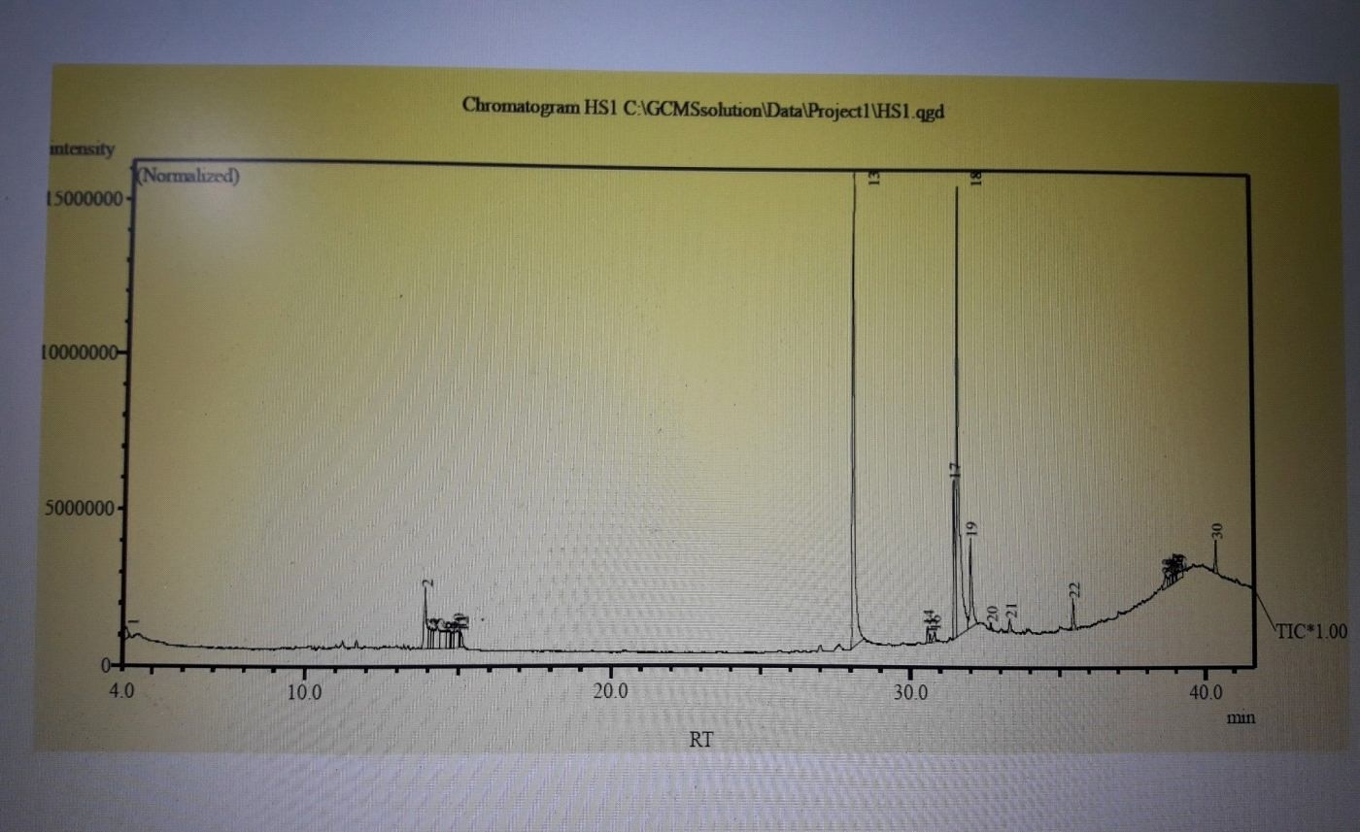
Octadecatrienoic acid, (Z,Z,Z)- (14.90%); 9,12,15-
Octadecatrienoic acid, methyl ester, (Z,Z,Z)- (11.52%); Pentadecanoic acid (10.54%); Vitamin E (6.82);
Hexadecanoic acid, methyl ester (5.85%); 9,12-
Octadecadienoicc acid (Z,Z)-, Methyl ester (4.98%); Stigmast-5-En-3- Ol, (3.Beta.)- (5.67), Phytol (1.77%) were present.
Alghamdi et al., (2017) found that the fatty acid
Behenic acid methyl ester (C22:0) and Cis-13, 16 Docosadienoic acid methyl ester (C22:2) were in higher percentages within the Egyptian oil of jojoba. On the other
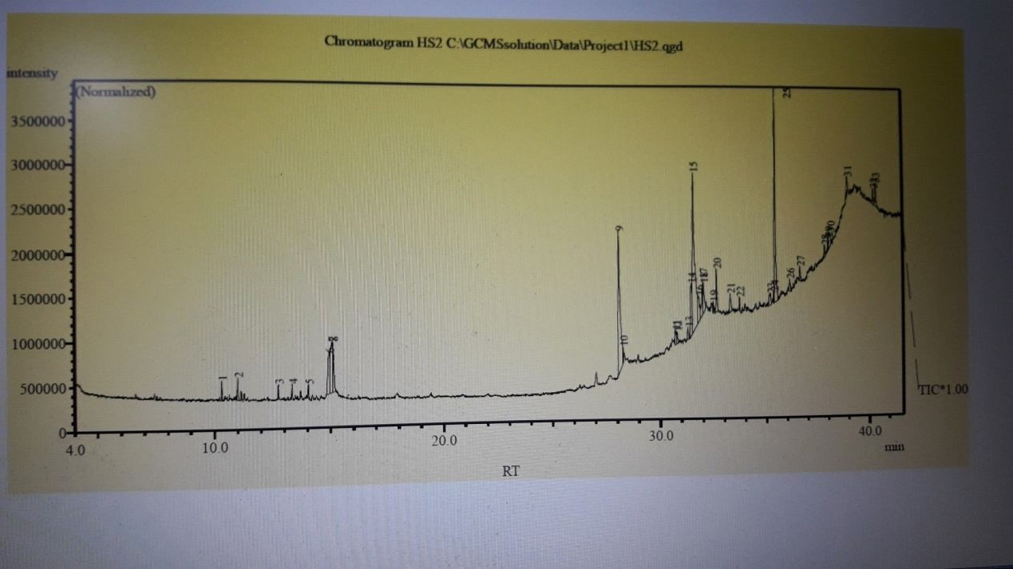
Fig.1: Components Identified in jojoba. hand, Egyptian oil was found to have lower percentage of the fatty acids; Eliadic acid, YLinolenic acid, Cis8,11,14 Eieosatrienoic acid, and Lingocernic acid.

Conclusion
It is concluded from the study that Gas Chromatography – Mass Spectroscopic analysis showed that cis-Vaccenic acid was the most prevailing compound in jojoba seed oil and henna leaves, while Diethyl Phthalate and 1-[2-Hydroxyethyl]-4-[4-[7-chloro-4quinolylamino]benzoyl]piperazine were most prevailing compound in frankincense and watercress seed oil Fig. 2: Components Identified in henna. respectively.

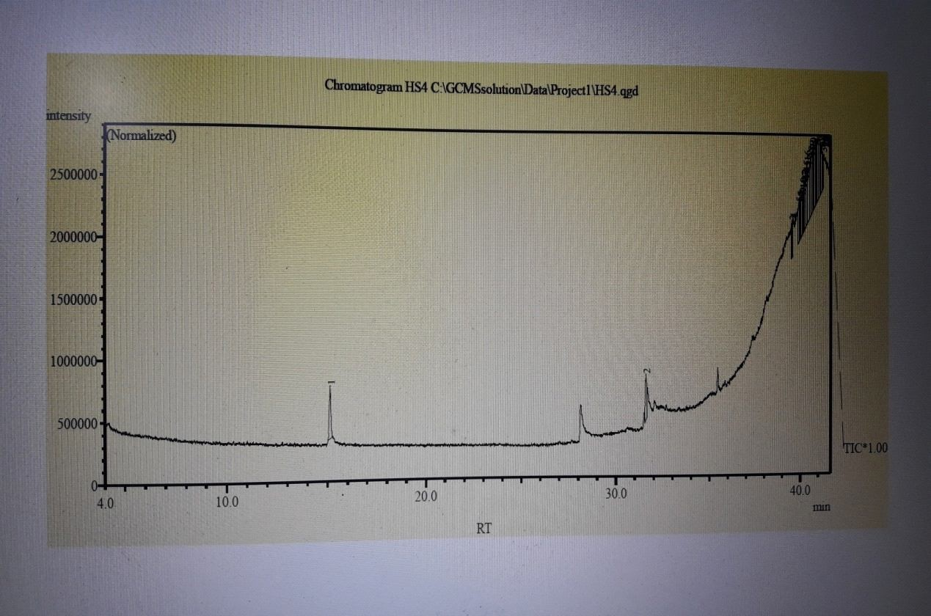
References
Al-Dujoi, A. (1996).Vegetable growing and production technology, Madbouly Library, Egypt.
Ahmed, K., A.K. Al-Ghamdi1, T.A. Elkholy, S. Abuhelal, H. Alabbadi, Q.D. Dina, H. Sobhy, H. Khalefah, N. Mohammad and M. Abu Hilal (2017). Study of jojoba (Simmondsia chinensis) oil by gas chromatography. Natural Products Chemistry & Research, 5(5): 1-3.
AL-Qizwini, H., AL-Khateeb, E. Mhaidat, N. M. ( 2014). Study of Jordanian jojoba (Simmondsia chinensis) liquid by GC and GC/MS. European Scientific Journal, vol.10, No.30:
278 – 293.
Fig. 3: Components Identified in frankincense.
A.O.A.C. (2000). Association of the Official Analytical Chemists, Methods of Analysis, 13 Ed. Washington D.C., U.S.A.
Bhandari, D.C. and K.P.S. Chaderl (1996). Status of rocket germplasm in India.Research accomplishments and priorities. In: Rocket, a mediterranean crop for the world.67P.
Biggs, I., J. Sirdaarta, A. White and I.E. Cock (2016). GC-MS Analysis of frankincense extracts which inhibit the growth of bacterial triggers of selected autoimmune diseases. Pharmacogn. Commn., 6(1):10-22.
Chandhary, G., G. Sandees and P. Priyanka (2010). Lawsonia inermis L. : A phytopharmacological review. Inter. J. Pharm. Sci. and Drug Res., 2(2): 91-98.
Cowan, M.M. (1999). Plant Products as antimicrobial agents. Fig. 4: Components Identified in frankincense. Clinical Microbiology Reviews,12(4):564-582.

Dasgupta, T., A.R. Rao and P.K. Yadava (2003). Modulatory effect of henna leaf (Lawsonia inermis L.) on drug metabolising enzymes,lipid peroxidation and chemically induced skin and forestomach papillomagensis in mice. Mol. cell biochem., 245(1-2):11-22.
Evans, W.C. (1999). Evans pharmacogenosy. 14ed., saunders company Ltd.
Friesen, R. and S.M. Innis (2006). “Trans fatty acids in human milk in Canada declined with the introduction of trans fat food labeling”. J. Nutr., 136(10): 2558-61.
Hema, R., S. Kumaravel, S. Gomathi and C. Sivasubramaniam (2010). Gas chromatographymass spectroscopic analysis of Lawsonia inermis Leaves. Life Science Journal, 7(4): 48-50.
Hila,Y., K. Soliman, S. Ihab, M. Ramadan, V. Jacob and T. Snait (2009). Potential skin anti-inflammatory effects of Umethylthiobut-ylisothio-cyanata (MTBI) isolated from rocket Erucca sativa Mill. Scels Bio. Factors, 35(3): 295305.
Huang, M., V. Badmaev, Y. Ding, J. Liu, J. Xie and C. Ho ( 2000). Anti-tumor and anti-carcinogenic activities of triterpenoid, beta-boswellic acid. Bio. Fac., 13: 225-230.
Kamel, M.M. (2004). Medicinal and Aromatic Plants. Modern University Office, Alexandria-Egypt.
Mansour, A.T. (2004). The Complete Guide to Medicinal Herbs and Medicinal Plants. Al-Mawkif Publishing House, Amman, Jordan.
Merza, H.H., H.H. Hussain, K.A. Tarawneh and J.M. Shakhanbeh (2000). Effect of applications of some Medicinal plants extracts used in Jordan on social aggression as well as testicular and preputial gland structures in male mice. Pakistan J. Biol. Sci., 3(3): 389402.
Naqvi, H.H. and I.P. Ting ( 1990). Jojoba.A unique liquid wax producer from the American desert. PP. 247-251, in J. Janick and J.E. Simon (eds), Advances in new crops.Timber press, Portland.
Precht, D. and J. Molkentin (1999). C186"1, C186"2 and C186"3 trans and cis fatty acid isomers including conjugated cis Ä9, trans Ä11 Linoleic Acid (CLA) as well as total fat composition of German human milk lipids, Nahrung, 43: 233-244.
Stone, W.S. (1993). Simmondsiaceae (Jogoba family). Jepson Flora Project. University of California.
Swami, N.C.D., D. Kantishree and M.W. Khan ( 2016). GC-MS analysis of photochemicals of methanolic extract of leaves of Lawsonia inwermis.
Tada, A., Z.L. Jin, N. Sugimoto, K. Satao, T. Yamazaki and K. Tanamoto (2005). Analysis of the constituents in jojoba was used as a food additive by LC,MS. Shokuhin Eiseigaku Zasshi, 46(5):198-204.
Verschuren, P.M.C. (1989). Evaluation of jojoba oil as low energy fat. Food and Chemical Toxicology, 27(1): 35-44.
Wolff, R.L. (1995). Recent Applications of Capillary Gas-Liquid Chromatography to Some Difficult Separations of Positional or Geometrical Isomers of Unsaturated Fatty
Acids, in New Trends in Lipid and Lipoprotein Analyses (Sébédio, J.-L., and Perkins, E.G., eds.), 147–180, AOCS Press, Champaign.

