Appendix A:

The therapeutic insulin resistance by metformin

Muataz Alameri

Submitted to the Institute of Graduate Studies and Research in partial fulfilment of the requirements for the degree of

Bachelor of Pharmacy

Eastern Mediterranean University
January 2018
Gazimağusa, North Cyprus

Appendix B:

Approval of the Faculty of Pharmacy:

Dean Of the Faculty: Prof. Dr. Mustafa Fethi Şahin

Thesis Supervisor: Assist. Prof. Dr. Jale Yüzügülen

Appendix C:

ACKNOWLEDGMENT

I would like to thank Assist. Prof. Dr. Jale Yüzügülen for his continuous support and guidance in the preparation of this study. Without his invaluable supervision, all my efforts could have been short-sighted.

I owe quit a lot to my family who allowed me to travel all the way from Nepal to Cyprus and supported me all throughout my studies. I would like to dedicate this study to them as an indication of their significance in this study as well as in my life.

Outline
- Abstracts
- Introduction
- General information about insulin
- Structure and Biosynthesis of insulin
- Insulin Secretion
- Effects of Insulin on the Targets
- Insulin resistance
- Mechanisms in the insulin resistance
- Types of insulin resistance
- Phases of insulin resistance
- Risk factors of insulin resistance
- The relationship between branched- chain amino acid and insulin resistance
- Metformin
- background
- Mechanism of metformin
- Action of metformin
- Therapeutic using of metformin
- Future therapeutic of metformin
- Aims of thesis project
- Discussion
- Conclusion
- References

Abstracts
Insulin resistance is a clinical condition shared by many diseases besides type 2 diabetes (T2DM) such as obesity, polycystic ovary syndrome (PCOS) and nonalcoholic fatty liver disease (NAFLD). Experimental evidence, produced over the years, suggests that metformin has many benefits in the treatment of these diseases. Metformin is a first-line drug in the treatment of overweight and obese type 2 diabetic patients, offering a selective pathophysiological approach by its effect on insulin resistance ( pala et al ., 2014).

Introduction
Insulin is the major anabolic hormone whose action is essential for appropriate tissue development, growth, and maintenance of glucose homeostasis. Insulin is secreted by the pancreatic b cells to reducing hepatic glucose production (via decreased gluconeogenesis and glycogenolysis) and increasing the rate of glucose uptake primarily into skeletal muscle and adipose tissue. Insulin resistance is a feature of a number of clinical disorders, including type 2 diabetes, obesity and hypertension clustering in the so-called metabolic syndrome (sesti et al ., 2006).
Diabetes is a pandemic disease characterized by autoimmune, genetic and metabolic abnormalities. While insulin deficiency manifested as hyperglycemia is a common sequel of both type 1 and type 2 diabetes (T1DM and T2DM) resulting from the functional loss of pancreatic β cells due to multifactorial mechanisms. Insulin resistance followed by β cell dysfunction and β cell loss is the characteristics of T2DM. Therefore, most patients with T2DM will require insulin treatment due to eventual loss of insulin secretion. Despite the evidence of early insulin treatment lowering macrovascular (coronary artery disease, peripheral arterial disease and stroke) and microvascular (diabetic nephropathy, neuropathy and retinopathy) complications of T2DM (Sanlioglu et al. , 2013).

General information about insulin
- Structure and Biosynthesis of insulin
Insulin is a small protein contains 51 amino acids arranged in two chains (A and B) linked by disulfide bridges. The human insulin gene, which consists of three exons and two introns, is on chromosome 11p15.5. While the first exon is the non-coding region, the second exon encodes a signal peptide, the B chain and a part of the connecting peptide (C peptide). The rest of the C peptide and the A chain are encoded in the third exon.
The Preproinsulin is encoded as a single-chain precursor from the insulin gene. Following translocation to ER, the signal peptide is cleaved to generate proinsulin, which is then reduced and unfolded (Fig. 1). the C peptide is still present linking the B and A chains by specific pairing of 3 disulfide bridges (A6A11, A7B7 and A20B19), which is required for stability and bioactivity of insulin, takes place after the folding of proinsulin in ER. Because proinsulin weakly binds to the insulin receptor its biologic activity is extremely low (5%). The C peptide is excised by specific prohormone convertases during its transit through the Golgi apparatus and entry into the immature secretory granules. the C peptide removal is necessary for proper folding of insulin, yielding the bioactive hormone. Prohormone Convertase 1 (PC1) cleaves proinsulin between residues 32 and 33 (Arg, Arg) while the cleavage site for Prohormone Convertase 2 (PC2) is between residues 65 and 66 (Lys, Arg).19 Then, the C-terminal Arg-Arg residues of the B chain are removed by carboxypeptidase H (a.k.a. carboxypeptidase E). Newly made insulin binds to Zn2+ and forms hexamers within specialized secretory granules for storage. Zn2+ provides insulin with protection against denaturation and misfolding, stabilizing the molecular structure.20 Stored insulin is predominantly released from the pancreatic β cells through a regulated pathway while only about 1% of insulin (and proinsulin) is secreted through the constitutive pathway.

In patients with diabetes, pancreatic β cells are destroyed by auto-immunity resulting in deficiency of both insulin and C-peptide. Although diabetic patients may routinely receive insulin injections to compensate the insulin deficit, no replacement for C-Peptide is currently administered to diabetic patients (Sanlioglu et al., 2013).
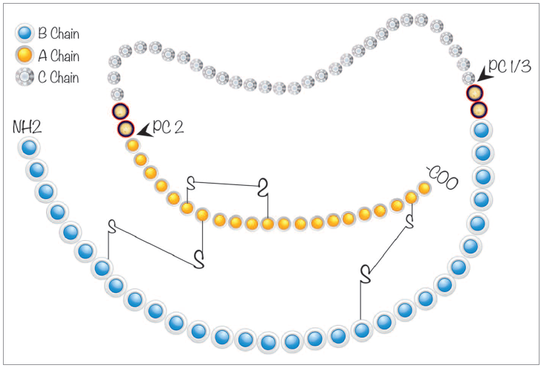
Figure 1. Schematic representation of human proinsulin. C-peptide, a 31 amino acid (aa) residue peptide, is depicted between A (21 aa) and B (30 aa) chains. In healthy individuals, both insulin and C-peptide are secreted in equimolar amounts from pancreatic β cells. Prohormone Convertase (PC 1/3 and PC 2) cleavage sites necessary for the removal of C-peptide from insulin are also shown.

- Insulin Secretion
Insulin is released from pancreatic beta cells at a low basal rate and at a much higher stimulated rate in response to a variety of stimuli, especially glucose. Other stimulants such as other sugars (eg, mannose), amino acids (especially gluconeogenic amino acids, eg, leucine, arginine), hormones such as glucagon-like polypeptide-1 (GLP-1), glucose-dependent insulinotropic polypeptide (GIP), glucagon,cholecystokinin, high concentrations of fatty acid (Bertram G.Katzung et al., 2015. P745).

Basal insulin is the secreted by the pancreas and is present throughout the day (24 h), regardless of feeding. Bolus insulin (quick bursts of insulin) refers to the additional amounts of insulin the pancreas would naturally produce in response to glucose absorbed from the food. Therefore, the amount of bolus insulin made depends on the size and content of the meal. Thus, whenever blood glucose concentration rises above 100 mg/dL (5.6 mmol/L), insulin is released from pancreatic β cells (Fig. 2)
In normal healthy people, endogenous insulin secretion generally peaks within one hour after a meal (postprandial glycemia). Then, insulin and glucose levels return to basal levels within two hours. Intriguingly, glucose-induced insulin secretion is biphasic. The first phase of insulin secretion, which takes place in humans within 5 min after stimulation, primarily results from the release of existing insulin containing vesicles stored in the cytoplasm. This first phase is responsible for suppressing hepatic glucose output, restricting PPG elevations, and inducing phase 2 insulin release of newly manufactured insulin. The second phase (plateau phase), in contrast, requires further processing of newly synthesized insulin and then the priming of insulin secretory vesicles (Fig. 2). This second phase lasts 1–2 h until normoglycemia is established. Interestingly, in patients with T2DM the first phase of insulin secretion is entirely absent and the second phase is severely reduced more than 50%.20 Therefore, there is a fundamental defect in postprandial insulin release in patients with T2DM and total absence of insulin in patients with T1DM (Sanlioglu et al., 2013).
One mechanism of stimulated insulin release results in increased intracellular ATP levels, which close the ATP-dependent potassium channels. Decreased outward potassium efflux results in depolarization of the beta cell and opening of voltage-gated calcium channels. The resulting increased intracellular calcium triggers secretion of the hormone.
(Bertram G.Katzung et al., 2015. P745).

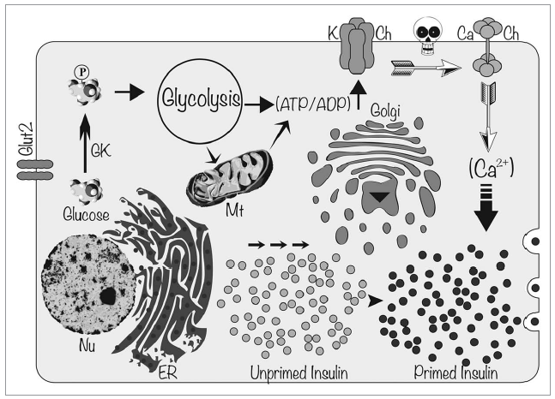
Figure 2. Molecular mechanism of glucose induced insulin secretion. When glucose enters into pancreatic β cells through Glucose Transporter-2 (GLUT-2), it gets phosphorylated to glucose 6-phosphate by GlucoKinase (GK). Phosphorylated glucose enters into glycolytic pathway and electrons are transported through the Electron Transport Chain in mitochondria yielding ATP. Increased ATP/ADP ratio and closure of ATP sensitive K channels (K Ch) lead to membrane depolarization. Change in membrane potential (depicted as a skull) opens up voltage gated Ca2+ channels (Ca Ch) causing influx of Ca2+ into pancreatic β cells. Increased cytosolic Ca2+ concentration facilitates the fusion of insulin-containing secretory vesicles with plasma membrane releasing insulin.

- Effects of Insulin on the Targets
Insulin promotes the storage of fat as well as glucose (both sources of energy) within specialized target cells ( Fig.3 ) and influences cell growth and the metabolic functions of a wide variety of
Tissues (Table-1 ) (Bertram G.Katzung et al., 2015. P.747).

TABLE-1: Endocrine effects of insulin.

Effect on liver:
- Reversal of catabolic features of insulin deficiency
- Inhibits glycogenolysis
- Inhibits conversion of fatty acids and amino acids to keto acids
- Inhibits conversion of amino acids to glucose
- Anabolic action
- Increases triglyceride synthesis and very-low-density lipoprotein formation
- Promotes glucose storage as glycogen (induces glucokinase and glycogen synthase, inhibits phosphorylase)

Effect on muscle:
- Increased protein synthesis
- Increases amino acid transport
- Increases ribosomal protein synthesis
- Increased glycogen synthesis
- Increases glucose transport
- Induces glycogen synthase and inhibits phosphorylase
Effect on adipose tissue:
- Increased triglyceride storage
- Lipoprotein lipase is induced and activated by insulin to hydrolyze triglycerides from lipoproteins
- Glucose transport into cell provides glycerol phosphate to permit esterification of fatty acids supplied by lipoprotein transport
- Intracellular lipase is inhibited by insulin

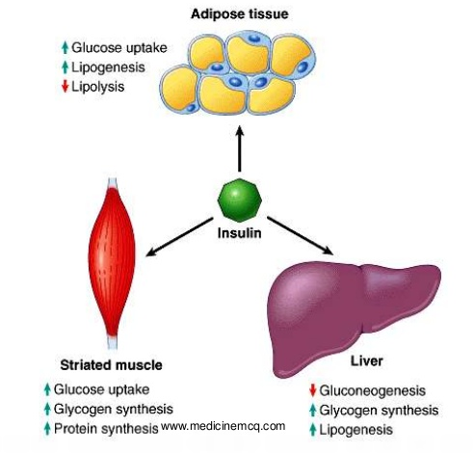
FIGURE 3: Insulin promotes synthesis (from circulating nutrients) and storage of glycogen, triglycerides, and protein in its major target tissues: liver, fat, and muscle. The release of insulin from the pancreas is stimulated by increased blood glucose, vagal nerve stimulation, and other factors

Insulin resistance
Insulin resistance is defined clinically as the inability of a known quantity of exogenous or endogenous insulin to increase glucose uptake and utilization which cells fail to respond normally to the hormone insulin (Lebovitz HE et al., 2001) . Insulin resistance (IR) is the pathogenic foundation underlying metabolic syndrome, steatosis and cirrhotic-NASH, and possibly HCC.
Types of insulin resistance
- Insulin resistance may be either peripheral which refers to diminished insulin-mediated uptake of glucose by skeletal muscle and depends primarily on the failure of glucose transporter type 4 (GLUT4) expression and translocation to the plasma membrane
- hepatic insulin resistance which describes impaired suppression of hepatic glucose production, and largely accounts for hyperglycemiaand glucose intolerance (El-Zayadi et al., 2010).

Phases of insulin resistance
- Prereceptor: due to abnormal insulin (mutations) or anti-insulin antibodies.
- Receptor: due to
- Decreased number of receptors and proteasomal degradation of insulin receptor substrate (IRS).
- Abnormal insulin receptor (mutation).
- Antibodies blocking insulin-receptor binding.
- Activation of receptor on serine rather than tyrosine kinase.
- Reactive oxygen species (ROS), which decreases tyrosine
phosphorylation of IRS.
- Postreceptor:
- TNF-a, IL-6 and insulin inhibit insulin signalling via induction of SOCs.
- Mutations of GLUT4.
- Combination of defects.
Risk factors of insulin resistance (Fig. 4)
- Gender: Increased visceral adiposity in men leads to a higher risk of IR than in women.
- Aging: Associated with increased levels of FFAs and TG, a decrease and mutation of GLUT4.
- Obesity: Associated with decreased number and down regulation of insulin receptors and impairment of postreceptor signalling. Overflow of FFAs from adipose tissue interferes with intrahepatic insulin signalling pathway via increased levels of pro-inflammatory cytokines such as TNF and proteasomal degradation of the insulin receptor substrate-1 and 2 (IRS-1 and 2).
- Smoking: Induces the production of high levels of circulating catecholamines, which act as antagonists to insulin-action Smoking contributes to increased levels of TG and decreased HDL.
- Alcohol: Doses higher than 50 g/day leads to higher risk of IR.
- Medications, particularly: Glucocorticoids, cyclosporine, growth hormones, thyroid hormones, sex hormones, protease inhibitors (HCV), nucleoside analogues (HBV), thiazides, b-blockers.
- Exercise: Low physical activity and high energy intake leads to high risk of IR. In addition it has been reported that IR improves after exercise.
- Periodontal infection: Patients with severe periodontitis have six times greater risk of worsening glycaemic control over time than patients without periodontitis, a finding attributed to increased insulin resistanc. Recent findings suggest that pro-inflammatory proteins can induce insulin resistance by interfering with lipid metabolism. It appears that prevention and treatment of periodontal infections can have a beneficial effect on glycaemic control in diabetic patients (El-Zayadi et al., 2010).

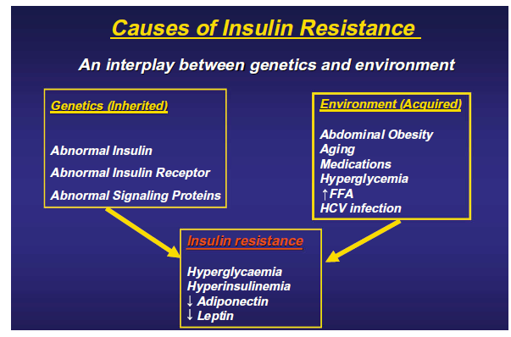

Figure-4: risk factors of insulin resistance

Mechanism of insulin resistance
The insulin activates tyrosine kinase of the insulin receptor, which stimulates insulin receptor substrate (IRS) phosphorylation followed by activation of phosphatidylinositol-4,5-bisphosphate 3-kinaseprotein kinase B(PI3K-AKT). Hyperglycemia lower insulin signaling through different mechanism (fig.5) ( kirti kaul et al.,2015)
- C-jun-N-terminal kinase pathway (JNK): inhibiter insulin signaling AKT2 (encodes a protein of the subfamily serine/threonine kinases)
- Variety of stress stimuli can activate JNK which play role in cytokines inflammatory signals, apoptosis and neurodegeneration.
- Cellular inflammatory pathway: when increase circulation cytokines, the NF-KB activated which leads to activator JNK that inhibitor phosphorylation of IRS-1.
- NF-KB (nuclear factor kappa-light-chain-enhancer of activated B cells) is a protein complex that controls transcription of DNA, cytokine production and cell survival. NF-κB plays a key role in regulating the immune response to infection. Incorrect regulation of NF-κB has been linked to cancer, inflammatory and autoimmune diseases, septic shock, and viral infection.
- When increase circulation FFA, the C18-DAG (diacylglyceral) causes translocation of PKC which inhibiter serine phosphorylation of insulin receptor substrate (IRS-1) and reduction of insulin mediated glucose transport/phosphorylation following by impaired glycogen synthesis in skeletal muscle.

- When increase circulation amino acid , the mTOR/S6K1 (mechanistic target of rapamycin/serine-6-kinase-1 pathway. mTOR functions as a serine/threonine protein kinase that regulates cell growth, cell proliferation, cell motility, cell survival, protein synthesis, autophagy, and transcription. mTOR also functions as a tyrosine protein kinase that promotes the activation of insulin receptors ) activated which inhibitor serine phosphorylation of IRS-1 following impaired hepatic glycogen synthesis.

- Abnormal mitochondrial function associated with insulin resistance which impaired impaired oxidative glucose and lipid metabolism, generation of reactive oxygen species (ROS) and oxidative stress seems to play an important role in inhibiting insulin signaling.
- ROS (reactive oxygen species) mediated damage of cellular proteins, lipids and nucleic acids could result in endoplasmic reticulum stress and activation of the unfolded protein response that the unfolded protein response activated the receptor of the immune system resulting in autoimmune response.
- OX. Stress is imbalance between reactive oxygen species and biological system ability to detoxify from intermediate or repair damage (figure-5).

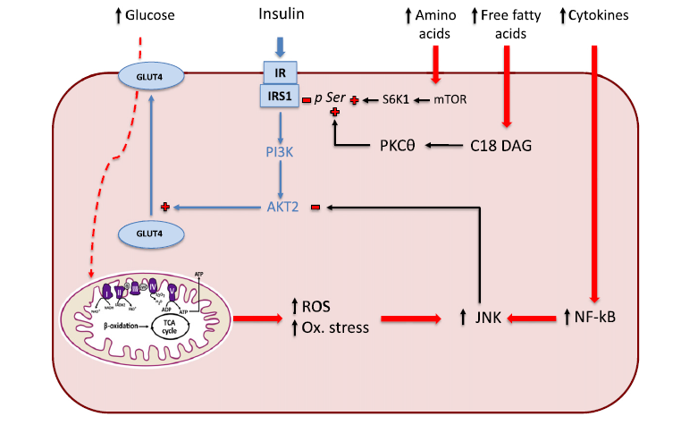
Figure-5: This flow chart summarizes current concepts for the understanding of insulin resistance. A main proposed mechanism is the inhibition of insulin signaling, as a result of chronic hyperglycemia, increased plasma FFA and amino acids and inflammatory processes. JNK: c-Jun-N terminal kinase pathway, PKC: protein kinase C activity AGE: advanced glycation end products, FFA: free fatty acids, IRS 1: insulin receptor substrate 1 ROS: reactive oxygen species, DAG: diacylglycerol.
- Higher glucose flux to the hexosamine pathway lead to increase insulin concentration (figure-6).

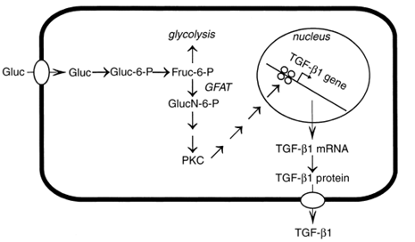
Figure-6: the patho-biochemical link between hyperglycemia and meningeal TGF-B1 production. Elevated flux through the hexosamine pathway results in activation of PKC. Activated and translocated PCK in turn activates transcription factors to form a complex that induce transcription of TGF-B1. The TGF-B1 protein is secreted and act autocrine/papcrine as prosclerotic cytokine.

The relationship between branched-chain amino acid and insulin resistance
Branched-chain amino acids (BCAAs; that is, leucine, isoleucine and valine) are essential amino acids that have direct and indirect effects on the regulation of body weight, muscle protein synthesis and glucose homeostasis. The circulating levels of BCAAs tend to be increased in individuals with obesity and are associated with worse metabolic health and future insulin resistance or type 2 diabetes mellitus (T2DM). increased levels of BCAAs and T2DM involves leucine-mediated activation of the mammalian target of rapamycin complex 1 (mTORC1), which results in uncoupling of insulin signalling at an early stage. BCAA dysmetabolism model proposes that the accumulation of mitotoxic metabolites promotes β-cell mitochondrial dysfunction, stress signalling and apoptosis associated with T2DM.
insulin resistance might promote aminoacidaemia by increasing the protein degradation that insulin normally suppresses, and by eliciting an impairment of efficient BCAA oxidative metabolism in some tissues. studies have highlighted that along with blood sugar, insulin and certain inflammatory markers, increased fasting concentrations of circulating BCAAs are associated with an increased risk of type 2 diabetes mellitus (T2DM) and insulin resistance in humans and in some rodent models (Lynch et al., 2014)

Metformin
Metformin (1,1-dimethylbiguanide hydrochloride), USA Food and Drug Administration (FDA)-approved biguanide derivative and the most widely prescribed antihyperglycemic drug, is used as first-line therapy for diabetes mellitus type 2. Metformin reduces blood glucose levels by inhibiting hepatic glucose production, increasing glucose uptake and utilization by the skeletal muscle, reducing insulin resistance in peripheral tissue, and suppressing gluconeogenesis in the liver (Yong Lei et al., 2017)

- Background
Metformin and the related drug phenformin are derived from galegine, a natural product from the plant Galega officinalis, used in herbal medicine in medieval Europe. Galegine was tested as a glucose-lowering agent in humans in the 1920s but was found to be too toxic. At about the same time, two synthetic derivatives of galegine, metformin and phenformin, were first synthesised and tested, although they were not introduced to clinical use until the 1950s. Chemically, galegine is an isoprenyl derivative of guanidine, while metformin and phenformin are biguanides containing two coupled molecules of guanidine with additional substitutions. It was established as a safe and effective therapy before detailed mechanistic studies became possible and despite its clinical use for 60 years, its molecular mechanisms of action remain much debated (Graham Rena et al., 2017). Metformin is a first-line drug for treating type 2 diabetes. Although metformin is known to phosphorylate AMP-activated protein kinase (AMPK), it is unclear how the glucose-lowering effect of metformin is related to AMPK activation (Kumsun Cho et al., 2015).

- Mechanism of metformin
Metformin accumulates within mitochondria in the liver which is catalyzed by the organic cation transporter-1 (OCT-1) because metformin carries a positive charge and the membrane potentials across the plasma membrane and mitochondrial inner membrane)Fig. 7). The mitochondrial action of metformin is the inhibition of Complex I of the respiratory chain which suppresses ATP production and increasing cytoplasmic ADP:ATP that replacement to AMP:ATP ratios by adenylate kinase which they is activated AMPK. Also the AMPK is activated by lysosomal mechanism. The Increasing of AMP:ATP ratio is inhibited fructose-1,6-bisphosphatase (FBPase), resulting inhibition of gluconeogenesis also inhibition adenylate cyclase and lowering cAMP production that reducing gluconeogenic enzyme. the AMPK is inhibited fat synthesis and activated fat oxidation enhancing hepatic insulin sensitivity in liver by phosphorylation of the two isoforms of acetyl-CoA carboxylase (ACC1/ACC2).also AMPK is activated specific cAMP enzyme which lowering cAMP production that reduced glucagon-induced cAMP (Graham Rena et al., 2017).

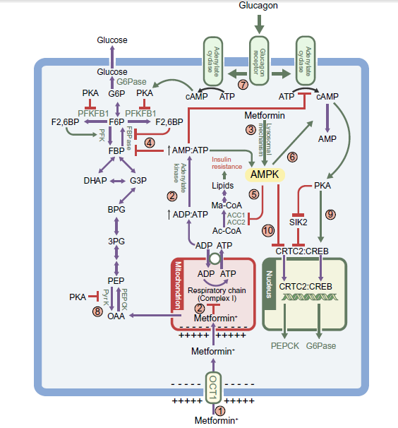
Figure-7: multiple mechanism of metformin
- Action of metformin
Metformin increases colonic uptake and metabolism of systemic glucose. Metformin may also impact on glucose metabolism by increasing glucagon-like peptide-1 (GLP-1) secretion, an effect that is described for both immediate-release and delayed release metformin. Metformin action was identified and involved a pathway linking duodenal metformin exposure to suppression of hepatic glucose production by the nucleus tractus solitarius and vagal efferents, through AMPK and GLP-1 receptor activation. A final potential gut-mediated mechanism of action of metformin involves alteration of the intestinal microbiome that metformin increased glucose utilisation in the gut (Fig. 8).
In the liver, metformin decreases lipogenesis and gluconeogenesis, as a result of its impact on molecular signaling and on mitochondrial function.

Metformin is suppressed the neutrophil to lymphocyte ratio (NLR) in type 2 diabetes, via have direct effects on inflammation, including effects on NF-κB signalling and differentiation of monocytes into macrophages as well as suppressing proinflammatory cytokines from these macrophages. In addition, metformin suppresses several inflammatory cytokines in human plasma in individuals without diabetes. NLR is a marker of inflammation that has recently been found to be a predictor of all-cause mortality and cardiac events (Fig.8). One of the cytokines suppressed by metformin is CC motif chemokine 11 (CCL11), which has previously been found to contribute to age-related cellular and tissue dysfunction. ( Graham Rena et al., 2017).

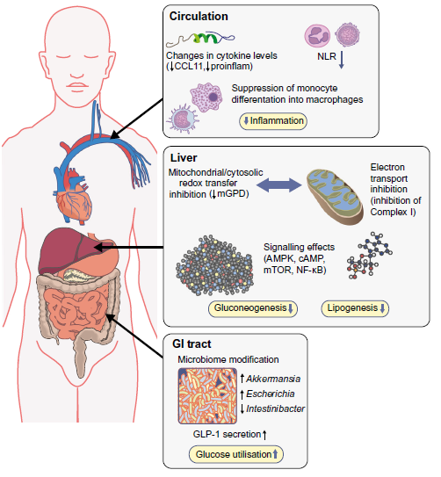
Figure-8: action of mMetformin.

- Therapeutic using of metformin
Metformin was played important role in the main therapeutics such as
- Type 2 diabetes by reducing Gluconeogenesis and Lipogenesis.
- Obesity by increasing fat oxidation and reducing fat synthesis.

- Future therapeutic of Metformin
metformin attracted increasing interests in recent years due to its anticancer effects which has demonstrated to reduce the development of prostate cancer, lung cancer, breast cancer, esophageal cancer, colon cancer, and melanoma. Several preclinical studies have reported that metformin reduced cell proliferation, induced apoptosis, and caused cell cycle arrest in vitro and also reduced occurrence and growth of experimental tumors in vivo by activation of adenosine monophosphate-activated protein kinase(AMPK) (Yong lei et al., 2017).
Recently, scientists have put their efforts in establishing metformin’s role in the treatment of neurodegenerative diseases, such as AD, amnestic mild
cognitive impairment and Parkinson’s disease. the scientists claim that activation of AMPK-dependent pathways in human neural stem cells
might be responsible for the neuroprotective activity of metformin. There is also some evidence that metformin decreases the activity of acetylcholinesterase (AChE), which is responsible for the degradation of acetylcholine (Ach), a neurotransmitter involved in the process of learning and memory (Magdalena Piasecka rt al., 2017).

Reference
- Ahter D. Sanlioglu (2013)
Ahter D. Sanlioglu, Hasan Ali Altunbas, Mustafa Kemal Balci, Thomas S. Griffith and Salih Sanlioglu* Clinical utility of insulin and insulin analogs.
Landes Bioscience.
- Abdel-Rahman El-Zayadi (2010)
Abdel-Rahman El-Zayadi. Insulin resistance. Arab Journal of Gastroenterology 11 (2010) 66–69
- Kirti Kaul (2015)
Kirti Kaula, Maria Apostolopoulou a, Michael Roden. Insulin resistance in type 1 diabetes mellitus. M E T A B O L I S M C L I N I C A L A N D E X P E R I M E N T A L 6 4 ( 2 0 1 5 ) 1 6 2 9 – 1 6 3 9
- Laura Pala (2014)
Laura Pala, Valeria Barbaro, Ilaria Dicembrini, Carlo Maria Rotella. The therapy of insulin resistance in other diseases besides type 2 diabetes. Eat Weight Disord (2014) 19:275–283.
- Bertram G.Katzung (2015)
Bertram G.Katzung, Anthony J. Trevor and Susan B. Masters. P ancreatic Hormones & Antidiabetic Drugs chapter41. P745 and P747. BASIC AND CLINICAL PHARMACOLOGY 12th EDITION.
- Magdalena Piasecka (2017)
Magdalena Markowicz-Piasecka, Joanna Sikora, Aleksandra Szydłowska, Agata Skupień, Elżbieta Mikiciuk-Olasik and Kristiina M. Huttunen3. Metformin – a Future Therapy for Neurodegenerative Diseases. Pharm Res-DOI 10.1007/s11095-017-2199-y.
- Graham Rena (2017)
Graham Rena & D. Grahame Hardie & Ewan R. Pearson. The mechanisms of action of metformin. Diabetologia (2017) 60:1577–1585.
- Yong Lei (2017)
Yong Lei, Yanhua Yi, Yang Liu, Xia Liu, Evan T. Keller, Chao‑Nan Qian, Jian Zhang and Yi Lu. Metformin targets multiple signaling pathways in cancer. Lei et al. Chin J Cancer (2017) 36:17.

- Kumsun Cho(2015)
Kumsun Cho, Jae Yong Chung, Sung Kweon Cho, Hyun-Woo Shin, In-Jin Jang, Jong-Wan Park, Kyung-Sang Yu & Joo-Youn Cho. Antihyperglycemic mechanism of metformin occurs via the AMPK/LXRa/POMC pathway. SCIENTIFIC REPORTS | 5 : 8145 | DOI: 10.1038/srep08145.
- Christopher J. Lynch (2014)
Christopher J. Lynch and Sean H. Adams. Branched-chain amino acids in metabolic signalling and insulin resistance. History of the human sciences 10(12): 723–736. doi:10.1038/nrendo.2014.171.

