**Identification of Novel Bacteria By Using 16S rRNA From Clinical and Soil Samples**

Enas A. Bady1, Saba 2, Rafeef 3 and Dheyaa B. Al-Rubeai 4

1,2,3 College of Pharmacy, University of Basrah, Iraq

4Director of Respiratory and Chest Disease Center, Basrah, Iraq

**ABSTRACT**

The 16S rRNA gene, a useful tool and molecular indication for identifiying novel bacterial species from different sources. It is widespread for members of this field and thanks continuous expansion of information sequence databases. We isolated Gram-negative and Gram- posative bacilli from the respiratory infections and soil respectively, and phenotypical and molecular identifications were performed. Phylogenetic analysis indicated that the isolated bacteria were a new species belonging to *Bacterium* strain *and Proteus sp. Bacterium* strain JND-RSIb-21A with Accession number MW013547.1 which closely related (99.8%) with *Bacillus subtilis strain* *JND-RSIb-21A* for its Transversion point mutation (G instead of C) at the position 445 bp. *Proteus sp.* strain AMJ131 with Accession number MW015095.1 the isolate related closely (99.8%) to *Proteus mirabilis* strain AMJ131for two-point mutations Transition of (G instead of T) and Transversion of (T instead of A) at position 9bp and 10bp respectively.

**1.0 INTRODUCTION**

The genus *Proteus,* apart of the *Enterobacteriaceae* family of rod-shaped bacilli,Gram-negative bacteria (1), facultative anaerobic, swarming motility by flagella, ability to self-elongate and secrete a polysaccharide when in contact with solid surfaces; this allows for attachment and easy motility along surfaces. Its ability to form biofilms and is suggested to contribute to resistance to host defenses and certain antibiotics (2). Widely spread in the environment mainly in water, soil, humans and animals (3). It is an opportunistic pathogen that is implicated in various human diseases of the respiratory tract, eye, ear, skin (4) and urinary tract (5). Its hardy, adaptable, and potentially pathogenic residents of the human gastrointestinal tract and have been underappreciated as a cause of gastrointestinal disease (6). Soil microbiology emerged as a distinct branch of soil science (7). Soil contains a wide range of microorganisms descried as a ‘black box’ (8) Soils are one of the world’s hotspots for biodiversity (9) and it is a natural habitate in which microbes live, multiply and die. Interest in microbial diversity has grown rapidly in the scientific community. Increasing attention is being drawn to microorganisms because the fertility of soil depends not only on its chemical composition, but also on the qualitative and quantitative nature of microorganisms inhabiting it (10). The activity of microorganisms in soil is important for a robust functioning of soil and related ecosys-tem services. (11). Most of the antibiotic producers used today are the soil microbes (12). One of the strategies to reduce time for microbial identification is the use of molecular biology techniques which may also be supplemented with numerous molecular fingerprinting techniques (13). Fast detection and identification of microorganisms is a challenging and significant feature from industry to medicine. Standard approaches are known to be very time-consuming and labor-intensive (e.g., culture media and biochemical tests). Conversely, screening techniques demand a quick and low-cost grouping of bacterial isolates and current analysis call for broad reports of microorganisms, involving the application of molecular techniques (e.g., 16S ribosomal RNA gene sequencing based on polymerase chain reaction) (14).

**2.0 MATERIALS AND METHODS**

**Sample collection**

Sputum samples were collected from patients with respiratory infections in the respiratory and chest disease center in Basra city. Soil samples were collected from pharmacy college garden/Basrah university and prepared by baraffin baiting technique (15).

**2.1 Isolation and purification of bacterial isolates**

Sterile dry swabs were used to streak sputum samples and soil samples by onto sterile petri dishes containing Sabouraud dextrose agar for 3 weeks at 37°C (16). The antifungal agent cyclohexamide (actidione) at 50 µg /ml was added to the sterilized media at 46°C (17). Single colonies were obtained using sterile inoculation needles. Colonies were then stained with Gram staining (18).Conventional and specific biochemical tests were used for the identification (19).

**2.2 DNA Extraction from Bacteria**

the bacterial isolates were transported to eppendroff tube (1.5) ml. The extraction of genomic DNA was achieved by Geneaid bacterial DNA extraction kit(GEE150), and the extraction steps performed according to the instructions of kits supplied company. then DNA was detected by gel of 1% agarose containing 0.5 μl ethidium bromide and electrophoresed at 60 volts for 1.5 hours.

**2.3 PCR for 16S Ribosomal DNA**

Primers 27-forward 5'-AGAGTTTGATCCTGGC-3' and 1492-reverse 5'-GGTTACCTTGTTACGACTT-3'(20). were applied to amplify 16SrDNA genes in eppendroff tube (20 μl) mixture (Intron, Korea) consisting of 5 μl Mastermix, 10 pmol primers (1μl) for each bacterium sample, 1μl DNA template, and 34.5 μl nuclease-free water. PCR program was 92 ºC for 2 min, 35 cycles of 94 ºC denaturation for 30 sec., 51.8 ºC annealing for 45 sec. and 72 ºC extension for 1.5 mim., finally, 72 ºC for 5 min. The bands of 1500 bp were observed by adding 5 μl of PCR product in 2% agarose gel with 0.5 μl ethidium bromide and electrophoresed with 5 μl of 1 kbp DNA ladder (Bioneer)

**2.4 Sequencing and Identification of 16S rDNA gene**

The PCR 16SrDNA gene was purified from gel using MEGAquick-spin™ Total Fragment DNA Purification Kit (Intron) Korea and then sequenced according to Macrogen Company conditions using an automated DNA sequencer. And by "BLAST" The alignment was identified for each bacteria, from the website http://blast.ncbi.nlm.nih.gov, and "CLUSTAL Omega" http://www.ebi.ac.uk /Tools /msa /clustalo/. were used for comparing all sequences.

**2.5 Phylogenetic Tree**

The 16SrDNA sequences data for each identified bacterial isolates were aligned for the concatenated of different lengths for isolates ranging from (537-706) bp and phylogenetic trees were inferred by using the Molecular Evolutionary Genetics Analysis" MEGA7" software.

**3.0 RESULTS**

**3.1 Identification by 16Sr DNA Gene**

Sequencing 16SrDNA gene from 5 bacterial isolates was observed on agarose gel at a suitable size (1500 bp) in comparison with the DNA ladder as in Figure (1). Only 4 were identified by 16S rDNA gene sequencing and compared with their type strains. The bacterial isolates belong to, *Bacillus sonorensis*, *Bacillus subtilis*, *Bacterium* strain, *and Proteus sp.*

**3.2 Phylogenetic Tree of Bacterial Species**

The phylogenetic tree (Figure 2 ) shows the distribution and phylogenetic relationships among the studied bacterial species, the bacterial strains showed closely related isolates (0.1549, 0.0140) for branch value. While for others identical were 0 and scale value=0.050). While Phylogenetic tree for newly recorded isolate *Bacterium* strain JND-RSlb-21A illustrates closely related isolates (0.0027, 0.0018 and for others identical were 0 and scale 0.0005), and for *Proteus sp* strain AMJ131 the phylogenetic tree shows closely related isolates with (0) for identical isolates, and scale= 0.001. (Figure 3and 4)

**3.3 Identification of New Global Bacterial Strains**

Two bacterial isolates were identified as new strains showing differences with their type strains in some numbers and placements of the bases isolates. *Bacterium* strain JND-RSIb-21A with Accession number MW013547.1 which closely related (99.8%) with *Bacillus subtilis strain JND-RSIb-21A* for its Transversion point mutation (G instead of C) at the position 445 bp (Figure 5). *Proteus sp.* strain AMJ131 with Accession number MW015095.1 the isolate related closely (99.8%) to *Proteus mirabilis* strain AMJ131for two-point mutations Transition of (G instead of T) and Transversion of (T instead of A) at position 9bp and 10bp respectively as shown in (Figure 6).

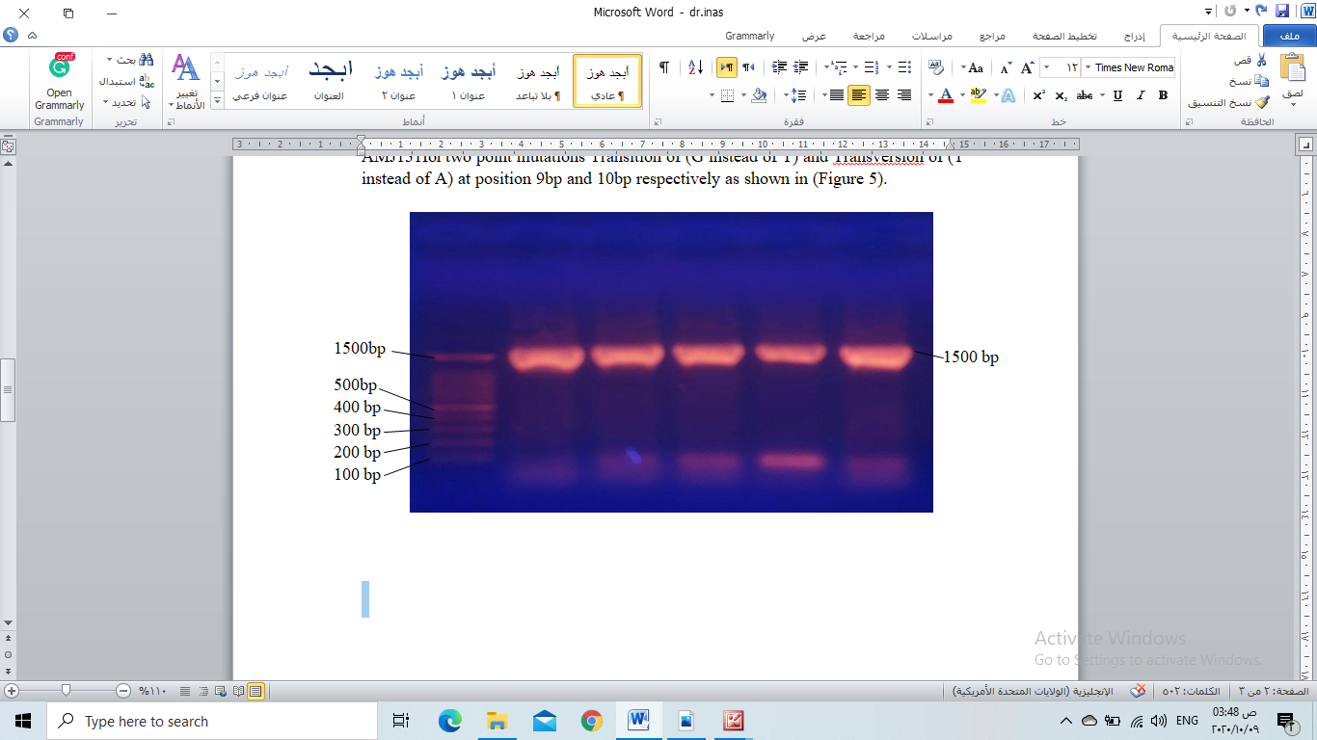

Figure 1: the Agarose gel electrophoresis of the 16SrDNA gene for each bacterial isolate.

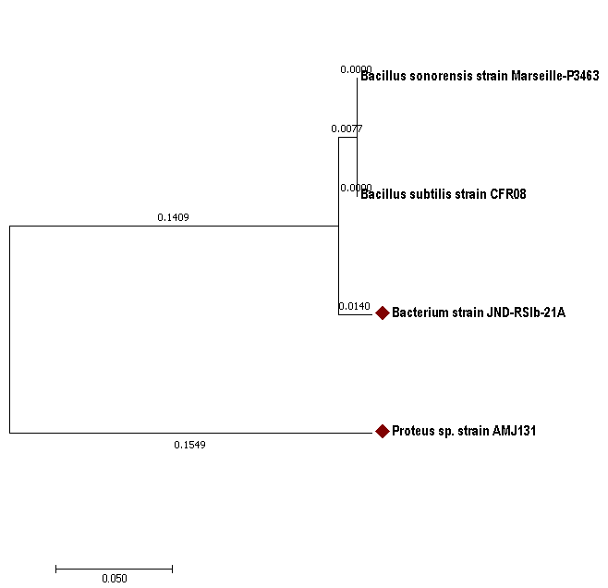

Figure 2. The phylogenetic tree for the bacterial isolates, newly recorded isolates

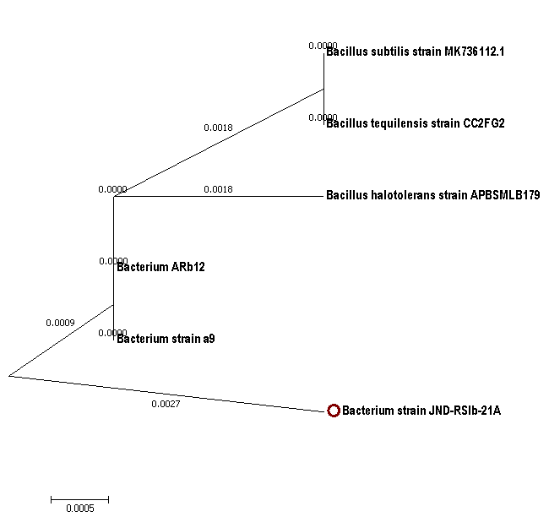

Figure 3: Phylogenetic tree for newly recorded isolate *Bacterium* strain JND-RSlb-21A

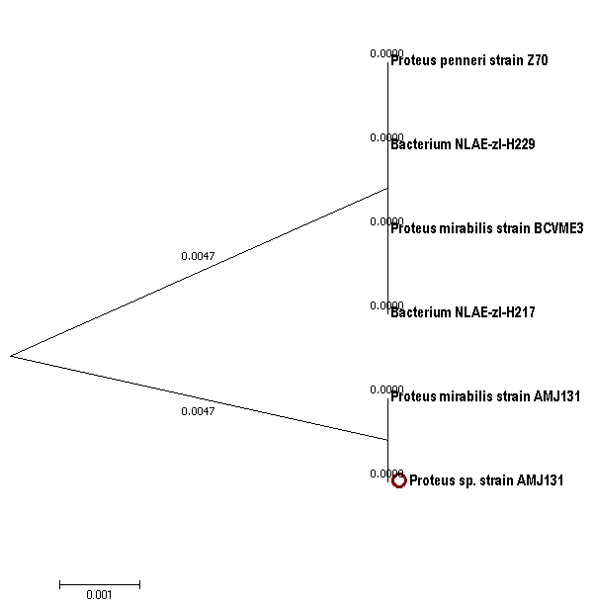

Figure 4: Phylogenetic tree for newly recorded isolate  *Proteus sp.* strain AMJ131

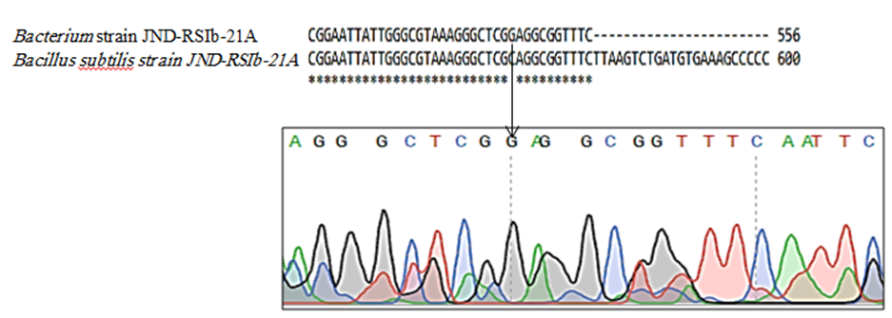

Figure 5:. Comparison of 16S rDNA nucleotide sequences (556 bp) for the isolate *Bacterium strain* JND-RSIb-21A from present study and *Bacillus subtilis* strain JND-RSIb-21A. A gene or point mutation type Transversion (G instead of C) at the position 445 bp.

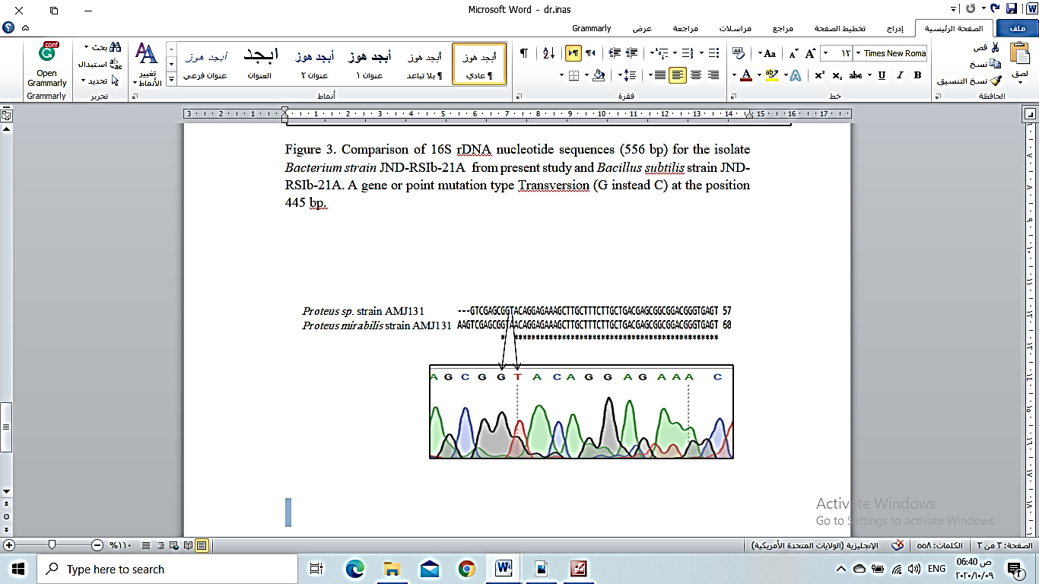

Figure 6: Comparison of 16S rDNA nucleotide sequences (539 bp) for the isolate *Proteus sp.* strain AMJ131 from the present study and *Proteus mirabilis strain AMJ131* gene or two-point mutation type Transition (G instead of T) and Transversion (T instead of A) at the position 9 bp and 10 bp respectively.

**4.0 DISCUSSION**

Respiratory infections are one of the most common causes of infectious disease-related morbidity and mortality worldwide (21) .Proteus belongs to the family Enterobacteriaceae and tribe of Proteeae (22).  In the late 19th century, Hauser was reported characterized the first isolates of *Proteus* (23). Proteus was isolated from sputum cultures according to the morphological and microscopical features, biochemical and APi 20 E tests confirm (24). The microorganisms in soil are very important to the planet in our lives, according to their role in the nutrient cycles (25). Therefore, soils rich in nutrients condidered a fertile environment for a wide range of microorganisms, but the number of bacteria in the soil exceeds the total of other populations of microorganisms in number and type. (26). *Enterobacter* spp., *Pseudomonas* spp.,*Ralstonia* spp., *Proteus* spp., *Aeromonas* spp., *Burkholderia* spp., *Pantoea* spp., *Raoultella* spp., *Achromobacter* spp., *Escherichia coli* and *Leclercia* spp. respectively isolated from the soils of Iraq(27). Rapid replication of DNA from less starting material by PCR makes it more sensitive techniques for detection bacterial species. PCR-based identification of bacterial DNA and sequencing of the 16S rRNA gene has become a standard molecular method and highly specific to each bacterial species. PCR-based methods are used for identification of bacteria that are difficult to grow in laboratory conditions (28). . The 16S rRNA gene that is commonly used for identification and classification of microbes from environmental samples. In this study we use this gene for the identification of different isolates from soil and human respiratory system. The 16S rRNA gene could be used as a phylogenetic marker because of its functional constancy and the presence of conserved and variable sequence regions evolving at very different rates (29).A phylogenetic tree is a diagram refer to evolutionary relationships among different species based on similarities and differences in their genetic characteristics. The phylogenetic tree was designed according to the bacterial isolates which showed 99% or 100% similarity with the type strains, giving two bacterial isolates as new strains, in this study (Figure 2) for the phylogenetic tree of the isolates illustrate. The *Bacillus sonorensis* strain Marseille-P3463 are closely related to *Bacillus subtilis* strain CFR08 but differ from newly recorded strain *Bacterium* strain JND-RSlb-21A and *Proteus sp.* strain AMJ131 because of the changing in 16s rRNA gene as a result of mutation (20). To explain the relationship between newly recoded isolates with other strain we draw two phylogenetic tree (Figure 3) shows the newly recorded strain *Bacterium* strain JND-RSlb-21A differ from other strain selected from GenBank (*Bacillus subtilis* strain MK736112.1, *Bacillus tequilensis* strain CC2FG2, *Bacillus halotolerans* strain APBSMLB179, *Bacterium* ARb12, *Bacterium* strain a9) which were isolated from the various sources, and that may be for transversion point mutation (G instead of C) at the position 445 bp as mention above in (Figure 5). The newly recorded strain *Proteus sp.* strain AMJ131 is closely related to *Proteus mirabilis* strain AMJ131 as illustrate in phylogenetic tree (Figure 4 ) but it differ from other strain from different sources selected from GenBank (*Proteus penneri* strain Z70, Bacterium *NLAE-zl-H229*, *Proteus mirabilis* strain BCVME3, *Bacterium* NLAE-zl-H217) and that difference explain according to two-point mutations Transition of (G instead of T) and Transversion of (T instead of A) at position 9bp and 10bp as in (Figure 6) (20; 30). A mutation is a permanent alteration in the sequence of the nitrogen base of the DNA that is generally may change the end product of the specific gene, mutations lead to change the genes that are very important in the bacterial evolution and that make a differ in the distribution of isolates in the phylogenetic tree. Mutations may occur by exposure of the bacteria to certain environmental factors such as radiation and chemical mutagens. Also, overuse of broad-spectrum antibiotics leads to a mutation and emergence of a new strain such as in bacteria isolated from humans such as the urinary tract (20).

**5.0 CONCLUSION**

Respiratory infections are the most prevalent and a chronic health problem in humans all over the world. Different bacterial species have the important role in the environment especially in soil. In this study,  new bacterial strains were isolated from the soil samples of pharmacy college garden and patients with respiratory infections belonging to *Bacterium* strain JND-RSIb-21A *and Proteus sp.* strain AMJ131 respectively. Result of 16S rRNA analysis showed that *Bacterium* strain JND-RSIb-21A with Accession number MW013547.1 which closely related (99.8%) with *Bacillus subtilis strain JND-RSIb-21A and Proteus sp.* strain AMJ131 with Accession number MW015095.1 which closely related (99.8%) to *Proteus mirabilis* strain AMJ131.

**REFERENCES**

**1.**Penner, J. L. (2005). “Genus XXIX. Proteus,” in Bergey’s Manual of Systematic Bacteriology. The Proteobacteria: Part B, the Gammaproteobacteria, 2nd Edn., eds D. J. Brenner, N. R. Krieg, J. T. Staley and G. M. Garrity (Philadelphia, PA: Lippincott Williams & Wilkins), 745–753. Pereira, C. S., Thompson, J. A., and Xavier, K. B. (2013). AI-2- Mediated Signalling in Bacteria. FEMS Microbiol. Rev. 37; 156–181.

**2.**Wang, S., Zhang, Y., Zhang, X. and Li, J. (2020). An Evaluation of Multidrug-Resistant (MDR) Bacteria in Patients with Urinary Stone Disease: data from a high-volume stone management center. World J. Urol. ;38(2):425-432.

**3.**Drzewiecka, D. (2016). Significance and Roles of *Proteus* spp. Bacteria in Natural Environments. Microb. Ecol.72; 741-758.

**4.**O’hara, C. M., Brenner, F. W., and Miller, J. M. (2000). Classification, Identification and Clinical Significance of *Proteus, Providencia*, and *Morganella*. Clin. Microbiol. Rev. 13; 534–546.

**5.**Jamil, R. T., Foris, L. A. and Snowden, J. (2020). “*Proteus mirabilis* Infections,” in StatPearls. (Treasure Island, FL: StatPearls Publishing). Available online at: <https://www.ncbi.nlm.nih.gov/books/NBK442017/->

**6.**Hamilton, A. L., Kamm,M. A.,Ng,S. C., Morrisond, M. (2018).*Proteus* spp. as Putative Gastrointestinal Pathogens. Clinical Microbiology Reviews ; 31( 3): e00085-17

**7.**Kapoor, R., Giri, B. and Mukerji, K.G. (2002). Soil Factors in Relation to Distribution and Occurrence of Vesicular Arbuscular Mycorrhiza. In: Mukerji KG, Manoharachari C, Chamola BP (eds) Techniques in mycorrhizal studies. Kluwer, Dordrecht, pp 51–85

**8.**Paul, E.A.,Clark, F.E. (1989). Soil Microbiology and Biochemistry. Academic Press, San Diego Payne JW (1981) Denitrification. Wiley, New York

**9.**Parker,S.S.(2010). Buried Treasure:Soil Biodiversity and Conservation, Biodivers.Conserv.;19:3743-3756.

**10.**Benizri, E., Dedourge, O., Di Battista-Leboeuf, C., Nguyen, C.S., Piutti, Guckert, A. (2002). Effect of Maize Rhizodeposits on Soil Microbial Community Structure. Appl Soil Ecol 21:261–265.

**11.**Thiele-Bruhn,S.,Schloter,M.,Wilke,B.,Beaudette,L.A.,Martin-Laurent,F., Cheviron, N., Mougin, C. and Römbke, J.(2020). Soil Identification of New Microbial Functional Standardsfor Soil Quality Assessment. SOIL; 6: 17–34.

**12.**Gupta,A.,Sao,S.,Kataria,R. and Jain, Y. (2017). Isolation, Identification and Characterization of Antibiotic Producing Bacteria from Soil At Dr C V Raman University Campus Bilaspur (C.G.). World Journal of Pharmaceutical Research;6 (8): 1004-1011.

**13.**Castro-Escarpulli, G.; Alonso-Aguilar, N.M.; Rivera, G.; Bocanegra-Garcia, V.; Guo, X.; Jurez-Enrquez, S.R.; Luna-Herrera, J.; Martnez, C.M.; Guadalupe, A.-A.M. (2016). Identification and Typing Methods for The Study of Bacterial Infections: A Brief Reviewand Mycobacterial as Case of Study. Arch. Clin. Microbiol.; 7, 1-10.

**14.** Franco-Duarte,R. , Cern áková, L. , Kadam, S. , Kaushik, K. S., Salehi, B. , Bevilacqua, A. , Corbo, M. R. , Antolak, H. , Dybka-St ˛epie ´n, K. , Leszczewicz, M., Tintino, S. R. , Alexandrino de Souza, V. C.,Sharifi-Rad, J. , Coutinho, H. D. , Martins, N. and Rodrigues, C. F.(2019). Advances in Chemical and Biological Methods to Identify Microorganisms-From Past to Present.Microorganisms; 7,130: 1-32.

**15.**Badi, E. A.(2011). Isolation and Identification of *Nocardia* spp.from Soil Emphasizing on Development of Highly Producing Antimicrobial and Antitumor Strains.Ph.D.Thesis, University of Basra, Basra, Iraq.

**16.**Singh, M., Sandhu, R. S. and Randhawa, H. S. (1987). Comparison of Paraffin Baiting and 218 AL-Qadisiyah Journal of pure Science Vol.23 No. 2 Year 2018 6 conventional culture techniques for isolation of Nocardia asteroids from sputum. J. Clin. Microbiol. 25(1): 176-177.

**17.**Nazar,M.,Jassim,M.Al-Hassan and Pridham,T.C.(1986). Thermodurant Sandy Desert Soil Streptomyces from Plant Rhizosphere Exposed to Natural Gas. J. Univ. Kuwait, 13:220-225.

**18.**Benson, H. J. (2002). Microbiological Applications. Laboratory Manual in General Microbiology. 8 thed., The McGraw Hill companies, Inc. 1221 Avenue of the Americas, New York, NY 10020.

**19.**Forbes, B. A.; Sahm, D. F. and Weissfeld, A. S. (2007). Bailey and Scott's Diagnostic Microbiology. 12th ed. Mosby Elsevier.

**20.**Al-abbas, M. J. A. and Jasim, N. (2016) Molecular Study of Urinary Tract Infection Bacteria and their Relationship to the Present of Oxalobacter formigenes in Stool of Kidney Stone Patients. American Scientific Research Journal for Engineering, Technology, and Sciences; 26, (1): 230-249.

**21**. Al-Zain Ahmed,S. M., Abdelrahman, S. S., Saad, D. M., Osman, I.S., Osman, M.G. and Khalil, E.A.G. (2018).Etiological Trends and Patterns of Antimicrobial Resistance in Respiratory Infections. The Open Microbiology Journal; 12: 34-40.

**22.**Murray, P.R., E.J. Baron, M.A., Pfaller, F.C.Tenover, and R.H. Yolken. (1999). Manual of clinical Microbiology. 7th edition. P. 116-135.

**23.**Manos J, Belas R. 2006. The genera Proteus, Providencia, and Morganella, p 245–269. In Dworkin M, Falkow S, Rosenberg E, Schleifer K-H, Stackebrandt E (ed), The prokaryotes. Springer, New York, NY.

**24.**Al-Bassam, W. W. and Al-Kazaz, A. (2013). The Isolation and Characterization of *Proteus mirabilis* from Different Clinical Samples. Journal of Biotechnology Research Center; 7 (2): 24-30.

**25.**Jansson, J. K., and Hofmockel, K. S. (2018). The Soil Microbiome-from Metagenomics to Metaphenomics.Curr.Opin.Microbiol.;43: 162–168.

**26.**Afrah A. L. (2018). The Biological Effect on Archaeological Pieces of the Soil. Archaeological and Historical Studies j.;5(13).

**27.**AL-Sudani1, S. F.K. and Alash, S. A. (2020). The Prevalence of Bacterial Species Isolated from Iraqi Soils. Annals of Tropical Medicine & Public Health; 23 (10).

**28.**Fouad, A.F., Barry, J., Caimano, M., Clawson, M., Zhu, Q., Carver, R., Hazlett, K. and Radolf, J.D. (2002). PCR-Based Identification of Bacteria Associated with Endodontic Infections. J. Clin. Microbiol.; 40: 3223–3231

**29.**Mukhtar, A. A. *et al.* (2018). Identification of *Proteus Mirabilis* on Banknotes Using 16s rRNA gene in Khartoum State. Sudan Journal of Medical Sciences; 13(3):175.

**30.**Das, P. *et al.* (2019). Isolation and Characterization of Marine Bacteria from East Coast of India: Functional Screening for Salt Stress Tolerance. Heliyon; 5(6):1869.