THE USAGE OF MITOMYCIN-C WITH PHOTOREFRACTIVE KERATECTOMY IN MYOPIC PATIENTS AND ITS EFFECT ON DENSITY OF CORNEAL ENDOTHELIUM
Ahmed Mohammed Al-Samak
MB, ChB, CABOphth, Lecturer of Ophthalmology at Al-Zahraa College of Medicine, University of Basrah, Basrah, Iraq.
Sajid Yousef Shehab
MB, ChB, CABOphth, Lecturer of Ophthalmology at College of medicine, University of Basrah, Basrah, Iraq.
Hashim Al Ameedee
MB, ChB, CABOphth, Professor of ophthalmology at Kufa University, Najaf, Iraq.

Original Article
Correspondence to: Ahmed M. Alsamak: +9647822114665, ahmed.abood@uobasrah.edu.iq
Mailing address: Al-Zahraa College of medicine, University of Basrah, Bab Alzubair, Basrah, Iraq
Number of pages: 6
Number of words: 1800
Number of tables: 2
Number of figures: 2

Abstract
Purpose: To evaluate the application of mitomycin-C on the density of corneal endothelialium after photorefractive keratectomy (PRK) in myopia patients.
Methods: We use case control study to evaluate 92 eyes of 46 patients (23 cases and 23 controls) with mean age of 27.6 years for cases group and 27.4 for control group (range: 20 - 40). All patients were myopic ranged from -3.00 to -6D underwent photorefractive keratectomy (PRK). The first group (cases) was treated with single usage of mitomycin-c for 30 seconds and second group (control) group was treated without mitomycin-c. The assessment was done by specular microscope before the procedure and after 3 months postoperatively for each eye to evaluate the density in corneal endothelialium (ECD) in both each group.
Results: Forty-six eyes of 23 cases and forty-six eyes of 23 control patients with myopia were treated with photorefractive keratectomy. After three months of surgery the mean ECD was decreased significantly.
Conclusion: The use of mitomycin-c for 30 seconds in myopic patients treated by PRK would affect corneal endothelial cell density after three months postoperatively.
Key words: endothelial cell density (ECD); mitomycin-c; myopia; photorefractive keratectomy (PRK).

Introduction: Over many years, mitomycin-c has been used to reduce corneal haziness after photo-
ablation and in the treatment of already existing haziness ¹. Corneal haziness after
photo- ablation may be the result of the healing process ² that was probably initiated
by keratocytes proliferation³. Mitomycin-C stop cells from proliferation by cross-
linking DNA ⁴. Mitomycin-C has hold the proliferation of keratocytes ⁵ and widely
used during many types of surgeries including pterygium removal, trabeculectomy,
and surface ablation surgeries. Mitomycin-C has a disadvantage of potential damage
to many types of corneal cells types including limbal cells, and endothelia. Many
clinical^{6, 7} and laboratory^{8, 9} researches have reported significant corneal endothelial
toxicity.
Patient and method:
We use case control study to evaluate 92 eyes of 46 patients, 23 cases (50%) and 23
controls (50%), with mean age of 27.6 years for cases group and 27.4 for control
group (range: 20 - 40). Female were 16 cases and 17 controls .All patient were
myopic ranged from -3.00 to -6.00D.Preoperative assessment of all patients were
done that include history, visual acuity, manifest and cycloplegic refraction, slit lamp
biomicroscopy, fundus examination, intraocular pressure by air puff tonometry,
central corneal pachymetry, corneal topography by Sirus topographer, Specular
microscopy (EM 3000, TOMY) to measure the density corneal endothelial cells
(ECD). All these were performed by the same operator.
Inclusion criteria
Myopic patients of same refractive error in both eyes ranged from -3 to -6 D
Exclusion criteria
keratoconus, corneal dystrophy, previous ocular trauma or surgery, cataract,
glaucoma, retinal diseases and severe dry eye were excluded from our study as these
are contraindications of photorefractive surgery.
Surgical technique
All patients were treated by photorefractive keratectomy by two ophthalmologist (at
AL Basira eye center/ Basra / Iraq) using Carl Zeiss Mel 90 excimer laser machine.
Topical anesthetic eye drops was used .The removal of corneal epithelium was done
by hockey spatula. Then the ablation was done with optical zone of 6.0 mm and
manifest refractive error was taken as our target for correction in all patients. After
that, a sponge soaked with mitomycin-C 0.02% (0.2 mg/mL, diluted in normal saline),
was put over the treated area for 30 seconds in the first group followed by copious
irrigation with normal saline, and finally we put a contact lens.
Follow-up period:
After surgery, all patients were given steroid/antibiotics eye drops
(tobramycine+dexamethasone) every 4 hours, artificial tears eye drops (tear natural II)
for 5 days. After 3 to 5 days the contact lens was removed. Then dexamethasone eye
drop 0.1% 6 hourly for 4 weeks.
The schedule of follow-up examinations were set 1, 5, 14, 30 days and 3 months after
surgery, and we assess visual acuity and manifest refraction, and tonometry. Specular
microscopy was repeated 3 months after surgery.
The same were done for the second control group except the application of
mitomycin-C and the patients was given the same eye drops and follow up
examinations were set 1, 5, 14,30 days and 3 months. Specular microscopy was
repeated 3 months after surgery.
Result
All patients had success photorefractive surgery with an average surgery time of 10-
15 minutes and peaceful follow-up period without any complication in both group.
The analysis was performed using the Statistical Package for the Social Sciences
(SPSS) version 23 software.
Ninety-two eyes of 46 patients (23 cases &23 controls) with mean age of 27.6 years
for cases group and 27.4 for control group (range: 20 - 40). Female were 16 (69.6%)
cases and 17 controls (73.9%) as in the figure (1) and (2).

Figure (1) sex distribution of cases group:
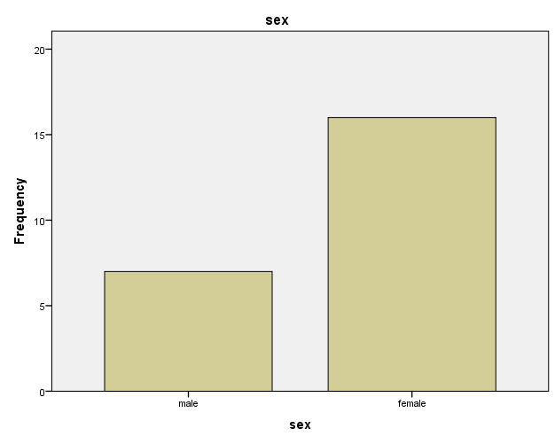

Figure (2) shows the sex distribution among control group:
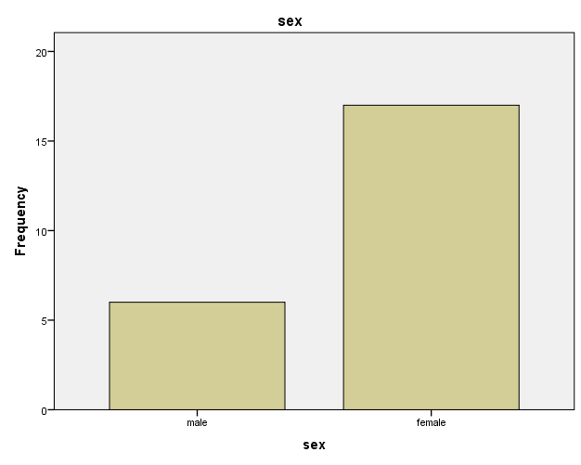
All patient were myopic ranged from -3.00 to -6.00D with mean refraction of -4.57 D
for cases group and -4.23 D for control group without differences regarding between
central corneal thickness, and ablation depth between both groups.
For patients with mitomycin-c, 3 months after the procedure the mean ECD was
reduced by 6.4% (p=0.01) from 2865.12 cells/mm² to 2679.32 cells/mm² for right eye
and 5.1 %( p=0.02) from 2764 cells/mm² to 2623 cells/mm² for the left eye as show in
table (1) below.
Table (1) the mean corneal endothelial cell density of cases group
Eye | ECD prePRK | ECD AFTER 3MONTHS | P value
Right | 2865.12 | 2679.32 | 0.01
Left | 2764 | 2623 | 0.02

The mean ECD change insignificantly in the control group (without mitomycin-c) 3
month after the procedure from 2745 cells/mm² to 2662 cells/mm² for the right eye
(3.02%) and from 2754 cells/ mm² to 2676 for the left eye (2.83%) as shown in table 2.
Table (2) the mean corneal endothelial cell density of control group
The Eye | ECD prePRK | ECD AFTER 3 MONTHS
Right Eye | 2745 | 2662
Left Eye | 2754 | 2676

Discussion
Several researches have studied the application of mitomycin-c during photorefractive
surgery and its effect on the corneal endothelium density. Although, most of these
researches have concluded that insignificant reduction in corneal endothelium density
with observation time from 3 to 18 months but with less application time^{10, 11,12,13}.
In contrast, clinical researches that found the application of mitomycin-c in
photorefractive surgery causes significant reduction in corneal endothelium density
are few in number and more recent. Two recent articles found significant decrease of
endothelial central density after PRK with mitomycin-c ^{6, 7}. Nassiri et al⁷ found that
usage of 0.02% mitomycin-c led to significant decrease in corneal endothelial cell
after a 6-month period and correlated with the application time of mitomycin-c during
procedure. Morales et al⁶ determined that 0.02% mitomycin-c application of 30
seconds caused significant reduction of corneal endothelium density after 3 months.
In our research we found the reduction in ECD was 6.4% in the RE and 5.1% in the
LE after 30 seconds application time of mitomycin-c while the control eyes show
reduction rate 3.02% in the RE and 2.83% in the LE.
In the prime operation, the application time of mitomycin-c were twelve seconds to
two minutes. Due to the interest about mitomycin-c benignity, a chain of alterations
on the application of mitomycin-c have been proposed which conducted to reduce the
application time of mitomycin-c with the target of haziness inhibition and least toxic
effects.
Application of mitomycin-c 0.02% for 12 seconds with PRK had no significant effect
on endothelial cell density or qualitative morphometric parameters¹⁰.
If the concentration is high, mitomycin-c can be toxic to cornea ^{14, 15, 16}.
Conclusion: The use mitomycin-c 0.02% for 30 seconds with PRK in myopic patients would affect
central corneal endothelial cell density after three months postoperatively.
So it is recommended to assess the corneal endothelial cell density in any suspected
cases prior to any type of ocular surgery that needs adjuvant application of the
mitomycin-c especially in the old patient or patient with history of trauma and take a
special interest to the time of application.

References
- Caroline Piva ,Marcony R. Santhiago , Mitomycin C application in refractive surgery , Rev. bras.oftalmol. vol.74 no.6 Rio de Janeiro Nov. /Dec. 2015.
- Hassan Hashemi,corresponding author1,2 Seied Mohammad Reza Taheri,2 Akbar Fotouhi,3 and Azita Kheiltash2, Evaluation of the prophylactic use of mitomycin-C to inhibit haze formation after photorefractive keratectomy in high myopia: a prospective clinical study , BMC Ophthalmol. 2004; 4: 12.Published online 2004 Sep 14.
- Winker Von Mohrenfels C, Reischl U, Lohmann CP. Corneal haze after photorefractive keratectomy for myopia: role of collagen IV mRNA typing as a predictor of haze. J Cataract Refract Surg. 2002; 28:1446–1451.
- Hata T, Hoshi T, Kanamori K, Matsumae A, Sano Y, Shima T, Sugawara R (1956) Mitomycin, a new antibiotic from Streptomyces. I. J Antibiot (Tokyo) 9 (4):141-146
- Katzung BG. Clinical pharmacology. San Mateo, CA: Appleton and Lange; 1988
- Morales AJ, Zadok D, Mora-Retana R, Martínez-Gama E, Robledo NE, Chayet AS. Intraoperative mitomycin and corneal endothelium after photorefractive keratectomy. Am J Ophthalmol. 2006;142:400–404
- Nassiri N, Farahangiz S, Rahnavardi M, Rahmani L, Nassiri N. Corneal endothelial cell injury induced by mitomycin-C in photorefractive keratectomy: nonrandomized controlled trial. J Cataract Refract Surg. 2008; 34:902–908.
- McDermott ML, Wang J, Shin DH. Mitomycin and the human corneal endothelium. Arch Ophthalmol. 1994; 112:533–537.
- Wu KY, Hong SJ, Huang HT, Lin CP, Chen CW. Toxic effects of mitomycin-C on cultured corneal keratocytes and endothelial cells. J Ocul Pharmacol Ther. 1999; 15:401–411.
- Goldsberry DH, Epstein RJ, Majmudar PA, Epstein RH, Dennis RF, Holley G, Edelhauser HF (2007) Effect of mitomycin C on the corneal endothelium when used for corneal sub epithelial haze prophylaxis following photorefractive keratectomy. J Refract Surg 23 (7):724-727
- Zhao LQ, Wei RL, Ma XY, Zhu H (2008) Effect of intraoperative mitomycin-C on healthy corneal endothelium after laser-assisted sub epithelial keratectomy. J Cataract Refract Surg 34 (10):1715-1719. doi:10.1016/j.jcrs.2008.06.016
- Gambato C, Ghirlando A, Moretto E, Busato F, Midena E (2005) Mitomycin C modulation of corneal wound healing after photorefractive keratectomy in highly myopic eyes. Ophthalmology 112 (2):208-218; discussion 219. doi:10.1016/j.ophtha.2004.07.035
- Zare M, Jafarinasab MR, Feizi S, Zamani M (2011) The effect of mitomycin-C on corneal endothelial cells after photorefractive keratectomy. Journal of ophthalmic & vision research 6 (1):8-12
- Thornton I, Xu M, Krueger RR (2008) Comparison of standard (0.02%) and low dose (0.002%) mitomycin C in the prevention of corneal haze following surface ablation for myopia. J Refract Surg 24 (1):S68-76.
- J J Khong and J Muecke. Complications of mitomycin C therapy in 100 eyes with ocular surface neoplasia. Br J Ophthalmol. 2006 Jul; 90(7): 819–822.
- COPPENS G., MAUDGAL P. Corneal complications of intraoperative mitomycin C in glaucoma surgery. Bull. Soc. belge Ophtalmol., 314, 19-23.

