Research Report Open Access
Occurrence of Two Grunt Fish (Haemulidae: Pomadasys) from the Iraqi Marine Waters
Abbas J. Al-Faisal , Falah M. Mutlak
Marine Science Centre, University of Basrah, Basrah, Iraq
Corresponding author email: abbasjsm71@yahoo.com
International Journal of Marine Science, 2018, Vol.8, No.21 doi: 10.5376/ijms.2018.08.0021
Received: 10 Jul., 2018
Accepted: 26 Jul., 2018
Published: 04 Aug., 2018
Copyright © 2018 Al-Faisal and Mutlak, This is an open access article published under the terms of the Creative Commons Attribution License, which permits unrestricted use, distribution, and reproduction in any medium, provided the original work is properly cited.
Preferred citation for this article:
Al-Faisal A.J., and Mutlak F.M., 2018, Occurrence of two grunt fish (Haemulidae: Pomadasys) from the Iraqi marine waters, International Journal of Marine Science, 8(21): 172-175 (doi: 10.5376/ijms.2018.08.0021)
Abstract The new record of Pomadasys commersonnii (Lacepède, 1801) and second appearance of Pomadasys aheneus McKay & Randall, 1995 are reported from the Iraqi marine waters, northwest of the Arabian Gulf. Total length of P. aheneus was 200 mm, while the total length of P. commersonnii was 240 mm. The Yellowback grunt (P. aheneus) could be distinguished by the brassy color on nape, anterior part of back, and upper sides, dorsal fin with 13 spines and 14 soft rays and pectoral fin with 13 rays. Whilst The Smallspotted grunter (P. Commersonnii) characterized by the body is relatively elongate, the color is silvery with small black spots on upper of body and Dorsal fin with 11 spines and 13 soft rays.
Keywords New record; Haemulidae; P. aheneus; P. commersonnii; Arabian Gulf
Background
The family Haemulidae (Perciformes) is commercially important fishes, there are 134 species belong to 19 genera distributed widely in the world (Eschmeyer and Fong, 2018). The English names of grunts, due to their ability to produce loud sounds by rubbing their pharyngeal teeth together (Tavera et al., 2012). Haemulidae be characterized by oblong and compressed body, head profile strongly convex, scales present on entire head except tip of snout, lips, and chin, mouth small or moderate, chin with two pores anteriorly and a median pit or six pores and no pit, dorsal fin single, with nine to 15 strong spines and 12 to 26 soft rays, anal fin with three spines and seven to nine soft rays, caudal fin truncate or emarginate, pelvic fins below base of pectoral fins, with one spine and five soft rays, pectoral fins long, scales ctenoid, small or moderate (Carpenter and Niem, 2001).
The genus Pomadasys Lacépède, 1802 be characterized by presence two pores in chin followed by a pit containing a pore on each side. Pomadasys contains 34 species with a very wide distribution. P. aheneus was known only from Gulf of Oman, it has also been recorded in Pakistan (Psomadakis et al., 2015) and Arabian Sea (Bogorodsky and Manilo, 2003), recently recorded from the northern Arabian Gulf off Iraq according to the short communication of Ali and Iwatsuki (2018), whereas P. Commersonnii distributed in the western Indian Ocean, South Africa and Madagascar (Froese and Pauly, 2018).
The species of Haemulidae have been identified from the Iraqi marine waters and the Arabian Gulf by many studies (Khalaf, 1961; Mahdi, 1962; Al-Daham, 1982; Abe and Kuronuma, 1986; Carpenter et al., 1997; Mohamed et al., 2001; Bishop, 2003; Iwatsuki et al., 2013). In this study, we described P. aheneus and P. commersonnii by the morphological characteristics from the Iraqi marine waters.
1 Materials and Methods
Two specimens of grunt fish (P. aheneus and P. commersonnii) were collected during November 2017 and May 2018 from the Iraqi marine waters, northwestern Arabian Gulf (Figure 1), depending on commercial fishery, by using trawl net. Seven meristic characters were counted employing dissection microscope and 19 morphometric characters were measured to the nearest mm by using fish measuring board and digital vernier following Carpenter et al. (1997). The specimens are deposited in the Marine Science Centre, University of Basrah, Iraq.
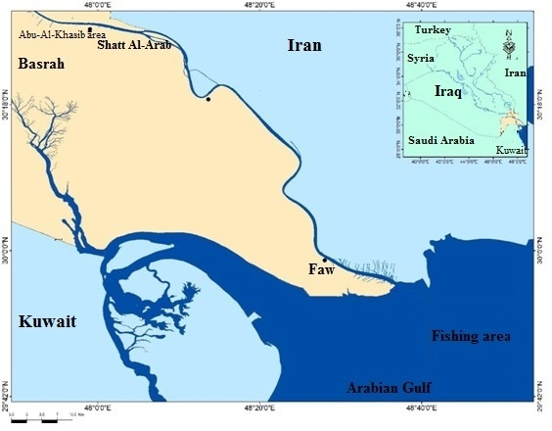

Figure 1 A map showing fishing area in the Iraqi marine waters
2 Results
2.1 Classification section
Class: Actinopterygii
Order: Perciformes
Family: Haemulidae
Genus: Pomadasys Lacepède, 1802
Species 1: Pomadasys aheneus McKay and Randall, 1995
Species 2: Pomadasys commersonnii (Lacepède, 1801)
2.2 Description
Table 1 and Table 2 show the morphometric and meristic characteristics of two grunt fish species from the Iraqi marine waters.
Table 1 Morphometric characters of P. aheneus and P. commersonnii from the Iraqi marine waters
Morphometric characters | P. aheneus | P. commersonnii
Total length (mm) | 200 | 240
Fork length (mm) | 198 | 221
Standard length [SL] (mm) | 160 | 192
Body depth% in SL | 42.61 | 33.50
Body width% in SL | 16.96 | 12.76
Head length% in SL | 35.44 | 36.86
Head depth% in SL | 32.22 | 27.65
Head width% in SL | 17.33 | 13.51
Snout length% in SL | 10.52 | 12.96
Eye diameter% in SL | 10.19 | 8.14
Interorbital distance% in SL | 7.85 | 8.04
Predorsal length% in SL | 37.29 | 34.90
Postdorsal length% in SL | 15.68 | 15.98
fin length% in SL Dorsal | 55.73 | 52.34
Anal fin length% in SL | 15.27 | 15.71
Pectoral fin length% in SL | 35.31 | 33.20
Pelvic fin length% in SL | 24.73 | 23.58
Caudal peduncle length% in SL | 21.91 | 17.92
Caudal peduncle depth% in SL | 11.99 | 9.30
2.2.1 Pomadasys aheneus
Total length of the specimen was 200 mm. Body depth 42.61% in standard length and compressed 16.96%. Head length 35.44%. Mouth small, terminal, without fleshy lips. Snout length 10.52% close to eye diameter 10.19%. Chin with two pores and a median pit, jaw teeth villiform. Dorsal fin with 13 spines and 14 soft rays, anal fin with three spines and eight soft rays. Pectoral fin has 13 rays. Gill rakers 7 on upper limb and 14 on lower limb of first gill arch. The color was brassy yellow on nape, anterior part of back, and upper sides, caudal fin and most of rayed dorsal fin blackish (Figure 2).
Table 2 Meristic characters of P. aheneus and P. commersonnii from the Iraqi marine waters
Meristic characters |  |  | P. aheneus |  | P. commersonnii
Dorsal fin spines |  |  | 13 |  | 11
Dorsal fin rays |  |  | 14 |  | 13
Anal fin spines |  |  | 3 |  | 3
Anal fin rays |  |  | 8 |  | 8
Pectoral fin rays |  |  | 13 |  | 17
Pelvic fin rays |  |  | 5 |  | 5
Gill rakers | upper raw |  | 7 |  | 7
 | lower raw |  | 14 |  | 14
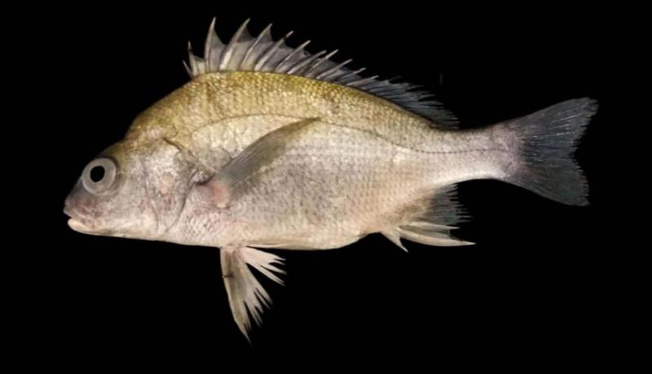

Figure 2 Pomadasys aheneus from the Iraqi marine waters
2.2.2 Pomadasys commersonnii
Total length 240 mm. Body relatively elongate its body depth 33.50% in standard length, Body width 12.76%. Head length 36.86%. Snout pointed its length 12.96%. Eye diameter 8.14%. Mouth small. Two pores and a median pit on chin. Dorsal fin with 11 spines and 13 soft rays, Pectoral fin has 17 rays, anal fin with three spines and eight soft rays. Gill rakers 7 on upper limb and 14 on lower limb of first gill arch. The color was silvery with small black spots on upper of body and on nape (Figure 3).
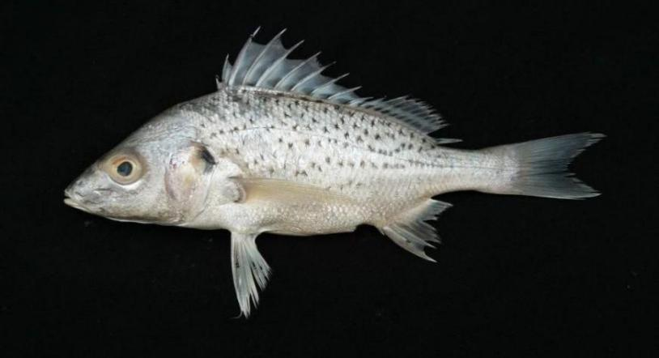

Figure 3 Pomadasys commersonnii from the Iraqi marine waters
3 Discussion
The genus Pomadasys is different from other genera of Haemulidae by presence two pores in chin followed by a pit containing a pore on each side, while the rest have six pores and no pit (Carpenter and Niem, 2001). Several species of Pomadasys known from northern Arabian Gulf off Iraq, P. argenteus (Forsskål, 1775), P. kaakan (Cuvier, 1830), P. maculatus (Bloch, 1793), P. olivaceus (Day, 1875), P. punctulatus (Rüppell, 1838) and P. stridens (Forsskål, 1775). The present record of P. aheneus and P. commersonnii is a new addition to list of Haemulidae for Iraq.
The properties of the Yellowback grunt (P. aheneus) and the Smallspotted grunter (P. Commersonnii) in our results agreed with previous studies with some differences in ranges of some meristic characters. P. aheneus is distinct by the brassy color on anterior part of back, and upper sides, dorsal fin with 13 spines and 14 soft rays, anal fin with 3 spines and 8 soft rays and pectoral fin with 13 rays (dorsal fin with 12 spines and 13-14 soft rays and anal fin with 3 spines and 7-8 soft rays in Randall (1995)). The Smallspotted grantor is distinguished by the body is relatively elongate, the color is silver with small black spots on upper body, dorsal fin with 11 spines and 13 soft rays and anal fin with 3 spines and 8 soft rays (dorsal fin with 11-12 spines and 13-16 soft rays and anal fin with 3 spines and 9-10 soft rays in Psomadakis et al. (2015)).
The range extension of P. aheneus and P. commersonnii in the Arabian Gulf and the Iraqi marine waters may due to climate change or some other recent environmental change.
Authors’ contributions
The first and second authors have contributed equally toward the publication of this paper.
Acknowledgments
We would like to thank Marine Science Centre, University of Basrah for giving us the opportunity to use the scientific facilities available.
References
Al-Daham N.K., 1982, The ichthyofauna of Iraq and the Arab Gulf: A check-list, Publications of the Basrah Natural History Museum, 4: 1-102
Ali A.H. and Iwatsuki Y., 2018, Record of the Yellowback Grunt Pomadasys aheneus McKay and Randall (Osteichthyes: Haemulidae) from the Arabian Gulf off Iraq, Short communication, Zoology in the Middle East
https://doi.org/10.1080/09397140.2018.1462600
Bishop J.M., 2003, History and current checklist of Kuwait’s Ichthyofauna, J Arid Environ Vol. 54: 237–256
https://doi.org/10.1006/jare.2001.0874
Carpenter K.E., Krupp F., Jones D.A., and Zajonz U., 1997, FAO species identification guide for fishery purposes, The living marine resources of Kuwait, Eastern Saudi Arabia, Bahrain, Qatar, and the United Arab Emirates, Rome, FAO
Carpenter K.E., and Niem V.H., 2001, FAO species identification guide for fishery purposes, The living marine resources of the Western Central Pacific, Volume 5, Bony fishes part 3 (Menidae to Pomacentridae), Rome, FAO, pp.2791-3380
Eschmeyer W.N., and Fong J.D., 2018, Species by family/subfamily in the Catalog of Fishes, California Academy of Sciences
Froese R., and Pauly D., 2018, Editors, FishBase, World Wide Web electronic publication
Iwatsuki Y., Jawad L.A., Tanaka F., Al-Busaidi H., Al-Mamry J.M., and Al-Kharusi L.H., 2013, Omani fishes collected in the vicinity of Mutrah, Gulf of Oman and Madrakah, southern Oman through 3 to 13 October 2010, Bull. Faculty of Agri., Univ. of Miyazaki, 59: 29-43
Khalaf K.T., 1961, The marine and fresh water fishes of Iraq, Al Rabbita press, Baghdad, pp.104
Kuronuma K., and Abe Y., 1986, Fishes of Arabian Gulf, Kuwait Institute for Scientific Research, Kuwait, pp.357
Mahdi N., Fishes of Iraq, 1962, Ministry of Education, Baghdad, pp.82
Manilo L.G., and Bogorodsky S.V., 2003, Taxonomic Composition, Diversity and Distribution of Coastal Fishes of the Arabian Sea, Journal of Ichthyology, Vol. 43, Suppl. 1: 75-149
Mohamed A.R.M., Hussain N.A., and Ali T.S., 2001, Estuarine components of the ichthyofauna of the Arabian Gulf, Mesopot, J. Mar. Sci. Vol. 16, pp.209-224
Psomadakis P.N., Osmany H.B., and Moazzam M., 2015, Field identification guide to the living marine resources of Pakistan, FAO Species Identification Guide for Fishery Purposes, Rome, FAO. x+386, pp. 42 colour plates
Randall J.E., 1995, Coastal fishes of Oman, University of Hawaii Press, Honolulu, Hawaii, pp.439
Tavera J.J., Acero A., Balart E.F., and Bernardi G., 2012, Molecular phylogeny of grunts (Teleostei, Haemulidae), with an emphasis on the ecology, evolution, and speciation history of New World species, BMC Evolutionary Biology, 12: 57

