SUGGESTING MULTIPATH ROUTING AND DIVIDING THE ZONE TO PROCESSING COMMUNICATION FAILURE IN AD HOC NETWORKS
Assistant Professor Nada Badr Jarah
University of Basra ,Collage of management and economic,
Statistics department-IRAQ
General Specialty: Computer Science
E-mail: nadabadrjarah@yahoo.com

Abstract
Ad hoc networks are characterized by ease of setup, low costs and frequent use in the corporate world and allow the user to remain safe and to maintain the confidentiality of the information circulated, as well as to address the case of communication failure in areas subject to the destruction of communication infrastructure and that the proposed protocols in the ad hoc networks often build only one path to achieve communication between the nodes due to the restrictions of battery run out and the movement of the nodes and this connection is often subject to a failure within a certain range, So multiple alternate paths in ad hoc networks use a solution to fail node communication, in addition, When looking at the situation where interference is widespread , Each path is preferably somewhat distant from the others , In this paper, we present a simple processing by building multipath routing that do not overlap at the level of an ad hoc network zone by dividing the zone , The evaluate by Network Simulator ( ns-allinone-3.20) , which showed that the proposed ad hoc network connection is higher than the connection with the traditional methods of constructing multipath routing.

Key words
Ad hoc , AODV, Multipath routing , Zone

1. Introduction
Research is actively being carried out on ad hoc networks, Which is one of the elements to achieve networking communication everywhere. Ad hoc networks do, as the term implies, create temporary networks and aim to use them only on an ad hoc basis, beginning with military contact in the early 1970s. To emergency situations when large-scale disasters such as earthquakes, floods, and other situations occur, where the infrastructure of the Internet is destroyed , such as several technical .
In ad hoc networks, there are many protocols to achieve communication between nodes in the network where each peripheral device performs routing to obtain routing information and traditionally, Ad hoc On-demand Distance Vector (AODV) is routing protocol of ad hoc networks that creates only one path because of terminal traffic or battery drain , and cutting the connection on the track requires rebuilding, and this takes some time , to solve this problem, protocols that create multipath routing have been suggested , then the data is sent to all paths created at the same time to reduce the communication load for each path [1,2].
There are protocols (AODV , DSR & NDMR) that improve communication by switching paths, which take place immediately after a path is interrupted without looking at the situation in which interruption of communication occurs intermittently in a specific place of the network , therefore, we suggest dividing the ad hoc network area into non-overlapping square zones and creating multipath non-overlapping paths at the zone level , if a connection fails, the path is blocked to a specific domain , the other paths are affected, and collection of information about the paths that pass through a different series of zones the efficient through only one flood, multipath are created from traditional methods using the concept of layers.[2]

2. Literature review
The researchers presented a number of studies by proposing protocols as follows to establish multiple paths to address the node connection failure state in networks. In the paper [3], we provide analysis of the carrier sense range effect on multimedia communication in the WMSNs. Therefore, we present a realistic solution at the routing layer to enhance the QoS/QoE while avoiding any type of multipath coupling effect. Our solution differs from the existing approaches that handle the problem at the MAC layer. Simulations conducted over the Network Simulator NS-2 show promising results in terms of delay, Packet Delivery Ratio (PDR), and QoE.
In paper [4], we specifically address the issues and comparison of various multipath routing protocols and we have also compared the multipath routing protocol (AOMDV) with a unipath routing protocol (AODV) using ns2 to illustrate that multipath routing performs better than unipath routing.
In paper [5], A possible optimization to the DSR and AODV routing protocols was proposed to make no node to be overburdened by distributing the load after finding the alternate multipath routes which were discovered in the Route discovery process. The simulation shows that the differences in the protocol highlighted major differences with the protocol performance. These differences have been analyzed with various network sizes, mobility, and network load. A new search table named Search of Next Node Enquiry Table (SONNET) was proposed to find the best neighbor node. Using SONNET the node selects the neighbor which can be reached in less number of hops and with less time delay and maintaining the QoS.
In paper [6], compared AOMDV (Ad Hoc On-demand Multipath Distance Vector ) with other routing protocols like AODV, DSR , and DSDV. On the basis of simulations, AOMDV performs best as compared to AODV. But, AODV also best suitable when the speed of network nodes is low. Packet dropping rates for AOMDV is less at higher speed rates of network nodes. At last, AOMDV is best recommended in a network, when the speed of nodes is high and also network connections are more.

3. Ad hoc On-demand Distance Vector Routing ( AODV)
It is the routing protocol for mobile stations in an ad hoc network. It has features such as rapid adaptation to dynamic link conditions, low processing and memory load, low network use, and specifies a unicast path to a destination in an ad hoc network. AODV always guarantees there is no loop by use number of Distance Vector to avoid problems that occur in the protocol.[7]
With AODV protocol, the path detection procedure begins when the Source (S) node needs to communicate with the Destination (D). The source node does not have a specific, known path, that starts running Route Discovery . To find the next hop. Gives the Route Request message (referred to as RREQ) which the next hop node receives (hereinafter referred to as the return path) to reach S. As in Figure 1.
The RREQ Received from source S, the return path is set to S. Node B receives RREQ from node A, set the return path to node A, and set it as the next step in the routing table. At this time, paths that are not used to transfer data packets after a certain period of time are voided and are subsequently deleted.
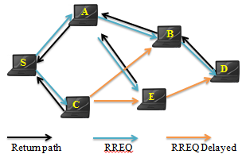
Figure 1. Path discovery with RREQ

Each node has a sequence number called RREQ ID. Which used to give a new loop-free path, S that implements Route Discovery by storing the value obtained by increasing its sequence number in RREQ every time it performs a search.
The RREQ ID is used by each node to determine whether a previously received RREQ and a later recipient RREQ (Delayed RREQ) are involved or not.
Each time Route Discovery is executed in the same way as the serial number. Then S RREQ ID increases and stores in RREQ.
If the RREQ ID of the previously received RREQ and the RREQ ID referred to in the deferred RREQ are the same . Each node specifies that RREQ is a duplicate RREQ and immediately ignores the delayed RREQ. It does not create a rewind path and does not retransmit RREQ. For example, when receiving a RREQ from node C after receiving a RREQ from node A as shown in node B in Figure 1, and since the RREQ ID for source S indicated in RREQ is the same, it is judged as a duplicate RREQ message and is ignored

4. Multipath routing protocols
The main problem experienced by ad hoc networks lies is the routing process, because there is no infrastructure, as each node takes responsibility for routing. Has been in recent years, several traditional routing protocols have been proposed and improvement to these protocols to support the quality of service represented by multipath routing protocols simultaneously. Which provides us with multipath alternative paths in the event of failure of the primary path, each of which follows an independent path selection procedure and determines the best route of routing information between the source node and the destination node.[8,9,10]
Where it is considered the secure multipath routing protocol (SecMR) one of the proposed protocols [8] to counter security attacks for malicious nodes, by increasing the number of nodes that the opponent must solve in order to control communications.
The protocol Dynamic Source Routing protocol (DSR)[9] consists of two mechanisms, path discovery and path maintenance, which work together to allow the contract to detect arbitrary destinations in the routing path in the ad hoc network and It should be free from interference .
The secure routing protocol based on multipath routing technology, namely the Secure Ad Hoc on-Demand Distance Vector (AODV) is AODVsec[10] , which divides a data unit into several data pieces and transmits these pieces through different paths , AODVsec limits the maximum number of data pieces an intermediate node can forward.
5.The proposed method
Multipath methods that do not overlap will be established at the level of a specific ad hoc network zone, where the network is divided into non-overlapping square zones, and the path information is efficiently collected by one flood.[2]
It is assumed that each node knows its own location and the zone identifier to which it belongs using the location coordinates of each node (xi, yi). As a result, even if the path is cut during communication, there is no need to specify the breaking point , The route can be changed immediately without waiting for the routing schedule to be updated. Also, even if a communication failure occurs in a certain range and the path is cut off, other methods are less affected . Then create multipath using the source directive that the source node holds path information. The Source node keeps the special path information for the main path and the path of reserves copy . Each intermediate node also contains a routing table, and when a message is received, it compares the information for each message, updates the routing table, and discards the packet. When the destination node receives RREQ, it specifies the primary path and backup path of RREQ.[7]
Shows Figure 2.Divide the ad hoc network into the proposed method and construct the main path from node S to node D.
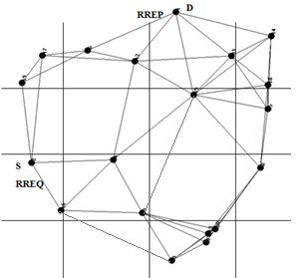
Figure 2. Dividing a ad hoc network into square zones
Below are the steps for implementing the proposed algorithm :
Step 1: Create the master path
    - When a connection request occurs, the source node creates RREQ and broadcasts it over the entire network.
    - The middle node that received the RREQ updates the RREQ information and floods. At this time, the region that has passed through the received RREQ over all regions that have passed from the previously received RREQ, or the same region is included in the region other than the region to which the source node belongs. Ignore this package if it is present.
    - Based on the RREQ information that first reached the destination node, the path through which RREQ has passed is set as the main path.
    - The RREP in which the main transmit path information is written to the source node along the main path.
    - When RREP reaches the source node, the main path information gets recorded in the source routing table.
    - When adding a record for the main path to the source routing table, the connection begins immediately using the log information for the main path, and a routing mark is set so that the path to be contacted can be determined.
Step2: Create path of reserves copy
- After receiving the first RREQ, The destination node collects RREQ for a specified period of time. When collecting RREQs, The zone IDs of the second RREQs are compared and The subsequent receiver is with zone identifiers used by the main path. At this time, except for the zone ID to which the source and destination nodes belong, If the zone ID is not duplicated, it is added as a new record of the destination routing table. If one zone ID is included, it is ignored.
- After the RREQ group times out, the backup path i is created with i = 1 based on the information recorded in the destination routing table.
- Compare zone IDs for paths for which the invalid tag is set, Mark the path with the fewest number of area jumps as Backup Route i. if there are two or more paths with the minimum number of hops in the zone, Then the path with the fewest node hops will be considered the next backup path. If there are two or more paths with the minimum number of node hops, the path that has an early access time is the next backup path. When the backup path is specified, the track identification number is recorded in the track log and the path priorities are specified.
- Create a RREP with the backup path information specific and unique to the source node along the backup path.
- In the destination table, set the signal is invalid on the record that includes the zone ID used in the backup path that was created in the path.
- If there is still a backup path to be created, repeat steps 3 through 5 in the procedure.
Figure 3 shows an example path construction. From the source node S to the destination node D, four paths were created without interference.

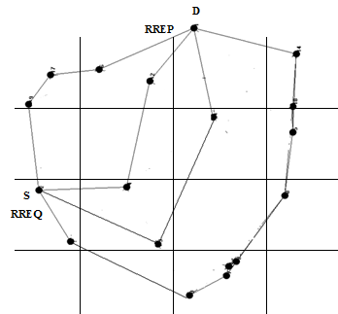
Figure 3. Building the path from S to D

6. Evaluate the Simulation
This section of the submitted paper provides an evaluation of the proposed method of simulation with a different number of areas using more than one performance parameters, and simulation was performed using different scenarios and performance measures to show the efficiency of the proposed technique. Performance measures and scenarios used in the current study are represented in table 1.

Table 1.simulation parameters
parameters | description
Number of nodes | 20, 50,80,100,150 [node]
Simulation size | 1000 x 1000 [pixel]
Communication range | 20 [pixel]
Number of zones | 16 , 25 , 36 , 49, 64[zone]
Obstacle zone | 0 , 5 , 10 [pixel]
Conventional routing protocol | AODV

The communication range between the nodes is calculated according to the law of distance d:
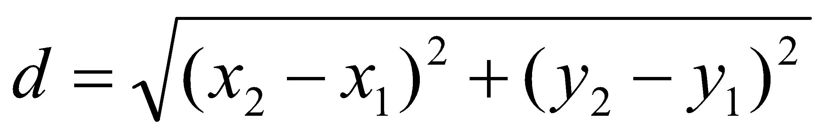------(1)
It does not exceed 20 pixel. The packet arrival rate is the lowest for 16 zones and the highest for 49 zones, because if the number of zones is small, the number of RREQs that pass through a different zone from the main path will be reduced, and the number of paths that can be created is reduced. If the number of zones is large, the number of RREQs that pass through a different zone from the main path increases, the number of paths that can be created increases, and therefore the packet arrival rate is considered to have improved. When the number of zones exceeds a certain number, the number of paths that can be created does not change, and therefore the packet arrival rate does not change. Therefore, the number of zones in subsequent simulations is assumed to be 64 zone with a high average packet arrival rate.
7. Results
The proposed method is considered to have excellent communication even when a communication failure occurs with a certain propagation range. So, in this simulation, we simulated AODV which is a traditional method for creating multiple paths, and the proposed processing is simulated provided that an error area occurs and the nodes move after the path is created .. The source node and destination node have been fixed, and the other nodes are randomly placed in the field. Since each node has coordinates (x, y) in the t-cycle.
You go to (x + Λ x, y + Λ y) at the t + 1 cycle,
Λ x and y determined randomly between [–v, v] where v is kinematic. In evaluation, after creating the path from the source node to the destination node, the node is moved for 10 cycles, and the condition in which the path is created in each successful cycle is considered. The results of all simulations were an average of 300 runs. In this simulation, even if the path is cut, the path is not repaired or rebuilt.
In simulation, an error zone was created near the center of the grid between 1 and 10 cycles. The malfunction area is circular and cannot contact the nodes in the malfunction zone.
Figure 4 shows the results of the packet arrival rate (the number of nodes here is 100 nodes).
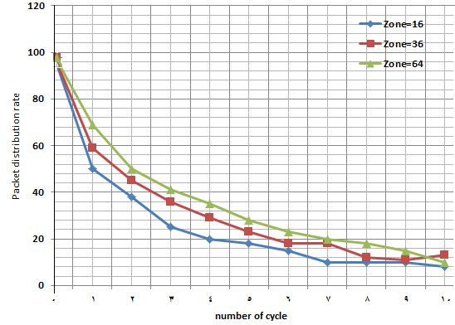
Figure 4. Packet Delivery Rate (100 nodes)
The simulation environment is the same as in Table 1. The packet arrival rate for the proposed method was high for both 100 and 150 nodes. This is thought to be because AODV creates multiple paths with the same number of hops as the shortest path, so it is easy to locate the nodes at the ends of the connection range, And a small amount of node movement often breaks the connection. The packet arrival rate increased in the proposed processing when the number of nodes increased from 100 to 150. This is because the number of nodes that can be created is small because when the number of nodes is 100, the number of nodes is not enough to build a path without overlapping the area. When the number of nodes reaches 150, the number of paths that can be created increases, and it is believed that the packet arrival rate has increased.
Figure 5 shows a Packet arrival rate comparison for the number of implementation cycles in the case of the AODV and proposed routing protocol.
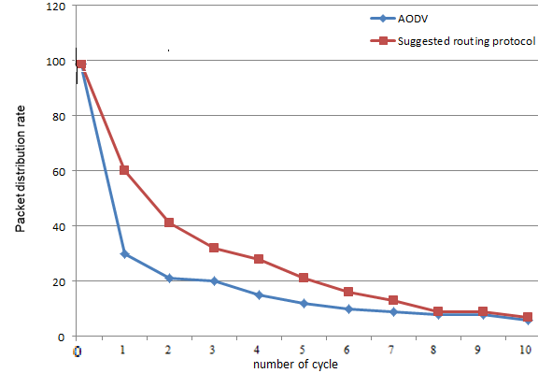
Figure 5. Packet arrival rate
8. Conclusions
In this paper, we suggest a simple treatment by building multipath that do not overlap at the level of an ad hoc network zone by dividing the zone. In the proposed method, the network is divided into non-overlapping regions, and multiple paths without overlapping regions are created by a single flood. The number of messages to be flooded can be reduced by sorting when path control messages are received, only path control messages are transmitted without region-wide duplication, and other messages are ignored. Additionally, since multipath are created by a single flood, the complexity of the process can be prevented. Properties were evaluated by simulation, and the proposed method connection showed to be superior to that of the conventional protocol that constructs multipath. In addition, there is better communication than traditional methods when a communication failure occurs within a certain range. In the future, in order to reduce the number of packages, we will study the conditions for choosing RREQ and consider the effect of increased packages on communication.

References
[1] Wang, L., Zhang, LF, Shu, YT, Dong, M. and Yang, OWW,2000, Multipath Source Routing in Wireless Ad Hoc Networks, Proc. IEEE CCECE , Halifax, Nova Scotia, Canada, pp.479–483 .
[2] Lee, SJ and Geria, M.2001, Split Multipath Routing with , Maximally Disjoint Paths in Ad hoc Networks, Proc. IEEE ICC 2001 , Vol.10, pp.3201–3205 .
[3] Bennis, H. Fouchal , K. Piamrat , O. Zytoune, D. Aboutajdine , 2015,A Realistic Multipath Routing for Ad Hoc Networks.
[4] V.C . Patil , Rajashree. V. Biradar , R. R. Mudholkar and S. R. Sawant ,2010, On-Demand Multipath Routing Protocols for Mobile Ad Hoc Networks Issues and Comparison, International Journal of Wireless Communication and Simulation Volume 2 Number 1 , pp. 21–38.
[5] Zeyad M. Alfawaer , Belgaum Mohammad Riyaz ,2018, An enhanced Multipath Strategy in Mobile Ad hoc Routing Protocols.
[6] Pushpender Sarao , 2019, Ad Hoc On-demand Multipath Distance Vector Based Routing in Ad-Hoc Networks Hyderabad Institute of Technology and Management, Hyderabad-501401, India Email: drpushpendersarao@gmail.com , Journal of Communications Vol. 14, No. 8.
[7] Sheng Liu, Yang Yang, Weixing Wang, 2013 , Research of AODV Routing Protocol for Ad Hoc Networks , School of Information Engineering, Chang’an University, Xi’an, 710064.
[8] Rosa Mavropodi , Panayiotis Kotzanikolaou , Christos Douligeris ,2006, SecMR – a secure multipath routing protocol for ad hoc networks , Department of Informatics, University of Piraeus, 80 Karaoli & Dimitriou, 18534 Piraeus, Greece Available online 28 .
[9] David B. Johnson David A. Maltz Josh Broch , DSR, 2001, The Dynamic Source Routing Protocol for Multi-Hop Wireless Ad Hoc Networks , Computer Science Department Carnegie Mellon University Pittsburgh, PA 15213-3891, http://www.monarch.cs.cmu.edu.
[10] Cuirong Wang , Shuxin Cai , Rui Li , 2009, AODVsec: A Multipath Routing Protocol in Ad-hoc Networks for Improving Security , dept. of electron. inf., northeastern univ. at qinhuangdao, qinhuangdao, china , international conference on multimedia information networking and security, Volume: 2, Pages: 401-404

اقتراح مسارات متعددة وتقسيم المنطقة لمعالجة فشل الاتصال في الشبكات المخصصة
الاستاذ المساعد ندى بدر جراح
جامعة البصرة / كلية الادارة والاقتصاد
قسم الاحصاء / العراق
التخصص العام: علوم حاسبات
nadabadrjarah@yahoo.com البريد الالكتروني :

الملخص
تحظى اليوم الخصوصية وعدم الكشف عن هوية المستخدم أهمية قصوى على الانترنت، وتعتبر الشبكات الخاصة أحد تلك الأدوات، والتي تسمح للمستخدم بالبقاء في مأمن وللحفاظ على سرية المعلومات المتداولة عبر هذه الشبكات التي تميزت بسهولة الاعداد وقلة تكاليفها وكثرة استخدامها في عالم الشركات ، كما اضافت اهمية كبيرة في معالجة حالة فشل الاتصال في المناطق التي تتعرض لتدمير البنى التحتية للاتصالات. وان البروتوكولات المقترحة في الشبكات الخاصة غالبا ما تبني مسارا واحداً فقط لتحقق الاتصال بين العقد نظرا لقيود نفاذ البطارية وحركة العقد وغالباً ما يتعرض هذا الاتصال الى حدوث فشل ضمن نطاق معين لذلك تستخدم مسارات بديلة متعددة في الشبكات الخاصة حلا لفشل اتصال العقدة ، بالإضافة إلى ذلك ، عند النظر في الحالة التي ينتشر فيها التداخل ، يُفضل أن يكون كل مسار بعيدًا عن المسارات الأخرى إلى حد ما ، نقدم في هذا البحث معالجة بسيطة ببناء طرق متعددة لا تتداخل على مستوى منطقة شبكة خاصة وذلك بتقسيم المنطقة ، وتم التقييم بمحاكاة الشبكة (ns-allinone-3.20).الذي اظهر ان اتصال الشبكة الخاصة المقترحة اعلى من الاتصال بالطرق التقليدية في انشاء طرق متعددة.

